METHOD FOR FINDING SHORTEST PATH IN PCBs LAYOUT VERIFICATION PROCESS
EXISTING PATENTS RELATED TO THIS INVENTION
Patent title: “Method for identifying short-circuit path in integrated circuit layout verification process”, Publication number: CN103186690 A, Publication date: 3 Jul 2013, Inventors: 王志明, 王国庆, 丁丰庆, 毛凌颖.
GOAL OF THE INVENTION
The invention disclodes a method for finding a shortest path between any two points in Printed Circuit Boards (PCBs) layout.
FIELD OF THE INVENTION
The invention belongs to the technical field of Electronics Design Automation (EDA) or Electronics Computer Aided Design (ECAD). Particularly, it relates to the field of PCB design and verification.
BACKGROUND OF THE INVENTION
EDA is a category of software tools for designing electronic systems such as Printed Circuit Boards (PCBs) and Integrated Circuits (ICs). Such tools help designer to manage the complexity of the design. To achieve that, they employ a lot of method for designing and verifying PCB designs. One of the methods is finding the shortest path between components in a PCB design. Particularly, in the PCB designs, sometime, the distance between two elements should be greater than a threshold to avoid some side effects such as crosstalk and overheating. So, the shortest path method is employed in this case to measure that distance. Our invention can be also employed in circuit routing problem which find a best path to connect components in PCB layout.
Finding the shortest path between two elements in a PCB layout can be transformed into a shortest path problem in 2D environment. In addition, because there have holes inside the PCB layout, the problem turns to finding the shortest path in polygonal domain. Our invention is constructed by using components: polygon triangulation algorithm, Dijkstra algorithm, and Funnel algorithm.
Polygon triangulation is the decomposition of a polygonal area (PCB layout) into a set of triangles. There have a lot of algorithms to triangulate a polygonal area such as ear clipping, monotone. Delaunay triangulation is another way to create a triangulation. Our invention uses constrained Delaunay triangulation algorithm for triangulate the PCB layout. The complexity of this algorithm is O(NlogN) with N is number of point constructing the PCB layout.
Dijkstra algorithm is an algorithm for finding the shortest path among nodes in a graph. In our invention, it is used to find a shortest sequence of triangles, called shortest channel, in the graph of triangles build by polygon triangulation algorithm above. The complexity of Dijkstra algorithm is O(|E| + VLog|V|) with V is number of triangles and E is number of edges in the graph of triangles.
Once we have the shortest channel from the start point to the end point, we can apply funnel algorithm on this channel. The funnel algorithm considers three structures: the path, the apex, and the funnel. The path is the series of line segments forming the portion of the shortest path. The funnel consists of two series of line segments which represent the area in which all shortest paths to the area not yet processed. Finally, the apex is the point which joins the path and the funnel. The first apex starts at start point. FIG 6 shows these structures. This algorithm can be done in time linear O(T) with T is number of triangles in channel. This number is much less than number of point constructing the PCB layout.
EFFECTS OF THE INVENTION
The overall complexity of our method is in polynomial time O(NlogN). Therefore, the present method quickly searches the shortest path between any two points in PCBs layout. It adapts with the complexity of PCB layout, so that the required storage space and the running efficiency is high compare to general search algorithms.
HOW GOOD FOR BUSINESS
Verification processes in EDA tools are important because they avoid defects in design and reduce design costs. However, PCBs are becoming increasingly large and complex, typically including millions of individual elements such as ICs, transistors and logic gates. As a result of this increased size and complexity, how to complete the verification of the design within the effective time has become the major issue need to be solved. The present invention can be employed in many kinds of verification process to reduce time for verifying designs but ensuring the reliability. In addition, a modified version of our invention can be applied in routing problem.

DRAWINGS OF THE INVENTION
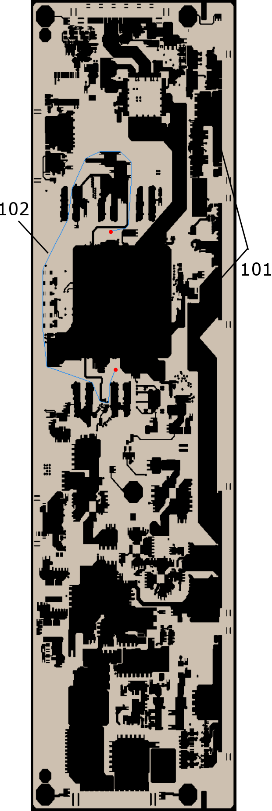
FIG. 1
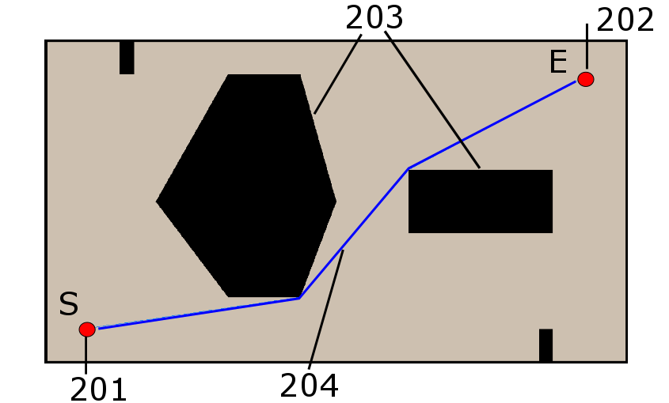
FIG. 2

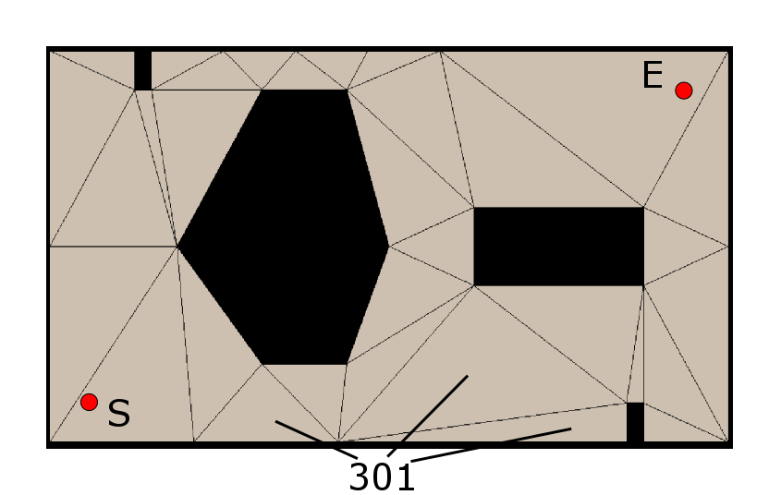
FIG. 3
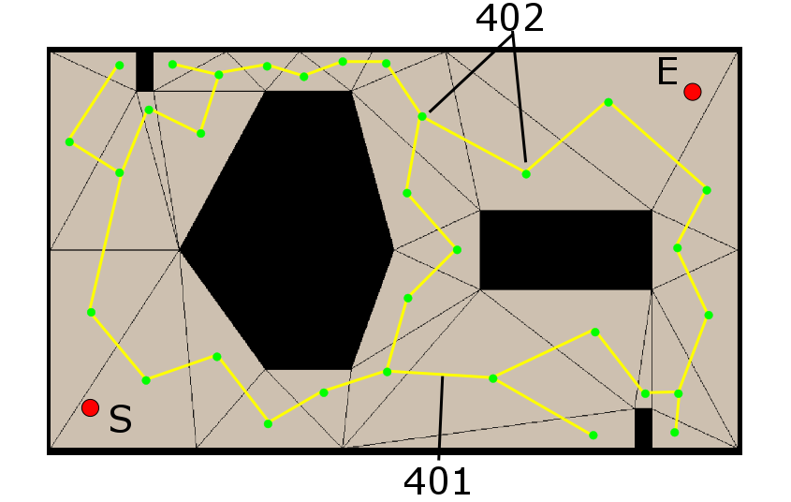
FIG. 4

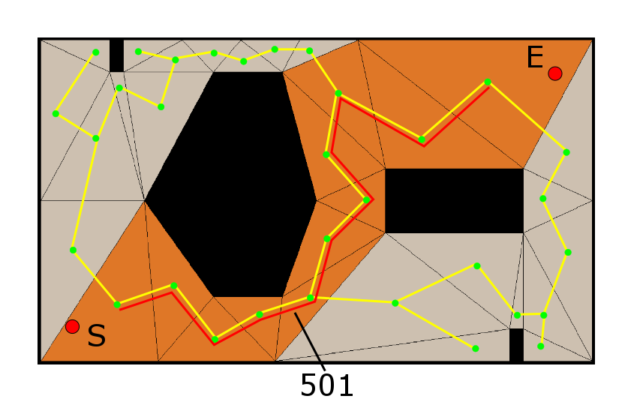
FIG. 5
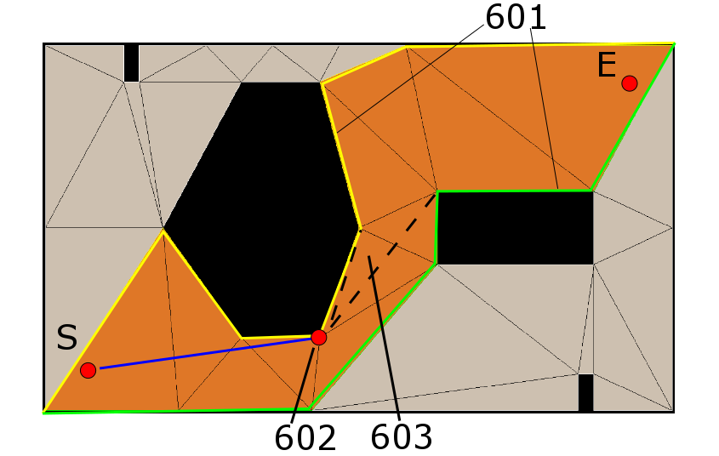
FIG. 6

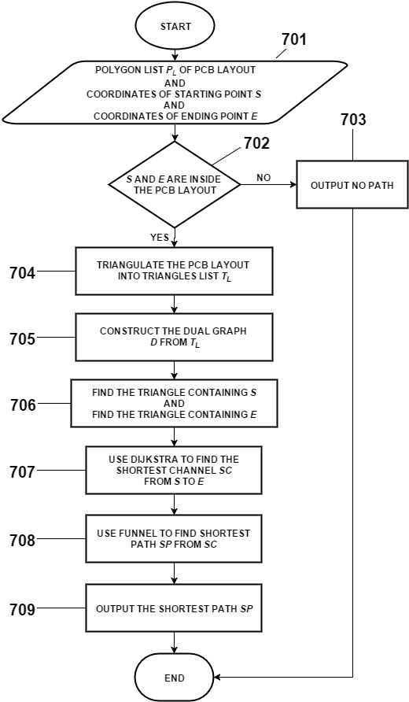
FIG. 7A
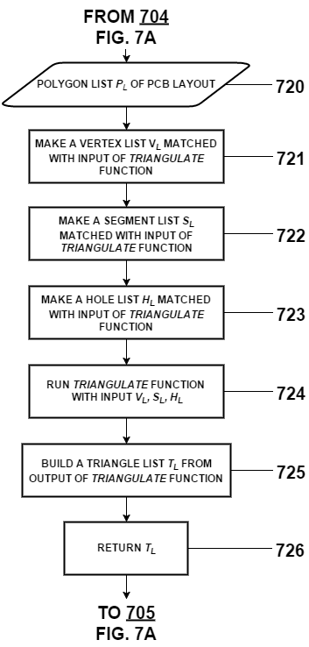
FIG. 7B

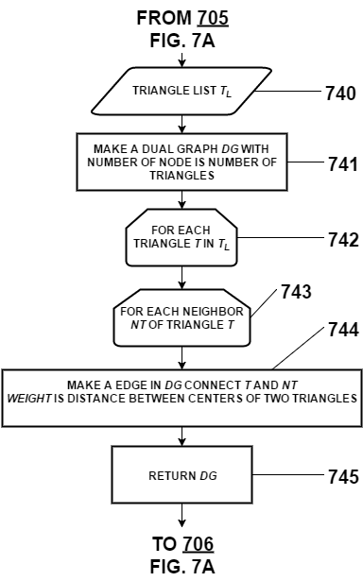
FIG. 7C

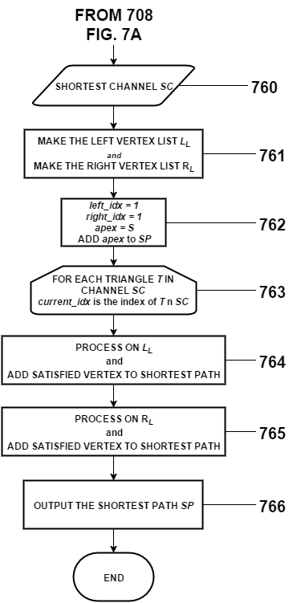
FIG. 7D

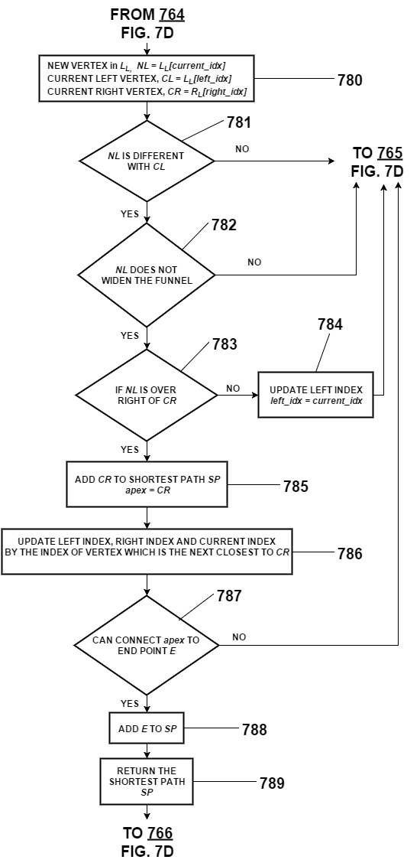
FIG. 7E
BRIEF DESCRIPTION OF THE DRAWING
FIG. 1 is a real PCB layout with a lot of holes 101 inside of it. It also illustrates shortest path 102 which is generated from our invention.
FIG 2 is a small PCB layout for easily illustrating our invention. It contains holes 203, start point 201 an end point 202.
FIG 3 illustrates the result after using constrained Delaunay triangulation algorithm. The whole layout area is divided into multiple triangles.
FIG 4 illustrates the dual graph of triangles. The nodes 402 is centers of triangles. Edge 401 is made between two nodes if they are two adjacent triangles. The weight of a edge is the distance between centers of two triangles.
FIG 5 illustrates channel 501 which is the result of Dijkstra algorithm performing on dual graph.
FIG 6 illustrates components of the funnel algorithm. At this time, the shortest path includes the start point S and apex 602. Algorithm still processes remaining triangles in the channel.
FIG 7A is a flowchart of the overall method for finding the shortest path in a PCB layout.
FIG 7B is a flowchart of the method for triangulating the PCB layout.
FIG 7C is a flowchart of steps for building dual graph.
FIG 7C is a flowchart of the funnel algorithm.
DETAILED DESCRIPTION OF THE INVENTION
Referring to FIG 7A, we show the flowchart of overall method. The method receives a polygon list P_{L} as an input 701. PL includes points of an outer polygon and points of multiple inner polygons (holes). The start point and end point are given manually and 702 check whether they outside the PCB layout or not. If they are outside the PCB layout, no shortest path returned and method is end. Otherwise, steps of triangulation the PCB 704 are perform to triangulate the PCB layout into triangles. A triangles list TL is returned in these steps and it is input to construct a dual graph D in 705. Dual graph D views triangles as nodes in its graph. So the number of nodes in graph equals to number of triangles of TL. If two triangles are adjacent triangles, an edge will be make between two nodes represented to two triangles. The weight of the edge is distance between two centers of two triangles. Step 706 determines the nodes in D containing the start point S and end point E. A Dijkstra algorithm at 707 is performed to find a shortest path SC between start node and end node on D. SC corresponds to a sequence of triangles from start point to end point and a funnel algorithm at 708 use it to give the shortest path SP. The method is end by output shortest path SP.
FIG 7B is detailed steps to triangulate a PCB layout. The main step is calling triangulate function 723 which based on constrained Delaunay triangulation algorithm. The input of algorithm includes three structures: a vertex list VL, a segment list SL, and a holes list HL. They are constructed from polygons list PL of PCB layout. Output of triangulate function is a triangles list whose element has a structure with an identity number, three vertices and identities of adjacent triangles.
TL is input of steps for constructing a dual graph DG which are clearly shown in FIG 7C. Particularly, for each triangle in TL, a node is added to DG. Additionally, an edge is connected to its adjacent triangles. The weight of the edge is measured by distance between two centers of it and the adjacent triangle. Finally, the dual graph DG is made and become the input of Dijkstra algorithm 707.
Referring to FIG 7D, a flowchart of the funnel algorithm is shown to illustrate step 708 in FIG 7A. A shortest channel found in 707 becomes the input of this algorithm. In detail, the channel is a sequence of adjacent triangles from triangle containing start point to triangle containing the end point (as shown in 501 FIG 5). The shortest path is constructed within this channel. To run the algorithm, it needs a left vertex list LL and a right vertex list RL which are illustrated in 601 (FIG 6). In addition, some variables 762 are made to control the algorithm. Variable left_idx controls the current index of left vertex list, variable right_idx controls the current index of right vertex list. Apex is current vertex in the shortest path and the first apex is start point. The algorithm is run by loop through the channel (763), and variable current_idx identifies for current triangle in the loop. For each triangle, the algorithm start to process on le LL first (764) and then on the RL (765). Every vertex satisfied the algorithm is add to shortest path SP and return at 766.
Because of symmetry of 765 and 765, FIG 7E only shows steps processed on the LL and steps processed on RL are referred from this figure. The definition of current right vertex (CR), current left vertex (CL) and new left vertex (NL) are shown in 780. CR will be added to SP when NL satisfies three conditions: different with current left vertex (CL), not make the funnel (603 in FIG 6) widen, over the right of current right vertex (CR). Otherwise, the algorithm skip to process on the LL and go to 765 for processing on the RL. After adding CR to the shortest path SP, the apex is updated by CR. In addition, the current left index, current right index and and current index are updated by the index of vertex which is in RL and is the next closest to the CR. At 787, if the current apex can connect to end point without intersecting with any part of the channel, end point is add to SP and algorithm is end by returning the SP.
THE INVENTION WE WANT TO PROTECT
1. A computer-implemented method determines the shortest path between two points in a PCB layout.
2. The method of claim 1 is implemented by any high level programing language such as C++, Java
3. The method of claim 1 comprises steps of:
(A) triangulate the PCB layout into triangles.
(B) construct a dual graph of the triangles.
(C) determine the nodes in dual graph containing start point and end point.
(D) use Dijkstra algorithm on the dual graph to find a shortest channel from start point to end point
(E) use funnel algorithm on the shortest channel to find the shortest path from start point to the end point.
4. The method of claim 3, wherein the step (A) comprises steps of:
(A)(1) loop through PCB layout to create three structures which are inputs of triangulate function. It includes a vertices list, a segments list and a holes list.
(A)(2) perform triangulate function and return triangles list.
5. The method of claim 3, wherein step (B) iterates through all triangles. For each triangle:
(B)(1) add a node to dual graph.
(B)(2) add an edge between the triangle and its adjacent triangle.
(B)(3) compute weight of the edge.
6. The method of claim 3, wherein the step (D) returns a shortest channel which is a sequence of triangle from start point to end point.
7. The method of claim 3, wherein the step (E) comprises steps of:
(E)(1) build the left vertex list and right vertex list.
(E)(2) iterate through all triangle in the channel and add satisfied vertex to the shortest path. For each triangle, we process vertices on the left vertex list first and then process vertices on the right vertex list.
8. The method of claim 7, wherein (E)(2), a vertex in the right (left) vertex list is added to shortest path if the processed vertex in the left (right) vertex list satisfies:
(E)(2)(a) different with current left vertex in left vertex list,
(E)(2)(b) not make the funnel widen
(E)(2)(c) over the right of current right vertex in right vertex list
9. The method of claim 7, wherein (E)(2), the funnel algorithm is end when all triangles in channel is iterated or the current apex at any iteration can connect to the end point without intersecting with any parts of the channel.

