METHOD FOR FINDING SHORTEST PATH IN PCBs LAYOUT VERIFICATION PROCESS
EXISTING PATENTS RELATED TO THIS INVENTION
Patent title: “Method for identifying short-circuit path in integrated circuit layout verification process”, Publication number: CN103186690 A, Publication date: 3 Jul 2013, Inventors: 王志明, 王国庆, 丁丰庆, 毛凌颖.
GOAL OF THE INVENTION
The invention discloses a method for finding the shortest path between any two points in layouts of Printed Circuit Boards (PCBs).
FIELD OF THE INVENTION
The invention belongs to the technical field of Electronics Design Automation (EDA) or Electronics Computer Aided Design (ECAD). Particularly, it relates to the field of PCB design and verification.
BACKGROUND OF THE INVENTION
EDA is a category of software tools for designing electronic systems such as Printed Circuit Boards (PCBs) and Integrated Circuits (ICs). These tools help designers to manage the complexity of the PCB designs and verify them. When designing PCBs, the distance between two elements should be greater than a threshold to avoid some side effects such as crosstalk and overheating. For measuring that distance, some methods such as finding the shortest path between components in a PCB design are employed. The invention presents a solution for finding the shortest path among components in a PCB layout. Besides, it can be a considered solution for the circuit routing problem.
Finding the shortest path between two elements in a PCB layout can be transformed into a 2D environment shortest path problem. However, because there might exist some holes inside the PCB layout, the problem turns into finding the shortest path in a polygonal domain. There have many steps involved for finding a shortest path such as decomposing polygonal area, running Dijkstra algorithm, building dual graph…
Polygon triangulation is a common approach to decompose polygonal area (PCB layout) into a set of triangles. There are some algorithms such as ear clipping and monotone to triangulate a polygonal area. Our invention uses constrained Delaunay triangulation algorithm that significantly reduces pathfinding search effort as well as better representing the basic structure of the environment (PCB layout). The complexity of this algorithm is O(NlogN) in which N is the number of points constructing the PCB layout.
Dijkstra algorithm is an algorithm for finding the shortest path among nodes in a graph. In our invention, this algorithm is used to find a shortest sequence of triangles, called a shortest channel, in the graph of triangles built by the polygon triangulation algorithm stated above. The complexity of Dijkstra algorithm is O(|E| + VLog|V|) in which V is the number of triangles and E is the number of edges in the graph of triangles.
Once we have the shortest channel from the start point to the end point, we can apply funnel algorithm on this channel. The funnel algorithm considers three structures: the path, the apex, and the funnel. The path is the series of line segments forming the portion of the shortest path. The funnel consists of two series of line segments that represent the area in which all shortest paths to the area are not yet processed. Finally, the apex is the point that joins the path and the funnel. The first apex starts at the start point. FIG 6 shows these structures. This algorithm can be performed in linear time O(T) in which T is the number of triangles in the channel. This number is much smaller than the number of points for constructing the PCB layout.
EFFECTS OF THE INVENTION
The overall complexity of our method is in polynomial time O(NlogN). Therefore, the present method quickly searches the shortest path between any two points in the PCBs layout. It adapts with the complexity of PCB layout so that the required storage space and the running efficiency is high compared to general search algorithms.

HOW GOOD FOR BUSINESS
Verification processes in EDA tools are important for avoiding defects and reducing costs in designs. However, PCBs are becoming increasingly large and complex, typically including millions of individual elements such as ICs, transistors, and logic gates. Therefore, finding a way to complete the verification of the design within the effective time has become the major issue that need to be solved. The present invention can be employed in many kinds of verification processes to reduce the running time for verification while ensuring reliability. In addition, a modified version of our invention can be applied for solving the circuit routing problem.

DRAWINGS OF THE INVENTION
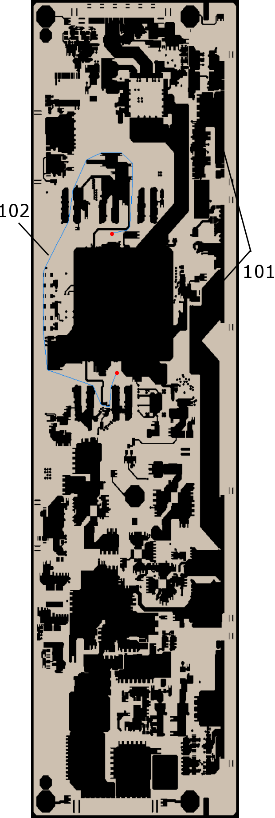
FIG. 1
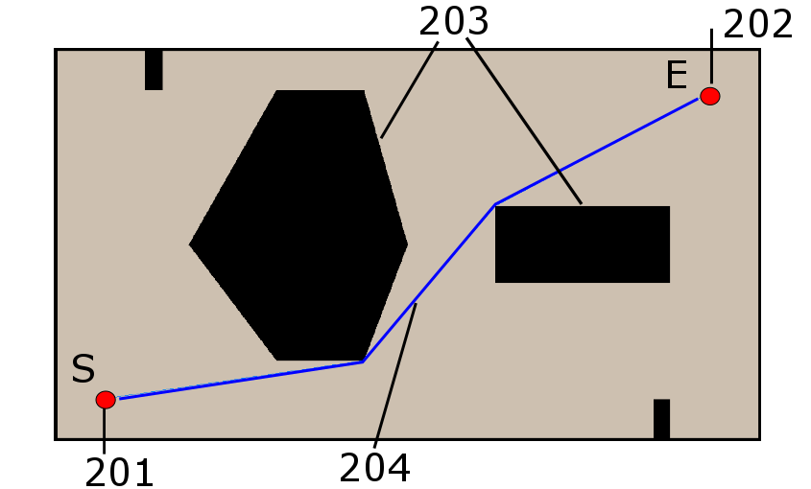
FIG. 2

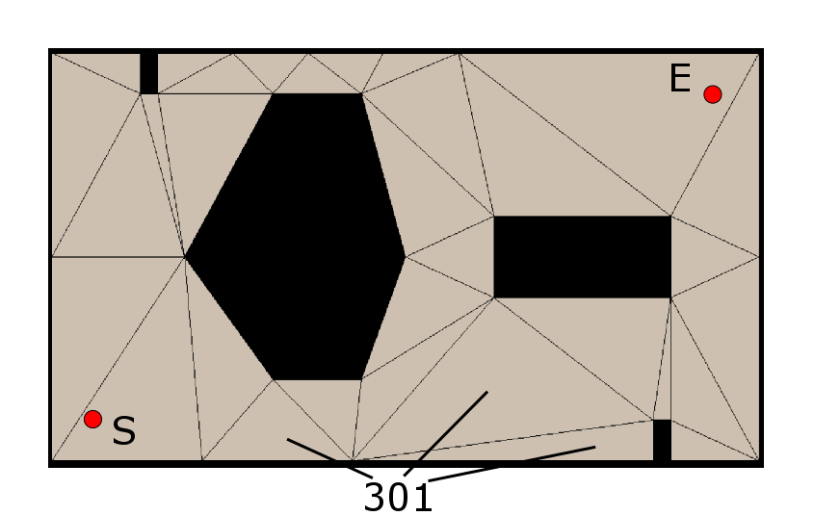
FIG. 3
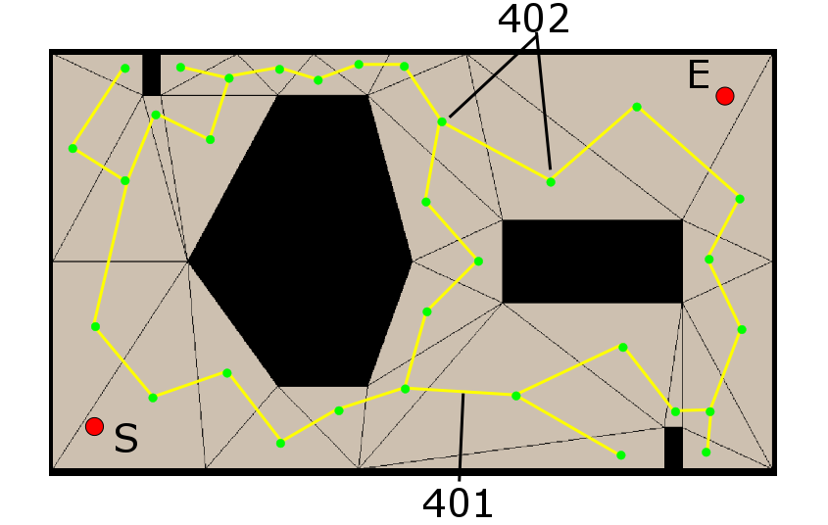
FIG. 4

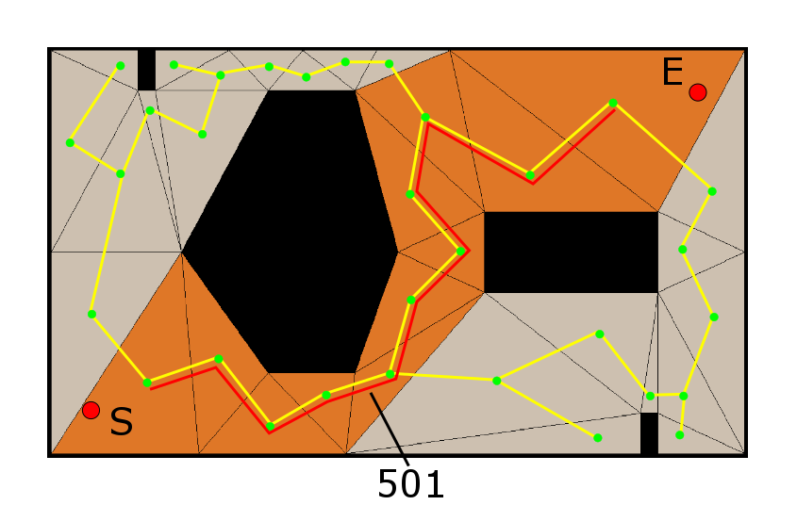
FIG. 5
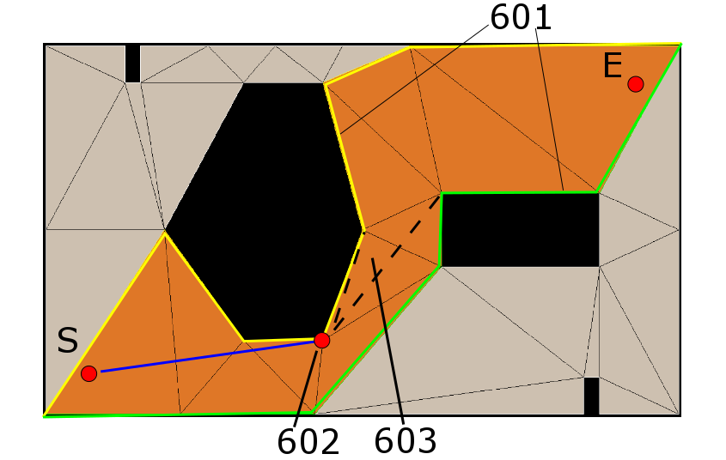
FIG. 6

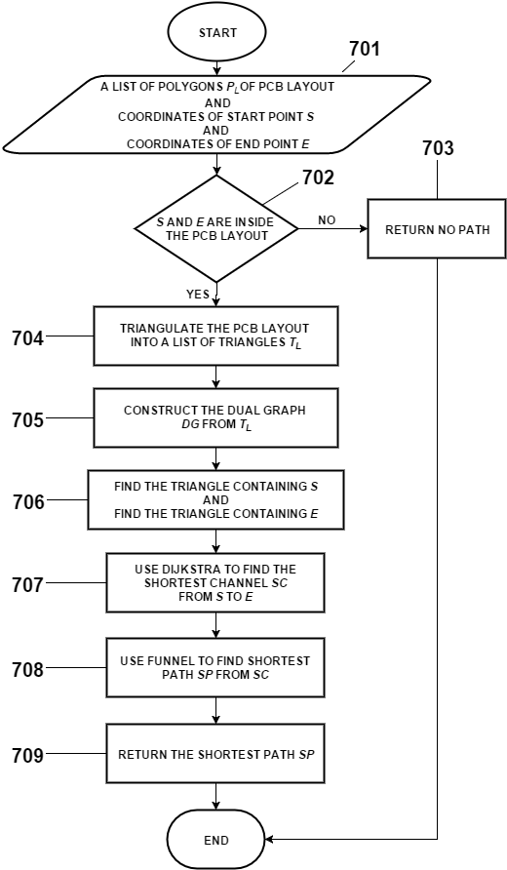
FIG. 7A
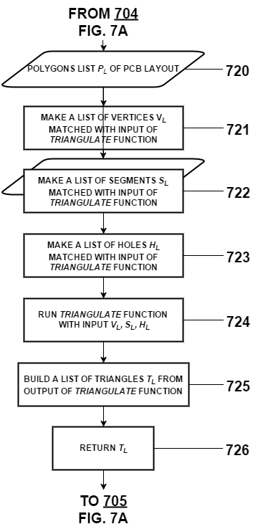
FIG. 7B

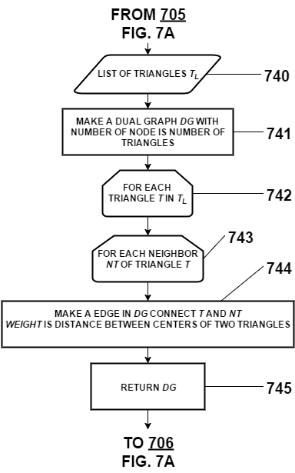
FIG. 7C

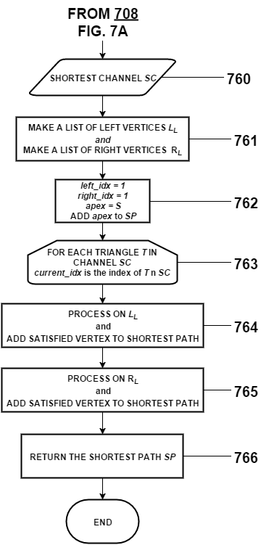
FIG. 7D

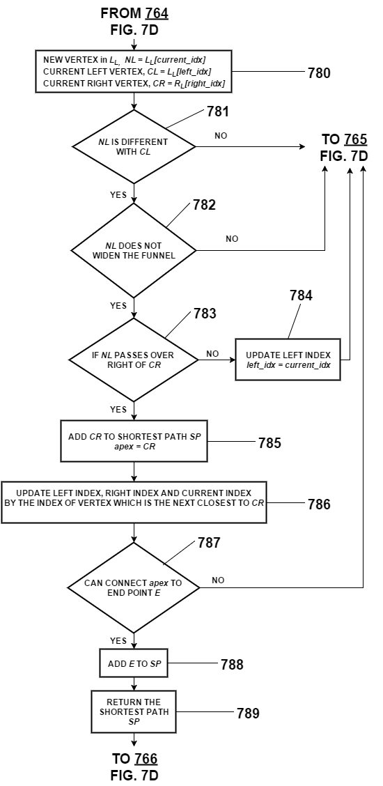
FIG. 7E
BRIEF DESCRIPTION OF THE DRAWING
FIG. 1 is a real PCB layout with many holes 101 inside of it. It also illustrates shortest path 102, which is generated from our invention.
FIG 2 is a small PCB layout for easily illustrating our invention. It contains holes 203, start point 201, and end point 202.
FIG 3 illustrates the result after using constrained Delaunay triangulation algorithm. The whole layout area is divided into multiple triangles.
FIG 4 illustrates the dual graph of triangles. Nodes 402 are centers of triangles. Edge 401 is done between two nodes if they are two adjacent triangles. The weight of an edge is the distance between centers of two triangles.
FIG 5 illustrates channel 501, which is the result of Dijkstra algorithm performing on a dual graph.
FIG 6 illustrates components of the funnel algorithm. At this point, the shortest path includes the start point S and apex 602. The algorithm is still processing remaining triangles in the channel.
FIG 7A is a flowchart of the overall method for finding the shortest path in a PCB layout.
FIG 7B is a flowchart of the method for triangulating the PCB layout.
FIG 7C is a flowchart of steps for building a dual graph.
FIG 7C is a flowchart of the funnel algorithm.
DETAILED DESCRIPTION OF THE INVENTION
In FIG 7A, we show the flowchart of the overall method. The method receives a list of polygons P_{L} as an input 701. P_{L} includes points of an outer polygon and points of multiple inner polygons (holes). The start point and end point are given manually, and 702 check whether they are outside the PCB layout or not. If these points are outside the PCB layout, no shortest path is returned and the method is ended. Otherwise, steps of triangulation the PCB 704 are performed to triangulate the PCB layout into triangles. A list of triangles T_{L} is returned in these steps, and it is set as an input to construct a dual graph DG in 705. Dual graph DG represents triangles as nodes in its graph. So the number of nodes in graph equals to the number of triangles of the T_{L}. If two triangles are adjacent triangles, an edge will be made between two nodes represented by two triangles. The weight of the edge is the distance between the centers of two triangles. Step 706 determines the nodes in DG containing the start point S and the end point E. A Dijkstra algorithm at 707 is performed to find a shortest path SC between the start node and the end node on DG. SC corresponds to a sequence of triangles from the start point to the end point, which is used to find the shortest path SP by the funnel algorithm at 708. The method is ended when the shortest path SP is generated.
FIG 7B shows the detailed steps to triangulate a PCB layout. Calling triangulate function 723 is the main step in the flowchart of this figure. For our implementation, we select constrained Delaunay triangulation algorithm. The input of this algorithm includes three structures: a list of vertices V_{L}, a list of segments S_{L}, and a list of holes H_{L}. They are constructed from polygons list P_{L} of the PCB layout. The output of the triangulate function is a list of triangles T_{L} whose each element has an identity number, three vertices, and identities of the adjacent triangles.
T_{L} is the input of the step for constructing a dual graph DG that is clearly shown in FIG 7C. Particularly, for each triangle T in T_{L}, a node is added to DG. For each adjacent triangle NT of triangle T, an edge is added to DG to connect T and NT. The weight of the edge is the distance between two triangles. Finally, the dual graph DG is generated and become the input of the Dijkstra algorithm 707.
FIG 7D shows a flowchart of the funnel algorithm to illustrate step 708 in FIG 7A. The shortest channel found in 707 becomes the input of this algorithm. In detail, the channel is a sequence of adjacent triangles from the triangle containing the start point to the triangle containing the end point (as shown in 501 FIG 5). The shortest path is constructed within this channel. For running the algorithm, a list of left vertices L_{L} and a list of right vertices R_{L} are required. They are illustrated in 601 (FIG 6). In addition, some variables 762 are set to control the algorithm. left_idx variable controls the current index of the left vertices list, and right_idx variable controls the current index of the right vertices list. Apex is the current vertex in the shortest path and the first apex is the start point. The algorithm iterates through all triangles of the channel (763), and current_idx variable identifies the current triangle in the iteration. For each triangle, the algorithm starts to process on the L_{L} first (764) and then on the RL (765). Every vertex satisfied the algorithm is added to the shortest path SP and returned at 766.
FIG 7E shows the steps processed on the L_{L} (764). 765 has the same as 764, but processed on the R_{L}. The definition of current right vertex C_{R}, current left vertex C_{L} and new left vertex N_{L} are shown in 780. C_{R} will be added to SP when N_{L} satisfies three conditions: different with C_{L}, not make the funnel (603 in FIG 6) widen, over the right of C_{R}. Otherwise, the algorithm skips to process on the L_{L} and go to 765 for processing on the R_{L}. After adding C_{R} to the shortest path SP, the apex is updated by C_{R}. In addition, the current left index, current right index and current index are updated by the index of the vertex which is in R_{L} and is the next closest to the C_{R}. At 787, if the current apex can connect to the end point without intersecting with any part of the channel, the end point is added to SP, and the algorithm is ended by returning the SP.
THE INVENTION WE WANT TO PROTECT
1. A computer-implemented method determines the shortest path between two points in a PCB layout.
2. The method of claim 1 can be implemented by any high-level programing language such as C++, Java
3. The method of claim 1 comprises steps of:
(A) triangulate the PCB layout into triangles.
(B) construct a dual graph of the triangles.
(C) determine the nodes in the dual graph containing the start and end point.
(D) use Dijkstra algorithm on the dual graph to find a shortest channel from the start point to the end point
(E) use funnel algorithm on the shortest channel to find the shortest path from the start point to the end point.
4. The method of claim 3, wherein the step (A) comprises steps of:
(A)(1) loop through PCB layout to create three structures which are the inputs of triangulate function. It includes a list of vertices, a list of segments and a list of holes.
(A)(2) perform triangulate function and return a list of triangles.
5. The method of claim 3, wherein step (B) iterates through all triangles. For each triangle:
(B)(1) add a node to the dual graph.
(B)(2) add an edge between the triangle and its adjacent triangle.
(B)(3) compute the weight of the edge.
6. The method of claim 3, wherein step (D) returns a shortest channel which is a sequence of triangles from the start point to the end point.
7. The method of claim 3, wherein the step (E) comprises steps of:
(E)(1) build a list of left vertices and a list of right vertices.
(E)(2) iterate through all triangle in the channel and add satisfied vertices to the shortest path. For each triangle, we process vertices on the list of left vertices first and then process vertices on the list of right vertices.
8. In the method of claim 7, wherein (E)(2), a vertex in the list of right (left) vertices is added to the shortest path if the processed vertex in the list of left (right) vertices satisfies:
(E)(2)(a) different with current left (right) vertex in the list of left (right) vertices.
(E)(2)(b) not make the funnel widen.
(E)(2)(c) pass over the right (left) of the right (left) funnel.
9. In the method of claim 7, wherein (E)(2), the funnel algorithm is ended when all triangles in the channel are iterated, or the current apex at any iteration can connect to the end point without intersecting with any parts of the channel.

