Data Quality Control Report

**Report Date:** 2017-03-09

# DATA FILE INFORMATION

**Filename:** QC_ECO66G12_Water_20140113_20140423.csv

**SiteID:** ECO66G12

**Period of Record, Requested:** 2014-01-13 to 2014-04-23

**Period of Record, Actual:** 2014-01-13 to 2014-04-22

**Recording Interval:** 30 minutes

**Data Type:** Water

**Parameters Included:** Water.Temp.C, Air.Temp.C, Water.BP.psi, Air.BP.psi, Water.Level.ft,

# DATA SUMMARY, OVERALL

Month and Day versus number of records.

|  |  |  |  |  |  |  |  |  |  |  |  |  |  |  |  |
| --- | --- | --- | --- | --- | --- | --- | --- | --- | --- | --- | --- | --- | --- | --- | --- |
|  | 1 | 2 | 3 | 4 | 5 | 6 | 7 | 8 | 9 | 10 | 11 | 12 | 13 | 14 | 15 |
| 1 | 0 | 0 | 0 | 0 | 0 | 0 | 0 | 0 | 0 | 0 | 0 | 0 | 26 | 48 | 48 |
| 2 | 48 | 48 | 48 | 48 | 48 | 48 | 48 | 48 | 48 | 48 | 48 | 48 | 48 | 48 | 48 |
| 3 | 48 | 48 | 48 | 48 | 48 | 48 | 48 | 48 | 48 | 48 | 48 | 48 | 48 | 48 | 48 |
| 4 | 48 | 48 | 48 | 48 | 48 | 48 | 48 | 48 | 48 | 48 | 48 | 48 | 48 | 48 | 48 |

|  |  |  |  |  |  |  |  |  |  |  |  |  |  |  |  |  |
| --- | --- | --- | --- | --- | --- | --- | --- | --- | --- | --- | --- | --- | --- | --- | --- | --- |
|  | 16 | 17 | 18 | 19 | 20 | 21 | 22 | 23 | 24 | 25 | 26 | 27 | 28 | 29 | 30 | 31 |
| 1 | 48 | 48 | 48 | 48 | 48 | 48 | 48 | 48 | 48 | 48 | 48 | 48 | 48 | 48 | 48 | 48 |
| 2 | 48 | 48 | 48 | 48 | 48 | 48 | 48 | 48 | 48 | 48 | 48 | 48 | 48 | 0 | 0 | 0 |
| 3 | 48 | 48 | 48 | 48 | 48 | 48 | 48 | 48 | 48 | 48 | 48 | 48 | 48 | 48 | 48 | 48 |
| 4 | 48 | 48 | 48 | 48 | 48 | 48 | 23 | 0 | 0 | 0 | 0 | 0 | 0 | 0 | 0 | 0 |

Expected number of records per day is 48.

# FLAGS, OVERALL, BY PARAMETER

Flags are assigned to each data point (a single measured parameter at a unique point in time) first by each of the QC tests below. Flags are assigned numerical values;

* **P** = Pass,
* **S** = Suspect,
* **F** = Fail,
* **X** = No Data or Not Applicable (NA).

Overall flags are assigned by examining the results of the four tests below.

* **P** = no Fail or Suspect and at least one Pass,
* **S** = no Fail and at least one Suspect,
* **F** = at least one Fail,,
* **X** = all tests were Missing Data.

Overall flags by parameter

## Water.Temp.C

|  |  |  |  |
| --- | --- | --- | --- |
| F | P | S | X |
| 162 | 4420 | 168 | 3 |

## Air.Temp.C

|  |  |
| --- | --- |
| P | X |
| 4750 | 3 |

## Water.BP.psi

|  |  |
| --- | --- |
| P | X |
| 4750 | 3 |

## Air.BP.psi

|  |  |
| --- | --- |
| P | X |
| 4750 | 3 |

## Water.Level.ft

|  |  |  |
| --- | --- | --- |
| P | S | X |
| 4744 | 5 | 4 |

# QC TESTS, BY PARAMETER

* **Gross Range Test (Gross):** Test if data point exceeds sensor or user defined min/max. The values are user defined based on parameter being measured and measuring instrument.
* **Spike Test (Spike):** Test if data point exceeds a user defined threshold relative to the previous data point. The user defined values are based on the parameter being measured.
* **Rate of Change Test (RoC):** Test if a data point exceeds a number of standard deviations from the previous data points over a user defined time period. Default is a 25 hour time period and 3 standard deviations.
* **Flat Line Test (Flat):** Test if a data point is within a user defined threshold from previous data points over a user defined range. Default is 3 previous points for suspect and 5 points for failure. The threshold is user defined and based on the measured parameter and sensitivity of the measuring instrument.

## QC TESTS, Water.Temp.C

### Flags

#### Flag summary, overall number of records.

|  |  |  |  |
| --- | --- | --- | --- |
| F | P | S | X |
| 162 | 4420 | 168 | 3 |

Month and Day versus number of records.

|  |  |  |  |  |  |  |  |  |  |  |  |  |  |  |  |
| --- | --- | --- | --- | --- | --- | --- | --- | --- | --- | --- | --- | --- | --- | --- | --- |
|  | 1 | 2 | 3 | 4 | 5 | 6 | 7 | 8 | 9 | 10 | 11 | 12 | 13 | 14 | 15 |
| 1 | 0 | 0 | 0 | 0 | 0 | 0 | 0 | 0 | 0 | 0 | 0 | 0 | 26 | 48 | 48 |
| 2 | 48 | 48 | 48 | 48 | 48 | 48 | 48 | 48 | 48 | 48 | 48 | 48 | 48 | 48 | 48 |
| 3 | 48 | 48 | 48 | 48 | 48 | 48 | 48 | 48 | 48 | 48 | 48 | 48 | 48 | 48 | 48 |
| 4 | 48 | 48 | 48 | 48 | 48 | 48 | 48 | 48 | 48 | 48 | 48 | 48 | 48 | 48 | 48 |

|  |  |  |  |  |  |  |  |  |  |  |  |  |  |  |  |  |
| --- | --- | --- | --- | --- | --- | --- | --- | --- | --- | --- | --- | --- | --- | --- | --- | --- |
|  | 16 | 17 | 18 | 19 | 20 | 21 | 22 | 23 | 24 | 25 | 26 | 27 | 28 | 29 | 30 | 31 |
| 1 | 48 | 48 | 48 | 48 | 48 | 48 | 48 | 48 | 48 | 48 | 48 | 48 | 48 | 48 | 48 | 48 |
| 2 | 48 | 48 | 48 | 48 | 48 | 48 | 48 | 48 | 48 | 48 | 48 | 48 | 48 | 0 | 0 | 0 |
| 3 | 48 | 48 | 48 | 48 | 48 | 48 | 48 | 48 | 48 | 48 | 48 | 48 | 48 | 48 | 48 | 48 |
| 4 | 48 | 48 | 48 | 48 | 48 | 48 | 23 | 0 | 0 | 0 | 0 | 0 | 0 | 0 | 0 | 0 |

Expected number of records per day is 48.

#### Flags by QC Test

##### Flags, Gross

|  |  |
| --- | --- |
| P | X |
| 4750 | 3 |

##### Flags, Spike

|  |  |
| --- | --- |
| P | X |
| 4749 | 4 |

##### Flags, RoC

|  |  |  |
| --- | --- | --- |
| P | S | X |
| 4745 | 4 | 4 |

##### Flags, Flat

|  |  |  |
| --- | --- | --- |
| F | P | S |
| 162 | 4427 | 164 |

QC Test Flag fields are saved in the data file so the user can identify data points that have been flagged as suspect or fail.

Test results marked as X (No/Missing Data) if unable to calculate the end point needed for the test. For example, the first record does not have a previous record for comparison for the Gross QC Test. QC Test flags are saved in the data file.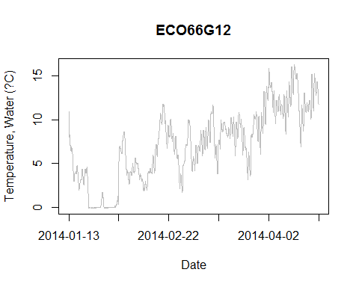

Discrete measurements, if any, show up as points on the plot.

## QC TESTS, Air.Temp.C

### Flags

#### Flag summary, overall number of records.

|  |  |
| --- | --- |
| P | X |
| 4750 | 3 |

Month and Day versus number of records.

|  |  |  |  |  |  |  |  |  |  |  |  |  |  |  |  |
| --- | --- | --- | --- | --- | --- | --- | --- | --- | --- | --- | --- | --- | --- | --- | --- |
|  | 1 | 2 | 3 | 4 | 5 | 6 | 7 | 8 | 9 | 10 | 11 | 12 | 13 | 14 | 15 |
| 1 | 0 | 0 | 0 | 0 | 0 | 0 | 0 | 0 | 0 | 0 | 0 | 0 | 26 | 48 | 48 |
| 2 | 48 | 48 | 48 | 48 | 48 | 48 | 48 | 48 | 48 | 48 | 48 | 48 | 48 | 48 | 48 |
| 3 | 48 | 48 | 48 | 48 | 48 | 48 | 48 | 48 | 48 | 48 | 48 | 48 | 48 | 48 | 48 |
| 4 | 48 | 48 | 48 | 48 | 48 | 48 | 48 | 48 | 48 | 48 | 48 | 48 | 48 | 48 | 48 |

|  |  |  |  |  |  |  |  |  |  |  |  |  |  |  |  |  |
| --- | --- | --- | --- | --- | --- | --- | --- | --- | --- | --- | --- | --- | --- | --- | --- | --- |
|  | 16 | 17 | 18 | 19 | 20 | 21 | 22 | 23 | 24 | 25 | 26 | 27 | 28 | 29 | 30 | 31 |
| 1 | 48 | 48 | 48 | 48 | 48 | 48 | 48 | 48 | 48 | 48 | 48 | 48 | 48 | 48 | 48 | 48 |
| 2 | 48 | 48 | 48 | 48 | 48 | 48 | 48 | 48 | 48 | 48 | 48 | 48 | 48 | 0 | 0 | 0 |
| 3 | 48 | 48 | 48 | 48 | 48 | 48 | 48 | 48 | 48 | 48 | 48 | 48 | 48 | 48 | 48 | 48 |
| 4 | 48 | 48 | 48 | 48 | 48 | 48 | 23 | 0 | 0 | 0 | 0 | 0 | 0 | 0 | 0 | 0 |

Expected number of records per day is 48.

#### Flags by QC Test

##### Flags, Gross

|  |  |
| --- | --- |
| P | X |
| 4750 | 3 |

##### Flags, Spike

|  |  |
| --- | --- |
| P | X |
| 4748 | 5 |

##### Flags, RoC

|  |  |
| --- | --- |
| P | X |
| 4748 | 5 |

##### Flags, Flat

|  |
| --- |
| P |
| 4753 |

QC Test Flag fields are saved in the data file so the user can identify data points that have been flagged as suspect or fail.

Test results marked as X (No/Missing Data) if unable to calculate the end point needed for the test. For example, the first record does not have a previous record for comparison for the Gross QC Test. QC Test flags are saved in the data file.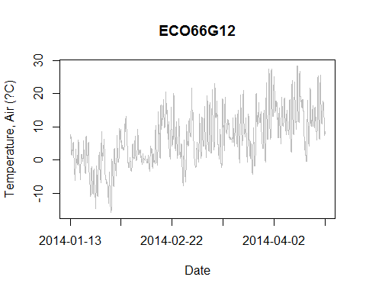

Discrete measurements, if any, show up as points on the plot.

## QC TESTS, Water.BP.psi

### Flags

#### Flag summary, overall number of records.

|  |  |
| --- | --- |
| P | X |
| 4750 | 3 |

Month and Day versus number of records.

|  |  |  |  |  |  |  |  |  |  |  |  |  |  |  |  |
| --- | --- | --- | --- | --- | --- | --- | --- | --- | --- | --- | --- | --- | --- | --- | --- |
|  | 1 | 2 | 3 | 4 | 5 | 6 | 7 | 8 | 9 | 10 | 11 | 12 | 13 | 14 | 15 |
| 1 | 0 | 0 | 0 | 0 | 0 | 0 | 0 | 0 | 0 | 0 | 0 | 0 | 26 | 48 | 48 |
| 2 | 48 | 48 | 48 | 48 | 48 | 48 | 48 | 48 | 48 | 48 | 48 | 48 | 48 | 48 | 48 |
| 3 | 48 | 48 | 48 | 48 | 48 | 48 | 48 | 48 | 48 | 48 | 48 | 48 | 48 | 48 | 48 |
| 4 | 48 | 48 | 48 | 48 | 48 | 48 | 48 | 48 | 48 | 48 | 48 | 48 | 48 | 48 | 48 |

|  |  |  |  |  |  |  |  |  |  |  |  |  |  |  |  |  |
| --- | --- | --- | --- | --- | --- | --- | --- | --- | --- | --- | --- | --- | --- | --- | --- | --- |
|  | 16 | 17 | 18 | 19 | 20 | 21 | 22 | 23 | 24 | 25 | 26 | 27 | 28 | 29 | 30 | 31 |
| 1 | 48 | 48 | 48 | 48 | 48 | 48 | 48 | 48 | 48 | 48 | 48 | 48 | 48 | 48 | 48 | 48 |
| 2 | 48 | 48 | 48 | 48 | 48 | 48 | 48 | 48 | 48 | 48 | 48 | 48 | 48 | 0 | 0 | 0 |
| 3 | 48 | 48 | 48 | 48 | 48 | 48 | 48 | 48 | 48 | 48 | 48 | 48 | 48 | 48 | 48 | 48 |
| 4 | 48 | 48 | 48 | 48 | 48 | 48 | 23 | 0 | 0 | 0 | 0 | 0 | 0 | 0 | 0 | 0 |

Expected number of records per day is 48.

#### Flags by QC Test

##### Flags, Gross

|  |  |
| --- | --- |
| P | X |
| 4750 | 3 |

##### Flags, Spike

|  |  |
| --- | --- |
| P | X |
| 4749 | 4 |

##### Flags, RoC

|  |  |
| --- | --- |
| P | X |
| 4749 | 4 |

##### Flags, Flat

|  |
| --- |
| P |
| 4753 |

QC Test Flag fields are saved in the data file so the user can identify data points that have been flagged as suspect or fail.

Test results marked as X (No/Missing Data) if unable to calculate the end point needed for the test. For example, the first record does not have a previous record for comparison for the Gross QC Test. QC Test flags are saved in the data file.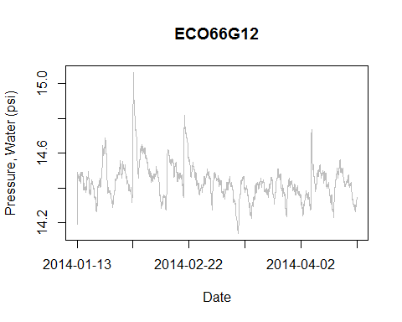

Discrete measurements, if any, show up as points on the plot.

## QC TESTS, Air.BP.psi

### Flags

#### Flag summary, overall number of records.

|  |  |
| --- | --- |
| P | X |
| 4750 | 3 |

Month and Day versus number of records.

|  |  |  |  |  |  |  |  |  |  |  |  |  |  |  |  |
| --- | --- | --- | --- | --- | --- | --- | --- | --- | --- | --- | --- | --- | --- | --- | --- |
|  | 1 | 2 | 3 | 4 | 5 | 6 | 7 | 8 | 9 | 10 | 11 | 12 | 13 | 14 | 15 |
| 1 | 0 | 0 | 0 | 0 | 0 | 0 | 0 | 0 | 0 | 0 | 0 | 0 | 26 | 48 | 48 |
| 2 | 48 | 48 | 48 | 48 | 48 | 48 | 48 | 48 | 48 | 48 | 48 | 48 | 48 | 48 | 48 |
| 3 | 48 | 48 | 48 | 48 | 48 | 48 | 48 | 48 | 48 | 48 | 48 | 48 | 48 | 48 | 48 |
| 4 | 48 | 48 | 48 | 48 | 48 | 48 | 48 | 48 | 48 | 48 | 48 | 48 | 48 | 48 | 48 |

|  |  |  |  |  |  |  |  |  |  |  |  |  |  |  |  |  |
| --- | --- | --- | --- | --- | --- | --- | --- | --- | --- | --- | --- | --- | --- | --- | --- | --- |
|  | 16 | 17 | 18 | 19 | 20 | 21 | 22 | 23 | 24 | 25 | 26 | 27 | 28 | 29 | 30 | 31 |
| 1 | 48 | 48 | 48 | 48 | 48 | 48 | 48 | 48 | 48 | 48 | 48 | 48 | 48 | 48 | 48 | 48 |
| 2 | 48 | 48 | 48 | 48 | 48 | 48 | 48 | 48 | 48 | 48 | 48 | 48 | 48 | 0 | 0 | 0 |
| 3 | 48 | 48 | 48 | 48 | 48 | 48 | 48 | 48 | 48 | 48 | 48 | 48 | 48 | 48 | 48 | 48 |
| 4 | 48 | 48 | 48 | 48 | 48 | 48 | 23 | 0 | 0 | 0 | 0 | 0 | 0 | 0 | 0 | 0 |

Expected number of records per day is 48.

#### Flags by QC Test

##### Flags, Gross

|  |  |
| --- | --- |
| P | X |
| 4750 | 3 |

##### Flags, Spike

|  |  |
| --- | --- |
| P | X |
| 4748 | 5 |

##### Flags, RoC

|  |  |
| --- | --- |
| P | X |
| 4748 | 5 |

##### Flags, Flat

|  |
| --- |
| P |
| 4753 |

QC Test Flag fields are saved in the data file so the user can identify data points that have been flagged as suspect or fail.

Test results marked as X (No/Missing Data) if unable to calculate the end point needed for the test. For example, the first record does not have a previous record for comparison for the Gross QC Test. QC Test flags are saved in the data file.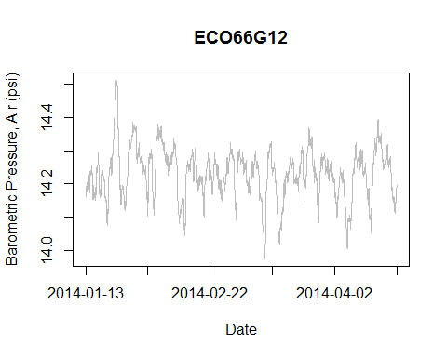

Discrete measurements, if any, show up as points on the plot.

## QC TESTS, Water.Level.ft

### Flags

#### Flag summary, overall number of records.

|  |  |  |
| --- | --- | --- |
| P | S | X |
| 4744 | 5 | 4 |

Month and Day versus number of records.

|  |  |  |  |  |  |  |  |  |  |  |  |  |  |  |  |
| --- | --- | --- | --- | --- | --- | --- | --- | --- | --- | --- | --- | --- | --- | --- | --- |
|  | 1 | 2 | 3 | 4 | 5 | 6 | 7 | 8 | 9 | 10 | 11 | 12 | 13 | 14 | 15 |
| 1 | 0 | 0 | 0 | 0 | 0 | 0 | 0 | 0 | 0 | 0 | 0 | 0 | 26 | 48 | 48 |
| 2 | 48 | 48 | 48 | 48 | 48 | 48 | 48 | 48 | 48 | 48 | 48 | 48 | 48 | 48 | 48 |
| 3 | 48 | 48 | 48 | 48 | 48 | 48 | 48 | 48 | 48 | 48 | 48 | 48 | 48 | 48 | 48 |
| 4 | 48 | 48 | 48 | 48 | 48 | 48 | 48 | 48 | 48 | 48 | 48 | 48 | 48 | 48 | 48 |

|  |  |  |  |  |  |  |  |  |  |  |  |  |  |  |  |  |
| --- | --- | --- | --- | --- | --- | --- | --- | --- | --- | --- | --- | --- | --- | --- | --- | --- |
|  | 16 | 17 | 18 | 19 | 20 | 21 | 22 | 23 | 24 | 25 | 26 | 27 | 28 | 29 | 30 | 31 |
| 1 | 48 | 48 | 48 | 48 | 48 | 48 | 48 | 48 | 48 | 48 | 48 | 48 | 48 | 48 | 48 | 48 |
| 2 | 48 | 48 | 48 | 48 | 48 | 48 | 48 | 48 | 48 | 48 | 48 | 48 | 48 | 0 | 0 | 0 |
| 3 | 48 | 48 | 48 | 48 | 48 | 48 | 48 | 48 | 48 | 48 | 48 | 48 | 48 | 48 | 48 | 48 |
| 4 | 48 | 48 | 48 | 48 | 48 | 48 | 23 | 0 | 0 | 0 | 0 | 0 | 0 | 0 | 0 | 0 |

Expected number of records per day is 48.

#### Flags by QC Test

##### Flags, Gross

|  |  |
| --- | --- |
| P | X |
| 4749 | 4 |

##### Flags, Spike

|  |  |
| --- | --- |
| P | X |
| 4748 | 5 |

##### Flags, RoC

|  |  |  |
| --- | --- | --- |
| P | S | X |
| 4743 | 5 | 5 |

##### Flags, Flat

|  |
| --- |
| P |
| 4753 |

QC Test Flag fields are saved in the data file so the user can identify data points that have been flagged as suspect or fail.

Test results marked as X (No/Missing Data) if unable to calculate the end point needed for the test. For example, the first record does not have a previous record for comparison for the Gross QC Test. QC Test flags are saved in the data file.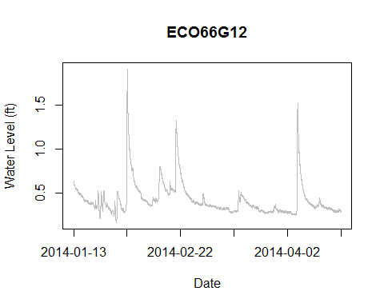

Discrete measurements, if any, show up as points on the plot.

# PLOTS, MULTIPARAMETER

Multiparameter plots if exist in the data.

## PLOT, Temperature (Air vs. Water)

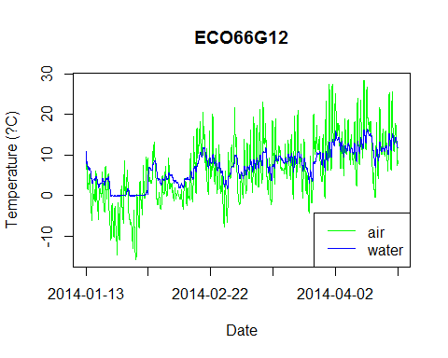

Discrete measurements, if any, show up as points on the plot.

## PLOT, Water Level vs. Water Temperature

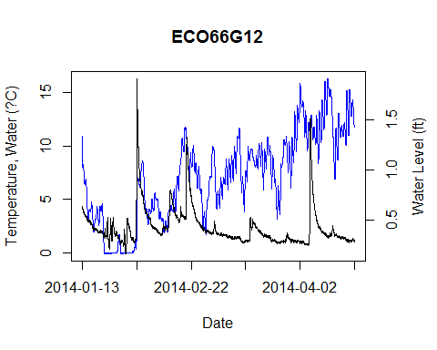

Discrete measurements, if any, show up as points on the plot.