Aggregate Report

**Report Date:** 2017-03-07

# DATA FILE INFORMATION

**Filename:** DATA_HRCC_Water_20120101_20161231.csv

**SiteID:** HRCC

**Period of Record, Requested:** 2012-01-01 to 2016-12-31

**Period of Record, Actual:** 2012-10-24 to 2014-12-11

**Recording Interval:** 30 minutes

**Data Type:** Water

**Parameters Included:** Water.Temp.C,

# PLOTS, PARAMETERS

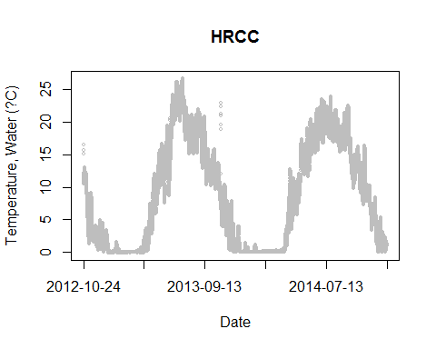

Discrete measurements, if any, show up as points on the plot.

# PLOTS, MULTIPARAMETER

Multiparameter plots if exist in the data.