Site Summary

2022-07-28 15:51:20

Table of Contents

# Site Information

**Site ID**

**Site Description**

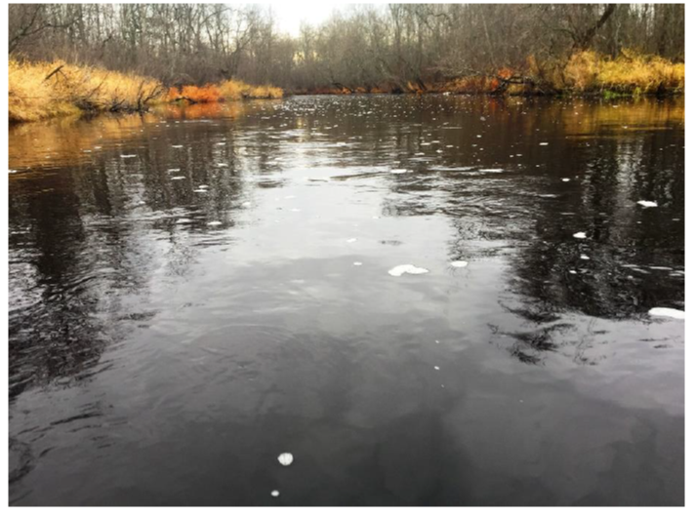

Photo of the sampling reach on Melodious Brook

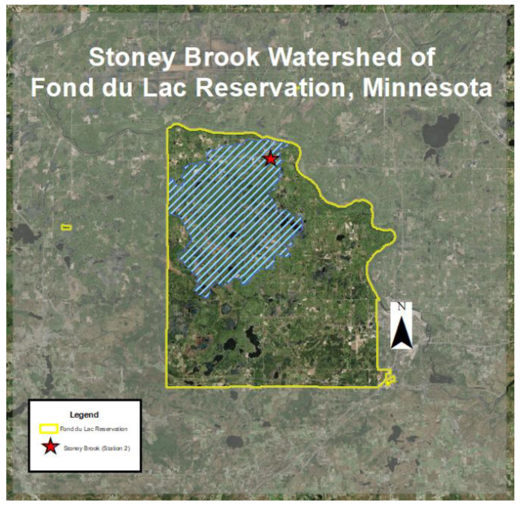

Site X is located in the Coastal Plain of a new US territory

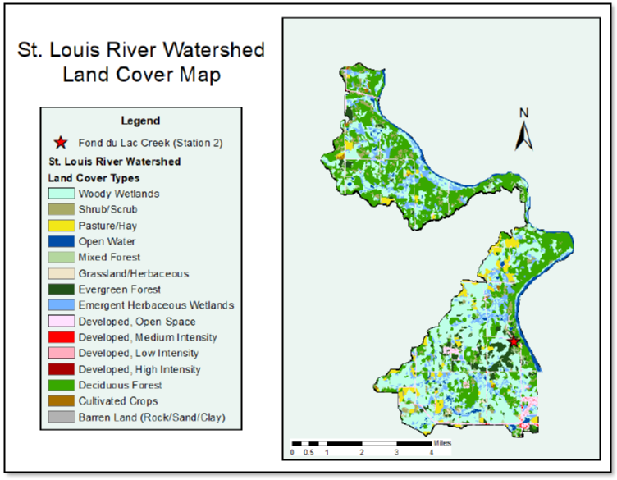

Land cover in the watershed, based on NLCD 2016 data

Land cover statistics over time, based on the NLCD dataset

|  |  |  |  |  |  |  |  |
| --- | --- | --- | --- | --- | --- | --- | --- |
| Percent.Land.Type | X2001 | X2004 | X2006 | X2008 | X2011 | X2013 | X2016 |
| Urban | 3.99 | 3.99 | 3.99 | 3.99 | 3.99 | 3.99 | 3.99 |
| Agriculture | 29.81 | 29.8 | 29.78 | 29.77 | 29.77 | 29.74 | 29.76 |
| Other | 0.56 | 0.54 | 0.56 | 0.62 | 0.49 | 0.5 | 0.46 |

Macroinvertebrate IBI scores and metrics

|  |  |  |  |  |  |  |  |  |  |  |  |  |  |  |  |  |  |  |  |  |  |  |
| --- | --- | --- | --- | --- | --- | --- | --- | --- | --- | --- | --- | --- | --- | --- | --- | --- | --- | --- | --- | --- | --- | --- |
| Year | X2000 | X2001 | X2002 | X2003 | X2004 | X2005 | X2006 | X2007 | X2008 | X2009 | X2010 | X2011 | X2012 | X2013 | X2014 | X2015 | X2016 | X2017 | X2018 | X2019 | X2020 | X |
| bibi_narr | exc | good | vgood | exc | good | vgood | good | fair | good | exc | exc | vgood | vgood | vgood | good | vgood | vgood | vgood | exc | vgood | vgood | NA |
| totind | 118 | 118 | 105 | 119 | 118 | 125 | 90 | 106 | 114 | 122 | 135 | 116 | 108 | 112 | 131 | 126 | 118 | 111 | 140 | 125 | 146 | NA |
| ntaxa | 24 | 21 | 28 | 29 | 18 | 24 | 23 | 22 | 28 | 32 | 31 | 22 | 24 | 25 | 22 | 28 | 25 | 26 | 32 | 25 | 24 | NA |
| nept | 14 | 15 | 16 | 18 | 13 | 15 | 14 | 14 | 18 | 18 | 19 | 17 | 17 | 16 | 15 | 20 | 20 | 20 | 20 | 17 | 17 | NA |
| nephem | 6 | 5 | 6 | 9 | 4 | 5 | 6 | 5 | 9 | 9 | 8 | 6 | 10 | 5 | 4 | 6 | 6 | 7 | 9 | 7 | 7 | NA |
| totephem | 58 | 35 | 44 | 50 | 63 | 56 | 26 | 32 | 42 | 43 | 59 | 63 | 74 | 43 | 30 | 36 | 39 | 38 | 46 | 65 | 45 | NA |
| nscrape | 6 | 3 | 4 | 5 | 2 | 3 | 4 | 4 | 5 | 7 | 4 | 3 | 6 | 3 | 3 | 4 | 3 | 3 | 5 | 3 | 4 | NA |
| totclimb | 12 | 8 | 26 | 5 | 18 | 36 | 24 | 2 | 11 | 15 | 10 | 13 | 9 | 15 | 11 | 20 | 15 | 5 | 18 | 21 | 12 | NA |
| totchiron | 14 | 13 | 32 | 10 | 6 | 23 | 34 | 1 | 21 | 16 | 17 | 4 | 2 | 7 | 16 | 17 | 8 | 3 | 15 | 8 | 9 | NA |
| totcling | 102 | 101 | 74 | 103 | 112 | 100 | 55 | 96 | 99 | 104 | 114 | 112 | 103 | 103 | 117 | 102 | 111 | 106 | 125 | 115 | 138 | NA |
| tottany | 10 | 8 | 25 | 5 | 3 | 12 | 23 | 0 | 8 | 10 | 6 | 3 | 2 | 3 | 11 | 16 | 7 | 1 | 11 | 3 | 6 | NA |
| totscrape | 24 | 15 | 11 | 24 | 42 | 13 | 16 | 20 | 9 | 26 | 20 | 28 | 44 | 20 | 25 | 27 | 23 | 23 | 24 | 31 | 17 | NA |
| totswim | 37 | 22 | 37 | 26 | 25 | 45 | 11 | 18 | 34 | 24 | 39 | 38 | 34 | 24 | 12 | 15 | 19 | 16 | 26 | 34 | 30 | NA |
| totdipt | 21 | 54 | 37 | 27 | 21 | 25 | 43 | 34 | 31 | 20 | 21 | 18 | 7 | 24 | 41 | 30 | 28 | 13 | 35 | 16 | 41 | NA |
| totintol_urb | 111 | 109 | 92 | 101 | 97 | 89 | 68 | 106 | 91 | 99 | 114 | 99 | 103 | 94 | 116 | 121 | 101 | 105 | 120 | 99 | 133 | NA |
| pephem | 49.15254237 | 29.66101695 | 41.9047619 | 42.01680672 | 53.38983051 | 44.8 | 28.88888889 | 30.18867925 | 36.84210526 | 35.24590164 | 43.7037037 | 54.31034483 | 68.51851852 | 38.39285714 | 22.90076336 | 28.57142857 | 33.05084746 | 34.23423423 | 32.85714286 | 52 | 30.82191781 | NA |
| pclimb | 10.16949153 | 6.779661017 | 24.76190476 | 4.201680672 | 15.25423729 | 28.8 | 26.66666667 | 1.886792453 | 9.649122807 | 12.29508197 | 7.407407407 | 11.20689655 | 8.333333333 | 13.39285714 | 8.396946565 | 15.87301587 | 12.71186441 | 4.504504505 | 12.85714286 | 16.8 | 8.219178082 | NA |
| pchiron | 11.86440678 | 11.01694915 | 30.47619048 | 8.403361345 | 5.084745763 | 18.4 | 37.77777778 | 0.943396226 | 18.42105263 | 13.1147541 | 12.59259259 | 3.448275862 | 1.851851852 | 6.25 | 12.21374046 | 13.49206349 | 6.779661017 | 2.702702703 | 10.71428571 | 6.4 | 6.164383562 | NA |
| pcling | 86.44067797 | 85.59322034 | 70.47619048 | 86.55462185 | 94.91525424 | 80 | 61.11111111 | 90.56603774 | 86.84210526 | 85.24590164 | 84.44444444 | 96.55172414 | 95.37037037 | 91.96428571 | 89.3129771 | 80.95238095 | 94.06779661 | 95.4954955 | 89.28571429 | 92 | 94.52054795 | NA |
| ptany | 8.474576271 | 6.779661017 | 23.80952381 | 4.201680672 | 2.542372881 | 9.6 | 25.55555556 | 0 | 7.01754386 | 8.196721311 | 4.444444444 | 2.586206897 | 1.851851852 | 2.678571429 | 8.396946565 | 12.6984127 | 5.93220339 | 0.900900901 | 7.857142857 | 2.4 | 4.109589041 | NA |
| pscrape | 20.33898305 | 12.71186441 | 10.47619048 | 20.16806723 | 35.59322034 | 10.4 | 17.77777778 | 18.86792453 | 7.894736842 | 21.31147541 | 14.81481481 | 24.13793103 | 40.74074074 | 17.85714286 | 19.08396947 | 21.42857143 | 19.49152542 | 20.72072072 | 17.14285714 | 24.8 | 11.64383562 | NA |
| pswim | 31.3559322 | 18.6440678 | 35.23809524 | 21.8487395 | 21.18644068 | 36 | 12.22222222 | 16.98113208 | 29.8245614 | 19.67213115 | 28.88888889 | 32.75862069 | 31.48148148 | 21.42857143 | 9.160305344 | 11.9047619 | 16.10169492 | 14.41441441 | 18.57142857 | 27.2 | 20.54794521 | NA |
| pdipt | 17.79661017 | 45.76271186 | 35.23809524 | 22.68907563 | 17.79661017 | 20 | 47.77777778 | 32.0754717 | 27.19298246 | 16.39344262 | 15.55555556 | 15.51724138 | 6.481481481 | 21.42857143 | 31.29770992 | 23.80952381 | 23.72881356 | 11.71171171 | 25 | 12.8 | 28.08219178 | NA |
| pintol_urb | 94.06779661 | 92.37288136 | 87.61904762 | 84.87394958 | 82.20338983 | 71.2 | 75.55555556 | 100 | 79.8245614 | 81.14754098 | 84.44444444 | 85.34482759 | 95.37037037 | 83.92857143 | 88.54961832 | 96.03174603 | 85.59322034 | 94.59459459 | 85.71428571 | 79.2 | 91.09589041 | NA |

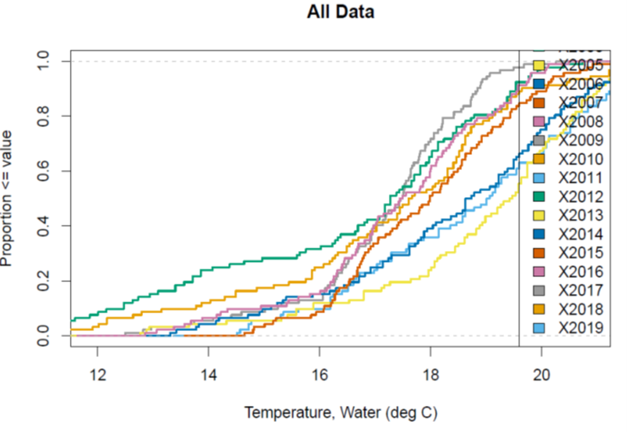

Cumulative distribution function (CDF) plot of annual temperature grouped by year, based on sensor data collected at 30-minute intervals

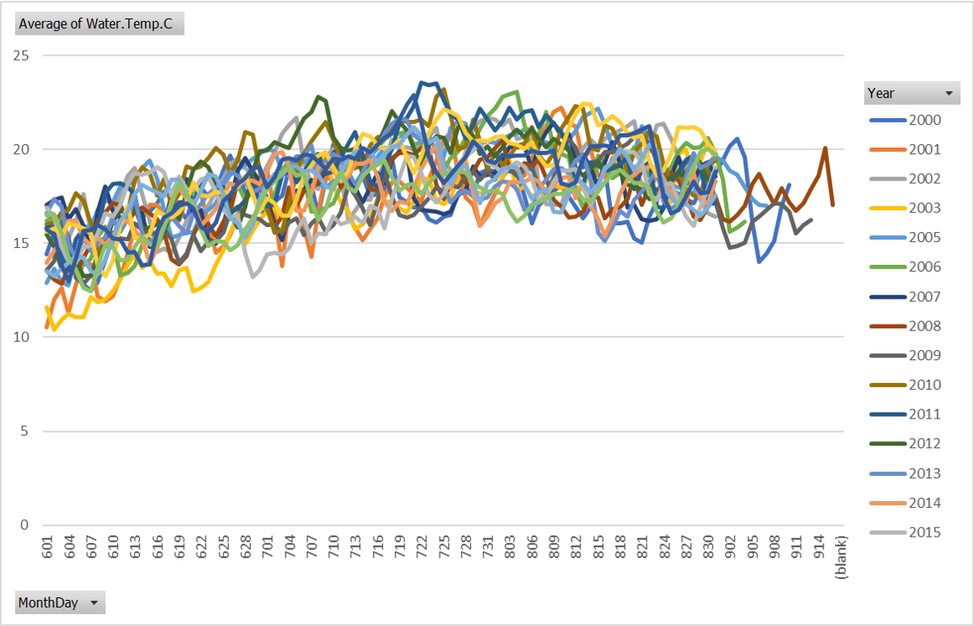

Time series plot of mean daily water temperature grouped by year, based on sensor data collected at 30-minute intervals

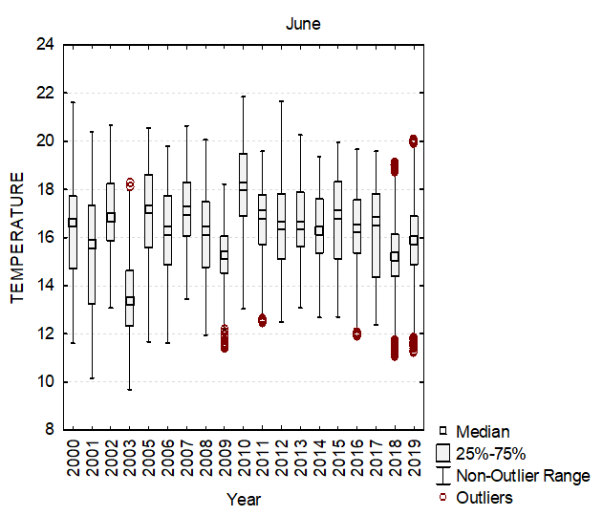

Box plot of June water temperature grouped by year, based on sensor data collected at 30-minute intervals

Mean monthly water temperature grouped by year, based on sensor data collected at 30-minute intervals

|  |  |  |  |  |  |  |  |  |  |  |  |  |  |  |  |  |  |  |  |  |
| --- | --- | --- | --- | --- | --- | --- | --- | --- | --- | --- | --- | --- | --- | --- | --- | --- | --- | --- | --- | --- |
| Month | X2000 | X2001 | X2002 | X2003 | X2004 | X2005 | X2006 | X2007 | X2008 | X2009 | X2010 | X2011 | X2012 | X2013 | X2014 | X2015 | X2016 | X2017 | X2018 | X2019 |
| July | 17.79 | 17.33 | 19.55 | 17.6 | NA | 19.79 | 19.28 | 17.95 | 18.54 | 17.04 | 20.08 | 20.28 | 20.6 | 19.22 | 18.33 | 17.09 | 19.65 | 19.22 | 18.27 | 19.83 |
| August | 17.41 | 19.36 | 19.67 | 18.74 | NA | 20.03 | 19.91 | 18.96 | 17.8 | 19.25 | 19.92 | 19.58 | 19.23 | 17.93 | 17.85 | 18.34 | 20.57 | 18.18 | 17.79 | 19.26 |
| September | 17.45 | NA | NA | NA | NA | 18.05 | 16.48 | NA | 17.52 | 16.03 | NA | NA | NA | NA | NA | NA | NA | NA | NA | NA |
|  | NA | NA | NA | NA | NA | NA | NA | NA | NA | NA | NA | NA | NA | NA | NA | NA | NA | NA | NA | NA |
|  | NA | NA | NA | NA | NA | NA | NA | NA | NA | NA | NA | NA | NA | NA | NA | NA | NA | NA | NA | NA |

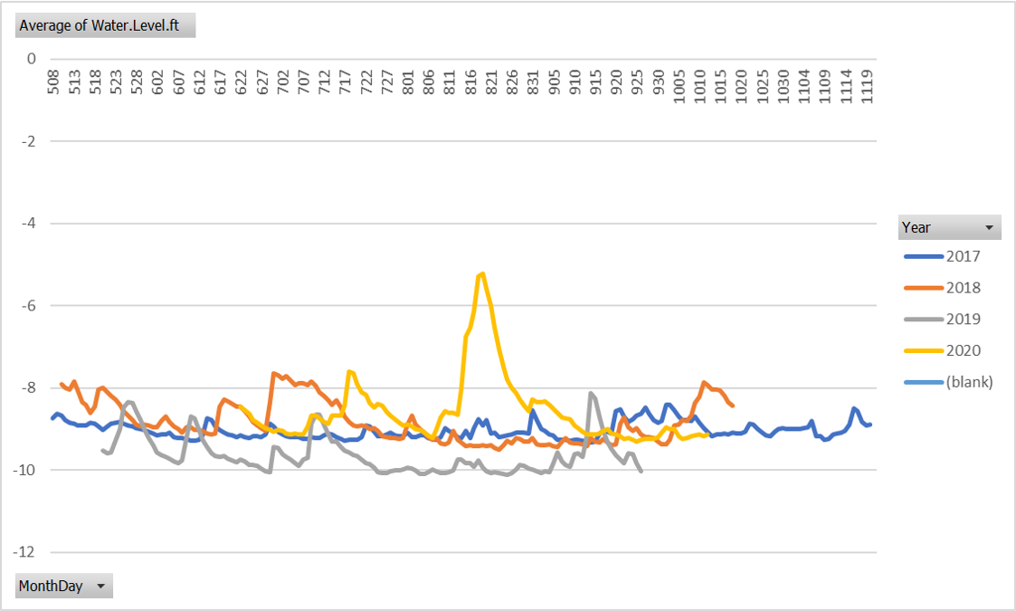

Time series plot of mean daily water level grouped by year, based on sensor data collected at 15-minute intervals

Mean monthly discharge grouped by year, based on sensor data collected at 15-minute intervals

|  |  |  |  |  |  |  |  |  |  |  |  |  |  |  |  |  |  |  |  |  |  |  |  |  |  |  |  |  |  |  |  |
| --- | --- | --- | --- | --- | --- | --- | --- | --- | --- | --- | --- | --- | --- | --- | --- | --- | --- | --- | --- | --- | --- | --- | --- | --- | --- | --- | --- | --- | --- | --- | --- |
| Month | X1987 | X1988 | X1989 | X1990 | X1991 | X1992 | X1993 | X1994 | X1995 | X1996 | X1997 | X1998 | X1999 | X2000 | X2001 | X2002 | X2003 | X2004 | X2005 | X2006 | X2007 | X2008 | X2009 | X2010 | X2011 | X2012 | X2013 | X2014 | X2015 | X2016 | X2017 |
| February | NA | 29 | NA | 62 | 69.5 | 24 | 19 | NA | NA | 127 | 57.5 | 82 | 49 | 58 | 28 | 20 | 58 | NA | 26 | 65 | 10 | 121 | 23.7 | 19.2 | 22.3 | 30 | 32.5 | 29.5 | NA | 38.3 | 16 |
| March | NA | 35.8 | NA | 62.8 | 80 | 48 | 55 | 119 | NA | 75 | 70 | 82 | 88 | 70 | 41 | 26 | 84 | 34 | 24 | 23 | 59 | 83.6 | 67.1 | 120 | 99.2 | 32.1 | 43.2 | 37.7 | 33.7 | 41.9 | 33 |
| April | NA | 25 | NA | 52 | 31 | 48 | 181 | 133 | NA | 67 | 86 | 45 | 20 | 41 | 96 | 22 | 58 | 53 | 70.5 | NA | 76 | 56.5 | 44.2 | 29.7 | 65.2 | 15.1 | 63.3 | 96 | 81 | 24.1 | NA |
| May | NA | 35.2 | NA | 45.1 | 29 | 17 | 12 | 29 | NA | 54 | 39 | 48 | 30 | 32 | 13 | 38 | 28 | 27 | 22 | NA | 15 | 25.9 | 21 | 14.9 | 32.1 | 20.5 | 17.6 | 38.3 | 5.29 | 15.9 | NA |
| June | NA | 4.13 | NA | 14.3 | 6.6 | 19 | 3.4 | 5.3 | NA | 6.4 | 4.2 | 29 | 4.2 | 30 | 20 | 30 | 58 | 7.3 | 5.7 | 23 | 17 | 11.1 | 34.6 | 11.8 | 20.8 | 8.48 | 73.4 | 12.3 | 17.9 | 4.17 | NA |
| July | NA | 2.8 | NA | 4.92 | 2.4 | 9.9 | 1 | 4.2 | NA | 11 | 3.7 | 8.9 | 2.1 | 26 | 1.7 | 2.2 | 6.7 | 5.3 | 4.2 | 7.5 | 7.9 | 7.31 | 25.9 | 2.52 | 5.51 | 2.66 | 14.1 | 18.6 | 10.4 | 1.38 | NA |
| August | NA | 2.3 | NA | 21.7 | 3.1 | 12 | 0.56 | 5.8 | NA | 3.1 | 4.9 | 1.5 | 0.91 | 15 | 1.2 | 0.74 | 8.5 | 11 | 1.3 | 1.7 | 6.2 | 18 | 11.8 | 1.2 | 10.1 | 3.09 | 7.41 | 8.75 | 2.46 | 0.95 | NA |
| September | NA | 4.13 | NA | 10.7 | 3.1 | 6.8 | 1.65 | 2.5 | NA | 13 | 2.7 | 1.5 | 14 | 7.5 | 12 | 1.5 | 16 | 16 | 0.82 | 6.2 | 1 | 26.2 | 5.34 | 0.36 | 40.8 | 8.09 | 11.2 | 3.42 | 4.72 | 0.7 | NA |
| October | 26.5 | 2.33 | 38.2 | 24 | 11 | 12 | 6.2 | 20 | 25 | 46 | 4.2 | 7.5 | 36 | 9.7 | 4.1 | 9.7 | 34 | 26 | 56 | 18 | 2.8 | 16.5 | 17.5 | 24 | 58.2 | 20.7 | 7.6 | 15 | 4.32 | 0.98 | NA |
| November | 25.7 | NA | 46.2 | 40 | 32 | 35 | 21 | NA | 57 | 38 | 48 | 12 | 26 | 25 | 4.2 | 34 | 54 | 24 | 39 | 51 | 10.9 | 43.1 | 38.5 | 33.6 | 59.1 | 23.9 | 18.1 | 26.4 | 10.2 | 7.6 | NA |
| December | 27.5 | NA | 13.2 | 60 | 44 | 48 | 41 | NA | NA | 90 | 43 | 10 | 36 | 19 | 9.9 | 44 | 66 | 57 | 82 | 28 | 18.7 | 88.8 | 49.9 | 47.5 | 54 | 22 | 36.4 | 79.9 | 19.1 | 9.14 | NA |

IHA group 2 discharge statistics grouped by year, based on sensor data collected at 15-minute intervals

|  |  |  |  |  |  |  |  |  |  |  |  |  |  |  |  |  |  |  |  |  |  |  |  |  |  |  |  |  |  |  |  |
| --- | --- | --- | --- | --- | --- | --- | --- | --- | --- | --- | --- | --- | --- | --- | --- | --- | --- | --- | --- | --- | --- | --- | --- | --- | --- | --- | --- | --- | --- | --- | --- |
| Metric | X1987 | X1988 | X1989 | X1990 | X1991 | X1992 | X1993 | X1994 | X1995 | X1996 | X1997 | X1998 | X1999 | X2000 | X2001 | X2002 | X2003 | X2004 | X2005 | X2006 | X2007 | X2008 | X2009 | X2010 | X2011 | X2012 | X2013 | X2014 | X2015 | X2016 | X2017 |
| 1 Day Max | 215 | 489 | 2120 | 1540 | 526 | 1710 | 977 | 696 | 1530 | 1620 | 435 | 1080 | 1900 | 1410 | 961 | 585 | 1130 | 1140 | 1930 | 1630 | 3330 | 1350 | 949 | 1700 | 4860 | 987 | 946 | 1360 | 439 | 1590 | 524 |
| 3 Day Min | 13.3 | 0.93 | 5.1 | 1.3 | 1.3 | 2.8 | 0.42 | 1.5 | 0.91 | 0.91 | 0.82 | 0.56 | 0.42 | 3.9 | 0.48 | 0.3 | 1.7 | 2.5 | 0.42 | 0.48 | 0.56 | 2.02 | 2.38 | 0.17 | 1.4 | 1.4 | 3.57 | 1.61 | 0.54 | 0.22 | 5.18 |
| 3 Day Max | 213 | 482.33 | 2076.67 | 1516.67 | 524 | 1680 | 973.67 | 693.33 | 1526.67 | 1616.67 | 434 | 1076.67 | 1896.67 | 1410 | 771 | 580.33 | 1123.33 | 1126.67 | 1916.67 | 1626.67 | 3323.33 | 1336.67 | 940.33 | 1686.67 | 4836.67 | 984.33 | 912.67 | 1360 | 437 | 1586.67 | 523 |
| 7 Day Min | 13.54 | 0.93 | 5.98 | 1.36 | 1.3 | 2.8 | 0.42 | 1.5 | 0.91 | 0.91 | 0.82 | 0.56 | 0.42 | 3.9 | 0.48 | 0.3 | 1.7 | 2.5 | 0.42 | 0.48 | 0.56 | 2.07 | 2.38 | 0.17 | 1.4 | 1.4 | 3.57 | 1.64 | 0.54 | 0.22 | 5.24 |
| 7 Day Max | 209.86 | 476.57 | 2000 | 1435.71 | 513.57 | 1610 | 963.71 | 680.57 | 1498.57 | 1585.71 | 431.71 | 1068.57 | 1880 | 1397.14 | 684.71 | 575 | 1120 | 1100 | 1898.57 | 1608.57 | 3271.43 | 1325.71 | 931.86 | 1684.29 | 4824.29 | 968.29 | 837.57 | 1341.43 | 434.43 | 1568.57 | 515 |
| 30 Day Min | 14.53 | 0.93 | 6.27 | 2.81 | 1.3 | 2.89 | 0.42 | 1.5 | 0.92 | 0.99 | 0.84 | 0.56 | 0.42 | 3.9 | 0.48 | 0.33 | 1.75 | 2.5 | 0.42 | 0.48 | 0.56 | 2.1 | 2.38 | 0.17 | 1.4 | 1.4 | 3.68 | 1.7 | 0.54 | 0.24 | 5.65 |
| 30 Day Max | 177.43 | 413.37 | 1487.03 | 1092.13 | 414.93 | 1113.43 | 895.83 | 539.9 | 1061.47 | 1196.27 | 373.23 | 965.23 | 1692 | 1296 | 641.9 | 516.73 | 1001.67 | 944.93 | 1662.33 | 1427.33 | 2787.33 | 1157 | 858.6 | 1591.67 | 4165.33 | 851.53 | 774.5 | 1108.83 | 418 | 1432.67 | 463.43 |
| 90 Day Min | 14.92 | 0.94 | 6.63 | 2.92 | 1.31 | 3.1 | 0.42 | 1.52 | 1 | 1.04 | 0.85 | 0.56 | 0.42 | 3.96 | 0.48 | 0.37 | 1.84 | 2.61 | 0.44 | 0.5 | 0.56 | 2.16 | 2.43 | 0.17 | 1.43 | 1.46 | 3.71 | 1.71 | 0.54 | 0.29 | 8.23 |
| 90 Day Max | 119.53 | 336.39 | 797.22 | 548.76 | 239.32 | 527.13 | 727.99 | 342.56 | 507.63 | 720.82 | 317.99 | 791.34 | 1030.32 | 901.62 | 558.84 | 405.18 | 627.27 | 578 | 1075.74 | 910.31 | 1901.77 | 774.2 | 617.17 | 1201.22 | 2511.1 | 536.27 | 586.5 | 758.39 | 378.37 | 926.9 | 332.38 |
| Zero flow days | 0 | 0 | 0 | 0 | 0 | 0 | 0 | 0 | 0 | 0 | 0 | 0 | 0 | 0 | 0 | 0 | 0 | 0 | 0 | 0 | 0 | 0 | 0 | 0 | 0 | 0 | 0 | 0 | 0 | 0 | 0 |
| Base index | 0.41 | 0.03 | 0.11 | 0.03 | 0.04 | 0.07 | 0.01 | 0.04 | 0.01 | 0.01 | 0.03 | 0.01 | 0.01 | 0.08 | 0.01 | 0.01 | 0.03 | 0.06 | 0.01 | 0.01 | 0.01 | 0.03 | 0.05 | 0 | 0.02 | 0.05 | 0.07 | 0.03 | 0.02 | 0.01 | 0.14 |

Water chemistry

|  |  |  |  |  |  |  |  |  |  |  |  |  |  |  |
| --- | --- | --- | --- | --- | --- | --- | --- | --- | --- | --- | --- | --- | --- | --- |
| Parameter | X2004 | X2008 | X2009 | X2010 | X2011 | X2012 | X2013 | X2014 | X2015 | X2016 | X2017 | X2018 | X2019 | X2020 |
| Specific Conductance (?S/cm) | 75.5 | 100.3 | 142.3 | 67.3 | 100.1 | 77.5 | 85.2 | 112.1 | 82.1 | 87.66 | 95.3 | 95.6 | 69.51 | NA |
| Acid Neutralizing Capacity (?eq/L) | 114.4 | 60.2 | 40.3 | 108.7 | 77.3 | 166.9 | 96.1 | 101.1 | 70.7 | 111 | 151.9 | 105.4 | 97.966 | NA |
| Dissolved Organic Carbon (mg/L) | 12.2 | 10.9422 | 7.6091 | 20.105 | 15.2825 | 17.8542 | 10.2886 | 9.3582 | 13.0268 | 16.464 | 16.558 | 18.192 | 15.973 | NA |
| Chloride (mg/L) | 11.08 | 12.812 | 20.8374 | 8.7168 | 19.4549 | 12.0366 | 15.4043 | 20.5162 | 14.5614 | 15.0105 | 16.2485 | 15.5372 | 11.0388 | NA |
| Sulfate (mg/L) | 6.43 | 17.145 | 21.4983 | 4.8299 | 9.6348 | 5.2235 | 8.635 | 8.86 | 6.9532 | 6.2474 | 7.1901 | 7.3807 | 4.8696 | NA |
| Total Nitrogen (mg/L) | 0.813 | 0.6897 | 0.5856 | 1.0972 | 0.9312 | 0.9982 | 0.7832 | 0.8799 | 0.8362 | 0.845 | 1.0129 | 1.2507 | 0.8969 | NA |
| Nitrate-Nitrogen (mg/L) | 0.35 | 0.2033 | 0.1802 | 0.227 | 0.2743 | 0.1366 | 0.217 | 0.4009 | 0.242 | 0.2355 | 0.3125 | 0.63 | 0.4096 | NA |
| Nitrite-Nitrogen (mg/L) | 0.007 | 0.0025 | 0.0019 | 0.007 | 0.005 | 0.0058 | 0.0032 | 0.0039 | 0.0032 | 0.0033 | 0.0055 | 0.0064 | 0.0074 | NA |
| Ammonia-Nitrogen (mg/L) | 0.0815 | 0.0119 | 0.0148 | 0.0549 | 0.0161 | 0.0335 | 0.0247 | 0.0404 | 0.0262 | 0.0188 | 0.0578 | 0.0646 | 0.0517 | NA |
| Total Phosphorus (mg/L) | 0.075 | 0.0343 | 0.0283 | 0.0983 | 0.0475 | 0.0884 | 0.0469 | 0.042 | 0.0542 | 0.0604 | 0.0819 | 0.0583 | 0.0615 | NA |
| Ortho-phosphate (mg/L) | 0.0083 | 0.0053 | 0.0063 | 0.019 | 0.0094 | 0.0106 | 0.0062 | 0.0063 | 0.01 | 0.0144 | 0.0151 | 0.0122 | 0.0159 | NA |
| Bromide (mg/L) | NA | NA | NA | NA | NA | NA | 0.0092 | 0.0162 | 0.0088 | 0.014 | 0.0233 | 0.0136 | 0.0179 | NA |
| Magnesium (mg/L) | NA | NA | 3.1409 | NA | NA | NA | NA | 2.376 | 1.667 | 2.048 | 2.592 | 2.329 | 1.692 | NA |
| Calcium (mg/L) | NA | NA | 6.6473 | NA | NA | NA | NA | 4.288 | 3.126 | 3.805 | 4.651 | 4.116 | 3.376 | NA |
| Copper (µg/L) | NA | NA | NA | NA | NA | NA | NA | 2.081 | 1.8 | 1.26 | 1.322 | 1.428 | 1.232 | NA |
| Zinc (µg/L) | NA | NA | NA | NA | NA | NA | NA | 12.442 | 20.429 | 15.056 | 11.775 | 10.802 | 10.082 | NA |

Habitat metrics

|  |  |  |  |  |  |  |  |  |  |  |  |  |  |  |  |
| --- | --- | --- | --- | --- | --- | --- | --- | --- | --- | --- | --- | --- | --- | --- | --- |
| Parameter | X2004 | X2008 | X2009 | X2010 | X2011 | X2012 | X2013 | X2014 | X2015 | X2016 | X2017 | X2018 | X2019 | X2020 | X |
| Epifaunal substrate (0-20) | 11 | 13 | 17 | 14 | 18 | 6 | 13 | 15 | 7 | 11 | 7 | 11 | 8 | 6 | NA |
| Velocity/Depth Diversity (0-20) | 14 | 6 | 9 | 8 | 7 | 1 | 9 | 8 | 6 | 5 | 8 | 8 | 12 | 5 | NA |
| Pool Quality (0-20) | 15 | 13 | 17 | 16 | 11 | 3 | 15 | 12 | 7 | 8 | 12 | 12 | 13 | 7 | NA |
| Riffle Quality (0-20) | 16 | 0 | 16 | 4 | 8 | 0 | 11 | 2 | 6 | 6 | 6 | 0 | 0 | 4 | NA |
| Shading (%) | 90 | 95 | 80 | 80 | 75 | 85 | 95 | 90 | 50 | 75 | 80 | 70 | 90 | 85 | NA |
| Embeddedness (%) | 100 | 85 | 100 | 100 | 30 | 85 | 100 | 90 | 100 | 100 | 100 | 100 | 100 | 85 | NA |
| Discharge (cfs) | 2.35 | 0 | 1.53 | 0.19 | 0.42 | 0 | 0.73 | 0 | 0 | 0.26 | 3.82 | 0.85 | 0.07 | 0.28 | NA |

Relative abundance of macroinvertebrate taxa, grouped by year

|  |  |  |  |  |  |  |  |  |  |  |  |  |  |  |  |  |  |  |
| --- | --- | --- | --- | --- | --- | --- | --- | --- | --- | --- | --- | --- | --- | --- | --- | --- | --- | --- |
| PHYLUM | ORDER | FAMILY | GENUS | TOL | X2004 | X2008 | X2009 | X2010 | X2011 | X2012 | X2013 | X2014 | X2015 | X2016 | X2017 | X2018 | X2019 | X2020 |
| Annelida | Haplotaxida | Naididae | na | T | NA | NA | NA | NA | NA | NA | NA | NA | 0.8 | 0.9 | NA | NA | NA | NA |
| Annelida | Lumbriculida | Lumbriculidae | na | M | NA | NA | NA | NA | NA | NA | NA | NA | NA | NA | NA | NA | 0.9 | NA |
| Annelida | Rhynchobdellida | Erpobdellidae | Erpobdella |  | 0.9 | NA | NA | NA | NA | NA | NA | NA | NA | NA | NA | NA | NA | NA |
| Annelida | Rhynchobdellida | Glossiphoniidae | Helobdella | M | 0.9 | NA | NA | 8.4 | NA | NA | NA | 3.5 | NA | NA | 4.8 | 4.2 | 5.6 | 57 |
| Annelida | Tubificida | Tubificidae | Limnodrilus | T | NA | NA | NA | 0.8 | NA | NA | NA | NA | NA | NA | NA | NA | NA | 0.8 |
| Annelida | Tubificida | Tubificidae | na | T | NA | NA | NA | NA | NA | NA | NA | NA | NA | NA | NA | NA | 0.9 | NA |
| Arthropoda | Amphipoda | Crangonyctidae | Crangonyx | M | NA | NA | NA | NA | NA | NA | NA | NA | NA | NA | NA | NA | 1.9 | NA |
| Arthropoda | Amphipoda | Crangonyctidae | Synurella | I | NA | NA | NA | NA | NA | NA | NA | NA | NA | NA | NA | NA | NA | 1.7 |
| Arthropoda | Amphipoda | Hyalellidae | Hyalella | M | 11 | NA | NA | 1.7 | NA | 1.8 | NA | 1.7 | NA | NA | NA | NA | 0.9 | NA |
| Arthropoda | Coleoptera | Dytiscidae | Neoporus | M | NA | 2.9 | 2.7 | NA | 8 | 6.2 | 31.2 | 16.5 | 17.5 | NA | 3.2 | NA | NA | 0.8 |
| Arthropoda | Coleoptera | Elmidae | Ancyronyx | T | NA | NA | NA | NA | NA | NA | NA | 0.9 | NA | 0.9 | NA | NA | NA | NA |
| Arthropoda | Coleoptera | Elmidae | Dubiraphia | M | 2.8 | NA | NA | NA | NA | NA | NA | NA | NA | NA | NA | NA | NA | NA |
| Arthropoda | Coleoptera | Gyrinidae | Dineutus | M | NA | NA | NA | NA | NA | NA | NA | NA | NA | NA | 0.8 | NA | NA | NA |
| Arthropoda | Coleoptera | Gyrinidae | Gyrinus | M | 0.9 | NA | NA | NA | NA | NA | NA | NA | NA | NA | NA | 0.8 | NA | NA |
| Arthropoda | Coleoptera | Haliplidae | Peltodytes | T | NA | NA | NA | NA | NA | NA | NA | NA | NA | NA | NA | 0.8 | NA | NA |
| Arthropoda | Collembola | Isotomidae | Isotomurus | M | NA | NA | NA | 0.8 | NA | NA | NA | NA | NA | NA | NA | NA | NA | NA |
| Arthropoda | Collembola | Sminthuridae | na |  | 2.8 | NA | NA | NA | NA | NA | NA | NA | NA | NA | NA | 2.5 | NA | NA |
| Arthropoda | Decapoda | Cambaridae | na | I | NA | NA | 3.6 | NA | NA | 0.9 | NA | 2.6 | NA | 4.7 | 2.4 | 0.8 | NA | NA |
| Arthropoda | Diptera | Ceratopogonidae | Ceratopogon | I | NA | NA | NA | 0.8 | NA | NA | NA | NA | NA | NA | NA | NA | 0.9 | 1.7 |
| Arthropoda | Diptera | Chironomidae | Ablabesmyia | T | NA | NA | NA | NA | NA | NA | NA | NA | 2.5 | NA | NA | NA | 1.9 | NA |
| Arthropoda | Diptera | Chironomidae | na | M | NA | NA | NA | NA | NA | NA | 0.8 | NA | NA | NA | NA | NA | NA | NA |
| Arthropoda | Diptera | Chironomidae | Conchapelopia | M | NA | NA | NA | NA | NA | NA | NA | NA | NA | NA | 1.6 | NA | NA | NA |
| Arthropoda | Diptera | Chironomidae | Cricotopus | T | NA | NA | NA | NA | NA | NA | NA | NA | NA | NA | NA | 0.8 | NA | NA |
| Arthropoda | Diptera | Chironomidae | Dicrotendipes | T | NA | NA | NA | NA | NA | NA | NA | NA | NA | NA | 1.6 | NA | NA | NA |
| Arthropoda | Diptera | Chironomidae | Diplocladius | M | NA | NA | NA | NA | NA | NA | 0.8 | NA | NA | NA | NA | NA | NA | NA |
| Arthropoda | Diptera | Chironomidae | Heterotrissocladius | I | NA | NA | NA | NA | NA | 0.9 | NA | NA | NA | NA | NA | NA | NA | NA |
| Arthropoda | Diptera | Chironomidae | Hydrobaenus | T | NA | NA | NA | NA | NA | NA | NA | 1.7 | NA | 4.7 | 0.8 | 0.8 | 2.8 | 0.8 |
| Arthropoda | Diptera | Chironomidae | Kiefferulus | M | NA | 1 | 8.1 | NA | NA | NA | 7.2 | 7.8 | 16.7 | 26.4 | 1.6 | 5.8 | 3.7 | NA |
| Arthropoda | Diptera | Chironomidae | Labrundinia | M | NA | NA | NA | NA | NA | NA | NA | NA | NA | NA | NA | NA | 0.9 | 1.7 |
| Arthropoda | Diptera | Chironomidae | Limnophyes | T | 1.8 | 2.9 | NA | 6.7 | NA | 2.7 | 0.8 | NA | NA | NA | NA | NA | 0.9 | NA |
| Arthropoda | Diptera | Chironomidae | Microtendipes | M | NA | NA | NA | NA | 0.9 | NA | NA | NA | NA | NA | NA | NA | NA | NA |
| Arthropoda | Diptera | Chironomidae | Nanocladius | T | NA | NA | NA | 0.8 | NA | NA | NA | NA | NA | NA | NA | NA | NA | NA |
| Arthropoda | Diptera | Chironomidae | Orthocladiinae | T | NA | 1 | NA | NA | NA | NA | NA | NA | NA | NA | NA | NA | NA | NA |
| Arthropoda | Diptera | Chironomidae | Orthocladius | T | NA | NA | NA | NA | NA | NA | NA | NA | NA | NA | NA | NA | 1.9 | NA |
| Arthropoda | Diptera | Chironomidae | Parachironomus | M | 0.9 | NA | NA | NA | NA | NA | NA | NA | NA | NA | NA | NA | NA | NA |
| Arthropoda | Diptera | Chironomidae | Parakiefferiella | I | 0.9 | NA | NA | NA | NA | NA | NA | NA | NA | NA | NA | NA | NA | NA |
| Arthropoda | Diptera | Chironomidae | Parametriocnemus | M | NA | NA | NA | NA | 0.9 | NA | NA | 0.9 | 0.8 | NA | NA | 1.7 | NA | NA |
| Arthropoda | Diptera | Chironomidae | Paraphaenocladius | M | NA | NA | NA | 1.7 | NA | NA | NA | NA | NA | NA | NA | NA | NA | NA |
| Arthropoda | Diptera | Chironomidae | Paratanytarsus | T | NA | NA | NA | NA | NA | NA | 0.8 | 0.9 | NA | NA | NA | 0.8 | NA | NA |
| Arthropoda | Diptera | Chironomidae | Paratendipes | M | NA | NA | NA | 3.4 | NA | NA | NA | 0.9 | NA | NA | 0.8 | NA | 1.9 | NA |
| Arthropoda | Diptera | Chironomidae | Phaenopsectra | T | NA | NA | NA | NA | NA | NA | NA | NA | NA | NA | NA | NA | 4.6 | NA |
| Arthropoda | Diptera | Chironomidae | Polypedilum | M | NA | NA | NA | NA | NA | NA | NA | NA | NA | NA | NA | 0.8 | NA | NA |
| Arthropoda | Diptera | Chironomidae | Procladius | I | NA | NA | NA | NA | NA | NA | NA | NA | NA | NA | NA | NA | 0.9 | NA |
| Arthropoda | Diptera | Chironomidae | Pseudorthocladius | M | 0.9 | NA | NA | 0.8 | NA | NA | NA | 0.9 | 0.8 | 3.8 | 0.8 | NA | 1.9 | NA |
| Arthropoda | Diptera | Chironomidae | Rheocricotopus | M | NA | NA | NA | NA | NA | NA | NA | NA | NA | NA | 1.6 | NA | NA | NA |
| Arthropoda | Diptera | Chironomidae | Rheosmittia | M | NA | NA | NA | NA | NA | NA | NA | NA | NA | NA | NA | NA | 0.9 | NA |
| Arthropoda | Diptera | Chironomidae | Rheotanytarsus | T | 5.5 | NA | 5.4 | 2.5 | 1.8 | 5.3 | 0.8 | NA | 10 | NA | 1.6 | 3.3 | NA | NA |
| Arthropoda | Diptera | Chironomidae | Stenochironomus | T | NA | NA | NA | NA | NA | NA | NA | NA | NA | NA | 0.8 | 0.8 | 4.6 | 0.8 |
| Arthropoda | Diptera | Chironomidae | Symposiocladius | M | NA | NA | NA | 0.8 | NA | NA | NA | NA | NA | NA | NA | NA | NA | NA |
| Arthropoda | Diptera | Chironomidae | Tanypodinae | T | NA | NA | NA | NA | NA | NA | NA | NA | NA | NA | 0.8 | NA | 1.9 | NA |
| Arthropoda | Diptera | Chironomidae | Tanytarsus | M | NA | NA | 0.9 | 0.8 | NA | NA | NA | NA | NA | NA | NA | NA | NA | NA |
| Arthropoda | Diptera | Chironomidae | Thienemanniella | M | 0.9 | 1 | 2.7 | 2.5 | 0.9 | 2.7 | 2.4 | 2.6 | 5.8 | NA | 4 | 1.7 | 1.9 | NA |
| Arthropoda | Diptera | Chironomidae | Thienemannimyia Group | T | 1.8 | NA | 3.6 | 4.2 | 2.7 | 6.2 | 6.4 | 7.8 | 3.3 | 21.7 | 4.8 | 3.3 | 5.6 | NA |
| Arthropoda | Diptera | Chironomidae | Tribelos | T | NA | NA | NA | NA | NA | NA | NA | NA | NA | 1.9 | 2.4 | NA | 2.8 | NA |
| Arthropoda | Diptera | Chironomidae | Tvetenia | M | NA | NA | NA | NA | NA | NA | NA | NA | NA | NA | NA | NA | 0.9 | NA |
| Arthropoda | Diptera | Simuliidae | Cnephia | M | NA | NA | NA | NA | NA | NA | NA | NA | NA | NA | NA | NA | NA | 1.7 |
| Arthropoda | Diptera | Simuliidae | Prosimulium | I | NA | NA | NA | NA | NA | NA | NA | NA | NA | NA | NA | NA | 0.9 | 1.7 |
| Arthropoda | Diptera | Simuliidae | na | M | NA | NA | NA | NA | NA | NA | NA | NA | NA | NA | NA | 0.8 | NA | NA |
| Arthropoda | Diptera | Simuliidae | Simulium | M | NA | NA | NA | NA | NA | NA | NA | 3.5 | NA | 0.9 | NA | NA | 1.9 | NA |
| Arthropoda | Diptera | Simuliidae | Stegopterna | I | NA | NA | NA | 0.8 | NA | NA | NA | NA | NA | NA | NA | NA | NA | NA |
| Arthropoda | Diptera | Tipulidae | Erioptera | M | NA | NA | NA | NA | NA | NA | NA | NA | NA | NA | 2.4 | NA | NA | NA |
| Arthropoda | Diptera | Tipulidae | Hexatoma | I | NA | NA | NA | NA | NA | NA | NA | NA | NA | NA | NA | 2.5 | 0.9 | NA |
| Arthropoda | Diptera | Tipulidae | Ormosia | M | NA | NA | NA | NA | NA | NA | NA | NA | NA | NA | NA | NA | NA | 0.8 |
| Arthropoda | Diptera | Tipulidae | Pseudolimnophila | I | NA | 1 | NA | NA | NA | NA | NA | NA | NA | 0.9 | NA | NA | 0.9 | NA |
| Arthropoda | Diptera | Tipulidae | Tipula | M | NA | NA | NA | NA | NA | 0.9 | NA | 0.9 | 0.8 | NA | NA | 0.8 | NA | NA |
| Arthropoda | Ephemeroptera | Caenidae | Caenis | I | NA | NA | NA | NA | NA | NA | NA | NA | 0.8 | NA | NA | NA | NA | NA |
| Arthropoda | Ephemeroptera | Heptageniidae | Maccaffertium | I | NA | 1.9 | NA | NA | NA | NA | NA | NA | 2.5 | NA | NA | NA | NA | 1.7 |
| Arthropoda | Ephemeroptera | Heptageniidae | Stenonema | M | NA | NA | NA | NA | NA | NA | NA | 1.7 | NA | NA | 2.4 | NA | NA | NA |
| Arthropoda | Ephemeroptera | Leptophlebiidae | na | I | 3.7 | NA | NA | 0.8 | NA | 22.1 | NA | NA | NA | NA | NA | NA | 0.9 | NA |
| Arthropoda | Hemiptera | Corixidae | na | M | NA | NA | NA | NA | NA | NA | NA | NA | NA | NA | 0.8 | NA | NA | NA |
| Arthropoda | Isopoda | Asellidae | Caecidotea | I | 9.2 | 13.3 | 37.8 | 8.4 | 33 | 17.7 | 33.6 | 27 | 19.2 | 0.9 | 23.4 | 46.7 | 13.9 | NA |
| Arthropoda | Lepidoptera | na | na | M | 5.5 | 11.4 | NA | NA | NA | NA | 0.8 | NA | NA | NA | NA | NA | NA | NA |
| Arthropoda | Megaloptera | Sialidae | Sialis | I | NA | NA | NA | NA | NA | NA | NA | NA | 0.8 | NA | NA | NA | NA | NA |
| Arthropoda | Odonata | Aeshnidae | Boyeria | M | NA | NA | NA | 0.8 | NA | NA | NA | NA | NA | NA | NA | NA | NA | NA |
| Arthropoda | Odonata | Calopterygidae | Calopteryx | T | 0.9 | NA | NA | NA | NA | NA | NA | NA | 2.5 | NA | NA | NA | NA | NA |
| Arthropoda | Odonata | Coenagrionidae | na | T | NA | NA | NA | NA | NA | NA | NA | NA | 0.8 | NA | NA | NA | 1.9 | NA |
| Arthropoda | Odonata | Corduliidae | Somatochlora | I | 4.6 | NA | NA | NA | NA | NA | NA | NA | NA | NA | NA | NA | NA | NA |
| Arthropoda | Plecoptera | Nemouridae | na | I | NA | NA | NA | NA | NA | 0.9 | NA | NA | NA | NA | NA | NA | 7.4 | NA |
| Arthropoda | Plecoptera | Nemouridae | Ostrocerca | I | NA | NA | NA | NA | NA | NA | NA | NA | NA | NA | 0.8 | NA | NA | NA |
| Arthropoda | Plecoptera | Nemouridae | Prostoia | M | NA | NA | NA | NA | NA | NA | NA | 0.9 | NA | NA | NA | NA | 0.9 | NA |
| Arthropoda | Plecoptera | Perlidae | Perlesta | I | NA | 22.9 | NA | 1.7 | NA | NA | NA | NA | NA | NA | 8.9 | NA | NA | NA |
| Arthropoda | Plecoptera | Perlidae | na | I | 21.1 | 1.9 | NA | 17.6 | NA | NA | NA | 2.6 | NA | 17 | 12.1 | 10 | 3.7 | 3.3 |
| Arthropoda | Plecoptera | Perlodidae | Isoperla | I | NA | NA | NA | NA | NA | NA | NA | NA | NA | NA | 0.8 | NA | NA | NA |
| Arthropoda | Plecoptera | Taeniopterygidae | Taeniopteryx | M | NA | NA | NA | 0.8 | NA | NA | NA | NA | NA | NA | NA | NA | 1.9 | NA |
| Arthropoda | Trichoptera | Hydropsychidae | Cheumatopsyche | M | 3.7 | 32.4 | 10.8 | 14.3 | 33.9 | 8 | 11.2 | 3.5 | 10 | 2.8 | 0.8 | 1.7 | NA | NA |
| Arthropoda | Trichoptera | Hydroptilidae | Oxyethira | I | 1.8 | NA | NA | NA | NA | NA | NA | 0.9 | 0.8 | 3.8 | NA | NA | NA | NA |
| Arthropoda | Trichoptera | Leptoceridae | Oecetis | M | 0.9 | NA | NA | NA | NA | NA | NA | NA | NA | NA | NA | NA | NA | NA |
| Arthropoda | Trichoptera | Limnephilidae | Ironoquia | M | NA | NA | NA | NA | NA | NA | NA | NA | NA | 0.9 | NA | NA | NA | NA |
| Arthropoda | Trichoptera | Limnephilidae | na | M | 0.9 | 1 | 0.9 | NA | 0.9 | NA | 0.8 | 3.5 | NA | NA | NA | NA | NA | 19.8 |
| Arthropoda | Trichoptera | Phryganeidae | Ptilostomis | M | NA | 1 | NA | NA | NA | NA | 2.4 | 0.9 | 2.5 | 0.9 | NA | 5.8 | NA | 5 |
| Arthropoda | Trichoptera | Rhyacophilidae | Rhyacophila | I | 0.9 | NA | NA | 3.4 | NA | NA | NA | 1.7 | NA | NA | NA | NA | NA | NA |
| Mollusca | Basommatophora | Physidae | Physa | T | 2.8 | NA | NA | 1.7 | NA | 2.7 | NA | NA | NA | NA | 1.6 | NA | 9.3 | NA |
| Mollusca | Basommatophora | Planorbidae | Menetus | T | NA | NA | NA | NA | NA | 0.9 | NA | NA | NA | NA | NA | NA | NA | NA |
| Mollusca | Mesogastropoda | Hydrobiidae | na | T | 11 | NA | NA | 8.4 | NA | 2.7 | NA | 3.5 | NA | 0.9 | 0.8 | 0.8 | 2.8 | NA |
| Mollusca | Neotaenioglossa | Hydrobiidae | Amnicola | T | NA | NA | NA | NA | NA | NA | NA | 0.9 | 0.8 | NA | NA | NA | NA | NA |
| Mollusca | Veneroida | Pisidiidae | Musculium | M | 0.9 | NA | NA | NA | NA | NA | NA | NA | NA | NA | 3.2 | NA | NA | NA |
| Mollusca | Veneroida | Pisidiidae | na | M | NA | NA | NA | NA | NA | 0.9 | NA | NA | NA | 4.7 | 7.3 | 1.7 | 1.9 | 0.8 |
| Mollusca | Veneroida | Pisidiidae | Pisidium | M | NA | 4.8 | 23.4 | 3.4 | 17 | 16.8 | NA | NA | NA | 0.9 | NA | NA | NA | NA |