Building an AI-Powered Coffee Shop Analytics with Snowflake Cortex & Streamlit

With the rise of AI in data analytics, modern tools like Snowflake Cortex are transforming how businesses interact with their data. Instead of writing complex SQL queries, users can now ask questions in natural language and get instant insights.
In this article, I’ll walk through a practical use case I built during my data analyst internship: —> an AI-powered analytics and search system for a coffee shop using Snowflake, Cortex Analyst, Cortex Search, and Streamlit.

Objective
Simulate a real-world business scenario where
- A coffee shop wants to analyze sales, customers, and products
- Non-technical users can ask questions in natural language
- AI translates those questions into SQL queries
- Results are displayed in an interactive dashboard

Overview
The system is composed of three main layers:
- Data → Snowflake database
- AI → Cortex Analyst & Cortex Search
- Visualization → Streamlit

Data Modeling
I created a relational database with the following tables:
- customers
- products
- categories
- orders
- order_items
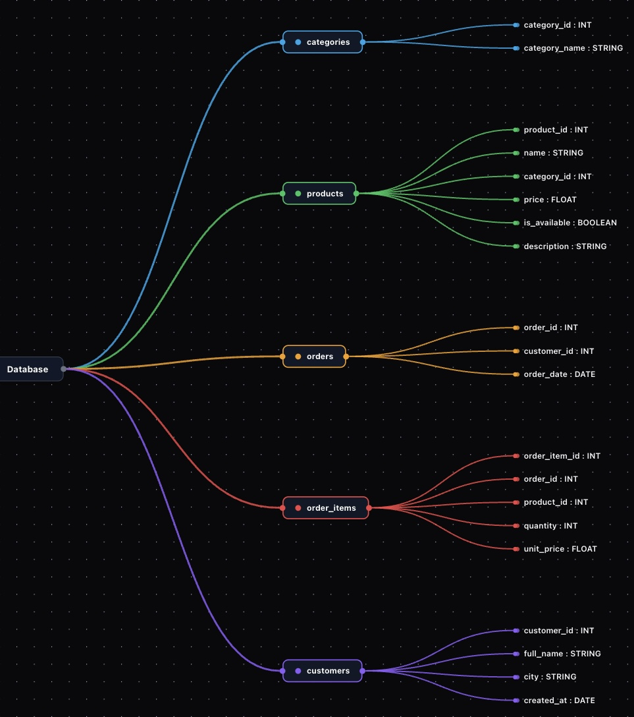
This structure allows us to analyze:
- Revenue
- Customer behavior
- Product performance
Cortex Analyst
Natural Language → SQL
Cortex Analyst allows users to ask questions like:
“Top selling products”
“Revenue by category”
“Which customer spent the most?” … etc
How it works
- User inputs a question in Streamlit
- A prompt is sent to Cortex
- Cortex generates a SQL query
- The query is executed in Snowflake
- Results are displayed
Setup
Permissions :
I granted access to the database and schema to allow Cortex to query the data
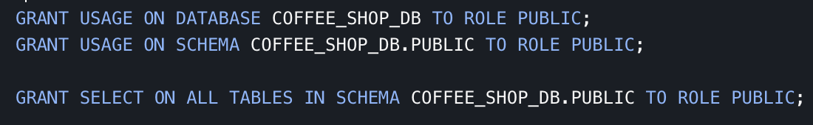
Prompt Engineering
One of the most important steps was defining a clear prompt
I explicitly described:
- Table structures
- Business logic
- Relationships between tables
This significantly improved the accuracy of generated SQL queries
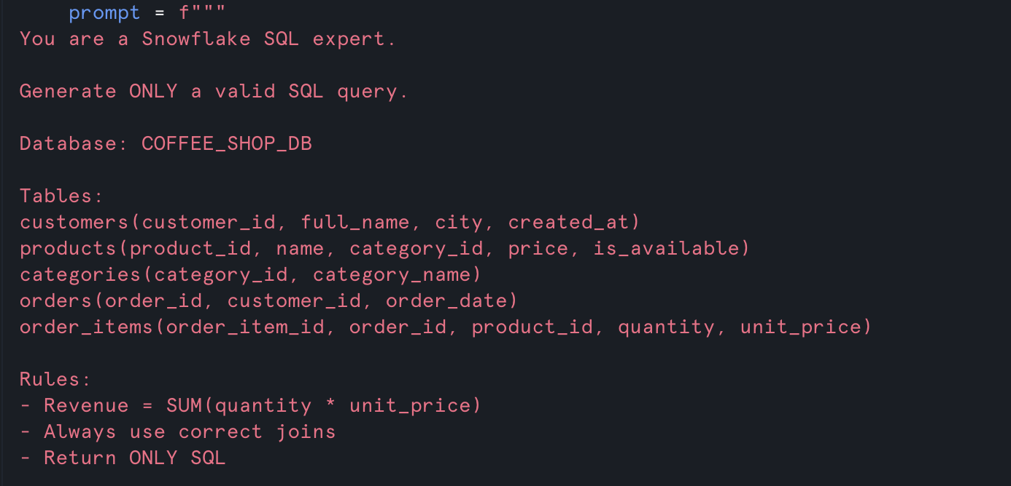
Users can now type: “Which are the top 3 best-selling products by total revenue?”
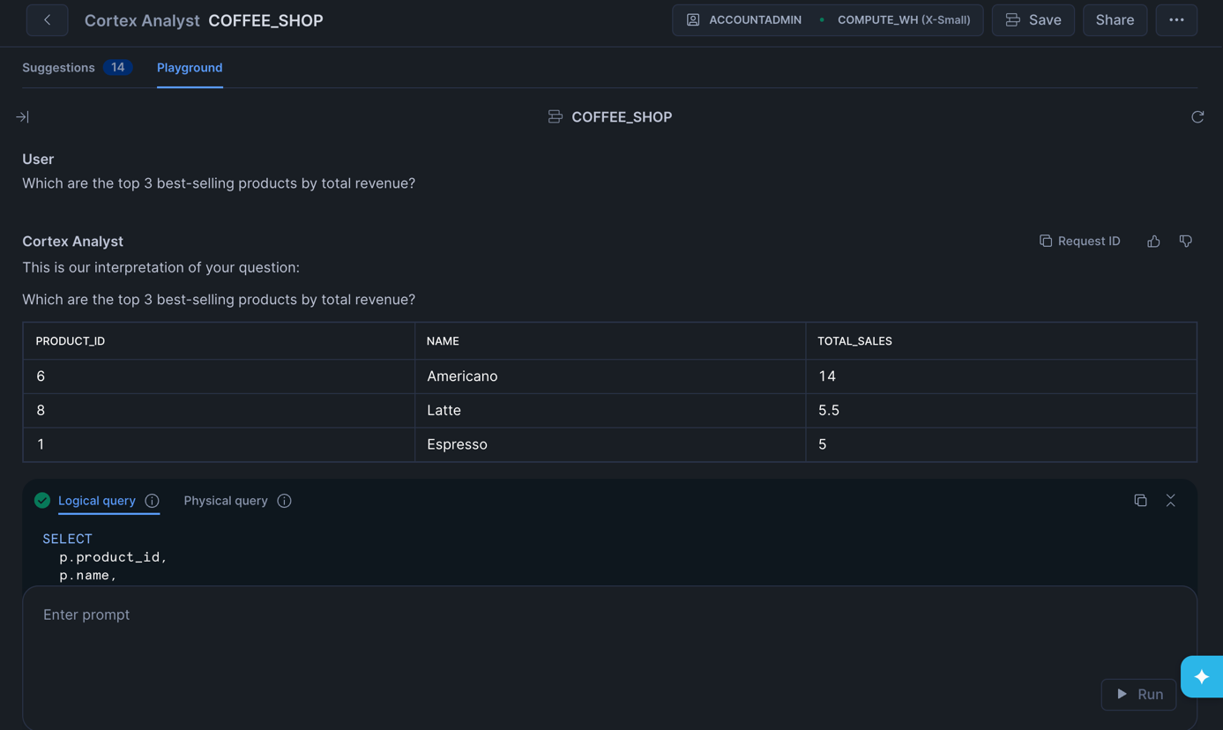

Integration with Streamlit
I connected Streamlit to Cortex:
- User inputs a question
- The question is sent to Cortex
- Cortex generates SQL
- SQL is executed in Snowflake
- Results are displayed dynamically
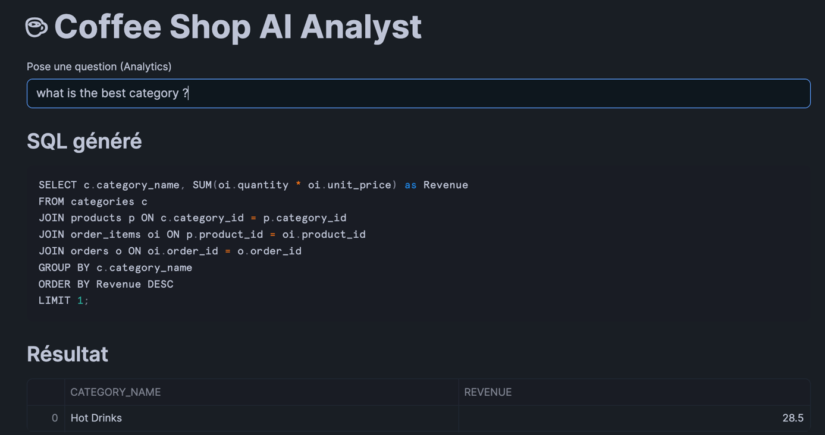

Interested in leveraging AI to simplify data analytics and generate insights without complex SQL? Feel free to reach out to discuss how Snowflake Cortex Analyst can be applied to your use cases!

Cortex Search
-> for unstructured data
Setup
Enriching Data
I enhanced the products table by adding a description column
Creating the Search Service
Using the Snowflake UI (AI & ML section), I:
- Navigated to Cortex Search
- Created a new search service
- Selected:
  - Database: COFFEE_SHOP_DB
  - Schema: PUBLIC
  - Table: PRODUCTS
  - Column: DESCRIPTION
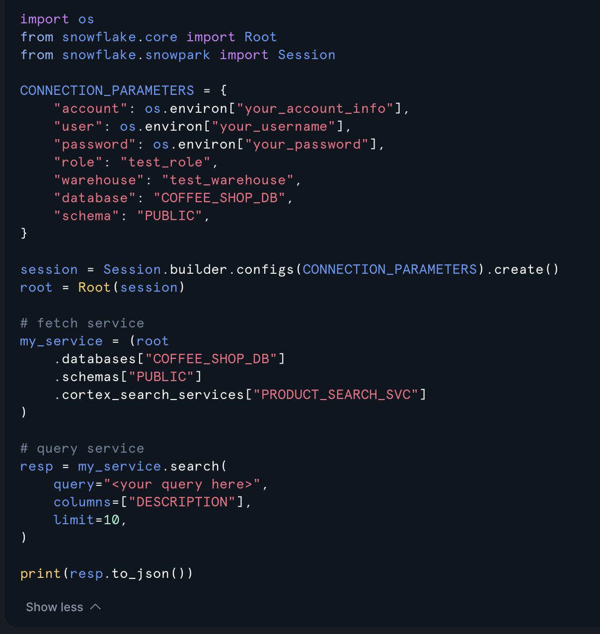
Users can now type: “refreshing drink”
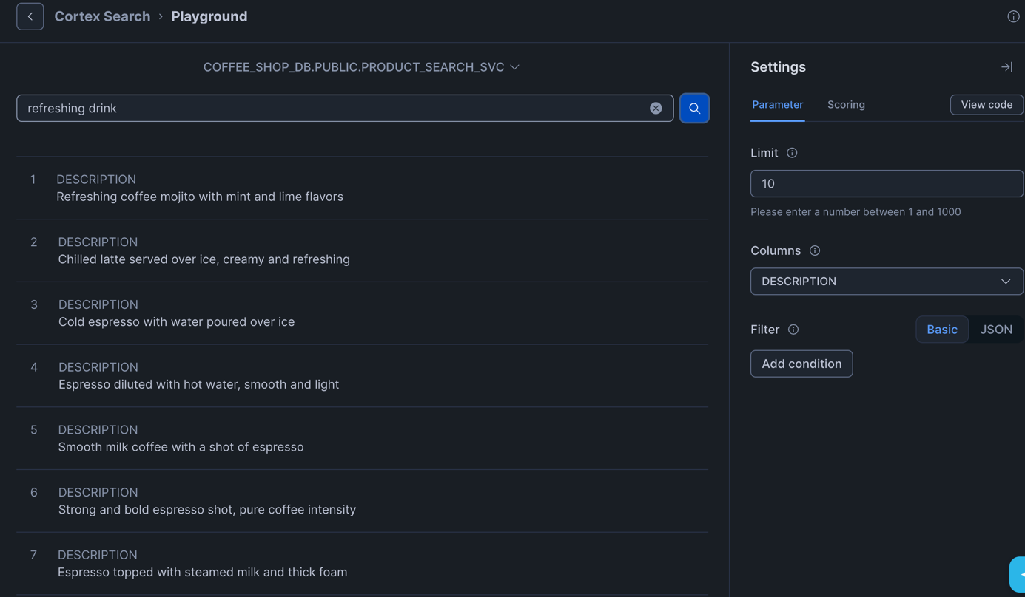
-> Cortex returns the most relevant products based on meaning Streamlit Integration
-> to build an interactive interface inside Snowflake
- Ask questions (Cortex Analyst)
- Search products (Cortex Search)
- Display tables and charts

Final Result
The application allows users to:
- Analyze sales with natural language - Identify top customers and products - Search products using semantic queries - Visualize results instantly

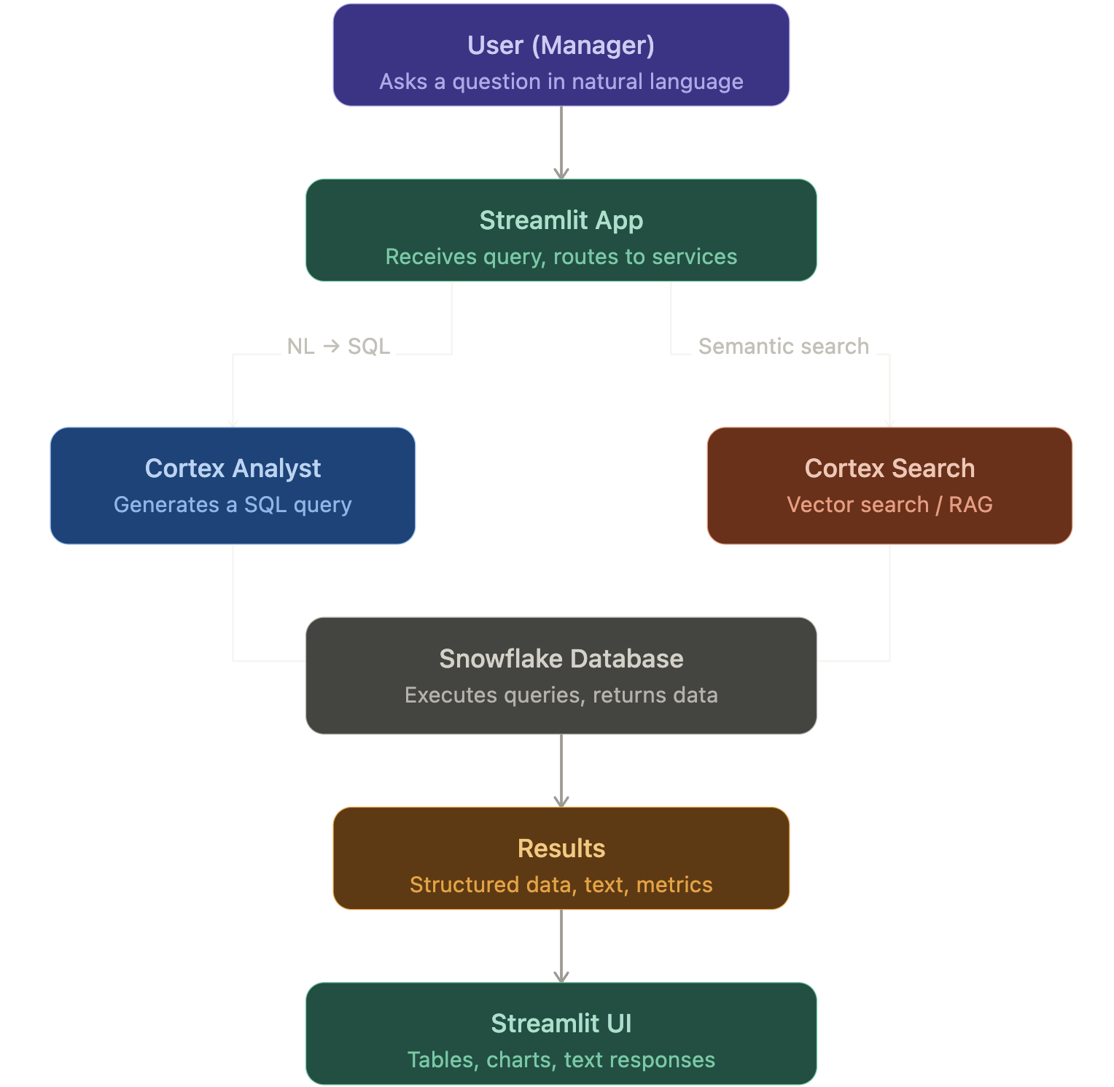
Looking to implement semantic search and enhance user experience with AI? Let’s connect and explore how Snowflake Cortex Search can bring value to your projects !

