Introductory Tutorial for the AMBER Score in DOCK6:

By

Devleena Shivakumar
The Scripps Research Institute
10550 N. Torrey Pines Rd, TPC 15
La Jolla, CA 92037, USA
Phone: (858)-784-9781, (858)-784-9768
FAX: (858)-784-8896
Email: devleena@scripps.edu, case@scripps.edu

5/2/06

What is Amber score?

The generalized Born/surface area (GB/SA) continuum model for solvation free energy is a fast and accurate alternative to using explicit solvent model for molecular simulations. We have now implemented this physics-based method in the Amber scoring function in the program DOCK6. To curtail the computational cost while still maintaining the accuracy, the atoms distant from the site of ligand binding are kept frozen. In doing so the CPU time is not spent updating the energy and derivatives during the course of the simulation. The main advantage of AMBER score is – both the ligand and the active site of the protein can be flexible, allowing small structural rearrangements to reproduce the so-called “induce-fit” while performing the scoring function.

When a user calls for Amber score, the program performs minimization, and MD simulation on individual ligand, receptor, and the compound, and calculates the score as follows:

E_{binding} = E_{complex} – (E_{receptor} + E_{ligand})

Where E is obtained from:
E = E_{MM} + (E_{p-sol} + E_{np-sol})

E_{MM =} E_{vdW} + E_{es} + E_{int} ---- obtained from AMBER MM potentials

E_{p-sol} --- Electrostatic part of solvation energy using GB

E_{np-sol} --- Non-polar part of solvation energy using SA

The user has the option to increase or decrease the number of minimization and MD simulation steps. However, it is not desirable to have higher number of steps due to the time taken for the calculations. For various protein test cases, we have found 100 minimization and 3000 MD steps to produce good results. These are set as defaults in the program.

It is highly recommended to run a DOCK calculation with a less expensive primary/secondary score to write out the topmost poses. Amber score should be used on these topmost pose for each ligand. For example, for T4 Lysozyme the DOCK score is calculated for 1 million compounds from ACD directory. Top 5000-10,000 compounds ranked by DOCK are passed through Amber score for further refinement. This is further illustrated in the cartoon below:

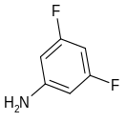
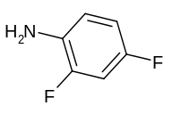
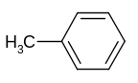
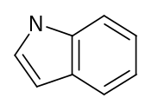
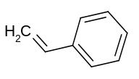
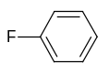
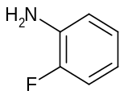
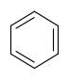
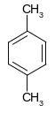
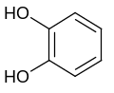
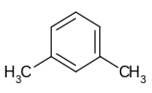
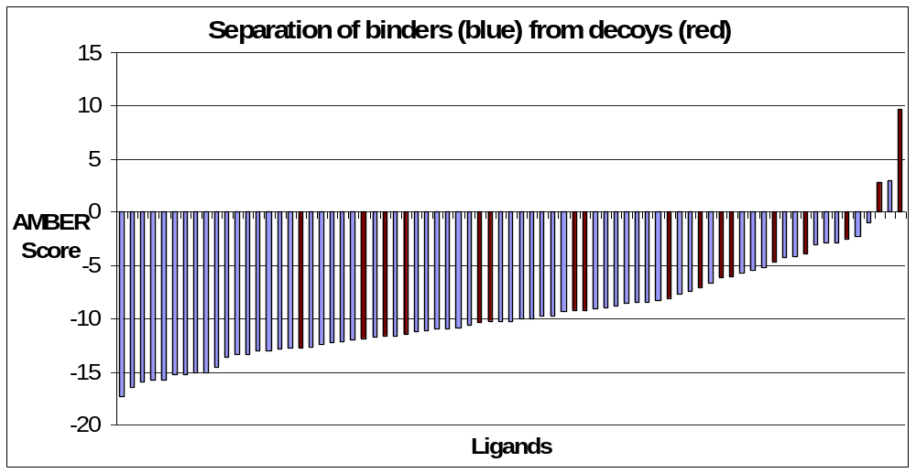
Filter using a fast DOCK scoring function. Top 10,000 selected for rescoring with Amber Score
Millions of compounds from a database
Rescoring with Amber Score

Part I: Input files preparation.

- Start with the output mol2 file from a previous DOCK run [lig.mol2].

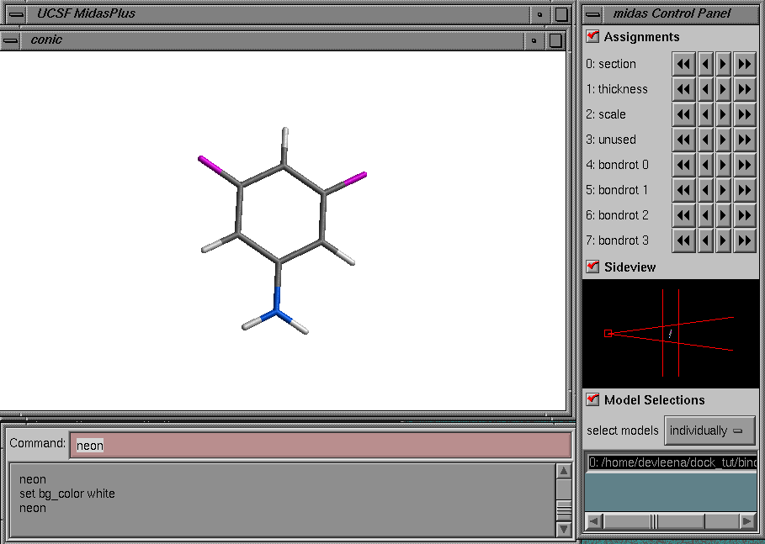

Receptor without cofactors. (1lgu.pdb)
  - Clean PDB:
Remove all the ligand, ions and crystal water molecules from the receptor pdb file. If you know that certain water molecules, ions play catalytic or structural role, use your scientific judgment to decide whether to keep them in the PDB file.

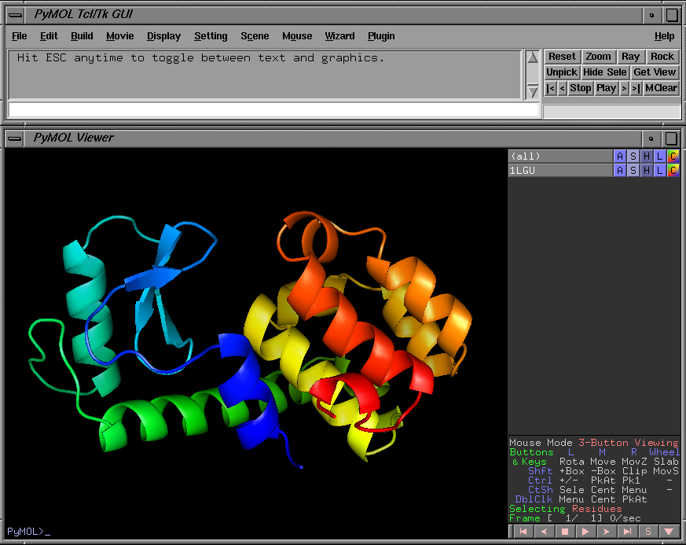

[Structure of T4 Lysozyme, PDB: 1LGU)]

  - Determine the protonation state of the histidine and other titratable residues in the receptor. Care should be taken to assign the appropriate protonation state, especially if the residue is at or near the active site or within the flexible region while scoring calculations. Use experimental data from the literature, or your chemical intuition to assign the protonation states for these residues. [Hint: Check for hydrogen bonding residues nearby to see whether the His or Asp should be protonated.] Or, you can use softwares to do this job. Some examples:
    - PDB2PQR [http://pdb2pqr.sourceforge.net/] - Python software package that automates the PDB file preparation and protonation state assignments.
    - H⁺⁺ [http://biophysics.cs.vt.edu/H++/] is a tool to estimate pKa's of protein side chains, and to automate the process of assigning protonation states for molecular dynamics simulations.

  - After assigning the protonation states, make sure that your receptor PDB file has residue names according to the AMBER readable format. Check the name of the residues to make sure that they have correct names:

Group or residue Residue Name, Alias
Acetyl beginning group ACE
Amine ending group NHE
N-methylamine ending group NME
Alanine ALA
Arginine ARG
Asparagine ASN
Aspartic acid ASP
Aspartic acid--protonated ASH
Cysteine CYS
Cysteine--deprotonated CYM
Cystine, S--S crosslink CYX
Glutamic acid GLU
Glutamic acid--protonated GLH
Glutamine GLN
Glycine GLY
Histidine, delta H HID
Histidine, epsilon H HIE
Histidine, protonated HIP
Isoleucine ILE
Leucine LEU
Lysine LYS
Methionine MET
Phenylalanine PHE
Proline PRO
Serine SER
Threonine THR
Tryptophan TRP
Tyrosine TYR
Valine VAL

Prepare AMBER readable input files for each ligand, receptor and the corresponding complex. This is done with the help of a perl script that is provided in the bin directory – prepare_amber.pl
Find out whether perl is installed in your machine.
$ which perl
/usr/bin/perl

If you cannot find perl on your machine, please install a copy.

The command line for using prepare_amber.pl is:

prepare_amber.pl lig.mol2 1lgu.pdb

Output files:

Files associated with Ligand:
lig.amber.score.mol2
lig.1.mol2
lig.1.amber.pdb
lig.1.gaff.mol2
lig.1.prmtop
lig.1.frcmod
lig.1.inpcrd

Files associated with receptor
1lgu.prmtop
1lgu.amber.pdb
1lgu.inpcrd

Files associated with complex:
1lgu.lig.1.prmtop
1lgu.lig.1.amber.pdb
1lgu.lig.1.inpcrd

prepare_amber.pl also has the capability to split a file containing multiple mol2 into individual mol2 files that are then read by the program.
Since in this example, there was only one ligand in lig.mol2, the output was lig.1.mol2. Had there been 2 ligands in the mol2 file, the output prefix will be: lig.1.mol2, lig.2.mol2 …

The following is done by the script prepare_amber.pl:
- Adds hydrogens to protein & ligand
- Generate a mol2 file with suffix amber.score.mol2 that will be read into the DOCK run (lig.amber.score.mol2).
- Run antechamber program to determine semi-empirical charges (am1-bcc) for the ligand.
- Creates parameter file for ligand using GAFF forcefield (prmtop and frcmod) and writes a mol2 file with GAFF atom types (gaff.mol2)
- Read in the PDB file for the receptor; add hydrogens if not present; add amber force field atom types and charges. Generate parameter and coordinate file.
- Combine each ligand with the receptor to generate the parameter and coordinate files for each complex.

Run DOCK6
Prepare an input file for DOCK6 run. For ligand_atom_file, use the output file with the suffix _.amber.score.mol2 generated from prepare_amber.pl (see (ii) above)

The following options are amber score specific option:
amber_score_primary yes
amber_score_secondary yes
receptor_file_prefix 1lgu
amber_score_movable_region ligand
amber_score_gb_model 5
amber_score_md_steps 1
amber_score_minimization_cycles 1
amber_score_nonbonded_cutoff 18.0
amber_score_temperature 300.0
amber_score_verbose no

For receptor_file_prefix, use the prefix of the receptor PDB file. For example in this case it is 1lgu for our pdb file 1lgu.pdb
Choose amber_score_movable_region as ligand. This defines the region that is allowed to move while scoring. To select other options, please read the manual.

********************************
dock.in file

ligand_atom_file lig.amber_score.mol2
ligand_outfile_prefix output
limit_max_ligands no
read_mol_solvation no
write_orientations no
write_conformations no
skip_molecule no
calculate_rmsd no
rank_ligands no
num_scored_conformers_written 1
orient_ligand no
flexible_ligand no
bump_filter no
score_molecules yes
contact_score_primary no
contact_score_secondary no
grid_score_primary no
grid_score_secondary no
chemgrid_score_primary no
chemgrid_score_secondary no
continuous_score_primary no
continuous_score_secondary no
gbsa_zou_score_primary no
gbsa_zou_score_secondary no
gbsa_hawkins_score_primary no
gbsa_hawkins_score_secondary no
amber_score_primary yes
amber_score_secondary yes
receptor_file_prefix 1lgu
amber_score_movable_region ligand
amber_score_gb_model 5
amber_score_md_steps 1
amber_score_minimization_cycles 1
amber_score_nonbonded_cutoff 18.0
amber_score_temperature 300.0
amber_score_verbose no

