Session-3: Training algorithm and implementation of PPNet
Contents
1. brief introduction 1
2. Python implementation and mathematical principles of PPNet training algorithm 1
3. sum up 8

Brief introduction
This session will introduce the Python implementation of PPNet's training algorithm. Readers interested in this topic can combine the debugging methods covered in Session 1 to debug and observe relevant variables or Tensor properties such as shape, data type, value range, and others on main.ipynb, to calibrate the understanding of the algorithm.

PPNet running on the main.ipynb is a simplified version for AI/ML beginners based on the original full version, so the configurations compared to the original paper is much lighter.

Python implementation and mathematical principles of PPNet training algorithm
Log in and open main.ipynb on a cloud server. The Python implementation of PPNet's simplified training algorithm is found in the train_or_test function of the 10-th cell in main.ipynb (as shown in Figure 1).
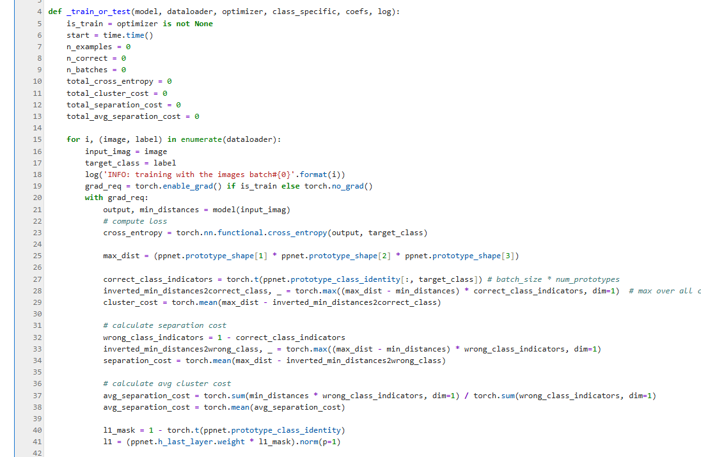
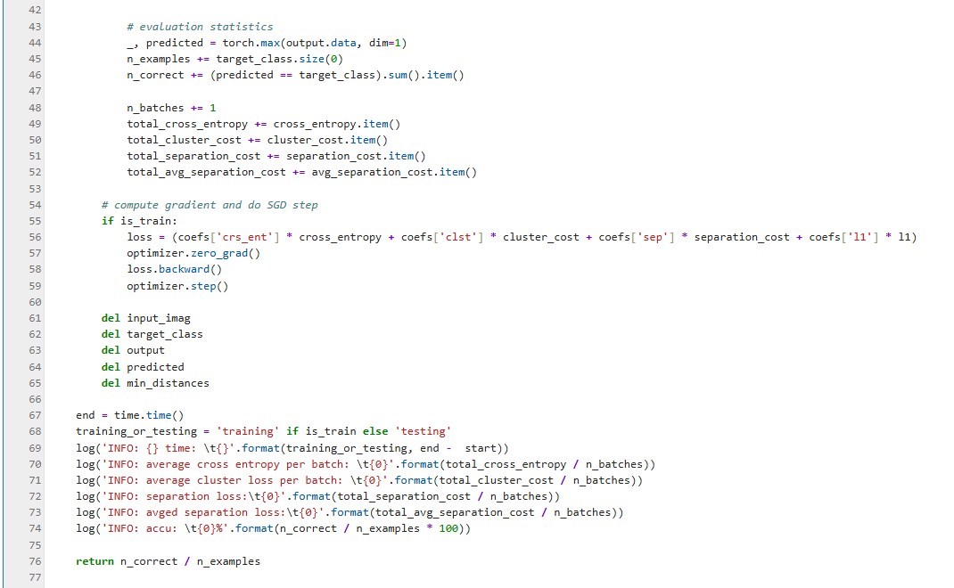
Figure 1 _train_or_test function

The implementation of the algorithm is explained below starting from the line 15 of this cell.

Line 15: Take each batch of multiple images from dataloader one by one patch:
-i: Counter, starting from 0
-image: The image is a Tensor. Its shape is 5×3×56×56. Here, 5 represents the batch size (corresponding to the n parameter in the original paper), 3 denotes the number of color channels in the input image (i.e., R, B, G), and 56×56 indicates the normalized dimensions (search for ‘img_size’ in main.ipynb) of the input image. While the original paper's implementation used 224×224 for img_size, this simplified version employs 56×56.

Each pixel in the image is a floating point number, for example:
image[0,0,:,:]=tensor([[-1.4843, -1.2788, -1.3130, ..., -0.8849, -1.5185, -1.4672],
[-1.3644, -1.5014, -1.6555, ..., -0.4911, -1.5014, -1.5185],
[-1.6384, -1.7240, -1.6727, ..., 0.1254, -1.3987, -1.5699],
...,
[-0.5938, -0.6281, -0.8164, ..., -0.2171, -0.5082, -0.6965],
[-0.7479, -0.8335, -0.8507, ..., -0.2342, -0.5253, -0.6965],
[-0.8164, -0.8507, -0.7993, ..., -0.2684, -0.5424, -0.6965]])

The values of batch_size and img_size are configured in the fifth cell of main.ipynb (see Figure 2);

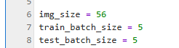
Figure 2 Configurations of batch_size and img_size

-label: is also a Tensor, its shape is 5 (that is, batch_size), and each element has a value of 0 or 1, for example:
label=tensor([0, 0, 0, 1, 0])
This is because: this simplified version has only two classes (i.e., K=2 in the original paper); whereas the first experiment in the original paper had 200 bird species (i.e., K=200 in the original paper).
The value of K is in the third cell of main.ipynb, about the third row (see Figure 3):
Figure 3 Number of K-class configurations

Lines 19 and 20: Used to open the context-manager and start tracking the gradient.

Line 21: Multiple images of each batch are input into the PPNet model to obtain output and min_distance.
PPNet is a model whose construction has been explained in detail in the previous session 2: it is the concatenation of the convolutional layers, the prototype layers and the fully connected layers of the ProtoPNet architecture in Figure 2 of the original paper.

-output: is a Tensor with shape 5*2. Here, 5 is the batch size, and 2 is the number of categories to be classified. Its elements are logits, for example:
output=tensor([[15.2223, 11.4460],
[11.9614, 12.5399],
[12.6952, 9.8602],
[13.5075, 11.0368],
[11.8025, 11.4291]], grad_fn=<MmBackward0>)

-min_distance is the output of max_pool in the architecture diagram of Figure 2 of the original paper, which is also the input used to calculate similarity score:
$$d_{j}≐\min_{\tilde{z}∈patches(f(x))}{‖\tilde{z}}−p_{j}‖_{2}^{2},j=0,1,2,...,m−1$$
x represents an image within each batch, while m denotes the total number of prototype vectors. In the original paper's experiments, this value was 2000, whereas in this simplified version it is set to 128. Consequently, the shape of min_distance is 5×128 (where 5 corresponds to the batch size and 128 represents the total number of prototype vectors m). An example of its element values would be:
min_distances=tensor([[2.1039, 0.9906, 2.6339, 1.9970, 1.3366, 1.7225, 2.0380, 1.0471, 2.0000,
1.4033, 2.7194, 2.0529, 1.7664, 2.9312, 1.9500, 2.7546, 1.0648, 2.5206,
1.4906, 1.4306, 1.3405, 1.4322, 2.5337, 2.1308, 2.2131, 2.5743, 3.2091,
0.9782, 1.8158, 1.8468, 2.7401, 1.7548, 2.4767, 1.0232, 1.0433, 0.5972,
1.9929, 3.9777, 1.8551, 2.9142, 1.4984, 3.0085, 1.9300, 1.9615, 2.2476,
1.2228, 1.5033, 2.1017, 2.4414, 3.0683, 2.6542, 3.2728, 1.1452, 1.2628,
2.2507, 3.3322, 1.6725, 3.0021, 1.7119, 2.4529, 2.7976, 2.5616, 3.0969,
0.9780, 3.4496, 3.1327, 0.7663, 1.6553, 2.4345, 2.3039, 2.5542, 1.9128,
2.9555, 1.2214, 1.6910, 2.1016, 2.4681, 1.4196, 2.6411, 3.3818, 2.3821,
2.6797, 1.7855, 0.8982, 1.8090, 2.1926, 1.9372, 1.5277, 2.3663, 1.3957,
2.1039, 3.0425, 2.3233, 1.7481, 2.8753, 2.4431, 4.2995, 2.1842, 2.8236,
2.4499, 1.3821, 3.7060, 2.9607, 3.3910, 3.1599, 1.7046, 1.5531, 3.8703,
1.5109, 1.8871, 2.3786, 2.0469, 3.0021, 2.9218, 2.7644, 2.4703, 1.4400,
0.4638, 1.6315, 2.4686, 2.2353, 4.0935, 2.9652, 2.7879, 1.6652, 1.5567,
2.0876, 2.5679],
.....

The configuration of "number m of prototype vectors" in the third unit of main.ipynb (Figure 4):

Figure 4 Configuration of the number m of prototype vectors

Line 23: Calculate the cross-entropy loss for each batch, which is the first part of the optimization problem formula in Section 2.2 Training algorithm of the original paper (denoted as Ce here):
$$Ce=\frac{1}{n}\sum_{i=1}^{n}{C}rsEnt(h∘g_{p}∘f(x_{i}),y_{i})$$
The definition of the CrsEnt() function is:

$$CrsEnt(\bar{o_{i}}, y_{i})≐−log\left(\frac{exp(o_{i,y_{i}})}{\sum_{c=1}^{C}{exp(o_{i,c})}}\right)$$
$$where，\bar{o_{i}}≐h∘g_{p}∘f(x_{i})$$

The full definition of cross-entropy (......) can be found in

https://docs.pytorch.org/docs/stable/generated/torch.nn.functional.cross_entropy.html

Interested readers can use other options for the function, including the use of class-specific weights and label smoothing.

Lines 25 to 29: Calculate the cluster cost (Clst) in the original paper
$$Clst≐\frac{1}{n}\sum_{i=1}^{n}{\min_{j:p_{j}∈P_{y_{i}}}{\min_{\tilde{z}∈patches(f(x_{i}))}{‖}}}\tilde{z}−p_{j}‖_{2}^{2}$$
As mentioned earlier, min_distance already is:
$$\min_{\tilde{z}∈patches(f(x))}{‖\tilde{z}}−p_{j}‖_{2}^{2},j=0,1,2,...,m−1$$
So, here we just need to distinguish between sets
$$\left\{j:p_{j}∈P_{y_{i}}\right\}$$
This can be done through line 27:
correct_class_indicators = torch.t(ppnet.prototype_class_identity[:, target_class])
(Here, torch.t is simply a transpose operation for 2D tensors.)

In addition: The calculations in rows 25 to 29 use the min-max transform:
For any set, $\left\{x_{1},x_{2},...,x_{n}\right\}$ when C is large enough, there is always:
$$min(x_{1},x_{2},...,x_{n})=C−max(C−x_{1},C−x_{2},...,C−x_{n})$$

Lines 32 to 34: Calculate the separation cost (Sep) in the original paper (note that there is a difference in the positive and negative sign here, which is later compensated by the positive and negative sign of $λ_{2}$).
$$Sep≐\frac{1}{n}\sum_{i=1}^{n}{\min_{j:p_{j}∉P_{y_{i}}}{\min_{\tilde{z}∈patches(f(x_{i}))}{‖}}}\tilde{z}−p_{j}‖_{2}^{2}$$
The calculation process is similar to that of cluster cost, except for the distinction between combined sets:
$$\left\{j:p_{j}∉P_{y_{i}}\right\}$$
Lines 37 and 38: This is another method of calculating separation cost introduced by the original author of the paper (this method is not mentioned in the original paper):
$$\tilde{Sep}≐\frac{1}{n}\sum_{i=1}^{n}{\underset{j:p_{j}∉P_{y_{i}}}{mean}}\min_{\tilde{z}∈patches(f(x_{i}))}{‖}\tilde{z}−p_{j}‖_{2}^{2}$$
In this experiment, the separation cost calculated by this method is only used for log printing.

Lines 40-41: This is the calculation of the 'L1-cost' of the fully connected layer of PPNet. This cost is described in the 'Convex optimization of last layer' in Section 2.2 of the original paper as:
$$L1≐\sum_{k=1}^{K}{\sum_{j:p_{j}∉P_{k}}{|}}w_{h}^{(k,j)}|$$
Lines 44-46: This is the calculation of the classification accuracy of PPNet: For each image, select the category with the largest output logits as the predicted result (i.e., _, predicted = torch.max(output.data, dim=1)

Lines 48-52: Used to collect data of various losses/costs calculated during training.

Lines 55-59: Calculate the loss and perform Stochastic Gradient Descent (SGD). The loss calculation follows the formula from Section 2.2 of the original paper titled "Training algorithm":
$$\min_{P,w_{conv}}{Ce}+λ_{1}Clst+λ_{2}Sep$$
The configuration $λ_{1,}λ_{2}$of the sum is in the 12th cell of main.ipynb (Figure 5):
Figure 5 Configuration of weight coefficients for loss calculation

After calculating the loss, then it executes the SGD update of PyTorch (as shown in Figure 6):

Figure 6 SGD update steps

This SGD update only needs to be performed during the training phase; it does not need to be performed during the testing phase.

Note: In $\min_{P,w_{conv}}{Ce}+λ_{1}Clst+λ_{2}Sep$ the optimization process, the parameters to be optimized are $P$ and $w_{conv}$, but no $w_{h}^{(.,.)}$. However, the calculation of loss in line 56 of main.ipynb is actually:
$$Ce++λ_{1}Clst+λ_{2}Sep+λ_{3}L1$$
So how do you tell the optimizer $P,w_{conv}$to optimize but not optimize $w_{h}^{(.,.)}$?

This is actually controlled by calling the function of the 10th cell of main.ipynb in the warm-only, joint, and last_only stages of training (as shown in Figure 7) to determine whether to compute the gradient of the corresponding parameters and update the parameters.
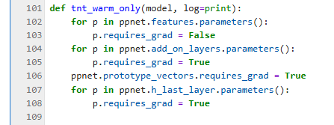
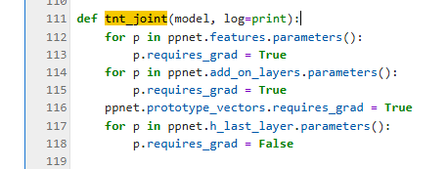
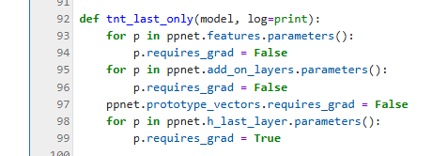
Figure 7 configuration of requires_grad in warm-up, joint and last stages

The following table lists the requires_grad configuration for each layer in the three phases (warm-only, joint, last_only):
requires_grad | Convolutional layers f |  | prototype layer | fully connected layer
requires_grad | VCG19 | add_on_layers | prototype layer | fully connected layer
warm-only | False | True | True | True
joint | True | True | True | False
last_only | False | False | False | True

Therefore, when in the joint phase, the gradient of the parameters of the full connected layers (that is $w_{h}^{(.,.)}$) will not be calculated (that is, it will remain zero), so that the value of the corresponding $w_{h}^{(.,.)}$is fixed.

Summary
This concludes the Python implementation guide for PPNet training, showcasing the original paper's authors' ingenious programming techniques and configuration strategies. In the next session, we'll explore another core algorithm from the original research: Prototype Projection.

