Mini Project 2

By: Anirudh Chaudhary, Quan Le, Bob LeBow, Richard More, Hao Nguyen

## Entity Relationship Diagram

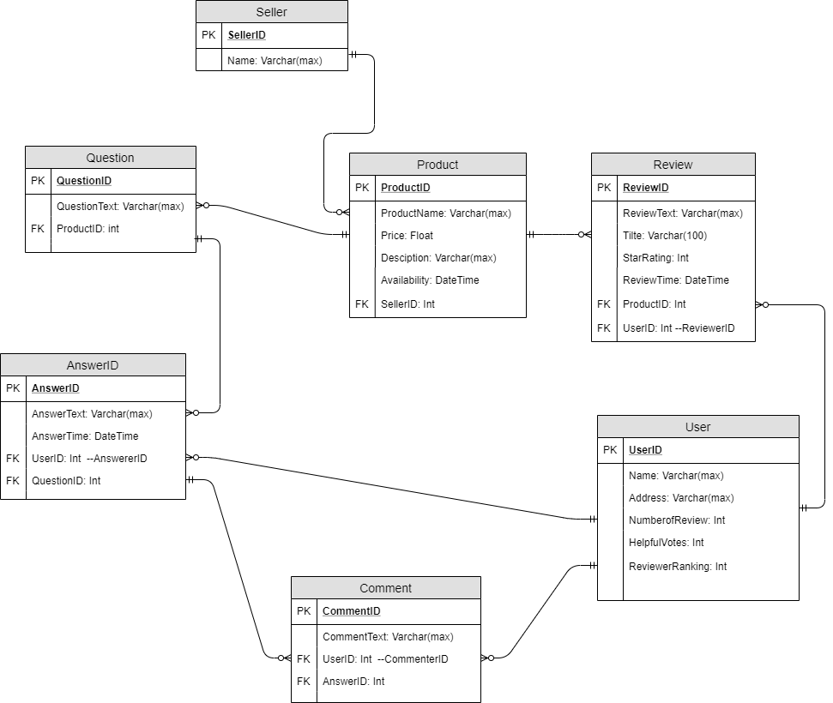

## Collections

* **Sellers**

**{**

**"seller_id": 123456,**

**"name": "Cloudtail.Inc"**

**}**

* **Products**

**{**

**"_id": 12345646,**

**"Product_ID": "AX123",**

**"Product Name": "Study Table",**

**"Price": "$40.00",**

**"Description": "The study table is made from wood and is brown in color.",**

**"Availability": "In Stock",**

**"SellerID": 123456,**

**"Reviews": [{**

**"Review_ID": "A1",**

**"ReviewText": "The table is strong and value for money.",**

**"Title": "Good table",**

**"StarRating": 4,**

**"ReviewTime": ISODate("2018-02-22"),**

**"UserID": "1X"**

**},**

**{**

**"Review_ID": "A2",**

**"ReviewText": "The table is weak. Total waste of money.",**

**"Title": "Bad table",**

**"StarRating": 4,**

**"ReviewTime": ISODate("2018-05-29"),**

**"UserID": "2X"**

**}**

**],**

**"Questions": [{**

**"Question_ID": "Q1",**

**"QuestionText": "The table is made from which wood?",**

**"Answers": [{**

**"Answer_ID": "AA1",**

**"AnswerText": "Sheesham",**

**"AnswerTime": ISODate("2018-06-29"),**

**"UserID": "1X"**

**},**

**{**

**"Answer_ID": "AA2",**

**"AnswerText": "Teak",**

**"AnswerTime": ISODate("2018-07-29"),**

**"UserID": "2X",**

**"Comments": [{**

**"Comment_ID": "COM1",**

**"CommentText": "Thank you for the answer.",**

**"UserID": "2X"**

**},**

**{**

**"Comment_ID": "COM2",**

**"CommentText": "Very Helpful info.",**

**"UserID": "3X"**

**}**

**]**

**}**

**]**

**},**

**{**

**"Question_ID": "Q2",**

**"QuestionText": "How many drawers are there in the table?"**

**}**

**]**

**}**

* **Users**

**{**

**"_id": "1X",**

**"Name": "Jim",**

**"Address": "Atlanta,GA",**

**"NumberOfReviews": 23,**

**"ReviewerRanking": "#344,689",**

**"HelpfulVotes": 67**

**}**

**{**

**"_id": "2X",**

**"Name": "Tim",**

**"Address": "Atlanta,GA",**

**"NumberOfReviews": 68,**

**"ReviewerRanking": "#133,689",**

**"HelpfulVotes": 99**

**}**

**{**

**"_id": "3X",**

**"Name": "Kate",**

**"Address": "Atlanta,GA",**

**"NumberOfReviews": 109,**

**"ReviewerRanking": "#122,689",**

**"HelpfulVotes": 224**

**}**

**Illustration:**

1. **The database used here is from the retail website Amazon.com**
2. **As specified above, the Collections used here are Sellers, Products, and Users**
3. **The documents used here are Reviews, Questions, Answers, and Comments.**
4. **Reviews, Questions, Answers and Comments are embedded in the Product collection; Seller and User are referenced in the Product collection.**

## Screenshots

* **Bob LeBow**
  + **Install MongoDB and Studio3T GUI**
  + **Populated database with Amazon reviews and metadata**

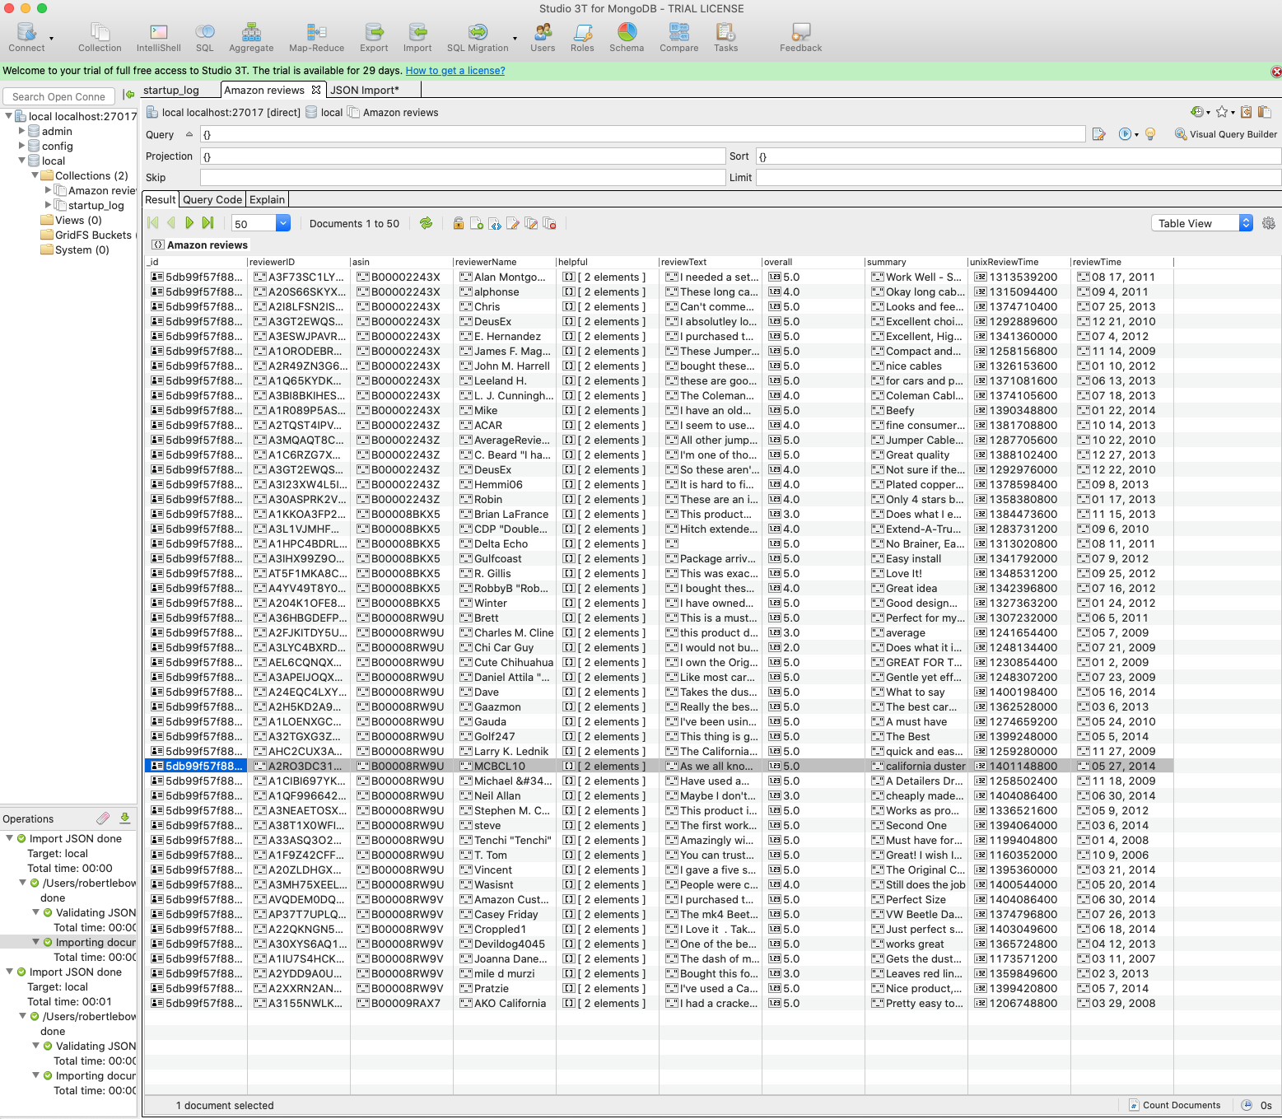

* **Richard More**
  + **Install (docker container)**
  + **Populated amazon database with reviews and metadata**

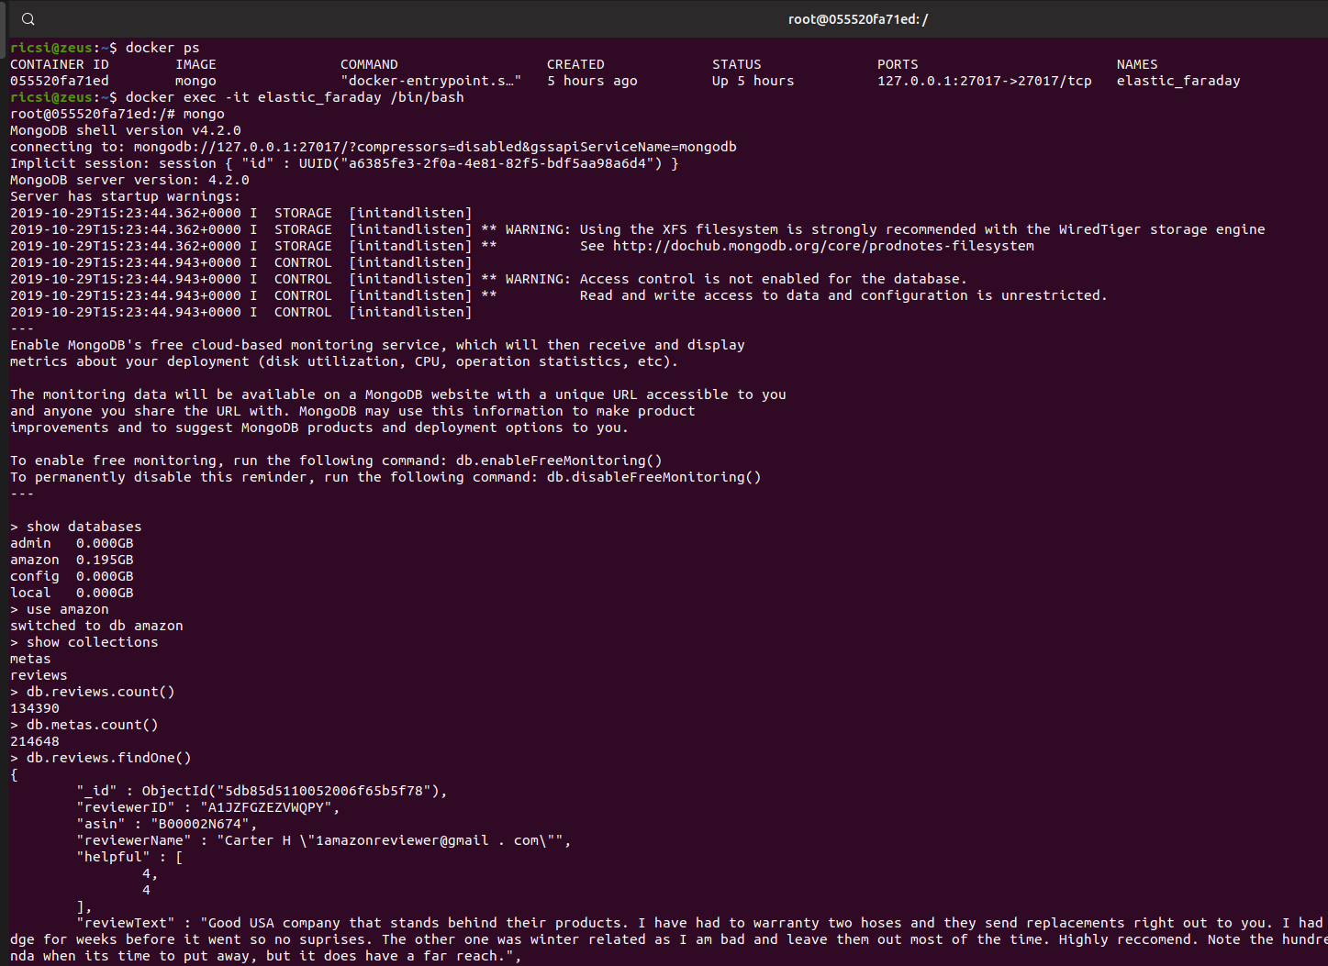

* **Quan Le**
  + **Install**
  + **Test MongoDB (Imported JSON to MongoDB)**

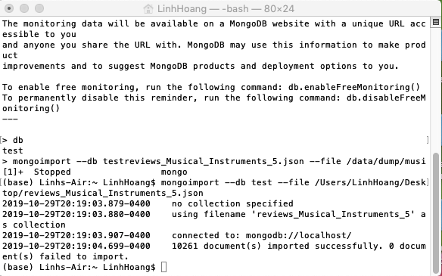

* **Anirudh Chaudhary**
  + **Install**



* + **Data migration**

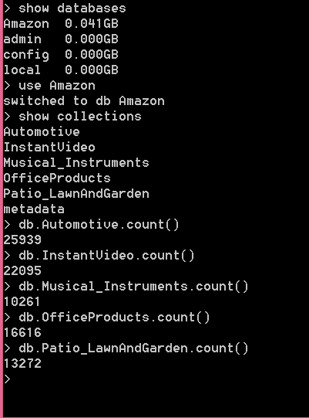

* **Hao Nguyen**
  + **Install**

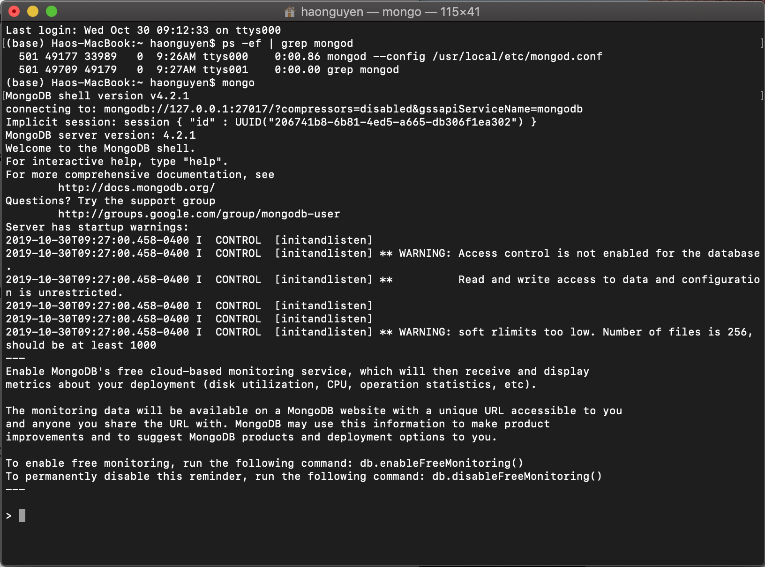

* + **Imported**

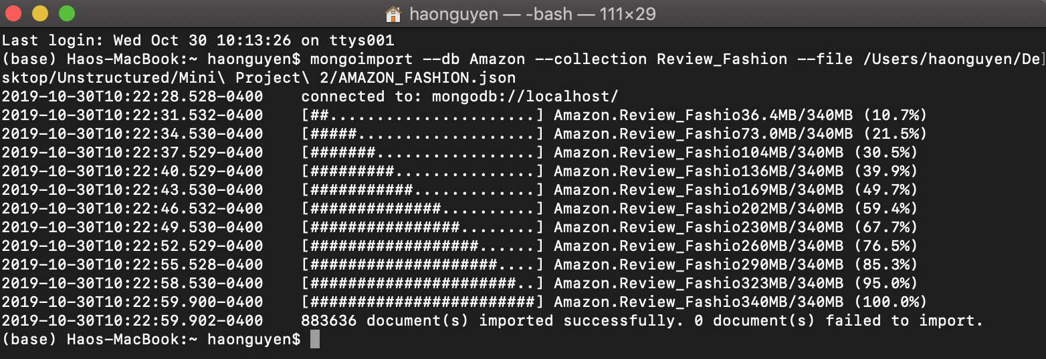

**Modified schema to capture the daily change in product prices up to one year (Part 2c):**

* **New Product Schema**

**{**

**"_id": 12345646,**

**"Product_ID": "AX123",**

**"Product Name": "Study Table",**

**"Prices":[{**

**Price: "$40.00"**

**ChangedDate: “10/30/2019”**

**},**

**{**

**Price: "$50.00"**

**ChangedDate: “10/31/2019”**

**}],**

**"Description": "The study table is made from wood and is brown in color.",**

**"Availability": "In Stock",**

**"SellerID": 123456,**

**"Reviews": [{**

**"Review_ID": "A1",**

**"ReviewText": "The table is strong and value for money.",**

**"Title": "Good table",**

**"StarRating": 4,**

**"ReviewTime": ISODate("2018-02-22"),**

**"UserID": "1X"**

**},**

**{**

**"Review_ID": "A2",**

**"ReviewText": "The table is weak. Total waste of money.",**

**"Title": "Bad table",**

**"StarRating": 4,**

**"ReviewTime": ISODate("2018-05-29"),**

**"UserID": "2X"**

**}**

**],**

**"Questions": [{**

**"Question_ID": "Q1",**

**"QuestionText": "The table is made from which wood?",**

**"Answers": [{**

**"Answer_ID": "AA1",**

**"AnswerText": "Sheesham",**

**"AnswerTime": ISODate("2018-06-29"),**

**"UserID": "1X"**

**},**

**{**

**"Answer_ID": "AA2",**

**"AnswerText": "Teak",**

**"AnswerTime": ISODate("2018-07-29"),**

**"UserID": "2X",**

**"Comments": [{**

**"Comment_ID": "COM1",**

**"CommentText": "Thank you for the answer.",**

**"UserID": "2X"**

**},**

**{**

**"Comment_ID": "COM2",**

**"CommentText": "Very Helpful info.",**

**"UserID": "3X"**

**}**

**]**

**}**

**]**

**},**

**{**

**"Question_ID": "Q2",**

**"QuestionText": "How many drawers are there in the table?"**

**}**

**]**

**}**

* **Handle Data upto one year**

**db.Product.createIndex{{ChangedDate: 1}, expireAfterSeconds: 31556952}**