**REPORT**

**Họ và Tên:** Lê Quang Nghĩa

**Lớp:** 21SE5

**Mã SV:** 21IT362

**Email:** nghialq.21it@vku.udn.vn

**Lớp học phần :** [Phát triển ứng dụng di động đa nền tảng (4)](https://classroom.google.com/c/NzA0MDgzODQyMzY2)

**LAB 1: I AM RICH**

# Introduction

# Create an app called I Am Rich and app that basically does absolutely nothing.

# It just shows a single icon of a red ruby on the screen. And decide to price it at the maximum possible price at the App Store would allow, which was $999.99, and pitched it as an art and lifestyle app, for people who are very rich to display to other people how rich they are.

# Objectives

# Flutter development and build our very first app. And that app is an app called I Am Rich.

# Methodology

* **I Am Rich Structure**

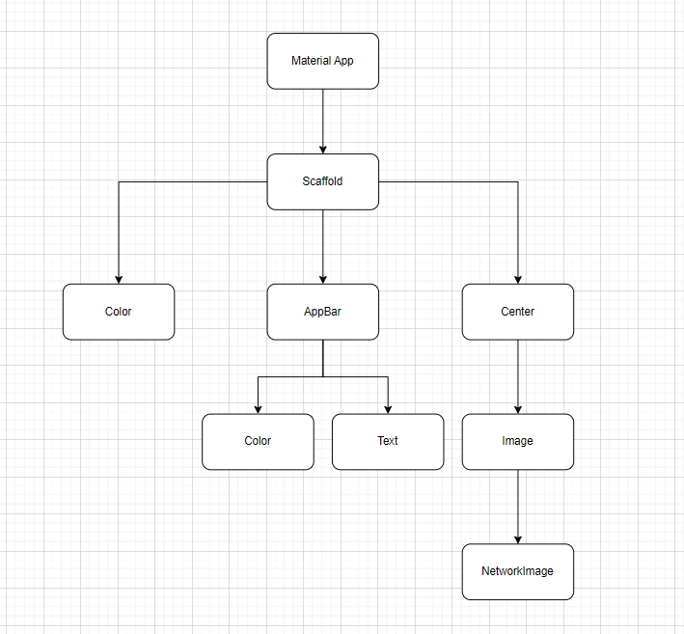

* User interface design with diamond member image.
* Programming image display functions and interactive facilities.
* Test the app on Android and iOS devices.

# Results

* **Creating a New Flutter Project from Scratch:**

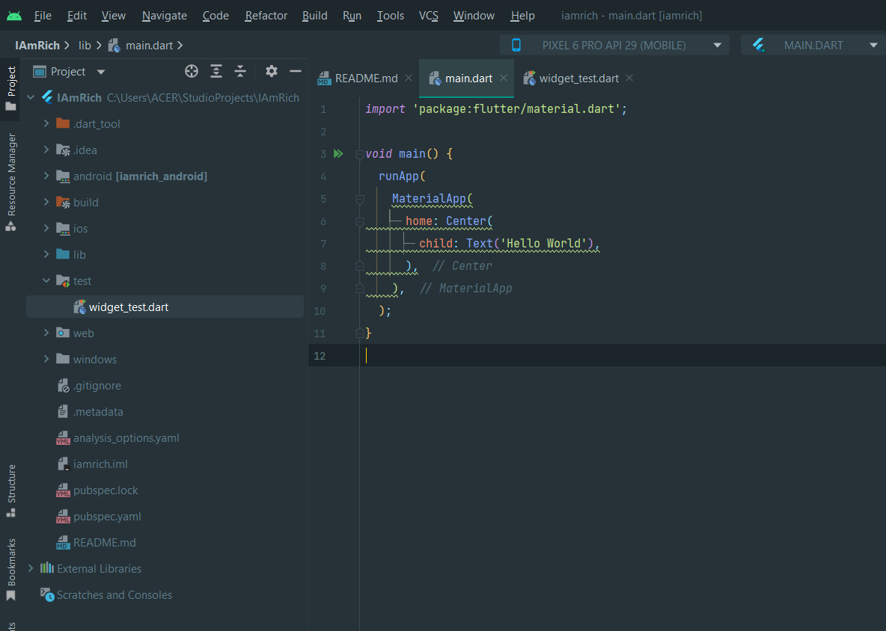

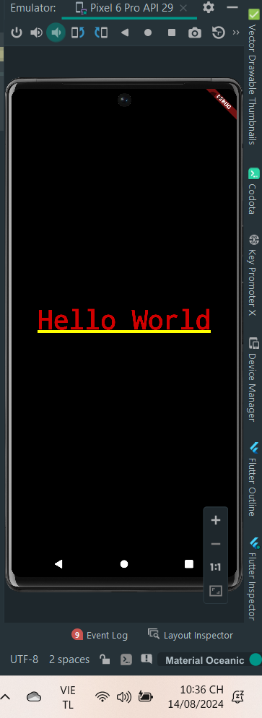

* **Scaffolding a Flutter App**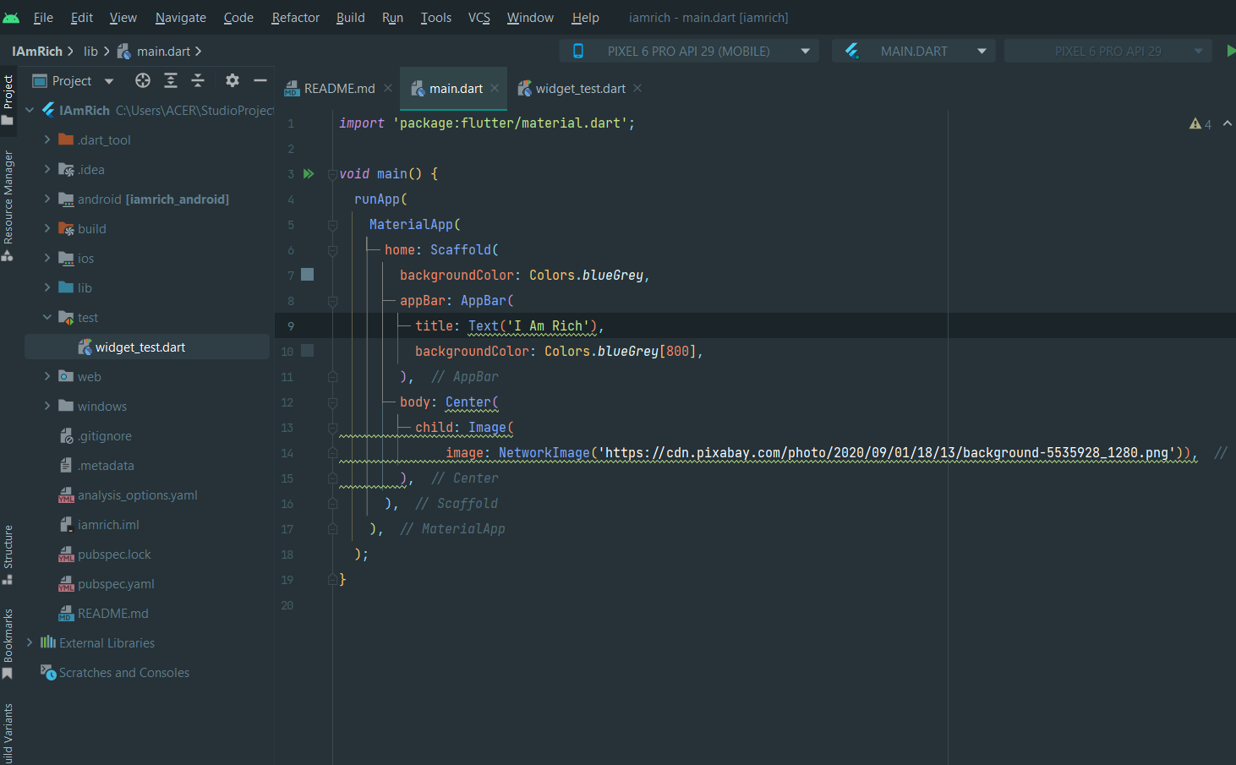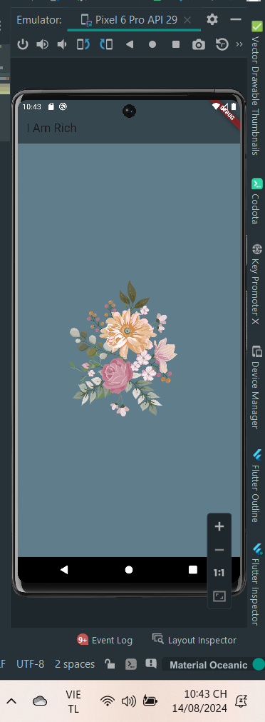
* Working with Assets in Flutter & the Pubspec file
  + Configuration file pubspec.yaml

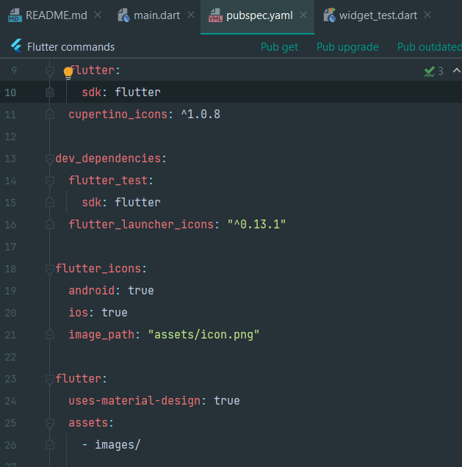

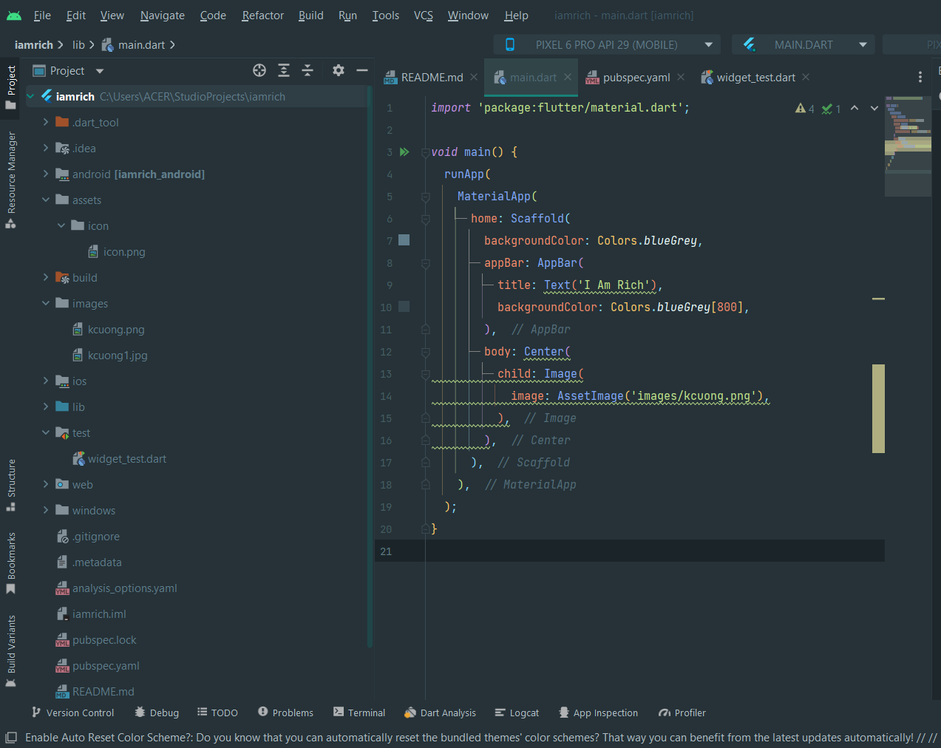

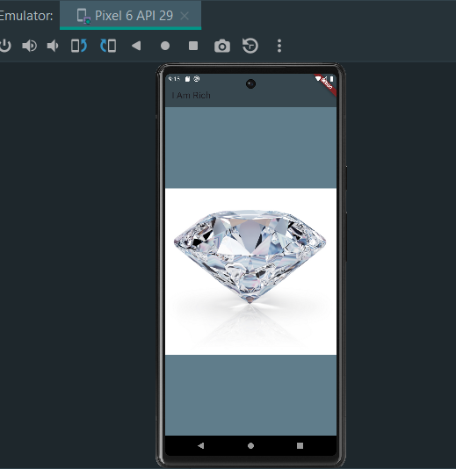

* **How to Add App Icons to the iOS and Android Apps**
* ***Setup the config file***

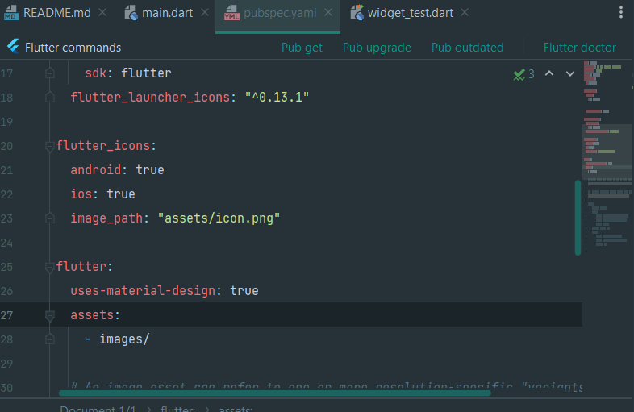

* ***Run the package***
* After setting up the configuration, all that is left to do is run the package.
  + - flutter pub get
    - flutter pub run flutter_launcher_icons

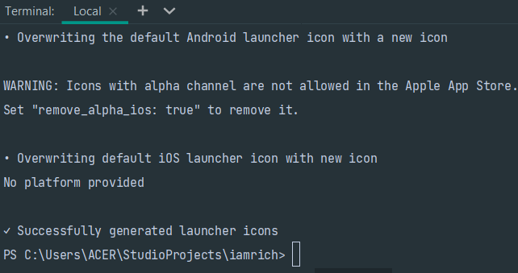

* Run app:

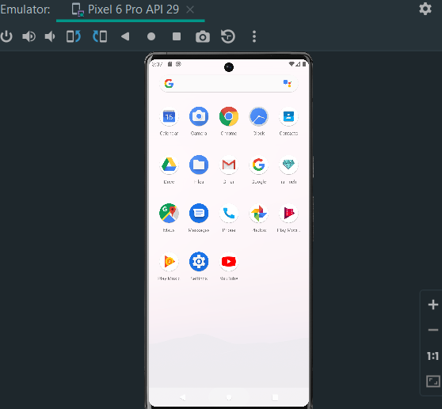

# Discussion

# The "I Am Rich" application has no actual function, mainly for symbolic or entertainment purposes only.

# Strengths:

# Use Flutter to enable fast and efficient app development across multiple platforms.

# Simple application, minimalist interface makes it easy for users to access and use.

# Weaknesses:

# Performance across device configurations needs to be improved.

# The interface is not optimal on all types of devices, especially those with uncommon screen sizes.

# The monotony of the app can affect the user's long-term enjoyment.

# Conclusion

* The "I Am Rich" app development experiment was successfully deployed and tested on both Android and iOS platforms, meeting the initial goals of the project. The app demonstrated good compatibility and provided a simple experience that stayed true to its iconic purpose.