**REPORT**

**LAB 4 : Dicee App**

**Student name: Lê Quang Nghĩa**

**Student ID: 21IT362**

**Student email: nghialq.21it@vku.udn.vn**

# Introduction

* Briefly describe the purpose of the lab report.

The objective of this lab is to explore the functionalities of the StatefullWiget and Expanded Widget in Flutter. Additionally, it aims to deepen understanding of two application states: Stageless and Stagefull. Through this exploration, participants will gain insights into how these widgets and application states contribute to building responsive and dynamic user interfaces

# Objectives

* Understand the core concept of StatefulWidget in Flutter.
* Learn when and how to use StatefulWidget effectively.
* Explore the role of the Expanded Widget in layout management.
* Differentiate between stateless and stateful states in Flutter applications.

# Methodology

The lab follows a hands-on approach, where participants create Flutter applications to test the functionalities of the StatefulWidget and Expanded Widget. The steps include:

* Building a simple Flutter app to experiment with different application states.
* Modifying the app to include a StatefulWidget and analyzing how state changes impact the user interface.
* Using the Expanded Widget to adjust layout behavior dynamically.

# Results

* Include screenshots of the app

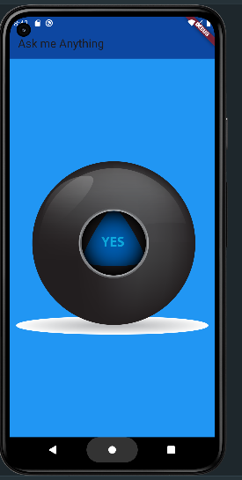 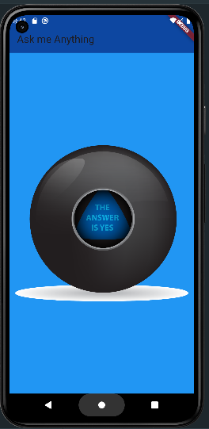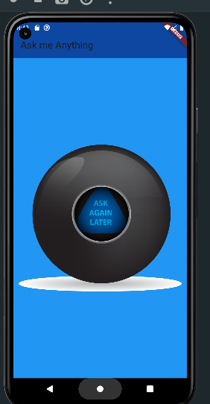

# Discussion

Through practical application, the lab demonstrated the following:

* The StatefulWidget allows Flutter apps to change their state dynamically and redraw the user interface when needed.
* To create a StatefulWidget, the createState function must be overridden to manage the state effectively.
* The initState function is used to initialize variables and setup data before the build function renders the UI.
* The Expanded Widget plays a key role in creating flexible layouts, helping to divide available space proportionally among widgets.

# Conclusion

* Summarize the main findings of the lab.

- Learn how to use state full widget

- Learn how to use state full widget when and how to use it properly

- A few things about statefulwidget :

- Override a function named createState

- Create a class and extend the State of the Widget

- Return in createState function

- InitState function: initializes values to decide how to display the user interface, runs before the

- build functionProvide continuous learning resources and encourage self-study.