In the report of this section, you should include the following:  
• Describe how to compile and use the program.  
• Present the results you achieved, explain the reasons for that result. Suggest ideas for improvement.  
• Point out the bad points of the program. (Does the data and model of the previous part match  
the requirements of the program, does the drawn bounding box fit the subject,...). Show how to  
fix it.  
• All links and books related to your submission must be mentioned

1. **Compile and using the program**

* Download file **model.weights** from link: <https://bit.ly/3t7Rd2m> and place it same directory with source code
* A test image named **cat_dog.jpg**
* Install keras and tensorflow library on python by run command line:   
  *pip install keras && pip install tensorflow*
* Run source code file **detection.py** or **detection.ipynb**
* All files needed are here (Backup Link): https://bit.ly/3mPSPwv

1. **Result & Bad point**

Below are the test results on 8 images in nearly 50 of any tested in the dataset. In general, the program's accuracy results are over 70%. The drawn bounding box does a good job with images with sharp contrasts in color, especially bright colors.

When it should be too dark or the tones are quite close together, the drawn bounding box has less accuracy.

For small objects, the program's detection ability is much higher than for large objects.

The program will encounter an error and be difficult to recognize when there are too many objects in the image that appear close to each other. In some cases, the animal's eyes were closed, which greatly affected the recognition (Figure 7).

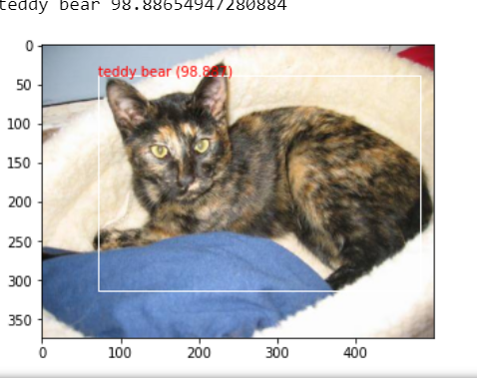 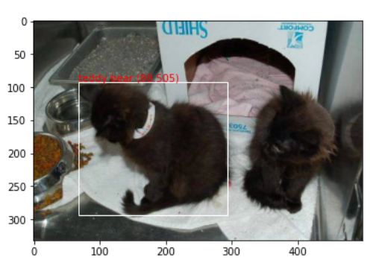 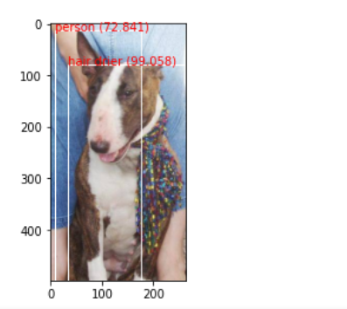

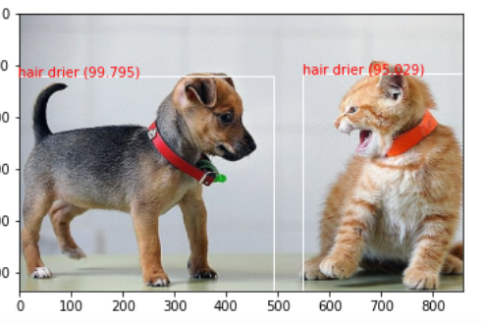 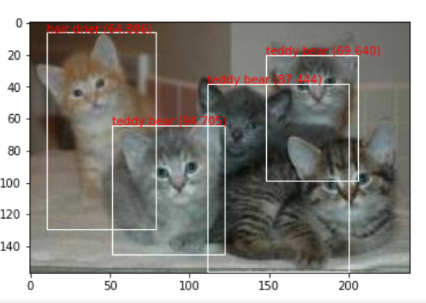 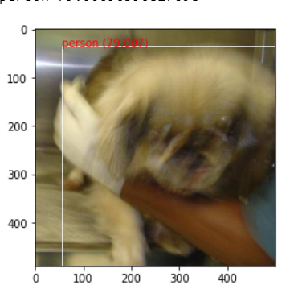

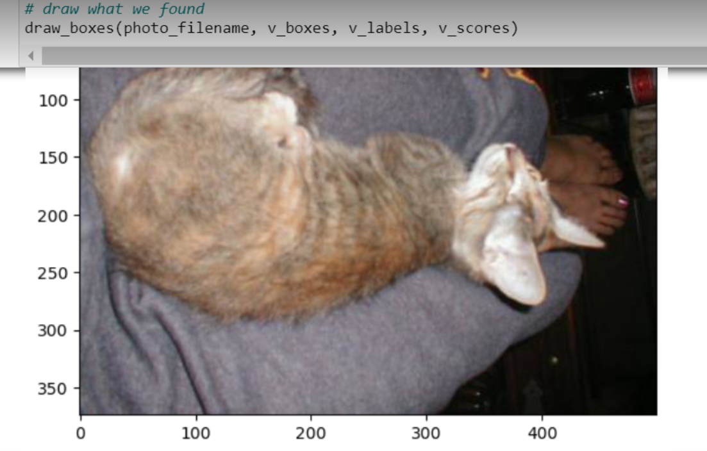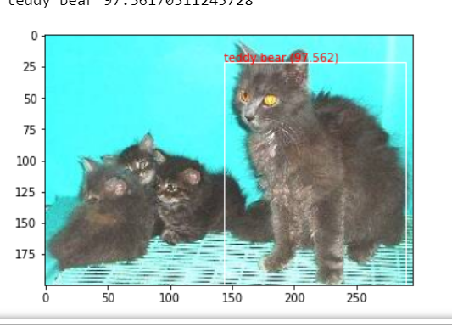 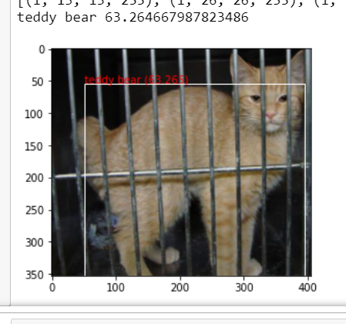

1. **Solution to improve program**

To further improve the accuracy of a model that requires pre-trained model weights with many close-toed figures, objects that do not clearly show eyes and nose should also be considered. Using inputs consisting of small objects gives the program more accuracy than large objects.