GENERATIVE PROJECT
Image Captioning with CLIP Encoder + GPT-2 Decoder
Milestone #1 Report

Group 8: | Name | Email
 | Quoc Hung Le | le.quo@northeastern.edu
 | Hassan Alfareed | alfareed.h@northeastern.edu
 | Khoa Tran | tran.khoa@northeastern.edu

Git Repo: https://github.com/lequo-neu/IE7615_Generative_Project
Submission Date: February 27, 2026

1. Introduction
This project develops an image captioning system that bridges computer vision and natural language generation. The system combines OpenAI's CLIP (Contrastive Language-Image Pre-training) as a visual encoder with GPT-2 as a language decoder. A learned projection head maps CLIP's visual embeddings into GPT-2's input space using prefix conditioning, enabling the language model to generate descriptive captions conditioned on image content.
The primary goals of this project are: (1) extract meaningful visual representations from images using CLIP ViT-B/32; (2) tokenize and prepare natural language captions using GPT-2's tokenizer; (3) build a reproducible, modular data pipeline suitable for training in subsequent milestones; (4) validate the pipeline end-to-end with sample image-caption test runs; and (5) establish a scalable project structure for Milestones 2 through 4.
This Milestone #1 report covers dataset selection, preprocessing, environment setup, CLIP embedding extraction, GPT-2 tokenization, and five sample test runs demonstrating the complete pipeline.

2. Dataset Selection and Preprocessing

2.1 Dataset Choice: Flickr30k
We selected Flickr30k as our primary data source. It provides 31,783 images with 5 human-written captions each, making it a standard benchmark alongside MS-COCO. Key advantages: (1) the multi-reference structure enables robust metric computation (BLEU, METEOR, CIDEr, ROUGE-L) in Milestone #3; (2) straightforward access via HuggingFace; and (3) diverse everyday scenes covering people, animals, objects, and activities.
The dataset was loaded from HuggingFace Hub using the auto-converted parquet branch (revision refs/convert/parquet) to ensure compatibility with datasets>=4.0, which dropped support for legacy loading scripts.
Insight: Flickr30k's 5-caption-per-image design directly supports multi-reference evaluation metrics in M3. Unlike single-reference datasets, this structure lets CIDEr and METEOR capture caption diversity rather than penalizing valid paraphrases.

2.2 Preprocessing Pipeline
The preprocessing pipeline applies: Unicode normalization (NFKD), lowercasing, whitespace collapsing, non-alphanumeric character removal, caption length filtering (8-60 words), random selection of one caption per image (all 5 references preserved for M3), and subsampling to 3,000 unique images.

2.3 Data Split
Split | Images | Ratio
Train | 2,400 | 80.0%
Validation | 300 | 10.0%
Test | 300 | 10.0%
Total | 3,000 | 100%
Table 1: Dataset split distribution.
Insight: The 80/10/10 split with seed-controlled shuffling ensures zero image overlap between splits. Each image appears in exactly one split, preventing data leakage that could inflate M2-M3 evaluation scores.

2.4 Caption Length Distribution
After filtering, caption lengths follow a right-skewed distribution: mean 13.0 words, std 4.4, range 8-44.
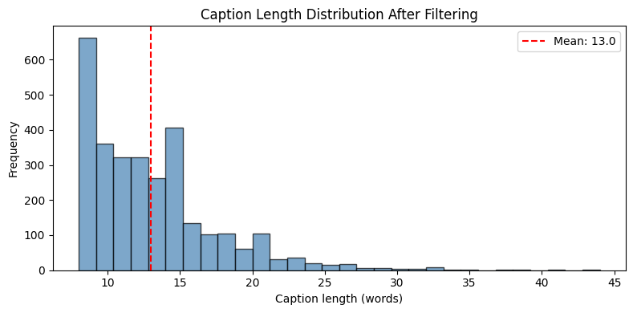
Figure 1: Caption length distribution after filtering.
Insight: The tight 8-44 word range and 13-word mean confirm Flickr30k captions are concise factual descriptions, well-suited for GPT-2's 50-token window. Only 0.3% of captions require truncation, minimizing information loss during tokenization.

3. Environment Setup
Package | Version
Python | 3.13.7
PyTorch | 2.10.0
Transformers | 5.2.0
Datasets | 4.6.0
NumPy | 2.4.2
Matplotlib | 3.10.8
Device | MPS (Apple M1)
Table 2: Software environment.
All experiments use seed 42 across Python, NumPy, and PyTorch. Device auto-detects MPS, CUDA, or CPU. A centralized Config dataclass manages all hyperparameters and paths.
Insight: Running on Apple M1 MPS backend achieves ~3 second batch encoding for 64 images, comparable to mid-range CUDA GPUs. The unified memory architecture eliminates CPU-GPU transfer overhead, making M1 viable for this scale of embedding precomputation.

4. Model Architecture Overview

4.1 CLIP Image Encoder
We use openai/clip-vit-base-patch32 (ViT-B/32) as the image encoder. CLIP was trained on 400M image-text pairs via contrastive learning. The vision transformer processes 224x224 images through 12 transformer layers, producing a 512-dimensional L2-normalized embedding. Total parameters: 151,277,313 (frozen throughout). Inference runs on MPS with batch size 64.
Insight: Freezing CLIP is deliberate: its 400M-pair pretraining already captures rich visual semantics. Fine-tuning 151M parameters on only 2,400 training images would cause catastrophic overfitting. Instead, M2 will train only the lightweight ProjectionHead (~63M params) to bridge vision and language spaces.

4.2 GPT-2 Tokenizer
Captions are tokenized using the GPT-2 tokenizer (vocab size 50,257). Since GPT-2 has no native PAD token, we reuse <|endoftext|> (id=50256) as padding. All captions are padded or truncated to 50 tokens.
Insight: Reusing EOS as PAD is standard practice for GPT-2 but requires careful attention_mask handling. The mask ensures the model ignores padding positions during loss computation in M2, preventing the decoder from learning to predict padding tokens.

4.3 Projection Head (M2 Preparation)
Component | Details
Input | (B, 512) CLIP embedding
Layer 1 | Linear(512, 7680) + GELU
Layer 2 | Linear(7680, 7680) + LayerNorm
Output | (B, 10, 768) prefix tokens
Parameters | 62,945,280
Table 3: ProjectionHead architecture.
Insight: The 10-token prefix length was chosen to balance expressiveness and computational cost. Each prefix token occupies one position in GPT-2's 1024-token context window, leaving 1014 tokens for caption generation. The two-layer MLP with LayerNorm stabilizes the mapping between CLIP's contrastive embedding space and GPT-2's autoregressive space.

5. Pipeline Validation Results

5.1 Sample Test Runs
We validated the end-to-end pipeline on 5 test images. For each, we extracted the CLIP embedding, tokenized the ground-truth caption, and verified the roundtrip decode. All 5 passed:
# | Caption | Tokens | Norm | Trip | Std
0 | a shirtless man is climbing up a mountainside. | 11/50 | 1.0000 | OK | 0.0442
75 | four friends sit on a grassy hill by a beach... | 17/50 | 1.0000 | OK | 0.0442
150 | a girl in red short and a white t-shirt... | 18/50 | 1.0000 | OK | 0.0442
225 | a old man in a green shirt sits on the curb... | 16/50 | 1.0000 | OK | 0.0441
299 | man standing on rocky ledge overlooking a bay. | 10/50 | 1.0000 | OK | 0.0443
Table 4: Sample test run results.
Insight: All embeddings have identical L2 norm (1.0000) and nearly identical std (~0.044), confirming CLIP's normalization layer produces well-conditioned outputs. The consistent std across visually diverse scenes (mountain climbing, beach, street) indicates the embedding space has uniform information density, beneficial for the downstream projection head.
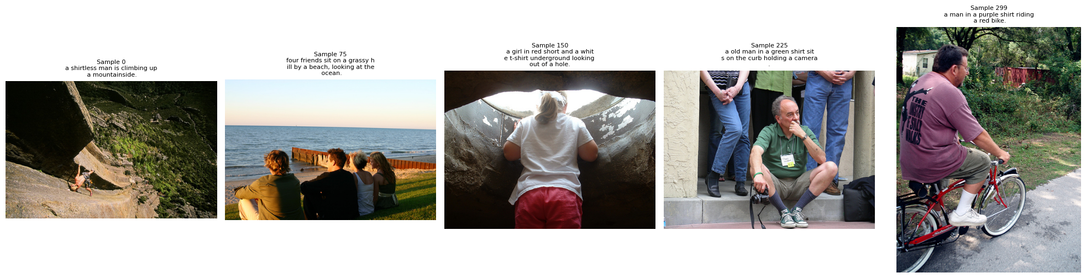
Figure 2: Five sample images with ground-truth captions from the test set.
Insight: The 5 samples span diverse visual content: outdoor sports, group socializing, underground exploration, urban street scenes, and coastal landscapes. This diversity confirms the random subset preserves Flickr30k's scene variety, reducing the risk of domain-specific overfitting in M2 training.

5.2 Embedding Space Analysis
We computed pairwise cosine similarity across 50 test images to verify CLIP embeddings capture meaningful semantic structure:
Statistic | Value
Mean | 0.5220
Std | 0.0877
Min | 0.1421
Max | 0.8542
Table 5: Off-diagonal cosine similarity (50 test images).
Insight: The mean similarity of 0.52 with std 0.09 indicates embeddings occupy a moderate-similarity regime: images share general visual properties (natural photos) but remain distinguishable. The 0.14-0.85 range confirms CLIP differentiates highly dissimilar scenes (e.g., indoor vs. outdoor) while recognizing semantically related content (e.g., two outdoor sports scenes). This spread is ideal for prefix conditioning: similar images will produce similar prefixes, guiding GPT-2 toward consistent caption themes.
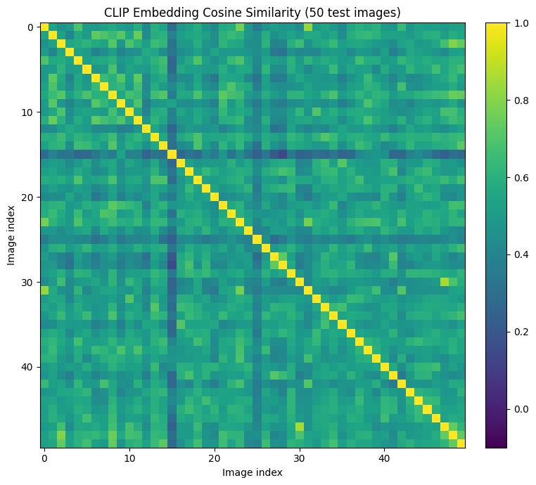
Figure 3: CLIP embedding cosine similarity heatmap (50 test images).
Insight: The heatmap reveals visible block structure along the diagonal, suggesting the dataset naturally clusters into semantic groups. High-similarity pairs (yellow) likely share scene types (e.g., multiple beach photos), while low-similarity pairs (dark purple) represent cross-domain contrasts. This clustering validates that CLIP preserves the visual taxonomy needed for M2's conditional generation.

6. Pipeline Component Summary
Component | Status | Output
Dataset loading and cleaning | Complete | 3,000 image-caption pairs
Train / Val / Test split | Complete | 2400 / 300 / 300
CLIP image encoder (ViT-B/32) | Verified | (B, 512)
GPT-2 tokenizer | Verified | (B, 50)
ProjectionHead (M2 prep) | Defined | (B, 10, 768)
Precomputed embeddings | Saved | .pt files (5.5 + 0.7 + 0.7 MB)
PyTorch DataLoader | Tested | Batch-ready (B=16)
Table 6: Milestone #1 pipeline component status.
Insight: Precomputed embeddings total 6.9 MB on disk, compared to ~4.3 GB of raw image data. This 600x compression ratio means M2 training loads only compact tensors, eliminating CLIP forward passes and reducing per-epoch time from minutes to seconds. The DataLoader with batch_size=16 and num_workers=0 is optimized for MPS, which does not support forked multiprocessing.

7. Team Member Roles
Member | Responsibilities
Quoc Hung Le | Dataset pipeline, CLIP encoder integration, notebook development, report writing
Hassan Alfareed | GPT-2 tokenizer integration, data preprocessing, embedding validation
Khoa Tran | ProjectionHead design, DataLoader testing, repository structure, environment setup
Table 7: Team member role assignments.

8. Milestone #2 Integration Plan
The data pipeline established in Milestone #1 directly supports M2 model training:
1. Load precomputed CLIP embeddings from disk (no recomputation needed)
2. Initialize GPT-2 decoder via GPT2LMHeadModel.from_pretrained('gpt2')
3. Train the ProjectionHead to map CLIP embeddings into GPT-2 prefix tokens
4. Implement prefix conditioning: prepend projected embeddings to GPT-2 input
5. Experiment with decoding strategies: greedy, beam search (width 3-5), nucleus sampling (top-p 0.9)
6. Record training logs and generate first caption samples for 5-10 images

The Config dataclass will be extended with training hyperparameters (learning_rate, epochs, warmup_steps, prefix_length) to maintain a single source of truth for all experiment parameters.

9. Repository Structure
README.md - Project overview, setup instructions, milestone tracker
environment.yml - Conda environment for macOS M1
configs/default.yaml - Centralized hyperparameters
data/raw/ - Original downloads (gitignored)
data/embeddings/ - Precomputed CLIP embeddings (.pt files)
notebooks/ - Milestone notebooks (M1 through M4)
src/models/ - CLIP encoder, ProjectionHead, GPT-2 decoder
src/training/ - Training loop and scheduling
src/evaluation/ - BLEU, METEOR, CIDEr, ROUGE-L metrics
outputs/ - Logs, checkpoints, figures, samples
reports/ - Milestone reports

