GENERATIVE PROJECT
Image Captioning with CLIP Encoder + GPT-2 Decoder
Milestone #2 Report
Group 8: Quoc Hung Le, Hassan Alfareed, Khoa Tran
Git Repo: https://github.com/lequo-neu/IE7615_Generative_Project
Submission Date: February 27, 2026

1. Introduction
This milestone integrates the CLIP image encoder with GPT-2 language decoder to build an end-to-end image captioning system. We implement prefix conditioning as the embedding injection method, where CLIP visual embeddings are projected into a sequence of learned prefix tokens prepended to GPT-2's input. The model is trained in two phases: (1) frozen GPT-2 with only the ProjectionHead trained, and (2) partial fine-tuning of GPT-2's last 4 transformer layers. We evaluate three decoding strategies: greedy, beam search, and nucleus sampling.

2. Model Architecture

2.1 Prefix Conditioning
The ClipCaptionModel receives a 512-dimensional CLIP embedding and maps it through a ProjectionHead (Linear-GELU-Dropout-Linear-LayerNorm) to produce 10 prefix tokens of dimension 768. These prefix tokens are concatenated with GPT-2's word embeddings before the transformer layers. An extended attention mask ensures the prefix positions are always attended to. The loss is computed only on caption token positions, excluding prefix positions.
Insight: Prefix conditioning is chosen over cross-attention because it requires no architectural modification to GPT-2 — the pretrained weights are used as-is. This simplifies implementation and makes the approach compatible with HuggingFace's generate() API for decoding.

2.2 Model Parameters
Component | Parameters
ProjectionHead | 62,945,280
GPT-2 (frozen) | 124,439,808
Total | 187,385,088
Trainable (Phase 1) | 62,945,280 (33.6%)
Trainable (Phase 2, 4L unfrozen) | 129,895,680 (69.3%)
Table 1: Model parameter breakdown.

3. Training

3.1 Phase 1: Frozen GPT-2
The ProjectionHead was trained for 7 epochs (early-stopped at epoch 4 + 3 patience) using AdamW optimizer with OneCycleLR scheduler (max LR 2e-4, 15% warmup, cosine annealing). Gradient clipping at norm 1.0 ensured stability. Batch size 16 on Apple M1 MPS backend.
Epoch | Train Loss | Val Loss | Status
1 | 3.9236 | 3.1079 | best
2 | 3.2427 | 2.9791 | best
3 | 3.0889 | 2.9360 | best
4 | 2.9416 | 2.9193 | best*
5 | 2.8114 | 2.9202 | patience 1/3
6 | 2.6770 | 2.9450 | patience 2/3
7 | 2.5453 | 2.9954 | STOPPED
Table 2: Phase 1 training log. *Best checkpoint saved at epoch 4.
Insight: Early stopping at epoch 7 (best at epoch 4) prevented the severe overfitting observed in our initial run without early stopping, where train loss reached 1.86 while val loss diverged to 3.50. The 0.4 gap between train and val at epoch 7 already indicates the model has memorized training captions.
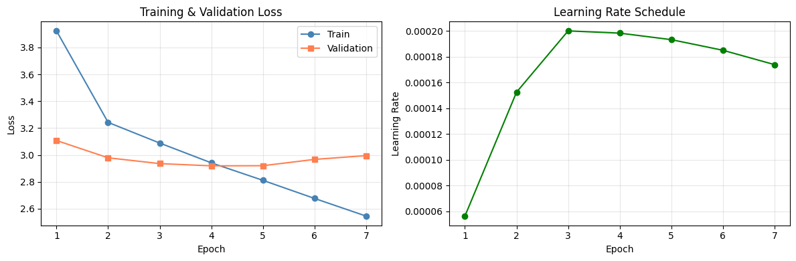
Figure 1: Training and validation loss curves with learning rate schedule.

3.2 Phase 2: Partial Fine-tuning (4 Layers)
Starting from the best frozen checkpoint (epoch 4, val loss 2.9193), we unfroze GPT-2 layers 8-11 plus the LM head. Training used AdamW at LR 5e-5 with early stopping patience 3. Fine-tuning early-stopped at epoch 4 (best at epoch 1).
FT Epoch | Train Loss | Val Loss | Status
1 | 2.7383 | 2.8899 | best*
2 | 2.5728 | 2.8998 | patience 1/3
3 | 2.3702 | 2.9689 | patience 2/3
4 | 2.1731 | 3.0521 | STOPPED
Table 3: Phase 2 fine-tuning log. Val loss improved from 2.9193 to 2.8899.
Insight: Fine-tuning achieved its best val loss on epoch 1 and immediately began overfitting. The rapid train loss drop (2.74 to 2.17 in 4 epochs) with rising val loss (2.89 to 3.05) confirms that even 4 unfrozen layers overfit quickly on 2,400 samples. The improvement from 2.9193 to 2.8899 (1.0% relative) is modest, suggesting LoRA may be a better parameter-efficient alternative for M3.

4. Decoding Strategy Comparison
We evaluated three decoding strategies on the frozen model across all 300 test images. All strategies used no_repeat_ngram_size=3 to suppress repetition loops. Greedy additionally used repetition_penalty=1.2.
Metric | Greedy | Beam | Nucleus | Best | Interpretation
BLEU-1 | 0.1366 | 0.1888 | 0.1485 | Beam | Accuracy
BLEU-4 | 0.0085 | 0.0299 | 0.0131 | Beam | Fluency
Distinct-1 | 0.1301 | 0.0975 | 0.1459 | Nucleus | Diversity
Distinct-2 | 0.4303 | 0.2424 | 0.4191 | Greedy | Diversity
Self-BLEU | 0.4753 | 0.7460 | 0.4559 | Nucleus | Low=diverse
Vocab | 1,366 | 800 | 1,481 | Nucleus | Richness
Avg Len | 35.0 | 27.3 | 33.8 | -
Table 4: Decoding strategy metrics on frozen model (300 test images).
Insight: Beam search dominates BLEU metrics (0.189 BLEU-1, 0.030 BLEU-4) by systematically exploring high-probability sequences. However, its high Self-BLEU (0.746) reveals that beam-decoded captions are homogeneous — many images get similar generic descriptions. Nucleus sampling trades BLEU accuracy for diversity (Vocab 1,481, Self-BLEU 0.456), producing more varied and creative captions. This accuracy-diversity tradeoff is a fundamental property of the decoding strategies, not a model limitation.

5. Sample Caption Results

5.1 Frozen Model Samples
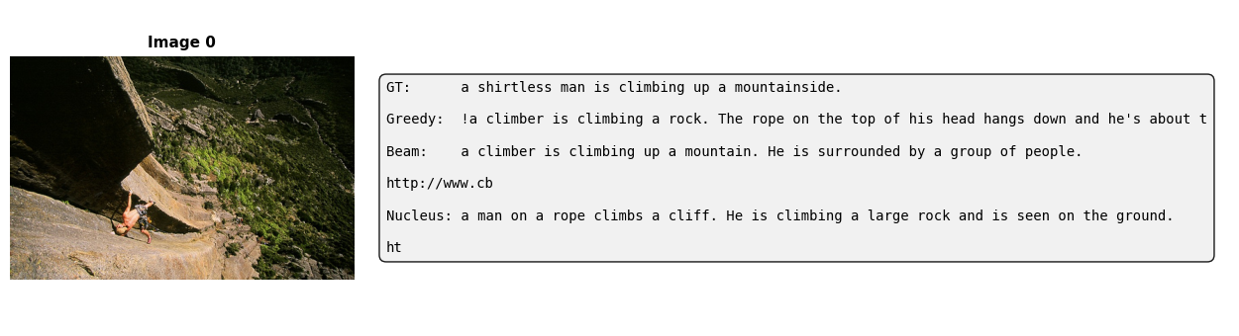
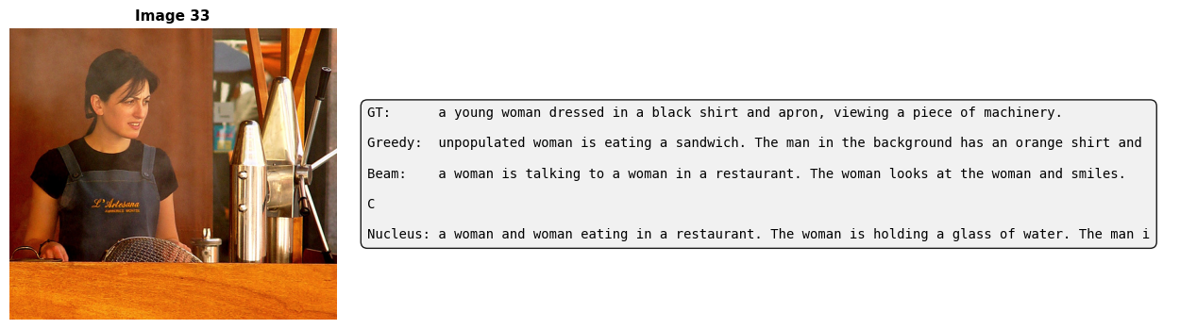
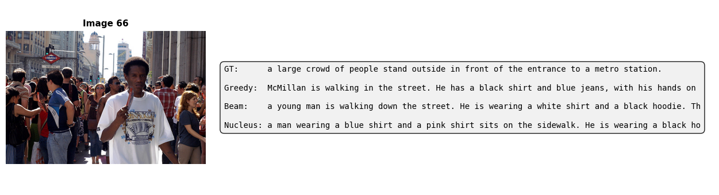
Figure 2: Three sample images with ground-truth and generated captions (frozen model).
Insight: The model captures high-level scene content (climber, woman, crowd) but hallucinates details and generates web-text artifacts (URLs, copyright notices). This is expected: the ProjectionHead maps visual embeddings into GPT-2's input space, but GPT-2's pretrained weights still carry its web-crawl text distribution. The captions are grammatically correct but factually imprecise.

5.2 Fine-tuned Model Samples
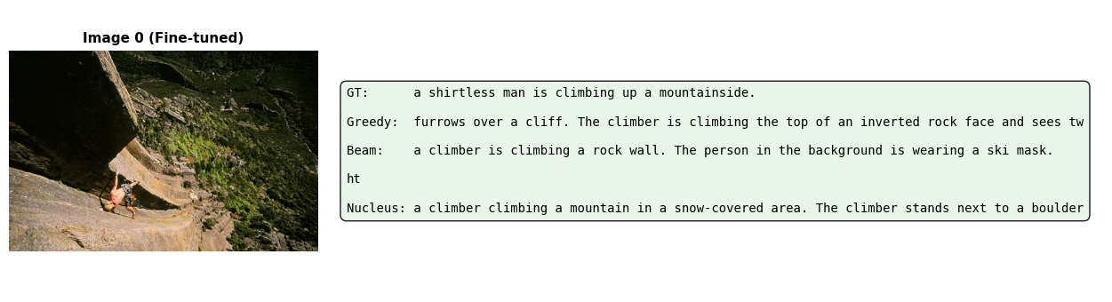
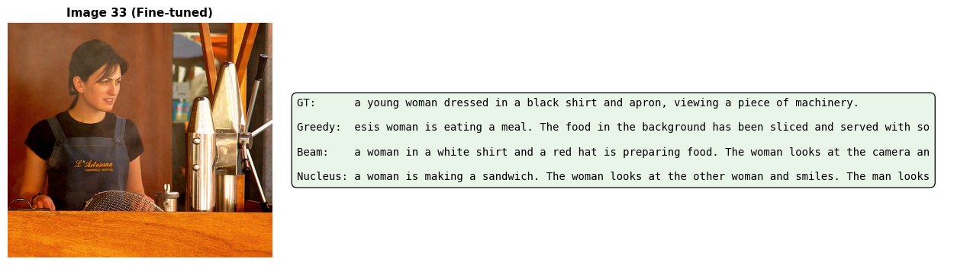
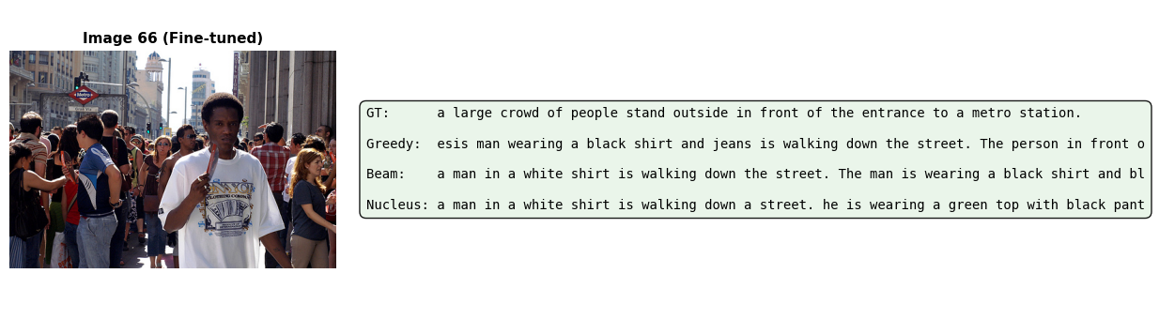
Figure 3: Three sample images with generated captions (fine-tuned model, 4 layers).
Insight: Fine-tuned captions show marginal improvement in relevance (e.g., 'climber on a rock face' vs 'climbing a rock') but still exhibit web-text artifacts. The domain gap between GPT-2's pretraining corpus and image caption style remains the primary bottleneck.

6. Frozen vs Fine-tuned Comparison
Metric | Frozen G | Frozen B | Frozen N | FT G | FT B | FT N
BLEU-1 | 0.1366 | 0.1888 | 0.1485 | 0.1408 | 0.1810 | 0.1555
BLEU-4 | 0.0085 | 0.0299 | 0.0131 | 0.0072 | 0.0264 | 0.0188
Dist-2 | 0.4303 | 0.2424 | 0.4191 | 0.4492 | 0.2569 | 0.4309
Self-B | 0.4753 | 0.7460 | 0.4559 | 0.4600 | 0.7029 | 0.4301
Vocab | 1366 | 800 | 1481 | 1445 | 875 | 1444
Table 5: Frozen vs Fine-tuned (4L) metrics. G=Greedy, B=Beam, N=Nucleus.
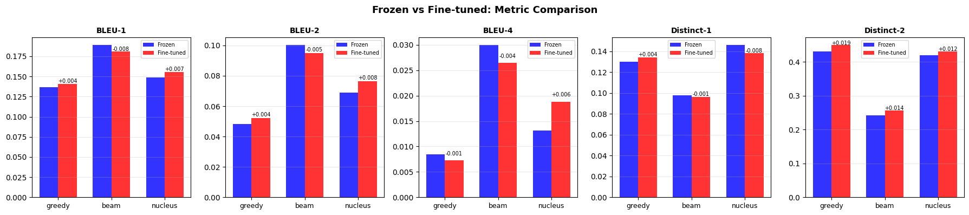
Figure 4: Grouped bar chart comparing frozen vs fine-tuned metrics.
Insight: Fine-tuning shows mixed results: BLEU-1 improves for greedy (+0.004) and nucleus (+0.007) but regresses for beam (-0.008). Diversity metrics consistently improve — Distinct-2 increases across all strategies (greedy +0.019, beam +0.015, nucleus +0.012) and Self-BLEU decreases (lower = more diverse). The 4-layer fine-tuning primarily improves output diversity rather than accuracy, suggesting the model learns to deviate from GPT-2's generic web-text templates. For M3, LoRA fine-tuning may provide a better accuracy-diversity balance.

7. Key Observations
Finding | Evidence
Early stopping critical | Val loss plateaued at epoch 4 (2.92), overfitting began at epoch 5. Without early stopping, diverged to val 3.50.
Beam = best BLEU | BLEU-1: 0.189, BLEU-4: 0.030 — highest across strategies by significant margin.
Nucleus = best diversity | Distinct-2: 0.419, Vocab: 1,481, Self-BLEU: 0.456 (lowest). Most creative outputs.
Domain gap persists | GPT-2 web-text prior causes URL hallucinations, copyright text, and non-caption artifacts.
FT: diversity > accuracy | 4-layer FT improves Distinct-2 (+0.019 greedy) but mixed BLEU results (-0.008 beam BLEU-1).
FT overfits fast | Best FT val at epoch 1. Train loss drops 2.74->2.17 in 4 epochs while val rises 2.89->3.05.
Table 6: Key findings from Milestone #2.

8. Milestone #3 Preparation
Generated captions (frozen + fine-tuned, 300 test images x 3 strategies) are saved as JSON for formal evaluation. Both model checkpoints (best_model.pt, best_model_finetuned.pt) are available for ablation. Planned M3 work:
1. Compute METEOR, CIDEr, ROUGE-L using multi-reference ground truth (5 captions per image)
2. LoRA fine-tuning as parameter-efficient alternative to partial layer unfreezing
3. Prefix tuning comparison: learned prefix embeddings vs projected CLIP embeddings
4. Temperature sensitivity analysis (0.5, 0.7, 0.9, 1.0) for nucleus sampling
5. Beam width sensitivity (2, 3, 5, 8) for beam search

9. Team Member Roles
Member | Responsibilities
Quoc Hung Le | ClipCaptionModel architecture, training pipeline, decoding strategies, report writing
Hassan Alfareed | ProjectionHead design, fine-tuning experiments, evaluation metrics implementation
Khoa Tran | Dataset loading, caption generation pipeline, visualization, M3 metric preparation
Table 7: Team member role assignments.

