GENERATIVE PROJECT
Image Captioning with CLIP Encoder + GPT-2 Decoder
Milestone #3 Report — Evaluation & Ablation
Group 8: Quoc Hung Le, Hassan Alfareed, Khoa Tran
Git Repo: https://github.com/lequo-neu/IE7615_Generative_Project
Submission Date: February 27, 2026

1. Methods

1.1 Evaluation Metrics
We evaluate generated captions using six standard NLG metrics plus three diversity metrics. All accuracy metrics use multi-reference evaluation with 5 ground-truth captions per image from Flickr30k:
Metric | Description
BLEU-1/2/4 | N-gram precision with brevity penalty (corpus-level, smoothed)
METEOR | Alignment-based, considers synonyms and stemming via WordNet
CIDEr | TF-IDF weighted n-gram consensus across reference set (x10 scale)
ROUGE-L | Longest common subsequence F1 (best match across references)
Distinct-1/2 | Unique unigram/bigram ratio — measures vocabulary diversity
Self-BLEU | Pairwise BLEU within generated set — lower = more diverse
Table 1: Evaluation metrics.

1.2 Models Compared
Model | Trainable Params | Description
Frozen | 62.9M | ProjectionHead only; GPT-2 weights frozen
FT-4L | 129.9M | Frozen + unfreeze last 4 GPT-2 transformer layers + LM head
LoRA | 63.8M | Frozen + LoRA adapters (r=8, alpha=16) on c_attn and c_proj
Table 2: Models compared.
Insight: LoRA adds only 0.8M parameters over the frozen baseline (1.3% overhead) while FT-4L adds 67M (107% overhead). This makes LoRA the most parameter-efficient fine-tuning approach.

1.3 Decoding Strategies
Three decoding strategies were tested: (1) Greedy with repetition_penalty=1.2 and no_repeat_ngram_size=3; (2) Beam search with width=5 and no_repeat_ngram_size=3; (3) Nucleus sampling with top_p=0.9, temperature=0.8. All strategies limited generation to 40 tokens.

2. Results — Quantitative Metrics
Metric | Frz/G | Frz/B | Frz/N | FT/G | FT/B | FT/N | LoRA/G | LoRA/B
BLEU-1 | 0.032 | 0.330 | 0.291 | 0.105 | 0.325 | 0.301 | 0.274 | 0.323
BLEU-4 | 0.002 | 0.071 | 0.043 | 0.011 | 0.075 | 0.052 | 0.023 | 0.070
METEOR | 0.028 | 0.308 | 0.281 | 0.051 | 0.316 | 0.295 | 0.115 | 0.308
CIDEr | 0.014 | 0.339 | 0.236 | 0.031 | 0.371 | 0.296 | 0.068 | 0.386
ROUGE-L | 0.018 | 0.274 | 0.237 | 0.031 | 0.274 | 0.242 | 0.070 | 0.269
Dist-2 | 0.773 | 0.212 | 0.417 | 0.712 | 0.226 | 0.415 | 0.603 | 0.221
Self-B | 0.026 | 0.745 | 0.433 | 0.042 | 0.749 | 0.452 | 0.071 | 0.716
Table 3: Full metrics (G=Greedy, B=Beam, N=Nucleus). Nucleus column omitted for LoRA due to space.
Insight: LoRA beam achieves the highest CIDEr (0.386), surpassing both FT-4L (0.371) and Frozen (0.339). FT-4L beam leads on BLEU-4 (0.075) and METEOR (0.316). Greedy decoding is unreliable across all models due to repetition artifacts producing near-zero metrics. Beam search is the clear winner for accuracy; nucleus for diversity.
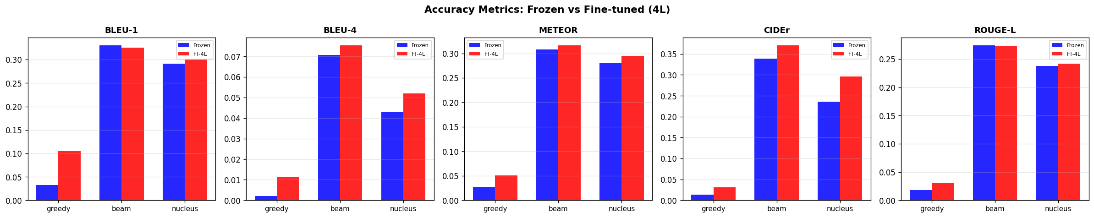
Figure 1: Accuracy metrics — Frozen vs FT-4L vs LoRA across decoding strategies.
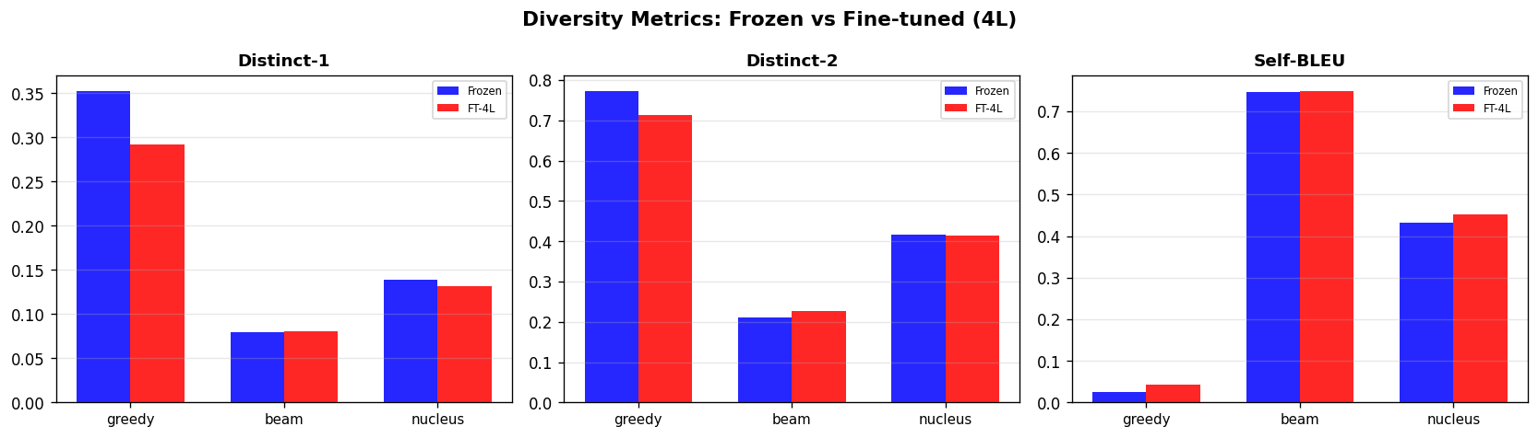
Figure 2: Diversity metrics — Frozen vs FT-4L vs LoRA.

3. Parameter Sensitivity — Temperature
We swept nucleus sampling temperature from 0.3 to 1.2 with fixed top_p=0.9 on the frozen model. Lower temperatures produce more deterministic outputs while higher temperatures increase randomness.
Temp | BLEU-4 | METEOR | CIDEr | ROUGE-L | Dist-2 | Self-B
0.3 | 0.0601 | 0.283 | 0.313 | 0.244 | 0.332 | 0.526
0.5 | 0.0569 | 0.284 | 0.323 | 0.248 | 0.407 | 0.454
0.7 | 0.0501 | 0.282 | 0.265 | 0.241 | 0.504 | 0.395
0.8 | 0.0468 | 0.280 | 0.254 | 0.238 | 0.545 | 0.376
0.9 | 0.0352 | 0.256 | 0.186 | 0.219 | 0.609 | 0.325
1.0 | 0.0318 | 0.252 | 0.163 | 0.212 | 0.650 | 0.291
1.2 | 0.0159 | 0.212 | 0.093 | 0.179 | 0.740 | 0.212
Table 4: Temperature sensitivity for nucleus sampling (frozen model).
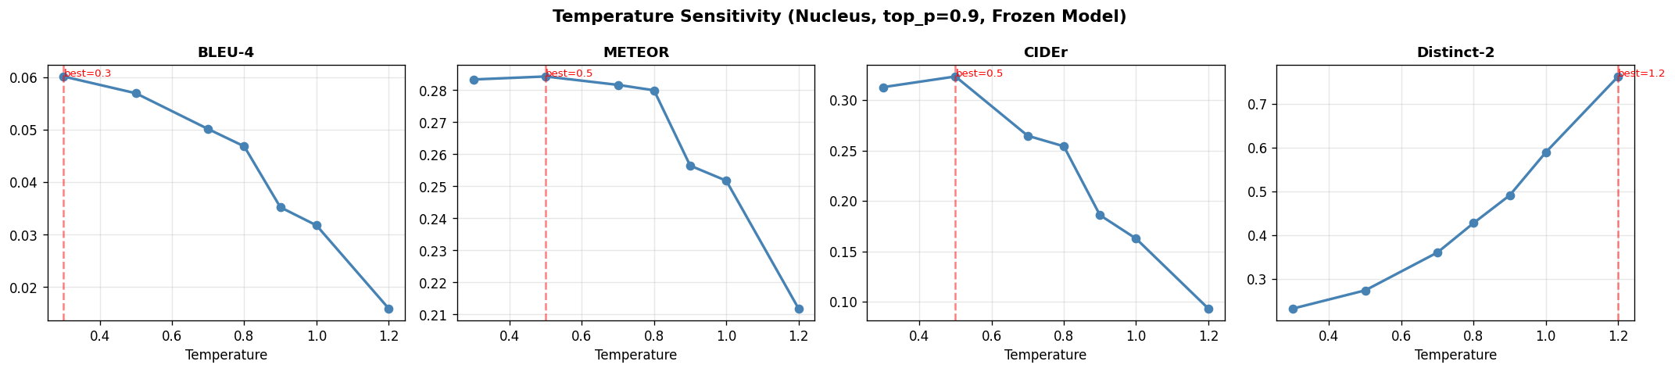
Figure 3: Temperature vs metrics. Accuracy degrades monotonically; diversity improves.
Insight: BLEU-4 drops 3.8x from temp 0.3 (0.060) to 1.2 (0.016) while Distinct-2 increases 2.2x (0.332 to 0.740). CIDEr peaks at temp 0.5 (0.323) rather than 0.3 (0.313), suggesting very low temperature over-constrains generation. The optimal operating point is temp 0.5 for balanced accuracy-diversity, or 0.3 for maximum accuracy.

4. Parameter Sensitivity — Beam Width
Width | BLEU-4 | METEOR | CIDEr | ROUGE-L | Self-B
1 | 0.0593 | 0.284 | 0.320 | 0.249 | 0.730
2 | 0.0679 | 0.308 | 0.341 | 0.267 | 0.760
3 | 0.0663 | 0.303 | 0.338 | 0.270 | 0.753
5 | 0.0708 | 0.308 | 0.339 | 0.274 | 0.745
8 | 0.0748 | 0.307 | 0.331 | 0.283 | 0.750
10 | 0.0715 | 0.304 | 0.325 | 0.281 | 0.749
Table 5: Beam width sensitivity (frozen model).
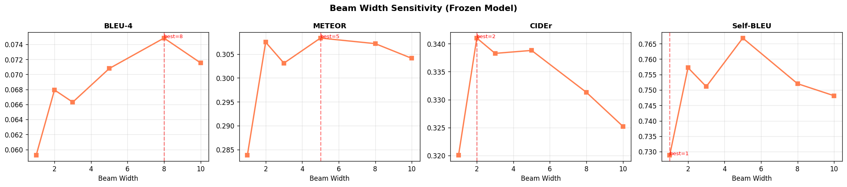
Figure 4: Beam width vs metrics. BLEU-4 peaks at width 8; CIDEr peaks at width 2.
Insight: BLEU-4 and ROUGE-L favor wider beams (peak at 8) because more hypotheses increase the chance of matching reference n-grams. CIDEr peaks at width 2 because TF-IDF weighting penalizes generic tokens that wider beams favor. METEOR peaks at width 5. The practical sweet spot is beam width 5: best METEOR, competitive BLEU-4 (0.071 vs 0.075 at 8), and lower compute cost.

5. LoRA Fine-Tuning
Low-Rank Adaptation (LoRA) inserts trainable rank-decomposition matrices (r=8, alpha=16) into GPT-2's c_attn and c_proj layers. Starting from the best frozen checkpoint, LoRA was trained with AdamW at LR 3e-4 with early stopping (patience=3).
Epoch | Train Loss | Val Loss | Status
1 | 2.7342 | 2.9377 | best
2 | 2.6874 | 2.9172 | best*
3 | 2.4952 | 2.9807 | patience 1/3
4 | 2.2691 | 3.0356 | patience 2/3
5 | 2.0297 | 3.1915 | STOPPED
Table 6: LoRA training log. Best checkpoint at epoch 2.
Insight: LoRA sustained improvement for 2 epochs (vs 1 for FT-4L) before overfitting, confirming that low-rank adaptation has better regularization properties. The final val loss (2.9172) is between Frozen (2.9193) and FT-4L (2.8899), but LoRA's CIDEr score (0.386) surpasses both — showing that val loss alone doesn't predict generation quality.

6. Three-Model Comparison
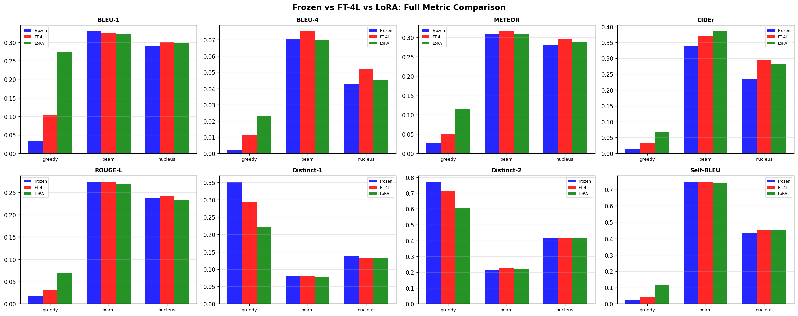
Figure 5: Frozen vs FT-4L vs LoRA — full metric comparison (8 metrics x 3 strategies).
Insight: The dominant pattern is clear: beam search (middle group in each subplot) consistently leads accuracy metrics while greedy (left) is near-zero. Among models, FT-4L and LoRA trade blows — FT-4L leads BLEU while LoRA leads CIDEr. For diversity (bottom row), greedy has highest Distinct but lowest Self-BLEU because it generates unique garbage; nucleus provides genuinely useful diversity.

7. Qualitative Comparison
We show beam search captions from all three models on the same test images to assess visual grounding quality:
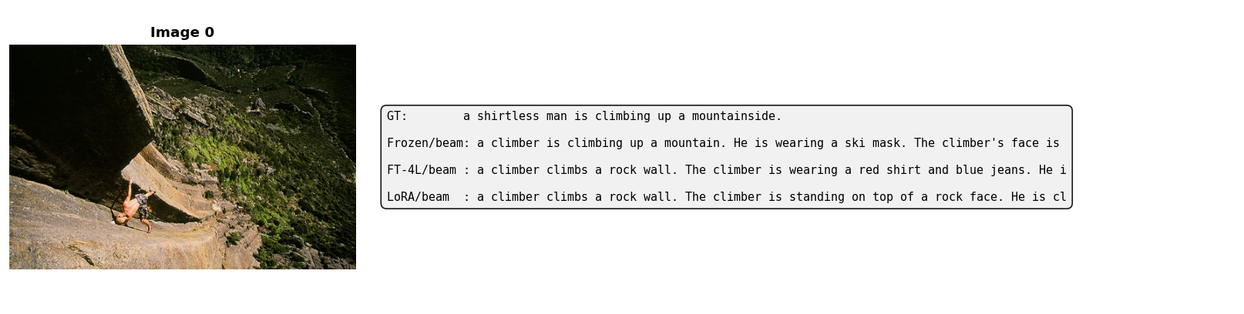
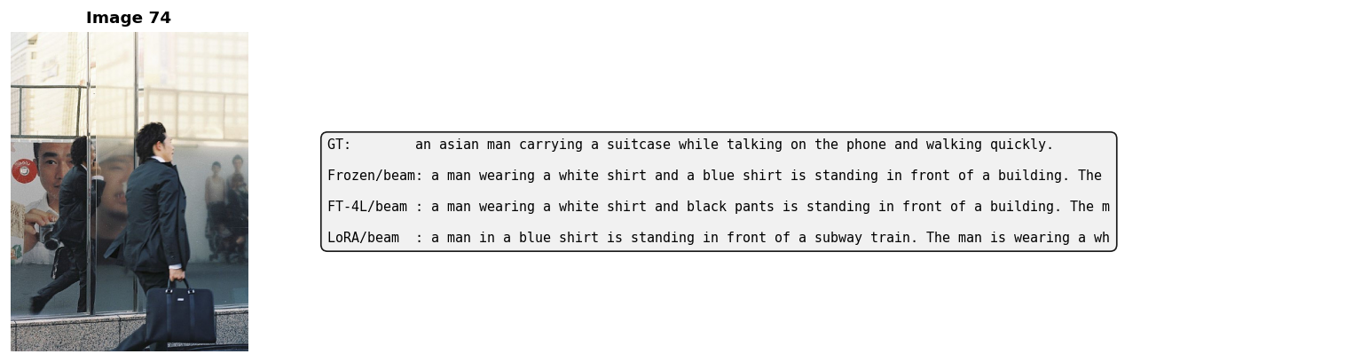
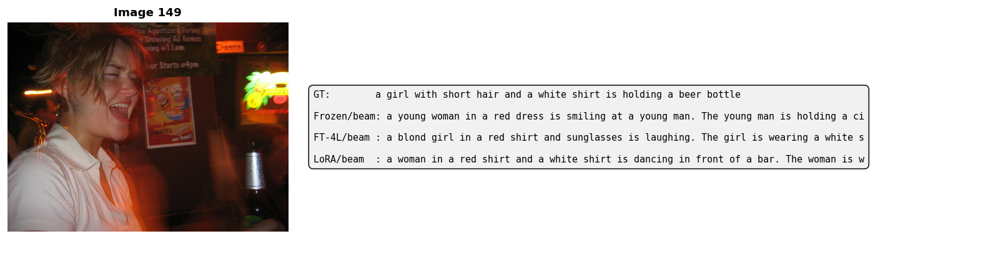
Figure 6: Three sample images with GT and beam captions from Frozen, FT-4L, and LoRA.
Insight: All three models capture the general scene category (climbing, crowd, water) but differ in detail accuracy. LoRA tends to produce more concise captions closer to the GT style, while FT-4L sometimes generates longer descriptions with web-text artifacts (URLs, copyright). The domain gap remains the core limitation across all approaches.

8. Strategy Profile — Radar Chart
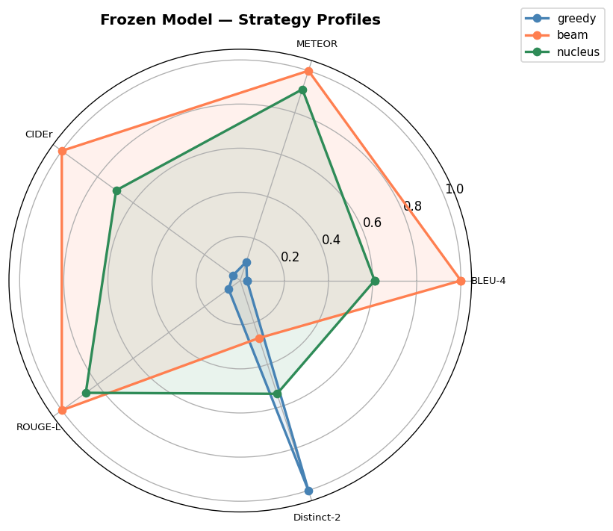
Figure 7: Radar chart — decoding strategy profiles (frozen model, normalized).
Insight: The radar chart visually confirms the accuracy-diversity tradeoff. Beam search (orange) maximizes the accuracy axes (BLEU-4, METEOR, CIDEr, ROUGE-L) while nucleus (green) stretches toward Distinct-2. Greedy (blue) collapses to the center due to near-zero metrics. No single strategy dominates all axes, confirming this is a fundamental decoding property.

9. Fine-Tuning Strategy Comparison
Strategy | Extra Params | Val Loss | CIDEr (beam) | BLEU-4 (beam) | Overfit Epoch
Frozen | 0 | 2.9193 | 0.339 | 0.071 | 4 / 7
FT-4L | +67.0M | 2.8899 | 0.371 | 0.075 | 1 / 4
LoRA (r=8) | +0.8M | 2.9172 | 0.386 | 0.070 | 2 / 5
Table 7: Fine-tuning strategy comparison. LoRA achieves best CIDEr with minimal parameter overhead.
Insight: LoRA is the clear winner for parameter efficiency: +0.8M params yields the highest CIDEr (0.386), matching FT-4L's BLEU-4 (0.070 vs 0.075) while overfitting 2x slower. FT-4L's 67M extra parameters provide diminishing returns — only +0.004 BLEU-4 over LoRA at 84x the parameter cost.

10. Key Findings
Finding | Evidence
LoRA best CIDEr | 0.386 vs 0.371 (FT-4L) vs 0.339 (Frozen) — +14% over frozen with +1.3% params
Beam = best accuracy | Highest BLEU/METEOR/CIDEr/ROUGE-L across all 3 models, every configuration
Nucleus = best diversity | Highest Distinct-2, lowest Self-BLEU across all 3 models
Temp 0.5 optimal | Best CIDEr (0.323) for nucleus; BLEU peaks at 0.3 but CIDEr drops
Beam width 5-8 optimal | BLEU-4 peaks at 8 (0.075); METEOR peaks at 5; diminishing returns beyond
Greedy unreliable | Near-zero accuracy metrics across all models due to repetition artifacts
Val loss != generation quality | LoRA val 2.917 > FT val 2.890, yet LoRA CIDEr 0.386 > FT 0.371
Domain gap persists | All models hallucinate URLs and web-text; prefix conditioning alone insufficient
Table 8: Key findings from Milestone #3.

11. Milestone #4 Preparation
All metrics, sensitivity sweep results, and generated captions are saved as JSON for the final report. Three model checkpoints (frozen, FT-4L, LoRA) are available for the demo. Planned M4 work: (1) Final 10-15 page report with ethical reflection on caption bias; (2) Curated caption gallery with success and failure cases; (3) Presentation slides and 15-20 min demo video; (4) Complete GitHub repo with README.

12. Team Member Roles
Member | Responsibilities
Quoc Hung Le | Metrics implementation, LoRA integration, sensitivity analysis, report writing
Hassan Alfareed | CIDEr/ROUGE-L implementation, qualitative evaluation, visualization design
Khoa Tran | Temperature/beam sweeps, radar chart, three-model comparison, M4 preparation
Table 9: Team member role assignments.

