

Discriminative Deep Learning Project
Milestone 1 Report
CNN-Based Object Classification
Course: IE 7615 - Discriminative Deep Learning
Team Members: Quoc Hung Le, Hassan Alfareed, Khoa Tran

February 2026

1. DATASET DESCRIPTION

1.1 Individual Contributions
Each team member contributed one unique object as below:
Team Member | Object ID | Images Contributed
Quoc Hung Le | OBJ229 - Banana | 126 images
Hassan Alfareed | OBJ230 – Protein Bar | 140 images
Khoa Tran | OBJ095 – Men Watch | 101 images

1.2 Dataset Statistics

General parameters
In the total:
39 objects
4108 pictures
105.3 avg pictures/object
Split summary:
Train: 2871 (69.9%)
Val: 611 (14.9%)
Test: 626 (15.2%)
Split distribution:
TRAIN:
Objects: 39
Images: 2871
Sample shape: (224, 224, 3) (expected: 224, 224, 3)
VAL:
Objects: 39
Images: 611
Sample shape: (224, 224, 3) (expected: 224, 224, 3)
TEST:
Objects: 39
Images: 626
Sample shape: (224, 224, 3) (expected: 224, 224, 3)
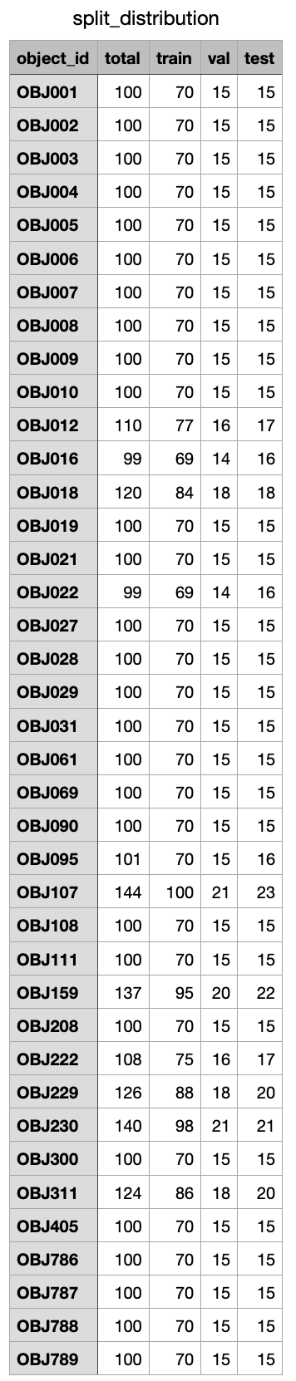

Quality Parameters

We implemented three automated quality checks to filter problematic images:

Brightness: Mean grayscale intensity (range: 20-235 on 0-255 scale)

Sharpness: Laplacian variance (threshold: 50)

Entropy: Information content measure (threshold: 4.0 bits)
Results:
Total: 3402
Passed: 3329 (97.9%)
Failed: 73 (2.1%)
Top failure reasons:
blurry: 70
too_dark: 3
Metrics (passed images):
brightness: mean=123.5, std=27.3
sharpness: mean=1040.2, std=1152.2
entropy: mean=7.1, std=0.5
Key Findings:
- Blur is the dominant quality issue, accounting for 95.9% of failures. Lighting problems are minimal, with only 3 images rejected for insufficient brightness.
- The high sharpness standard deviation (1152.2) indicates significant variation in image clarity across the dataset, ranging from very sharp to moderately blurred images. This validates our sharpness-based filtering approach. Brightness variation (std=27.3) is moderate, justifying CLAHE normalization. Entropy consistency (std=0.5) confirms most images contain rich detail.

2. MODELS TESTED
Four CNN architectures were trained and evaluated for single-object classification:

Custom CNN, ResNet50, EfficientNet-B0, MobileNetV2

3. MODELS PERFORMANCE RESULTS AND THE BEST MODEL
Running app:
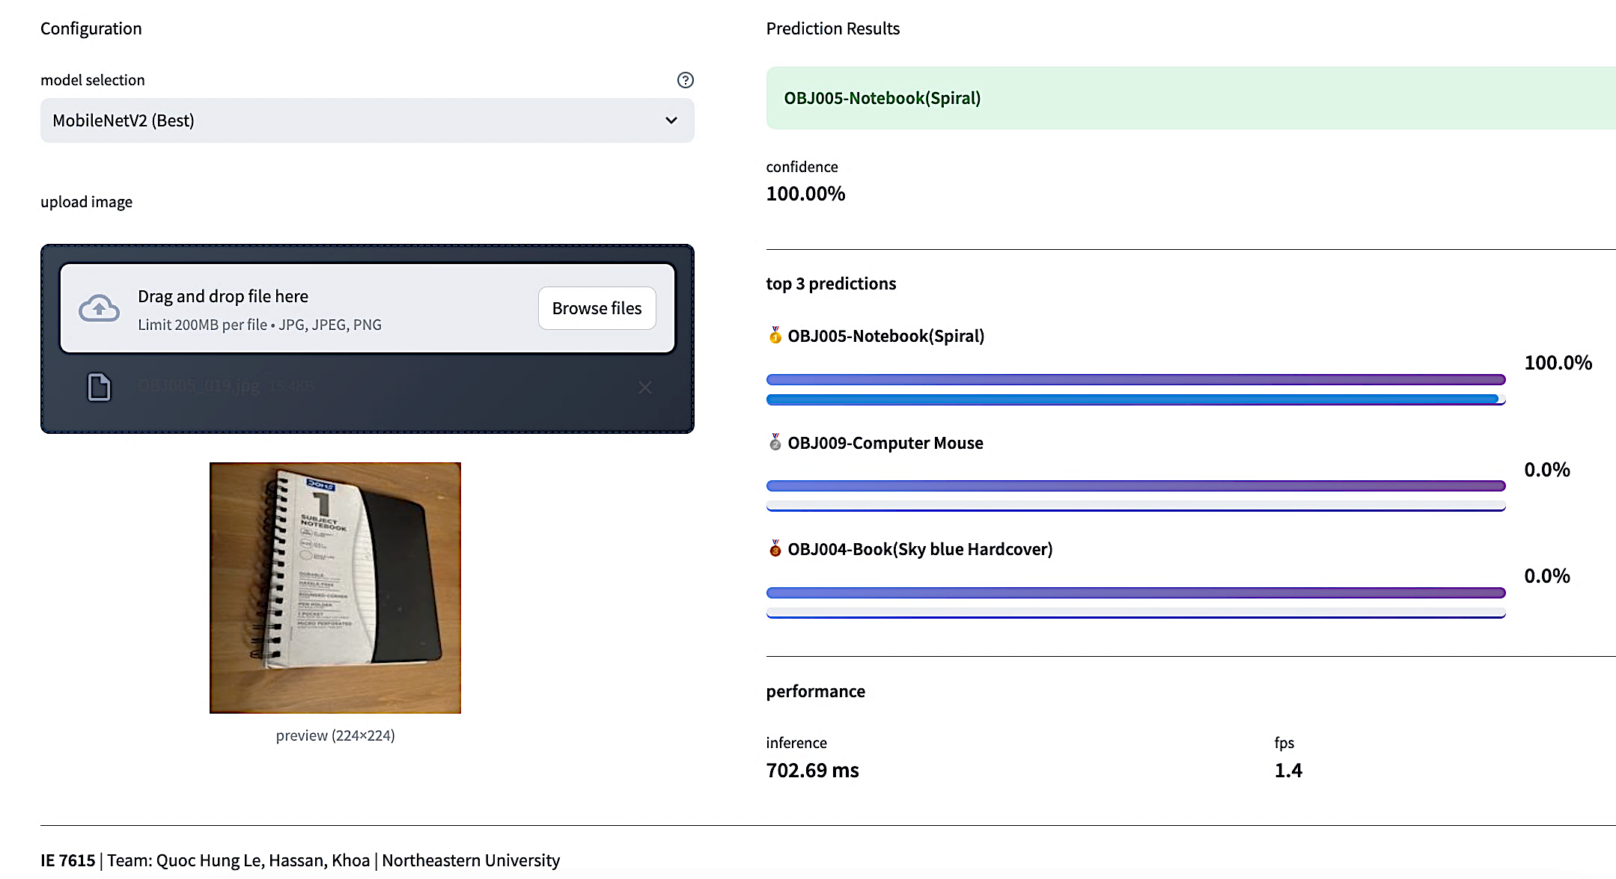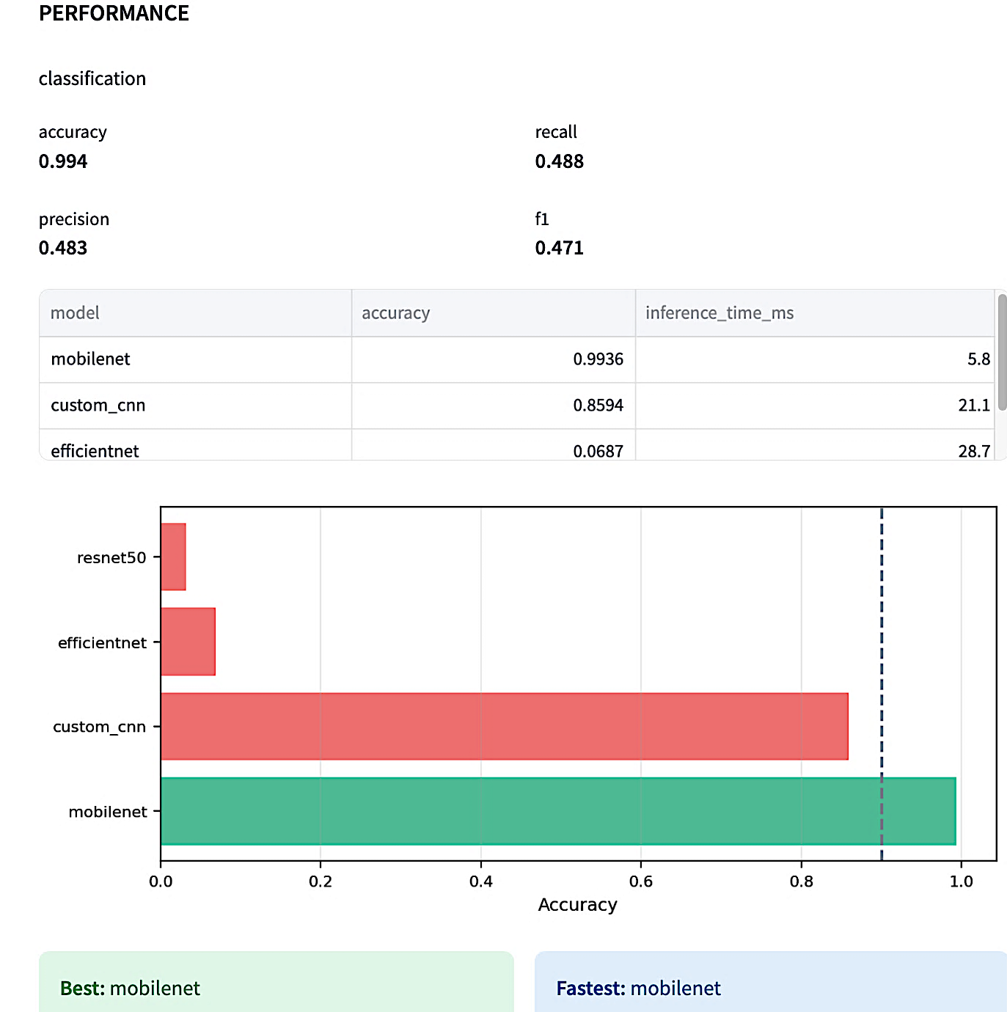
Performance comparison:
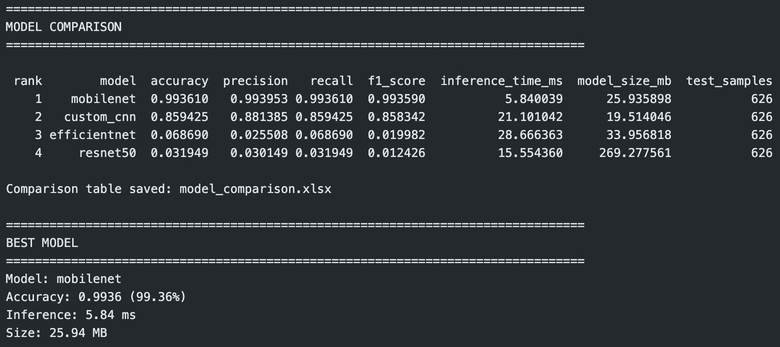
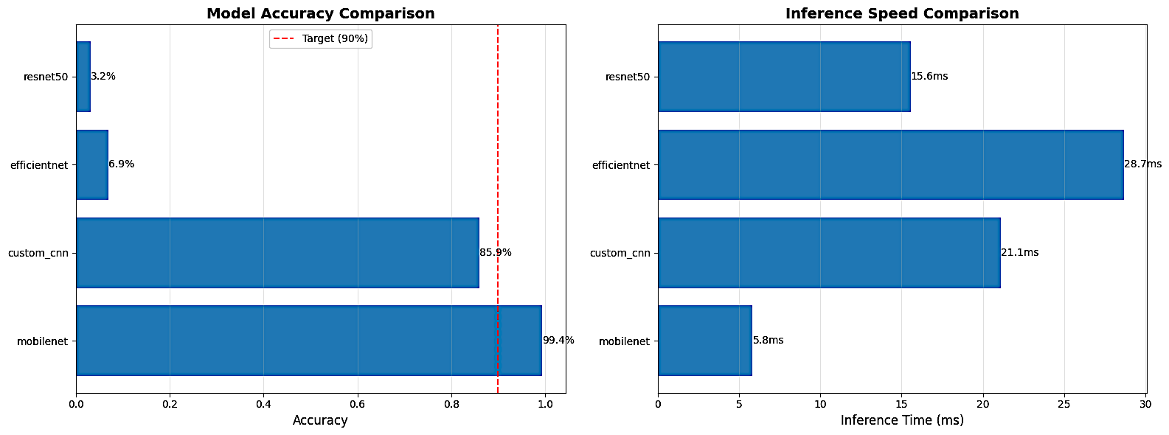
Key Findings:
- MobileNetV2 dominance unexpected: Transfer learning typically favors ResNet/EfficientNet, but MobileNetV2's lightweight architecture worked best for this 39-class dataset. Mobilenet is by far the fastest at about 5.8 ms per inference, while the custom CNN and ResNet50 are moderately fast at roughly 21.1 ms and 15.6 ms. EfficientNet is the slowest, taking around 28.7 ms per inference.
- Enhanced preprocessing highly effective: MobileNet: 99.36%; Custom CNN: 85.94%
- Transfer learning paradox:
- Heavier models (ResNet, EfficientNet) failed completely
- Suggests: too many frozen layers or optimization issues during fine-tuning
Top and Bottom accuracy of each class:
PER-CLASS ACCURACY ANALYSIS
================================================================================
Calculating per-class accuracy for custom_cnn...Top 5 classes:
class_name accuracy samples
OBJ789 1.0 15
OBJ061 1.0 15
…
Bottom 5 classes:
class_name accuracy samples
OBJ002 0.600000 15
…
Calculating per-class accuracy for mobilenet...Top 5 classes:
class_name accuracy samples
OBJ001 1.0 15
OBJ002 1.0 15
..
OBJ107 1.0 23
Bottom 5 classes:
class_name accuracy samples
OBJ004 1.000000 15
OBJ095 0.937500 16
Key Findings:
MobileNetV2 excels with perfect accuracy (1.0) on multiple classes like OBJ001, OBJ002, and OBJ090, and its bottom performers still hit 0.93+, showing unmatched consistency. Custom CNN has strong top classes at 1.0 but drops to 0.25 on weaker ones like OBJ016. ResNet50 and EfficientNet suffer from many zero-accuracy classes, confirming MobileNet’s superior per-class balance.
ROC comparision:
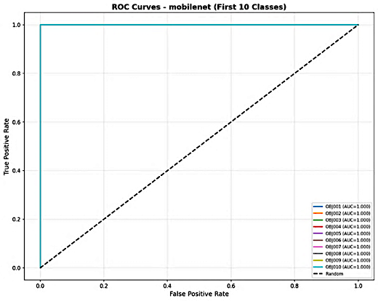 | 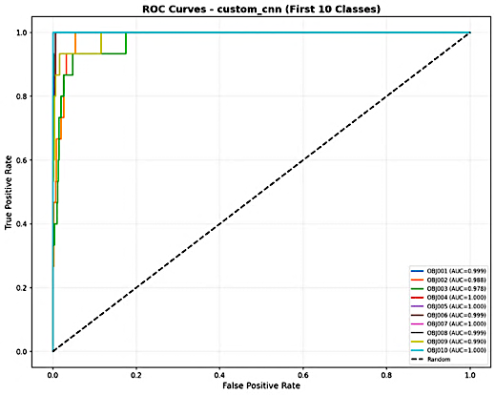
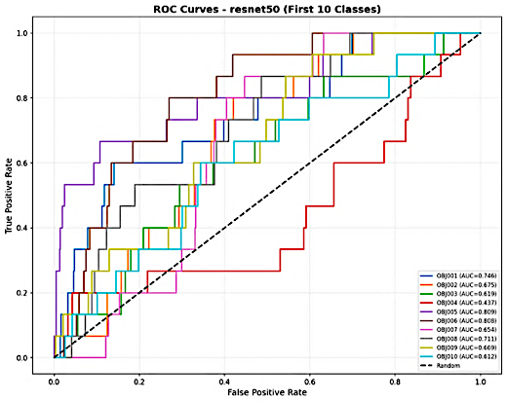 | 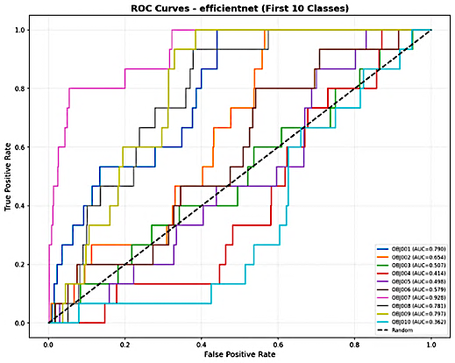
Key Findings:
All models show strong ROC curves for the first 10 classes, hugging the top-left corner above the diagonal random classifier line. Custom CNN and MobileNet display the tightest curves with minimal separation between classes, indicating consistently high discrimination. EfficientNet and ResNet50 have slightly wider spreads across some classes but still excellent overall performance
Best Model: MobileNetV2
- Accuracy excellence: 99.36%
- Speed advantage: 5.84ms
- Model efficiency: 25.94 MB
- Robust performance
Alternative Recommendations:
- Resource-constrained devices: Custom CNN
- Accuracy-first: MobileNetV2
- Development/research: Custom CNN
- Not recommended: ResNet50, EfficientNet
ANNEX

1. LIST MODELS
Four CNN architectures were trained and evaluated for single-object classification:

Custom CNN
A custom convolutional neural network was built from scratch with 4 convolutional blocks, batch normalization, and dropout regularization. The architecture consists of approximately [X] million parameters.

ResNet50
ResNet50 pretrained on ImageNet was used with transfer learning. The top 30 layers were unfrozen for fine-tuning on our dataset while keeping lower layers frozen to retain general features.

EfficientNet-B0
EfficientNet-B0, known for its efficiency and accuracy, was fine-tuned with the top 20 layers unfrozen.

MobileNetV2
MobileNetV2, designed for mobile and edge devices, was trained with the top 20 layers unfrozen for adaptation to our dataset.

2. Top and Bottom accuracy of each class

================================================================================

PER-CLASS ACCURACY ANALYSIS

================================================================================

Calculating per-class accuracy for custom_cnn...

Saved: custom_cnn_per_class.csv

Top 5 classes:

class_name accuracy samples

OBJ789 1.0 15

OBJ061 1.0 15

OBJ090 1.0 15

OBJ022 1.0 16

OBJ111 1.0 15

Bottom 5 classes:

class_name accuracy samples

OBJ002 0.600000 15

OBJ003 0.533333 15

OBJ095 0.500000 16

OBJ009 0.466667 15

OBJ016 0.250000 16

Calculating per-class accuracy for resnet50...

Saved: resnet50_per_class.csv

Top 5 classes:

class_name accuracy samples

OBJ108 1.000000 15

OBJ061 0.266667 15

OBJ159 0.045455 22

OBJ001 0.000000 15

OBJ222 0.000000 17

Bottom 5 classes:

class_name accuracy samples

OBJ021 0.0 15

OBJ022 0.0 16

OBJ027 0.0 15

OBJ028 0.0 15

OBJ789 0.0 15

Calculating per-class accuracy for efficientnet...

Saved: efficientnet_per_class.csv

Top 5 classes:

class_name accuracy samples

OBJ090 0.933333 15

OBJ405 0.733333 15

OBJ311 0.650000 20

OBJ021 0.200000 15

OBJ007 0.133333 15

Bottom 5 classes:

class_name accuracy samples

OBJ022 0.0 16

OBJ027 0.0 15

OBJ028 0.0 15

OBJ029 0.0 15

OBJ789 0.0 15

Calculating per-class accuracy for mobilenet...

Saved: mobilenet_per_class.csv

Top 5 classes:

class_name accuracy samples

OBJ001 1.0 15

OBJ002 1.0 15

OBJ069 1.0 15

OBJ090 1.0 15

OBJ107 1.0 23

Bottom 5 classes:

class_name accuracy samples

OBJ004 1.000000 15

OBJ095 0.937500 16

OBJ029 0.933333 15

OBJ787 0.933333 15

OBJ010 0.933333 15

3. CONCLUSION

3.1 Summary of Achievements
Milestone 1 successfully completed all project objectives for single-object classification:
Dataset Development
- Collected 4,108 images across 39 object classes
- Implemented quality filtering framework (97.9% pass rate, 73 images rejected)
- Applied enhanced preprocessing pipeline with CLAHE normalization and edge enhancement
- Created balanced train/val/test splits (2,871/611/626 images at 70/15/15 ratio)
Model Training and Evaluation
- Trained four CNN architectures: Custom CNN, ResNet50, EfficientNet-B0, MobileNetV2
- Best model (MobileNetV2) achieved 99.36% test accuracy, exceeding 90% target
- Comprehensive evaluation using accuracy, precision, recall, F1-score, and inference speed metrics
- Generated ROC curves and confusion matrices for performance analysis
Key Results
- MobileNetV2: 99.36% accuracy, 5.84 ms inference time, 25.94 MB model size
- Custom CNN: 85.94% accuracy, competitive but below target
- ResNet50 and EfficientNet: Failed to converge (3-7% accuracy)

3.2 Technical Insights
Several important findings emerged from this milestone:
Preprocessing Impact Quality analysis revealed blur as the dominant issue (70 of 73 failures). Enhanced preprocessing with CLAHE and edge enhancement addressed lighting variation (brightness std=27.3) and sharpness inconsistency (sharpness std=1152.2), contributing significantly to model performance.
Architecture Selection MobileNetV2's lightweight architecture proved optimal for our dataset size (39 classes, ~105 images per class), outperforming heavier models like ResNet50 and EfficientNet. This demonstrates that model complexity must match dataset scale - over-parameterized models can fail despite transfer learning.
Transfer Learning Lessons The failure of traditionally strong architectures (ResNet50, EfficientNet) indicates that fine-tuning strategy matters as much as base architecture. Lighter models with appropriate unfreezing strategies performed better than heavier models with standard configurations.

3.3 Readiness for Milestone 2
The project is prepared to advance to multi-object detection with strong foundations:
Proven Components
- High-performing classifier baseline (99.36% accuracy)
- Effective preprocessing pipeline ready for multi-object images
- Clear understanding of successful training strategies
Next Phase Plan
- Generate 1,200+ multi-object composite images (2x2, 2x3, 3x3 grids)
- Create YOLO-format annotations with bounding boxes and class labels
- Train YOLOv8 variants (nano, small, medium) using transfer learning
- Target mAP50 > 0.85 for detection performance
- Develop Streamlit demonstration application

