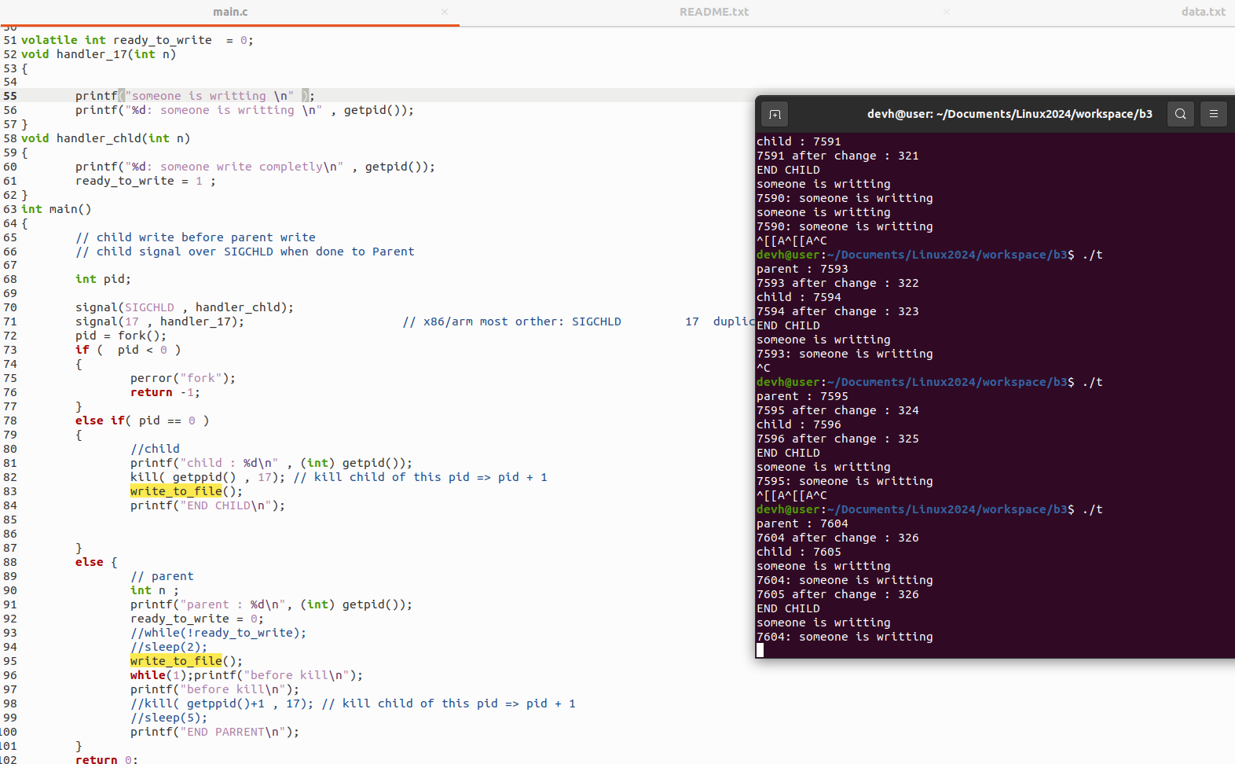
SIGCHLD is a signal can ignore, when call kill() this can be ignored.

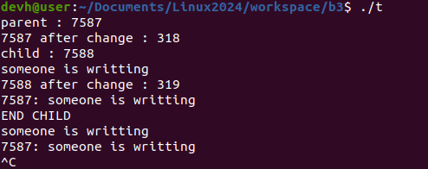
It can make many case. CANNOT control flow.

