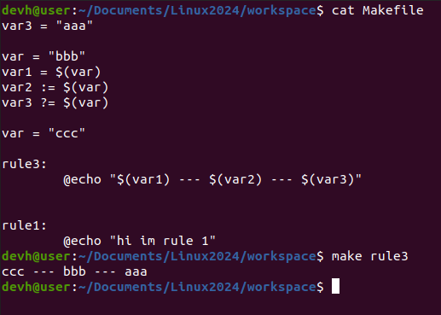
→ = assignment reference value
:= assignment direct value
?= assignment check FIRST TIME. If left variable NON allocate value before.

Include file :
- ex: include abc.mk

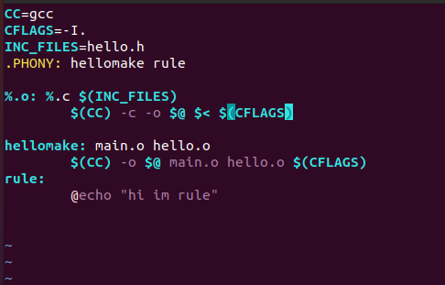

INC_FILE : is a purpose no1 in order to update all file .h
.PHONY: all_rule → update when if any file.c be modified.
%.o → all file .o
$@ → character place in left symbol “:” @< → character place in right symbol “:”

UBOOT
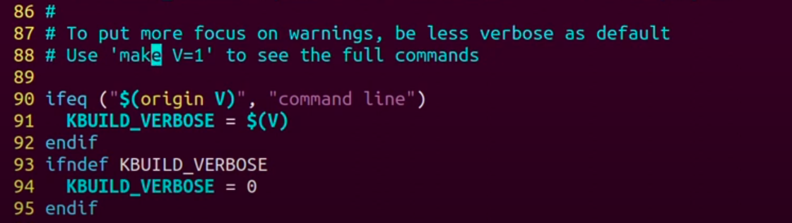
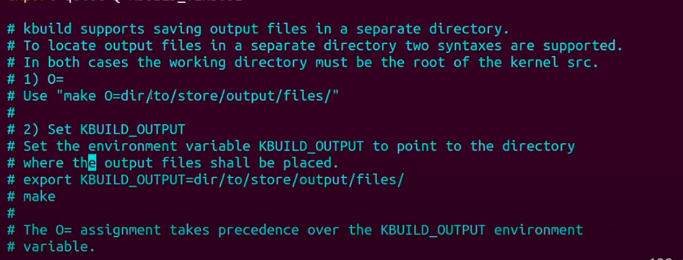
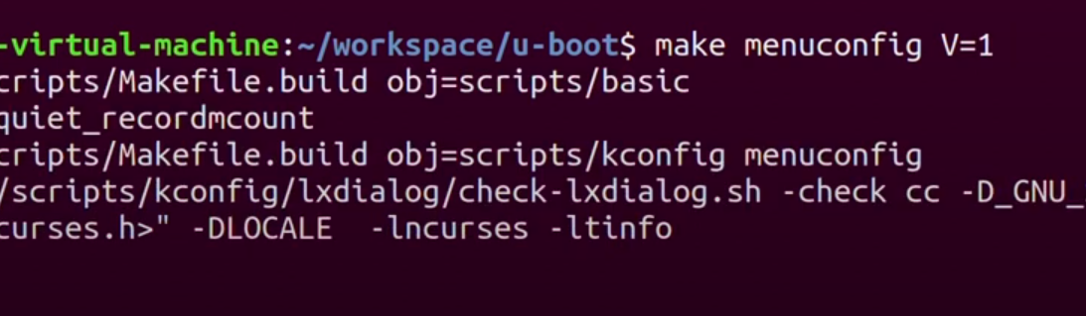
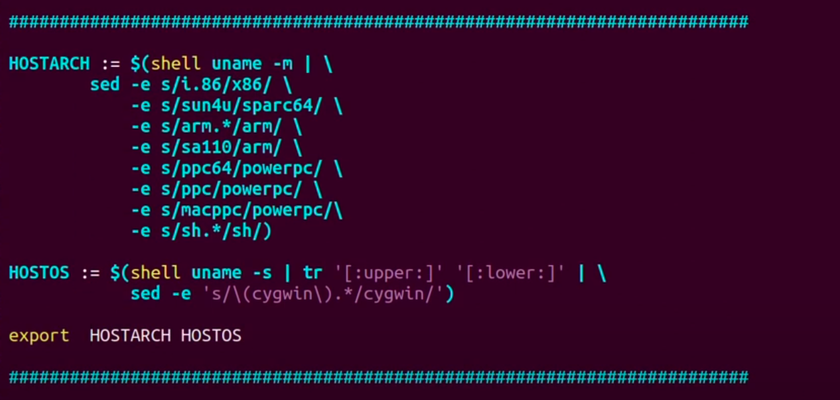
→ get arch of Soc

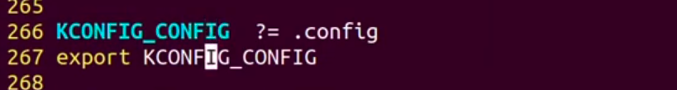
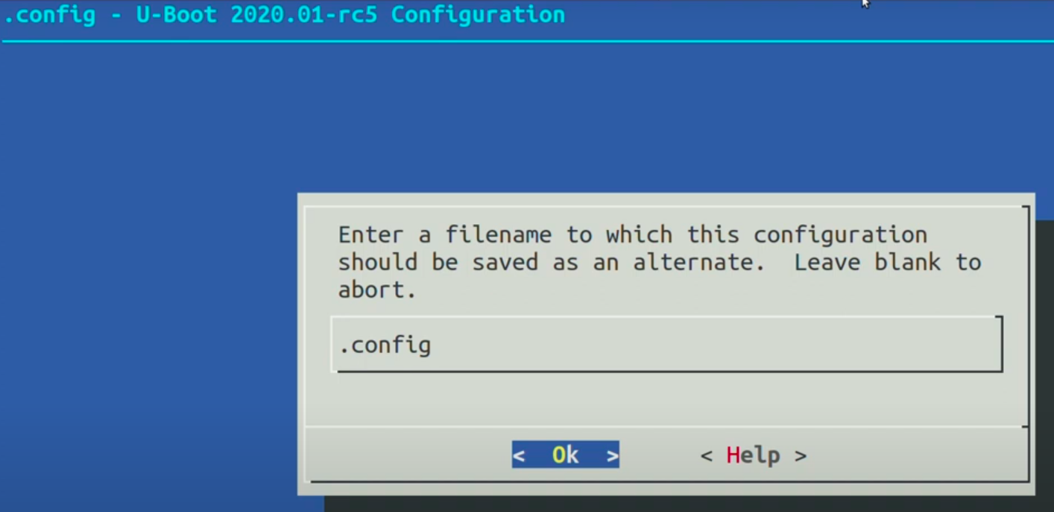
obj-m: build not load to system, load by manual

obj-y: auto load to system

CONFIG_FASTBOOT at column number in 82 file: drivers/Makefile depend obj-y

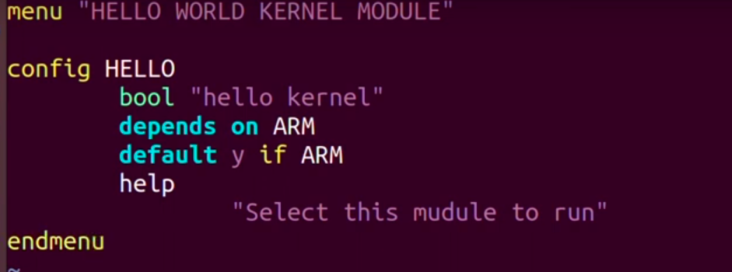
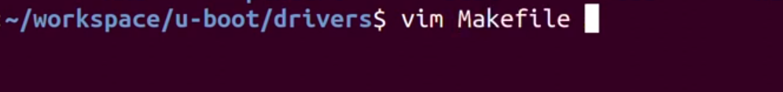
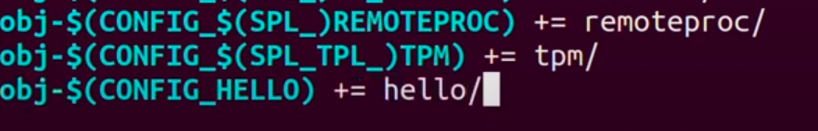

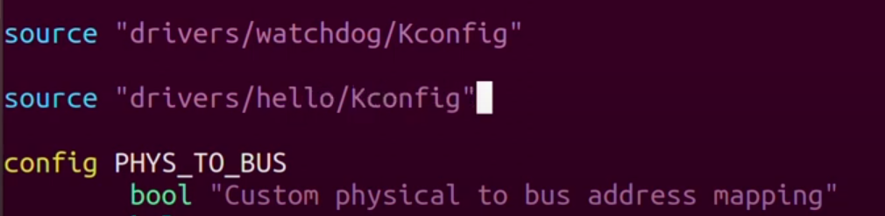
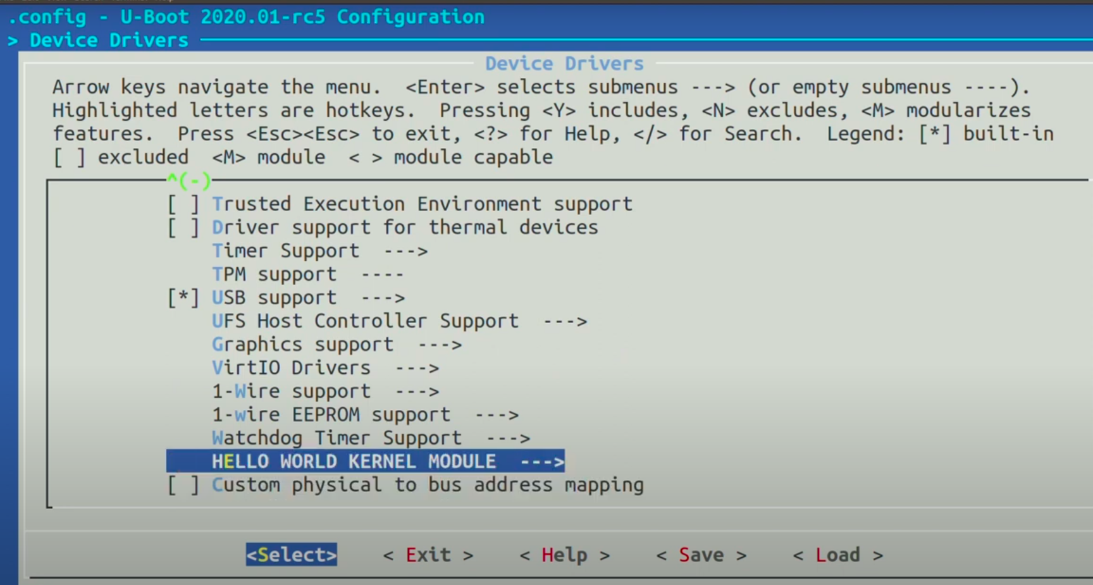
→ Step1: go to Device Driver

