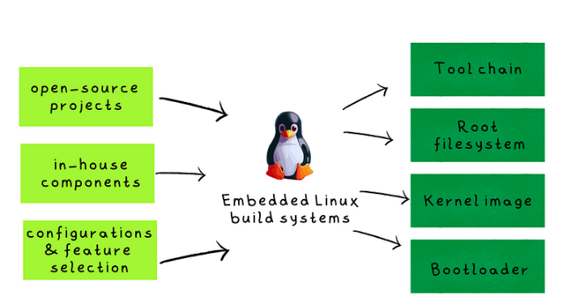
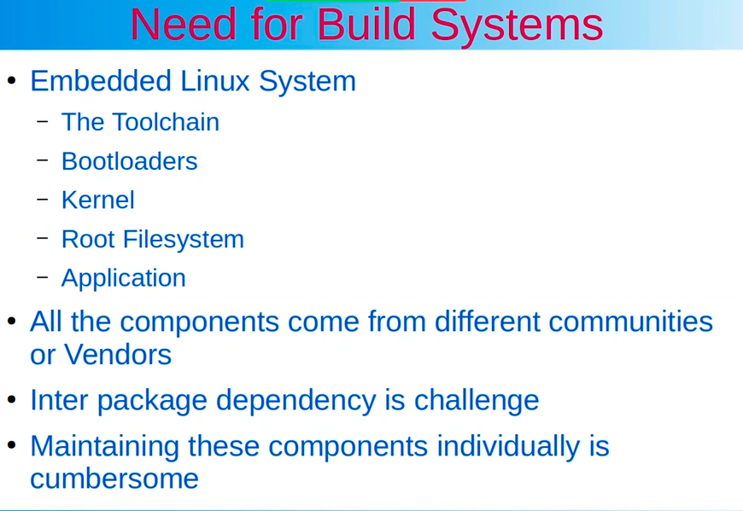

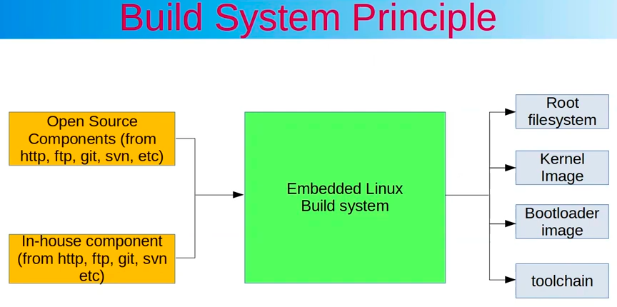
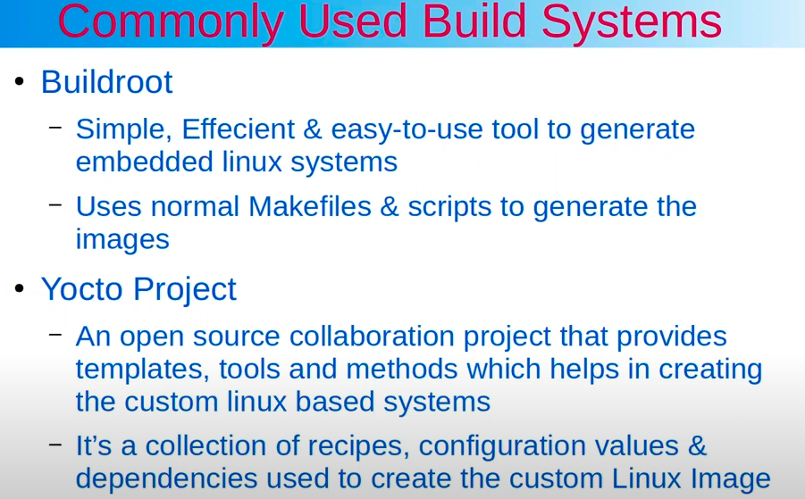

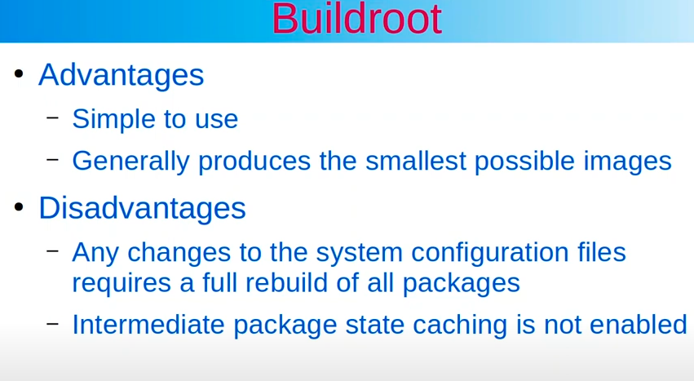
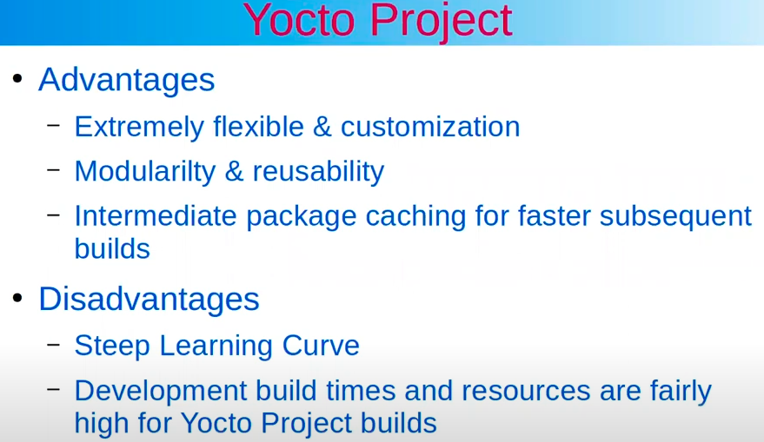

BUILD_ROOT: → make build rootfs
Use: Make file & Kconfig

KBUILD: BUILD_ROOT
→ rootfs + uboot + kernel

OPEN_EMBEDDED
→ make many distributed version (eg file.iso…) of Linux
Use: bitbake + recipes (meta data)

YOCTO_PROJECT : BUILD_ROOT, OPEN_EMBEDDED
→ This is the name of project, can use it to make: rootfs; uboot; kernel; or distributed version of Linux
Use: poky (BitBake + metadata) + tools + upstream (create many version branch)
metadata = configurations(.conf) + recipes(.bb)
https://git.yoctoproject.org/
→ metadata : layer of Yocto

https://github.com/openembedded
→ openembedded is a upstream of yocto_poky

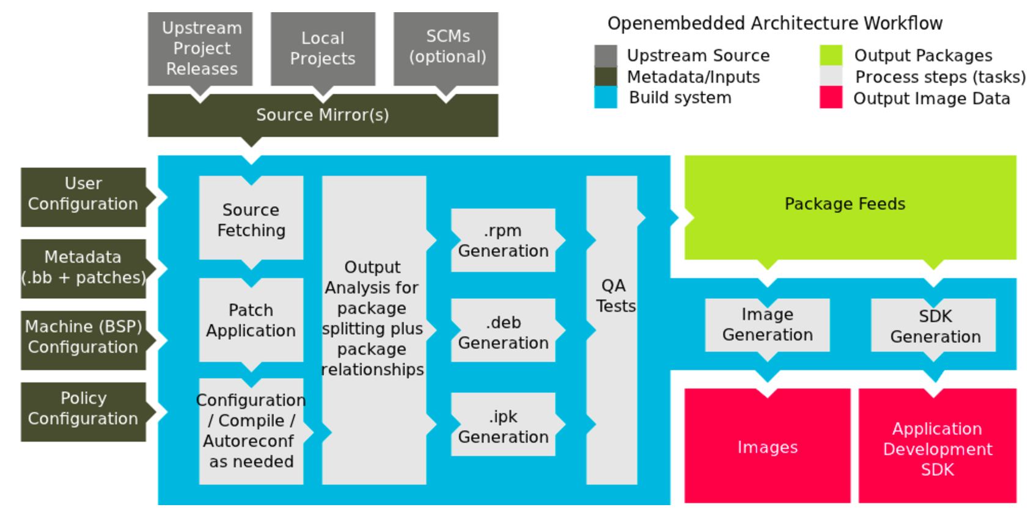

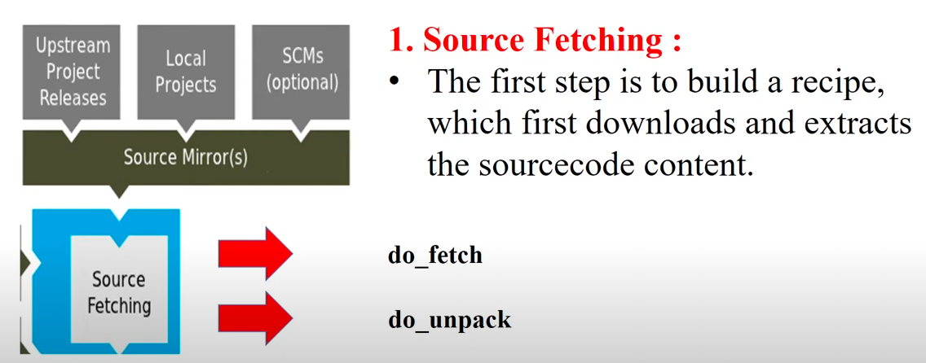

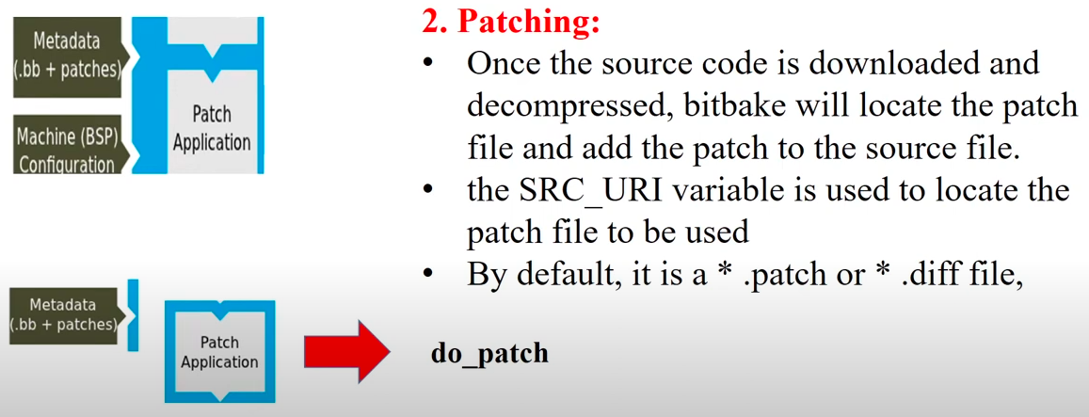

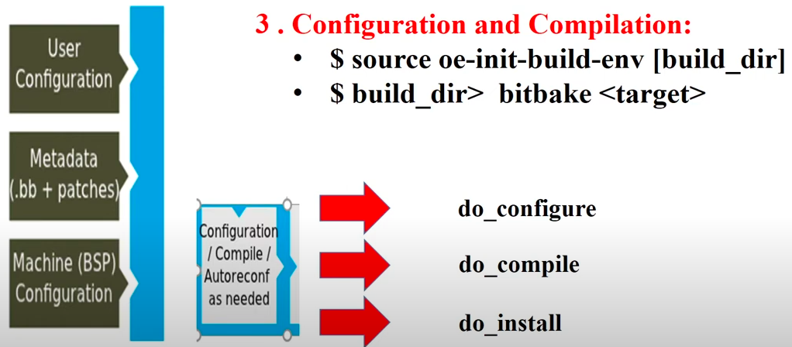
→ do_install : wrappe package file.rpm, f.deb, f.ipk

4. Package Slitting :
{ do_package_write/read rmp
do_package → { do_package_write/read deb
{ do_package_write/read ipk

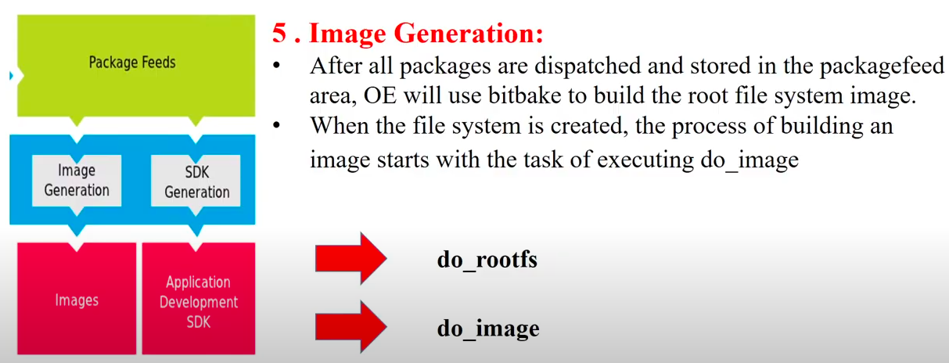

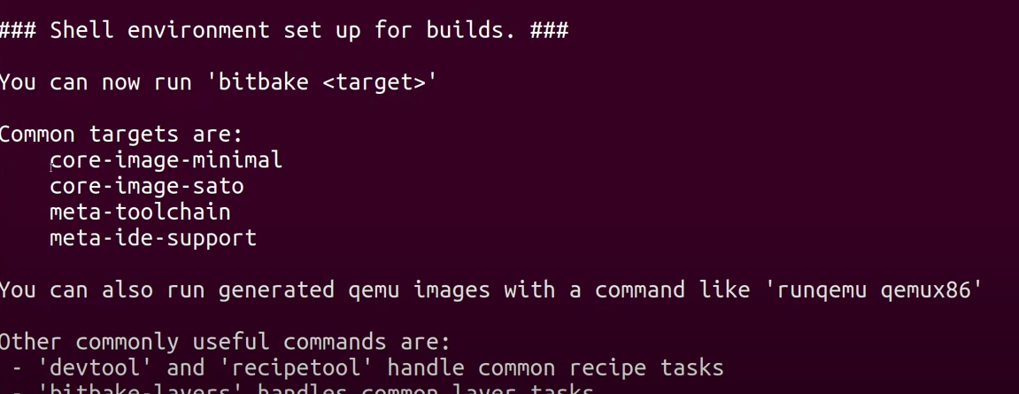
target.
TODO: NOTE delete url web disable before this step.
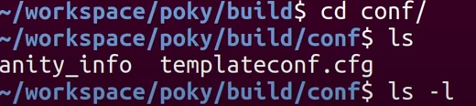
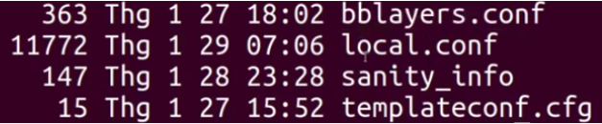
fileconfig: bblayers + local
1. INTRODUCE:
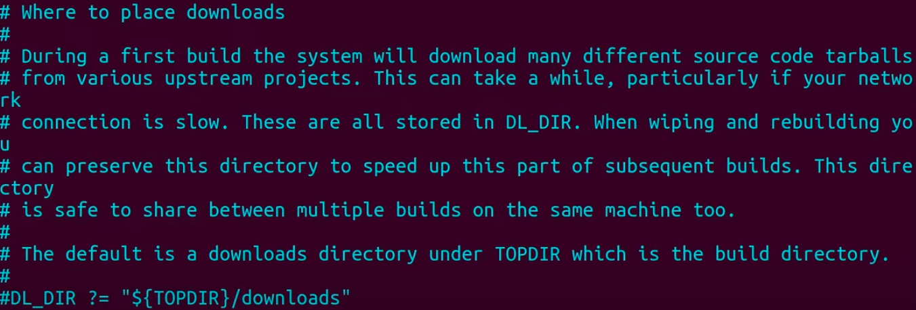

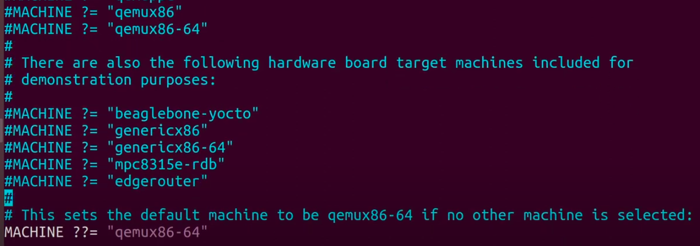
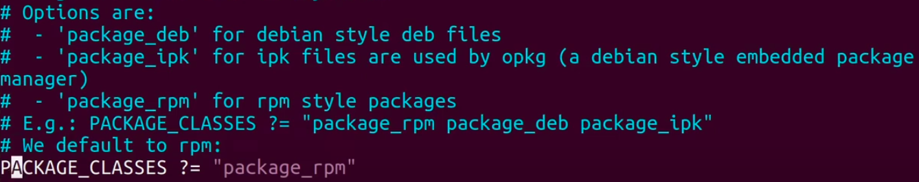
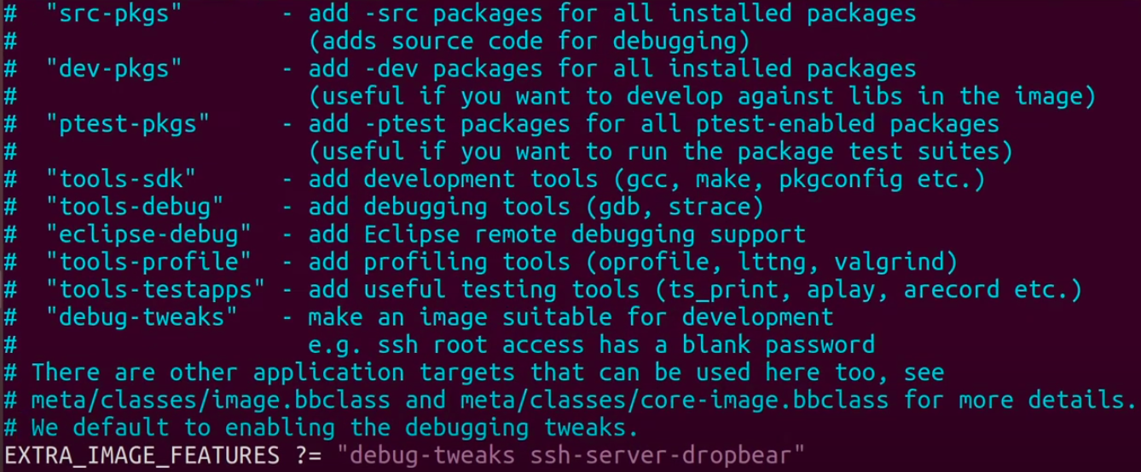
https://docs.yoctoproject.org/3.2.3/ref-manual/ref-features.html

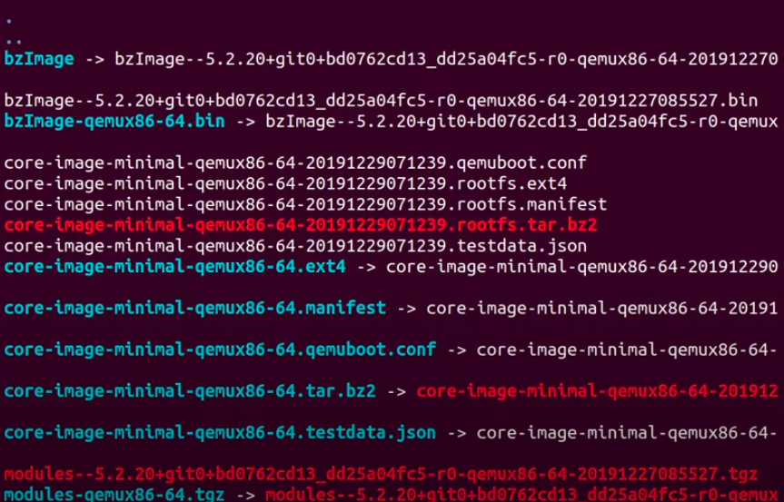
→ waiting
+= poweroff

2. ADD PACKAGE

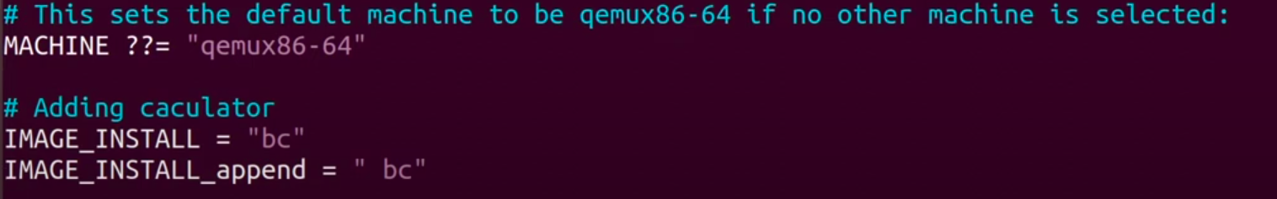
note : space before bc

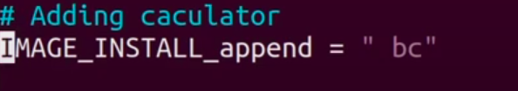
waiting...
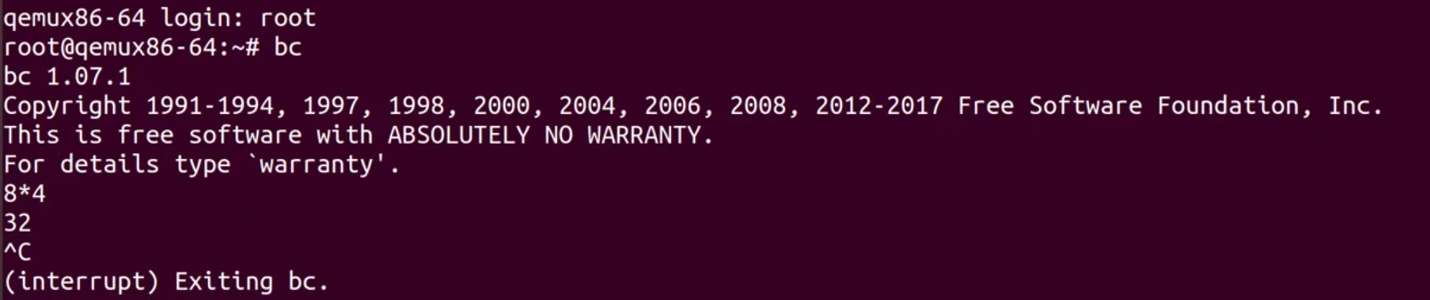
3. ADD EXTRA FEATURE

waiting…

[OPEN NEW TAB]

this is default IP

4. CREATE METADATA (LAYER)

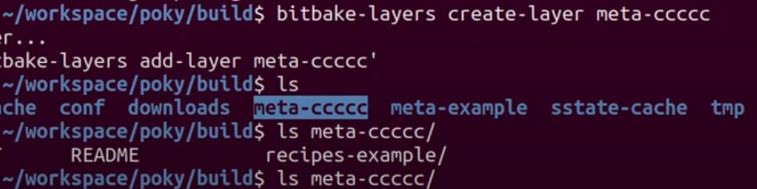
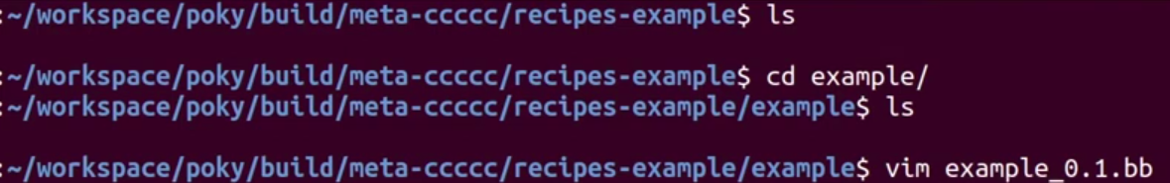
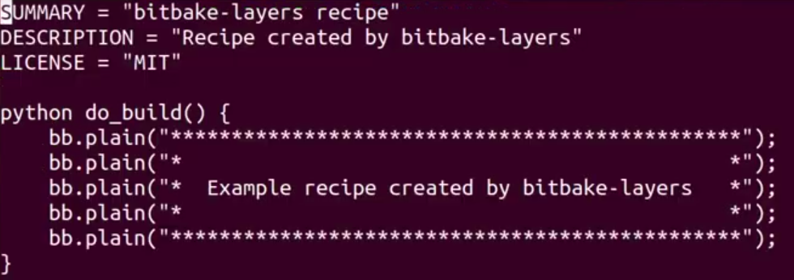

bitbake + [name] (except “_” and after this)
[NEW TAB] and wiew:

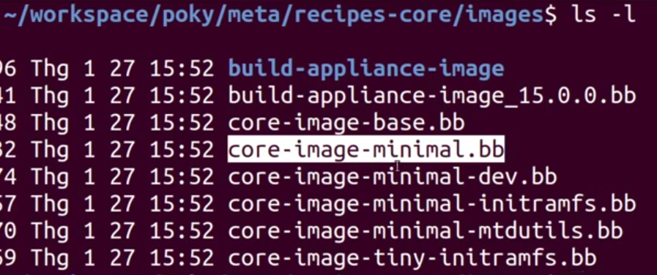
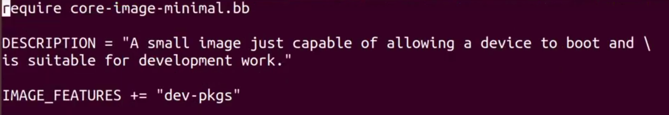
[RETURN TAB]:

…..
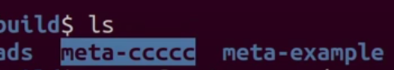
LIKE A SAME: author build before to avoid to wasting time

IMPLEMENT in FILE meta-example:

NOTE: bitbake hello-example
waiting….

conf/local.conf

OTHER: bitbake hello-example before TO COMPARE

COMPARE:

→ 14M << 239M
→ build tool chain is assign large memory

5. BUILD TOOL CHAIN IN HOST

build directly
[NEW TAB FOR BUILD TOOL CHAIN]

waiting...
output
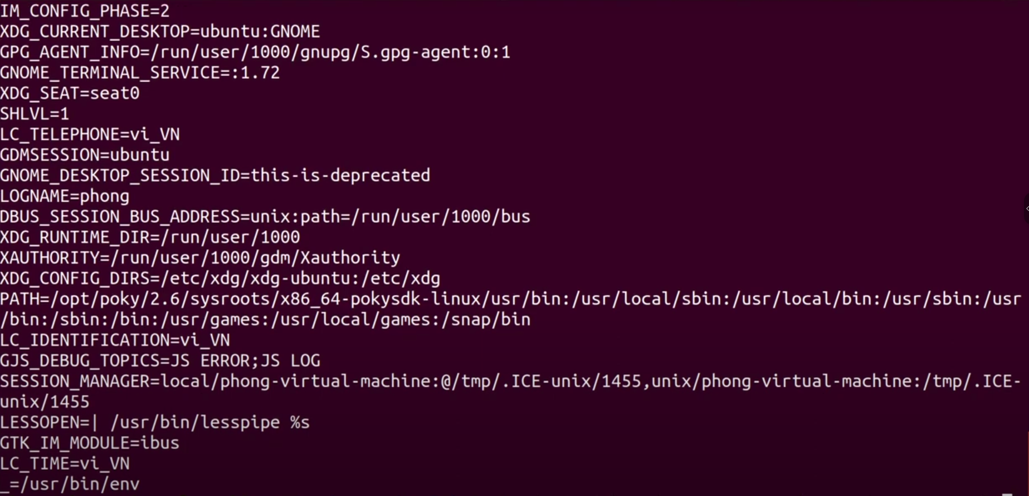
mkdir hello

add 2 file for test:
2 method build: ... + cmake (build sdk in host and cross-compile for board)
ls
result
run file excute

