prinenv

build-essential

Nội dung khóa học Buổi 1: Hello world kernel driver Bài 2: Character Device File Bai 3: Integerbased gpio N sysfs Bài 4: Practice and Create Sysfs Bài 5: Device Tree Bài 6: Practice Device Tree Bài 7: Pin control Subsystem And Device Tree Bài 8: Practice Pincontrol, DeviceTree and PWM Bài 9: U boot Bài 10: Practice Uboot Bài 11: Debug Code Using Gdb, Valgrind, Strace
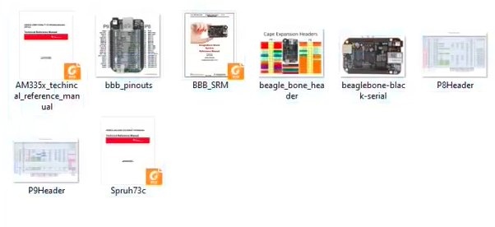
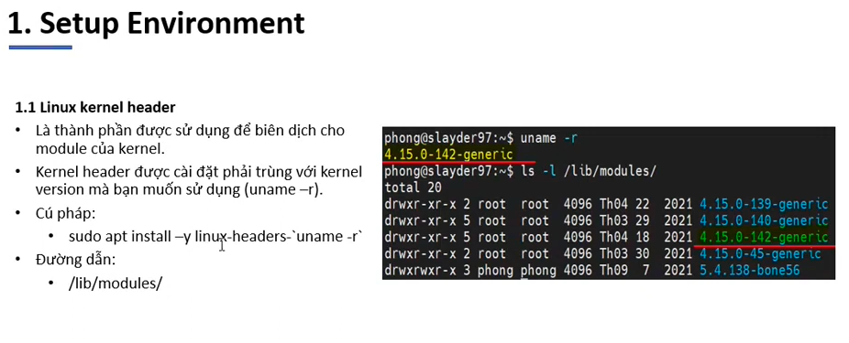
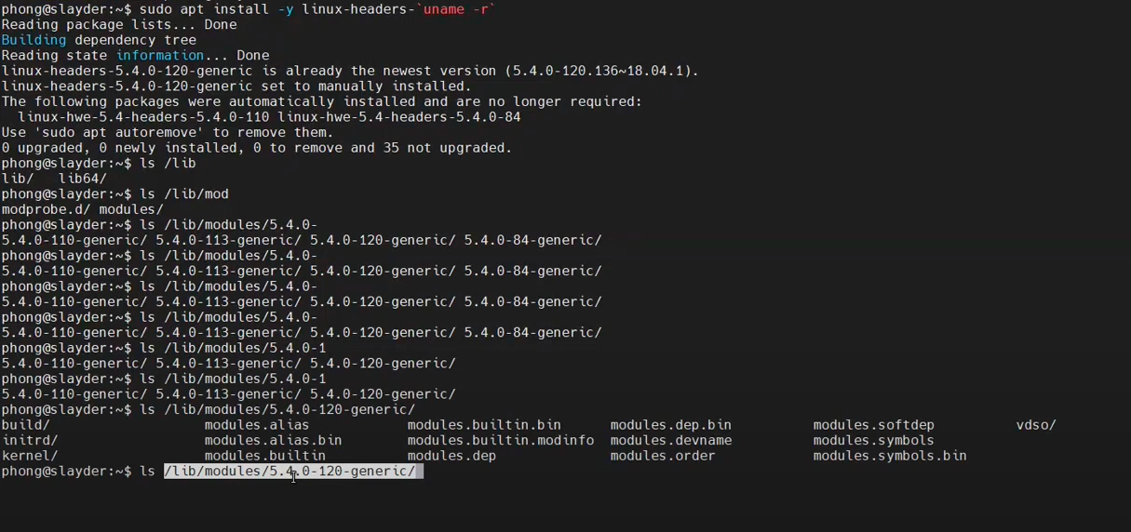

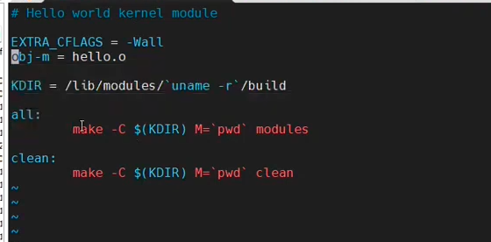
lsmod → show all LKM

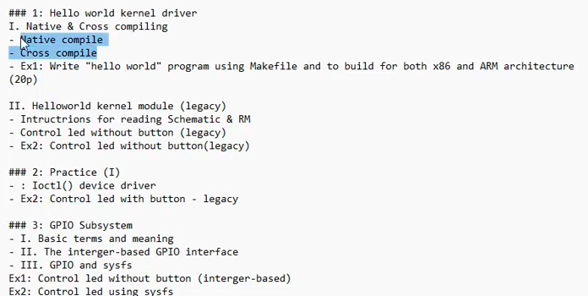
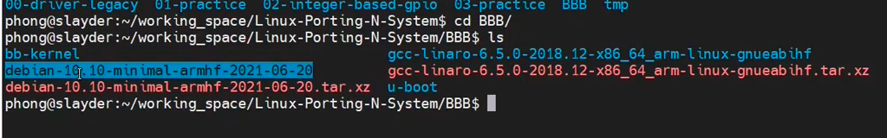
debian…-20: rootfs: /…./application..
…. ihf: toolchain download to host To crosscompile

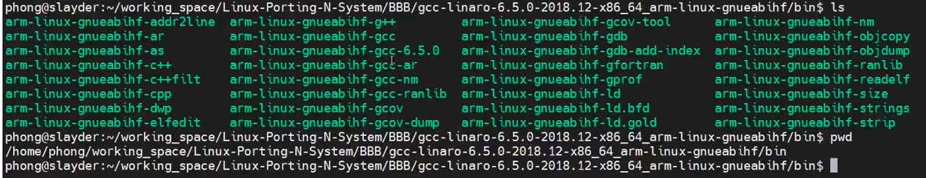
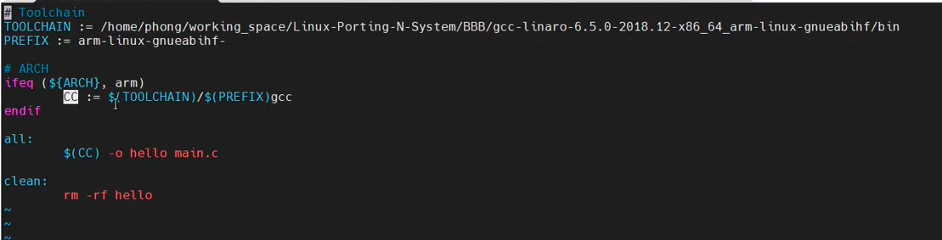

check ARCH

Check in BBB
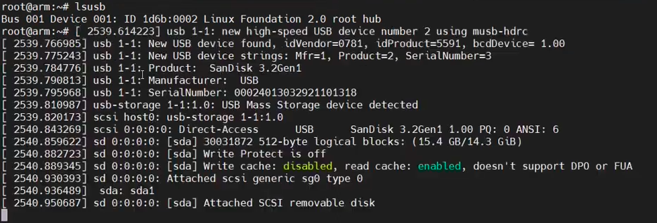
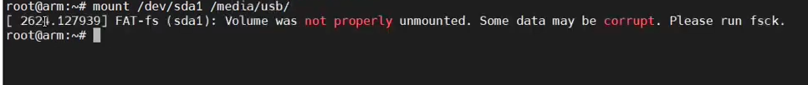

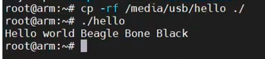
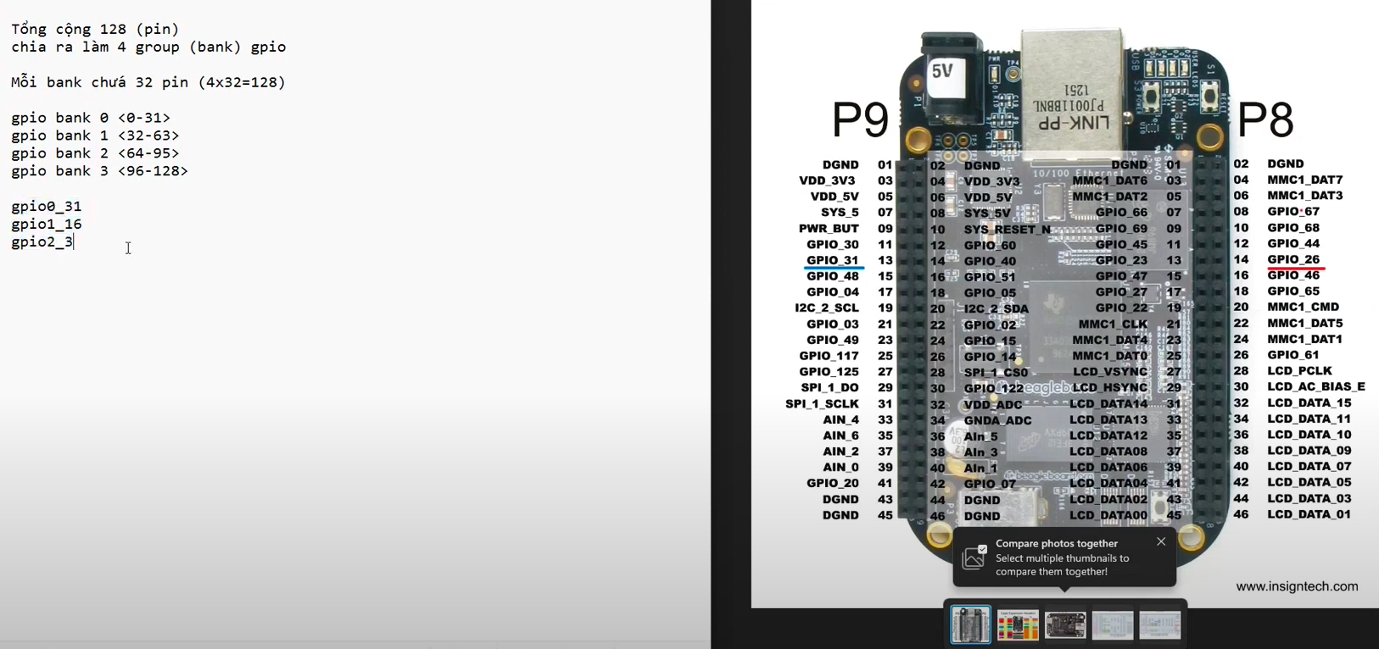
BANK
MEMMAP→GPIO0
GPIO→ in/out put GPIO_OE

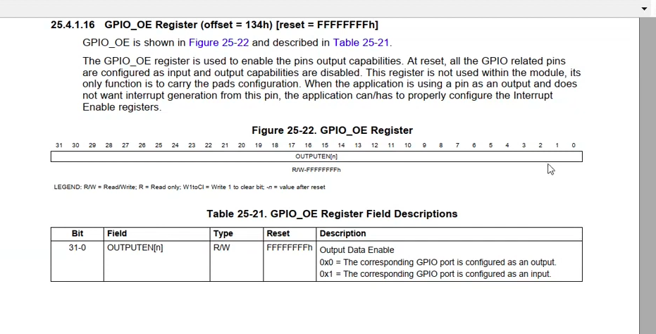

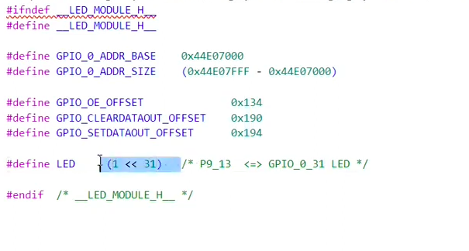
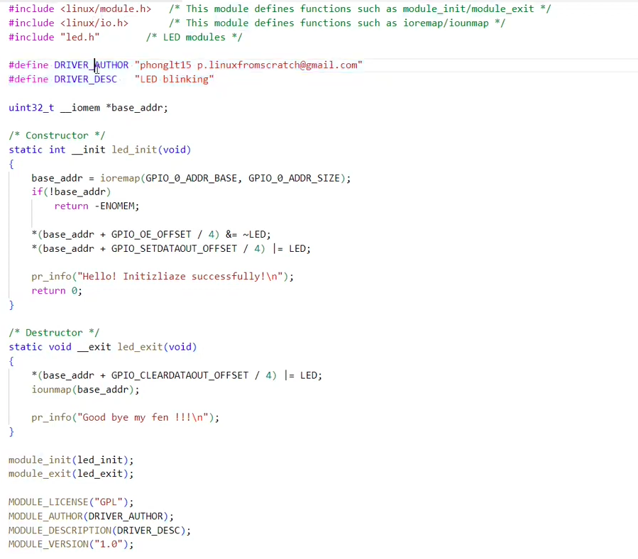
1 la 1byte → chuyen sang bit nen chia 4
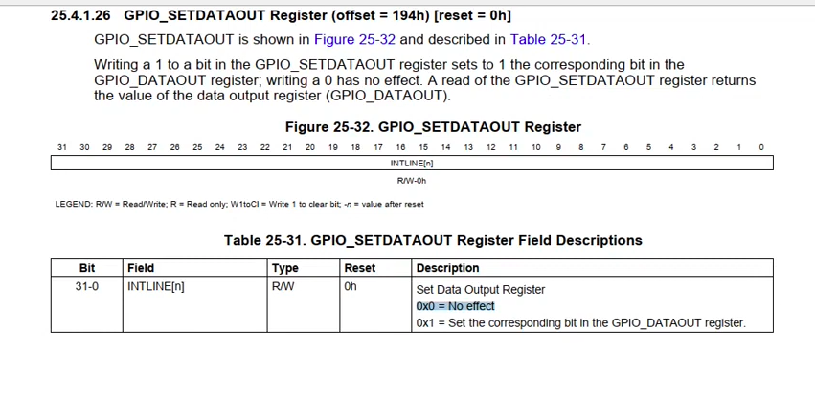
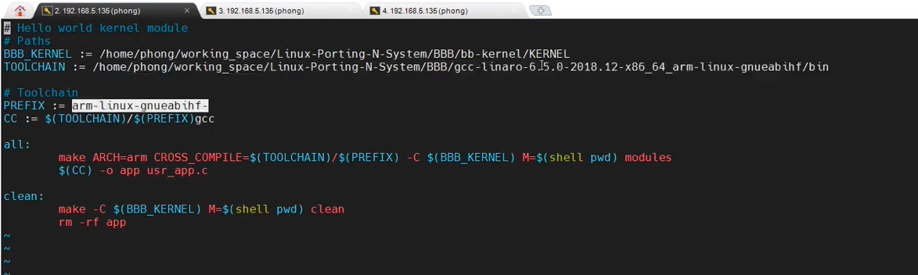
SS2 IOCTL

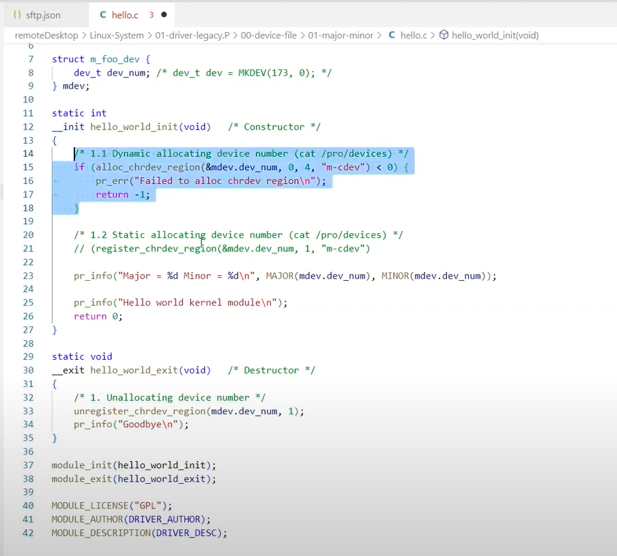
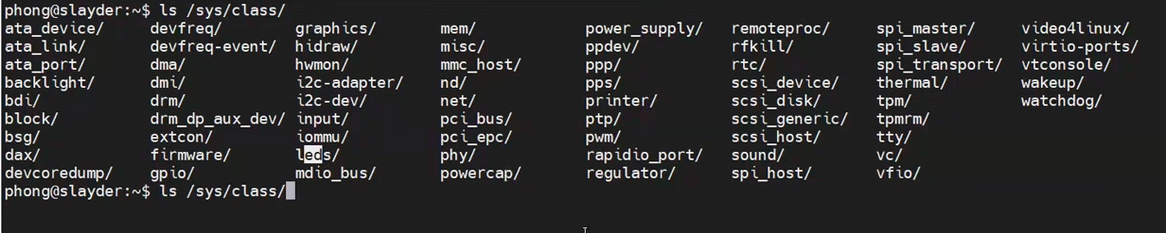

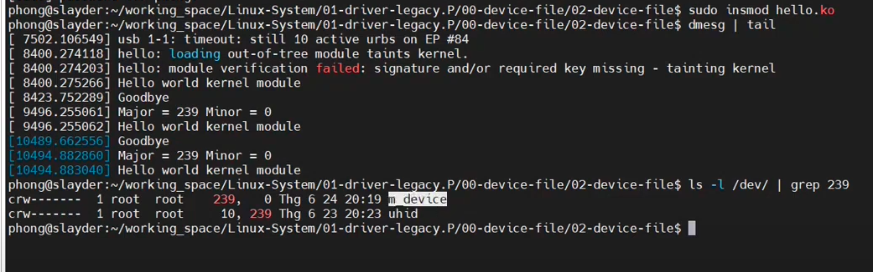

SS3 GPIO SUBSYSTEM

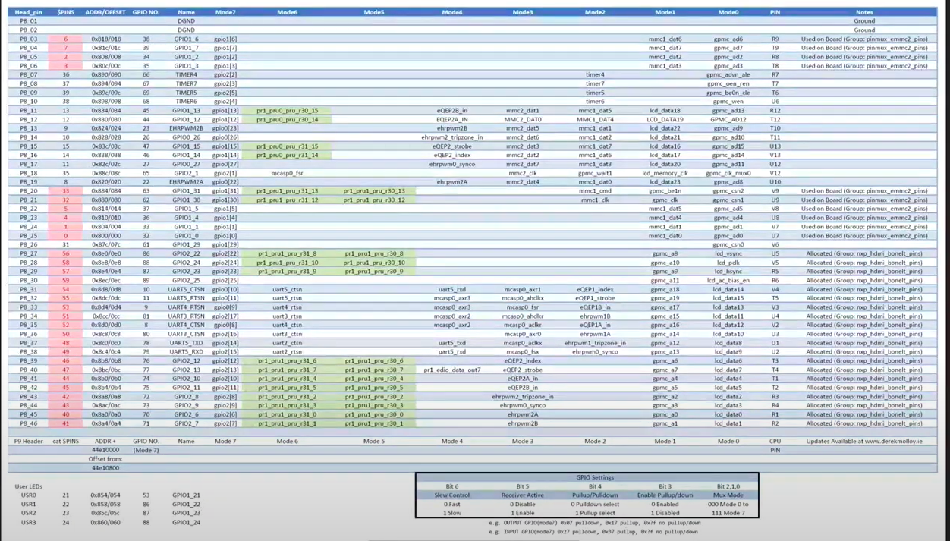
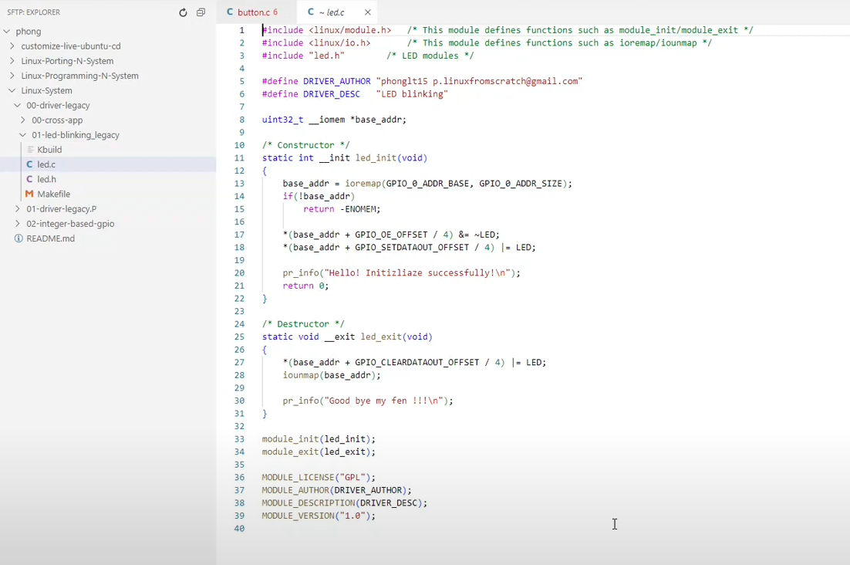
OLD

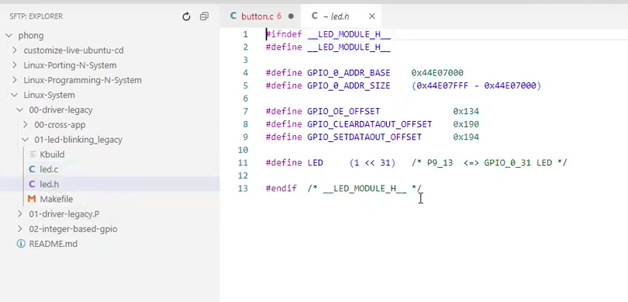
OLD
- Subsystem:
integer base API
descriptor base API
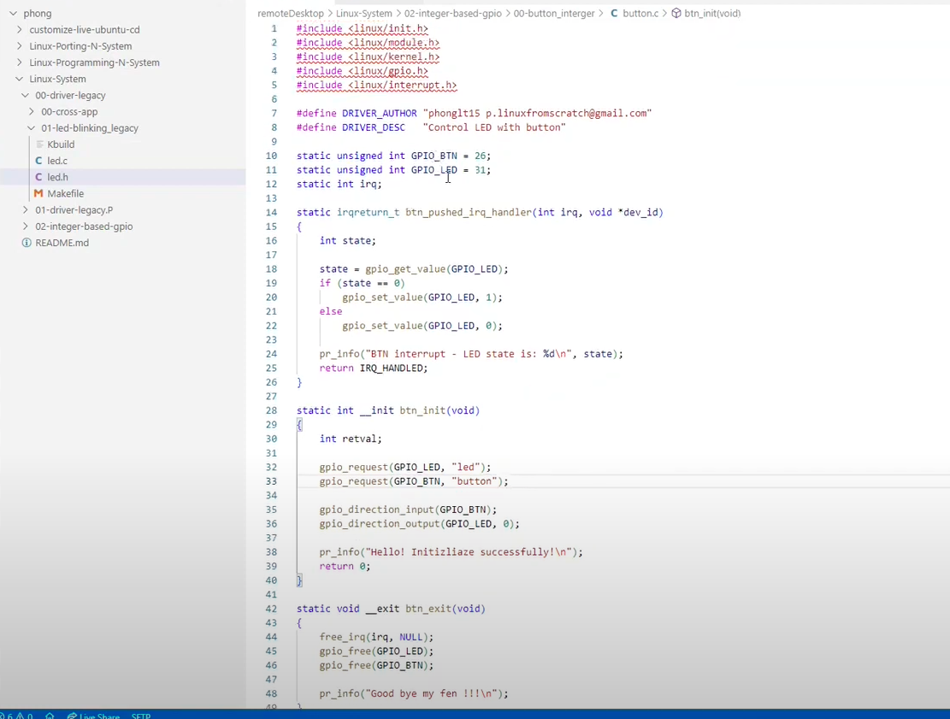

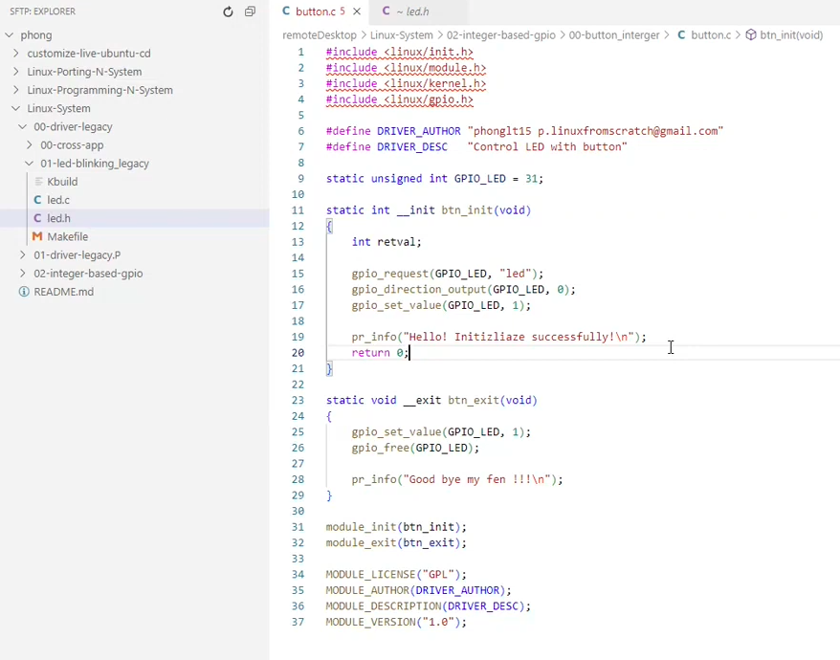
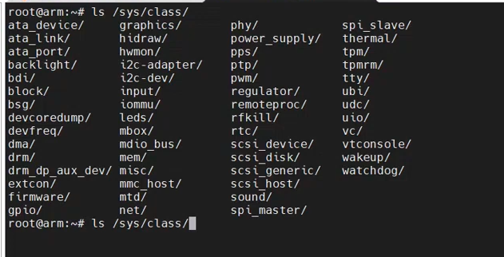

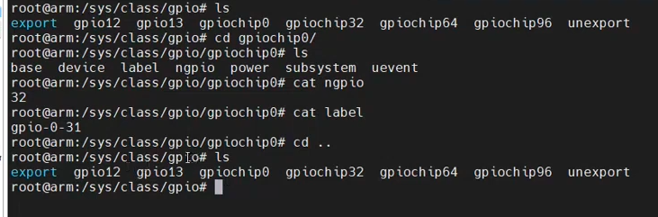
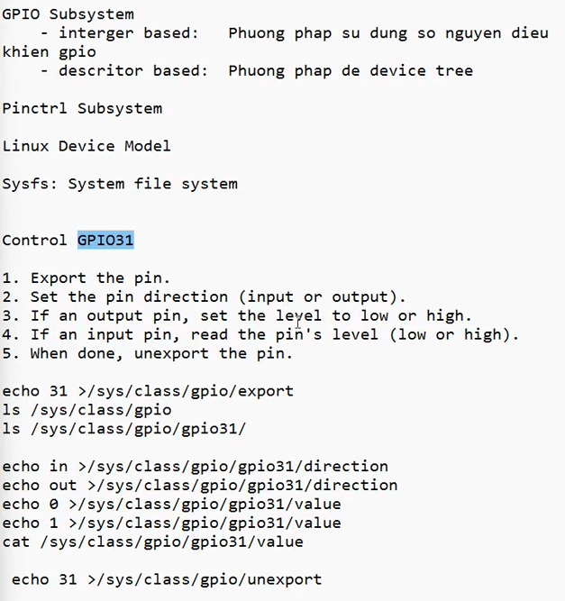

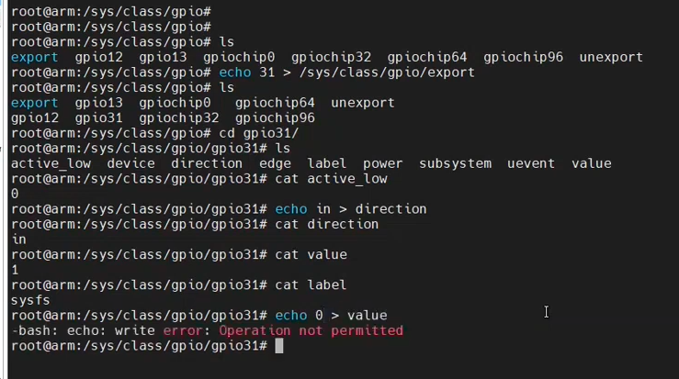
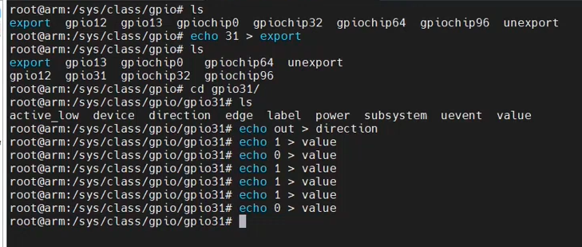
End: unexport

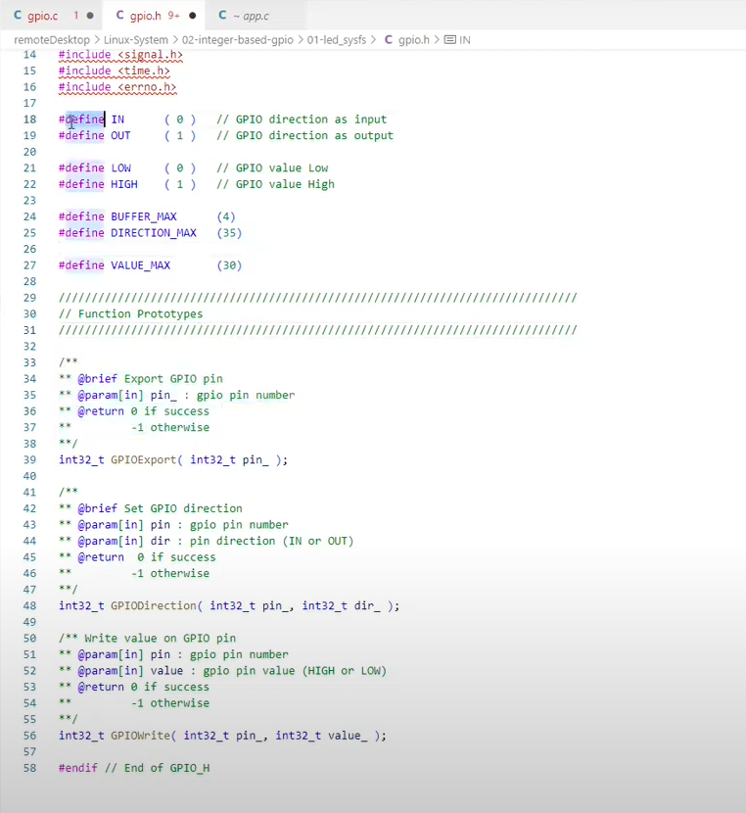

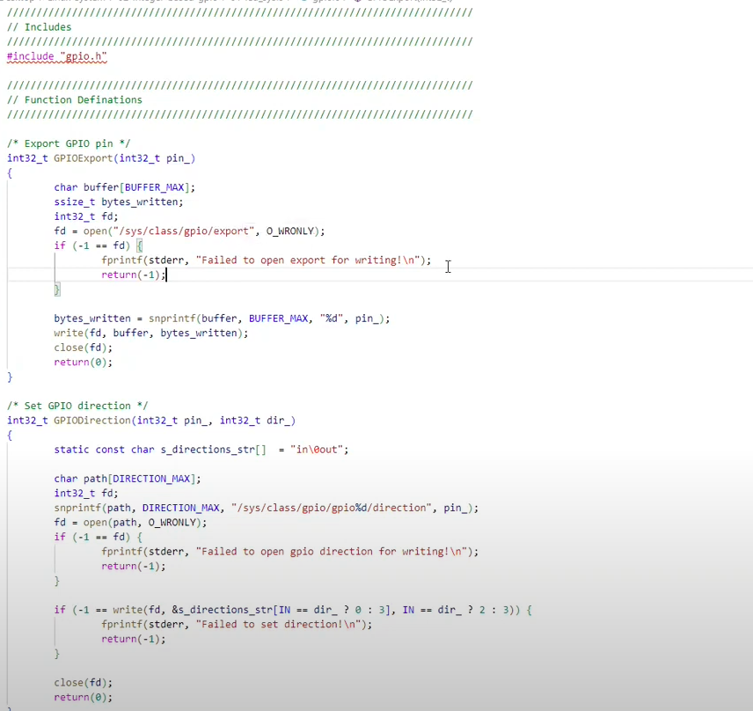
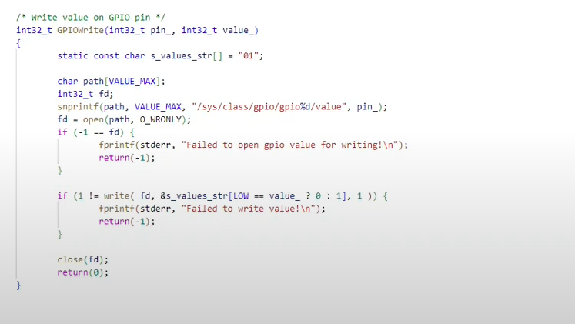
ssize_t write(int fd, const void buf[.count], size_t count);

// Online C compiler to run C program online
#include <stdio.h>
static const char CHAR[] = "in\0out";
char a[50];
int main() {
// Write C code here
int num = 0;
//printf("%s", &CHAR[num == 0 ? 0 : 3]); // CAN USE
sprintf(a, "%s", &CHAR[num == 0 ? 0 : 3]);
puts(a);
return 0;
}

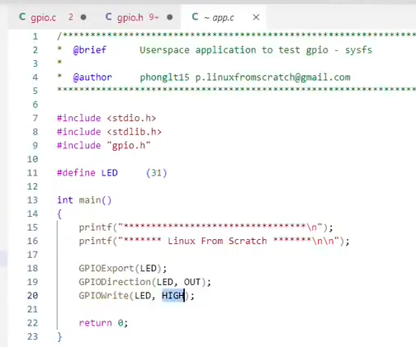

SS4 CREATE SYSFS

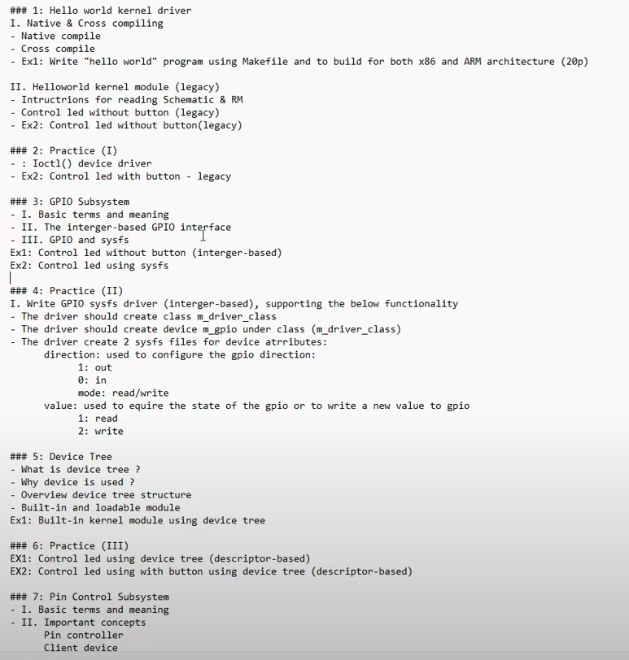

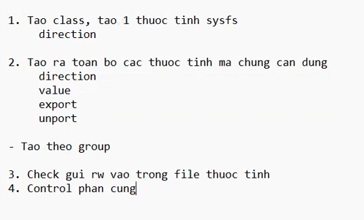
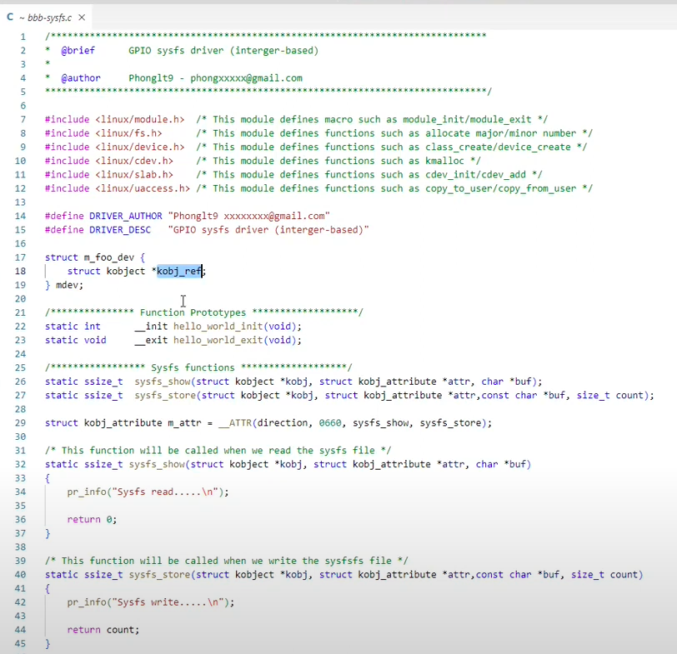

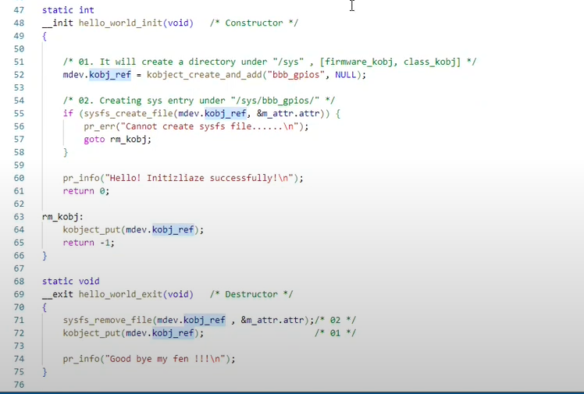
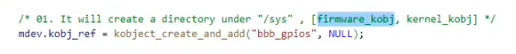
Neu pargm
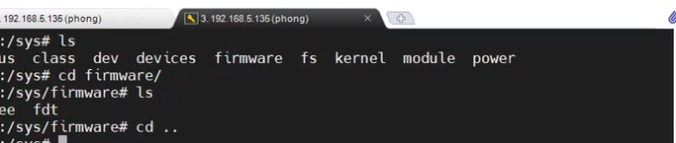

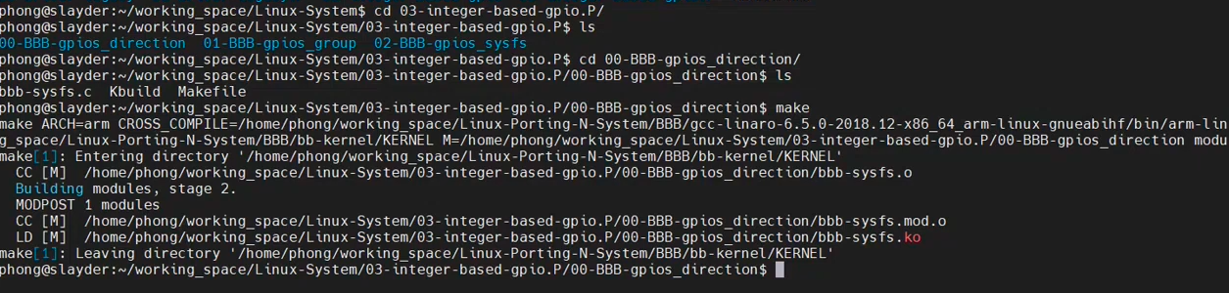
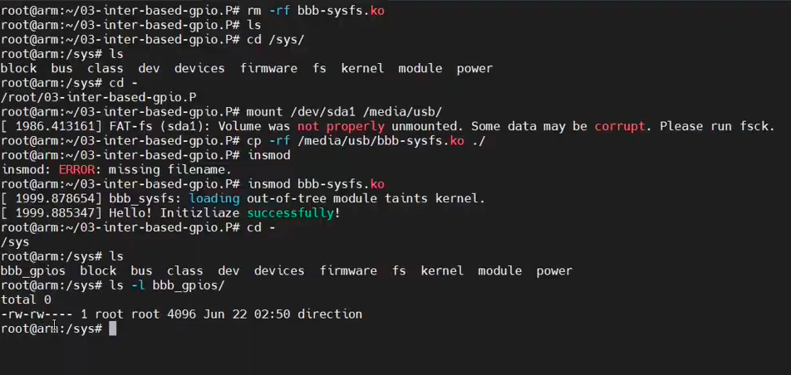
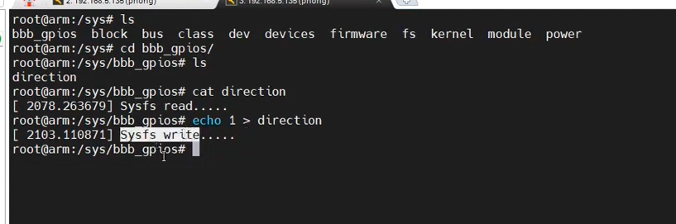

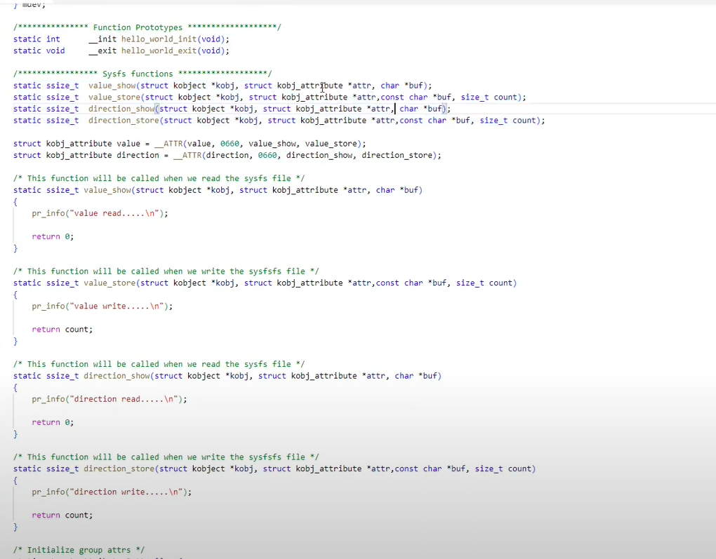

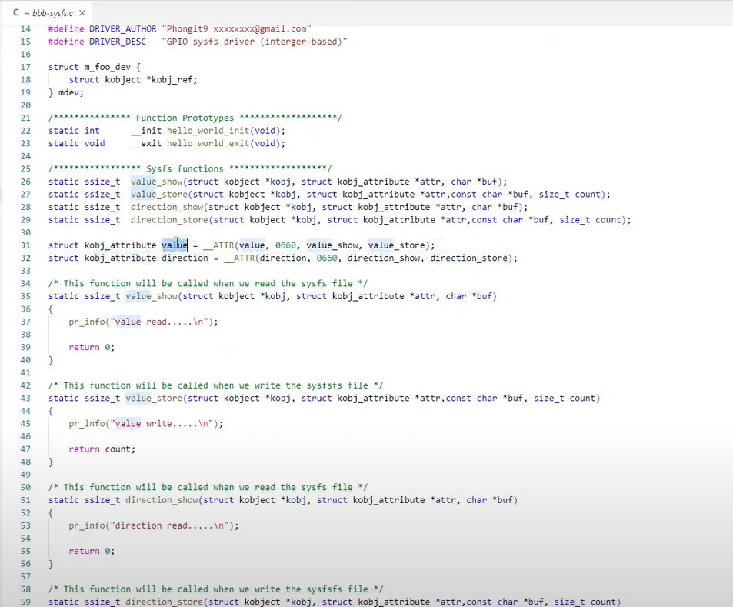

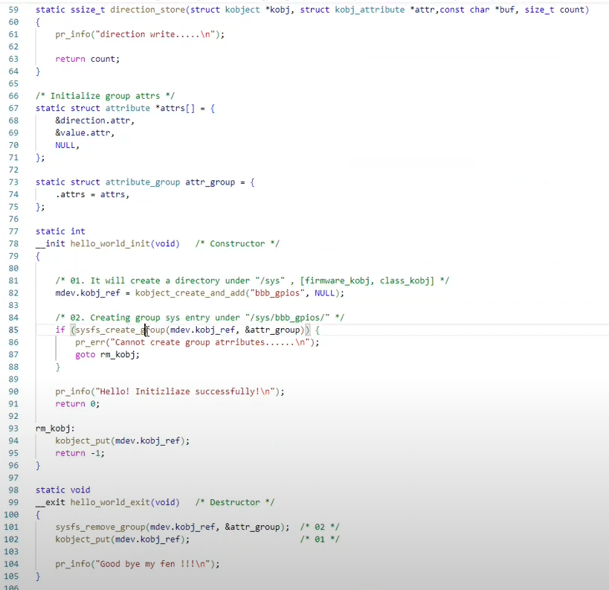
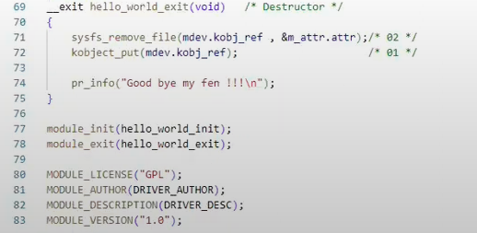
use USB clone code
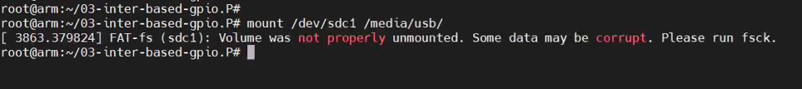
rmod …

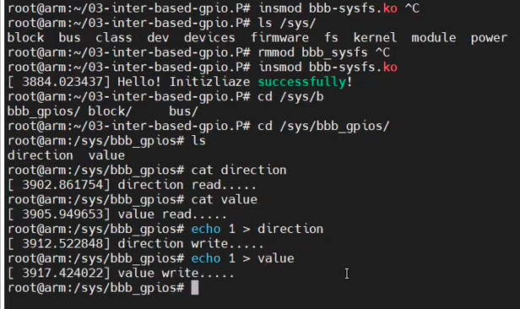

LED:

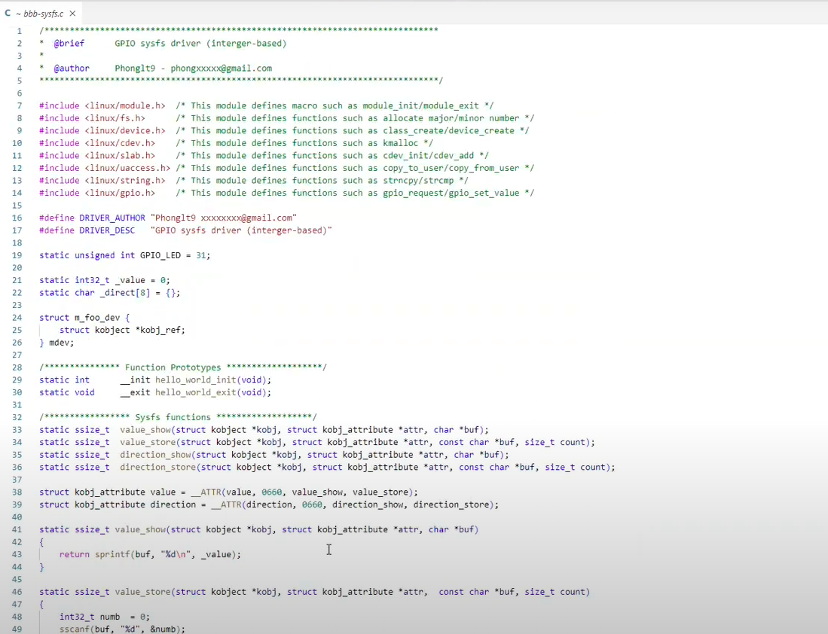

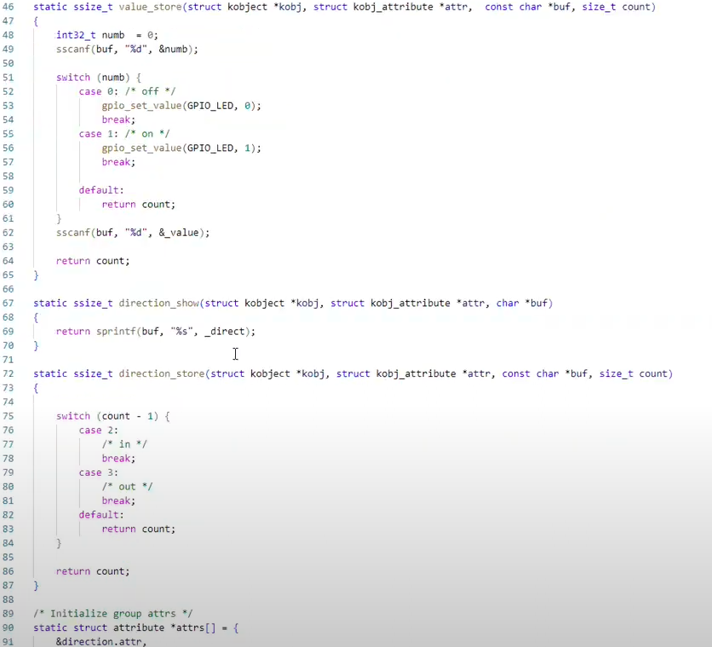

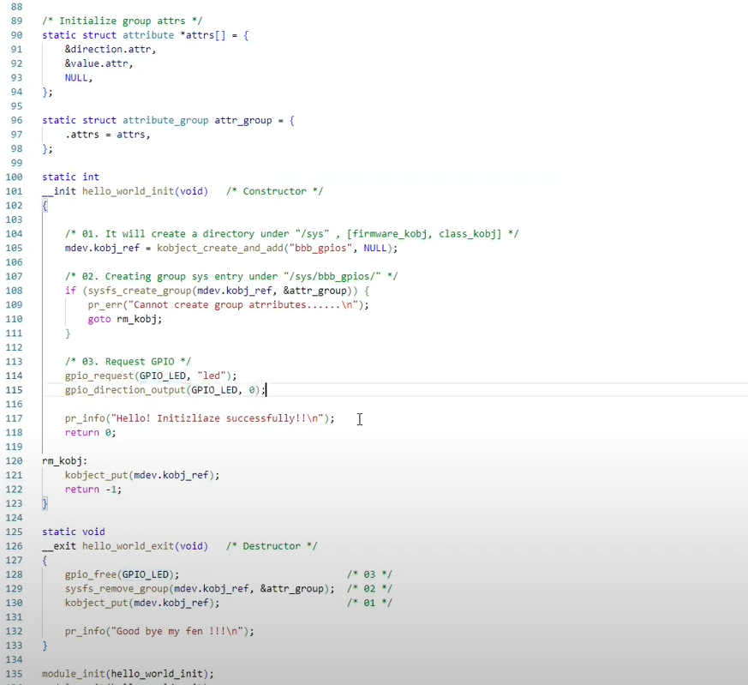

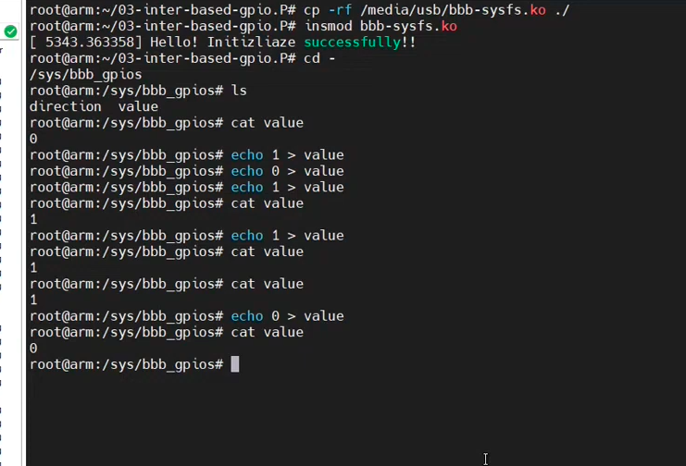
refer:
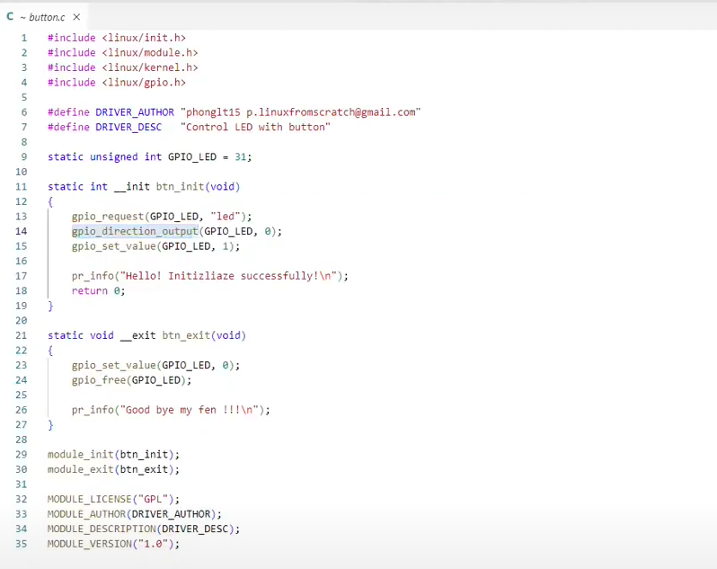
NON

Bai tap:

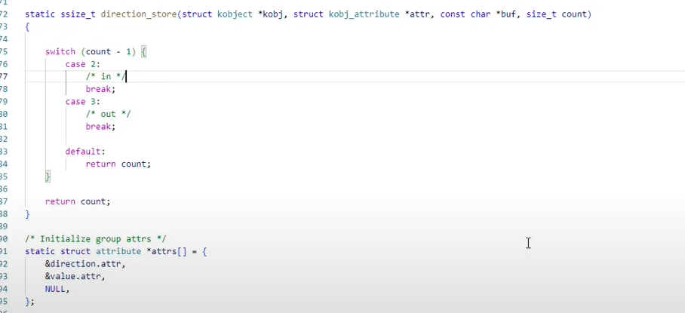
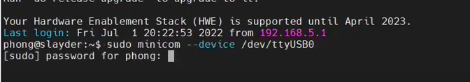
use minicom
export >>> GPIO_request >>>> information of GPIO

SS5 Device tree

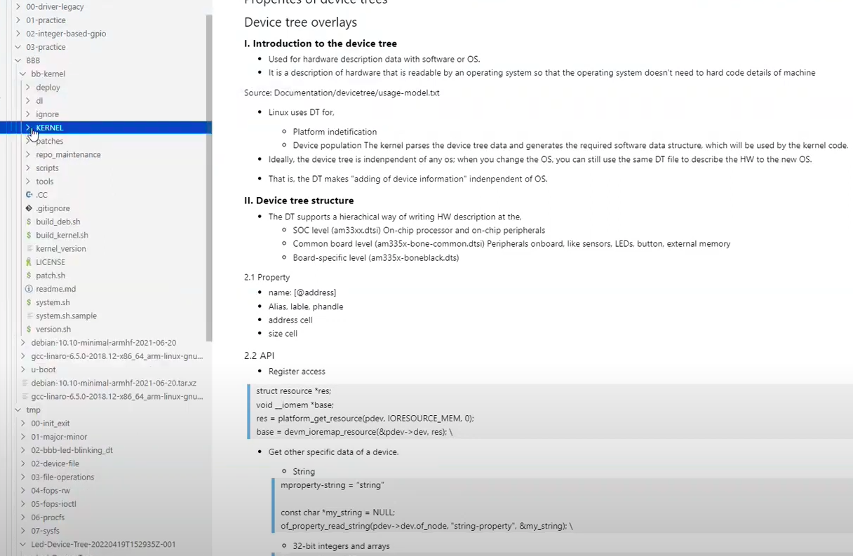
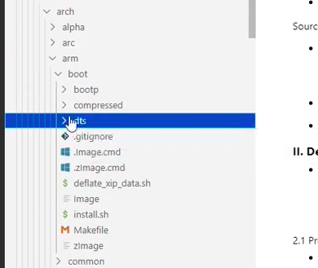

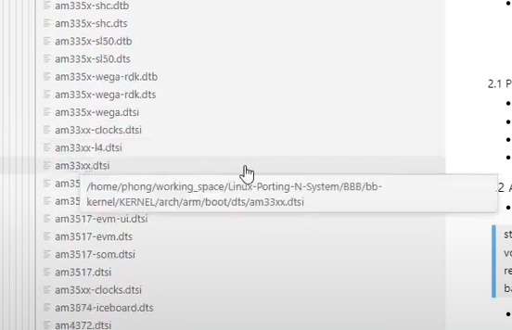
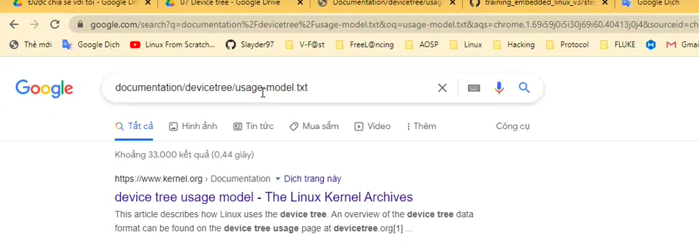
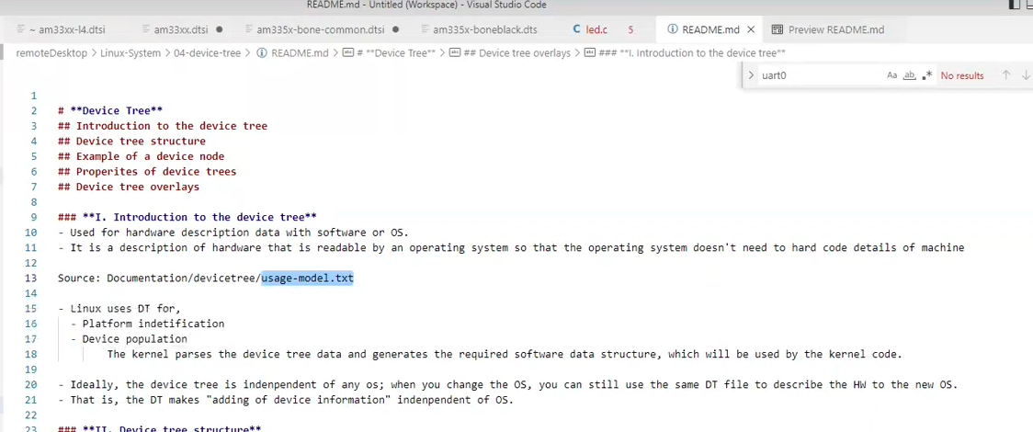

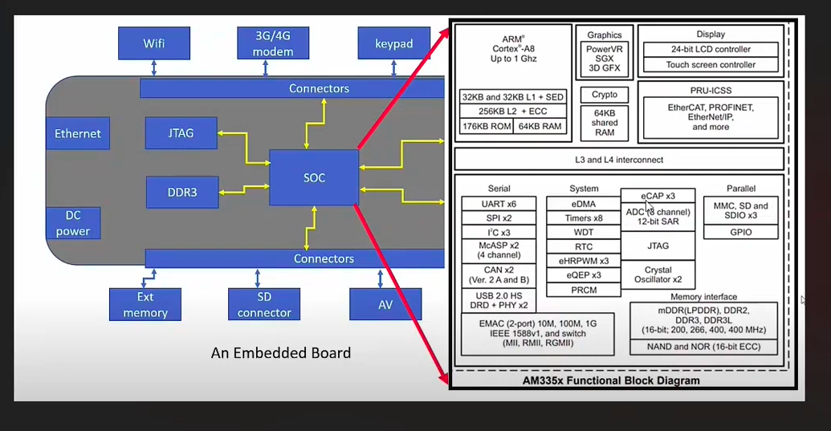
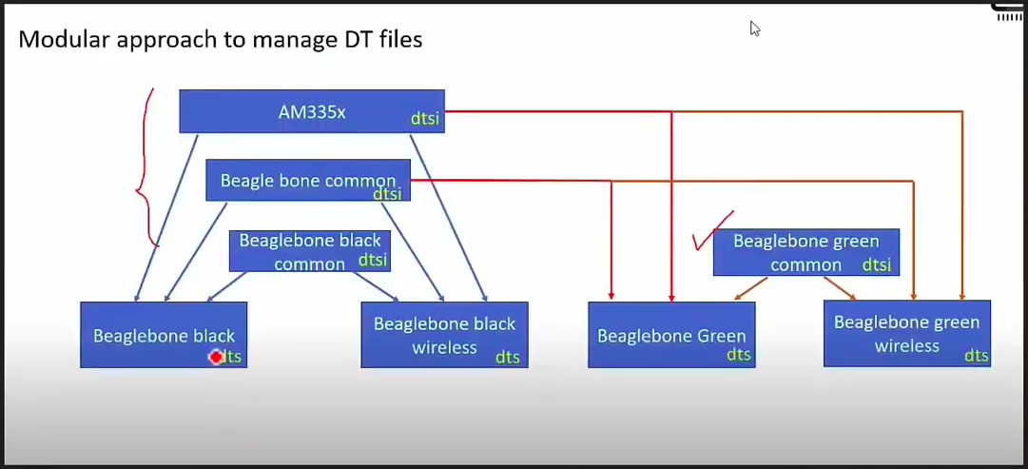
doc

LED descriptor base:
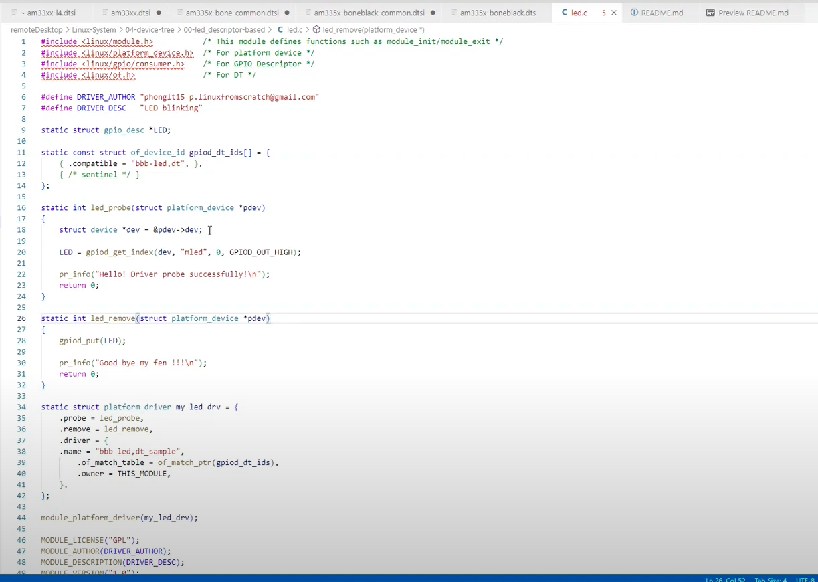
1 struct of_device_id compatible
2 struct platform_driver {
.probe .remove .driver {.of_match_table = (struct of_device_id )……}

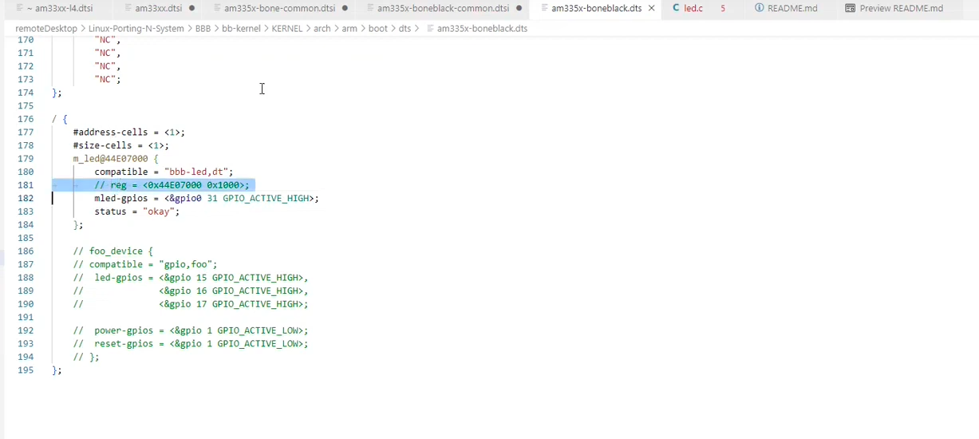
MAKE BUILD-IN

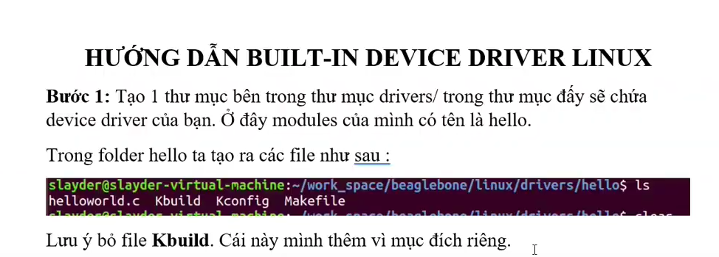

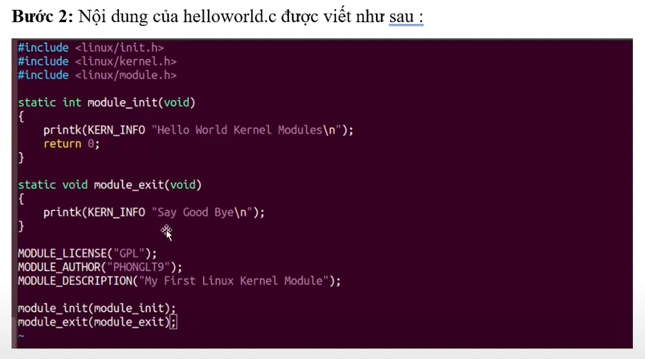
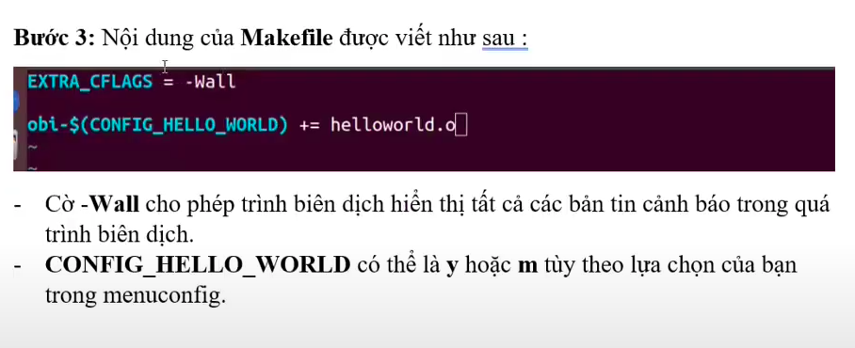
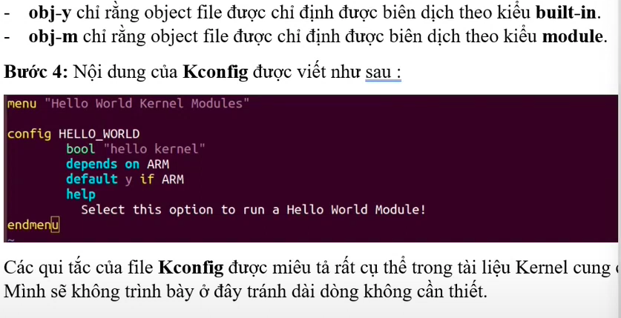
HELLO_WORLD bo CONFIG_ o buoc 3

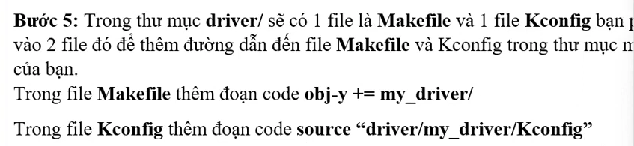
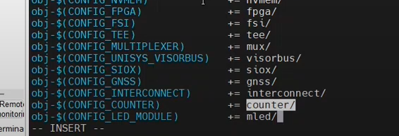
add to the end file Makefile at KERNEL/driver

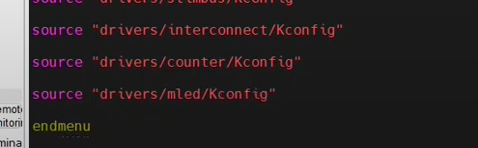
add to the end file Kconfig at KERNEL/driver

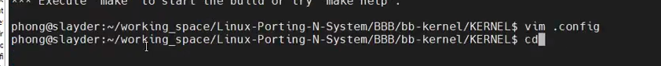
after save make menuconfig ARCH=arm



