Depth first search

Base
bool dfs (vexSource) {
// do first clean
// do mark : visited [vexSource] = true
// do check list neithbor :
// do sth 1
for (auto neithbor : adjList [vexSource] )
{
//do sth 2
// do when not visited yet
if(!visited [vexSource]) {
// do sth 3
// do mark :
dfs (neighbor);
// do sth 4
}
else {
// do sth 5
}
// do sth 6
}
// do sth 7
}

Breadth First Search

bool bfs ( vexSource ) {
// do clean
// Step1 : do init local
// init queue and clean queue
q.push ( vexSource )
// do mark : visited [vexSource] = true
// do sth 1
// Step 2 : Loop when queue empty
while (!q.empty) {
// get vertex in q
auto vertex = q.front();
q.pop
// do sth 2
// visited vertex
for (auto neithbor : adjList [ vertex ]) {
// do sth 3
// if not visited yet → visit
if (!visted [neighbor]) {
// do sth 4
q.push(neighbor)
// do mark: visited [neighbor] = true
// do sth 5
}
else { do sth 6 }
}
// do sth 7
}
// do sth 8
}

// O (n (V+U)) // n ~ a number of connected component
//init counter variable; data sth 1
// int cnt; or init variable + return;
// TODO :create vector list all connected component push to a group
int connectedComponent ( ) {
// clean ( ) : cnt , ...
// loop all vertex by non visted
for ( auto noVertex : adjList) {
// do sth 2
if (! visited [ noVertex ] )
// do sth 3
cnt++;
dfs(noVertex); // or bfs(noVertex) // basic
// do sth 4
else { do sth 5 }
}
// do sth 6
return cnt // or sth void*, vector
}

add global parent []

at dfs() // do mark2: add parent[neighbor] = vexSource
at bfs() // do mark2: add parent[neighbor] = vexSource

findPathNoWeight (source, distination, algorithms = bfs()) {
// clean () // parent, visited
// do sth 1
dfs(source); // or bfs(source)
// do sth 2
if (! visited[distination]) {
//do sth 3 : log > no path
} else {
vector<int> path;
// do sth 4
while(source != destination) {
// store path and call back parent
path.push_back(destination)
destination = parent (destination)
// do sth 5
}
path.push_back(source);
reverse(path.begin(), path.end());
// do sth 6
}
// do sth 7
}

dfs/bfs in table caro
arr[N][N]
visited[N][N];
dx[4] = {-1, 0, 0, 1}
dx[4] = {0, -1, 1, 0}
cin >> n >> m;

void dfs ( i, j) {
// clean: visited …
// do sth 1
// mark visited, mark arr
visited[i][j] = true;
arr[i][j] = “UN_ACCEPT”;
// 4 point neithbor
for (int k < 4) {
int i1 = i+dx[k];
int j1 = j+dy[k];
// check size
if(i1 >= 1 && i1 <= maxC \
&& j1 >= 1 && j1 <= maxR) {
if (a[i1][j1] != UN_ACCEPT) {
if(!visited[i1][j1]) {
// do sth 2
dfs(i1, j1);
// or if(dfs(i1,j1))return true;
// do sth 2 }
}
} else { // do sth 3 }
// do sth 4
}
// do sth 5
return false; // visited or over size or UN_ACCEPT
}

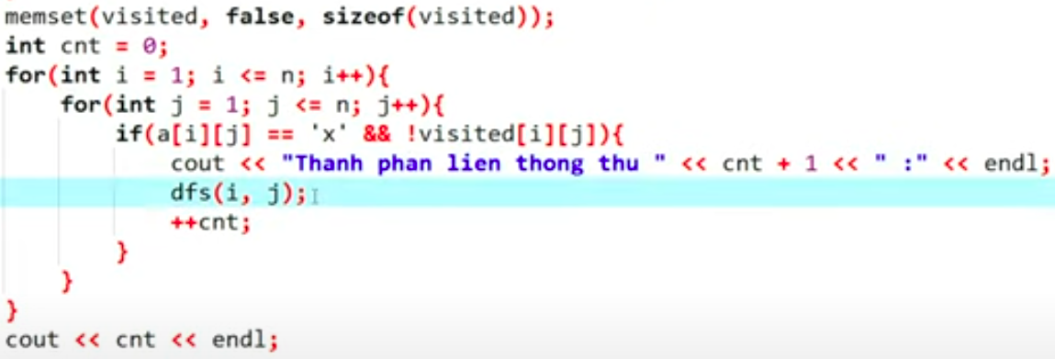

bool bfs ( i,j ) {
// do clean
// do sth 1
// Step1 : do init local
// init queue and clean queue
queue<pair<int,int>> q;
q.push ( {i,j} )
// do mark : visited; arr: TODO: can clone new arr2
visited [i][j] = true;
arr[i][j] = “UN_ACCEPT”;
// Step 2 : Loop when queue empty
while (!q.empty) {
// get vertex in q
pair<int,int> top = q.front();
q.pop
// do sth 2
// visited vertex
for (int k < 4) {
int i1 = top.first + dx[k];
int j1 = top.second + dy[k];
// check size
if(i1 >= 1 && i1 <= maxC \
&& j1 >= 1 && j1 <= maxR) {
if (a[i1][j1] == MARK_ACCEPT) {
if(!visited[i1][j1]) {
// do sth 3
q.push( {i1,j1} )
// do sth 4 cout >> i,j
}
}
} else { // do sth 5 }
// do sth 6
}
// do sth 7
}
// do sth 8
return false;
}

at dfs(i,j) add do sth 1 check if (arr[i][j] == “DISTINATION”) return true;
at bfs(i,j) add do sth 1
mark arr[i][j] UN_ACCEPT
mark d[i][j] = 0;
at bfs – add do sth 3
d[i1][j1] = d[top.first][top.second];
check if (arr[i][j] == “DISTINATION”) return true;
at bfs – add do sth 4 mark UN_ACCEPT
findShortestPathNoWeight {





