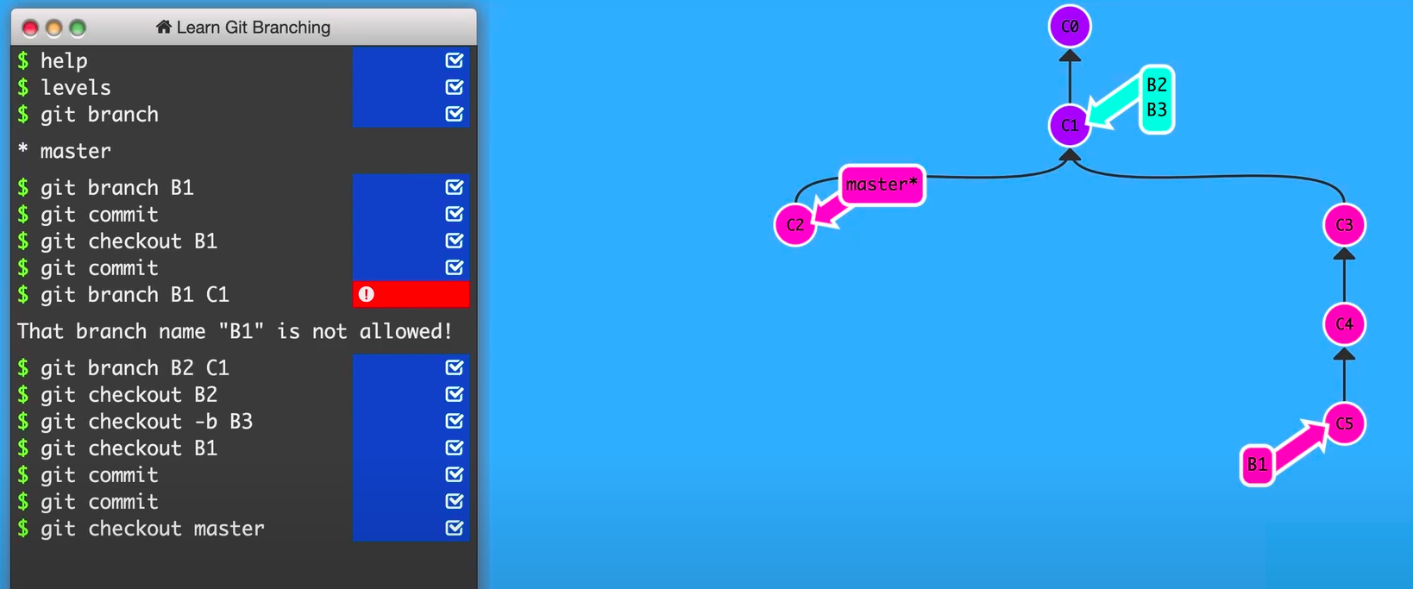

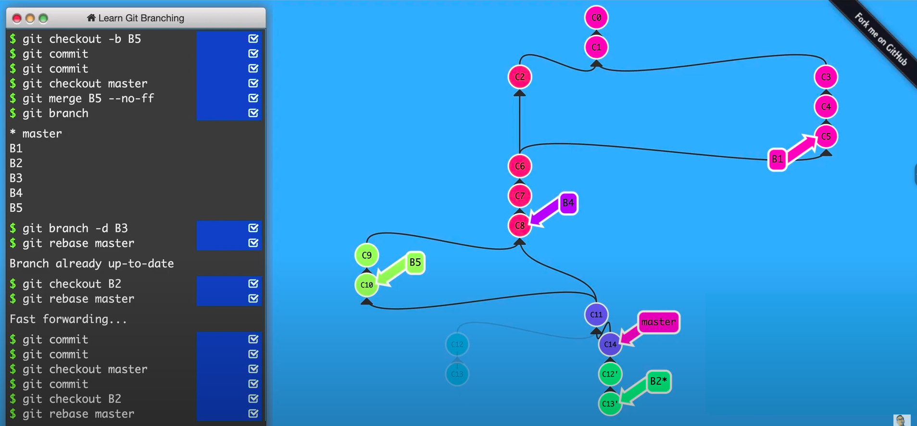
GIT ADVANDCE

git commit -a -m "msg title"

-a : = git add .

git commit --amend -a
--amend := add new change&merge + edit -m msg title

git push --force
--force := override WARRNIGGGGGGGGG
NOTE: If use force NOT RESET repo because it delete ALL COMMIT

git log --online
:= history

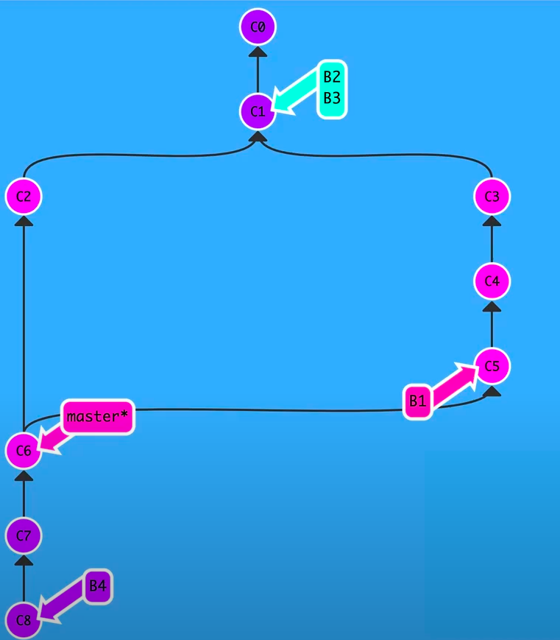

NO FAST FORWARD

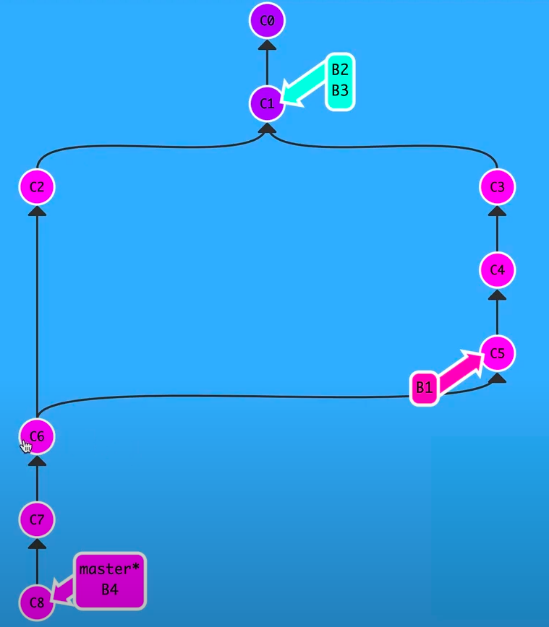
git merge --no-ff
:= no fast forward to save explicit history

git checkout B2
git rebase master
:= add subcommit point to continue master. Unit calc is master.

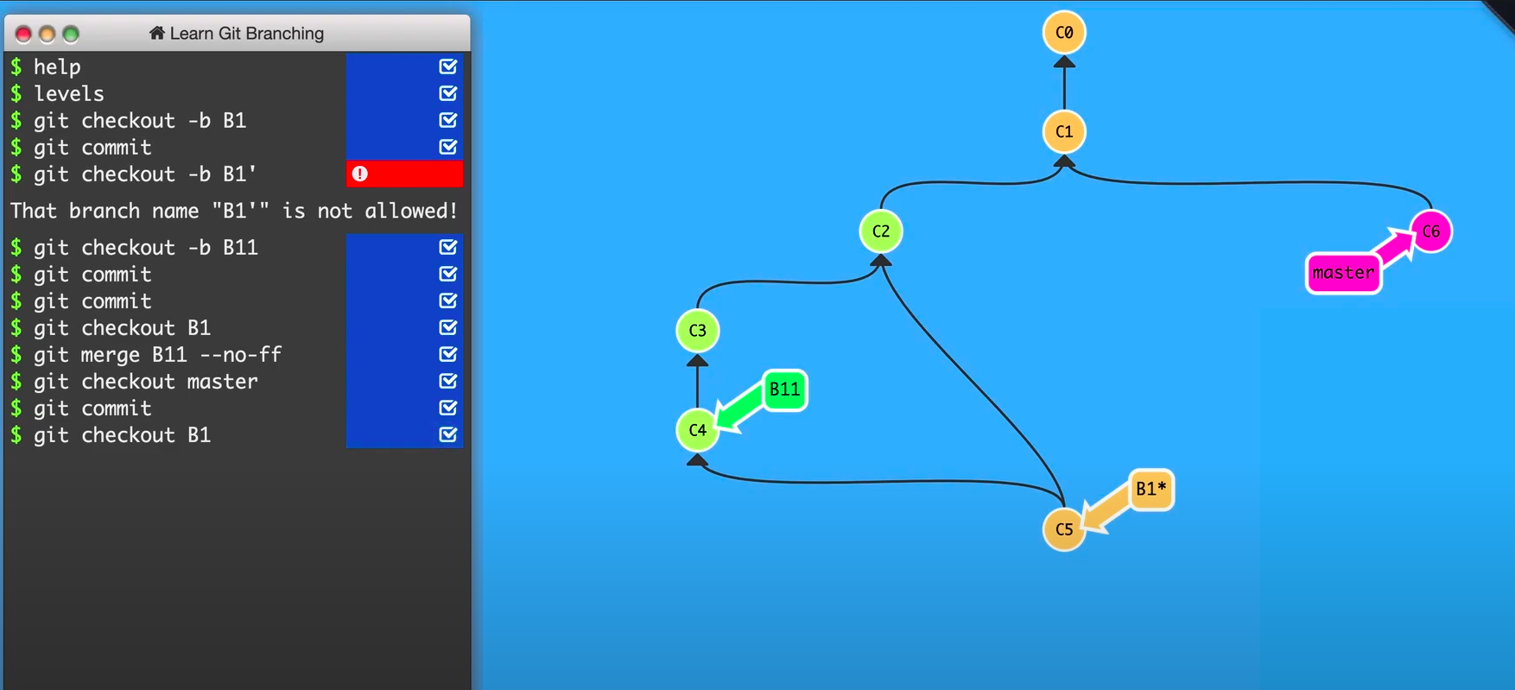
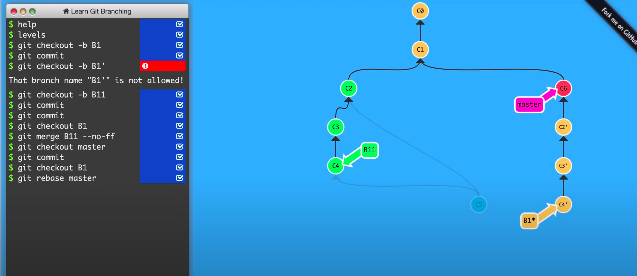
WRONG: When Commit C5: merge b11 + C2(b1) => to B1. DONT USE rebase only. Bc it explicit (every one not clear source of c2’ c3’ c4’)
USE : rebase –preserve-merges

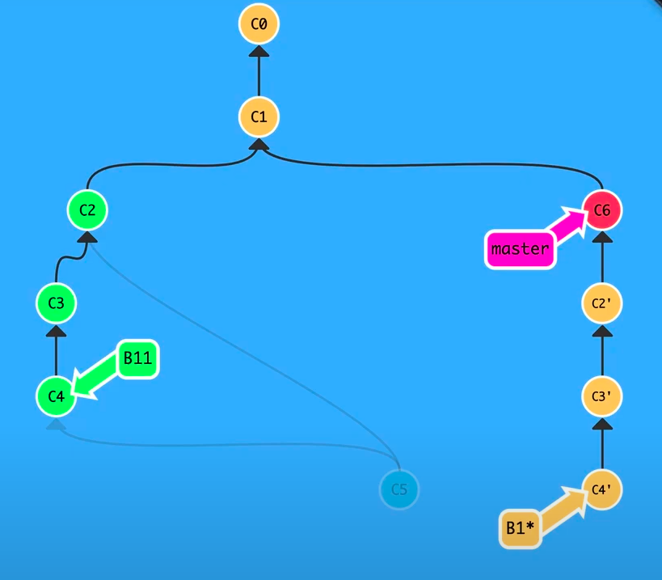
git reset - -hard C2

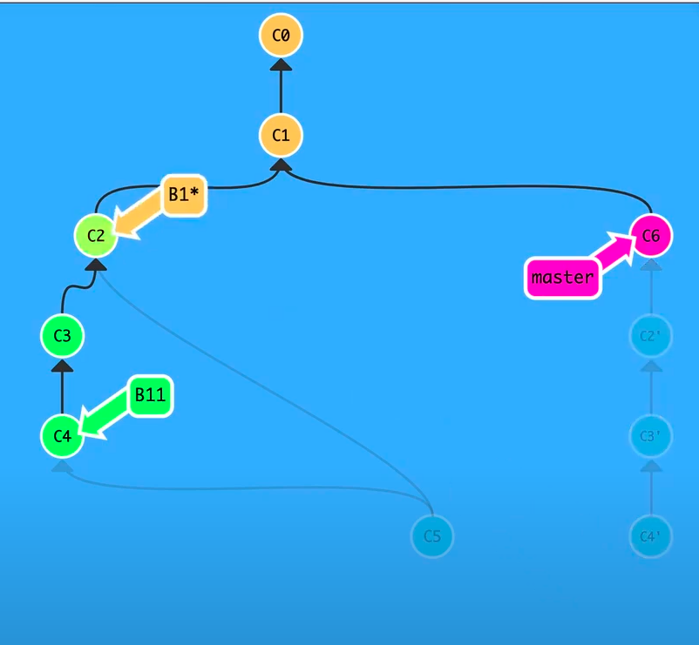
git merge B11 --no-ff

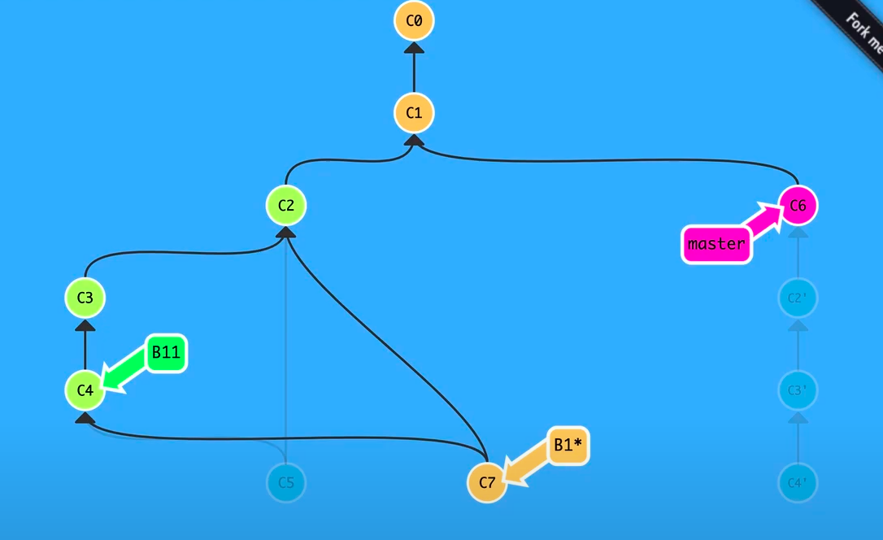
git checkout B1
git rebase master - -preserve- -merges
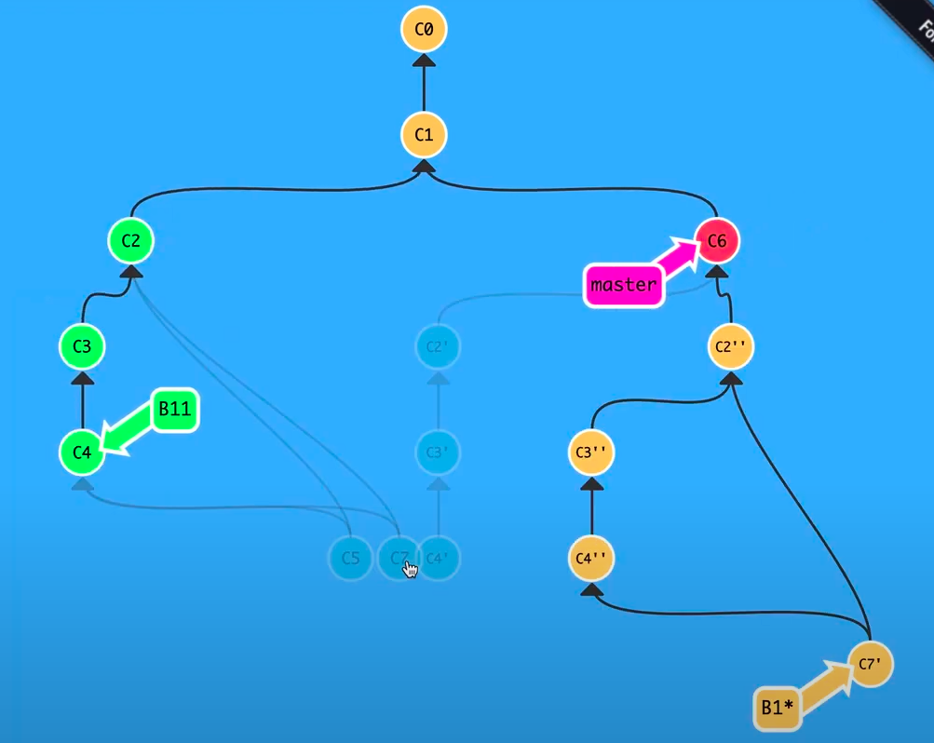

squash:

git rebase B1 -i
:= interaction squash commit : change commit = squash

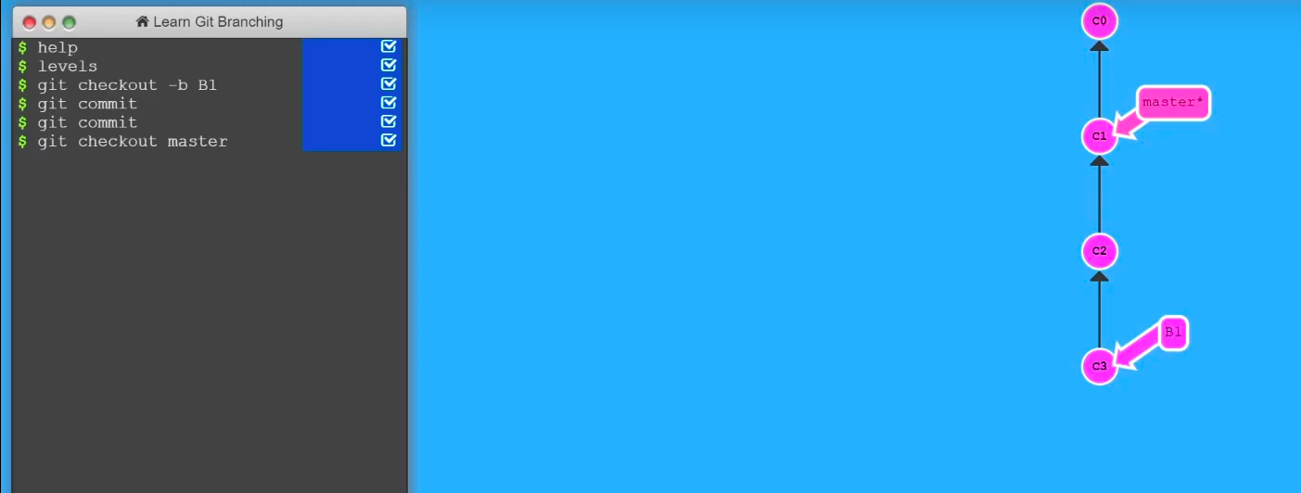
git cherry-pick C2

