Bài tập thực hành

Lab 1

Bài tập 1

Bước 1: Tạo dự án
Tạo Project → Bacsic Views Activity → lequochuy_1150070016
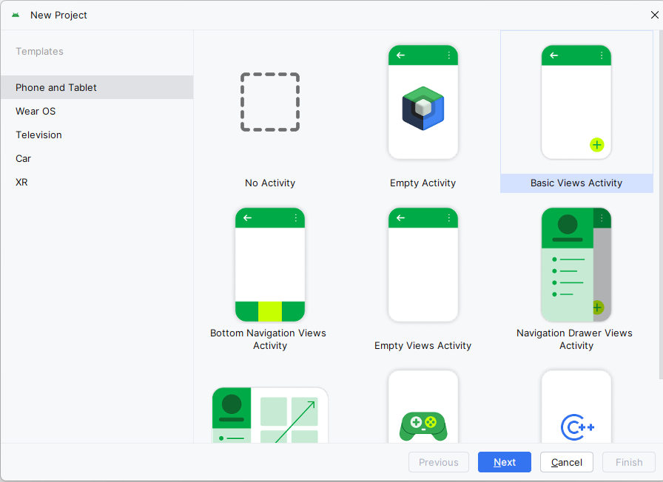

Bước 2: Thiết kế giao diện activity_main.xml
<?xml version="1.0" encoding="utf-8"?>
<LinearLayout xmlns:android="http://schemas.android.com/apk/res/android"
android:layout_width="match_parent"
android:layout_height="match_parent"
android:orientation="vertical"
android:padding="16dp">
<TextView
android:id="@+id/tvTitle"
android:layout_width="wrap_content"
android:layout_height="wrap_content"
android:text="@string/app_name"
android:textSize="20sp"
android:textStyle="bold"
android:layout_marginBottom="12dp" />
<EditText
android:id="@+id/edtSo1"
android:layout_width="match_parent"
android:layout_height="wrap_content"
android:hint="@string/so_thu_nhat"
android:inputType="numberDecimal"
android:layout_marginBottom="8dp" />
<EditText
android:id="@+id/edtSo2"
android:layout_width="match_parent"
android:layout_height="wrap_content"
android:hint="@string/so_thu_hai"
android:inputType="numberDecimal"
android:layout_marginBottom="12dp" />
<TextView
android:id="@+id/tvKetQua"
android:layout_width="match_parent"
android:layout_height="wrap_content"
android:text="@string/ket_qua_mac_dinh"
android:textSize="18sp"
android:layout_marginBottom="16dp" />
<LinearLayout
android:layout_width="match_parent"
android:layout_height="wrap_content"
android:orientation="horizontal"
android:weightSum="5">
<Button
android:id="@+id/btnCong"
android:layout_width="0dp"
android:layout_height="wrap_content"
android:layout_weight="1"
android:text="@string/btn_cong" />
<Button
android:id="@+id/btnTru"
android:layout_width="0dp"
android:layout_height="wrap_content"
android:layout_weight="1"
android:text="@string/btn_tru" />
<Button
android:id="@+id/btnNhan"
android:layout_width="0dp"
android:layout_height="wrap_content"
android:layout_weight="1"
android:text="@string/btn_nhan" />
<Button
android:id="@+id/btnChia"
android:layout_width="0dp"
android:layout_height="wrap_content"
android:layout_weight="1"
android:text="@string/btn_chia" />
<Button
android:id="@+id/btnMod"
android:layout_width="0dp"
android:layout_height="wrap_content"
android:layout_weight="1"
android:text="@string/btn_mod" />
</LinearLayout>
</LinearLayout>
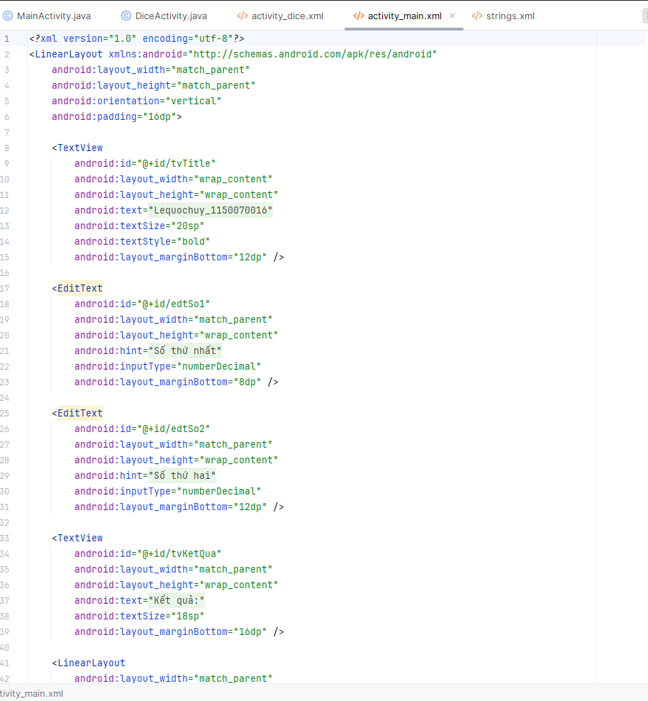

Bước 3: Khai báo chuỗi ở strings.xml
<string name="so_thu_nhat">Số thứ nhất</string>
<string name="so_thu_hai">Số thứ hai</string>
<string name="ket_qua_mac_dinh">Kết quả: </string>
<string name="btn_cong">+</string>
<string name="btn_tru">-</string>
<string name="btn_nhan">*</string>
<string name="btn_chia">/</string>
<string name="btn_mod">%</string>
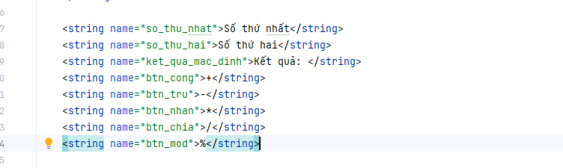

Bước 4: Ánh xạ control MainActivity.java
package com.example.lequochuy_1150070016;
import androidx.appcompat.app.AppCompatActivity;
import android.os.Bundle;
import android.view.View;
import android.widget.Button;
import android.widget.EditText;
import android.widget.TextView;
public class MainActivity extends AppCompatActivity {
EditText edtSo1, edtSo2;
TextView tvKetQua;
Button btnCong, btnTru, btnNhan, btnChia, btnMod;
@Override
protected void onCreate(Bundle savedInstanceState) {
super.onCreate(savedInstanceState);
setContentView(R.layout.activity_main);
initControl();
initEvent();
}
private void initControl() {
edtSo1 = findViewById(R.id.edtSo1);
edtSo2 = findViewById(R.id.edtSo2);
tvKetQua = findViewById(R.id.tvKetQua);
btnCong = findViewById(R.id.btnCong);
btnTru = findViewById(R.id.btnTru);
btnNhan = findViewById(R.id.btnNhan);
btnChia = findViewById(R.id.btnChia);
btnMod = findViewById(R.id.btnMod);
}
private void initEvent() {
btnCong.setOnClickListener(new View.OnClickListener() {
@Override
public void onClick(View v) {
tinh("+");
}
});
btnTru.setOnClickListener(new View.OnClickListener() {
@Override
public void onClick(View v) {
tinh("-");
}
});
btnNhan.setOnClickListener(new View.OnClickListener() {
@Override
public void onClick(View v) {
tinh("*");
}
});
btnChia.setOnClickListener(new View.OnClickListener() {
@Override
public void onClick(View v) {
tinh("/");
}
});
btnMod.setOnClickListener(new View.OnClickListener() {
@Override
public void onClick(View v) {
tinh("%");
}
});
}
private void tinh(String op) {
String s1 = edtSo1.getText().toString().trim();
String s2 = edtSo2.getText().toString().trim();
if (s1.isEmpty() || s2.isEmpty()) {
tvKetQua.setText("Nhập đủ số");
return;
}
double a = Double.parseDouble(s1);
double b = Double.parseDouble(s2);
double kq = 0;
if (op.equals("+")) kq = a + b;
else if (op.equals("-")) kq = a - b;
else if (op.equals("*")) kq = a * b;
else if (op.equals("/")) {
if (b == 0) {
tvKetQua.setText("Không chia được");
return;
}
kq = a / b;
} else if (op.equals("%")) {
if (b == 0) {
tvKetQua.setText("Không chia được");
return;
}
kq = a % b;
}
tvKetQua.setText(String.valueOf(kq));
}
}

Kết quả
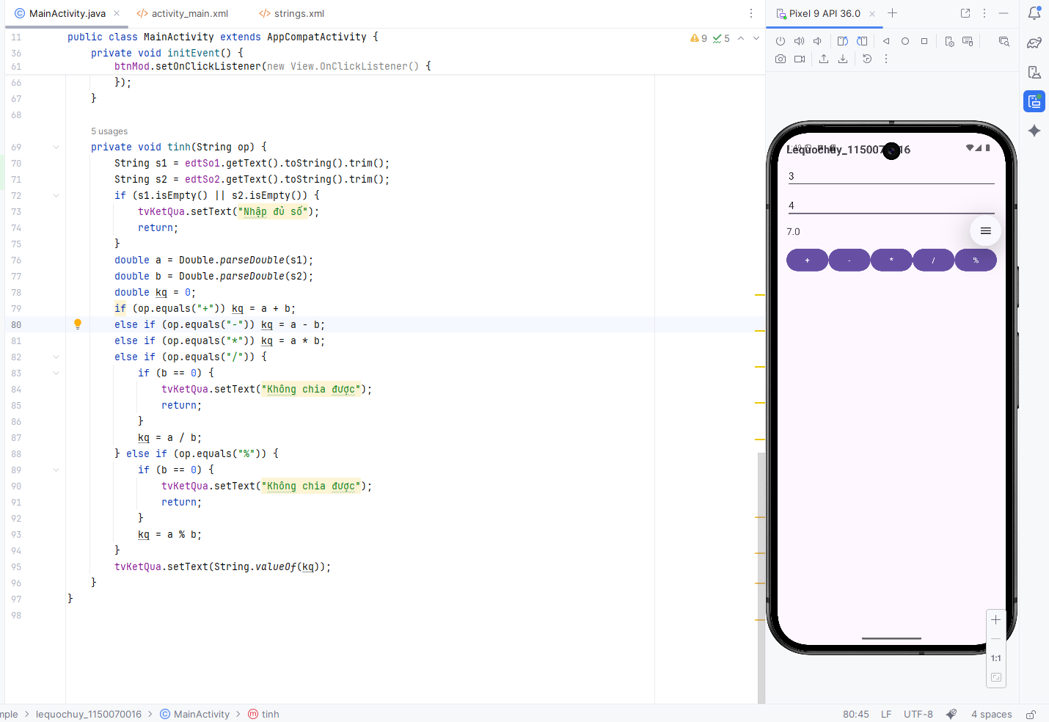

Bài tập 2

Bước 1: Tạo Activity mới tên DiceActivity

Bước 2: Thiết kế giao diện activity_dice.xml
<?xml version="1.0" encoding="utf-8"?>
<LinearLayout xmlns:android="http://schemas.android.com/apk/res/android"
android:layout_width="match_parent"
android:layout_height="match_parent"
android:orientation="vertical"
android:gravity="center"
android:padding="16dp">
<TextView
android:id="@+id/txtNumber"
android:layout_width="wrap_content"
android:layout_height="wrap_content"
android:text="@string/title_number_default"
android:textSize="40sp"
android:layout_marginBottom="16dp" />
<Button
android:id="@+id/btnRandom"
android:layout_width="wrap_content"
android:layout_height="wrap_content"
android:text="@string/btn_random" />
<ImageView
android:id="@+id/imgDice"
android:layout_width="150dp"
android:layout_height="150dp"
android:layout_marginTop="32dp"
android:src="@drawable/dice1" />
<Button
android:id="@+id/btnRoll"
android:layout_width="wrap_content"
android:layout_height="wrap_content"
android:text="@string/btn_roll"
android:layout_marginTop="16dp" />
</LinearLayout>
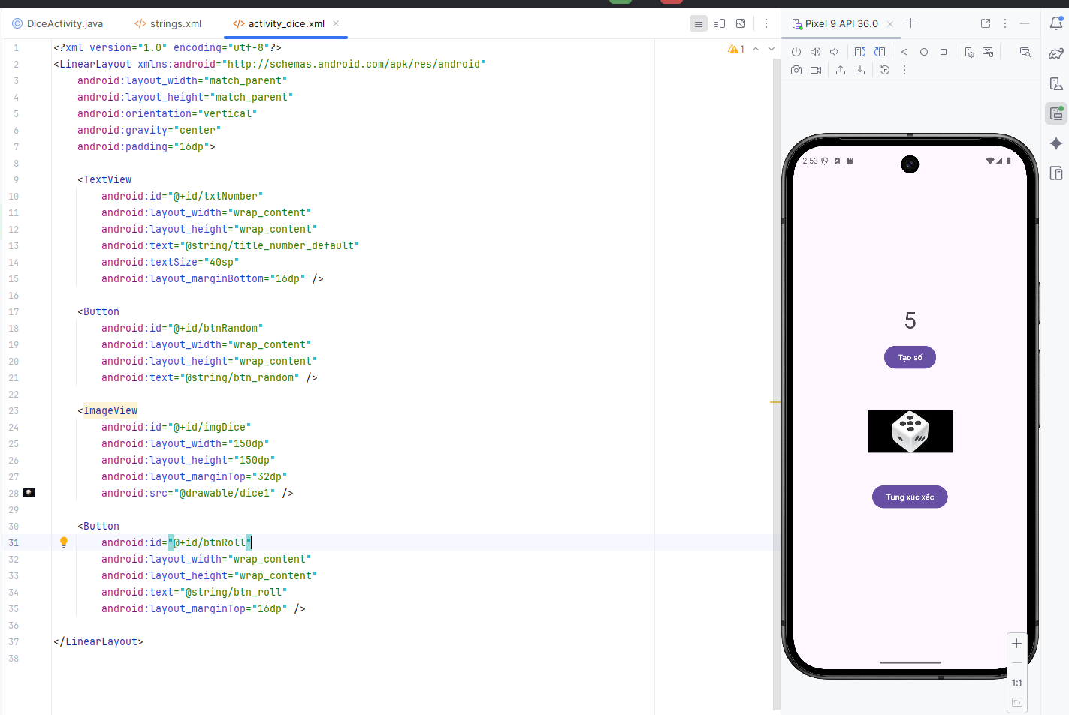

Bước 3: Khai báo chuỗi ở strings.xml
<string name="dice_number_default">0</string>
<string name="btn_random">Tạo số</string>
<string name="btn_roll">Tung xúc xắc</string>
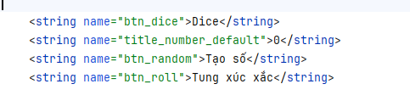

Bước 4: Chuẩn bị hình trong drawable
Thêm 6 hình xúc xắc vào res/drawable với tên
dice1, dice2, dice3, dice4, dice5, dice6
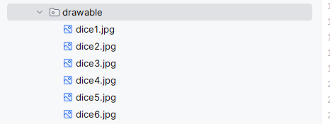

Bước 5: Code xử lý trong DiceActivity.java
package com.example.lequochuy_1150070016;
import androidx.appcompat.app.AppCompatActivity;
import android.os.Bundle;
import android.view.View;
import android.widget.Button;
import android.widget.ImageView;
import android.widget.TextView;
import java.util.Random;
public class DiceActivity extends AppCompatActivity {
TextView txtNumber;
Button btnRandom, btnRoll;
ImageView imgDice;
Random random = new Random();
@Override
protected void onCreate(Bundle savedInstanceState) {
super.onCreate(savedInstanceState);
setContentView(R.layout.activity_dice);
txtNumber = findViewById(R.id.txtNumber);
btnRandom = findViewById(R.id.btnRandom);
btnRoll = findViewById(R.id.btnRoll);
imgDice = findViewById(R.id.imgDice);
btnRandom.setOnClickListener(new View.OnClickListener() {
@Override
public void onClick(View v) {
int face = random.nextInt(6) + 1;
txtNumber.setText(String.valueOf(face));
showFace(face);
}
});
btnRoll.setOnClickListener(new View.OnClickListener() {
@Override
public void onClick(View v) {
int face = random.nextInt(6) + 1;
txtNumber.setText(String.valueOf(face));
showFace(face);
}
});
}
private void showFace(int face) {
switch (face) {
case 1:
imgDice.setImageResource(R.drawable.dice1);
break;
case 2:
imgDice.setImageResource(R.drawable.dice2);
break;
case 3:
imgDice.setImageResource(R.drawable.dice3);
break;
case 4:
imgDice.setImageResource(R.drawable.dice4);
break;
case 5:
imgDice.setImageResource(R.drawable.dice5);
break;
case 6:
imgDice.setImageResource(R.drawable.dice6);
break;
}
}
}
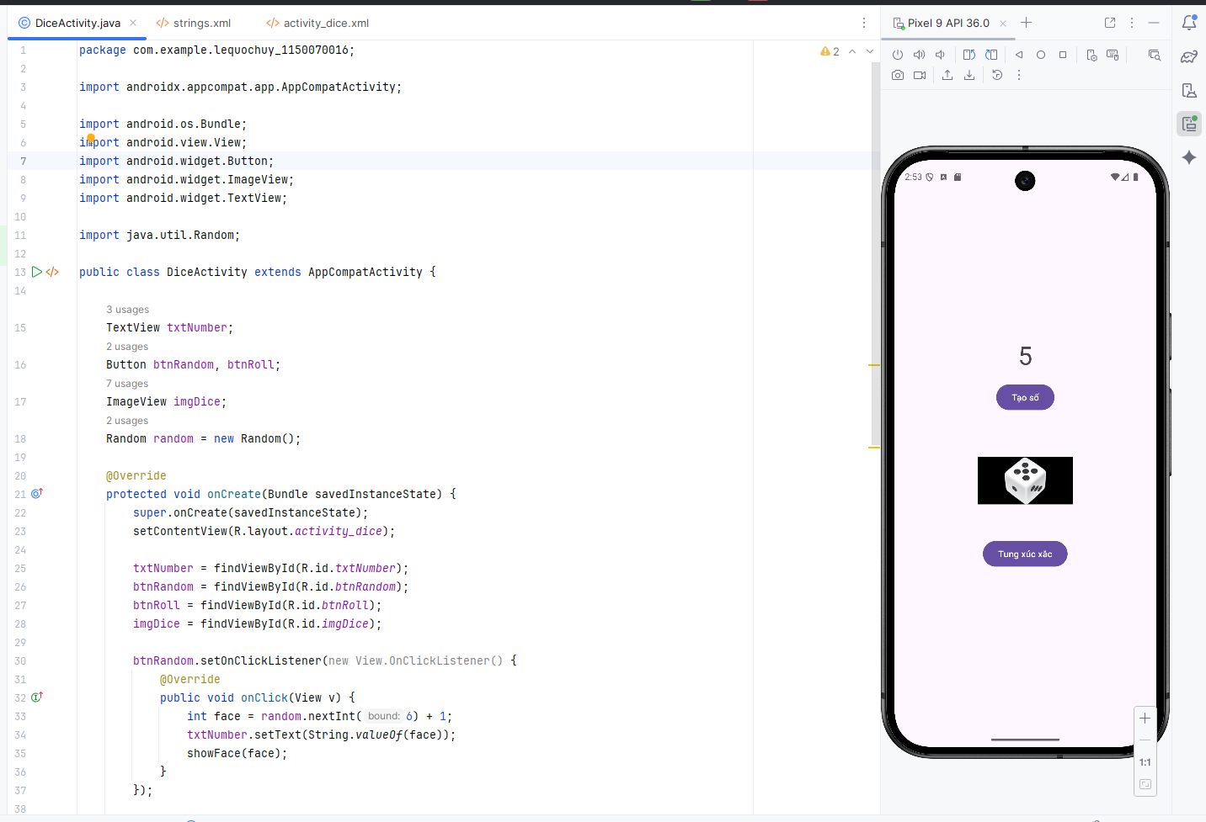

Bước 6: Khai báo Activity trong AndroidManifest.xml
<activity android:name=".DiceActivity" />
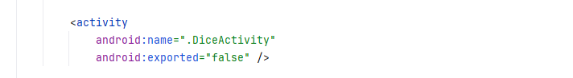

Bước 7: Mở từ MainActivity
Nếu bạn muốn từ bài 1 bấm nút để qua bài 2 thì trong activity_main.xml thêm 1 nút
<Button
android:id="@+id/btnDice"
android:layout_width="wrap_content"
android:layout_height="wrap_content"
android:text="@string/btn_dice" />
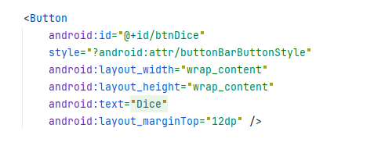
và trong MainActivity.java:
Button btnDice = findViewById(R.id.btnDice);
btnDice.setOnClickListener(new View.OnClickListener() {
@Override
public void onClick(View v) {
Intent i = new Intent(MainActivity.this, DiceActivity.class);
startActivity(i);
}
});
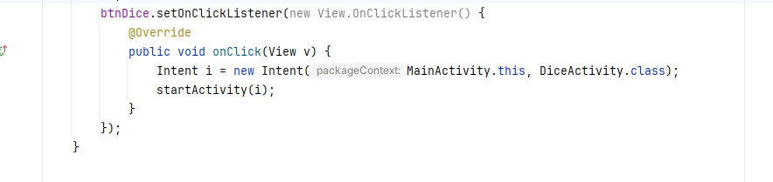

Kết quả
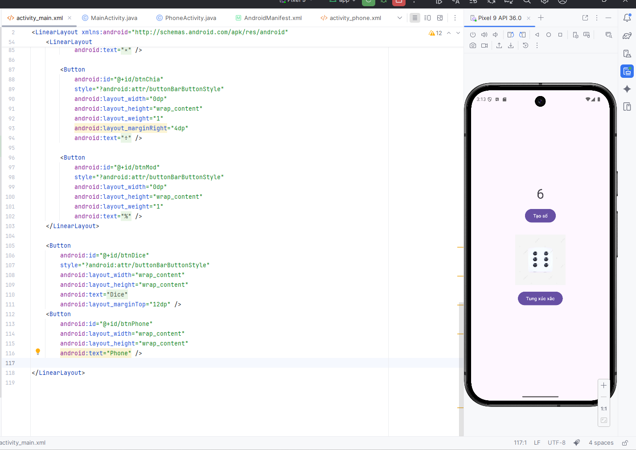

Bài tập 3

Bước 1: Tạo Activity PhoneActivity

Bước 2: Thiết kế giao diện activity_phone.xml
<?xml version="1.0" encoding="utf-8"?>
<LinearLayout xmlns:android="http://schemas.android.com/apk/res/android"
android:layout_width="match_parent"
android:layout_height="match_parent"
android:orientation="vertical"
android:padding="16dp">
<TextView
android:id="@+id/tvTitlePhone"
android:layout_width="wrap_content"
android:layout_height="wrap_content"
android:text="@string/title_phone"
android:textSize="20sp"
android:textStyle="bold"
android:layout_marginBottom="12dp" />
<EditText
android:id="@+id/edtPhone"
android:layout_width="match_parent"
android:layout_height="wrap_content"
android:hint="@string/hint_phone"
android:inputType="phone"
android:layout_marginBottom="8dp" />
<EditText
android:id="@+id/edtSms"
android:layout_width="match_parent"
android:layout_height="wrap_content"
android:hint="@string/hint_sms"
android:inputType="text"
android:minLines="3"
android:gravity="top"
android:layout_marginBottom="16dp" />
<LinearLayout
android:layout_width="match_parent"
android:layout_height="wrap_content"
android:orientation="horizontal"
android:weightSum="2">
<Button
android:id="@+id/btnCall"
android:layout_width="0dp"
android:layout_height="wrap_content"
android:layout_weight="1"
android:text="@string/btn_call" />
<Button
android:id="@+id/btnSms"
android:layout_width="0dp"
android:layout_height="wrap_content"
android:layout_weight="1"
android:text="@string/btn_sms" />
</LinearLayout
</LinearLayout>
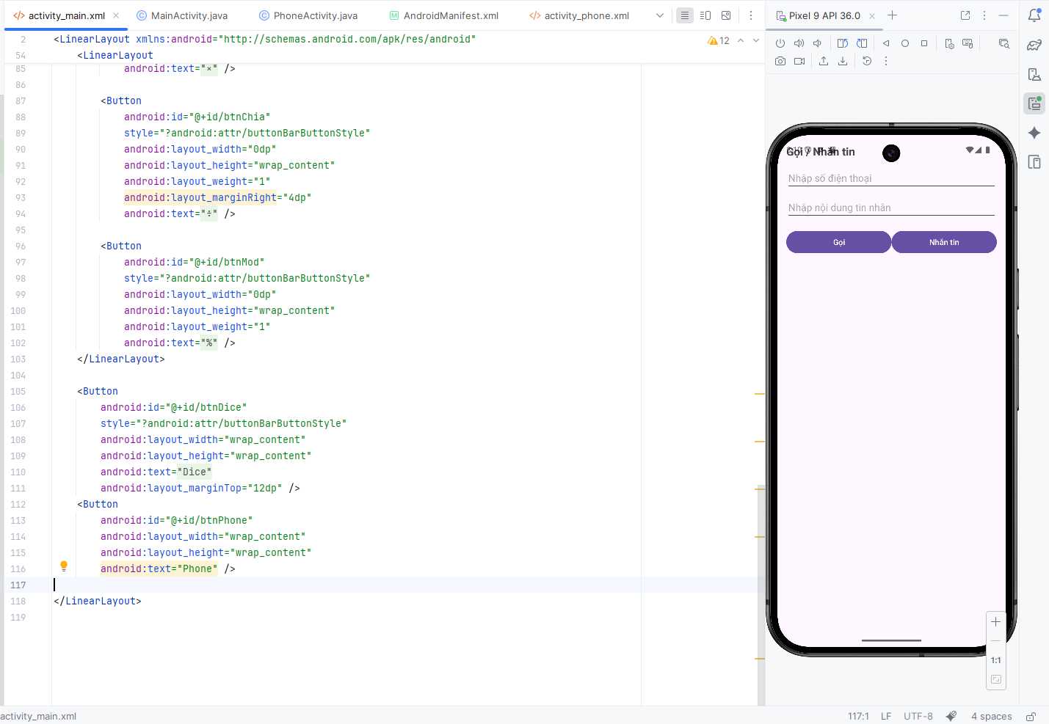

Bước 3: Khai báo chuỗi ở strings.xml
<string name="title_phone">Gọi / Nhắn tin</string>
<string name="hint_phone">Nhập số điện thoại</string>
<string name="hint_sms">Nhập nội dung tin nhắn</string>
<string name="btn_call">Gọi</string>
<string name="btn_sms">Nhắn tin</string>
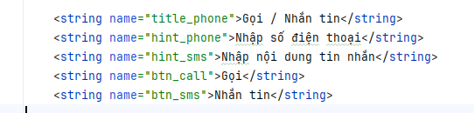

Bước 4: Xử lý trong PhoneActivity.java
package com.example.lequochuy_1150070016;
import androidx.appcompat.app.AppCompatActivity;
import android.content.Intent;
import android.net.Uri;
import android.os.Bundle;
import android.view.View;
import android.widget.Button;
import android.widget.EditText;
public class PhoneActivity extends AppCompatActivity {
EditText edtPhone, edtSms;
Button btnCall, btnSms;
@Override
protected void onCreate(Bundle savedInstanceState) {
super.onCreate(savedInstanceState);
setContentView(R.layout.activity_phone);
edtPhone = findViewById(R.id.edtPhone);
edtSms = findViewById(R.id.edtSms);
btnCall = findViewById(R.id.btnCall);
btnSms = findViewById(R.id.btnSms);
btnCall.setOnClickListener(new View.OnClickListener() {
@Override
public void onClick(View v) {
String phone = edtPhone.getText().toString().trim();
if (phone.isEmpty()) return;
Intent intent = new Intent(Intent.ACTION_DIAL, Uri.parse("tel:" + phone));
startActivity(intent);
}
});
btnSms.setOnClickListener(new View.OnClickListener() {
@Override
public void onClick(View v) {
String phone = edtPhone.getText().toString().trim();
String msg = edtSms.getText().toString().trim();
if (phone.isEmpty()) return;
Intent intent = new Intent(Intent.ACTION_SENDTO, Uri.parse("smsto:" + phone));
intent.putExtra("sms_body", msg);
startActivity(intent);
}
});
}
}
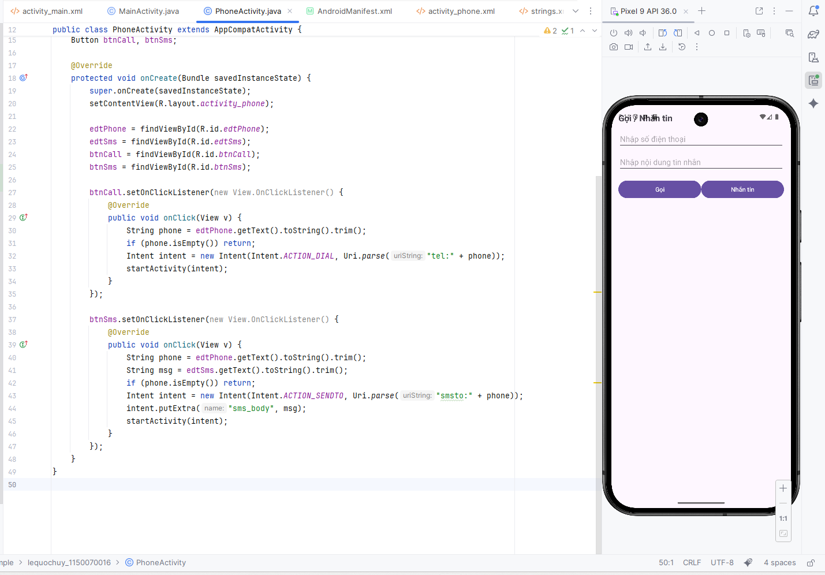

Bước 5: Khai báo Activity trong AndroidManifest.xml
<activity android:name=".PhoneActivity" />

Bước 6: Mở từ MainActivity
Nếu bạn muốn từ bài 1 bấm để mở bài 3, thì trong activity_main.xml thêm 1 nút:
<Button
android:id="@+id/btnPhone"
android:layout_width="wrap_content"
android:layout_height="wrap_content"
android:text="Phone" />
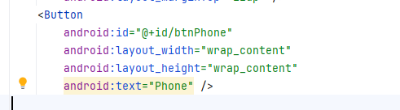
và trong MainActivity.java:
Button btnPhone = findViewById(R.id.btnPhone);
btnPhone.setOnClickListener(v -> {
Intent i = new Intent(MainActivity.this, PhoneActivity.class);
startActivity(i);
});
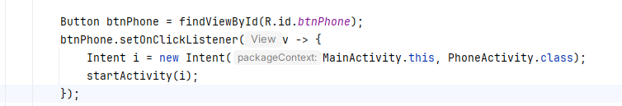

Kết quả
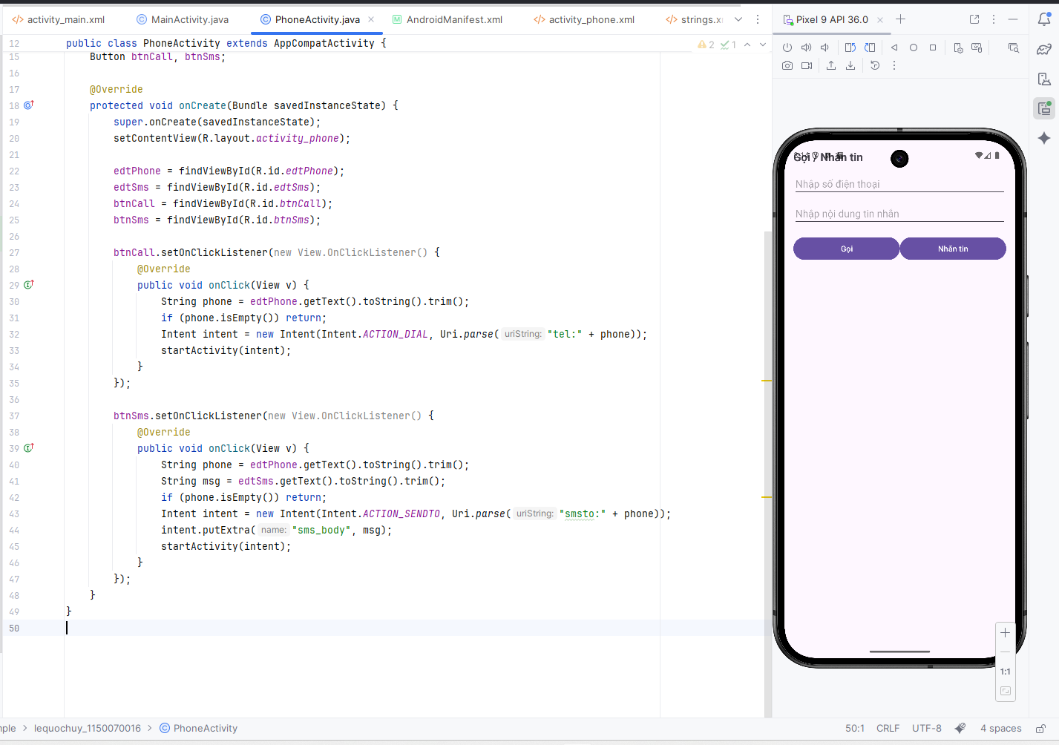

Lab 2

Bài tập 1

Bước 1: Tạo Activity SplashActivity

Bước 2: Thiết kế giao diện activity_splash.xml
<?xml version="1.0" encoding="utf-8"?>
<LinearLayout xmlns:android="http://schemas.android.com/apk/res/android"
android:id="@+id/rootSplash"
android:layout_width="match_parent"
android:layout_height="match_parent"
android:orientation="vertical"
android:gravity="center"
android:padding="16dp">
<ImageView
android:id="@+id/imgAnimal"
android:layout_width="128dp"
android:layout_height="128dp"
android:src="@drawable/ic_penguin" />
<TextView
android:id="@+id/tvTitle"
android:layout_width="wrap_content"
android:layout_height="wrap_content"
android:layout_marginTop="12dp"
android:text="@string/app_name"
android:textSize="22sp"
android:textStyle="bold" />
</LinearLayout>
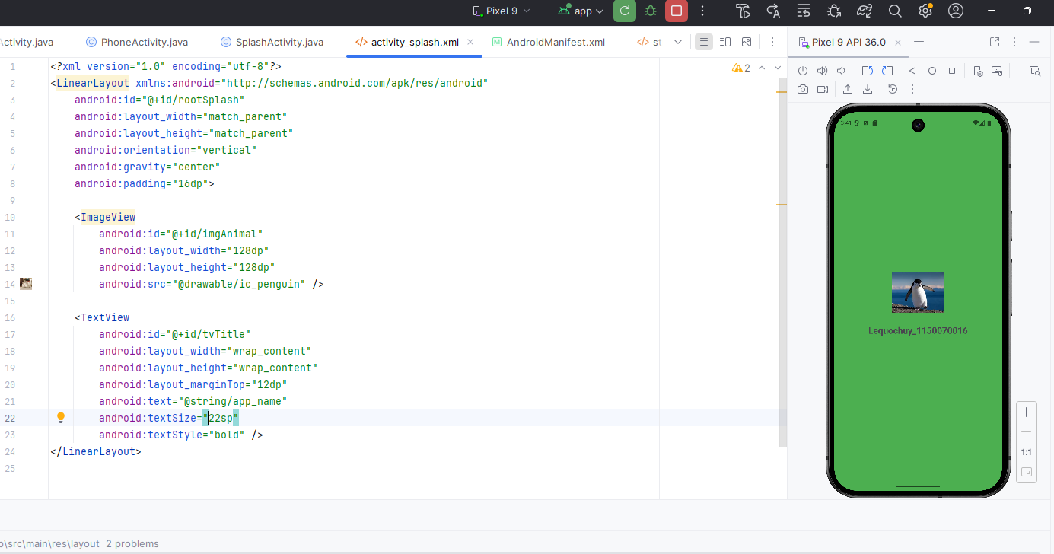

Bước 3: Khai báo chuỗi ở strings.xml
<string name="splash_title">Animal sound</string>

Bước 4: Chuẩn bị tài nguyên
colors.xml
<color name="splash_1">#3F51B5</color>
<color name="splash_2">#FF9800</color>
<color name="splash_3">#4CAF50</color>
<color name="splash_4">#9C27B0</color>
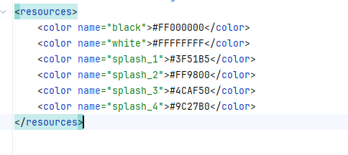
ic_penguin.png, ic_cat.png, ic_dog.png, ic_lion.png
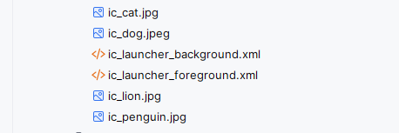

Bước 5: Code xử lý trong SplashActivity.java
package com.example.lequochuy_1150070016;
import androidx.appcompat.app.AppCompatActivity;
import android.os.Bundle;
import android.widget.ImageView;
import android.widget.LinearLayout;
import java.util.Random;
public class SplashActivity extends AppCompatActivity {
LinearLayout rootSplash;
ImageView imgAnimal;
int[] bgColors = {
R.color.splash_1,
R.color.splash_2,
R.color.splash_3,
R.color.splash_4
};
int[] animalIcons = {
R.drawable.ic_penguin,
R.drawable.ic_cat,
R.drawable.ic_dog,
R.drawable.ic_lion
};
@Override
protected void onCreate(Bundle savedInstanceState) {
super.onCreate(savedInstanceState);
setContentView(R.layout.activity_splash);
rootSplash = findViewById(R.id.rootSplash);
imgAnimal = findViewById(R.id.imgAnimal);
Random random = new Random();
int colorIndex = random.nextInt(bgColors.length);
rootSplash.setBackgroundColor(getResources().getColor(bgColors[colorIndex]));
int iconIndex = random.nextInt(animalIcons.length);
imgAnimal.setImageResource(animalIcons[iconIndex]);
}
}
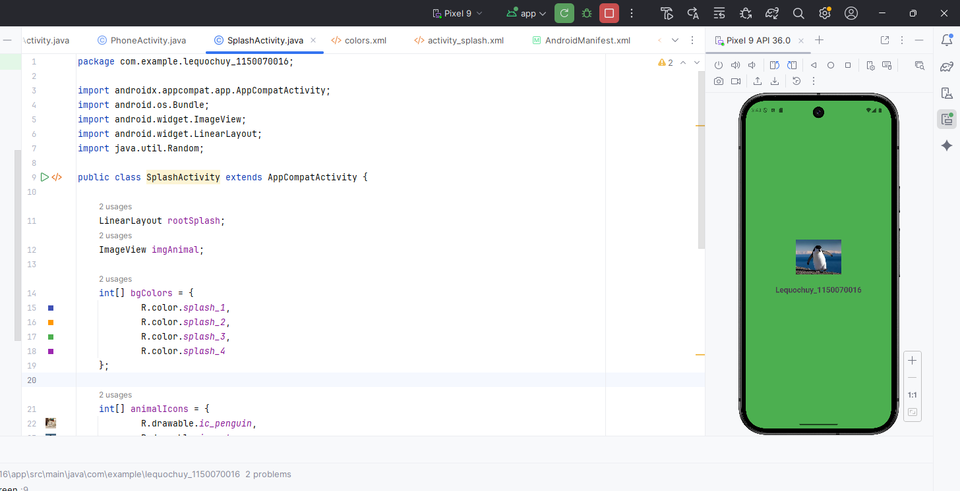

Bước 6: Khai báo Activity trong AndroidManifest.xml
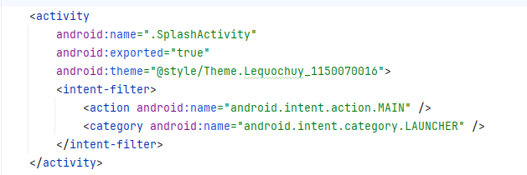

Kết quả
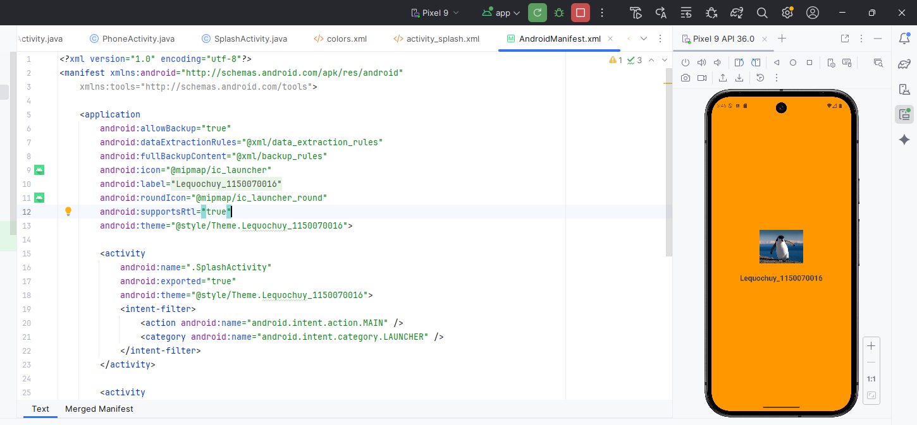

Bài tập 2

Bước 1: Tạo layout loading riêng item_loading.xml
<?xml version="1.0" encoding="utf-8"?>
<LinearLayout xmlns:android="http://schemas.android.com/apk/res/android"
android:layout_width="match_parent"
android:layout_height="match_parent"
android:orientation="vertical"
android:gravity="center"
android:background="#BF000000"> <!-- nền đen mờ -->
<ProgressBar
android:layout_width="60dp"
android:layout_height="60dp"
android:indeterminate="true"
android:indeterminateTint="@android:color/white" />

<TextView
android:layout_width="wrap_content"
android:layout_height="wrap_content"
android:layout_marginTop="10dp"
android:text="@string/txt_loading"
android:textColor="@android:color/white"
android:textSize="16sp" />
</LinearLayout>
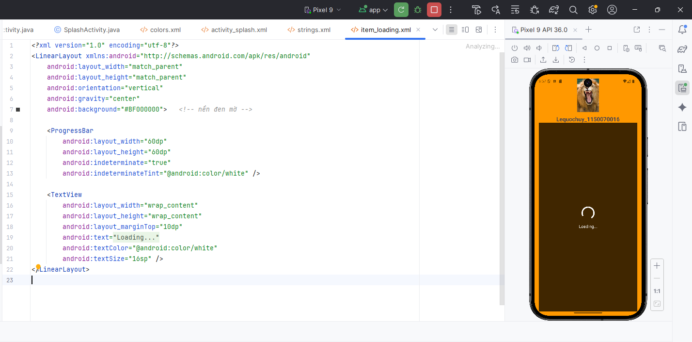

Bước 2: Khai báo chuỗi trong strings.xml
<string name="txt_loading">Loading...</string>

Bước 3: Sửa layout màn hình splash để đè loading lên
<?xml version="1.0" encoding="utf-8"?>
<LinearLayout xmlns:android="http://schemas.android.com/apk/res/android"
android:id="@+id/rootSplash"
android:layout_width="match_parent"
android:layout_height="match_parent"
android:orientation="vertical"
android:gravity="center"
android:padding="16dp">
<ImageView
android:id="@+id/imgAnimal"
android:layout_width="128dp"
android:layout_height="128dp"
android:src="@drawable/ic_penguin" />
<TextView
android:id="@+id/tvTitle"
android:layout_width="wrap_content"
android:layout_height="wrap_content"
android:layout_marginTop="12dp"
android:text="@string/app_name"
android:textSize="22sp"
android:textStyle="bold" />
<include
android:id="@+id/viewLoading"
layout="@layout/item_loading" />
</LinearLayout>

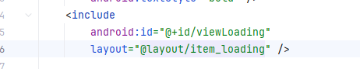

Bước 4: Thêm code SplashActivity
package com.example.lequochuy_1150070016;
import androidx.appcompat.app.AppCompatActivity;
import android.os.Bundle;
import android.view.View;
import android.widget.ImageView;
import android.widget.LinearLayout;
import java.util.Random;
public class SplashActivity extends AppCompatActivity {
private LinearLayout rootSplash;
private ImageView imgAnimal;
private View viewLoading;
private final int[] bgColors = {
R.color.splash_1,
R.color.splash_2,
R.color.splash_3,
R.color.splash_4
};
private final int[] animalIcons = {
R.drawable.ic_penguin,
R.drawable.ic_cat,
R.drawable.ic_dog,
R.drawable.ic_lion
};
@Override
protected void onCreate(Bundle savedInstanceState) {
super.onCreate(savedInstanceState);
setContentView(R.layout.activity_splash);
viewLoading = findViewById(R.id.viewLoading);
rootSplash = findViewById(R.id.rootSplash);
imgAnimal = findViewById(R.id.imgAnimal);
Random random = new Random();
int colorIndex = random.nextInt(bgColors.length);
rootSplash.setBackgroundColor(
getResources().getColor(bgColors[colorIndex])
);
int iconIndex = random.nextInt(animalIcons.length);
imgAnimal.setImageResource(animalIcons[iconIndex]);
}
}
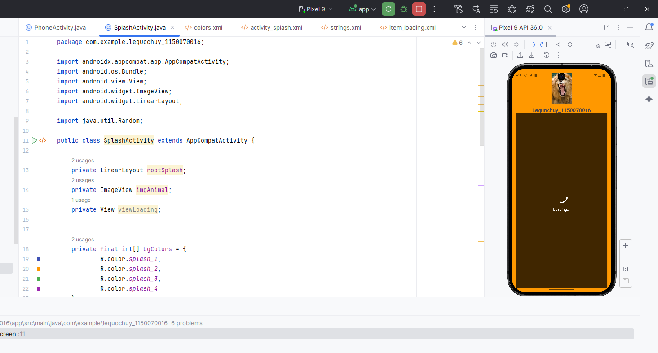

Kết quả
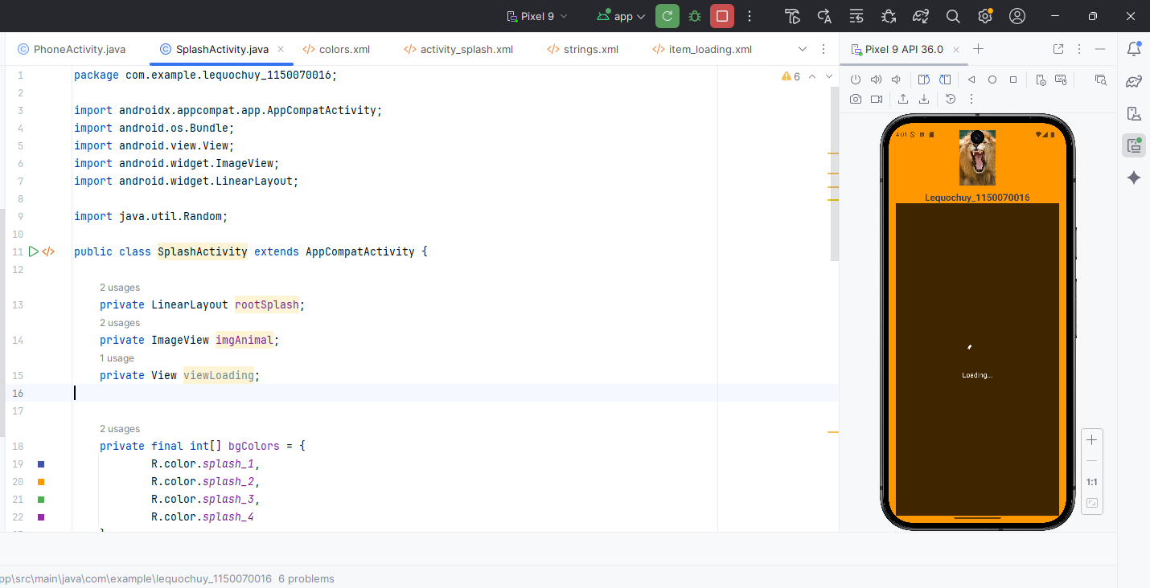

Bài tập 3

Bước 1: Chuẩn bị layout có ImageView activity_splash.xml
<?xml version="1.0" encoding="utf-8"?>
<FrameLayout xmlns:android="http://schemas.android.com/apk/res/android"
android:layout_width="match_parent"
android:layout_height="match_parent">
<LinearLayout
android:id="@+id/rootSplash"
android:layout_width="match_parent"
android:layout_height="match_parent"
android:orientation="vertical"
android:gravity="center"
android:padding="16dp">
<ImageView
android:id="@+id/imgAnimal"
android:layout_width="128dp"
android:layout_height="128dp"
android:src="@drawable/ic_penguin" />
<TextView
android:id="@+id/tvTitle"
android:layout_width="wrap_content"
android:layout_height="wrap_content"
android:layout_marginTop="12dp"
android:text="@string/app_name"
android:textSize="22sp"
android:textStyle="bold" />
</LinearLayout>
<include
android:id="@+id/viewLoading"
layout="@layout/item_loading" />
</FrameLayout>
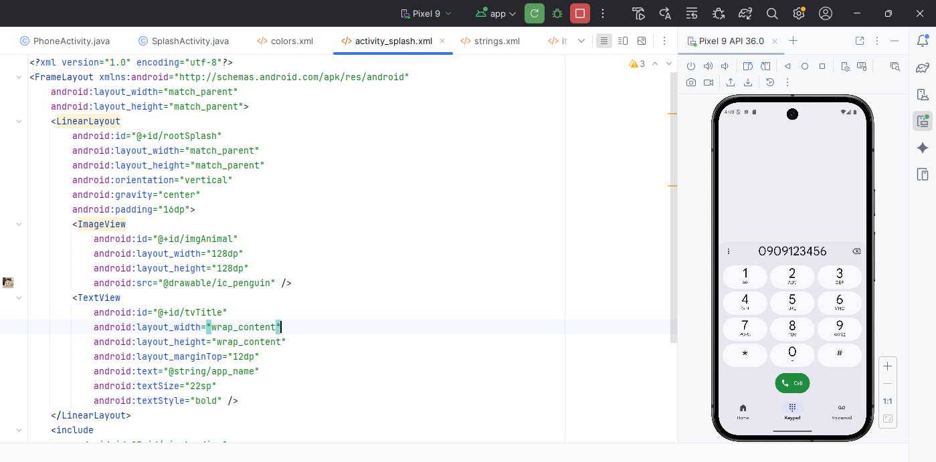

Bước 2: Viết code trong SplashActivity
package com.example.lequochuy_1150070016;

import androidx.appcompat.app.AppCompatActivity;
import android.content.Intent;
import android.net.Uri;
import android.os.Bundle;
import android.view.View;
import android.widget.ImageView;
import android.widget.LinearLayout;
import java.util.Random;
public class SplashActivity extends AppCompatActivity {
LinearLayout rootSplash;
ImageView imgAnimal;
View viewLoading;
int[] bgColors = {
R.color.splash_1,
R.color.splash_2,
R.color.splash_3,
R.color.splash_4
};
int[] animalIcons = {
R.drawable.ic_penguin,
R.drawable.ic_cat,
R.drawable.ic_dog,
R.drawable.ic_lion
};
@Override
protected void onCreate(Bundle savedInstanceState) {
super.onCreate(savedInstanceState);
setContentView(R.layout.activity_splash);
viewLoading = findViewById(R.id.viewLoading);
rootSplash = findViewById(R.id.rootSplash);
imgAnimal = findViewById(R.id.imgAnimal);
Random random = new Random();
int colorIndex = random.nextInt(bgColors.length);
rootSplash.setBackgroundColor(getResources().getColor(bgColors[colorIndex]));
int iconIndex = random.nextInt(animalIcons.length);
imgAnimal.setImageResource(animalIcons[iconIndex]);
imgAnimal.setOnClickListener(new View.OnClickListener() {
@Override
public void onClick(View v) {
String phone = "0909123456";
Intent intent = new Intent(Intent.ACTION_DIAL,
Uri.parse("tel:" + phone));
startActivity(intent);
}
});
}
}
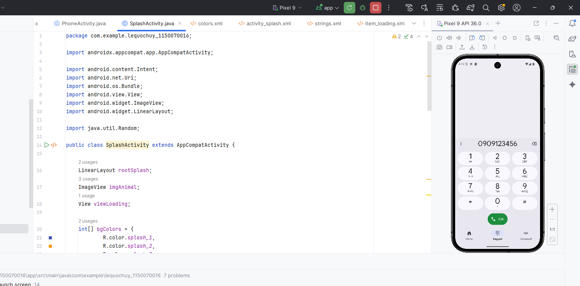

Kết quả
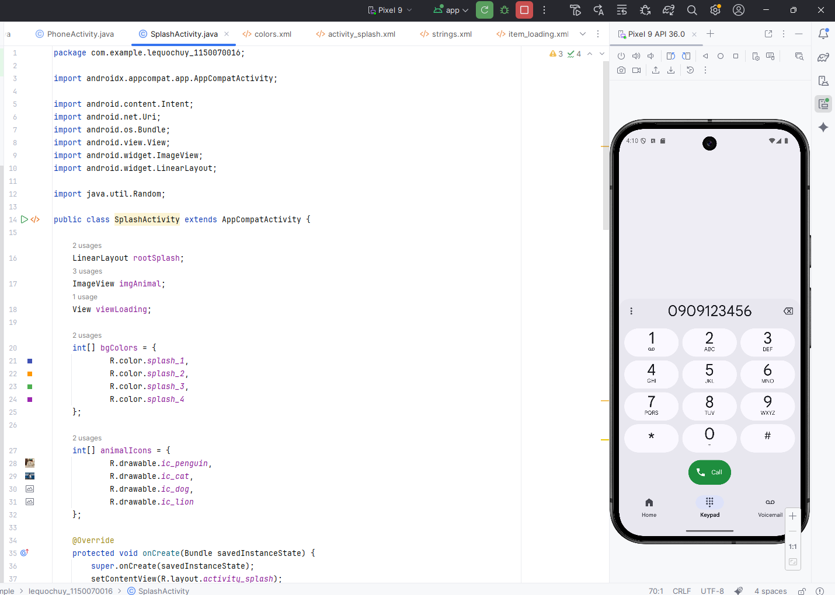

Bài tập 4

Bước 1: Thiết kế giao diện activity_main.xml
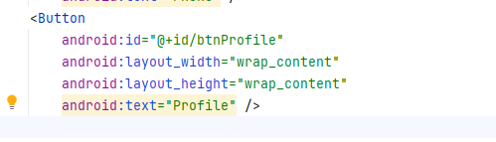

Bước 2: Thêm nút trong MainActivity.java
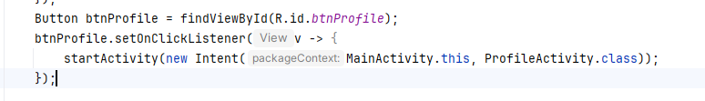

Kết quả
