Bài tập thực hành
Lê Quốc Huy _số máy 15

Bài 1 Xây dựng chương trình đổi tiền tệ

Bước 1: Tạo layout cho activity_main.xml
<?xml version="1.0" encoding="utf-8"?>
<LinearLayout xmlns:android="http://schemas.android.com/apk/res/android"
android:layout_width="match_parent"
android:layout_height="match_parent"
android:orientation="vertical"
android:padding="16dp">
<TextView
android:id="@+id/txtTitle"
android:layout_width="wrap_content"
android:layout_height="wrap_content"
android:text="@string/app_name"
android:textSize="22sp"
android:textStyle="bold" />
<TextView
android:id="@+id/txtAuthor"
android:layout_width="wrap_content"
android:layout_height="wrap_content"
android:text="@string/author"
android:layout_marginTop="4dp" />
<TextView
android:id="@+id/txtComputer"
android:layout_width="wrap_content"
android:layout_height="wrap_content"
android:text="@string/computer"
android:layout_marginBottom="16dp" />
<EditText
android:id="@+id/edtAmount"
android:layout_width="match_parent"
android:layout_height="wrap_content"
android:hint="@string/textbox_hint"
android:inputType="numberDecimal" />
<TableLayout
android:layout_width="match_parent"
android:layout_height="wrap_content"
android:layout_marginTop="16dp">
<TableRow
android:layout_width="match_parent"
android:layout_height="wrap_content">
<ImageView
android:id="@+id/imgFrom"
android:layout_width="40dp"
android:layout_height="24dp"
android:layout_marginEnd="8dp" />
<Spinner
android:id="@+id/spnFrom"
android:layout_width="0dp"
android:layout_height="wrap_content"
android:layout_weight="1" />
</TableRow>
<TableRow
android:layout_width="match_parent"
android:layout_height="wrap_content"
android:layout_marginTop="8dp">
<ImageView
android:id="@+id/imgTo"
android:layout_width="40dp"
android:layout_height="24dp"
android:layout_marginEnd="8dp" />
<Spinner
android:id="@+id/spnTo"
android:layout_width="0dp"
android:layout_height="wrap_content"
android:layout_weight="1" />
</TableRow>
</TableLayout>
<Button
android:id="@+id/btnConvert"
android:layout_width="match_parent"
android:layout_height="wrap_content"
android:text="@string/convert_button"
android:layout_marginTop="16dp" />
<TextView
android:id="@+id/txtResult"
android:layout_width="wrap_content"
android:layout_height="wrap_content"
android:text="@string/result_label"
android:layout_marginTop="16dp"
android:textSize="18sp" />
</LinearLayout>
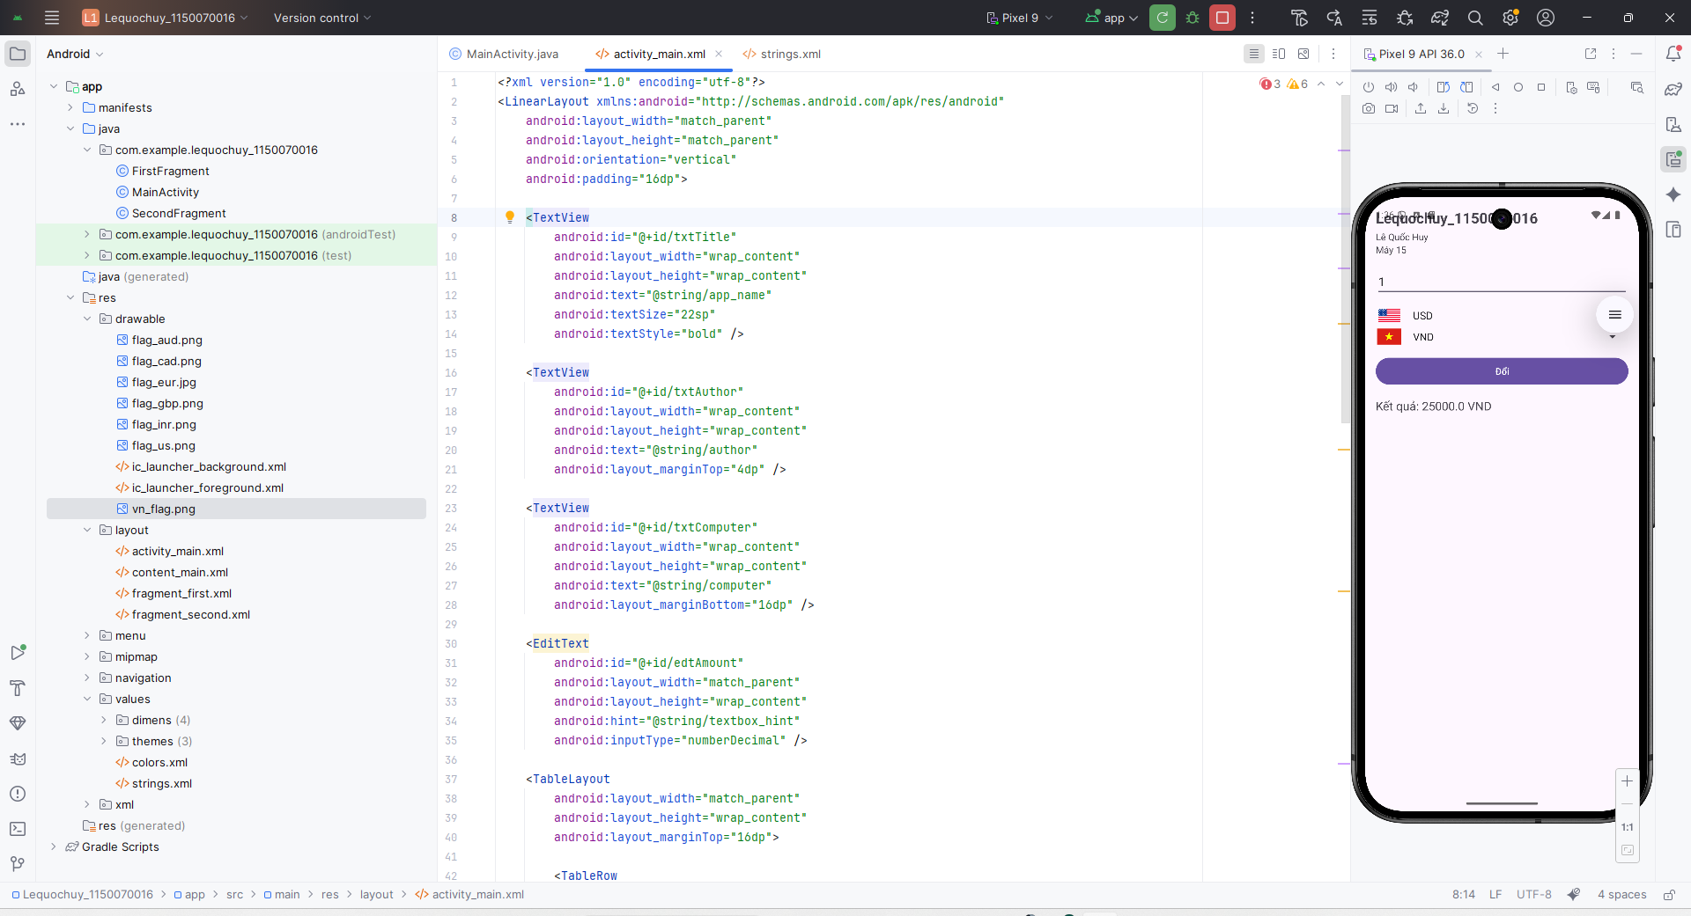

Bước 2: Khai báo chuỗi trong strings.xml
<string name="author">Lê Quốc Huy</string>
<string name="computer">Máy 15</string>
<string name="textbox_hint">Nhập số tiền</string>
<string name="convert_button">Đổi</string>
<string name="result_label">Kết quả:</string>
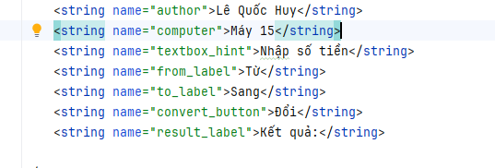

Bước 3: Thêm hình cờ vào drawable
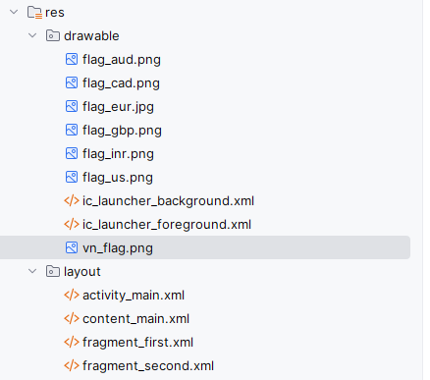

Bước 4: Cấu hình class MainActivity.java
package com.example.lequochuy_1150070016;
import androidx.appcompat.app.AppCompatActivity;
import android.os.Bundle;
import android.view.View;
import android.widget.AdapterView;
import android.widget.ArrayAdapter;
import android.widget.Button;
import android.widget.EditText;
import android.widget.ImageView;
import android.widget.Spinner;
import android.widget.TextView;
import android.widget.Toast;
public class MainActivity extends AppCompatActivity {
private String[] units = {
"USD", "EUR", "GBP", "INR",
"AUD", "CAD", "ZAR", "NZD",
"JPY", "VND"
};
private int[] flagRes = {
R.drawable.flag_us,
R.drawable.flag_eur,
R.drawable.flag_gbp,
R.drawable.flag_inr,
R.drawable.flag_aud,
R.drawable.flag_cad,
0,
0,
0,
R.drawable.vn_flag
};
private double[][] rate = {
{1.0, 0.9, 0.8, 83, 1.5, 1.4, 19, 1.6, 150, 25000},
{1.1, 1.0, 0.88, 90, 1.6, 1.5, 20, 1.7, 160, 27000},
{1.25, 1.14, 1.0, 100, 1.8, 1.7, 22, 1.9, 180, 30000},
{0.012, 0.011, 0.01, 1.0, 0.018, 0.017, 0.22, 0.019, 1.8, 300},
{0.67, 0.62, 0.56, 55, 1.0, 0.95, 13, 1.1, 120, 19000},
{0.7, 0.65, 0.59, 58, 1.05, 1.0, 13.5, 1.15, 125, 20000},
{0.053, 0.05, 0.045, 4.5, 0.077, 0.074, 1.0, 0.085, 9, 1500},
{0.63, 0.59, 0.53, 53, 0.95, 0.87, 12, 1.0, 110, 18000},
{0.0067, 0.0062, 0.0056, 0.56, 0.0083, 0.008, 0.11, 0.009, 1.0, 160},
{0.00004, 0.000037, 0.000033, 0.0033, 0.000053, 0.00005, 0.00067, 0.000055, 0.0063, 1.0}
};
private EditText edtAmount;
private Spinner spnFrom, spnTo;
private Button btnConvert;
private TextView txtResult;
private ImageView imgFrom, imgTo;
@Override
protected void onCreate(Bundle savedInstanceState) {
super.onCreate(savedInstanceState);
setContentView(R.layout.activity_main);
edtAmount = findViewById(R.id.edtAmount);
spnFrom = findViewById(R.id.spnFrom);
spnTo = findViewById(R.id.spnTo);
btnConvert = findViewById(R.id.btnConvert);
txtResult = findViewById(R.id.txtResult);
imgFrom = findViewById(R.id.imgFrom);
imgTo = findViewById(R.id.imgTo);
ArrayAdapter<String> adapter = new ArrayAdapter<>(
this,
android.R.layout.simple_spinner_item,
units
);
adapter.setDropDownViewResource(android.R.layout.simple_spinner_dropdown_item);
spnFrom.setAdapter(adapter);
spnTo.setAdapter(adapter);
spnFrom.setSelection(0);
spnTo.setSelection(units.length - 1);
setFlag(imgFrom, 0);
setFlag(imgTo, units.length - 1);
spnFrom.setOnItemSelectedListener(new AdapterView.OnItemSelectedListener() {
@Override
public void onItemSelected(AdapterView<?> parent, View view, int position, long id) {
setFlag(imgFrom, position);
}
@Override
public void onNothingSelected(AdapterView<?> parent) {
}
});
spnTo.setOnItemSelectedListener(new AdapterView.OnItemSelectedListener() {
@Override
public void onItemSelected(AdapterView<?> parent, View view, int position, long id) {
setFlag(imgTo, position);
}
@Override
public void onNothingSelected(AdapterView<?> parent) {
}
});
btnConvert.setOnClickListener(new View.OnClickListener() {
@Override
public void onClick(View v) {
convertMoney();
}
});
}
private void setFlag(ImageView img, int index) {
int resId = flagRes[index];
if (resId != 0) {
img.setImageResource(resId);
} else {
img.setImageDrawable(null);
}
}
private void convertMoney() {
String sAmount = edtAmount.getText().toString().trim();
if (sAmount.isEmpty()) {
Toast.makeText(this, "Vui lòng nhập số tiền", Toast.LENGTH_SHORT).show();
return;
}
double amount = Double.parseDouble(sAmount);
int fromIndex = spnFrom.getSelectedItemPosition();
int toIndex = spnTo.getSelectedItemPosition();
double result = amount * rate[fromIndex][toIndex];
String unitTo = units[toIndex];
txtResult.setText("Kết quả: " + result + " " + unitTo);
}
}
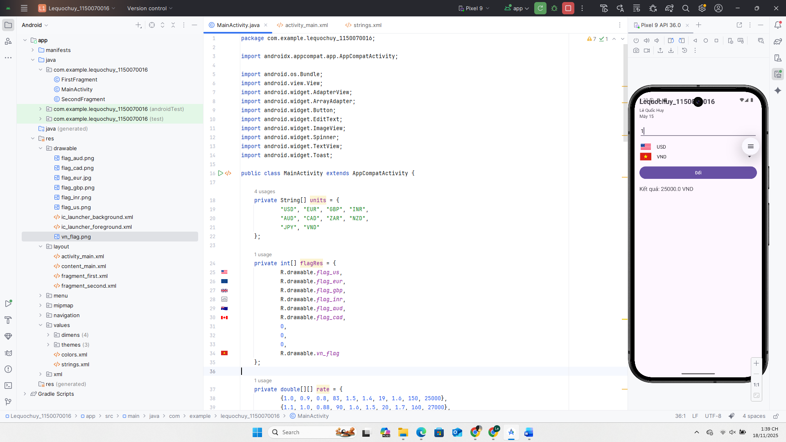

Kết quả:
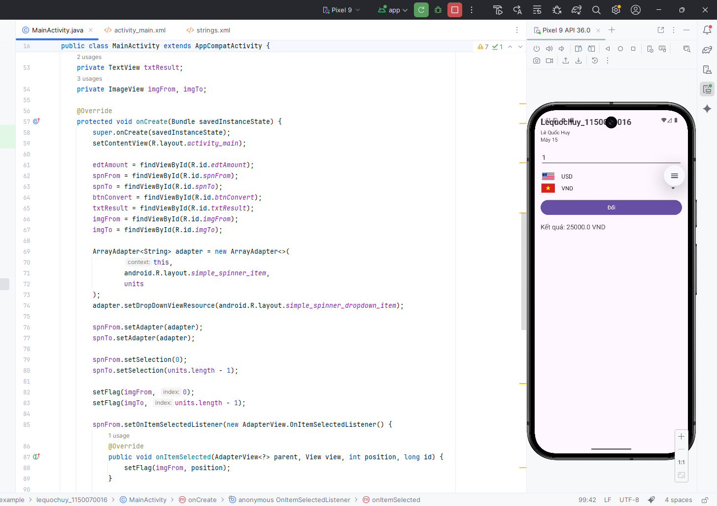

Bài tập chương trình đổi độ dài

Bước 1: Tạo layout activity_length.xml
<?xml version="1.0" encoding="utf-8"?>
<LinearLayout xmlns:android="http://schemas.android.com/apk/res/android"
android:layout_width="match_parent"
android:layout_height="match_parent"
android:orientation="vertical"
android:background="#FFFFFF"
android:paddingTop="24dp">
<LinearLayout
android:layout_width="match_parent"
android:layout_height="wrap_content"
android:orientation="horizontal"
android:paddingLeft="8dp"
android:paddingRight="8dp"
android:paddingTop="8dp"
android:paddingBottom="4dp">
<EditText
android:id="@+id/edtValue"
android:layout_width="0dp"
android:layout_height="wrap_content"
android:layout_weight="1"
android:hint="@string/hint_value"
android:inputType="numberDecimal"
android:text="1.23" />
<Spinner
android:id="@+id/spnUnit"
android:layout_width="wrap_content"
android:layout_height="wrap_content"
android:layout_marginLeft="8dp" />
</LinearLayout>
<TextView
android:id="@+id/txtHeader"
android:layout_width="match_parent"
android:layout_height="wrap_content"
android:text="@string/header_text"
android:textStyle="bold"
android:textAllCaps="true"
android:paddingLeft="8dp"
android:paddingTop="4dp"
android:paddingBottom="4dp"
android:background="#00796B"
android:textColor="#FFFF00" />
<ListView
android:id="@+id/lvResult"
android:layout_width="match_parent"
android:layout_height="0dp"
android:layout_weight="1"
android:dividerHeight="1dp"
android:background="#FFFFFF" />
</LinearLayout>
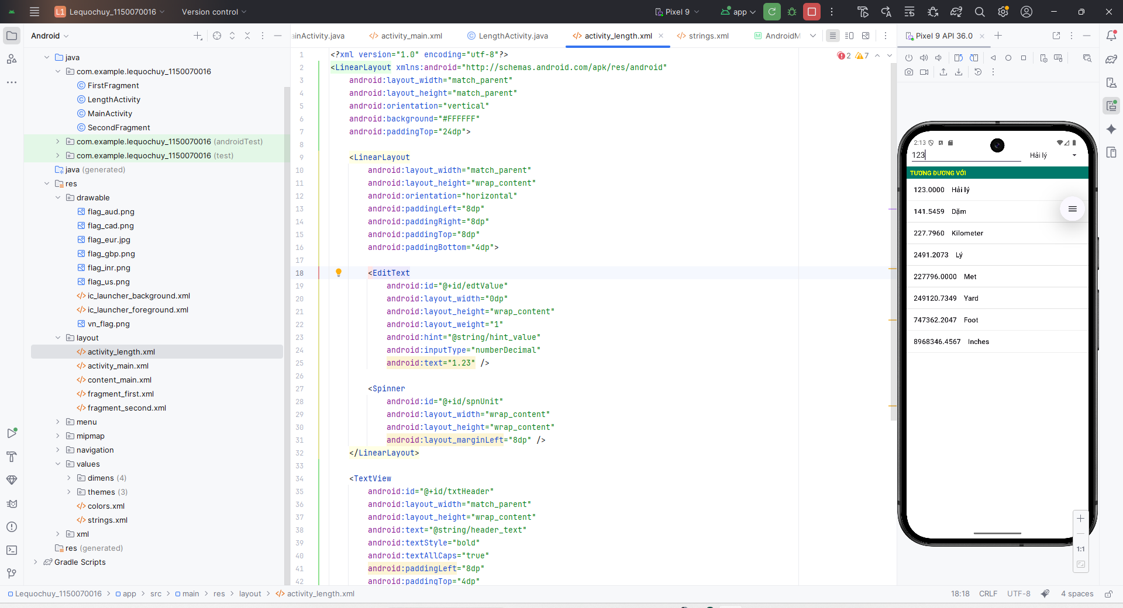

Bước 2: Khai báo chuỗi trong strings.xml
<string name="unit_sea_mile">Hải lý</string>
<string name="unit_mile">Dặm</string>
<string name="unit_km">Kilometer</string>
<string name="unit_li">Lý</string>
<string name="unit_m">Met</string>
<string name="unit_yd">Yard</string>
<string name="unit_ft">Foot</string>
<string name="unit_in">Inches</string>
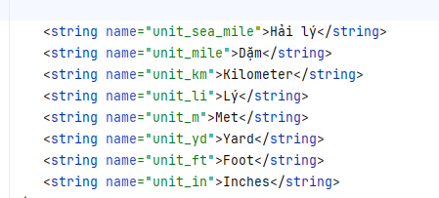

Bước 3: Tạo class LengthActivity
package com.example.lequochuy_1150070016;
import androidx.appcompat.app.AppCompatActivity;
import android.os.Bundle;
import android.text.Editable;
import android.text.TextWatcher;
import android.view.View;
import android.widget.AdapterView;
import android.widget.ArrayAdapter;
import android.widget.EditText;
import android.widget.ListView;
import android.widget.Spinner;
import android.widget.Toast;
import java.util.ArrayList;
import java.util.Locale;
public class LengthActivity extends AppCompatActivity {
private EditText edtValue;
private Spinner spnUnit;
private ListView lvResult;
private String[] unitNames;
private double[] toKm = {
1.852,
1.609344,
1.0,
0.09144,
0.001,
0.0009144,
0.0003048,
0.0000254
};
@Override
protected void onCreate(Bundle savedInstanceState) {
super.onCreate(savedInstanceState);
setContentView(R.layout.activity_length);
setTitle(R.string.length_title);
edtValue = findViewById(R.id.edtValue);
spnUnit = findViewById(R.id.spnUnit);
lvResult = findViewById(R.id.lvResult);
unitNames = new String[]{
getString(R.string.unit_sea_mile),
getString(R.string.unit_mile),
getString(R.string.unit_km),
getString(R.string.unit_li),
getString(R.string.unit_m),
getString(R.string.unit_yd),
getString(R.string.unit_ft),
getString(R.string.unit_in)
};
ArrayAdapter<String> unitAdapter = new ArrayAdapter<>(
this,
android.R.layout.simple_spinner_item,
unitNames
);
unitAdapter.setDropDownViewResource(android.R.layout.simple_spinner_dropdown_item);
spnUnit.setAdapter(unitAdapter);
spnUnit.setSelection(1);
spnUnit.setOnItemSelectedListener(new AdapterView.OnItemSelectedListener() {
@Override
public void onItemSelected(AdapterView<?> parent, View view, int position, long id) {
updateList();
}
@Override
public void onNothingSelected(AdapterView<?> parent) {
}
});
edtValue.addTextChangedListener(new TextWatcher() {
@Override
public void beforeTextChanged(CharSequence s, int start, int count, int after) {
}
@Override
public void onTextChanged(CharSequence s, int start, int before, int count) {
}
@Override
public void afterTextChanged(Editable s) {
updateList();
}
});
edtValue.setText("1.23");
updateList();
}
private void updateList() {
String s = edtValue.getText().toString().trim();
if (s.isEmpty()) {
lvResult.setAdapter(null);
return;
}
double value;
try {
value = Double.parseDouble(s);
} catch (NumberFormatException e) {
Toast.makeText(this, "Giá trị không hợp lệ", Toast.LENGTH_SHORT).show();
return;
}
int fromIndex = spnUnit.getSelectedItemPosition();
double valueInKm = value * toKm[fromIndex];
ArrayList<String> lines = new ArrayList<>();
for (int i = 0; i < unitNames.length; i++) {
double v = valueInKm / toKm[i];
String line = String.format(Locale.US, "%.4f %s", v, unitNames[i]);
lines.add(line);
}
ArrayAdapter<String> resultAdapter = new ArrayAdapter<>(
this,
android.R.layout.simple_list_item_1,
lines
);
lvResult.setAdapter(resultAdapter);
}
}
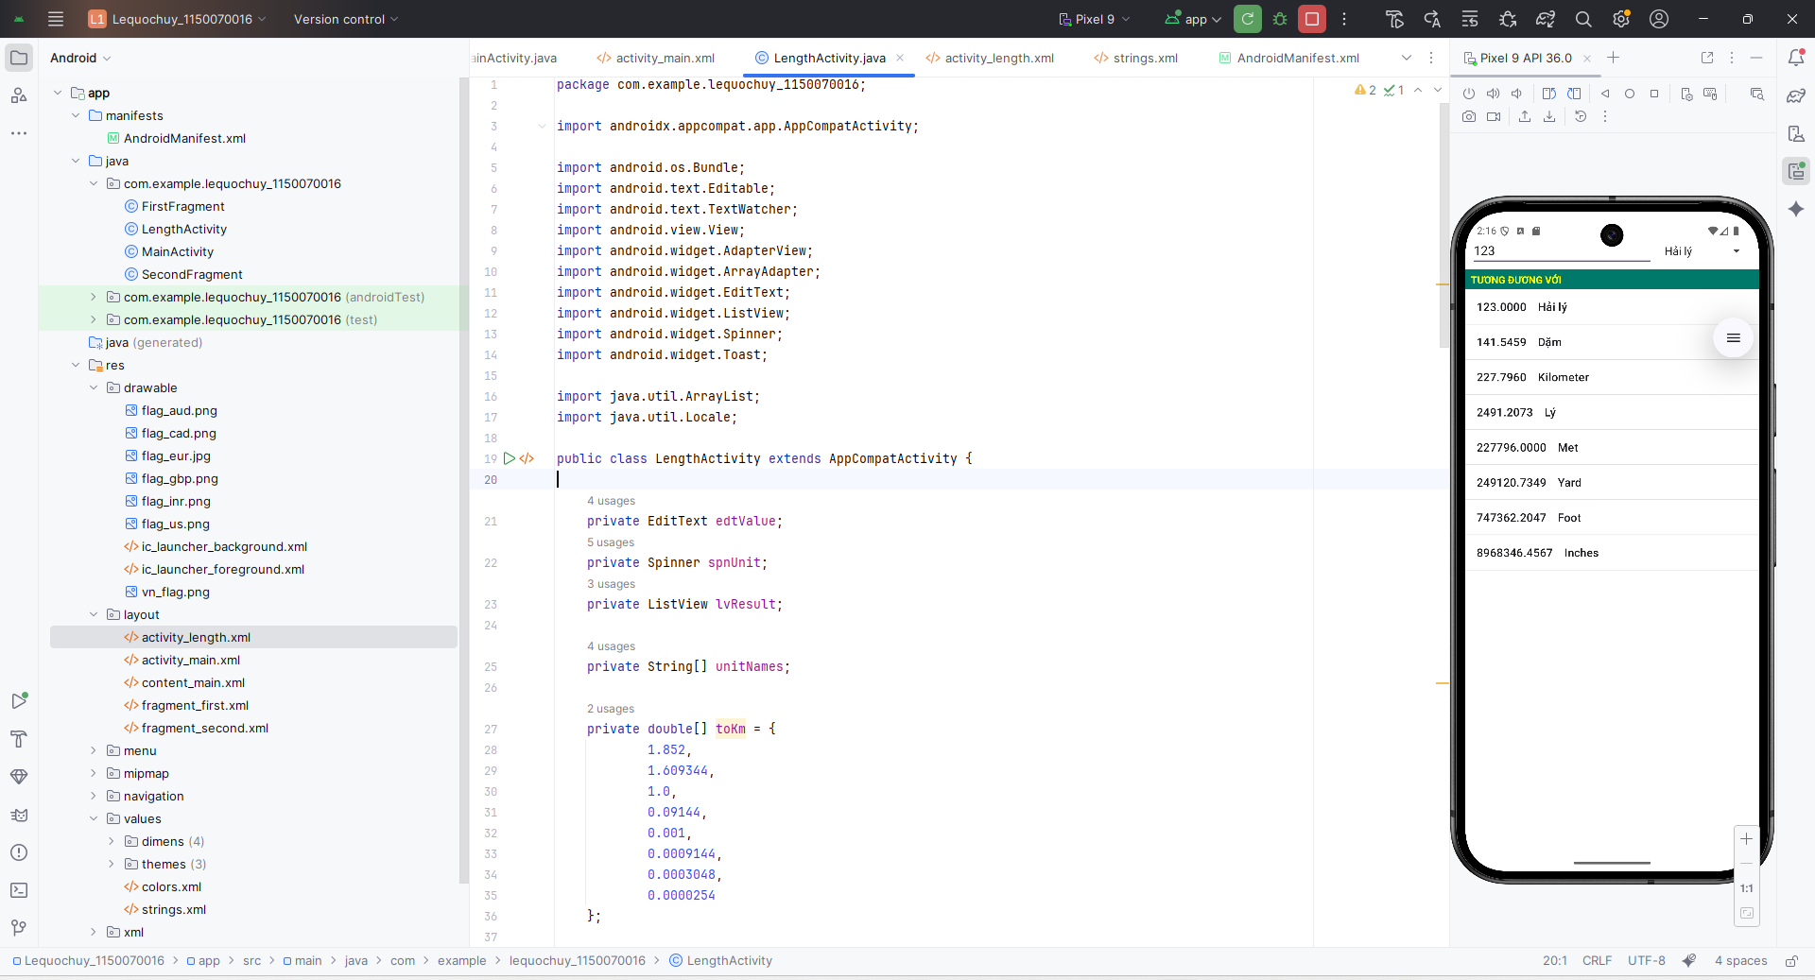

Bước 4: Thêm nút cho mainactivity
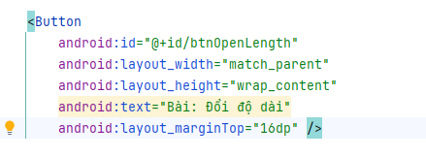
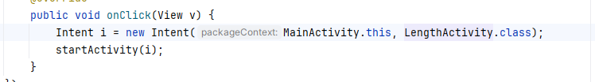

Bước 5 : Sửa AndroidManifest.xml

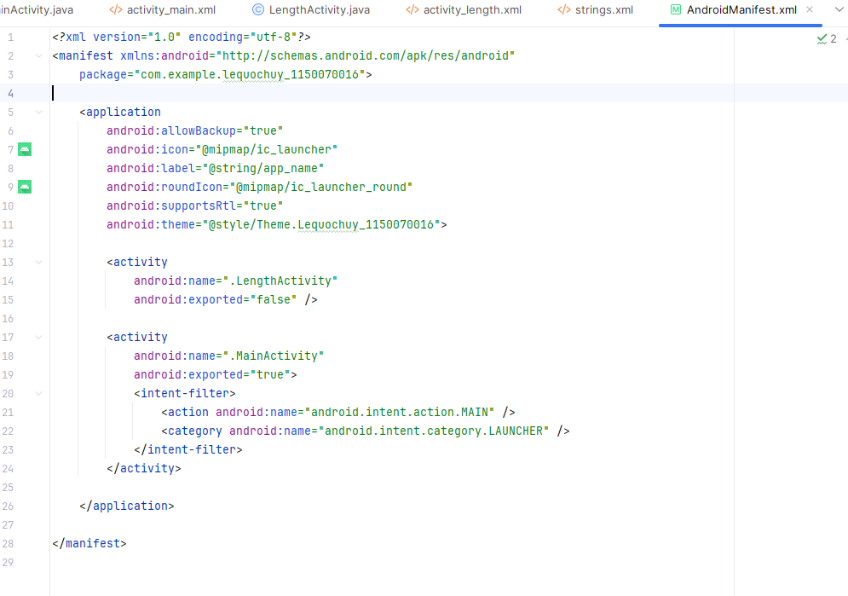

Kết quả
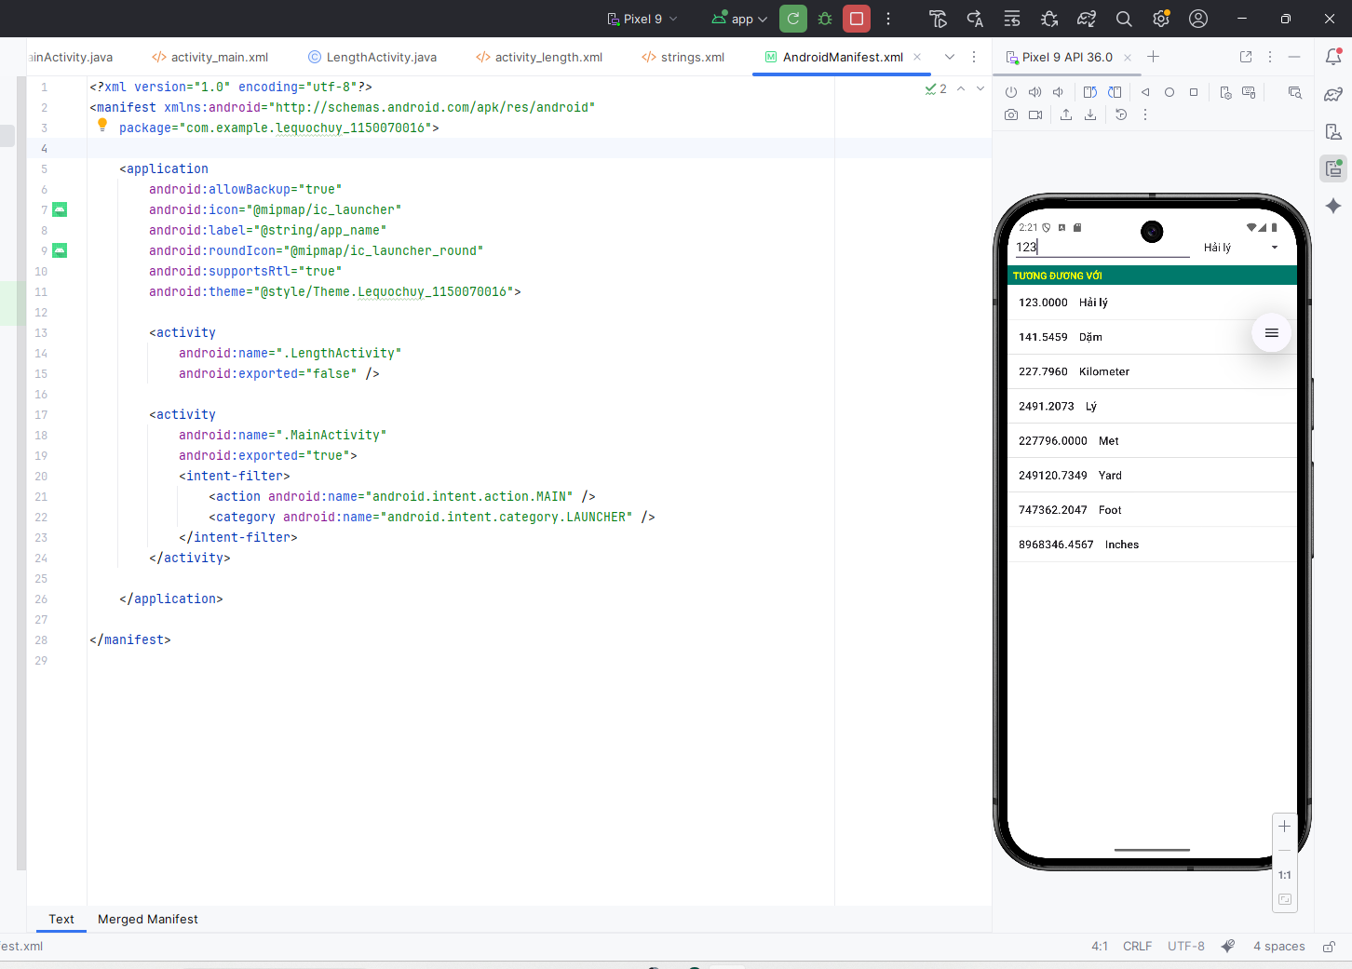

Bài tập 2: Sử dụng Custom Button, thiết kế giao diện như hình sau:

Bước 1: Tạo layout activity_lab7.xml
<?xml version="1.0" encoding="utf-8"?>
<ScrollView xmlns:android="http://schemas.android.com/apk/res/android"
android:layout_width="match_parent"
android:layout_height="match_parent"
android:background="#FFFFFF">

<LinearLayout
android:layout_width="match_parent"
android:layout_height="wrap_content"
android:orientation="vertical"
android:padding="16dp">

<TextView
android:id="@+id/txtAppTitle"
android:layout_width="wrap_content"
android:layout_height="wrap_content"
android:text="Custom Button"
android:textSize="22sp"
android:textStyle="bold"
android:textColor="#D32F2F"
android:layout_gravity="center_horizontal"
android:layout_marginBottom="16dp" />

<LinearLayout
android:layout_width="match_parent"
android:layout_height="wrap_content"
android:orientation="horizontal"
android:layout_marginBottom="8dp">

<TextView
android:layout_width="0dp"
android:layout_height="wrap_content"
android:layout_weight="1"
android:text="Selectors"
android:textStyle="italic"
android:textSize="16sp"
android:gravity="center_horizontal" />

<TextView
android:layout_width="0dp"
android:layout_height="wrap_content"
android:layout_weight="1"
android:text="Shapes+Selectors"
android:textStyle="italic"
android:textSize="16sp"
android:gravity="center_horizontal" />
</LinearLayout>

<LinearLayout
android:layout_width="match_parent"
android:layout_height="wrap_content"
android:orientation="horizontal">

<LinearLayout
android:layout_width="0dp"
android:layout_height="wrap_content"
android:layout_weight="1"
android:orientation="vertical"
android:gravity="center_horizontal">

<Button
android:id="@+id/btnColoredSelector"
android:layout_width="wrap_content"
android:layout_height="wrap_content"
android:text="COLORED SELECTOR"
android:textAllCaps="true"
android:textSize="12sp"
android:background="@drawable/btn_colored_selector"
android:layout_marginBottom="8dp" />

<Button
android:id="@+id/btnColoredDisabled"
android:layout_width="wrap_content"
android:layout_height="wrap_content"
android:text="COLOR SELECTOR&#10;DISABLED"
android:textAllCaps="true"
android:textSize="12sp"
android:background="@drawable/btn_colored_selector"
android:enabled="false"
android:layout_marginBottom="16dp" />

<Button
android:id="@+id/btnFaceLeftTop"
android:layout_width="64dp"
android:layout_height="64dp"
android:background="@drawable/btn_face"
android:text="😊"
android:textSize="28sp"
android:layout_marginBottom="8dp" />

<Button
android:id="@+id/btnFaceLeftBottom"
android:layout_width="64dp"
android:layout_height="64dp"
android:background="@drawable/btn_face"
android:text="😊"
android:textSize="28sp" />
</LinearLayout>

<LinearLayout
android:layout_width="0dp"
android:layout_height="wrap_content"
android:layout_weight="1"
android:orientation="vertical"
android:gravity="center_horizontal">

<Button
android:id="@+id/btnRoundShape"
android:layout_width="wrap_content"
android:layout_height="wrap_content"
android:text="ROUND SHAPE"
android:textAllCaps="true"
android:textSize="12sp"
android:background="@drawable/btn_round_shape"
android:layout_marginBottom="8dp" />

<Button
android:id="@+id/btnGradientShape"
android:layout_width="wrap_content"
android:layout_height="wrap_content"
android:text="SHAPE WITH GRADIENT"
android:textAllCaps="true"
android:textSize="12sp"
android:background="@drawable/btn_gradient_shape"
android:layout_marginBottom="8dp" />

<Button
android:id="@+id/btnSelectorShape"
android:layout_width="wrap_content"
android:layout_height="wrap_content"
android:text="SELECTOR SHAPE"
android:textAllCaps="true"
android:textSize="12sp"
android:background="@drawable/btn_shape_selector"
android:layout_marginBottom="16dp" />

<Button
android:id="@+id/btnFaceRight"
android:layout_width="64dp"
android:layout_height="64dp"
android:background="@drawable/btn_face_border"
android:text="😊"
android:textSize="28sp" />
</LinearLayout>
</LinearLayout>

</LinearLayout>
</ScrollView>

Bước 2: Tạo các file drawable cho Custom Button
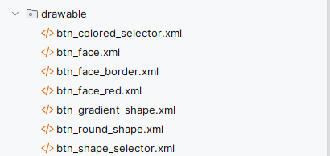

Bước 3: Tạo class Lab7Activity.java
package com.example.lequochuy_1150070016;
import androidx.appcompat.app.AppCompatActivity;
import android.os.Bundle;
import android.view.View;
import android.widget.Button;
import android.widget.Toast;
public class Lab7Activity extends AppCompatActivity {
private Button btnColoredSelector;
private Button btnColoredDisabled;
private Button btnRoundShape;
private Button btnGradientShape;
private Button btnSelectorShape;
private Button btnFaceLeftTop;
private Button btnFaceLeftBottom;
private Button btnFaceRight;
@Override
protected void onCreate(Bundle savedInstanceState) {
super.onCreate(savedInstanceState);
setContentView(R.layout.activity_lab7);
setTitle("DrawableExample");
btnColoredSelector = findViewById(R.id.btnColoredSelector);
btnColoredDisabled = findViewById(R.id.btnColoredDisabled);
btnRoundShape = findViewById(R.id.btnRoundShape);
btnGradientShape = findViewById(R.id.btnGradientShape);
btnSelectorShape = findViewById(R.id.btnSelectorShape);
btnFaceLeftTop = findViewById(R.id.btnFaceLeftTop);
btnFaceLeftBottom = findViewById(R.id.btnFaceLeftBottom);
btnFaceRight = findViewById(R.id.btnFaceRight);
View.OnClickListener listener = new View.OnClickListener() {
@Override
public void onClick(View v) {
Button b = (Button) v;
String text = "Bạn nhấn: " + b.getText();
Toast.makeText(Lab7Activity.this, text, Toast.LENGTH_SHORT).show();
}
};
btnColoredSelector.setOnClickListener(listener);
btnRoundShape.setOnClickListener(listener);
btnGradientShape.setOnClickListener(listener);
btnSelectorShape.setOnClickListener(listener);
btnFaceLeftTop.setOnClickListener(listener);
btnFaceLeftBottom.setOnClickListener(listener);
btnFaceRight.setOnClickListener(listener);
}
}

Bước 4: Thêm nút mở bài 2 trên MainActivity
<Button
android:id="@+id/btnOpenLab7"
android:layout_width="match_parent"
android:layout_height="wrap_content"
android:text="Lab 7: Custom Button"
android:layout_marginTop="8dp" />
Bước 5: Khai báo Lab7Activity trong AndroidManifest.xml
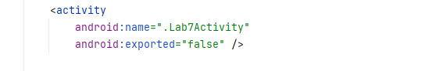
Kết quả
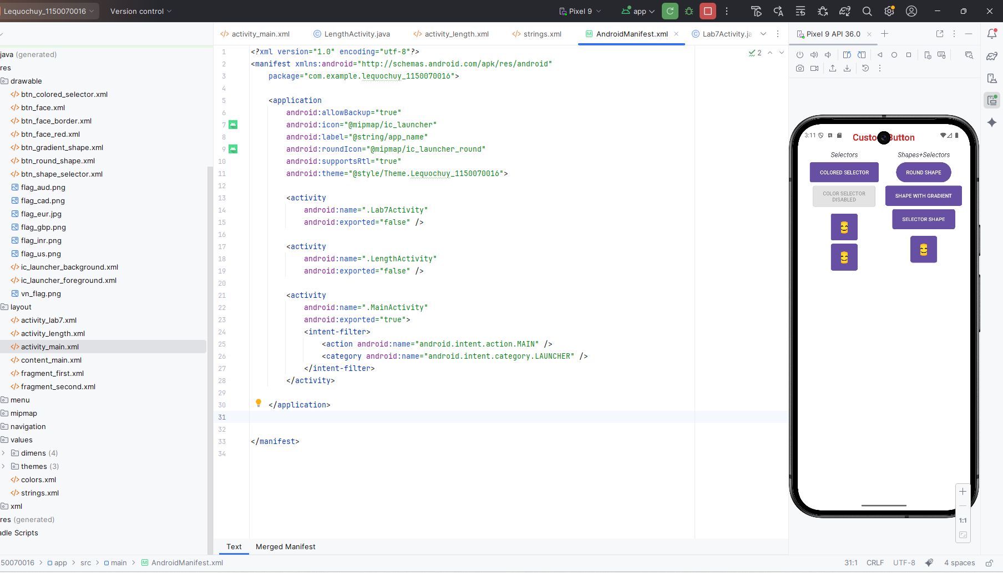

Bài tập 3: Sử dụng Seekbar, viết chương trình cho phép chọn màu RGB và màu

Bước 1: Tạo layout activity_color.xml
<?xml version="1.0" encoding="utf-8"?>
<LinearLayout xmlns:android="http://schemas.android.com/apk/res/android"
android:layout_width="match_parent"
android:layout_height="match_parent"
android:orientation="vertical"
android:padding="16dp">

<TextView
android:id="@+id/txtRValue"
android:layout_width="wrap_content"
android:layout_height="wrap_content"
android:text="R = 0" />

<SeekBar
android:id="@+id/seekR"
android:layout_width="match_parent"
android:layout_height="wrap_content"
android:max="255"
android:progressDrawable="@drawable/seekbar_progress"
android:thumb="@drawable/seekbar_thumb" />

<TextView
android:id="@+id/txtGValue"
android:layout_width="wrap_content"
android:layout_height="wrap_content"
android:text="G = 0"
android:layout_marginTop="8dp" />

<SeekBar
android:id="@+id/seekG"
android:layout_width="match_parent"
android:layout_height="wrap_content"
android:max="255"
android:progressDrawable="@drawable/seekbar_progress"
android:thumb="@drawable/seekbar_thumb" />

<TextView
android:id="@+id/txtBValue"
android:layout_width="wrap_content"
android:layout_height="wrap_content"
android:text="B = 0"
android:layout_marginTop="8dp" />

<SeekBar
android:id="@+id/seekB"
android:layout_width="match_parent"
android:layout_height="wrap_content"
android:max="255"
android:progressDrawable="@drawable/seekbar_progress"
android:thumb="@drawable/seekbar_thumb" />

<LinearLayout
android:layout_width="match_parent"
android:layout_height="wrap_content"
android:orientation="horizontal"
android:layout_marginTop="16dp">

<TextView
android:layout_width="0dp"
android:layout_height="wrap_content"
android:layout_weight="1"
android:text="RGB"
android:gravity="center_horizontal" />

<TextView
android:layout_width="0dp"
android:layout_height="wrap_content"
android:layout_weight="1"
android:text="CMY"
android:gravity="center_horizontal" />
</LinearLayout>

<LinearLayout
android:layout_width="match_parent"
android:layout_height="0dp"
android:layout_weight="1"
android:orientation="horizontal"
android:layout_marginTop="8dp">

<View
android:id="@+id/viewRgb"
android:layout_width="0dp"
android:layout_height="match_parent"
android:layout_weight="1"
android:background="#000000" />

<View
android:id="@+id/viewCmy"
android:layout_width="0dp"
android:layout_height="match_parent"
android:layout_weight="1"
android:background="#FFFFFF" />
</LinearLayout>

</LinearLayout>

Bước 2: Tạo các file drawable cho Custom Seekbar
<?xml version="1.0" encoding="utf-8"?>
<layer-list xmlns:android="http://schemas.android.com/apk/res/android">
<item android:id="@android:id/background">
<shape>
<corners android:radius="8dp" />
<solid android:color="#DDDDDD" />
</shape>
</item>
<item android:id="@android:id/progress">
<clip>
<shape>
<corners android:radius="8dp" />
<solid android:color="#E91E63" />
</shape>
</clip>
</item>
</layer-list>

Bước 3: Tạo class ColorActivity.java
package com.example.lequochuy_1150070016;

import androidx.appcompat.app.AppCompatActivity;

import android.graphics.Color;
import android.os.Bundle;
import android.view.View;
import android.widget.SeekBar;
import android.widget.TextView;

public class ColorActivity extends AppCompatActivity {

private SeekBar seekR, seekG, seekB;
private TextView txtRValue, txtGValue, txtBValue;
private View viewRgb, viewCmy;

private int r = 0, g = 0, b = 0;

@Override
protected void onCreate(Bundle savedInstanceState) {
super.onCreate(savedInstanceState);
setContentView(R.layout.activity_color);
setTitle("ChooseColor");

seekR = findViewById(R.id.seekR);
seekG = findViewById(R.id.seekG);
seekB = findViewById(R.id.seekB);
txtRValue = findViewById(R.id.txtRValue);
txtGValue = findViewById(R.id.txtGValue);
txtBValue = findViewById(R.id.txtBValue);
viewRgb = findViewById(R.id.viewRgb);
viewCmy = findViewById(R.id.viewCmy);

SeekBar.OnSeekBarChangeListener listener = new SeekBar.OnSeekBarChangeListener() {
@Override
public void onProgressChanged(SeekBar seekBar, int progress, boolean fromUser) {
if (seekBar == seekR) {
r = progress;
} else if (seekBar == seekG) {
g = progress;
} else if (seekBar == seekB) {
b = progress;
}
updateColor();
}

@Override
public void onStartTrackingTouch(SeekBar seekBar) {
}

@Override
public void onStopTrackingTouch(SeekBar seekBar) {
}
};

seekR.setOnSeekBarChangeListener(listener);
seekG.setOnSeekBarChangeListener(listener);
seekB.setOnSeekBarChangeListener(listener);

updateColor();
}

private void updateColor() {
txtRValue.setText("R = " + r);
txtGValue.setText("G = " + g);
txtBValue.setText("B = " + b);

int rgbColor = Color.rgb(r, g, b);
viewRgb.setBackgroundColor(rgbColor);

int c = 255 - r;
int m = 255 - g;
int y = 255 - b;
int cmyColor = Color.rgb(c, m, y);
viewCmy.setBackgroundColor(cmyColor);
}
}

Bước 4: Thêm nút mở bài 3 trên MainActivity
<Button
android:id="@+id/btnOpenColor"
android:layout_width="match_parent"
android:layout_height="wrap_content"
android:text="Bài 3: Choose Color"
android:layout_marginTop="8dp" />

Bước 5: Khai báo ColorActivity trong AndroidManifest.xml
<activity
android:name=".ColorActivity"
android:exported="false" />
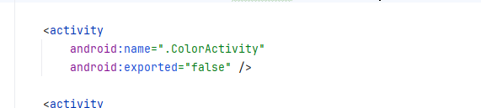
Kết quả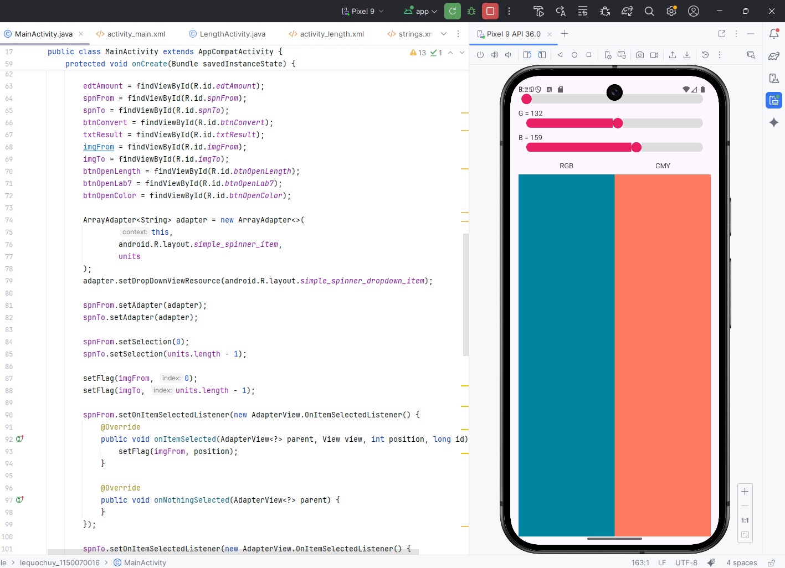

Bài tập 4: Sử dụng ListView hiển thị danh sách món ăn

Bước 1: Tạo layout activity_food_list.xml
<?xml version="1.0" encoding="utf-8"?>
<LinearLayout xmlns:android="http://schemas.android.com/apk/res/android"
android:layout_width="match_parent"
android:layout_height="match_parent"
android:orientation="vertical"
android:padding="16dp">

<ListView
android:id="@+id/lvFood"
android:layout_width="match_parent"
android:layout_height="0dp"
android:layout_weight="1"
android:divider="@android:color/darker_gray"
android:dividerHeight="1dp" />

<TextView
android:id="@+id/txtSelectedFood"
android:layout_width="match_parent"
android:layout_height="wrap_content"
android:text="Chọn một món ăn..."
android:textSize="16sp"
android:paddingTop="8dp" />
</LinearLayout>

Bước 2: Tạo layout item_food.xml cho từng dòng ListView
<?xml version="1.0" encoding="utf-8"?>
<LinearLayout xmlns:android="http://schemas.android.com/apk/res/android"
android:layout_width="match_parent"
android:layout_height="80dp"
android:orientation="horizontal"
android:padding="8dp">

<ImageView
android:id="@+id/imgFood"
android:layout_width="64dp"
android:layout_height="match_parent"
android:scaleType="centerCrop"
android:src="@drawable/mon_pho" />

<LinearLayout
android:layout_width="0dp"
android:layout_height="match_parent"
android:layout_weight="1"
android:orientation="vertical"
android:layout_marginStart="8dp">

<TextView
android:id="@+id/txtFoodName"
android:layout_width="match_parent"
android:layout_height="0dp"
android:layout_weight="1"
android:text="Tên món"
android:textStyle="bold"
android:textSize="16sp" />

<TextView
android:id="@+id/txtFoodDesc"
android:layout_width="match_parent"
android:layout_height="0dp"
android:layout_weight="1"
android:text="Mô tả"
android:textSize="14sp" />
</LinearLayout>

</LinearLayout>

Bước 3: Thêm hình ảnh món ăn vào drawable
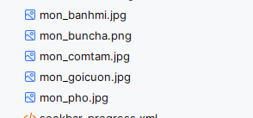

Bước 4: Tạo class Food.java
package com.example.lequochuy_1150070016;

public class Food {
private int imageResId;
private String name;
private String description;

public Food(int imageResId, String name, String description) {
this.imageResId = imageResId;
this.name = name;
this.description = description;
}

public int getImageResId() {
return imageResId;
}

public String getName() {
return name;
}

public String getDescription() {
return description;
}
}

Bước 5: Tạo class FoodAdapter.java
package com.example.lequochuy_1150070016;

import android.content.Context;
import android.view.LayoutInflater;
import android.view.View;
import android.view.ViewGroup;
import android.widget.BaseAdapter;
import android.widget.ImageView;
import android.widget.TextView;

import java.util.List;

public class FoodAdapter extends BaseAdapter {

private Context context;
private int layout;
private List<Food> foodList;

public FoodAdapter(Context context, int layout, List<Food> foodList) {
this.context = context;
this.layout = layout;
this.foodList = foodList;
}

@Override
public int getCount() {
return foodList.size();
}

@Override
public Object getItem(int position) {
return foodList.get(position);
}

@Override
public long getItemId(int position) {
return position;
}

static class ViewHolder {
ImageView imgFood;
TextView txtFoodName;
TextView txtFoodDesc;
}

@Override
public View getView(int position, View convertView, ViewGroup parent) {
ViewHolder holder;

if (convertView == null) {
LayoutInflater inflater = LayoutInflater.from(context);
convertView = inflater.inflate(layout, parent, false);

holder = new ViewHolder();
holder.imgFood = convertView.findViewById(R.id.imgFood);
holder.txtFoodName = convertView.findViewById(R.id.txtFoodName);
holder.txtFoodDesc = convertView.findViewById(R.id.txtFoodDesc);

convertView.setTag(holder);
} else {
holder = (ViewHolder) convertView.getTag();
}

Food food = foodList.get(position);
holder.imgFood.setImageResource(food.getImageResId());
holder.txtFoodName.setText(food.getName());
holder.txtFoodDesc.setText(food.getDescription());

return convertView;
}
}

Bước 6: Tạo class FoodListActivity.java
package com.example.lequochuy_1150070016;

import androidx.appcompat.app.AppCompatActivity;

import android.os.Bundle;
import android.view.View;
import android.widget.AdapterView;
import android.widget.ListView;
import android.widget.TextView;

import java.util.ArrayList;

public class FoodListActivity extends AppCompatActivity {

private ListView lvFood;
private TextView txtSelectedFood;
private ArrayList<Food> foodList;
private FoodAdapter adapter;

@Override
protected void onCreate(Bundle savedInstanceState) {
super.onCreate(savedInstanceState);
setContentView(R.layout.activity_food_list);
setTitle("Danh sách món ăn");

lvFood = findViewById(R.id.lvFood);
txtSelectedFood = findViewById(R.id.txtSelectedFood);

foodList = new ArrayList<>();
foodList.add(new Food(R.drawable.mon_pho, "Phở bò", "Bánh phở với thịt bò"));
foodList.add(new Food(R.drawable.mon_buncha, "Bún chả", "Bún với chả nướng"));
foodList.add(new Food(R.drawable.mon_comtam, "Cơm tấm", "Cơm tấm sườn bì chả"));
foodList.add(new Food(R.drawable.mon_banhmi, "Bánh mì", "Bánh mì thịt"));
foodList.add(new Food(R.drawable.mon_goicuon, "Gỏi cuốn", "Bánh tráng cuốn tôm thịt"));

adapter = new FoodAdapter(this, R.layout.item_food, foodList);
lvFood.setAdapter(adapter);

lvFood.setOnItemClickListener(new AdapterView.OnItemClickListener() {
@Override
public void onItemClick(AdapterView<?> parent, View view, int position, long id) {
Food f = foodList.get(position);
String info = f.getName() + " - " + f.getDescription();
txtSelectedFood.setText(info);
}
});
}
}

Bước 7: Thêm nút mở bài 4 trên MainActivity
<Button
android:id="@+id/btnOpenFoodList"
android:layout_width="match_parent"
android:layout_height="wrap_content"
android:text="Bài 4: List món ăn"
android:layout_marginTop="8dp" />

Bước 8: Khai báo FoodListActivity trong AndroidManifest.xml
<activity
android:name=".FoodListActivity"
android:exported="false" />
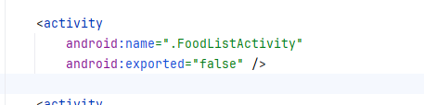

Kết quả
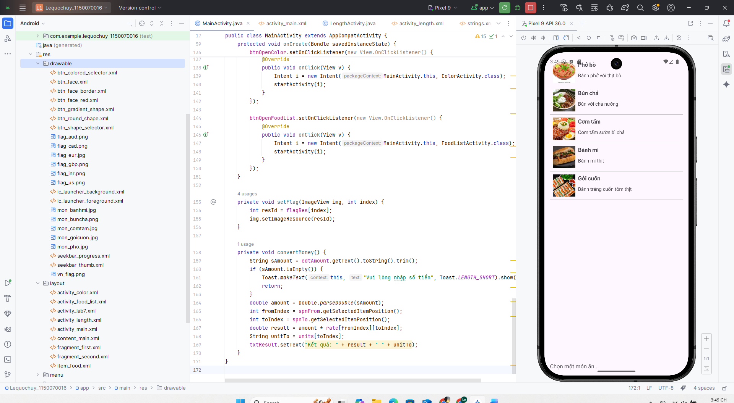

Bài tập 5: Sử dụng Custom GridView, thiết kế chương trình hiển thị các món ăn theo dạng lưới

Bước 1: Tạo layout activity_food_grid.xml
<?xml version="1.0" encoding="utf-8"?>
<LinearLayout xmlns:android="http://schemas.android.com/apk/res/android"
android:layout_width="match_parent"
android:layout_height="match_parent"
android:orientation="vertical"
android:padding="16dp">

<GridView
android:id="@+id/gridFood"
android:layout_width="match_parent"
android:layout_height="0dp"
android:layout_weight="1"
android:numColumns="2"
android:horizontalSpacing="8dp"
android:verticalSpacing="8dp"
android:stretchMode="columnWidth" />

<TextView
android:id="@+id/txtSelectedGridFood"
android:layout_width="match_parent"
android:layout_height="wrap_content"
android:text="Chọn một món ăn..."
android:textSize="16sp"
android:paddingTop="8dp" />
</LinearLayout>

Bước 2: Tạo layout item_food_grid.xml cho từng ô GridView
<?xml version="1.0" encoding="utf-8"?>
<LinearLayout xmlns:android="http://schemas.android.com/apk/res/android"
android:layout_width="match_parent"
android:layout_height="150dp"
android:orientation="vertical"
android:padding="8dp"
android:gravity="center">

<ImageView
android:id="@+id/imgFoodGrid"
android:layout_width="80dp"
android:layout_height="80dp"
android:scaleType="centerCrop"
android:src="@drawable/mon_pho" />

<TextView
android:id="@+id/txtFoodGridName"
android:layout_width="wrap_content"
android:layout_height="wrap_content"
android:text="Tên món"
android:textStyle="bold"
android:layout_marginTop="4dp" />
</LinearLayout>

Bước 3: Tạo class FoodGridAdapter.java
package com.example.lequochuy_1150070016;

import android.content.Context;
import android.view.LayoutInflater;
import android.view.View;
import android.view.ViewGroup;
import android.widget.BaseAdapter;
import android.widget.ImageView;
import android.widget.TextView;

import java.util.List;

public class FoodGridAdapter extends BaseAdapter {

private Context context;
private int layout;
private List<Food> foodList;

public FoodGridAdapter(Context context, int layout, List<Food> foodList) {
this.context = context;
this.layout = layout;
this.foodList = foodList;
}

@Override
public int getCount() {
return foodList.size();
}

@Override
public Object getItem(int position) {
return foodList.get(position);
}

@Override
public long getItemId(int position) {
return position;
}

static class ViewHolder {
ImageView imgFood;
TextView txtFoodName;
}

@Override
public View getView(int position, View convertView, ViewGroup parent) {
ViewHolder holder;

if (convertView == null) {
LayoutInflater inflater = LayoutInflater.from(context);
convertView = inflater.inflate(layout, parent, false);

holder = new ViewHolder();
holder.imgFood = convertView.findViewById(R.id.imgFoodGrid);
holder.txtFoodName = convertView.findViewById(R.id.txtFoodGridName);

convertView.setTag(holder);
} else {
holder = (ViewHolder) convertView.getTag();
}

Food food = foodList.get(position);
holder.imgFood.setImageResource(food.getImageResId());
holder.txtFoodName.setText(food.getName());

return convertView;
}
}

Bước 4: Tạo class FoodGridActivity.java
package com.example.lequochuy_1150070016;

import androidx.appcompat.app.AppCompatActivity;

import android.os.Bundle;
import android.view.View;
import android.widget.AdapterView;
import android.widget.GridView;
import android.widget.TextView;

import java.util.ArrayList;

public class FoodGridActivity extends AppCompatActivity {

private GridView gridFood;
private TextView txtSelectedGridFood;
private ArrayList<Food> foodList;
private FoodGridAdapter adapter;

@Override
protected void onCreate(Bundle savedInstanceState) {
super.onCreate(savedInstanceState);
setContentView(R.layout.activity_food_grid);
setTitle("Grid món ăn");

gridFood = findViewById(R.id.gridFood);
txtSelectedGridFood = findViewById(R.id.txtSelectedGridFood);

foodList = new ArrayList<>();
foodList.add(new Food(R.drawable.mon_pho, "Phở bò", "Bánh phở với thịt bò"));
foodList.add(new Food(R.drawable.mon_buncha, "Bún chả", "Bún với chả nướng"));
foodList.add(new Food(R.drawable.mon_comtam, "Cơm tấm", "Cơm tấm sườn bì chả"));
foodList.add(new Food(R.drawable.mon_banhmi, "Bánh mì", "Bánh mì thịt"));
foodList.add(new Food(R.drawable.mon_goicuon, "Gỏi cuốn", "Bánh tráng cuốn tôm thịt"));

adapter = new FoodGridAdapter(this, R.layout.item_food_grid, foodList);
gridFood.setAdapter(adapter);

gridFood.setOnItemClickListener(new AdapterView.OnItemClickListener() {
@Override
public void onItemClick(AdapterView<?> parent, View view, int position, long id) {
Food f = foodList.get(position);
String info = f.getName() + " - " + f.getDescription();
txtSelectedGridFood.setText(info);
}
});
}
}

Bước 5: Thêm nút mở bài GridView trên MainActivity
<Button
android:id="@+id/btnOpenFoodGrid"
android:layout_width="match_parent"
android:layout_height="wrap_content"
android:text="Bài 5: GridView món ăn"
android:layout_marginTop="8dp" />
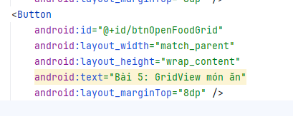

Bước 6: Khai báo FoodGridActivity trong AndroidManifest.xml
<activity
android:name=".FoodGridActivity"
android:exported="false" />
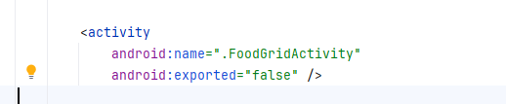

Kết quả
