Bài tập thực hành
Lê Quốc Huy _số máy 15

Bài tập: Tạo ra 10 truyện cười thiếu nhi

Bước 1: Khởi tạo dự án Android
Mở Android Studio → chọn New Project → Basic Views Activity
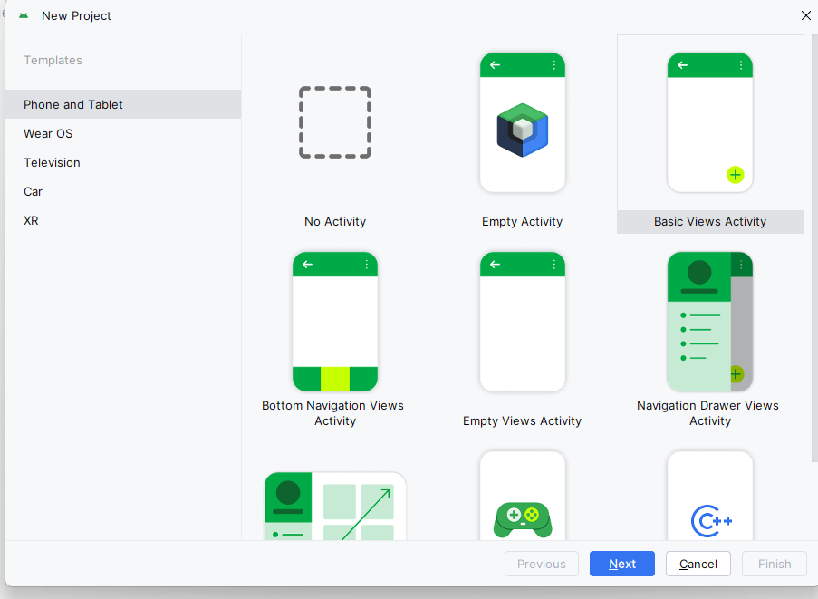

Bước 2: Chuẩn bị dữ liệu hình ảnh và txt trong thư mục assets
Nhấp chuột phải vào thư mục main → chọn New → Directory → tạo thư mục mới tên assets.
Trong thư mục assets, tiếp tục tạo thư mục con tên photo.
Sao chép các file hình ảnh truyện vào đường dẫn.
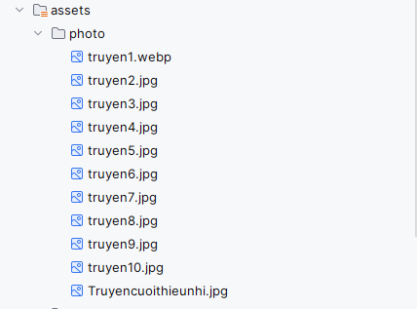
Trong thư mục assets, tiếp tục tạo thư mục con tên story
Tạo các file .txt
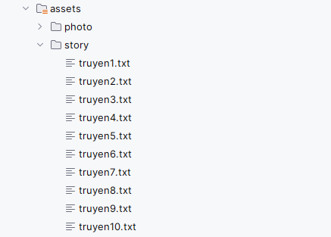

Bước 3: Thiết kế giao diện màn hình chính MainActivity
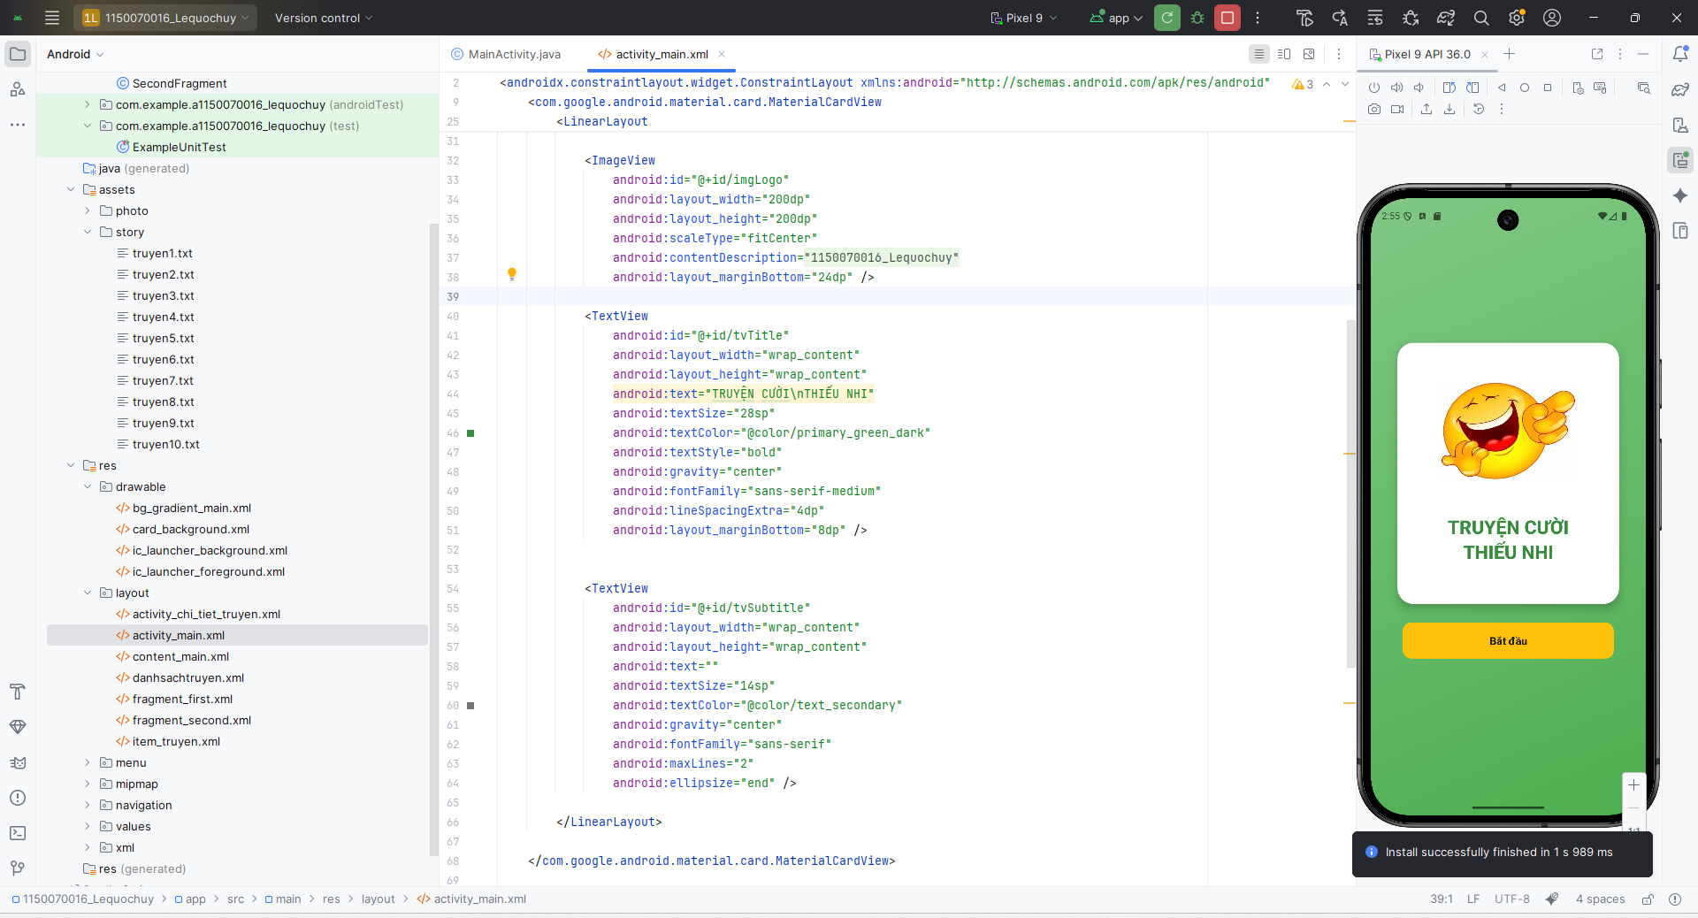
<?xml version="1.0" encoding="utf-8"?>
<androidx.constraintlayout.widget.ConstraintLayout xmlns:android="http://schemas.android.com/apk/res/android"
xmlns:app="http://schemas.android.com/apk/res-auto"
xmlns:tools="http://schemas.android.com/tools"
android:layout_width="match_parent"
android:layout_height="match_parent"
android:background="@drawable/bg_gradient_main"
android:padding="16dp">
<com.google.android.material.card.MaterialCardView
android:id="@+id/cardMain"
android:layout_width="0dp"
android:layout_height="wrap_content"
android:layout_marginStart="24dp"
android:layout_marginEnd="24dp"
app:cardCornerRadius="24dp"
app:cardElevation="8dp"
app:cardBackgroundColor="@color/card_background"
app:strokeWidth="0dp"
app:layout_constraintTop_toTopOf="parent"
app:layout_constraintBottom_toBottomOf="parent"
app:layout_constraintStart_toStartOf="parent"
app:layout_constraintEnd_toEndOf="parent"
app:layout_constraintVertical_bias="0.4">
<LinearLayout
android:layout_width="match_parent"
android:layout_height="wrap_content"
android:orientation="vertical"
android:gravity="center"
android:padding="32dp">
<ImageView
android:id="@+id/imgLogo"
android:layout_width="200dp"
android:layout_height="200dp"
android:scaleType="fitCenter"
android:contentDescription="@string/app_name"
android:layout_marginBottom="24dp" />
<TextView
android:id="@+id/tvTitle"
android:layout_width="wrap_content"
android:layout_height="wrap_content"
android:text="TRUYỆN CƯỜI\nTHIẾU NHI"
android:textSize="28sp"
android:textColor="@color/primary_green_dark"
android:textStyle="bold"
android:gravity="center"
android:fontFamily="sans-serif-medium"
android:lineSpacingExtra="4dp"
android:layout_marginBottom="8dp" />
<TextView
android:id="@+id/tvSubtitle"
android:layout_width="wrap_content"
android:layout_height="wrap_content"
android:text=""
android:textSize="14sp"
android:textColor="@color/text_secondary"
android:gravity="center"
android:fontFamily="sans-serif"
android:maxLines="2"
android:ellipsize="end" />
</LinearLayout>
</com.google.android.material.card.MaterialCardView>
<com.google.android.material.button.MaterialButton
android:id="@+id/btnStart"
android:layout_width="0dp"
android:layout_height="wrap_content"
android:text="Bắt đầu"
android:textSize="16sp"
android:textStyle="bold"
android:padding="16dp"
android:layout_marginStart="32dp"
android:layout_marginEnd="32dp"
android:layout_marginTop="24dp"
app:cornerRadius="12dp"
app:backgroundTint="@color/accent_yellow"
android:textColor="@color/text_primary"
app:layout_constraintTop_toBottomOf="@id/cardMain"
app:layout_constraintStart_toStartOf="parent"
app:layout_constraintEnd_toEndOf="parent"
app:elevation="4dp" />
</androidx.constraintlayout.widget.ConstraintLayout>

Bước 4: Tạo class Mainactivity
package com.example.a1150070016_lequochuy;
import androidx.appcompat.app.AppCompatActivity;
import android.content.Intent;
import android.graphics.Bitmap;
import android.graphics.BitmapFactory;
import android.os.Bundle;
import android.view.View;
import android.widget.ImageView;
import com.google.android.material.button.MaterialButton;
import java.io.IOException;
import java.io.InputStream;
public class MainActivity extends AppCompatActivity {
private ImageView imgLogo;
private MaterialButton btnStart;
@Override
protected void onCreate(Bundle savedInstanceState) {
super.onCreate(savedInstanceState);
setContentView(R.layout.activity_main);
imgLogo = findViewById(R.id.imgLogo);
btnStart = findViewById(R.id.btnStart);
loadLogo();
btnStart.setOnClickListener(new View.OnClickListener() {
@Override
public void onClick(View v) {
Intent intent = new Intent(MainActivity.this, danhsachtruyen.class);
startActivity(intent);
}
});
}
private void loadLogo() {
try {
InputStream is = getAssets().open("photo/Truyencuoithieunhi.jpg");
Bitmap bmp = BitmapFactory.decodeStream(is);
imgLogo.setImageBitmap(bmp);
is.close();
} catch (IOException e) {
e.printStackTrace();
imgLogo.setImageResource(android.R.drawable.ic_menu_gallery);
}
}
}

Bước 5 Thêm màu cho giao diện
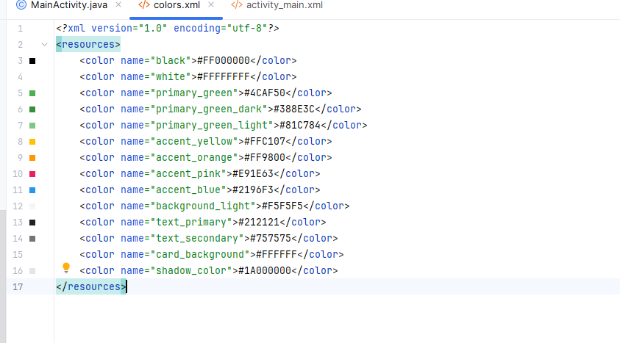
<resources>
<color name="black">#FF000000</color>
<color name="white">#FFFFFFFF</color>
<color name="primary_green">#4CAF50</color>
<color name="primary_green_dark">#388E3C</color>
<color name="primary_green_light">#81C784</color>
<color name="accent_yellow">#FFC107</color>
<color name="accent_orange">#FF9800</color>
<color name="accent_pink">#E91E63</color>
<color name="accent_blue">#2196F3</color>
<color name="background_light">#F5F5F5</color>
<color name="text_primary">#212121</color>
<color name="text_secondary">#757575</color>
<color name="card_background">#FFFFFF</color>
<color name="shadow_color">#1A000000</color>
</resources>

Bước 6 Tạo giao diện danh sách truyện
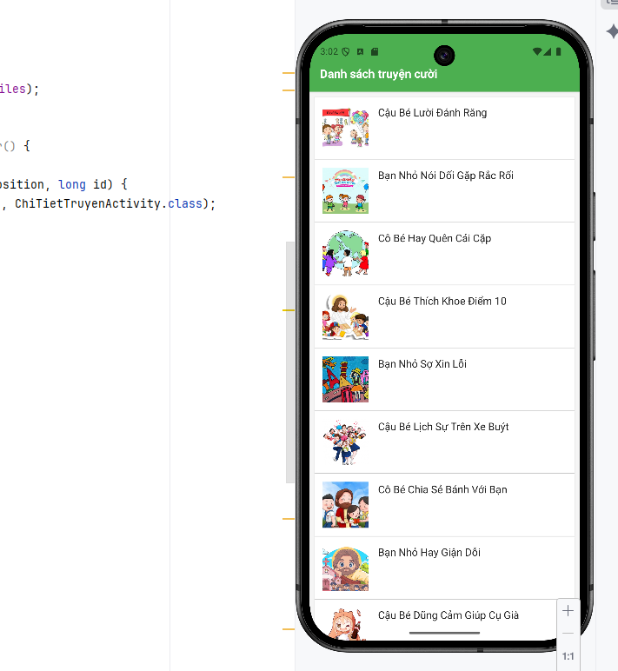
<?xml version="1.0" encoding="utf-8"?>
<RelativeLayout xmlns:android="http://schemas.android.com/apk/res/android"
android:layout_width="match_parent"
android:layout_height="match_parent"
android:background="@color/background_light">
<LinearLayout
android:id="@+id/headerLayout"
android:layout_width="match_parent"
android:layout_height="wrap_content"
android:orientation="horizontal"
android:paddingStart="16dp"
android:paddingEnd="16dp"
android:paddingTop="48dp"
android:paddingBottom="16dp"
android:background="@color/primary_green"
android:elevation="2dp"
android:layout_alignParentTop="true">
<TextView
android:id="@+id/tvTitleList"
android:layout_width="0dp"
android:layout_height="wrap_content"
android:layout_weight="1"
android:text="Danh sách truyện cười"
android:textSize="18sp"
android:textStyle="bold"
android:textColor="@color/white"
android:gravity="center_vertical"
android:minHeight="24dp" />
</LinearLayout>
<ListView
android:id="@+id/lvStories"
android:layout_width="match_parent"
android:layout_height="match_parent"
android:layout_below="@id/headerLayout"
android:divider="@android:color/transparent"
android:dividerHeight="1dp"
android:padding="8dp"
android:clipToPadding="false" />
</RelativeLayout>

<?xml version="1.0" encoding="utf-8"?>
<LinearLayout xmlns:android="http://schemas.android.com/apk/res/android"
android:layout_width="match_parent"
android:layout_height="wrap_content"
android:orientation="horizontal"
android:padding="12dp"
android:background="@color/card_background"
android:layout_margin="4dp"
android:elevation="1dp"
android:minHeight="80dp">
<ImageView
android:id="@+id/imgStory"
android:layout_width="70dp"
android:layout_height="70dp"
android:scaleType="centerCrop"
android:layout_gravity="center_vertical"
android:background="@color/primary_green_light"
android:contentDescription="@string/app_name" />
<TextView
android:id="@+id/tvStoryTitle"
android:layout_width="0dp"
android:layout_height="wrap_content"
android:layout_weight="1"
android:gravity="center_vertical"
android:layout_marginStart="14dp"
android:text="Tiêu đề truyện"
android:textSize="16sp"
android:textColor="@color/text_primary"
android:textStyle="normal"
android:maxLines="2"
android:ellipsize="end" />
</LinearLayout>

Bước 7 Tạo class danh sách truyện
package com.example.a1150070016_lequochuy;
import androidx.appcompat.app.AppCompatActivity;
import android.content.Context;
import android.content.Intent;
import android.graphics.Bitmap;
import android.graphics.BitmapFactory;
import android.os.Bundle;
import android.view.LayoutInflater;
import android.view.View;
import android.view.ViewGroup;
import android.widget.AdapterView;
import android.widget.ArrayAdapter;
import android.widget.ImageView;
import android.widget.ListView;
import android.widget.TextView;
import java.io.IOException;
import java.io.InputStream;
public class danhsachtruyen extends AppCompatActivity {
private ListView lvStories;
private String[] titles = {
"Cậu Bé Lười Đánh Răng",
"Bạn Nhỏ Nói Dối Gặp Rắc Rối",
"Cô Bé Hay Quên Cái Cặp",
"Cậu Bé Thích Khoe Điểm 10",
"Bạn Nhỏ Sợ Xin Lỗi",
"Cậu Bé Lịch Sự Trên Xe Buýt",
"Cô Bé Chia Sẻ Bánh Với Bạn",
"Bạn Nhỏ Hay Giận Dỗi",
"Cậu Bé Dũng Cảm Giúp Cụ Già",
"Bạn Nhỏ Biết Nói Cảm Ơn"
};
private String[] imageFiles = {
"truyen1.webp",
"truyen2.jpg",
"truyen3.jpg",
"truyen4.jpg",
"truyen5.jpg",
"truyen6.jpg",
"truyen7.jpg",
"truyen8.jpg",
"truyen9.jpg",
"truyen10.jpg"
};
@Override
protected void onCreate(Bundle savedInstanceState) {
super.onCreate(savedInstanceState);
setContentView(R.layout.danhsachtruyen);
lvStories = findViewById(R.id.lvStories);
StoryAdapter adapter = new StoryAdapter(this, titles, imageFiles);
lvStories.setAdapter(adapter);
lvStories.setOnItemClickListener(new AdapterView.OnItemClickListener() {
@Override
public void onItemClick(AdapterView<?> parent, View view, int position, long id) {
Intent intent = new Intent(danhsachtruyen.this, ChiTietTruyenActivity.class);
intent.putExtra("position", position);
intent.putExtra("title", titles[position]);
intent.putExtra("imageFile", imageFiles[position]);
startActivity(intent);
}
});
if (getSupportActionBar() != null) {
getSupportActionBar().hide();
}
}
private static class StoryAdapter extends ArrayAdapter<String> {
private final Context context;
private final String[] titles;
private final String[] imageFiles;
public StoryAdapter(Context context, String[] titles, String[] imageFiles) {
super(context, 0, titles);
this.context = context;
this.titles = titles;
this.imageFiles = imageFiles;
}
@Override
public View getView(int position, View convertView, ViewGroup parent) {
View row = convertView;
if (row == null) {
LayoutInflater inflater = LayoutInflater.from(context);
row = inflater.inflate(R.layout.item_truyen, parent, false);
}
ImageView imgStory = row.findViewById(R.id.imgStory);
TextView tvTitle = row.findViewById(R.id.tvStoryTitle);
tvTitle.setText(titles[position]);
try {
InputStream is = context.getAssets().open("photo/" + imageFiles[position]);
Bitmap bmp = BitmapFactory.decodeStream(is);
imgStory.setImageBitmap(bmp);
is.close();
} catch (IOException e) {
e.printStackTrace();
imgStory.setImageResource(android.R.drawable.ic_menu_gallery);
}
return row;
}
}
}

Bước 8: Tạo giao diện chi tiết đọc truyện
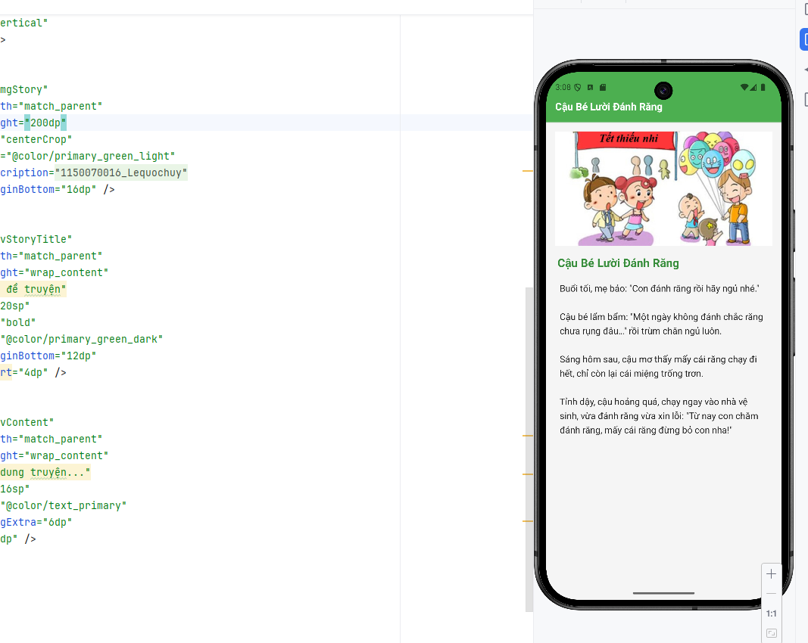
<?xml version="1.0" encoding="utf-8"?>
<RelativeLayout xmlns:android="http://schemas.android.com/apk/res/android"
android:layout_width="match_parent"
android:layout_height="match_parent"
android:background="@color/background_light">
<LinearLayout
android:id="@+id/headerLayout"
android:layout_width="match_parent"
android:layout_height="wrap_content"
android:orientation="horizontal"
android:paddingStart="16dp"
android:paddingEnd="16dp"
android:paddingTop="48dp"
android:paddingBottom="16dp"
android:background="@color/primary_green"
android:elevation="2dp"
android:layout_alignParentTop="true">
<TextView
android:id="@+id/tvTitle"
android:layout_width="0dp"
android:layout_height="wrap_content"
android:layout_weight="1"
android:text="Tiêu đề truyện"
android:textSize="18sp"
android:textStyle="bold"
android:textColor="@color/white"
android:gravity="center_vertical"
android:minHeight="24dp" />
</LinearLayout>
<ScrollView
android:layout_width="match_parent"
android:layout_height="match_parent"
android:layout_below="@id/headerLayout"
android:fillViewport="true">
<LinearLayout
android:layout_width="match_parent"
android:layout_height="wrap_content"
android:orientation="vertical"
android:padding="16dp">
<ImageView
android:id="@+id/imgStory"
android:layout_width="match_parent"
android:layout_height="200dp"
android:scaleType="centerCrop"
android:background="@color/primary_green_light"
android:contentDescription="@string/app_name"
android:layout_marginBottom="16dp" />
<TextView
android:id="@+id/tvStoryTitle"
android:layout_width="match_parent"
android:layout_height="wrap_content"
android:text="Tiêu đề truyện"
android:textSize="20sp"
android:textStyle="bold"
android:textColor="@color/primary_green_dark"
android:layout_marginBottom="12dp"
android:paddingStart="4dp" />
<TextView
android:id="@+id/tvContent"
android:layout_width="match_parent"
android:layout_height="wrap_content"
android:text="Nội dung truyện..."
android:textSize="16sp"
android:textColor="@color/text_primary"
android:lineSpacingExtra="6dp"
android:padding="8dp" />
</LinearLayout>
</ScrollView>
</RelativeLayout>

Bước 9: Tạo class chi tiết đọc truyện
package com.example.a1150070016_lequochuy;
import androidx.appcompat.app.AppCompatActivity;
import android.graphics.Bitmap;
import android.graphics.BitmapFactory;
import android.os.Bundle;
import android.widget.ImageView;
import android.widget.TextView;
import java.io.BufferedReader;
import java.io.IOException;
import java.io.InputStream;
import java.io.InputStreamReader;
public class ChiTietTruyenActivity extends AppCompatActivity {
private TextView tvTitle;
private TextView tvStoryTitle;
private TextView tvContent;
private ImageView imgStory;
@Override
protected void onCreate(Bundle savedInstanceState) {
super.onCreate(savedInstanceState);
setContentView(R.layout.activity_chi_tiet_truyen);
tvTitle = findViewById(R.id.tvTitle);
tvStoryTitle = findViewById(R.id.tvStoryTitle);
tvContent = findViewById(R.id.tvContent);
imgStory = findViewById(R.id.imgStory);
int position = getIntent().getIntExtra("position", 0);
String title = getIntent().getStringExtra("title");
String imageFile = getIntent().getStringExtra("imageFile");
tvTitle.setText(title);
tvStoryTitle.setText(title);
loadStoryImage(imageFile);
loadStoryContent(position);
}
private void loadStoryImage(String imageFile) {
if (imageFile != null && !imageFile.isEmpty()) {
try {
InputStream is = getAssets().open("photo/" + imageFile);
Bitmap bmp = BitmapFactory.decodeStream(is);
imgStory.setImageBitmap(bmp);
is.close();
} catch (IOException e) {
e.printStackTrace();
imgStory.setImageResource(android.R.drawable.ic_menu_gallery);
}
}
}
private void loadStoryContent(int position) {
try {
String fileName = "story/truyen" + (position + 1) + ".txt";
InputStream is = getAssets().open(fileName);
BufferedReader reader = new BufferedReader(new InputStreamReader(is, "UTF-8"));
StringBuilder content = new StringBuilder();
String line;
boolean firstLine = true;
while ((line = reader.readLine()) != null) {
if (firstLine && line.trim().isEmpty()) {
firstLine = false;
continue;
}
if (firstLine) {
firstLine = false;
continue;
}
content.append(line).append("\n");
}
reader.close();
is.close();
tvContent.setText(content.toString().trim());
} catch (IOException e) {
e.printStackTrace();
tvContent.setText("Không thể đọc nội dung truyện.");
}
}
}

Bước 10 Chỉnh sửa AndroidManifest.xml
<?xml version="1.0" encoding="utf-8"?>
<manifest xmlns:android="http://schemas.android.com/apk/res/android"
xmlns:tools="http://schemas.android.com/tools">
<application
android:allowBackup="true"
android:dataExtractionRules="@xml/data_extraction_rules"
android:fullBackupContent="@xml/backup_rules"
android:icon="@mipmap/ic_launcher"
android:label="@string/app_name"
android:roundIcon="@mipmap/ic_launcher_round"
android:supportsRtl="true"
android:theme="@style/Theme._1150070016_Lequochuy">
<activity
android:name=".MainActivity"
android:exported="true"
android:theme="@style/Theme._1150070016_Lequochuy">
<intent-filter>
<action android:name="android.intent.action.MAIN" />
<category android:name="android.intent.category.LAUNCHER" />
</intent-filter>
</activity>
<activity android:name=".danhsachtruyen" />
<activity android:name=".ChiTietTruyenActivity" />
</application>
</manifest>

Kết quả
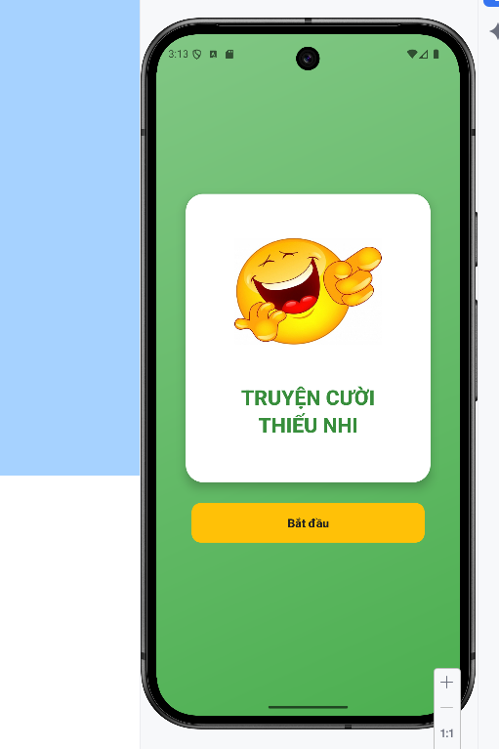
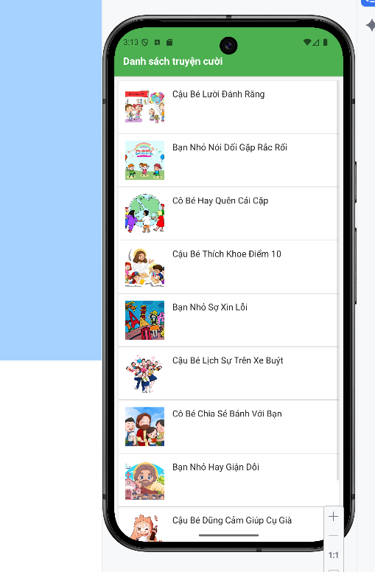

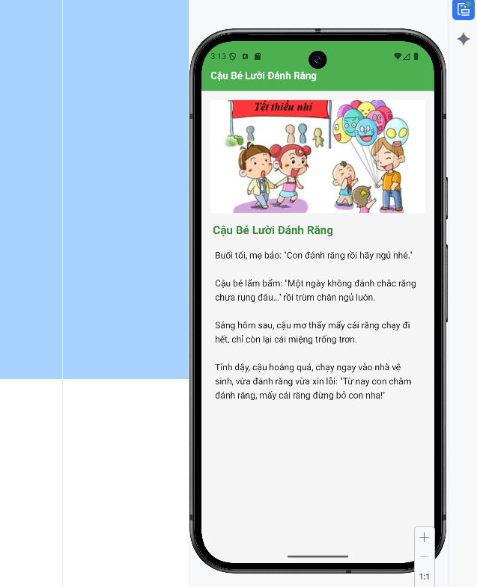

Bài tập: 12 Cung Hoàng Đạo

Bước 1: Tạo giao diện cho activity_cung_hoang_dao
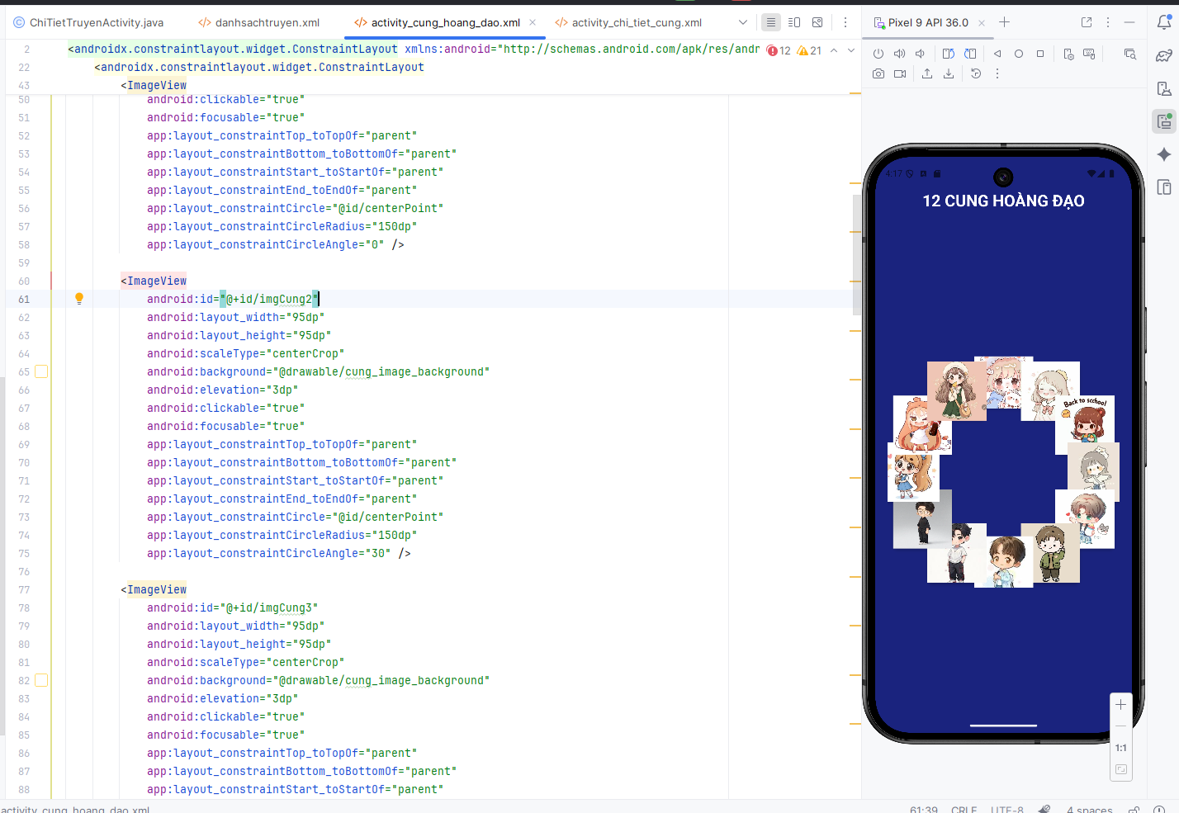
<?xml version="1.0" encoding="utf-8"?>
<androidx.constraintlayout.widget.ConstraintLayout xmlns:android="http://schemas.android.com/apk/res/android"
xmlns:app="http://schemas.android.com/apk/res-auto"
android:layout_width="match_parent"
android:layout_height="match_parent"
android:background="@color/zodiac_dark_blue">
<TextView
android:id="@+id/tvTitle"
android:layout_width="wrap_content"
android:layout_height="wrap_content"
android:text="12 CUNG HOÀNG ĐẠO"
android:textSize="26sp"
android:textStyle="bold"
android:textColor="@color/white"
android:layout_marginTop="52dp"
android:layout_marginBottom="20dp"
app:layout_constraintTop_toTopOf="parent"
app:layout_constraintStart_toStartOf="parent"
app:layout_constraintEnd_toEndOf="parent" />
<androidx.constraintlayout.widget.ConstraintLayout
android:id="@+id/circleContainer"
android:layout_width="0dp"
android:layout_height="0dp"
android:layout_margin="20dp"
app:layout_constraintTop_toBottomOf="@id/tvTitle"
app:layout_constraintBottom_toBottomOf="parent"
app:layout_constraintStart_toStartOf="parent"
app:layout_constraintEnd_toEndOf="parent"
app:layout_constraintDimensionRatio="1:1">
<View
android:id="@+id/centerPoint"
android:layout_width="1dp"
android:layout_height="1dp"
android:visibility="invisible"
app:layout_constraintTop_toTopOf="parent"
app:layout_constraintBottom_toBottomOf="parent"
app:layout_constraintStart_toStartOf="parent"
app:layout_constraintEnd_toEndOf="parent" />
<ImageView
android:id="@+id/imgCung1"
android:layout_width="95dp"
android:layout_height="95dp"
android:scaleType="centerCrop"
android:background="@drawable/cung_image_background"
android:elevation="3dp"
android:clickable="true"
android:focusable="true"
app:layout_constraintTop_toTopOf="parent"
app:layout_constraintBottom_toBottomOf="parent"
app:layout_constraintStart_toStartOf="parent"
app:layout_constraintEnd_toEndOf="parent"
app:layout_constraintCircle="@id/centerPoint"
app:layout_constraintCircleRadius="150dp"
app:layout_constraintCircleAngle="0" />
<ImageView
android:id="@+id/imgCung2"
android:layout_width="95dp"
android:layout_height="95dp"
android:scaleType="centerCrop"
android:background="@drawable/cung_image_background"
android:elevation="3dp"
android:clickable="true"
android:focusable="true"
app:layout_constraintTop_toTopOf="parent"
app:layout_constraintBottom_toBottomOf="parent"
app:layout_constraintStart_toStartOf="parent"
app:layout_constraintEnd_toEndOf="parent"
app:layout_constraintCircle="@id/centerPoint"
app:layout_constraintCircleRadius="150dp"
app:layout_constraintCircleAngle="30" />
<ImageView
android:id="@+id/imgCung3"
android:layout_width="95dp"
android:layout_height="95dp"
android:scaleType="centerCrop"
android:background="@drawable/cung_image_background"
android:elevation="3dp"
android:clickable="true"
android:focusable="true"
app:layout_constraintTop_toTopOf="parent"
app:layout_constraintBottom_toBottomOf="parent"
app:layout_constraintStart_toStartOf="parent"
app:layout_constraintEnd_toEndOf="parent"
app:layout_constraintCircle="@id/centerPoint"
app:layout_constraintCircleRadius="150dp"
app:layout_constraintCircleAngle="60" />
<ImageView
android:id="@+id/imgCung4"
android:layout_width="95dp"
android:layout_height="95dp"
android:scaleType="centerCrop"
android:background="@drawable/cung_image_background"
android:elevation="3dp"
android:clickable="true"
android:focusable="true"
app:layout_constraintTop_toTopOf="parent"
app:layout_constraintBottom_toBottomOf="parent"
app:layout_constraintStart_toStartOf="parent"
app:layout_constraintEnd_toEndOf="parent"
app:layout_constraintCircle="@id/centerPoint"
app:layout_constraintCircleRadius="150dp"
app:layout_constraintCircleAngle="90" />
<ImageView
android:id="@+id/imgCung5"
android:layout_width="95dp"
android:layout_height="95dp"
android:scaleType="centerCrop"
android:background="@drawable/cung_image_background"
android:elevation="3dp"
android:clickable="true"
android:focusable="true"
app:layout_constraintTop_toTopOf="parent"
app:layout_constraintBottom_toBottomOf="parent"
app:layout_constraintStart_toStartOf="parent"
app:layout_constraintEnd_toEndOf="parent"
app:layout_constraintCircle="@id/centerPoint"
app:layout_constraintCircleRadius="150dp"
app:layout_constraintCircleAngle="120" />
<ImageView
android:id="@+id/imgCung6"
android:layout_width="95dp"
android:layout_height="95dp"
android:scaleType="centerCrop"
android:background="@drawable/cung_image_background"
android:elevation="3dp"
android:clickable="true"
android:focusable="true"
app:layout_constraintTop_toTopOf="parent"
app:layout_constraintBottom_toBottomOf="parent"
app:layout_constraintStart_toStartOf="parent"
app:layout_constraintEnd_toEndOf="parent"
app:layout_constraintCircle="@id/centerPoint"
app:layout_constraintCircleRadius="150dp"
app:layout_constraintCircleAngle="150" />
<ImageView
android:id="@+id/imgCung7"
android:layout_width="95dp"
android:layout_height="95dp"
android:scaleType="centerCrop"
android:background="@drawable/cung_image_background"
android:elevation="3dp"
android:clickable="true"
android:focusable="true"
app:layout_constraintTop_toTopOf="parent"
app:layout_constraintBottom_toBottomOf="parent"
app:layout_constraintStart_toStartOf="parent"
app:layout_constraintEnd_toEndOf="parent"
app:layout_constraintCircle="@id/centerPoint"
app:layout_constraintCircleRadius="150dp"
app:layout_constraintCircleAngle="180" />
<ImageView
android:id="@+id/imgCung8"
android:layout_width="95dp"
android:layout_height="95dp"
android:scaleType="centerCrop"
android:background="@drawable/cung_image_background"
android:elevation="3dp"
android:clickable="true"
android:focusable="true"
app:layout_constraintTop_toTopOf="parent"
app:layout_constraintBottom_toBottomOf="parent"
app:layout_constraintStart_toStartOf="parent"
app:layout_constraintEnd_toEndOf="parent"
app:layout_constraintCircle="@id/centerPoint"
app:layout_constraintCircleRadius="150dp"
app:layout_constraintCircleAngle="210" />
<ImageView
android:id="@+id/imgCung9"
android:layout_width="95dp"
android:layout_height="95dp"
android:scaleType="centerCrop"
android:background="@drawable/cung_image_background"
android:elevation="3dp"
android:clickable="true"
android:focusable="true"
app:layout_constraintTop_toTopOf="parent"
app:layout_constraintBottom_toBottomOf="parent"
app:layout_constraintStart_toStartOf="parent"
app:layout_constraintEnd_toEndOf="parent"
app:layout_constraintCircle="@id/centerPoint"
app:layout_constraintCircleRadius="150dp"
app:layout_constraintCircleAngle="240" />
<ImageView
android:id="@+id/imgCung10"
android:layout_width="95dp"
android:layout_height="95dp"
android:scaleType="centerCrop"
android:background="@drawable/cung_image_background"
android:elevation="3dp"
android:clickable="true"
android:focusable="true"
app:layout_constraintTop_toTopOf="parent"
app:layout_constraintBottom_toBottomOf="parent"
app:layout_constraintStart_toStartOf="parent"
app:layout_constraintEnd_toEndOf="parent"
app:layout_constraintCircle="@id/centerPoint"
app:layout_constraintCircleRadius="150dp"
app:layout_constraintCircleAngle="270" />
<ImageView
android:id="@+id/imgCung11"
android:layout_width="95dp"
android:layout_height="95dp"
android:scaleType="centerCrop"
android:background="@drawable/cung_image_background"
android:elevation="3dp"
android:clickable="true"
android:focusable="true"
app:layout_constraintTop_toTopOf="parent"
app:layout_constraintBottom_toBottomOf="parent"
app:layout_constraintStart_toStartOf="parent"
app:layout_constraintEnd_toEndOf="parent"
app:layout_constraintCircle="@id/centerPoint"
app:layout_constraintCircleRadius="150dp"
app:layout_constraintCircleAngle="300" />
<ImageView
android:id="@+id/imgCung12"
android:layout_width="95dp"
android:layout_height="95dp"
android:scaleType="centerCrop"
android:background="@drawable/cung_image_background"
android:elevation="3dp"
android:clickable="true"
android:focusable="true"
app:layout_constraintTop_toTopOf="parent"
app:layout_constraintBottom_toBottomOf="parent"
app:layout_constraintStart_toStartOf="parent"
app:layout_constraintEnd_toEndOf="parent"
app:layout_constraintCircle="@id/centerPoint"
app:layout_constraintCircleRadius="150dp"
app:layout_constraintCircleAngle="330" />
</androidx.constraintlayout.widget.ConstraintLayout>
</androidx.constraintlayout.widget.ConstraintLayout>

Bước 2: Tạo giao diện chi tiết cung
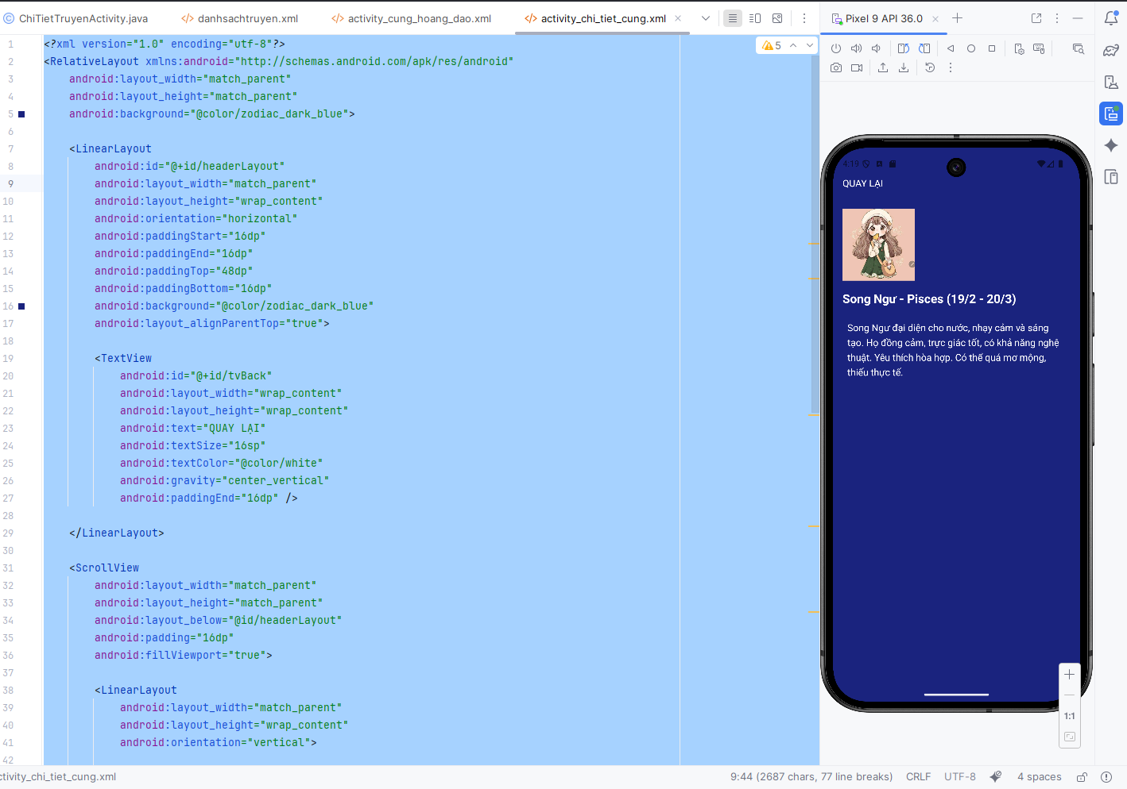
<?xml version="1.0" encoding="utf-8"?>
<RelativeLayout xmlns:android="http://schemas.android.com/apk/res/android"
android:layout_width="match_parent"
android:layout_height="match_parent"
android:background="@color/zodiac_dark_blue">
<LinearLayout
android:id="@+id/headerLayout"
android:layout_width="match_parent"
android:layout_height="wrap_content"
android:orientation="horizontal"
android:paddingStart="16dp"
android:paddingEnd="16dp"
android:paddingTop="48dp"
android:paddingBottom="16dp"
android:background="@color/zodiac_dark_blue"
android:layout_alignParentTop="true">
<TextView
android:id="@+id/tvBack"
android:layout_width="wrap_content"
android:layout_height="wrap_content"
android:text="QUAY LẠI"
android:textSize="16sp"
android:textColor="@color/white"
android:gravity="center_vertical"
android:paddingEnd="16dp" />
</LinearLayout>
<ScrollView
android:layout_width="match_parent"
android:layout_height="match_parent"
android:layout_below="@id/headerLayout"
android:padding="16dp"
android:fillViewport="true">
<LinearLayout
android:layout_width="match_parent"
android:layout_height="wrap_content"
android:orientation="vertical">
<ImageView
android:id="@+id/imgCung"
android:layout_width="120dp"
android:layout_height="120dp"
android:scaleType="centerCrop"
android:layout_gravity="start"
android:background="@android:color/transparent"
android:layout_marginBottom="16dp" />
<TextView
android:id="@+id/tvTitle"
android:layout_width="match_parent"
android:layout_height="wrap_content"
android:text="Tên cung hoàng đạo"
android:textSize="20sp"
android:textStyle="bold"
android:textColor="@color/white"
android:layout_marginBottom="16dp" />
<TextView
android:id="@+id/tvContent"
android:layout_width="match_parent"
android:layout_height="wrap_content"
android:text="Nội dung mô tả cung hoàng đạo..."
android:textSize="16sp"
android:textColor="@color/white"
android:lineSpacingExtra="6dp"
android:padding="8dp" />
</LinearLayout>
</ScrollView>
</RelativeLayout>

Bước 3: Tạo class cunghoangdaoact
package com.example.a1150070016_lequochuy;
import androidx.appcompat.app.AppCompatActivity;
import android.content.Intent;
import android.graphics.Bitmap;
import android.graphics.BitmapFactory;
import android.os.Bundle;
import android.view.View;
import android.view.animation.Animation;
import android.view.animation.ScaleAnimation;
import android.widget.ImageView;
import java.io.IOException;
import java.io.InputStream;
public class cunghoangdaoact extends AppCompatActivity {
private ImageView[] imgCungs = new ImageView[12];
private String[] cungNames = {
"Bạch Dương", "Kim Ngưu", "Song Tử", "Cự Giải",
"Sư Tử", "Xử Nữ", "Thiên Bình", "Bọ Cạp",
"Nhân Mã", "Ma Kết", "Bảo Bình", "Song Ngư"
};
@Override
protected void onCreate(Bundle savedInstanceState) {
super.onCreate(savedInstanceState);
setContentView(R.layout.activity_cung_hoang_dao);
if (getSupportActionBar() != null) {
getSupportActionBar().hide();
}
initViews();
loadImages();
setupClickListeners();
}
private void initViews() {
imgCungs[0] = findViewById(R.id.imgCung1);
imgCungs[1] = findViewById(R.id.imgCung2);
imgCungs[2] = findViewById(R.id.imgCung3);
imgCungs[3] = findViewById(R.id.imgCung4);
imgCungs[4] = findViewById(R.id.imgCung5);
imgCungs[5] = findViewById(R.id.imgCung6);
imgCungs[6] = findViewById(R.id.imgCung7);
imgCungs[7] = findViewById(R.id.imgCung8);
imgCungs[8] = findViewById(R.id.imgCung9);
imgCungs[9] = findViewById(R.id.imgCung10);
imgCungs[10] = findViewById(R.id.imgCung11);
imgCungs[11] = findViewById(R.id.imgCung12);
}
private void loadImages() {
for (int i = 0; i < 12; i++) {
try {
String fileName = "photo/cung" + (i + 1) + ".jpg";
InputStream is = getAssets().open(fileName);
Bitmap bmp = BitmapFactory.decodeStream(is);
imgCungs[i].setImageBitmap(bmp);
is.close();
} catch (IOException e) {
try {
String fileName = "photo/cung" + (i + 1) + ".webp";
InputStream is = getAssets().open(fileName);
Bitmap bmp = BitmapFactory.decodeStream(is);
imgCungs[i].setImageBitmap(bmp);
is.close();
} catch (IOException ex) {
ex.printStackTrace();
imgCungs[i].setImageResource(android.R.drawable.ic_menu_gallery);
}
}
}
}
private void setupClickListeners() {
for (int i = 0; i < 12; i++) {
final int position = i;
imgCungs[i].setOnClickListener(new View.OnClickListener() {
@Override
public void onClick(View v) {
ScaleAnimation scaleAnimation = new ScaleAnimation(
1.0f, 0.9f, 1.0f, 0.9f,
Animation.RELATIVE_TO_SELF, 0.5f,
Animation.RELATIVE_TO_SELF, 0.5f
);
scaleAnimation.setDuration(100);
scaleAnimation.setAnimationListener(new Animation.AnimationListener() {
@Override
public void onAnimationStart(Animation animation) {}
@Override
public void onAnimationEnd(Animation animation) {
ScaleAnimation scaleBack = new ScaleAnimation(
0.9f, 1.0f, 0.9f, 1.0f,
Animation.RELATIVE_TO_SELF, 0.5f,
Animation.RELATIVE_TO_SELF, 0.5f
);
scaleBack.setDuration(100);
v.startAnimation(scaleBack);
Intent intent = new Intent(cunghoangdaoact.this, ChiTietCungActivity.class);
intent.putExtra("position", position);
intent.putExtra("cungName", cungNames[position]);
startActivity(intent);
}
@Override
public void onAnimationRepeat(Animation animation) {}
});
v.startAnimation(scaleAnimation);
}
});
}
}
}

Bước 4:Thêm ảnh vào photo
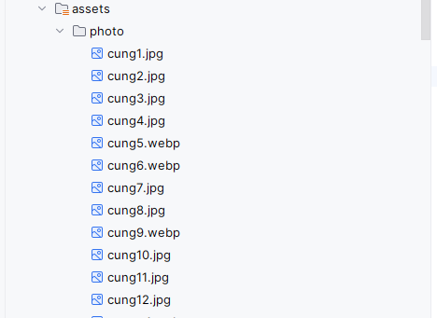

Bước 5: Thêm vào AndroidManifest.xml
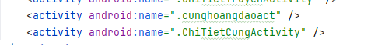
Kết quả
