Shopping list sort system

Members:

Reza Kajbaf 300904096

Andre Batista Valentim Oliveira 300909648

Leenoy Rajkhowa 300891338

COMP246-008

Table of Contents

Section 1: Project description 4

Section 2: Workflows and Activity diagrams 5

2-1 Category Registration 5

2-2 Product Registration 6

2-3 Planogram Management 7

2-4 Shopping List Creation 8

Section 3: Use-cases 9

3-1 Authentication Sub-System 10

3-2 Inventory Sub-System 11

3-3 Reporting Sub-System 12

Section 4: Detailed Use Cases 13

4-1 Create Promotion 13

4-1-1 Use Case Description 13

4-1-2 Sequence Diagram 14

4-2 Shopping List Management 15

4-2-1 Use case description 15

4-2-2 Sequence Diagram 16

Section 5: System Sequence Diagrams 17

5-1 Review Reply 17

5-2 Shopping List Management 18

Section 6: UI Mockups 19

6-1 Form Designs 19

6-2 Report Designs 21

Section 7: Entity Relationship Model 23

7-1 ERD Diagram 23

7-2 ERD Table 24

Section 8: System Structural Architecture 25

8-1 High Level Software Architecture Diagram 25

8-2 Components Diagram 26

8-3 Deployment Diagram 27

Section 9: CRC Cards & Design Class Diagram 28

Section 11: State Diagrams 30

11-1 Shopping List State Diagram 30

11-2 Promotion State Diagram 30

Section 12: Technology Tools for Software Development 31

Section 13: Project Plan 32

# Section 1: Project description

**Problem Description:**

One of the common issues between customers is where to find their needed items as they walk into a store since store layouts are different and it wastes the time of consumers to find their needed items. At times, they are not even aware that what they are looking for is not carried in that store.  Even if the store provides the items customer is looking for, it is always a headache to go through all the aisles and shelves to find them. And they may miss an item that is right in front of them and they have to come back to the same aisle to pick it up.

It is recommended that a system would be developed to help consumers save their time by optimizing their shopping list and suggesting the store that fits their needs best based on their shopping list acquired.

**System capabilities:**

Collects and stores retail store’s information

Enables the users to save and edit their shopping lists on the go

Enables the users to create an account to save their information for further ease of use.

Enables the store to register the list of what they sell

**Business Benefits:**

Reduces store-traffic by helping consumers shop faster

Raise store's profit by enabling customers to find more items in a shorter time

Reduces customers time spent on shopping

Reduces customer inconvenience during shopping

**Subsystems:**

1. Reporting
2. Inventory
3. Authentication

# Section 2: Workflows and Activity diagrams

## 2-1 Category Registration

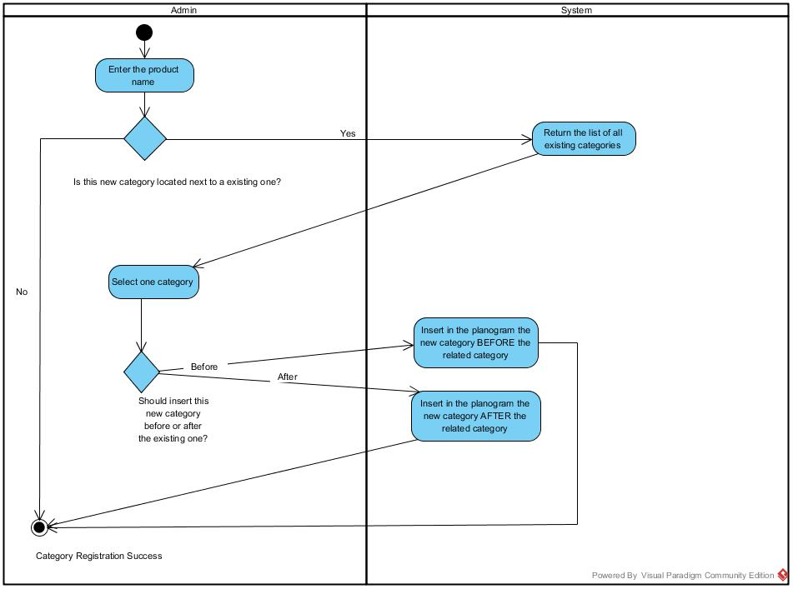

1. System administrator enters a new category name.
2. User is prompted if they know where the new category should be placed, if yes we move to next step. If no, category will be created without a specific location.
3. System returns a list of all existing categories.
4. User will select one category, which they want the new category next to.
5. User will specify if the new category should be placed before or after the existing one.
6. If the answer is before, system will place the category before or after the selected category based on user’s decision.
7. Category is created and placed accordingly.

## 2-2 Product Registration

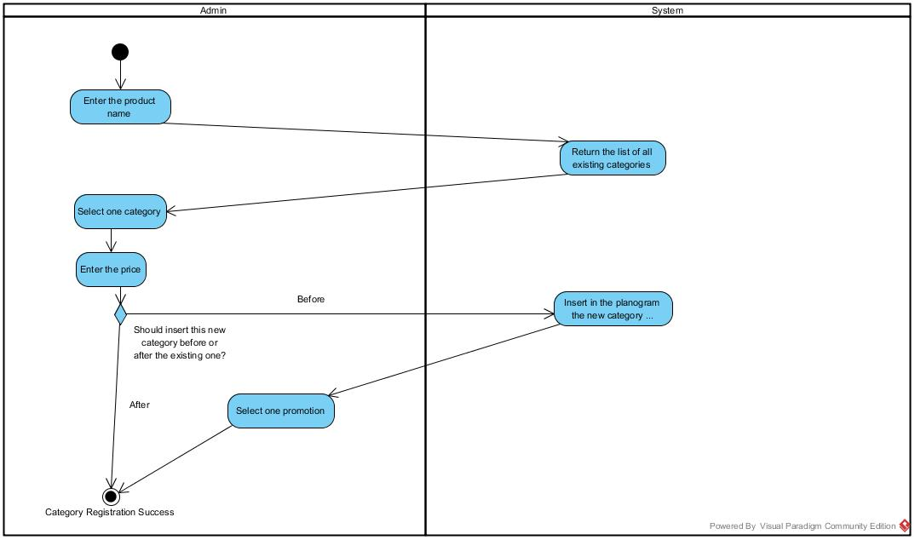

1. User enters a product name.
2. System return list of categories registered in the system.
3. User selects one of the categories to register the product under it.
4. User enters the price for that product.
5. User is prompted whether the product should be placed next to a desired category.
6. If there is a desired placement, determine whether to insert the new category before or after the selected category.

## 2-3 Planogram Management

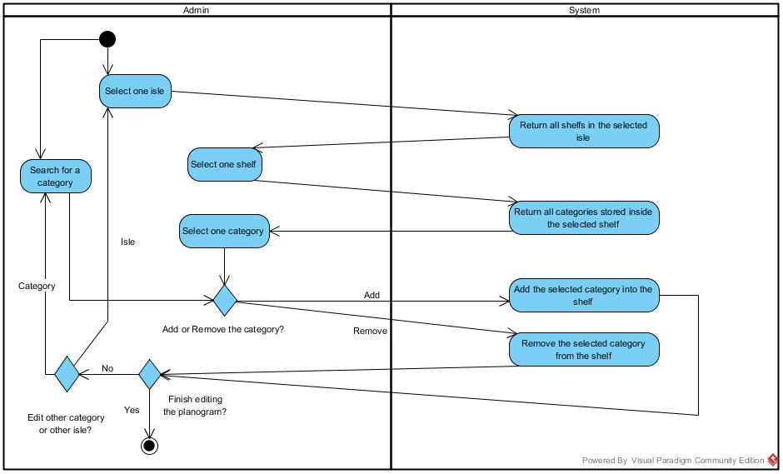

1. User selects the category
   1. The user knows the category they are looking for
      1. User selects one isle.
      2. System returns all shelves in the selected isle.
      3. User selects one shelf
      4. System returns all categories belonging to the specified shelf.
      5. User selects desired category.
2. User is prompted whether they want to add or remove the category.

2-1- If user needs to add a category system will add that category to the shelf.

2-2- If user wants to remove the selected category, system will do so.

1. User is asked if they are finished editing the planogram.

3-1- If the answer is ‘Yes’: exit.

3-2- If the answer is ‘No’: redo the process for a new category

## 2-4 Shopping List Creation

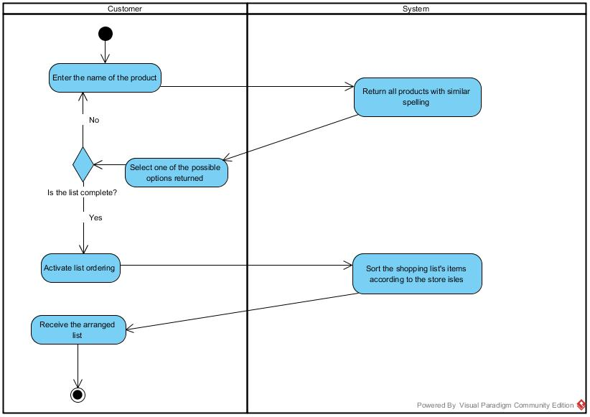

1. Customer enters the name of the product he/she is looking for
2. System returns the products that match customer’s searched terms.
3. In case customer selects one of the search results, if customer is done with shopping list he/she proceeds to ordering the list. If he/she needs more items, they will be directed to entering name of new product again.
4. When customer is done with wanted products, order list will be transferred to system where the shopping list will be sorted in accordance with store isles.
5. Customer receives the sorted shopping list.

# Section 3: Use-cases

| USER | USER GOAL AND RESULTING USE CASE |
| --- | --- |
| Potential Customer | Search for Item  Fill shopping list  Edit shopping list  Generate ordered list |
| Admin (Authentication) | Maintain and troubleshoot customer accounts  Update customer account information  Manage customer account permissions |
| Admin (Inventory) | Manage Products  Manage Categories for products  Manage Planogram for products  Manage Promotion for products |
| Admin (Reporting) | Monitor customer usage  Analyze customer feedback  Receive maintenance notification alerts |

## 3-1 Authentication Sub-System

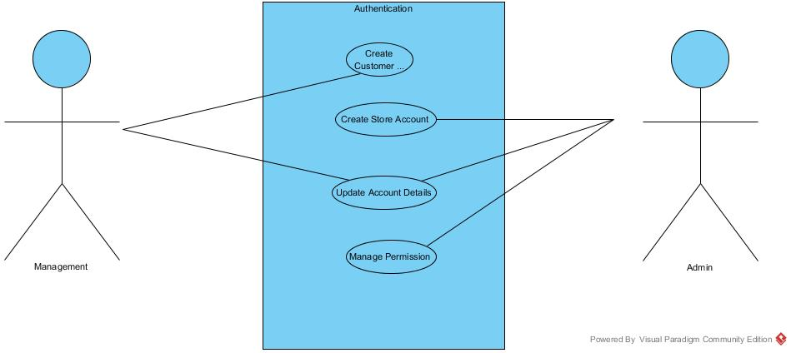

| USE CASES | USE CASE DESCRIPTION | ACTORS |
| --- | --- | --- |
| Create customer account | Actor enters new customer account data, and the system assigns account number, creates a customer record and creates and account record. | Customer |
| Create store account | Actor enters new store account data, and the system assigns account number, creates a store record and creates an account record. | Admin |
| Update account details | Actor updates any new information in the account and the system updates the information respectively. | Customer, Admin |
| Manage account permissions | Actor verifies account information and prohibits access to accounts (both customer and store) when a suspicious or malicious activity is encountered. | Admin |

## 3-2 Inventory Sub-System

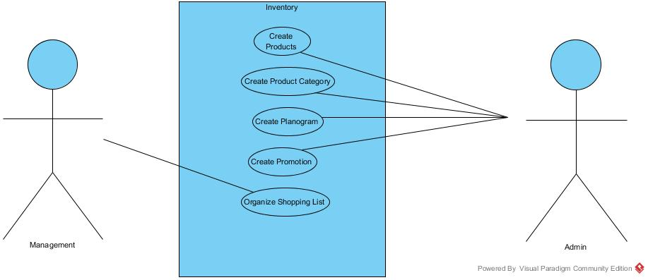

| USE CASES | USE CASE DESCRIPTION | ACTORS |
| --- | --- | --- |
| Create Products | Actor enters new products into the system by putting the name of the product, its price, its promotional details and the product is then register in the database. | Admin |
| Create Product Category | Actor enters new product category to store the product information, the categories are stored and registered in the database. | Admin |
| Create Planogram | Actor enters aisle information to store the categorized products, the categorized and ordered information is stored in the database. | Admin |
| Create Promotion | Actor enters promotional and sale details for products or product categories, the system stores and registers this information on to the database. | Admin |
| Organize Shopping List | Actor uses an application event to organize the created shopping list, the system receives the event trigger and organizes the shopping list based on the backend system database. | Customer |

## 3-3 Reporting Sub-System

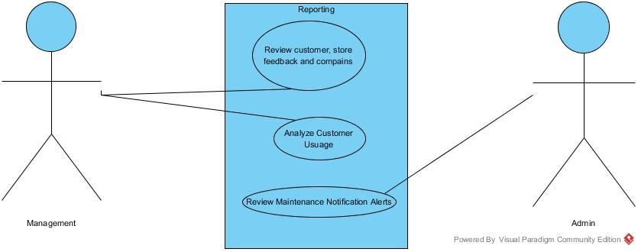

| USE CASES | USE CASE DESCRIPTION | ACTORS |
| --- | --- | --- |
| Review customer or store feedback, complains and suggestions | Actor reviews the feedback, suggestions or complains that is received from either the customer or the store from using the application** | Management |
| Analyze customer usuage | Actor performs data analytics on customer usage (such as frequency of use, customer retention rate) to receive insights about the product architecture | Management |
| Review maintenance notification alerts | Actor receives periodical notifications through the system when an event occurs such as a customer account is created, account permissions are changed or store information is updated. | Admin |

# Section 4: Detailed Use Cases

## 4-1 Create Promotion

The admin is able to launch promotional events and is able to add products to their specific categories for the customers using the application.

### 4-1-1 Use Case Description

|  |  |
| --- | --- |
| **Use Case Description** | |
| **Use Case Name** | Create Promotion |
| **Use Case ID** |  |
| **Actor(s)** | Admin |
| **Scenario** | Admin wants to create a promotion. |
| **Triggering Event** | Admin logs into to their respective account. |
| **Description** | After the admin logs in to the account, he/she is able to launch a promotion for a specific product. The promotion may include items of sales that the customers will be able to view from accounts while using the web application. |
| **Related Use Cases** | 1. Customer Searching for Products 2. Admin login to their account 3. Customer login to their account |
| **Pre-Conditions** | 1. A category for the product must exist 2. A product must be available |
| **Post-Conditions** | 1. Promotion is established 2. Customers can purchase items on sale |
| **Flow of Events** | Actor System  1) Admin logs into to their account.  2) Admin checks the list of category of products.  3) Admin selects the specific product to be on promotion.  4) Admin creates the promotion. |
| **Exception Conditions** | 1. Provided login information is not valid. 2. Requested account already exists. 3. Item not available in the desired category |

### 4-1-2 Sequence Diagram

## 4-2 Shopping List Management

The customer is able to select product from the specific available categories. The user can add, remove products from the list and can also create new lists and delete any outdated lists. Any unorganized list could be organized with the help of the *sort button.*

### 4-2-1 Use case description

|  |  |
| --- | --- |
| **Use Case Description** | |
| **Use Case Name** | Shopping List Management |
| **Use Case ID** |  |
| **Actor(s)** | Customer |
| **Scenario** | User wants to create a sorted shopping list. |
| **Triggering Event** | User logs into to their respective account. |
| **Description** | After the user logs in to the account, he/she is able select products from specific categories to put them on his/her list. Once the items are put on the list, the user can sort the list with the application logic. |
| **Related Use Cases** | 1. Search for Products 2. Promotion of products 3. Customer login to their account |
| **Pre-Conditions** | 1. A category for the product must exist 2. A product must be available |
| **Post-Conditions** | 1. User is logged in to his/her account |
| **Flow of Events** | Actor System  1) Customer logs into to their account.  2) Customer checks the list of products.  3) Customer selects the specific product to be on the list.  4) Customer generates the sorted list. |
| **Exception Conditions** | 1. Provided login information is not valid. 2. Requested account already exists. 3. Item not available in the desired category |

### 4-2-2 Sequence Diagram

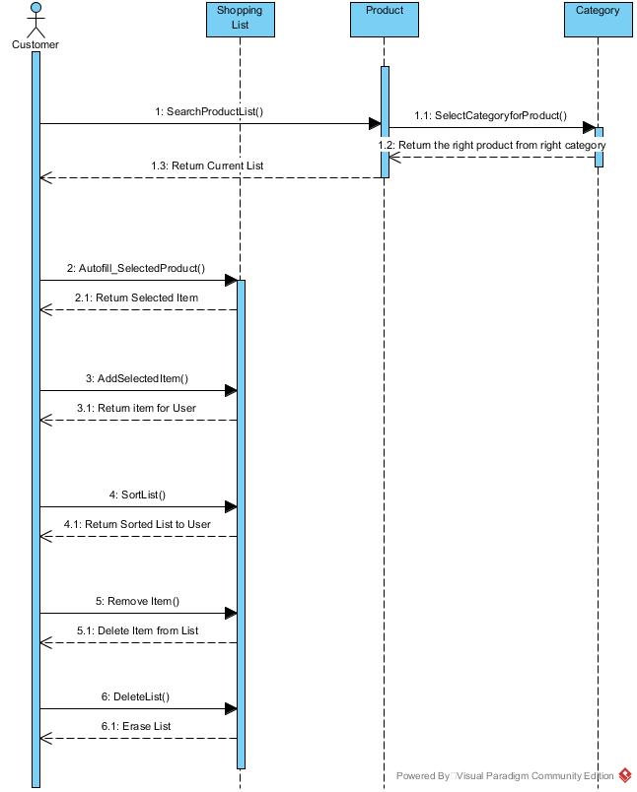

# Section 5: System Sequence Diagrams

## 5-1 Review Reply

## 5-2 Shopping List Management

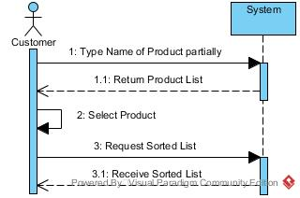

Section 6: UI Mockups

6-1 Form Designs

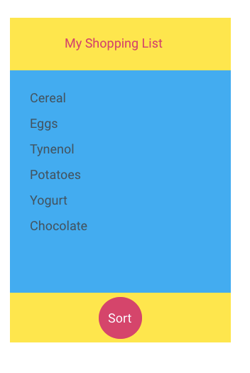

Figure 1: The user can add various items to his/her shopping list for them to be sorted. Then the user has to press the ‘Sort’ Button for them to get sorted.

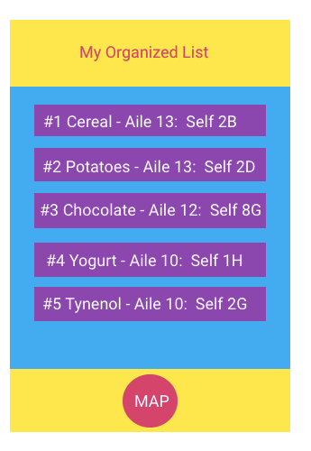

Figure 2: Once the ‘Sort’ button is clicked, an organized list is presented to the user that includes the aisles and shelves for each item location.

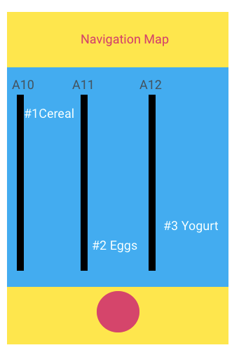

Figure 3: Once the map button is clicked a navigation map is presented to the user showing each item in the respective aisles and shelves.

6-2 Report Designs

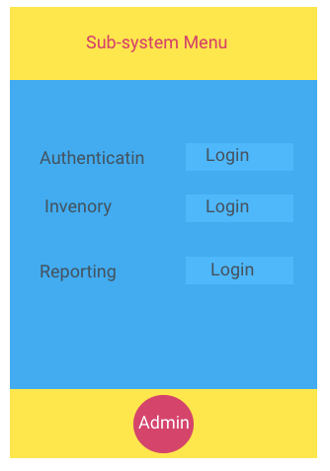

Figure 4: This main menu is for the admin user where he/she can navigate between admin functionalities such as planogram / updating, reporting, inventory management.

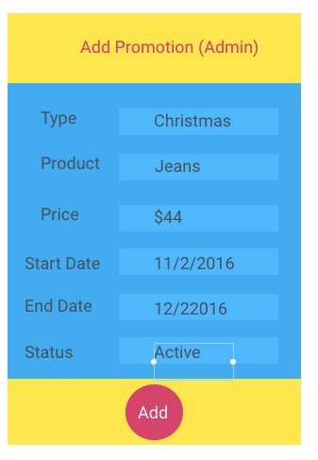

Figure 5: This promotion form is for the admin user where he/she can add new promotions depending on its type, product, price and period.

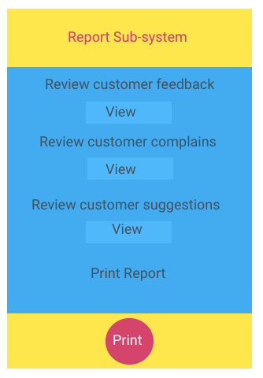

Figure 6: This menu is for the admin user where he/she can print and view reports such as summary, detailed, exception reports as per requirement.

# Section 7: Entity Relationship Model

## 7-1 ERD Diagram

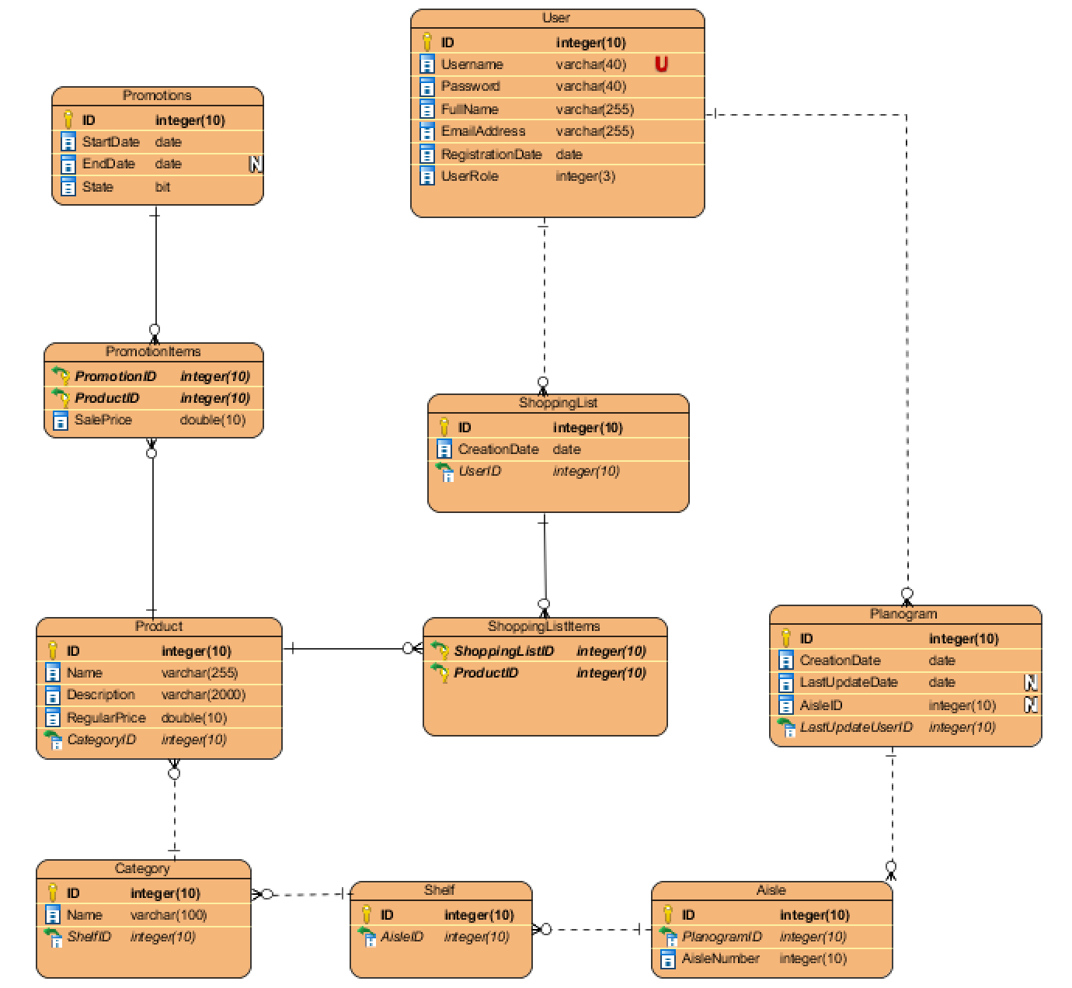

## 7-2 ERD Table

|  |  |  |
| --- | --- | --- |
| **Table** | **PK** | **FK** |
| User | ID |  |
| ShoppingList | ID | UserId |
| ShoppingListItems | ShoppingListID, ProductID |  |
| Product | ID | CategoryID |
| Category | ID | ShelfID |
| Shelf | ID | AisleID |
| Aisle | ID | PlanogramID |
| Planogram | ID | AisleID, LastUpdateUserID |
| Promotions | ID |  |
| PromotionItems | PromotionID, ProductID |  |

# Section 8: System Structural Architecture

8-1 High Level Software Architecture Diagram

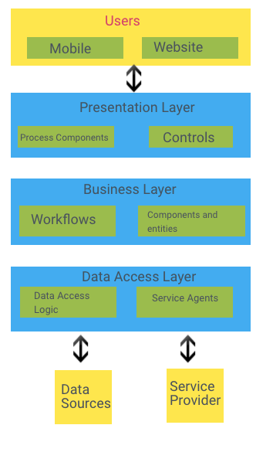

## C:\Users\Reza\Desktop\componentDiagram.png8-2 Components Diagram

## 8-3 Deployment Diagram

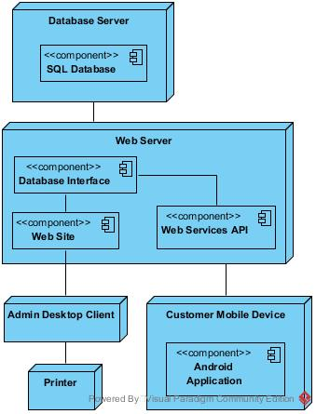

# Section 9: CRC Cards & Design Class Diagram

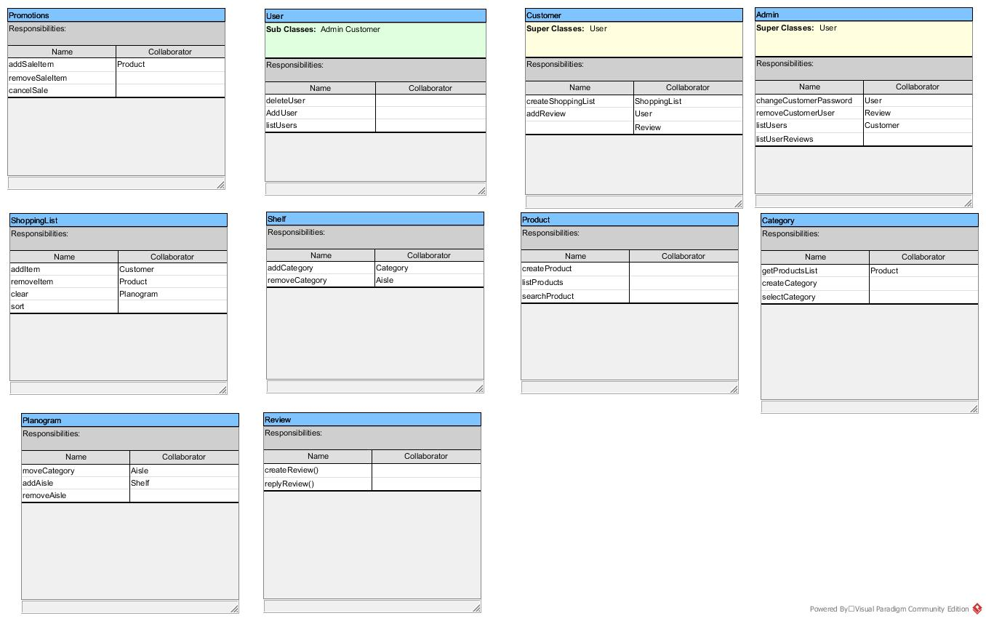

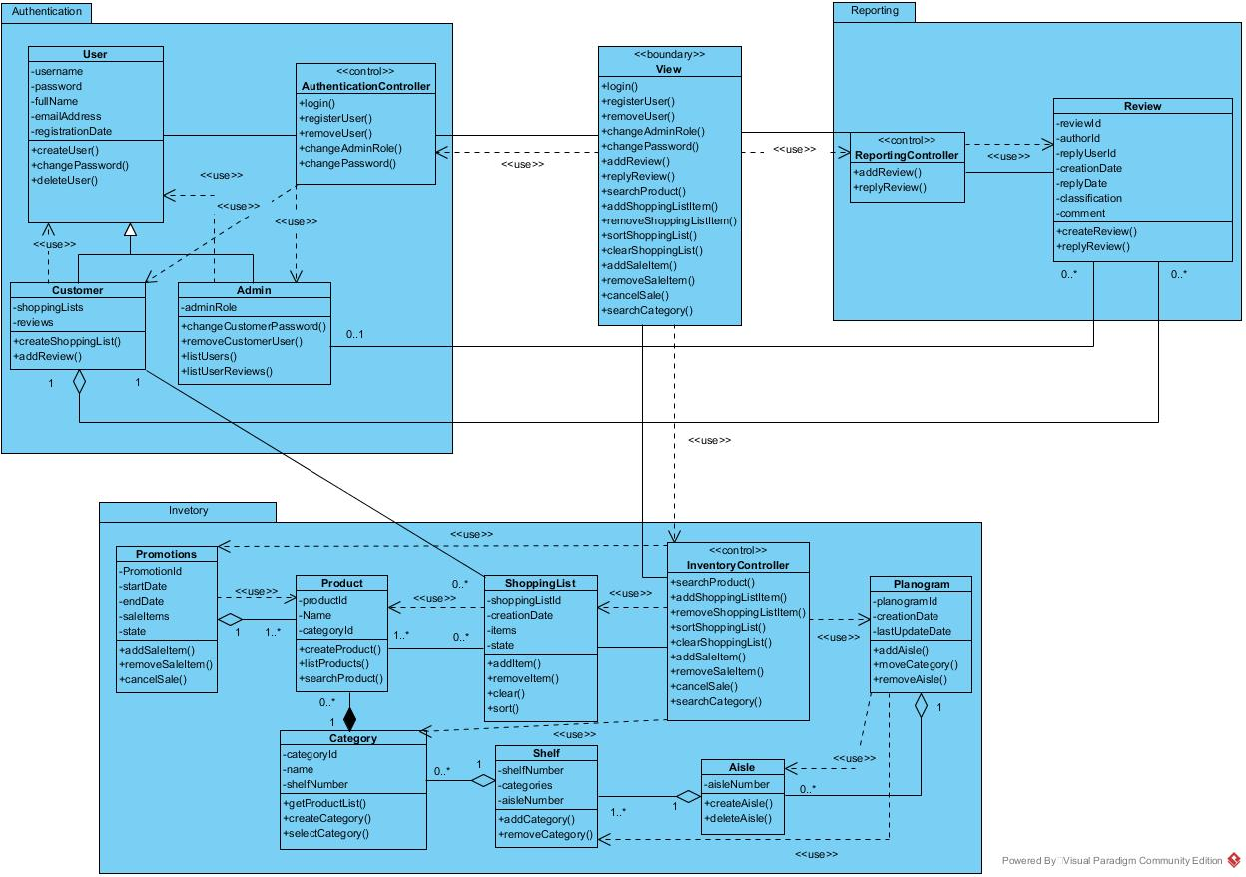

# Section 11: State Diagrams

## 11-1 Shopping List State Diagram

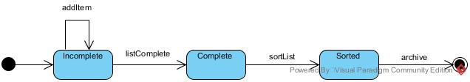

## 11-2 Promotion State Diagram

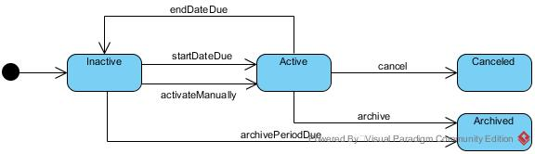

# Section 12: Technology Tools for Software Development

|  |  |  |
| --- | --- | --- |
| Tier | Tools | Description |
| Documentation | * Microsoft word * Visual Paradigm * Google Drive * Team Gantt * Marvel | Tools used to prepare documentation, diagrams, UI mockups and sharing the work between our team mates |
| Presentation | * HTML/CSS/JavaScript * Android * Java * Visual Studio * Eclipse * Google Chrome * Motorola Moto X 2nd Gen | Tools, devices and programming-languages used to develop our user interfaces. |
| Business Logic | * .NET MVC C# * Java * Visual Studio * Eclipse * SQL Developer | Technologies used to implement the business logic layer that includes the website controllers, mobile app controllers and database procedures/functions/triggers. |
| Data | * JSON * .NET Entity Framework * ADO .NET * SQL Developer * Oracle Database Server | Platforms used to implement the data persistency layer. The data is stored in an Oracle Database and the interface is provided as a centralized web service API. |

# Section 13: Project Plan

