**SMAPP: BEANZ-VERITAS STUDY**

***How to use the map***

The role of the MAP object is to provide geo-tagged answers/data to the underlying questionnaire through a simple but effective interface. This is a generic object and as such it can be used with any SMAPP questionnaire. The MAP object was developed using Google Maps API which allowed not only the implementation of the basic mapping functions but also some of the web services such as Street View, Directions and Places (search).

The main usage of the ***MAP*** is to identify specific locations (residence, school, work place, neighbourhoods, etc.) and create markers or shapes identifying these locations. Once this process finished, closing the ***MAP*** the data is transferred to the questionnaire.

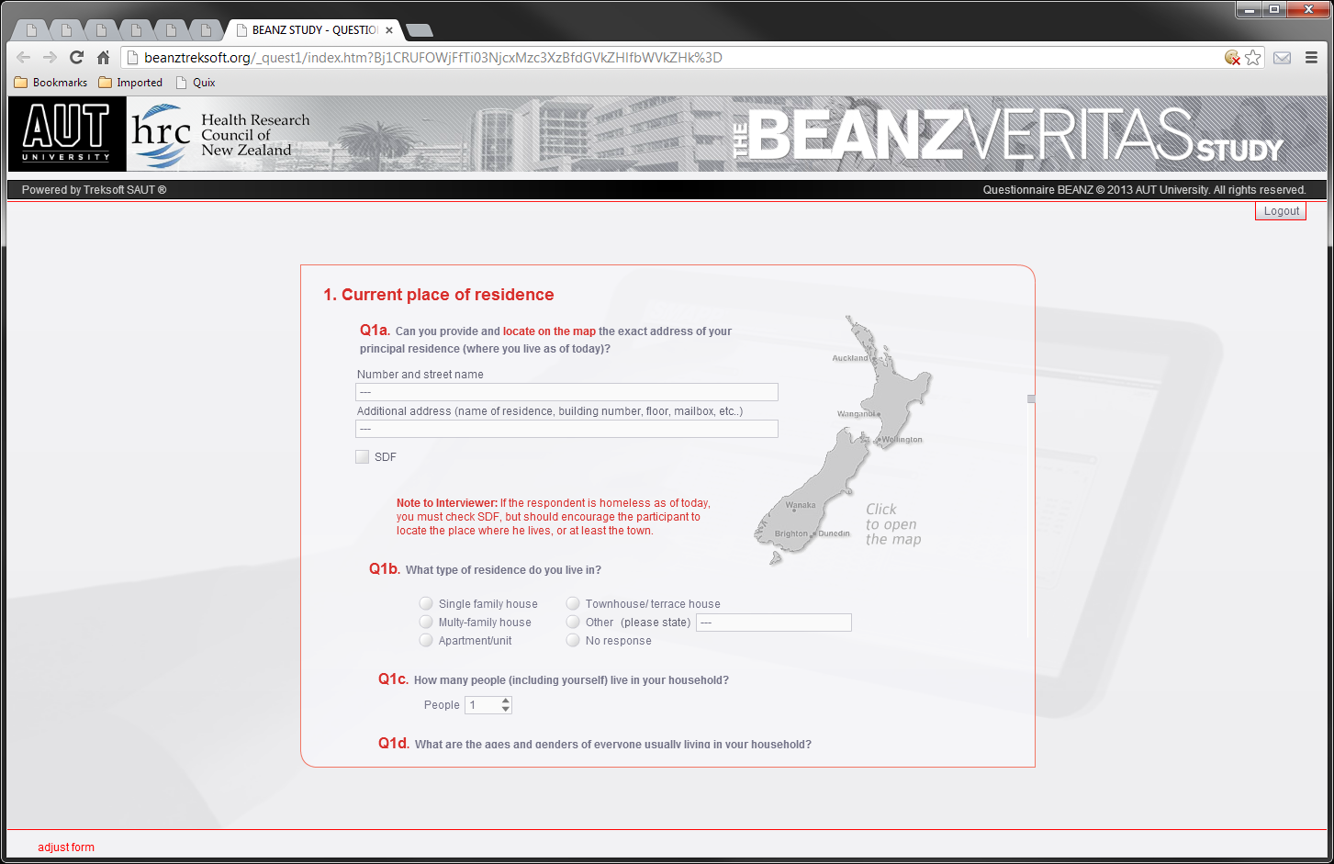

To access the map from the questionnaire just click on the map button in the current questionnaire page, if available.

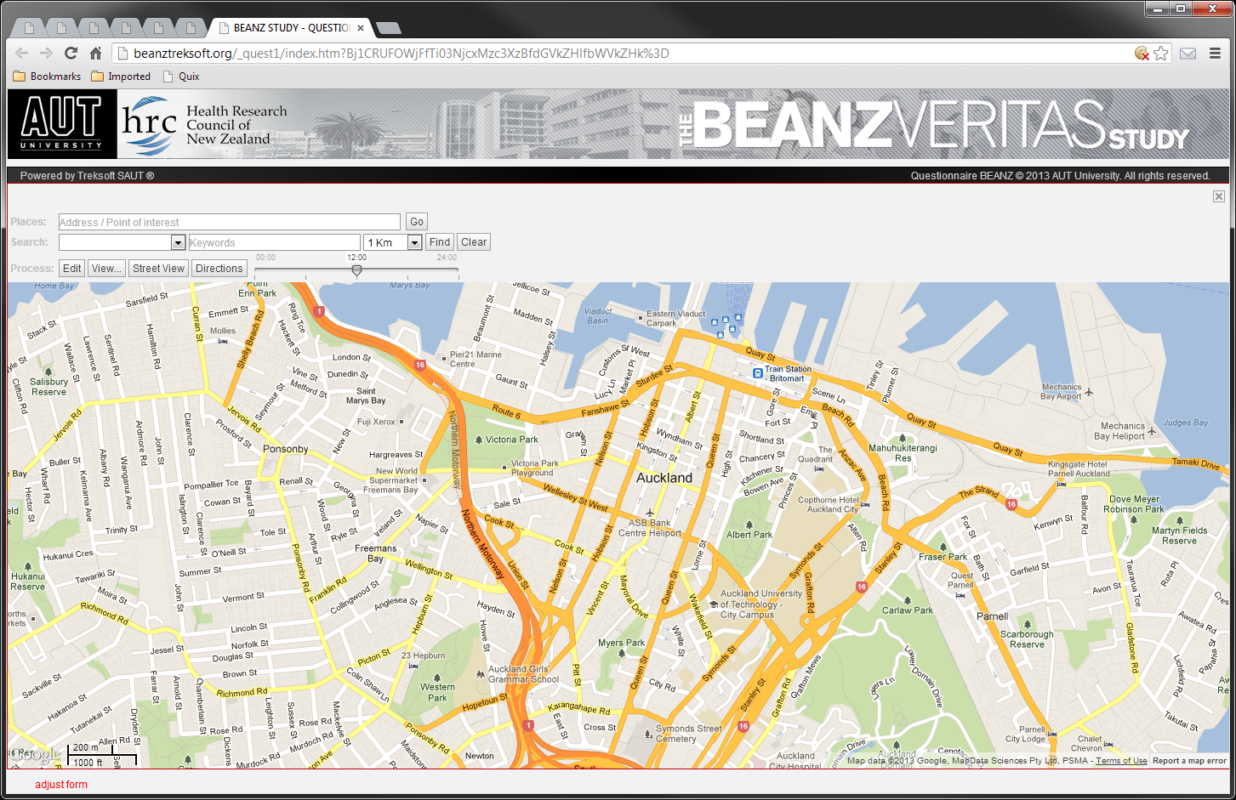

Let’s identify the controls used to manipulate the ***MAP***

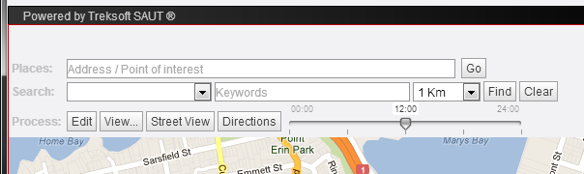

On the first row, ***Places***, we have the ***Current Address*** text box and the ***Go*** button.

If a marker or a shape object is selected, the ***Current Address*** contains that location’s address. If you click any place on the ***MAP*** that address is displayed here and the same goes when choosing locations in the ***Street View*** panel. Pressing the ***Go*** button a marker will be placed on the ***MAP*** at the current address.

The second row contains the ***Search*** controls. The first drop-down box allows you to choose a category/type of places to search such as schools, churches, stadiums, etc. The next text box to the right lets you enter specific keywords which will filter down the category.

The second drop-down list allows you to determine a search radius from the center of the map.

**Example:** if you choose *Cafe* as category/type and add the *Internet* keyword the search will return only the *Internet cafes*. Without a keyword the search will return all the *cafes* in the given radius.

The third controls row lets you edit the markers and shapes, to determine the current view of the ***MAP*** (roads, terrain, satellite) and some of the following overlays (bicycle paths, transit map, traffic map, etc.) The ***View*** button also lets you filter the visible shapes and markers on the ***MAP***.

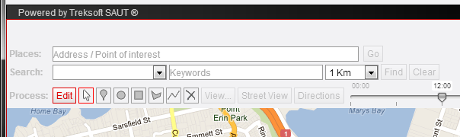

The ***Edit*** button opens the Toolbox used to create and position your own markers and shapes.

The first tool (arrow) is used to drag the objects to new positions and to edit the *shapes* once created.

The following five tools are the object creation tools: select the tool and then click on the map at the desired location. Click again at a different location to create another object.

The polygons and the polylines are special cases for you have to complete creating the vertices before making a new object. In the case of the polygon the last vertex should be on the top of the first vertex in order to close the shape. For the polyline you need to *double-click* on the last vertex to finish the object.

To delete some of the objects, select the last tool, then click on the objects you wish to delete. Currently there is no Undo function available.

The ***Street View*** button opens the ***Street View*** service window placed at the current address (see ***Current Address*** text box). Moving to a new location in the ***Street View*** window updates the ***Current Address*** content. Clicking the ***Go*** button now will create a marker corresponding to the ***Street View*** location. Clicking an existing marker, shape or directly on the map will refresh the ***Street View*** location.

**Examples:**

*To be continued…*