[1]

Classifying Dog Breeds Through Transfer Learning

Joe Jiang, Rikel Djoko, Johnson Ekedum, Lavonnia Newman

*Abstract*— A frequent question received by dog owners is the breed of their beloved pet. Using a dataset that contains thousands of images of 120 different dog breeds, we developed a classifier capable of predicting dog breeds range from *Afghan Hound* to *Yorkshire Terriers*. Using TensorFlow and Google autoML cloud vision, we evaluated several pretrained computer vision models such as Res-Net 50, VGG and Inception V4 and fine-tuned our dog breed classifier. We evaluated the models on the test dataset and used various classification metrics to choose the most appropriate one for deployment on google cloud console.

# INTRODUCTION

O

ne of the most common questions when people meet dog owners and their puppies is “what is the breed of your dog?”. The answer might be one of the well-known breeds, but more often, the owners might not be sure of that themselves. Don’t you wish that you can just take out your phone and snap a picture of the pup and tell the owner the most likely breed or maybe even a mixture of potential breeds of their dog?

In this project, the dog breed classifier will take advantage of the recent breakthroughs in computer vision research, specifically, several advanced computer vision models based on deep convolution neural networks, such as Res-Net, VGG and inception models. The most appealing aspect of these models is the fact that we can use these pretrained models (both their architecture and weights associated with all layers) to fine tune our own specific models, in this case, a dog breed classifier. There are several distinctive advantages of this setup: 1. It is much easier and faster to train your own models based on existing proven models; 2. Fine tuning a pretrained model in general requires much smaller training dataset which is the case for our model; 3. The feature vectors extracted from image by these pretrained models are general enough to be easily adapted for our specific task: a 120 Softmax classifier.

# Dog Breeds

A dog is classified as “man’s best friend”, so much so that dogs are the most recognized animal of the pet industry.  But the word “dog” doesn’t cover the depth and breadth of the pet. The breed is what defines the type of dog and frames the picture in one’s mind of what that dog’s size, physical shape, temperament, barking level, shedding, and activity level1 will be.  At the highest level, breeds can be classified as a pure, cross, mixed or natural.  Humans breed dogs for specific purpose and function like hunting, guarding, herding, tracking and even toys.

The Kennel Club in the United Kingdom was formed in 1873  and was the first organization to develop a breed registry.  Since then other kennel clubs have been established in other countries and each carries its own list of recognized dog breeds.  The registry isn’t used to identify the quality or ethical manner in which the dog was raised from a puppy. The registry was used to identify the breed of the dog’s parents.   With all of the combination options for breeding, there isn’t a single list to recognize all of the breeds of the world, but the dogs can be classified to contributing breeds based on certain features.   The United States Kennel club currently recognizes 193 breeds even though there are over 400 breeds recognized worldwide.

# Architecture

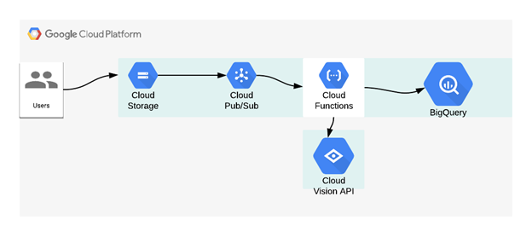 The broad idea is to develop a custom a vision model for image recognition. The concepts of neural architecture search and transfer learning are used under the hood to find the best network architecture and the optimal hyperparameter configuration that minimizes the loss function of the model. In this project we leverage Cloud AutoML Vision alongside other relevant Google clouds services including cloud storage  to store our training data, pub/sub for messaging, cloud functions to run our code on a fully managed services and BigQuery for analysis.

1. This work was completed in SMU Cloud Computing curriculum as requested by Dr. Sohail Rafiqi..

   Joe Jiang is a data science student at Southern Methodist University, and is based in Seattle, WA USA ([joejiang@smu.edu](mailto:joejiang@smu.edu)).

   Rikel Djoko is a data science student at Southern Methodist University, and is based in Seattle, WA USA ([rdjoko@smu.edu](mailto:rdjoko@smu.edu)).

   Johnson Ekedum is a data science student at Southern Methodist University, and is based in San Francisco, CA ([jekedum@smu.edu](mailto:jekedum@smu.edu)).

   Lavonnia Newman is a data science student at Southern Methodist University, and is based in Frisco, TX ([lavonnian@smu.edu](mailto:lavonnian@smu.edu))

   1 Hunsburger, Dale. “Breed Type Defines the Breed”, American Kennel Club, September 6, 2018.