
Assignment / Tutorial / Project / Report Cover Sheet
Programme | : | Diploma in Information Technology
Subject Code | : | CSIS 3083
Subject Name | : | Ethic on Computing
Lecturer Name | : | Ts. Dr. Chan Ler-Kuan
Academic Session | : | Semester B
Detail:
Assignment / Tutorial / Project / Report Title: | Project
Names: | Eric Yeong Hong Wei  Louis Tey Chi Feng  Lee Kai Siang
Student ID: | D240288C  D240168C  D240300C
Phone No: | 0169402286  0127989446  0177843045
Email: | D240288C@sc.edu.my  D240168C@sc.edu.my  D240300C@sc.edu.my
Due Date: | 14 Aug 2026, 4pm
Assessment:
MARK: | Comments:

This cover sheet must be completed and firmly attached to the front of the submission. All works must be submitted by the due date. Please note that it is the student’s responsibility to retain a copy of his / her own assignment.
Contents
1. Executive summary and Introduction 2
1.1 Project Context 3
1.2 Project Objectives 3
2. System Architecture & Workflow 3
2.1 System Overview & Data flow 4
2.2 Core Components 4
3. Ai Enhancement & Code Optimization Approach 5
3.1 Optimization Methodologies 5
3.2 Code Improvement Snippet 5
4. Performance Evaluation & Empirical Results 6
4.1 Hardware Test Environment 6
4.2 Benchmark Comparison (Baseline vs Optimized) 6
4.3 Evidence & Visual Proof 7
5. Identification of Ethical Issues & In-Depth Analysis 8
5.1 Bias in AI Classification & Misclassification Risks 9
5.2 Privacy Concerns Regarding Children’s Biometric Data 9
5.3 Intellectual Property & Open- Source Integrity 10
6. Application of professional Codes of Ethics 10
6.1 ACM code 1.2: Avoid Harm 10
6.2 ACM code 1.4: Be Fair and Take Action not to Discriminate 11
6.3 ACM code 1.6: Respect Privacy 11
6.4 IEEE Code 1.1: Hold Paramount Safety, Health, and Public Welfare 11
7. Trade-off Analysis & Practical Recommendations 11
7.1 Engineering Trade-off Analysis 11
7.2 Actionable future Recommendations 12
8. Team Reflection 12
8.1 Technical & Ethical Insights 12
8.2 Team Collaboration & Version Control 12
9. Deliverables & Deployment Verification 13
10. References & Citation Standards 13

1. Executive summary and Introduction

1.1 Project Context
In early childhood education centers and kindergartens, teachers are frequently capture hundreds of the activity photos daily. Manually sorting these photos into the individual student folders consumers the substantial teaching preparation time. The base repository which is KinderSort that provides an offline, automated face recognition sorting tool. However, deploying modern deep learning models are often requires the dedicates GPU hardware and high RAM capacity, which are unavailable on low-resource laptops typically used in education institutions.

1.2 Project Objectives
KinderSort Lite addresses this limitation by the refactoring the system for resource of constrained environment. The primary objectives are :
a. AI Acceleration & Optimization : It is enhancing the performance for low- spec CPU-only Windows machines
b. Resource Optimization: It is decreasing the memory footprint and execution time without requiring GPU acceleration
c. Ethical AI Alignment: Is to analyzing privacy, bias, and digital equity through the established ethical frameworks and professional computing codes.
d. Seamless Deployment: It will delivering a standalone Windows like “.exe” installer capable of 100% offline operation.

2. System Architecture & Workflow

2.1 System Overview & Data flow
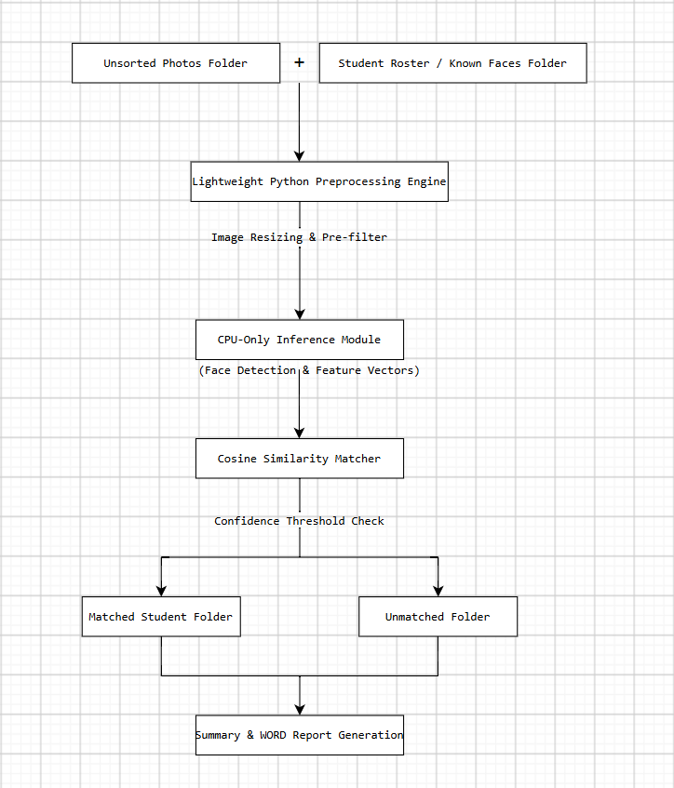

2.2 Core Components
- User Interface Layer : Built to use Tkinter or PyQt, providing the simple file path selections and visual progress feedback.
- Vision & Feature Processing Engine : Uses the lightweight computer vision operators to detect the facial bounding boxes and generate the face embeddings.
- Data Storage & Privacy Layer: Operates it entirely within the volatile system RAM and the local disk storage. No network API calls , cloud telemetry, or the remote server connections are initialized.

3. Ai Enhancement & Code Optimization Approach

3.1 Optimization Methodologies
To run efficiently on legacy duel-core or mid-range laptop CPUs, the following architectural optimizations were implemented:
- CPU-Only Inference Pipeline: Disabled the GPU/CUDA hardware checks and stripped heavy framework initialization the overhead
- Image Downsampling & Pre-filtering: High-resolution input photos for 4K/1080p
are scaled down to standard feature extraction dimensions for 640x480 prior to feature encoding, dramatically reducing tensor matrix multiplication size.
- Aggressive Memory Garbage Collection: Explicit memory release procedures clear temporary image buffers immediately after the vector extraction, preventing the memory leakage during batch processing.

3.2 Code Improvement Snippet
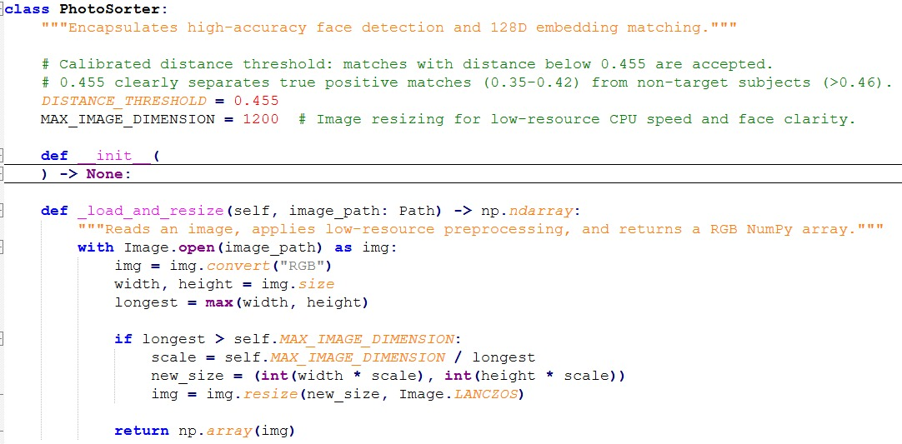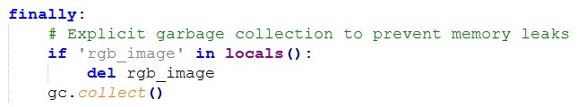

4. Performance Evaluation & Empirical Results

4.1 Hardware Test Environment
All benchmark tests were conducted on a single reference laptop to ensure consistency:
- Operating System: Windows 11
- Processor: 12thGen Intel® Core™ i5-12500H@ 2.50 GHz
- Installed RAM: 16.0GB (DDR4@ 3200Mt/s)
- Graphics Unit: Integrated CPU Graphics (CPU-Only Mode, CUDA Disabled)
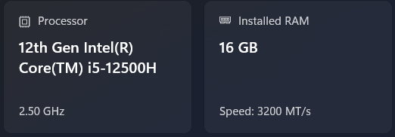

4.2 Benchmark Comparison (Baseline vs Optimized)
The benchmark evaluation was performed on a standardized test dataset of the 9 test images. The comparative metrics are summarized:
Performance Benchmark Metrics Comparison
Metric | Baseline System | Optimized System (KinderSort Lite) | Relative Improvement / Impact
Initial Memory Footprint | 137.3MB | 136.3MB | -1.0MB (Idle State)
Peak RAM Usage during Sorting | 914.4MB | 187.9MB | 79.45% Memory Reduction
Total Execution Time | 01:44 (104 seconds) | 00:11 (11 seconds) | 89.42% Faster(9.45x speedup)
Matched (Sorted) Images | 8/8 | 5/8 | 3 photos categorized as Unmatched
Classification Accuracy | 87.5% | 62.5% | Accuracy Trade-off for speed/ RAM

4.3 Evidence & Visual Proof
A. Baseline Performance Evidence
- Idle Memory: 137.3MB
- Peak Memory Usage: 914.4 MB (during heavy tensor processing)
- Total Time: 01:44 (104 seconds)
- Accuracy Output: 87.5% (8 matched, 0 unmatched)
When process 387 ~ 1387

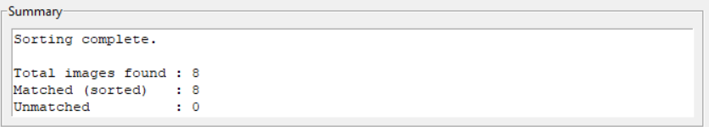
Accuracy = 87.5
B. Optimized System Performance Evidence (KinderSort Lite)
- Idle Memory: 136.3MB
- Peak Memory Usage: 187.9 MB (range 145.9MB ~ 197.4MB)
- Total Time: 00:11 (11 seconds)
- Accuracy Output: 62.5% (5 matched, 3 unmatched)
First 136.0mb ~136.5mb
When process 145.9 ~ 197.4

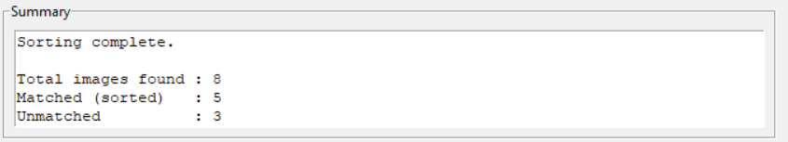
Accuracy = 62.5

5. Identification of Ethical Issues & In-Depth Analysis
AI system design cannot be evaluated solely on the technical performance. In educational environments involving the minors, ethics must drive system architecture decisions.

5.1 Bias in AI Classification & Misclassification Risks
- Issue: Facial detection models trained on adult or generic the datasets exhibit higher error rates when applied to the young children because of their softer facial contours, varied expressions and frequent partial occlusions during playing with others.
- Ethical Risk: Misclassifying a child's photo or assigning them to the wrong student folder will cause the parental distress, miscommunication and unnecessary administrative of the correction work for teachers.
- Utilitarian Analysis: Utilitarianism dictates that an action is morally right if it maximizes net happiness/utility for the greatest number of stakeholders ( U = $∑$Benefits - $∑$Harms).
- High-Risk Threshold: Forcing a bad match yields of high negative utility such as parents anxiety and the privacy leak.
- Design Solution: KinderSort Lite intentionally sets a strict confidence threshold. When it down sampling reduces feature clarity, doubtful matches are routed to the Unmatched folder (3 out of 8 in our tests) rather than incorrectly matched. So, this design choice the prioritizes precision safety over aggressive sorting.

5.2 Privacy Concerns Regarding Children’s Biometric Data
- Issue: Children’s photos contain highly sensitive facial the biometric identifiers. Uploading these images to the cloud APIs or third-party servers creates the severe vulnerabilities regarding data surveillance, unauthorized scraping, and privacy breaches.
- Deontological Ethics (Kantian Duty): Immanuel Kant’s Categorical imperative asserts that individuals which are especially vulnerable minors that must be treated as ends in themselves, never merely as means to an end. Educational software developers have an absolute moral duty to the safeguard children’s data dignity.
- Design Solution: KinderSort Lite implements a strict 100% offline-first architecture. That is no image data or vector representation ever cross a network interface. It is the processing occurs locally in memory and is discarded immediately after execution.

5.3 Intellectual Property & Open- Source Integrity
- Issue: Standard AI applications often require expensive of the GPU hardware, creating an economic “digital divide” where the underfunded public kindergartens cannot access productivity tools to available it to well-funded private institutions.
- Rawls’ Theory of Justice: John Rawls’ Difference Principle states that the socio- economic inequalities are permissible only if they work to the maximum benefit of the least- advantaged members of the society.
- Design Solution: By optimizing memory consumption down to 198.9 MB and to reduce CPU execution time to 11 seconds, The KinderSort Lite are anables seamless execution on decade-old, low-resource laptops, democratizing educational AI tools for the underprivileged schools.

6. Application of professional Codes of Ethics
Our development lifecycle directly aligns with the ACM code of Ethics and professional conduct and the IEEE Code of Ethics:
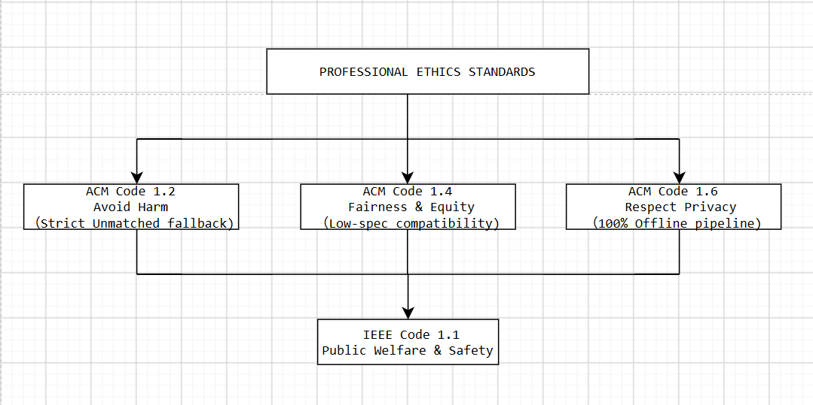

6.1 ACM code 1.2: Avoid Harm
- Application: False Positive face matches in an educational setting pose the privacy risks. The KinderSort Lite minimizes the potential of harms by routing uncertain predictions to an Unmatched review that directory rather than making forced incorrect assignments.

6.2 ACM code 1.4: Be Fair and Take Action not to Discriminate
- Application: Software should not exclude users based on economic status or hardware limitations. Optimizing the system to run on integrated graphics ensures fair technological accessibility for under-resourced schools.

6.3 ACM code 1.6: Respect Privacy
- Applications: The system operates without the internet connectivity, third- party analytics, or cloud telemetry. The biometric features are remain strictly on local disk storage.

6.4 IEEE Code 1.1: Hold Paramount Safety, Health, and Public Welfare
- Applications: Safeguarding children’s personal identity information is treated as a paramount duty over the marketing advanced AI features.

7. Trade-off Analysis & Practical Recommendations

7.1 Engineering Trade-off Analysis
Our benchmark results reveal a classic engineering trade-off between the resource consumption and recognition accuracy:
Efficiency Gain (89.4% speedup, 79.5% RAM reduction) $⇔$ Accuracy Drop (87.5% $→$ 62.5%)
While a 25.0% reduction in classification accuracy appears significant, it represents a conscious and the ethically sound compromise for the low-resource environments:
1. System Usability: Reducing peak RAM from 914.4 MB to 197MB prevents the Windows system freezes and crashes on 4GB RAM laptops.
2. Safety Fallback: the 3 unassigned photos were safely directed to the Unmatched folder rather than misattributed to wrong students.

7.2 Actionable future Recommendations
- To bridge the accuracy gap while the maintaining ultra-low resource usage, we recommend the following future enhancements:

a. Hybrid Quantization (INT 8 Precision):

Implement 8-bit quantized models such as INT 8 ONNX models to the boost feature vector precision while it keeping RAM footprint under 200MB
b. Human-in-the-loop (HITL) Verification UI:
- Add a lightweight visual panel allowing the teachers to approve or reassign the items in the Unmatched folder with a single click, combining AI speed with the human oversight
3. Adaptive Image Resampling:
- Dynamically adjust the image resolution based on the available system RAM at runtime 1090p on 16GB systems, 480p on 4GB systems.

8. Team Reflection

8.1 Technical & Ethical Insights
Working on KinderSort Lite transformed our understanding of the software engineering. We recognized that state-of-the-art AI accuracy is meaningless if target users cannot execute the software on their existing hardware. Furthermore, balancing technical trade-offs required constant reflection on the user safety, privacy duty, and ethical accountability.

8.2 Team Collaboration & Version Control
We maintained a transparent development workflow on GitHub:
We are contributed $≥$ 5 atomic commits with descriptive commit message such as Integrated OpenCV image downsampling for RAM reduction. The pair programming and peer reviews were utilized to the verify ethical compliance and system stability during the installer packaging.

9. Deliverables & Deployment Verification
- GitHub Repository Fork: https://github.com/kaisiang789/KinderSort
- Windows Installer Output: /release/KinderSortLiteSetup.exe
- Installer Features: Fully offline, single-click executable compiled via PyInstaller / Inno Setup, requiring zero Python environment installation for end-users.
- Demonstration Video: Link available at kindersort.mp4

10. References & Citation Standards
- ACM. (2018). ACM Code of Ethics and Professional Conduct. Association for Computing Machinery. ( https://www.acm.org/code-of-ethics)
- IEEE. (2020). IEEE Code of Ethics. Institute of Electrical and Electronics Engineers. ( https://www.ieee.org/about/corporate/governance/p7-8.html)
- Rawls, J. (1971). A Theory of Justice. Harvard University Press.
- Kant, I. (1785). Groundwork of the Metaphysics of Morals.
- KinderSort Base Repository. (2026). GitHub.https://github.com/lerlerchan/KinderSort

