Alexander Lerma

A20315236

Math 485

Due: April 13, 2017

Project 2

**1. Black-Scholes-Merton**

1. Strike vs price for both set of options

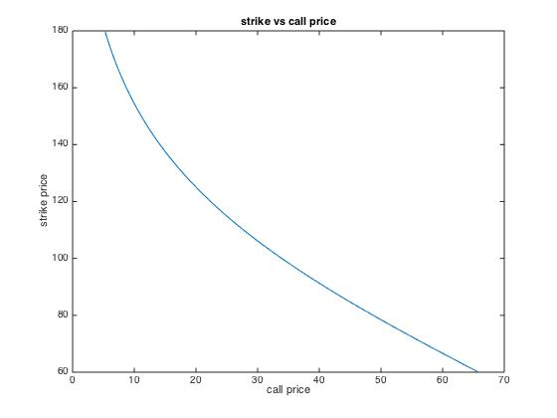

For strike vs call price we see that as call price increases, strike price decreases, they are inversely proportional. The first derivative is always negative, therefore always decreasing. The second derivative is positive, indicating the rate of growth is slowing down. This makes sense because the payoff of a call option is max(0, st – K). If we keep a fixed st, as K increases, the amount of payoff becomes less and less making the option less valuable.

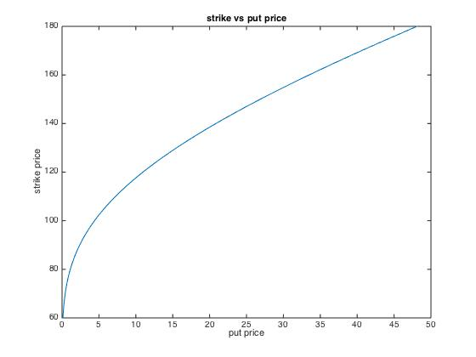

For strike vs put price we see that as put price increases, strike price increases, they are proportional. The first derivative is always positive, therefore always increasing. The second derivative is negative, indicating the rate of growth is slowing down. This makes sense because the payoff of a put option is max(0, K – st). If we keep a fixed st, as K increases, the amount of payoff becomes more making the option more valuable.

b. “maturity vs price” for both sets of options.

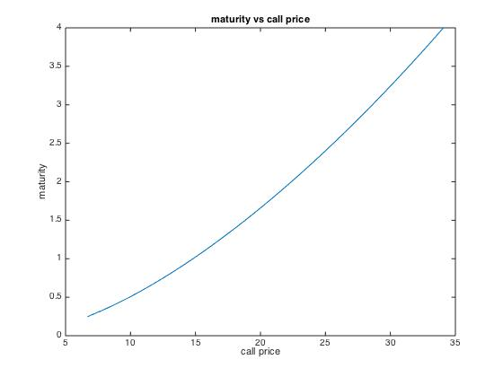

As call price increases, maturity increases. The first derivative is always positive, therefore always increasing. The second derivative is positive, indicating the rate of growth is increasing. This makes sense because when you are further away from maturity, the option has much more time to fluctuate up or down making it more valuable. When time is very close to maturity, the stock price wont have as much room to change and the option is priced lower.

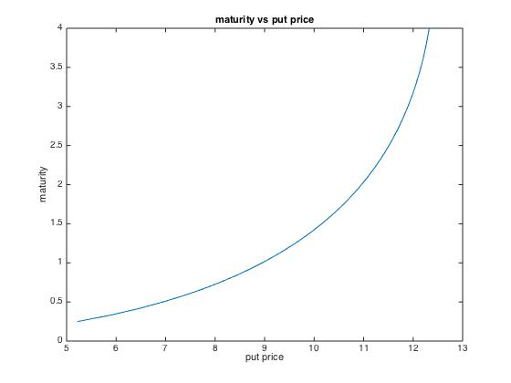

As put price increases, maturity increases. The first derivative is always positive, therefore always increasing. The second derivative is positive, indicating the rate of growth is increasing. This makes sense because when you are further away from maturity, the option has much more time to fluctuate up or down. When time is very close to maturity, the stock price will not have as much room to change and the option is priced lower.

c. “volatility vs price” for both sets of options.

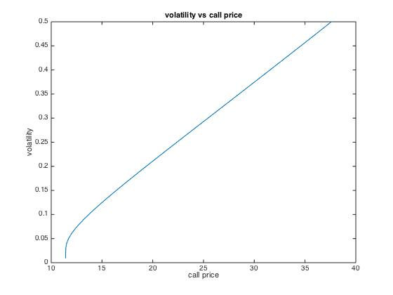

As call price increases, volatility increases. The graph is concave down, increasing and its rate of growth is slowing down. Stocks with high volatility have higher value due to the possibility of the price rapidly increasing. Stocks with low volatility will likely remain consistent and do not have a much potential gain.

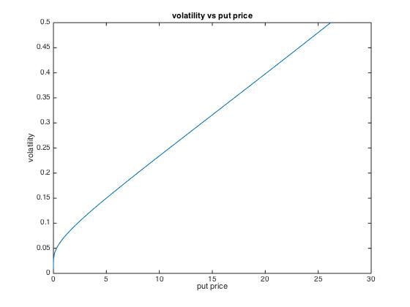

As put price increases, volatility increases. The graph is concave down, increasing and its rate of growth is slowing down. Stocks with high volatility have higher value due to the possibility of the price rapidly increasing. Stocks with low volatility will likely remain consistent and do not have a much potential gain.

d. interest rate vs price for both sets of options.

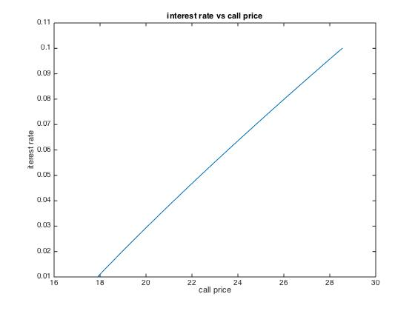

As call price increases, interest rate increases. The graph is concave down but somewhat linear, increasing, and its rate of growth is slowing down. Call options with higher interest rates yield higher payoffs.

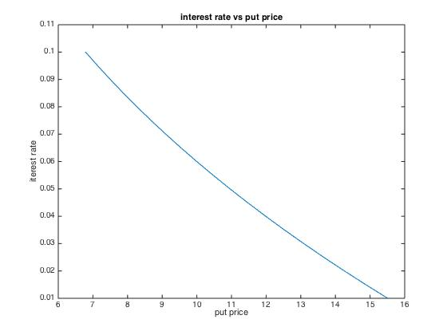

As put price increases, interest rate decreases. The graph is concave up but somewhat linear, decreasing, and its rate of growth is slowing down. Put options with higher interest rates yield higher payoffs.

**2. Monte Carlo (MC) Simulations**

a. Using this program, compute the price of the call option K = 100, T = 1, for different number of simulations N = 100, 500, 1000, 5000, and 10000. Also compute the price of this call option by using the explicit Black-Scholes formula. Compare the obtained prices, in particular, discuss how the number of simulations affects the error.

For this particular simulation with fixed values as noted in problem:

Price of European call using explicit B-S formula

bs_call =

10.8706

Price of European call using MC Simulation for n = 100

ans =

35.3101

Price of European call using MC Simulation for n = 500

ans =

0.0708

Price of European call using MC Simulation for n = 1000

ans =

3.8542

Price of European call using MC Simulation for n = 10000

ans =

11.3644

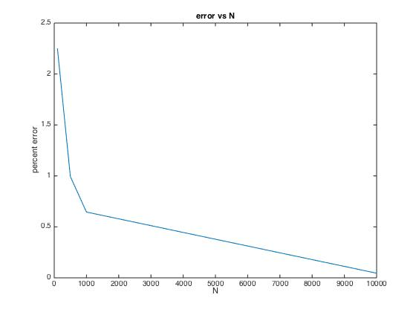

We see that as N increases, percent error decreases. This makes sense because there are more random variables to work with when simulating Brownian motion. This allows outliers to have less impact on pricing the data.

b. Consider the option VT = (180ST − ST2 − 7200)+ = max(0, 180ST − ST2 − 7200). Find the price of this option by MC simulations.

Price of european call using MC simulations with explicit payoff

ans =

796.4799

**Code attached on next page for both problems.**