Colour Mixer App

The Colour Mixeer App is an intuitive tool that allows users to mix up to three predefined colours and visualize the resulting colour. Additionally, the app displays the corresponding HEX and RGB values of the mixed colour, and users can interact with a colour palette to quickly see the HEX and RGB values of individual colours.

Features
- Predefined Colour Palette: Choose from 8 predefined colours: Red, Orange, Yellow, Green, Blue, Purple, Black, and White.
- Mix Up to Three Colours: Users can select up to three colours and specify the percentage proportion of each colour to create a custom mix.
- HEX and RGB Display: The app dynamically displays the HEX and RGB values of the resulting mixed colour.
- Palette Interaction: Users can click on any colour in the palette to instantly view the HEX and RGB values for that colour.
- Simple and User-friendly Interface: A clean, easy-to-use interface for seamless interaction.

Colour Palette
The following colours are available in the app:
- Red: #FF0000
- Orange: #FFA500
- Yellow: #FFFF00
- Green: #008000
- Blue: #0000FF
- Purple: #800080
- Black: #000000
- White: #FFFFFF

Screenshots

Main Screen with Colour Palette and Mixing Options
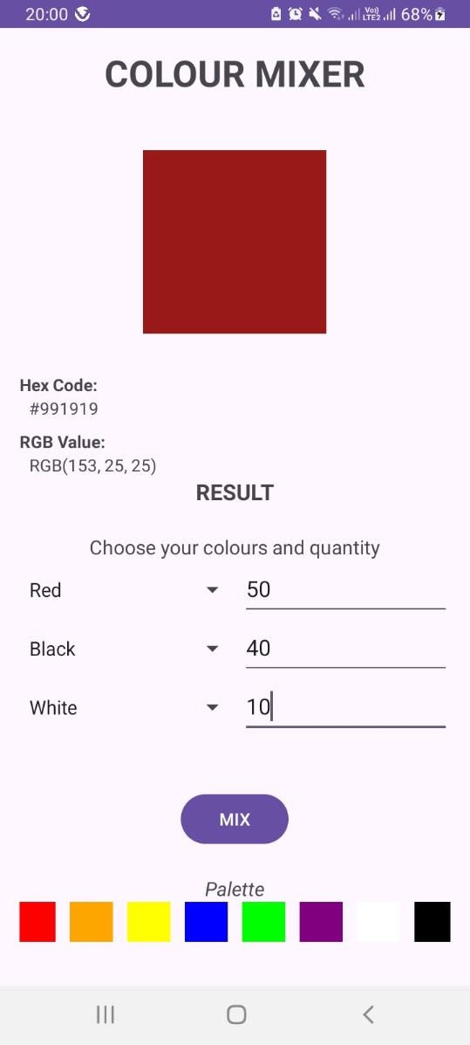

How It Works
- Colour Selection: Enter the name of up to three colours from the predefined palette and specify the proportion of each colour (as a percentage).
- View Mixed Colour: The app generates the resulting mixed colour based on the proportions entered and displays the final colour in the result view.
- HEX & RGB Values: Below the result, the app shows the HEX and RGB values of the resulting mixed colour.
- Palette Interaction: Clicking on any colour from the palette automatically fills the result view with that colour and updates the HEX and RGB values accordingly.

Technologies Used
- Android SDK
- Java
- XML for UI layout
- Android Views: ImageView, TextView, Spinner, and more.

Getting Started
Prerequisites
- Android Studio
- A device/emulator running Android 5.0 or higher

Installation
- Clone this repository:
bash
Copy code
git clone https://github.com/yourusername/colour-mixer-app.git
2. Open the project in Android Studio.
3. Build and run the app on your preferred device/emulator.

Usage
- Select colours from the dropdown and input the mixing proportion for each.
- Press the Mix button to see the resulting colour along with its HEX and RGB values.
- Click on any colour in the palette to instantly view its details.

Future Enhancements
- Allow users to save and name custom colour mixtures.
- Add an option to share or export the resulting colour’s hex code.
- Incorporate a colour history feature to revisit previously mixed colours.

Contributing
Feel free to contribute to the project! If you encounter any bugs or have suggestions, create an issue or submit a pull request.

License
This project is licensed under the MIT License. See the LICENSE file for more details.

