# (S3)Simple storage service

1. **Create an S3 bucket and upload some objects to S3.**

* Go the aws console.
* Open a search bar press s3.
* Create a bucket name with unique in globally.
* Then this will show uh the block access don’t block anything.
* **For security purpose normally we block the the permissons.**
* Then upload a two files in ur bucket.

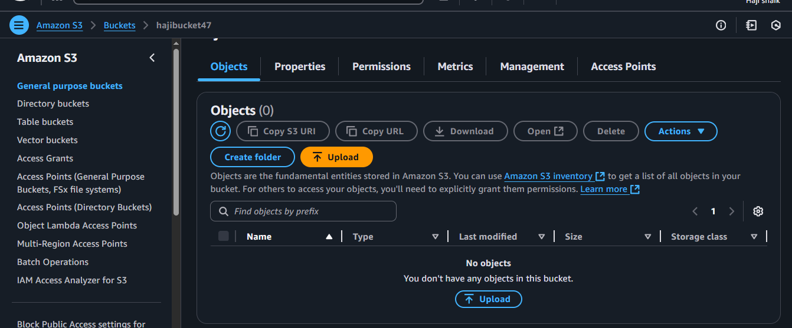

* **Uploaded two files in bucket:**

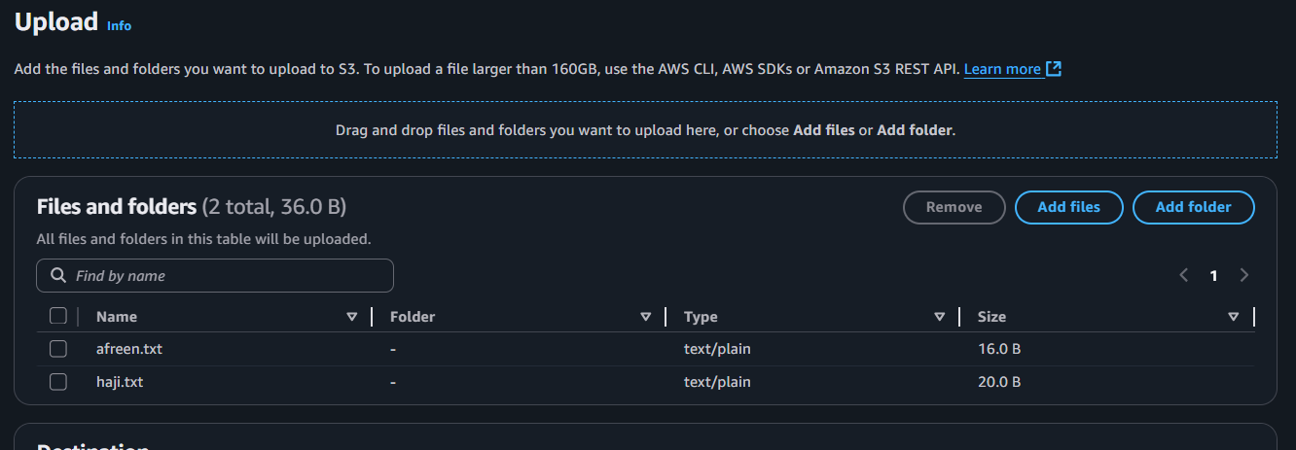

* **Then unblock the access:**

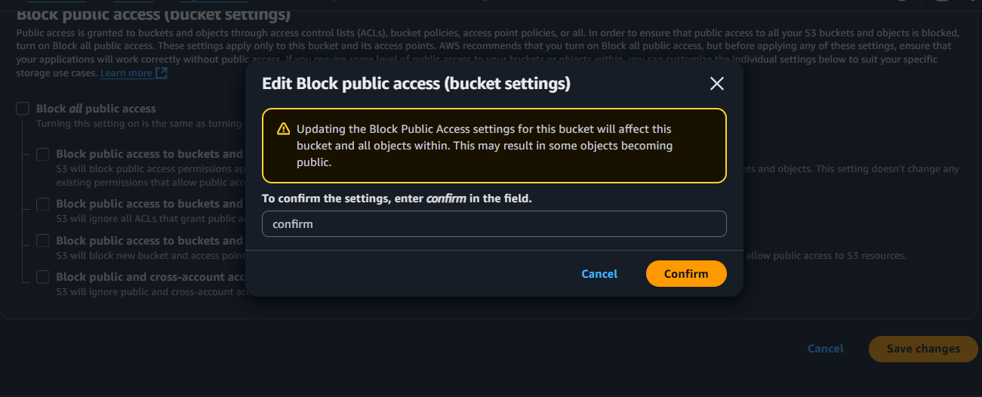

* Make your two files in public acl:
* Open a object then go to the actions and make them public:

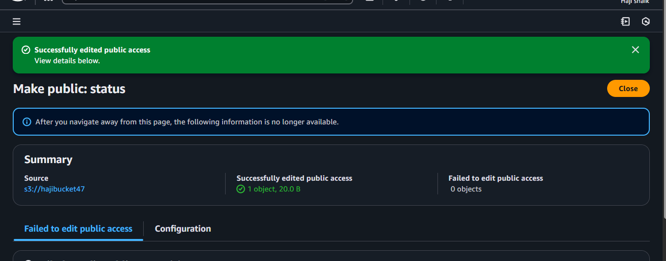

* **Then copy the object link and paste in to your browser here the results are:**

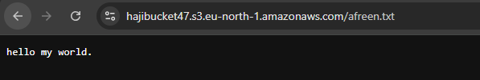

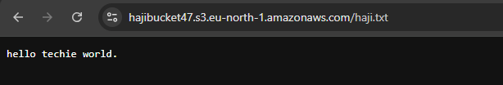

1. **Deploy a static website in the S3 bucket.**

* go to the aws console.
* Then search bar in s3.
* Then create bucket.
* Go to the permissons then create a 2 files .html files.
* Then upload the files.then gave a prmsn to public.

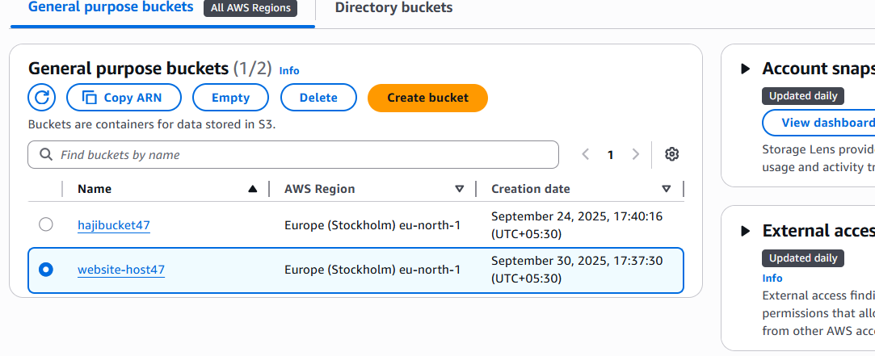

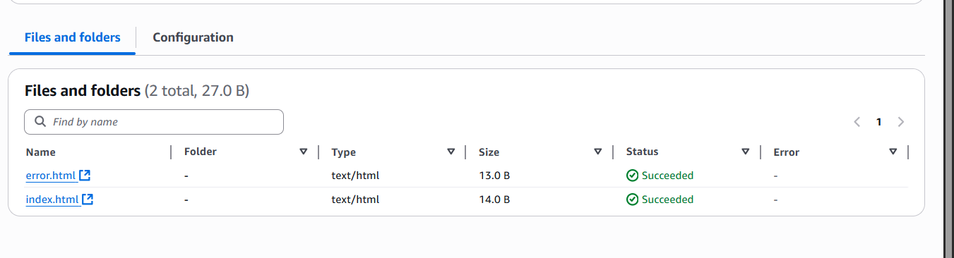

**Enable the static website host:**

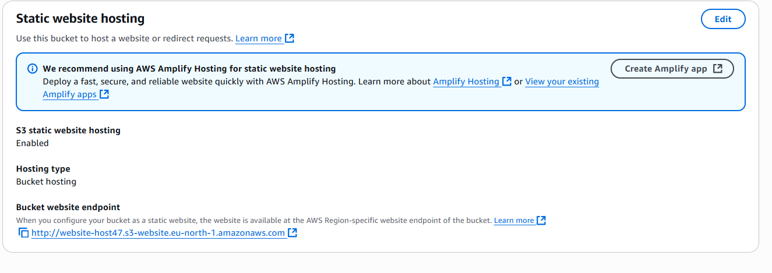

**Make 2 files convert in to public:**

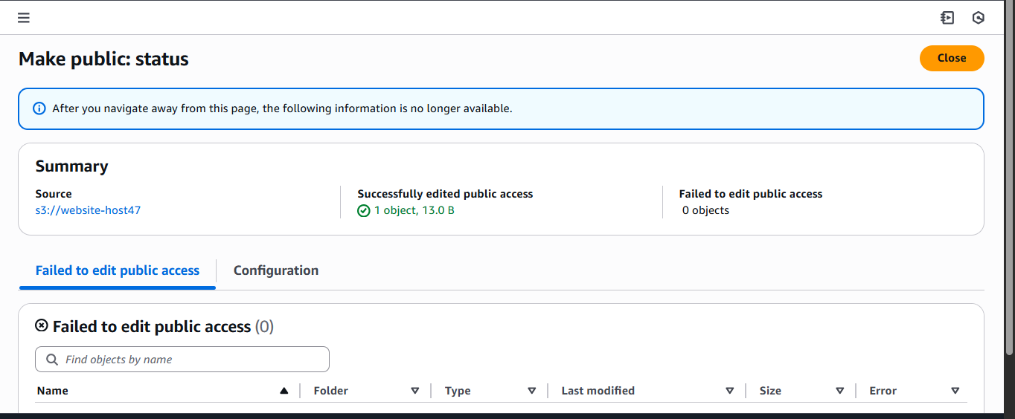

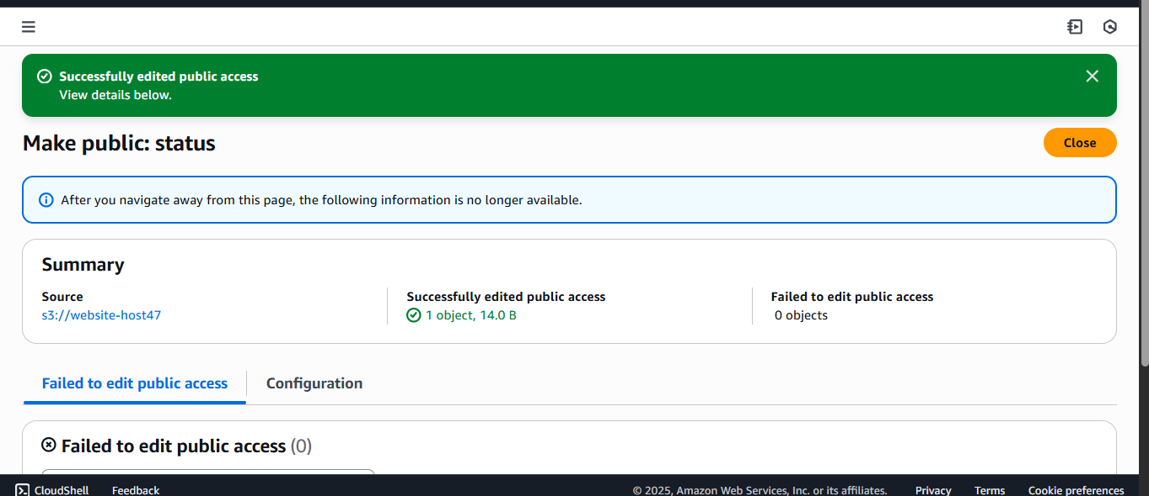

**Then copy the both links:**

**And paste in to the browser:**

**Here the results are for index.html>>>>>**

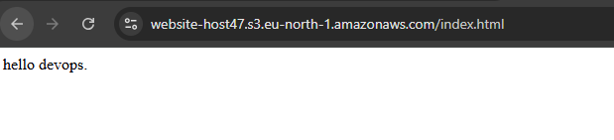

**Here the results are for error.html>>>>>**

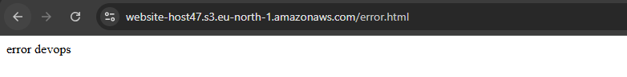

1. **Enable cross-region replication on S3 buckets.**

* Go to aws console.
* Then search s3 and create 2 buckets in different region.
* And use a policy s3full access.

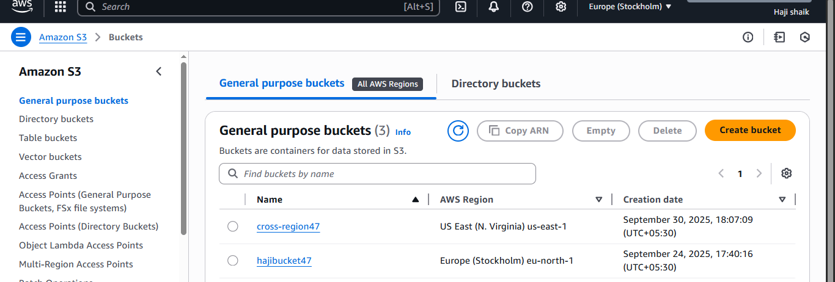

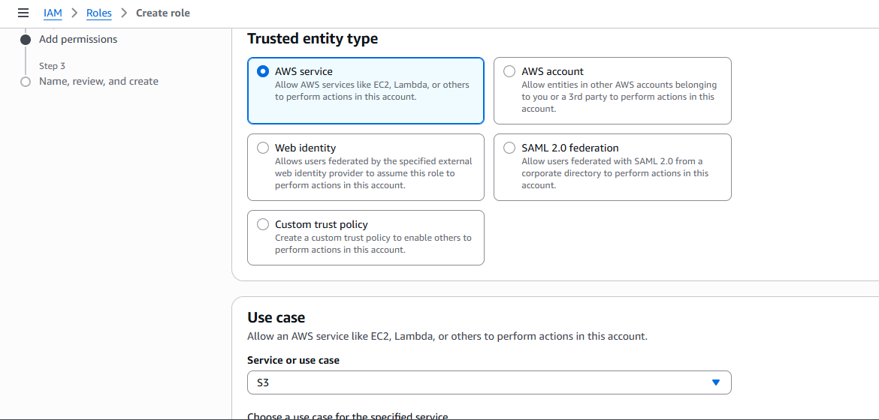

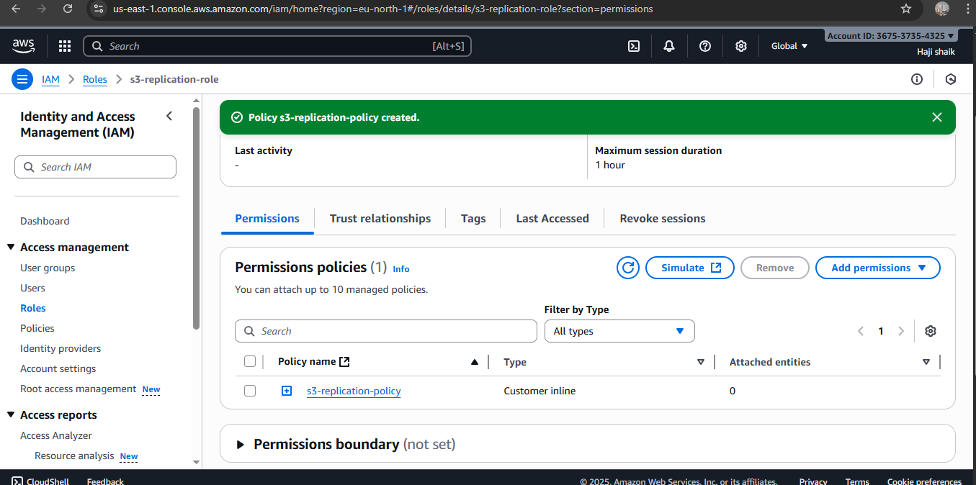

* Then create a reapplication rule in source-bar.
* In this replication rule we need to gave a our destination path.
* Then upload a file in source bar and make that object to public.
* Then the result will appear in destination bar.

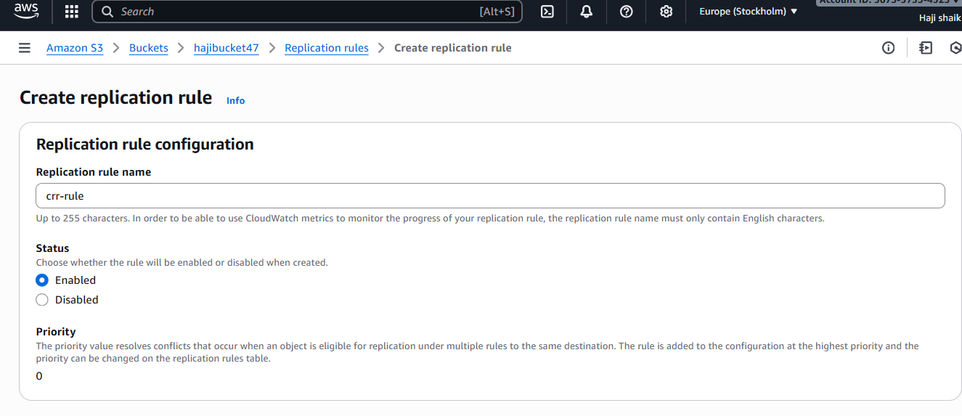

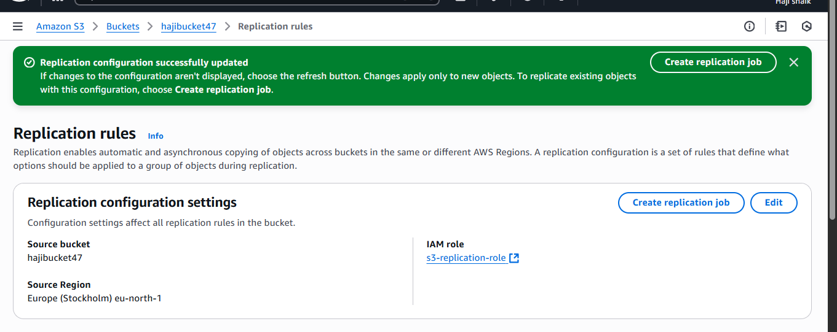

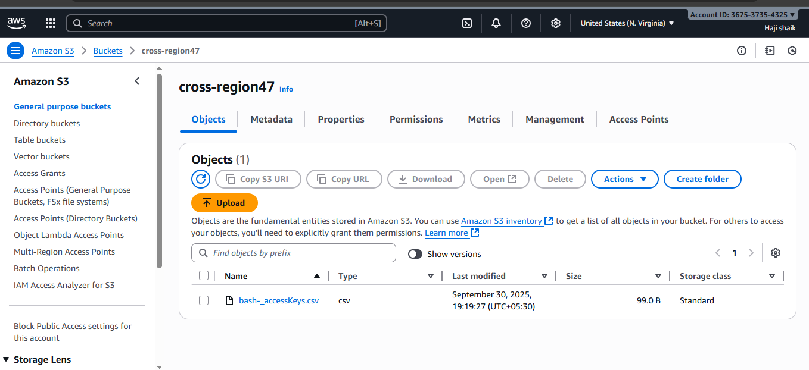

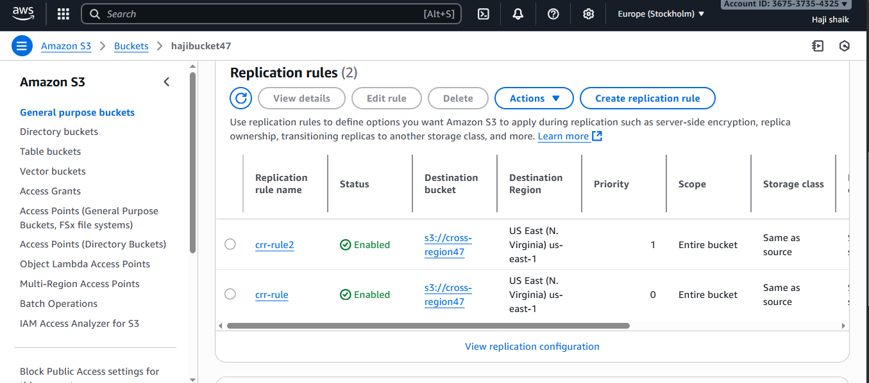

1. **Configure a bucket policy so only the Admin user can see the objects of the S3 bucket.**
2. **Set up lifecycle policies to automatically transition or delete objects based on specific criteria.**

* **Go to the AWS Console.**
* S3 in search bar. And create a bucket name with life cycle.
* Then create a life cycle rule. In the bucket.
* **There** is option of management tab and go for a mangment tab there is option of create a life cycle rule in that specifically use a option of delete.
* Here the results are:

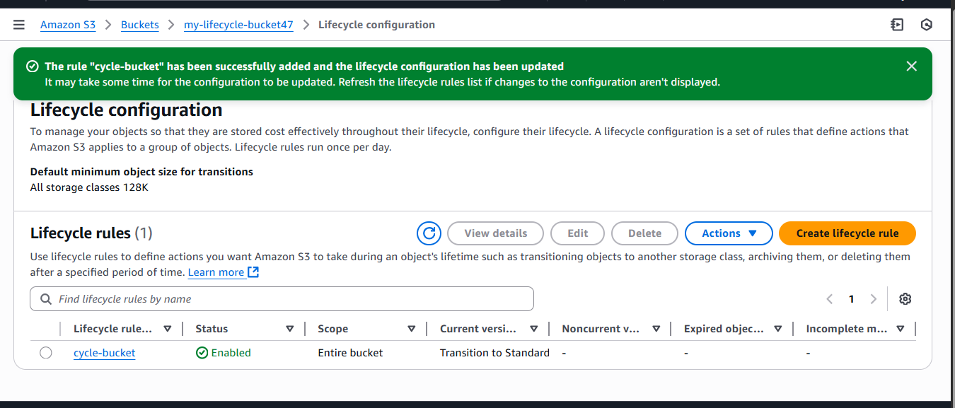

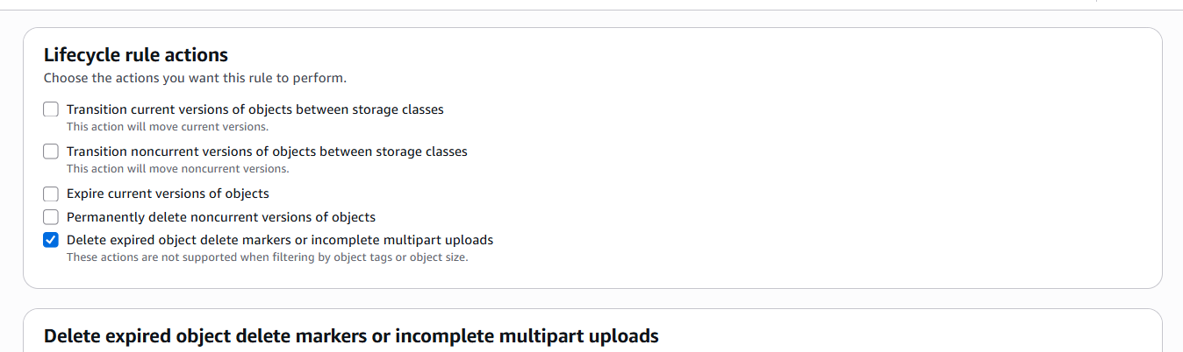

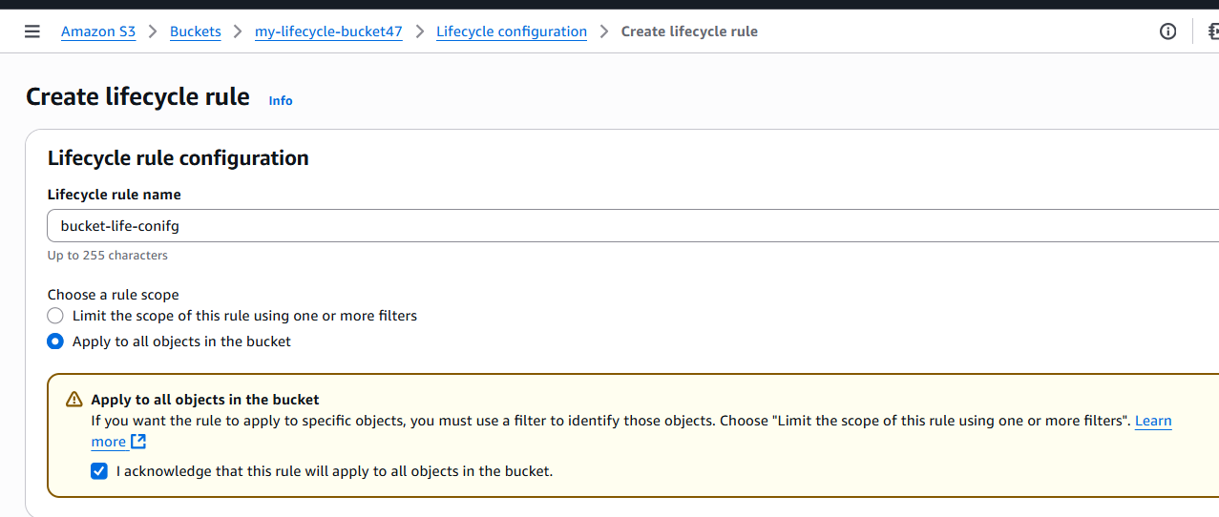

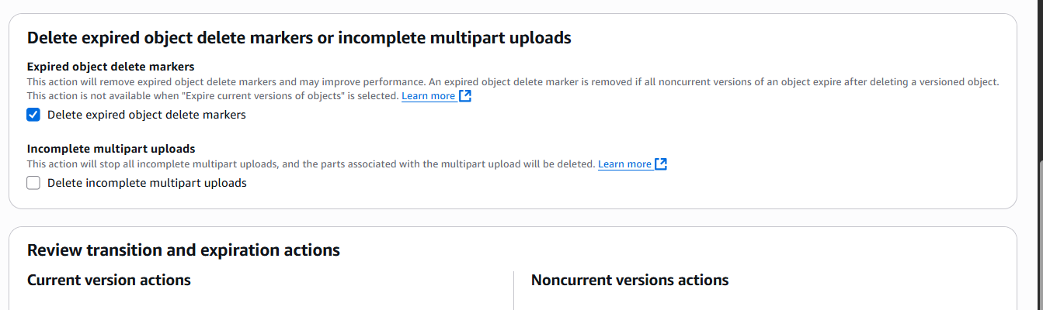

1. **Push some objects to S3 using the AWS CLI.**

* Go to aws console.
* Go to s3 bucket.
* Check the permissons of bucket. It should be s3 full access permisson.
* If there is no permisson for that go to iam and gave a policy of json.
* And after create a policy and permissons will acceptable:

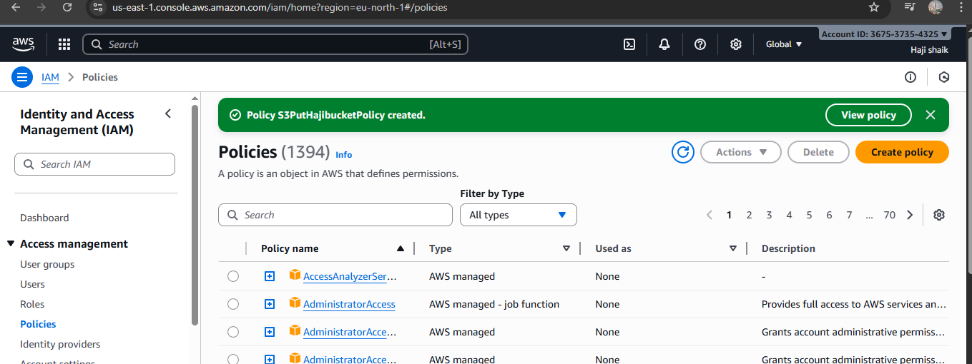

* Check the cli is installed or not.
* **Aws --version** this will show uh the version of cli.
* Then **aws configure.**
* **We already created bucket and we have txt file in our bucket:**
* Use a command of “**aws s3 cp file.txt s3://bucket_name**”
* Here the results are:

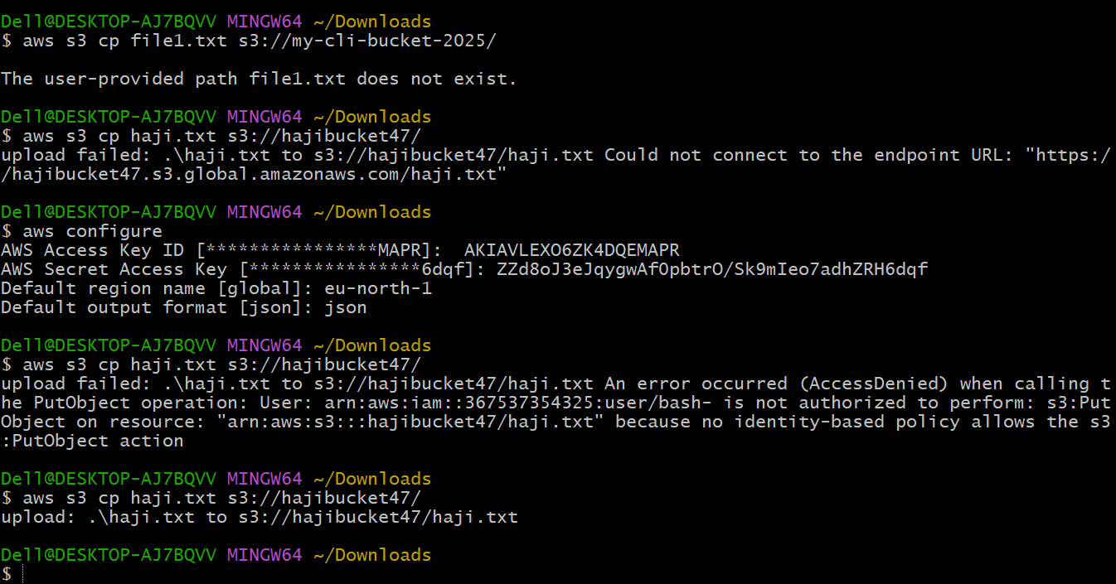

1. **Write a Bash script to create an S3 bucket.**

* **Go to downloads and open a git bash there.**
* Why downloads.
* Because of my secreat key and access key.
* Then open a git bash.
* Check cli upadate.
* Aws configure.
* Then create one file with name of **create-s3-bucket.sh**
* Write a if bash script for create a bucket.
* Then gave permisson of **chmod755 and file name.**
* Then ./file_name here the results are:

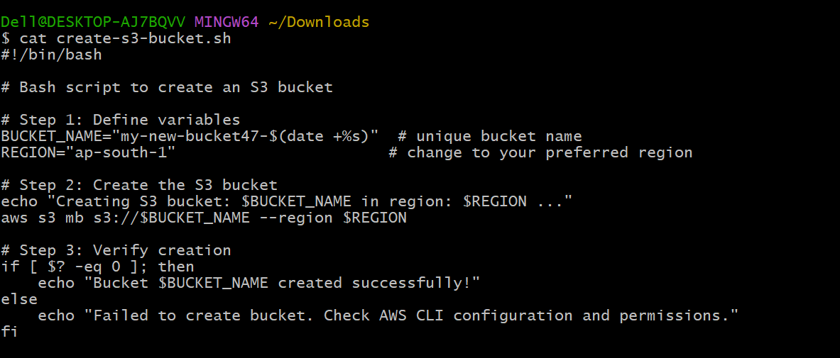

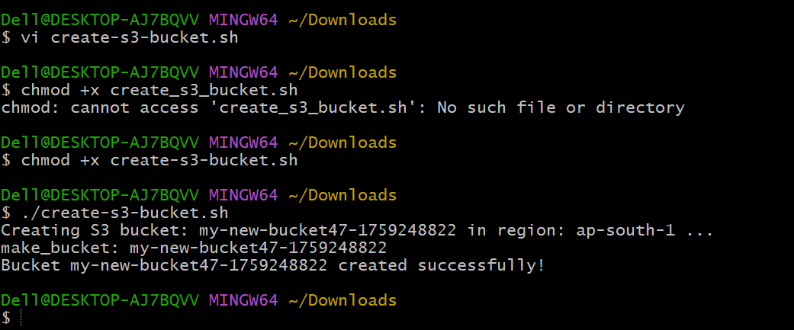

Using a command of aws s3 ls:

**my bucket list:**

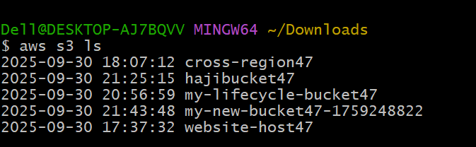

1. **Upload a 1 GB file to S3 using the CLI.**

* go to downloads and open gita bash there.
* Then using $ dd if=/dev/zero of=bigfile1GB.txt bs=1M count=1024
* **this command is create a on dummy file for 1 gb capacity.**
* Then check ur bucket list **aws s3 ls.**
* **Then**

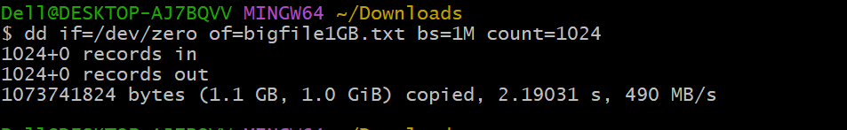

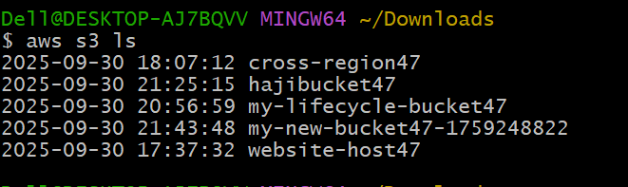

* **Then**  “aws s3 cp bigfile1GB.txt s3://my-new-bucket47-1759248822/ --region ap-south-1”
* This for verify upload big file.
* Here the results are:

