MMC MSP430 Programming Procedure

Synopsis
This document describes the procedure for updating MBARI MMC MSP430 firmware.

Required Materials
(See appendix for supplier list)
MSP430 Programming Software | Quadravox AQ430 Development Tools
MSP430 firmware binary file | .rxc file produced by AQ430 toolchain
Computer
- Parallel communications port
- Win2000/XP

MSP430 Programmer | 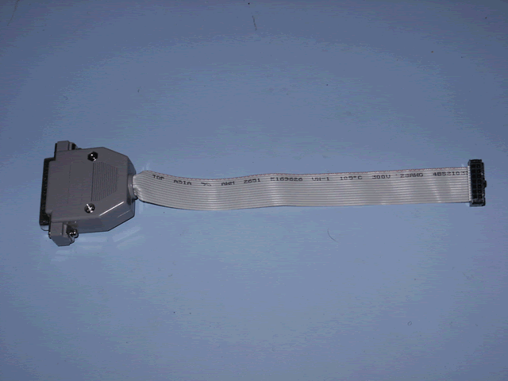
MMC | 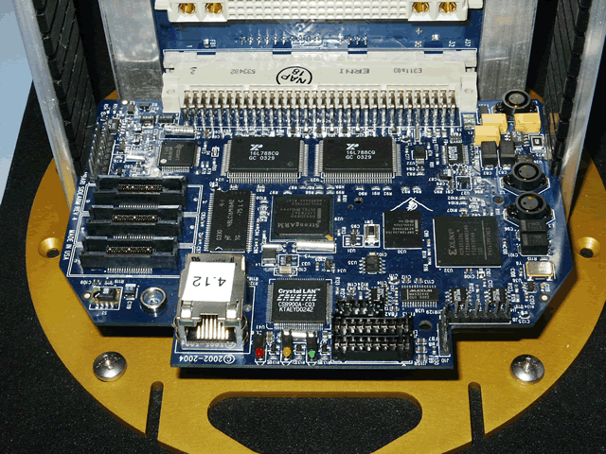
Backplane | 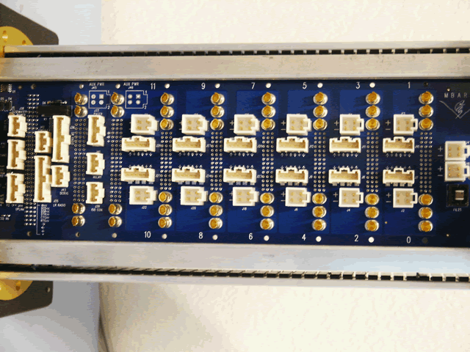
Chassis (optional) | 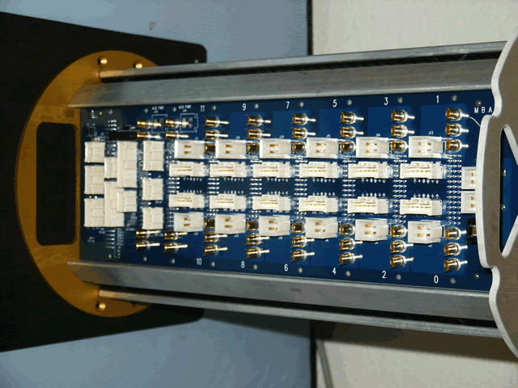
MMC power cable | 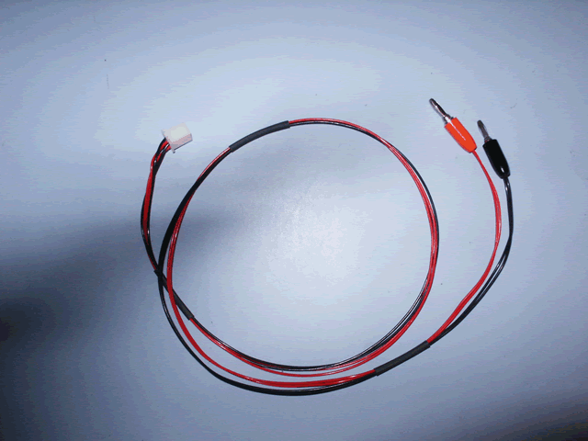
MMC serial console cable (optional) | 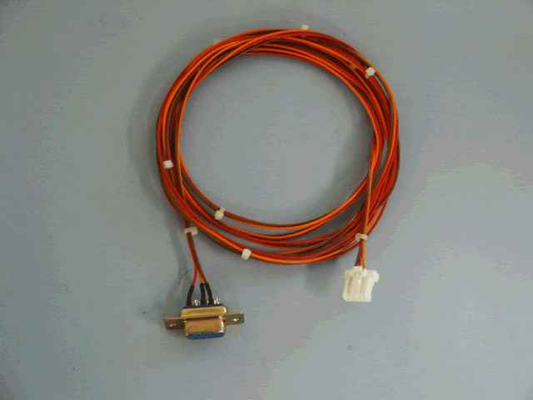
DC Power Supply
- 12V, 2A min

Procedure

Connect host computer to MMC
- Connect the power supply to the backplane using the MMC power cable:
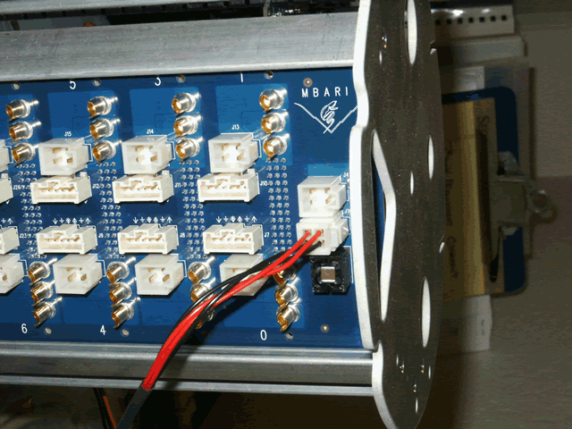
- Connect the MSP430 programmer ribbon cable connector to the header J3 on the Sidearm board
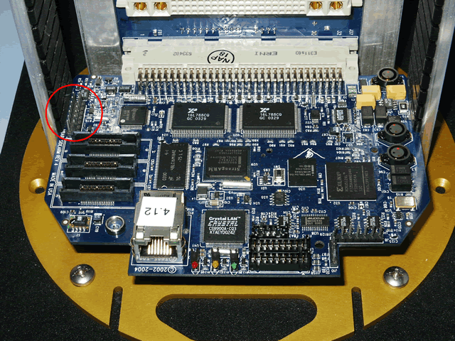
- Connect the MSP430 programmer DB25 connector to the computer’s parallel port

Turn MMC power on
- Before connecting anything to the DC power supply, set the power supply output to12 volts and current limit it to 100 milliamps if possible. After the lab DC power supply has been set, power it down and connect the MMC power cable banana plugs to it.
- Turn on 12 VDC

- Start the AQ430 IDE.
- Check that the JTAG cable and programming adapter have been connected correctly by doing a "Hardware Check" with the AQ430 IDE (Options>>Hardware Check).
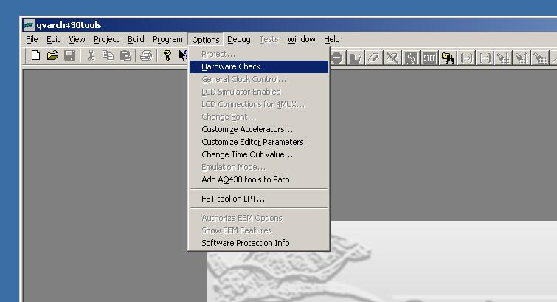

The AQ430 IDE should respond with the following dialog box if the MMC is powered up and the JTAG and adapter cable are connected correctly.

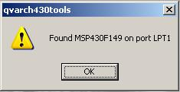

- When the PUCK "Hardware Check" has been completed select "Load Executable" from the "Build" menu and choose an ".rcx" file to load using the "Open" dialog box. The MMC MSP430 firmware .rcx files are maintained in the MBARI CVS repository at
http://moonjelly.shore.mbari.org/cgi-bin/cvsweb.cgi/moosmc/envp/src

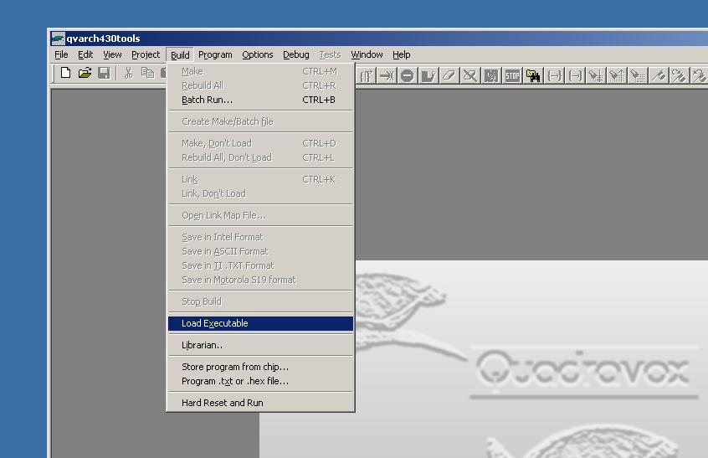

- When the ".rcx" file is opened the AQ430 IDE will display a dialog requesting to "Erase Info Memory?", select yes.
- Another dialog will appear requesting to "Erase Main Memory?", select yes.
- A dialog will then appear showing target programming progress as the firmware is being loaded. Another dialog may appear indicating that the ".ddf" file for the chip could not be located, simply acknowledge this dialog.
- After the firmware is loaded exit the AQ430 IDE, power down the DC power supply, and remove the programming cable from the J3 header.

Appendix

Supplier List

Item | Supplier
Quadravox AQ430 Development Tools | Available from Quadravox  http://www.quadravox.com/AQ430.htm
MSP430 Programmer | Spark Fun Electronics  P/N MSP430-JTAG  http://www.sparkfun.com
MSP430 Programming Adapter Cable | Available from MBARI technical support  MBARI drawing numbers:  1002921 (schematic)  1002922 (layout)

