MMC Firmware Upgrade Procedure

Introduction
This document describes the procedures and equipment required to program the MMC CPLD, a Xilinx XCR3512XL-12FT256C in the CoolRunner XPLA3 family.

Required Materials
See Appendix for supplier information

Computer
Windows 2000/XP or Linux
Parallel port or USB port
PS2 Port or USB-PS2 converter
Serial port or USB-RS232 converter (optional)
Terminal emulator (optional)

Xilinx Programming cable:

One of the following programming cables, plus fly leads are required

Cable | Xilinx P/N
Parallel Cable IV | HW-PC4 | 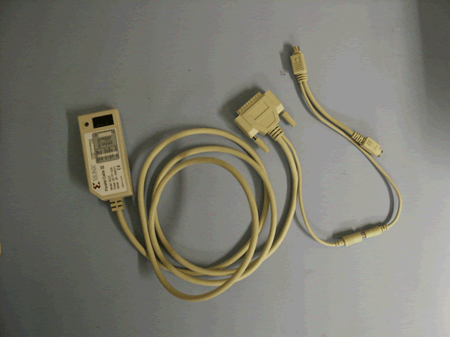
Platform Cable USB | HW-USB | 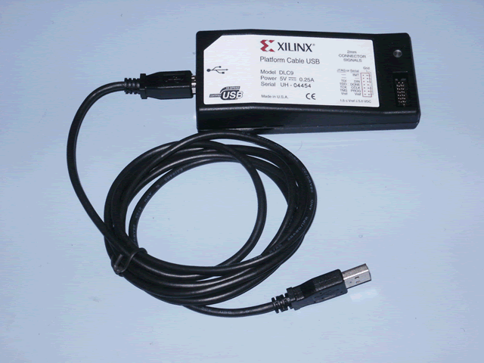
Parallel Cable Fly Leads | HW-FLYLEADS | 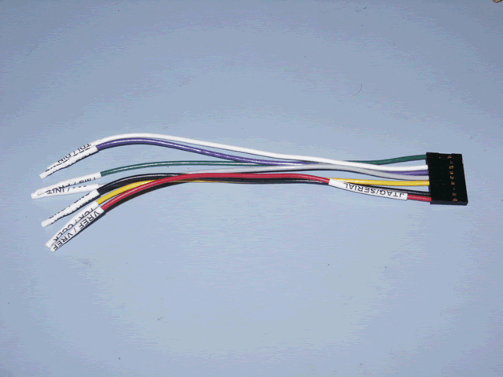
USB Cable Fly Leads |  | 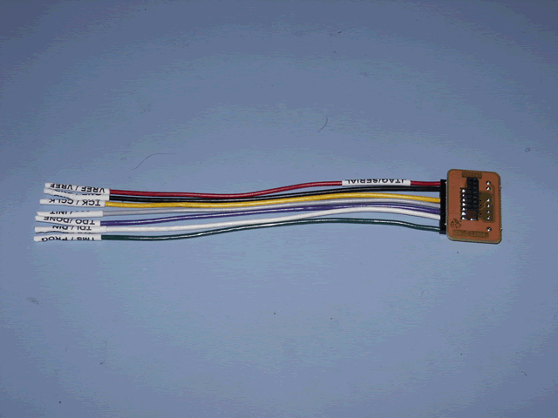

Xilinx programming software:
iMPACT, contained in Xilinx ISE WebPack
USB cable drivers (if using USB programming cable)

MMC Hardware
MMC | 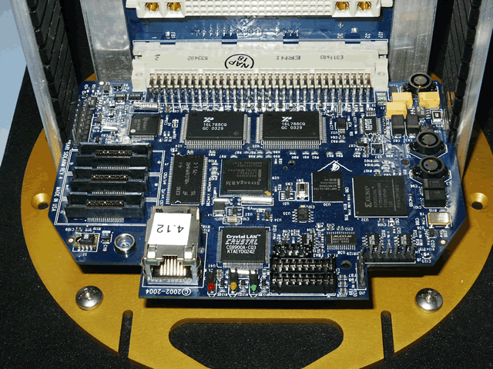
Backplane | 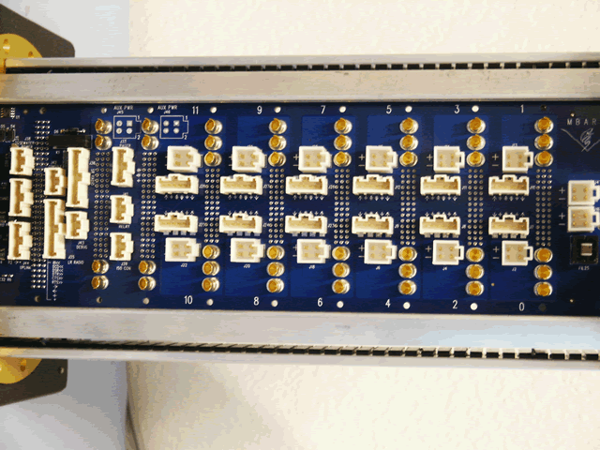
Chassis (optional) | 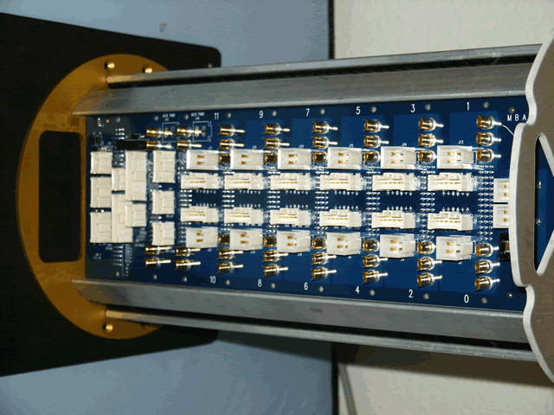
MMC power cable | 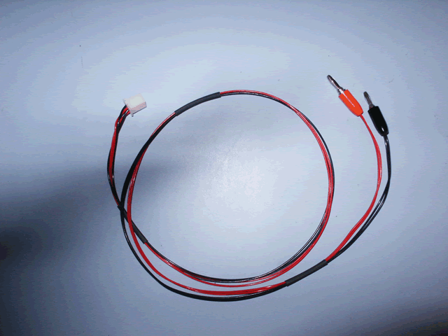
MMC serial console cable (optional) | 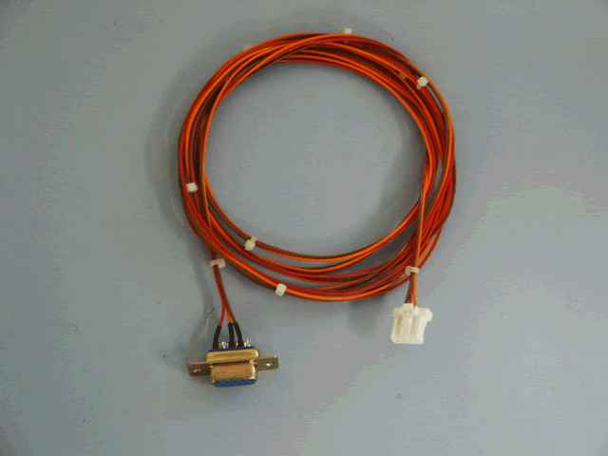

Power Supply
2A@12 V

Procedure

Install Xilinx ISE WebPack software on host computer
For CPLD programming purposes, only the iMPACT programming tool is needed. The ISE webpack includes other components for development and test.

Download using WebInstall is recommended; single download files are available, but require additional service pack download.
Follow installation instructions
Optionally install design tools
Need to install CPLD family of parts (Spartan, Virtex families not required)

Connect host computer to MMC
- Connect the programming cable to the host PC parallel or USB port; the programming cable requires power; unplug your PS2 mouse or keyboard and replace it with the PS2 Y-Cable that came with the programming cable. Plug the mouse or keyboard into the Y-cable.
- Plug the fly lead header into the programming cable (it is keyed)
- Being careful not to flex the MMC, connect the fly leads:
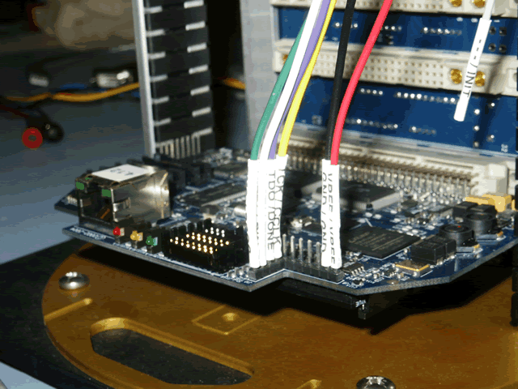
- Plug the power lead into the programming cable; the indicator light on the programmer should be green.
- Connect the power supply to the backplane using the MMC power cable:
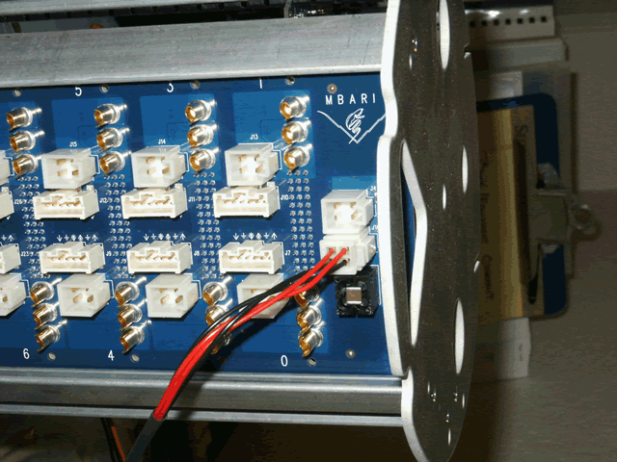

Turn MMC power on
- 12 VDC

Use iMPACT to program the CPLD
- Start iMPACT (Start > Xilinx > Accessories > iMPACT)
- When prompted for a project file, select one or create a default iMPACT project file in the directory with firmware binary | 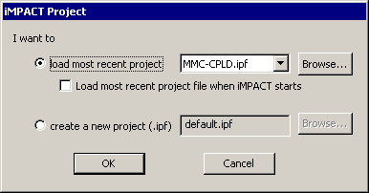
- If creating a default project, cancel the wizard that comes up
- From the menu: Output>Cable Setup…  - Parallel IV/ Platform Cable USB  - LPT1  - Max Speed  - Local  - OK | 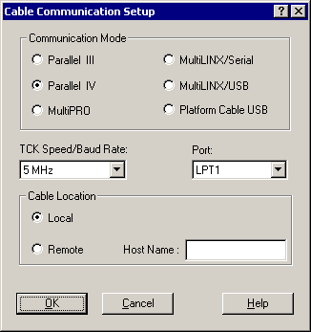
- Select the Boundary Scan tab in the main window | 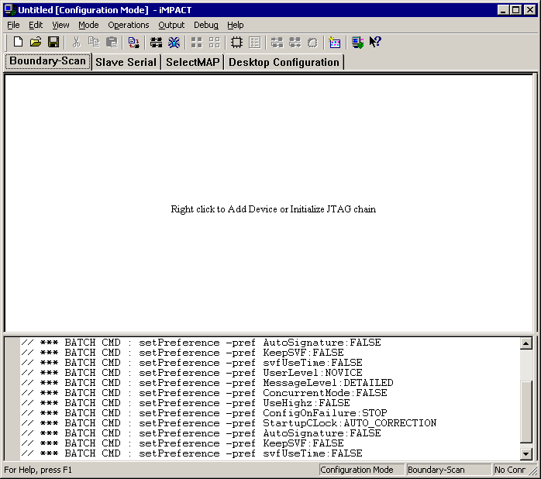
- Right click in the tab’s upper window
- Add Xilinx Device…; select firmware binary (JED) | 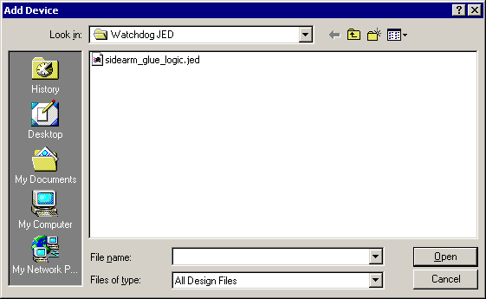
- Right click on device icon in the tab’s upper window | 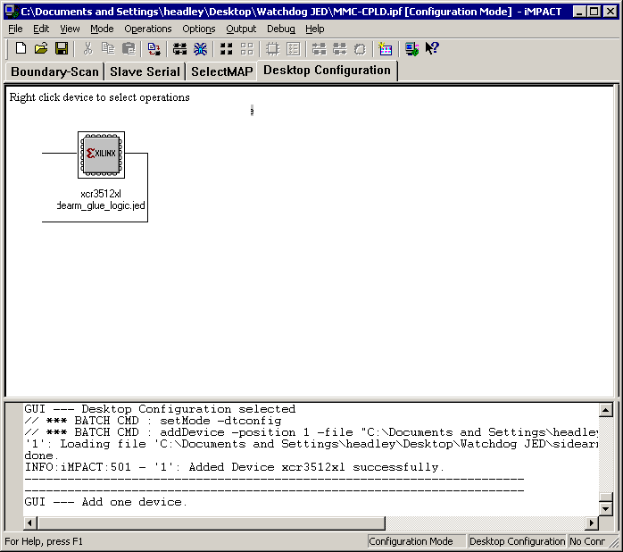
- Select “Program…”  - Erase before programming  - Verify | 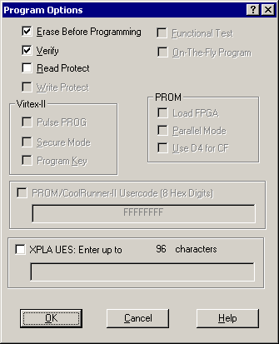
- Progrogramming takes a ~6 seconds  - Message appears in tab’s upper window indicating success  - programmer indicator light is green | 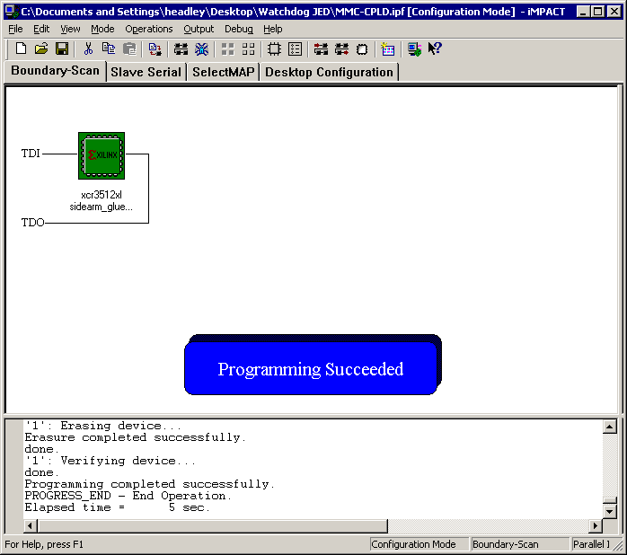
- Exit iMPACT
  - May opt to save project file, which may be used again for subsequent operations.
- Disconnect programmer power cable
- Remove fly leads
- Reboot MMC

Appendix

Suppliers
Xilinx FPGA programming cable:
Available from Xilinx Online Store:
http://www.xilinx.com
Xilinx : Xilinx Online Store : Hardware and Cables : Programming Solutions : Programming

Name | Xilinx P/N | Approximate Cost
Parallel Cable IV | HW-PC4 | $95.00
Platform Cable USB | HW-USB | $149.00
Parallel Cable Fly Leads | HW-FLYLEADS | $15.00

Xilinx Programming software (iMPACT)
Available from Xilinx Products and Services:
http://www.xilinx.com
Home : Products & Services : ISE Logic Design Tools : ISE WebPACK

included in ISE WebPack available free from
http://www.xilinx.com/ise/logic_design_prod/webpack.htm (must register first)

