SUPPLEMENTARY FIGURES AND TABLES FROM:

Gene network simulations provide testable predictions for the molecular domestication syndrome

A. Le Rouzic, E. Burban, M. I. Tenaillon

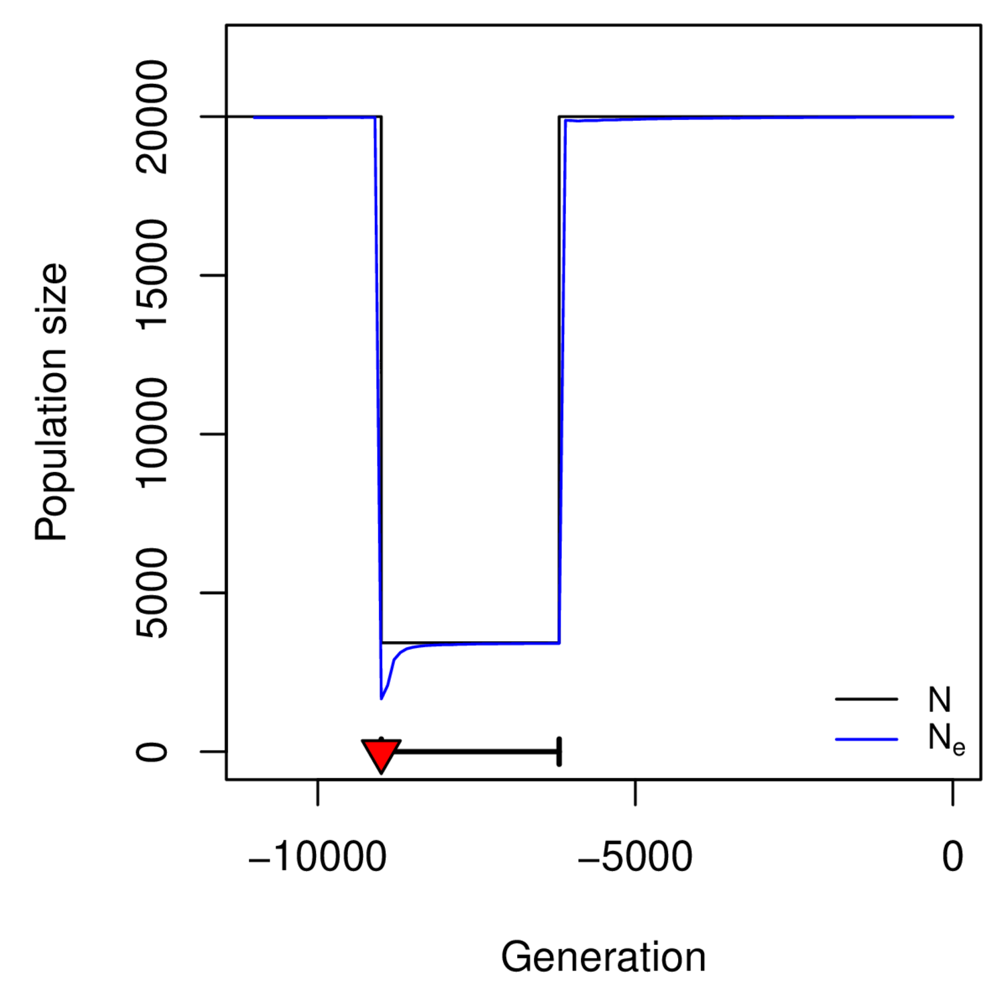

Figure S1: Dynamics of the population size during the domestication process (Default scenario). The variation of N was a parameter of the model (drop of the population size from N=20,000 to N=3,500 during 2,800 generations); the effective population size N_{e} was estimated from the variance in fitness (averaged over 1000 simulation replicates). As selection increases the variance in fitness, N_{e} was smaller than N during adaptation. The average effective population size during the bottleneck is indicated in the figure.

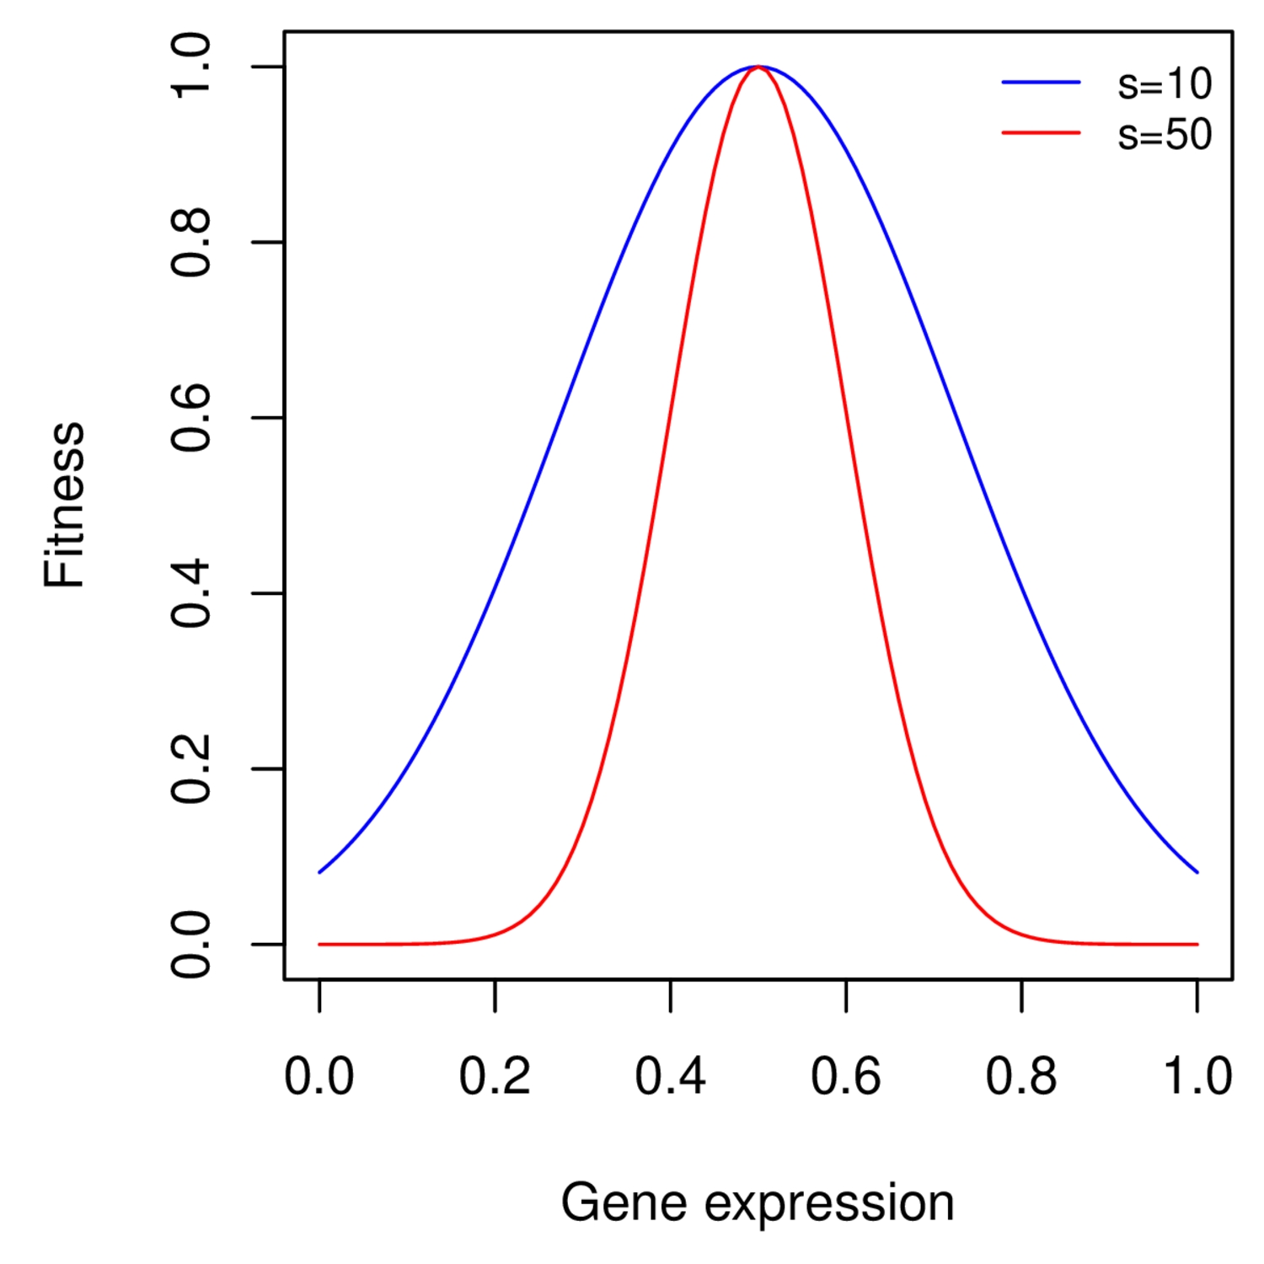

Figure S2: Illustration of the fitness function around an optimal expression of , for two strengths of selection (s=10, the default simulations, and s=50, the strong selection setting).

 | Before domestication | After domestication
 |  | Plastic | Stable | Non-selected
Plastic (p) | 6 | 2 | 2 | 2
Stable (s) | 6 | 0 | 4 | 2
Non-selected (n) | 12 | 0 | 4 | 8
Total | 24 | 2 | 10 | 12

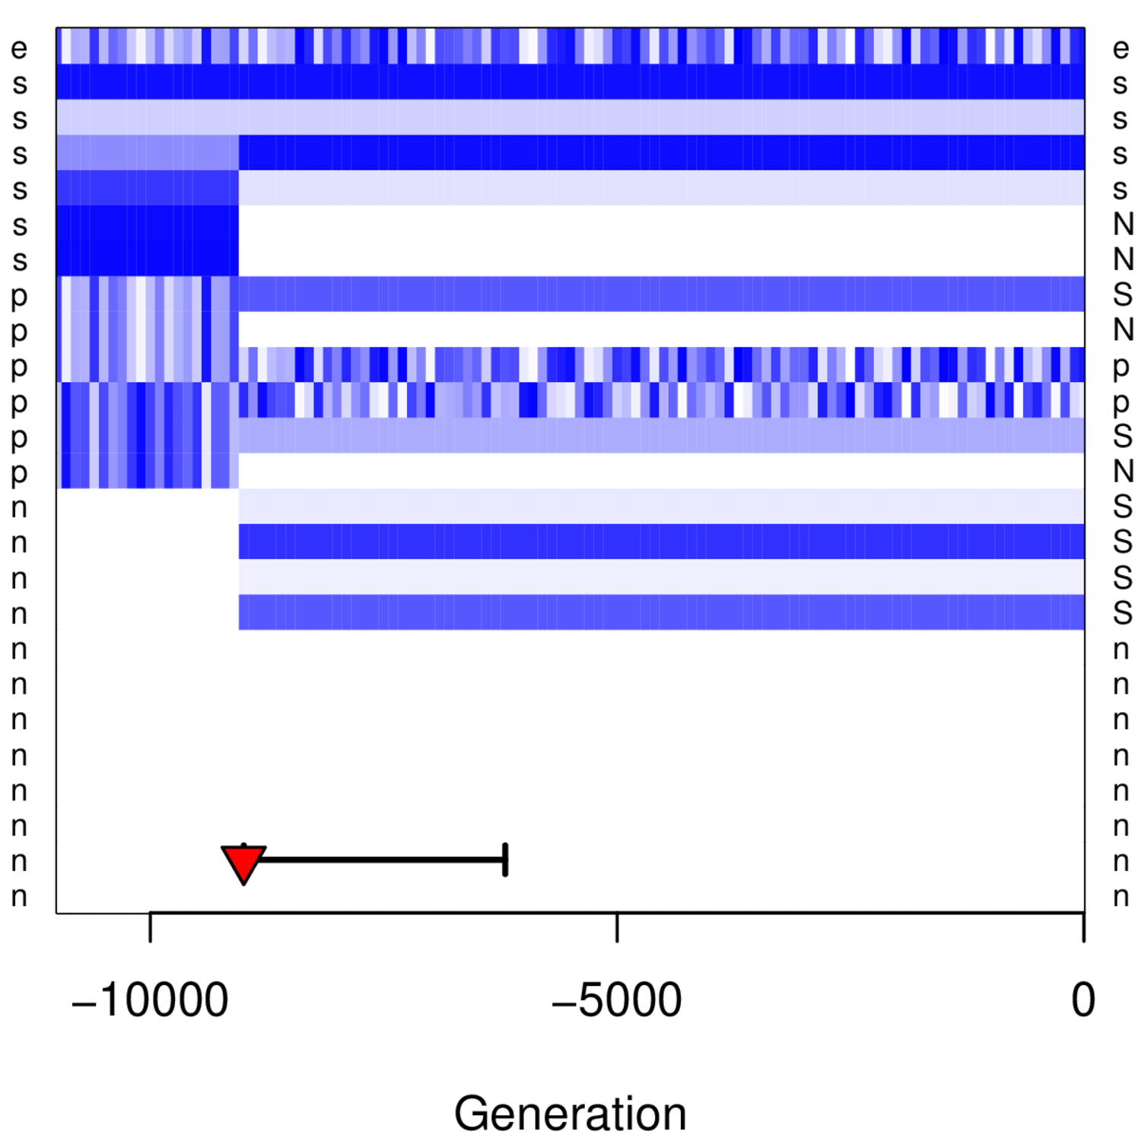

Figure S3: Description of the selection switch.Top: summary table of the selection switch. Three categories of genes were considered: “stable” (s), which optimum does not change throughout the simulation (except at the onset of domestication for half of them), “plastic” (p), which optimum tracks the environmental signal (with a +1 correlation for half the genes, and a -1 correlation for the other half), and “non-selected” genes (n), which expression is not part of the fitness function. Capital letters on the right indicate genes which status changed during the domestication process. The total number of selected genes (12 out of 24) remains the same before and after domestication. Bottom: illustration of the variation of gene expression optima from a single simulation. The figure indicates the expression of the sensor gene (first line, e), and the optimal expression for all other genes (light: low expression, dark: strong expression). White stands for unselected genes, and capital letters for genes which status changed.

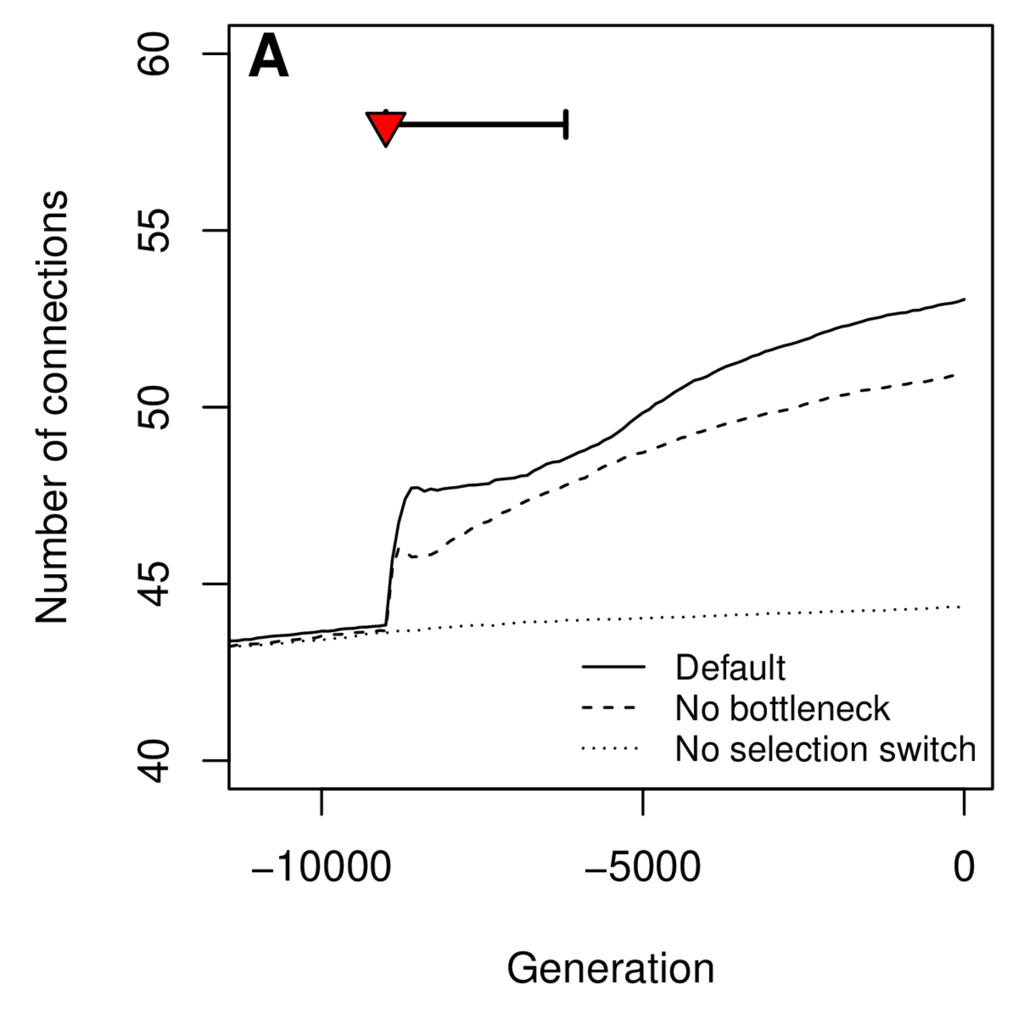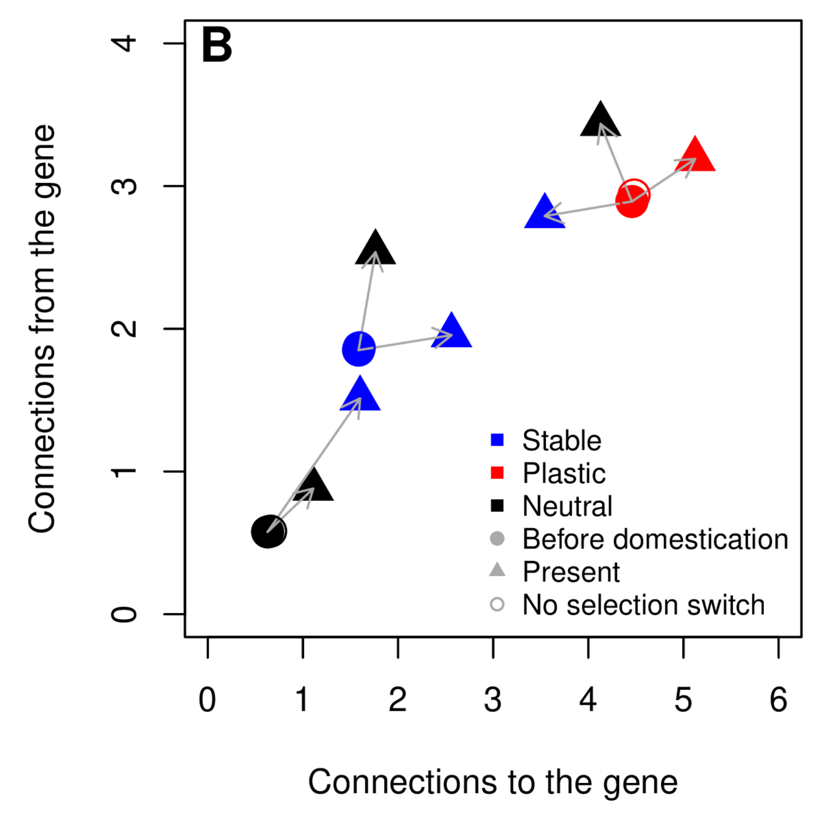

Figure S4: Evolution of the number of strong connections in the GRN through time. A: Evolution of the average number of strong connections in different evolutionary scenarios. B: Evolution of the numbers of connections to (number of regulators of the target gene) and from (number of genes regulated by the target gene) each type of gene during domestication in the default simulation (bottleneck and selection switch). The “no selection switch” scenario (open circles) is indicated as a control.

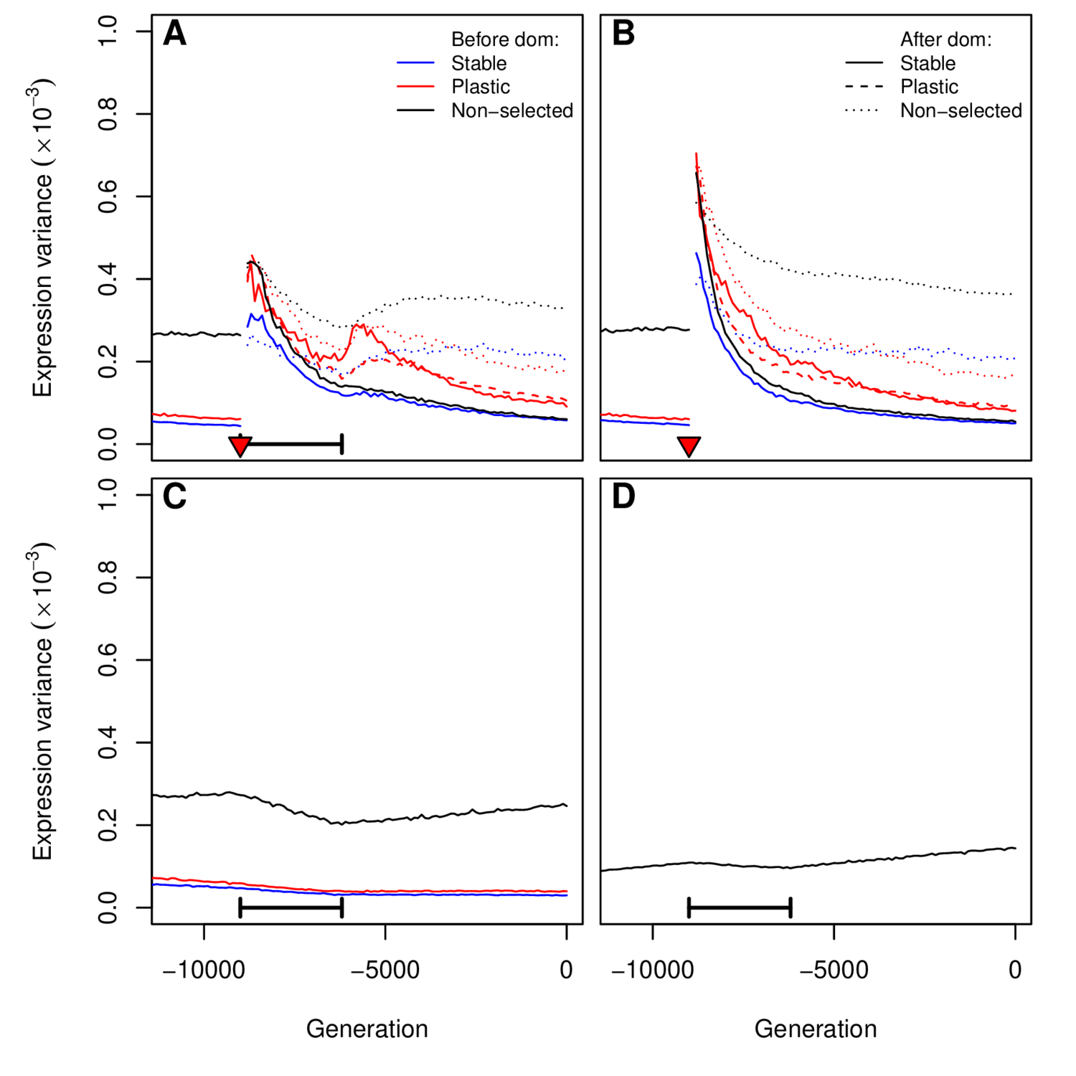

Figure S5: Evolution of expression variance through time. Genetic expression variance was averaged across 1000 simulations for every type of gene. A: Default simulations (bottleneck and selection switch), B: No bottleneck, C: No selection switch, D: no selection on the optimum. Colors indicate the gene status before domestication (constant and stable genes were merged for clarity), and the line type indicates the gene status after domestication.

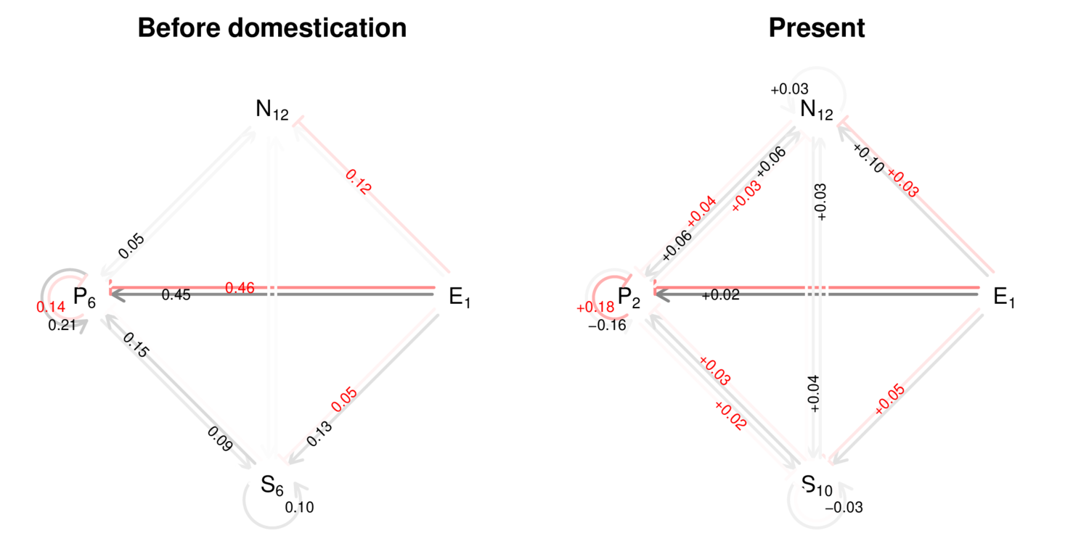

Figure S6: Summary of the topological changes in the network. The figure displays the location of the “strong” connections in the network, based on the effect of regulation on gene expression (details in the “methods” section). Three categories of genes are represented: non-selected (N), plastic (P), stable (S), and (E) stands for the gene that is directly reflecting the environment. Subscripts indicate the number of genes for each category. The left panel indicates the frequency of connections between each gene category (i.e. the number of strong connections divided by the theoretical maximum) before domestication. Right: Network at the end of the simulations. Numbers stand for the differences compared to the left panel. In both panels, connections between genes from the same category are indicated as curved arrows. Red arrows stand for negative (inhibition) effects, black arrows for positive (activation) effects. Connection frequencies less than 5% are omitted for clarity.

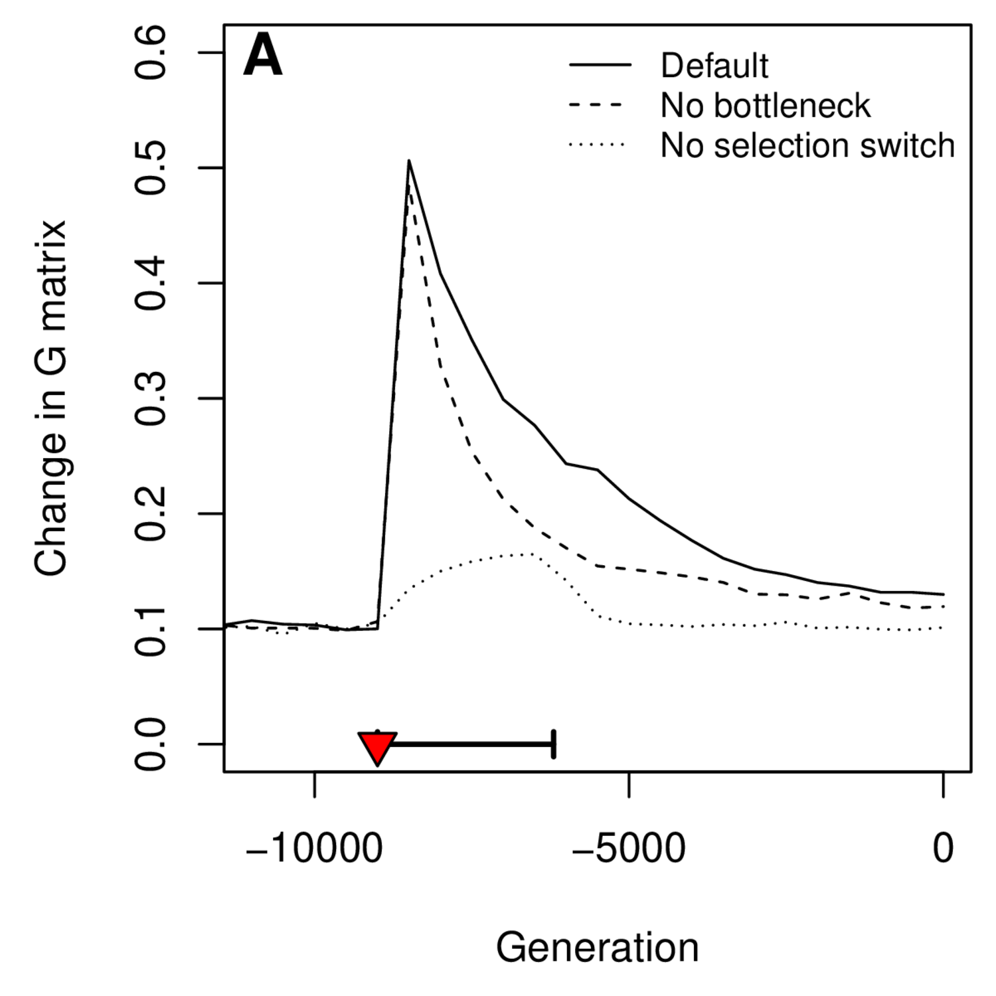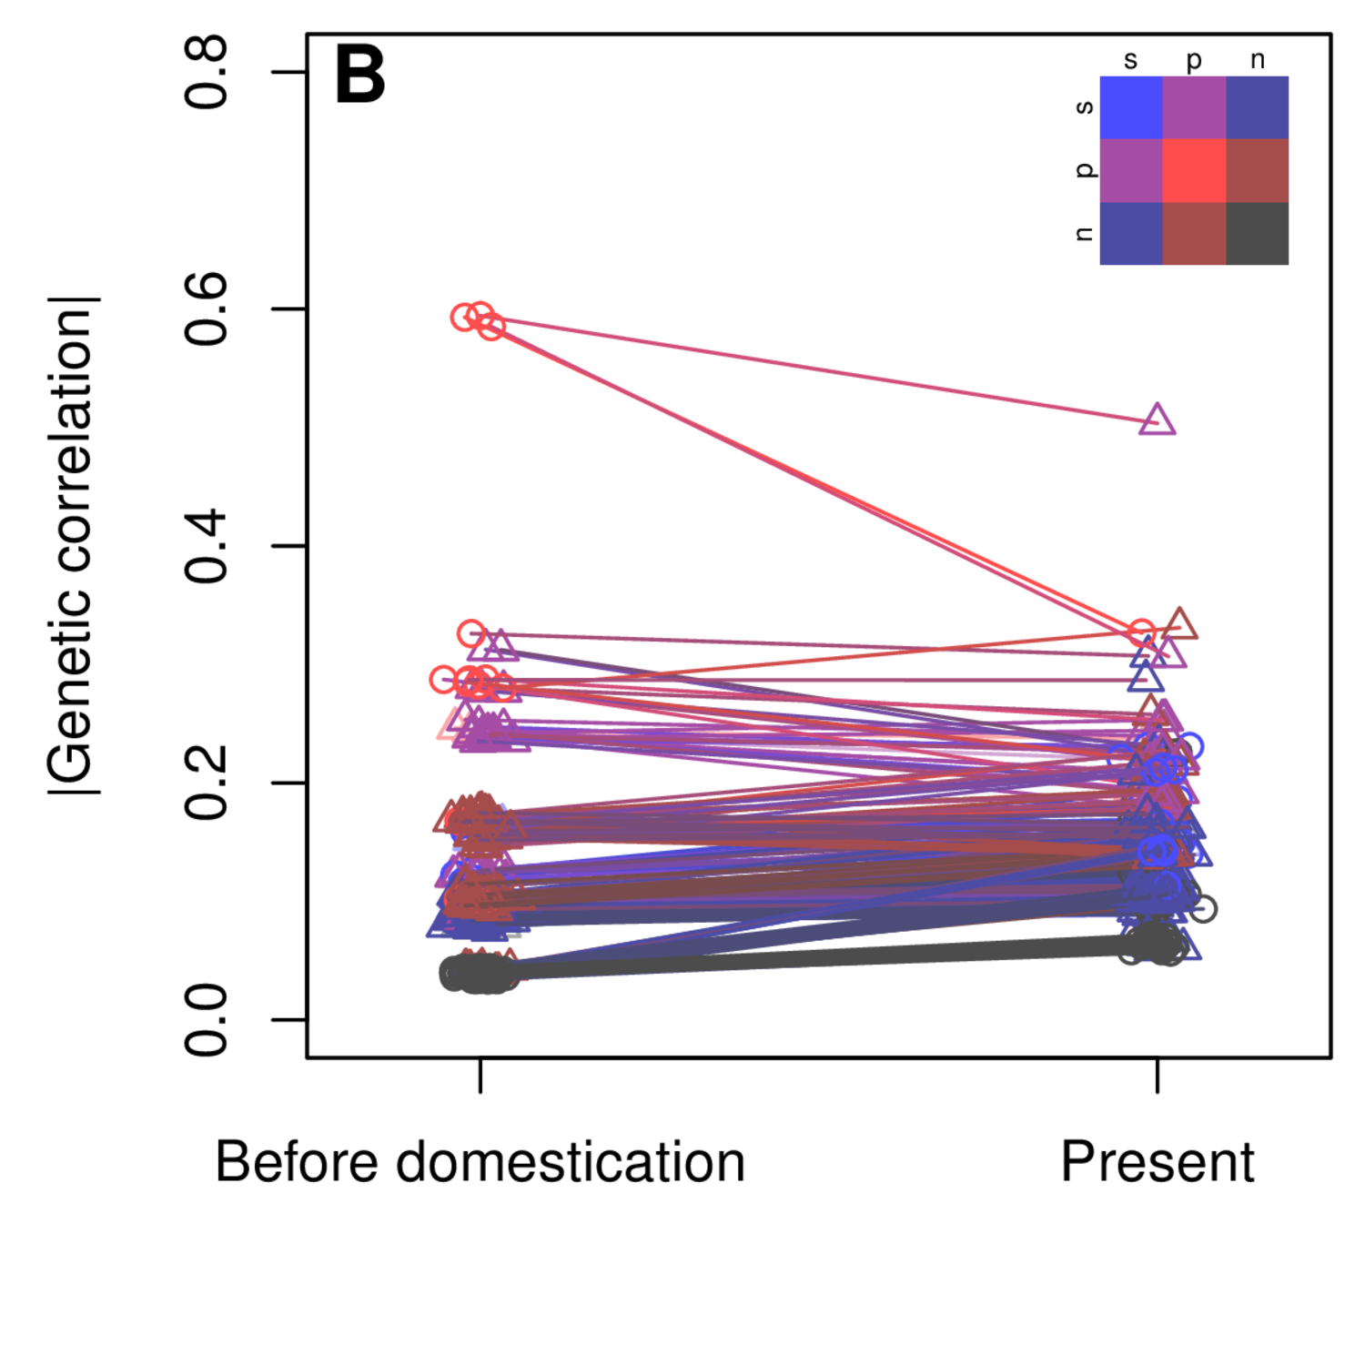

Figure S7: Evolution of the genetic coexpression structure. (A) The evolution of the genetic (G) covariance matrix of all gene expressions was tracked by measuring the distance between G every 500 generations (details in the methods section). (B) Genetic correlations before (generation -9000) and after (generation 0) domestication were compared between all pairs of genes. The color code indicates the category of the genes compared:blue for stable/constant, red for plastic, black for non-selected, and intermediate colors for comparisons between genes of different categories. Circles denotes correlations between genes from the same category, triangles from different categories. The x-axis was slightly jittered for clarity.

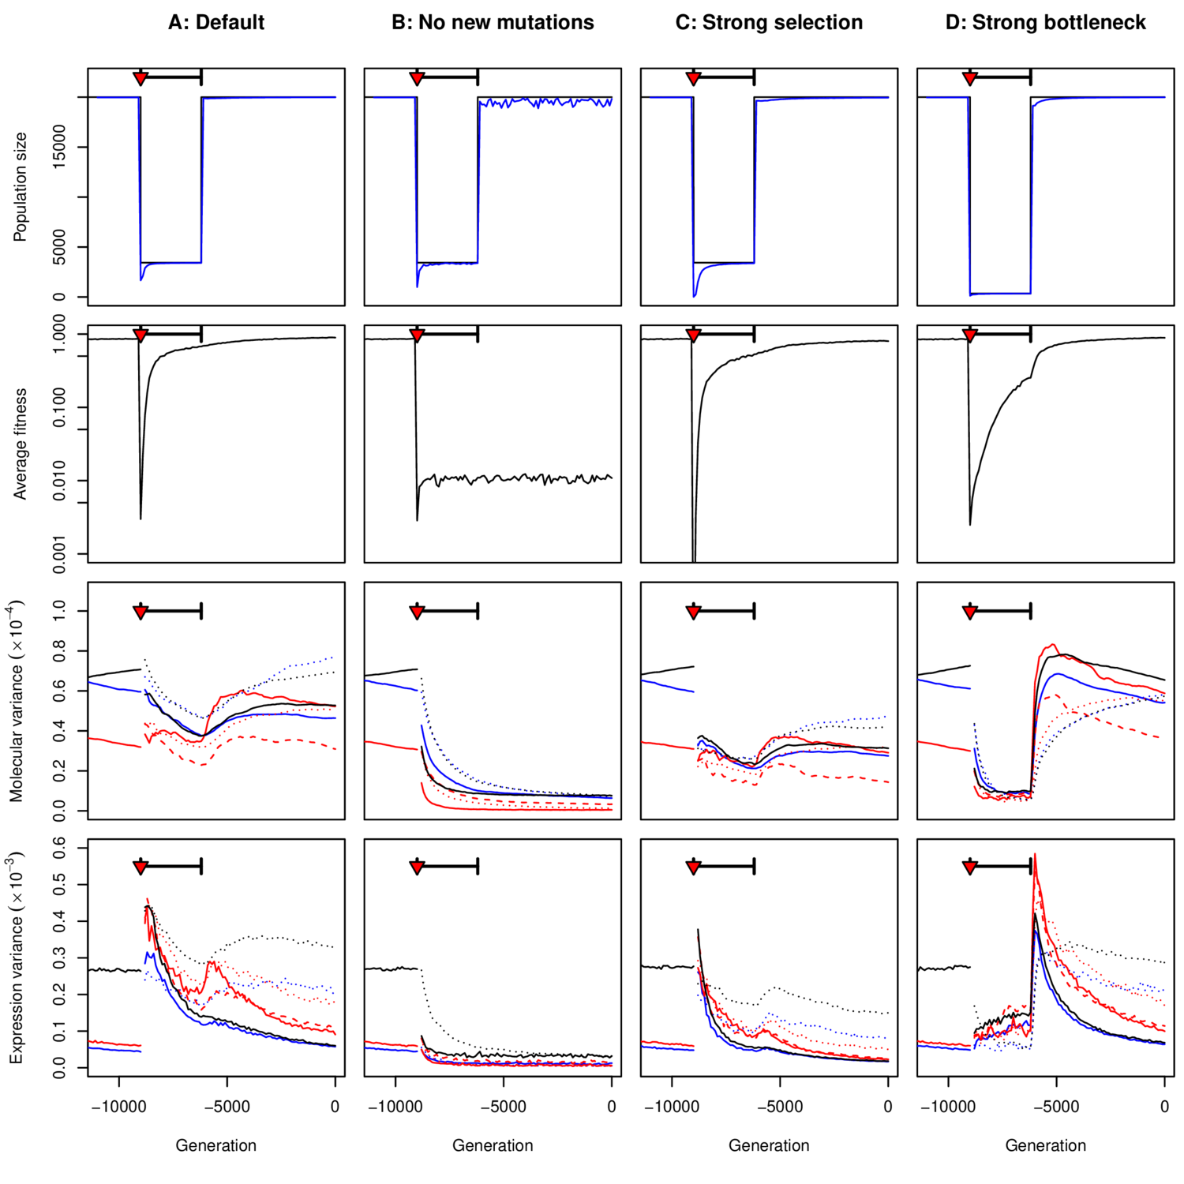

Figure S8: Sensitivity to variations in the model parameters. The left column (A) stands for the default parameter set. B: “No new mutations”: the response to domestication relied only on the standing genetic variation (mutation rate set to 0 at the onset of domestication); C: “Strong selection”: the selection coefficient was set to 50 instead of 10 (as illustrated in Figure S2); D: “Strong bottleneck”: the strength of the bottleneck was 10 times stronger (350 individuals instead of 3500). First row; census and effective population sizes (same caption as fig S1), second row: Average fitness (same caption as fig 1), third row: Molecular variance (same caption as fig 3A, same colors as fig S5), fourth row: expression variance (same caption as fig S5).

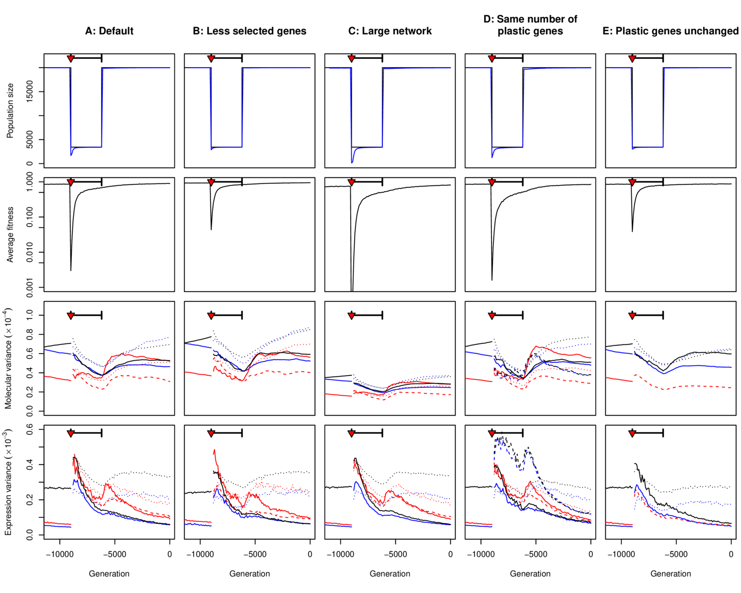

Figure S9: Sensitivity to variations in the model parameters.The left column (A) represents the default parameter set. B: “Less selected genes”: the network still contained 24 genes, but only 6 (instead of 12) evolved under selection, with the same proportion of plastic, stable, and non-selected genes; C: “Large network”: 48 genes (+ environment) were considered in the simulation, with 24 genes under selection. D: “Same number of plastic genes”: Domestication was not associated with less selection on plasticity; 6 genes are still selected for plasticity during the domestication process, but these were not the same as the plastic genes before domestication. E: “Plastic genes unchanged”: the six plastic genes after domestication were the same as the ones before domestication. Rows stand for the same parameters as in fig S7.

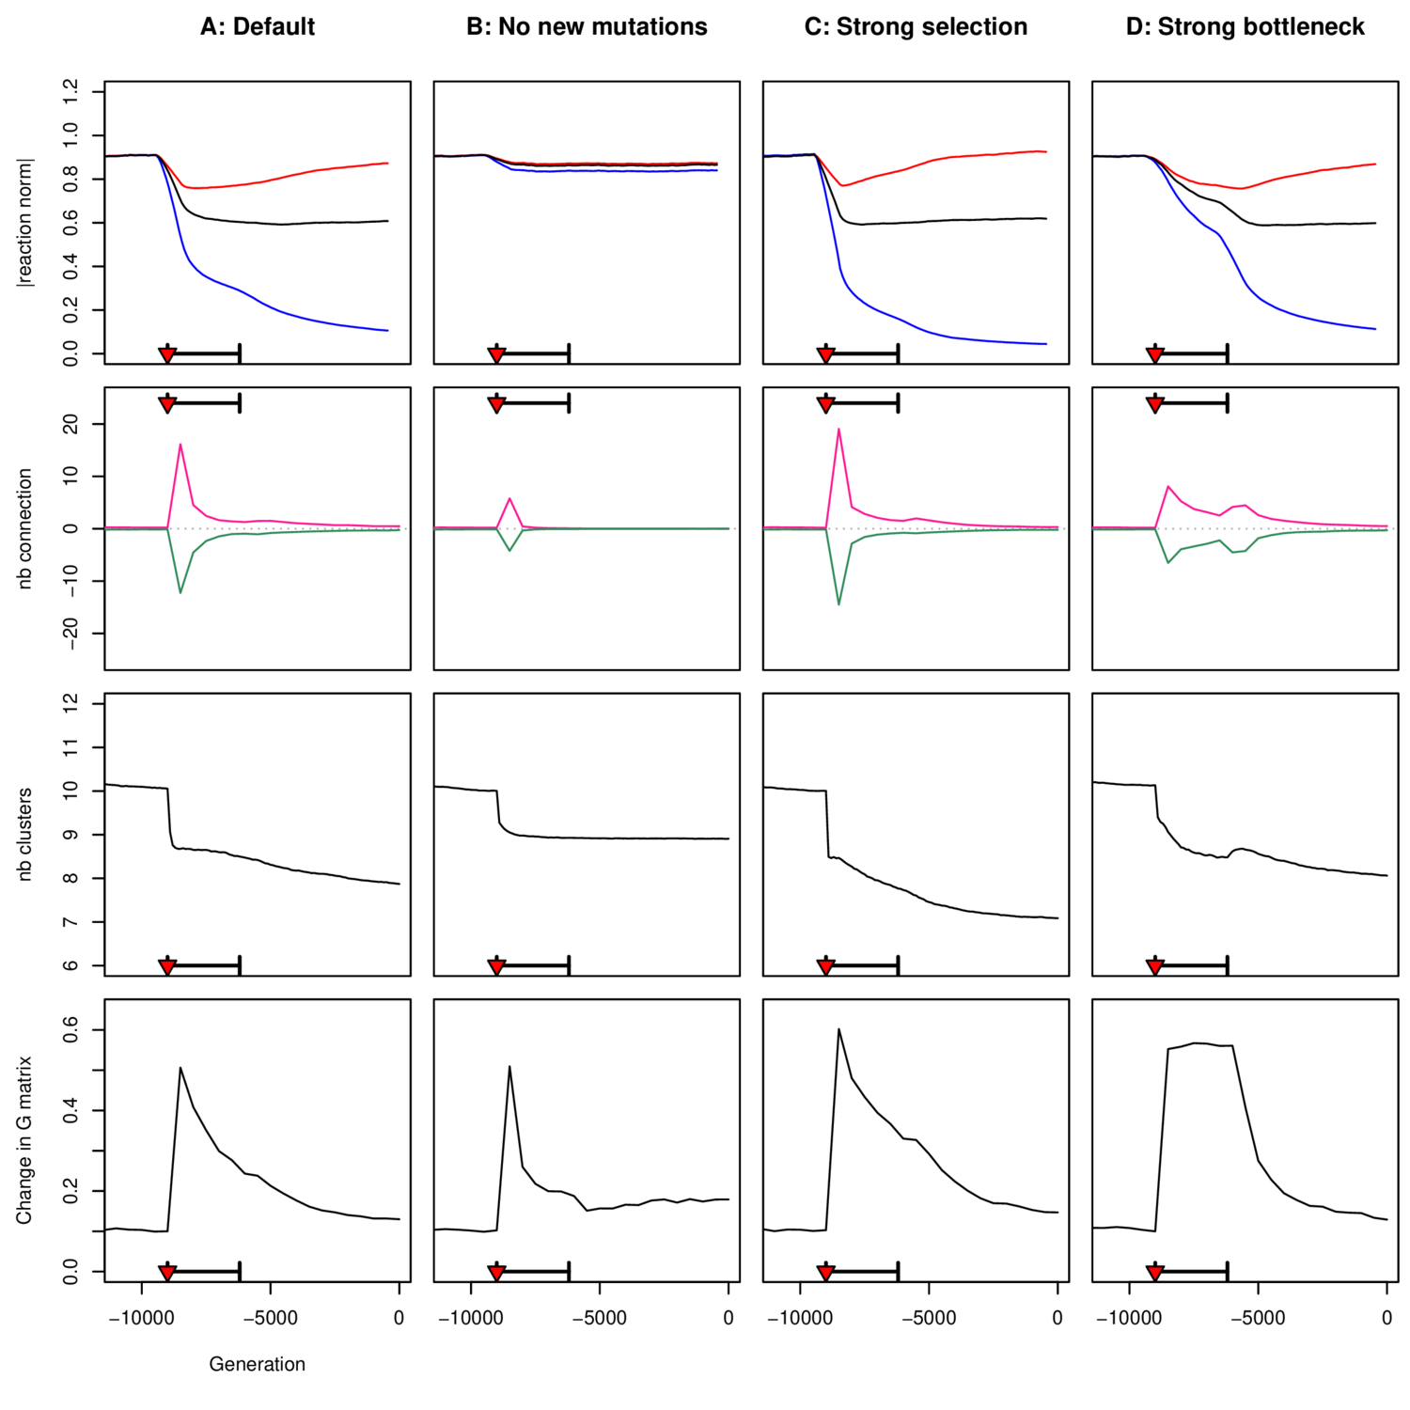

Figure S10: Sensitivity to variations in the model parameters. Columns are the same as in Figure S8. Rows stand for, respectively, the average absolute reaction norm (as in Figure 2B), The number of gained vs loss connections (as in Figure 5A), the average number of clusters (as in Figure 5B), and the dynamics of the change in the genetic covariance matrix (as in Figure S7A).

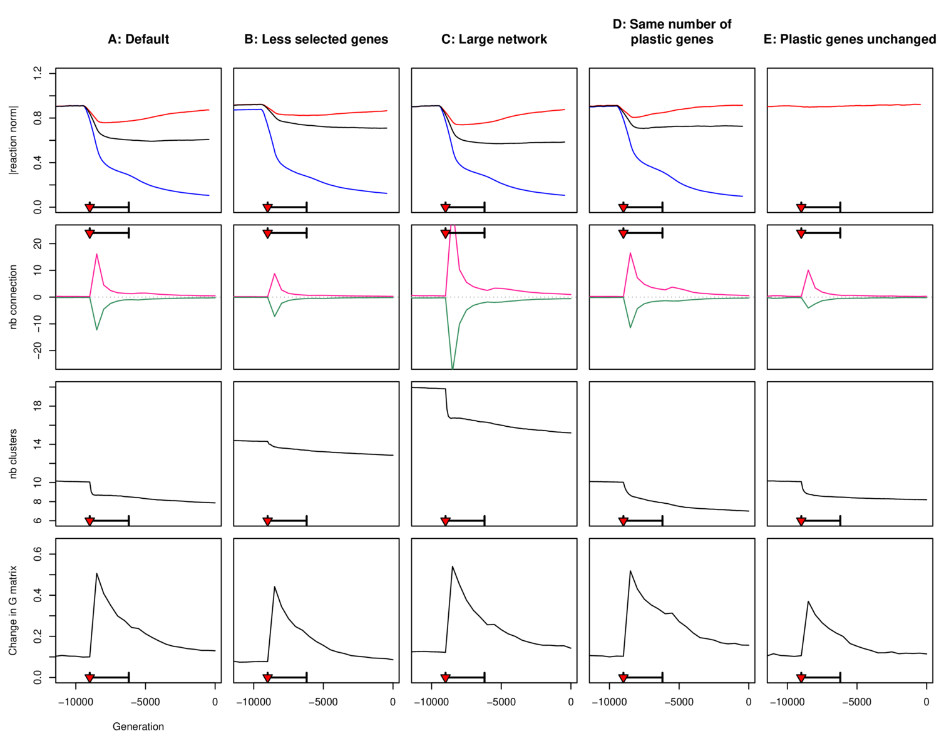

Figure S11: Sensitivity to variations in the model parameters. Columns are the same as in Fig S9, Rows are the same as in Fig S10.

