INTERNSHIP REPORT
ON
DESIGN AMD IMPLEMENTATION OF AN AV/VR ENVIRONMENT FOR TEACHERS AND STUDENTS TO MEET FOR ONLINE CLASSES

PRESENTED TO
IUES INSAM
DEPARTMENT OF COMPUTER ENGINEERING
SPECIALITY : SOFTWARE ENGINEERING
PRESENTED BY
NFOTA LEROY-FRED EWONJUG
MATRICULE : 25F976
INTERNSHIP ORGANISATION
NEW GENERATION TECHNOLOGIES
INTERNSHIP PERIOD
[1ST JUNE -30RD AUGUST]
INDUSTRIAL SUPERVISOR
[NAME OF SUPERVIOR]
ACADEMIC SUPERVISOR
[NAME OF ACADEMIC SUPERVISOR]
ACADEMIC YEAR
2026/2027

DECLARATION
I, NFOTA LEROY-FRED EWONJUG, hereby declare that this internship report entitled ‘’Design and Implementation of an AV/AR Environnent for Teachers and Students to Meet for Online Classes’’ is the reuslt of the practical work and learning experience acquired during, my internship a NEW GENERATION TECHNOLOGISE.

This report has been prepared as part of the academic requirement of my programme in Computer Engineering, specializing in Software Engineering. The information presented describes the activities undertaken, knowledge acquired challenges encountered, and software Project developed during the internship.

I futher declare that the work presented in this report has not kwowingly been copied or submitted to another institution for the award of another qualification.

S t u d e n t : N F O T A L E R O Y – F R E D E W O N J U G
Signature : - - - - - - - - - - - - - - - - - - - - - - - - - - - - - - - - - - - -
Date : _____________________________

CERTIFICATION

This is to certify that NFOTA LEROY-FRED EWONJUG, a student of Computer Engineering, specializing in Software Engineering, carried out an internship at NEW GENERATION TECHNOLOGIES during the period [START DATE – END DATE]

During the internship, the student participated in practical activities related to software engineering and information technology and worked on the project entitled “Design and Implementation of an AR/VR Environment for Teachers and Students to Meet for Online Classes.”

Industrial Supervisor: - - - - - - - - - - - - - - - - - - - - - - - - - - - - - - - - - - - - - - - - - - - - - - - - - - -

Signature: - - - - - - - - - - - - - - - - - - - - - - - - - - - - - - -

Date: - - - - - - - - - - - - - - - - - - - - - - - - - - - - - - - - - - - - -

Academic Supervisor: - - - - - - - - - - - - - - - - - - - - - - - - - - - - - - - - - - - - - - - - - - - - - - - - - -

Signature: - - - - - - - - - - - - - - - - - - - -

Date: - - - - - - - - - - - - - - - - - - - - - - - - - - - - - - - - - -

DEDICATION

I dedicate this work first and foremost to God Almighty for His protection, guidance, wisdom, strength, and grace throughout my academic journey and internship period.

I also dedicate this work to my parents and family members for their continuous encouragement, sacrifices, prayers, and support. I further dedicate this work to my lecturers, supervisors, friends, classmates, and everyone who contributed directly or indirectly to my academic and professional development.

ACKNOWLEDGEMENT

I sincerely thank God Almighty for giving me the strength, wisdom, good health, patience, and determination required to successfully complete my internship and prepare this report.

My special appreciation goes to NEW GENERATION TECHNOLOGIES for accepting me as an intern and providing an environment in which I could develop practical knowledge and professional skills. I am particularly grateful to my internship supervisor for guidance, corrections, explanations, and professional advice.

I also appreciate the lecturers and administration of [ESTUARY ACADEMIC AND
STRATEGIC INSTITUTE], especially the Department of Computer Engineering, for providing the academic foundation necessary to undertake this internship. I am grateful to my parents, family, classmates and friends for their support and encouragement.

ABSTRACT

Internship training constitutes an important component of professional education because it allows students to transfer theoretical knowledge acquired in the classroom into practical situations. This report presents the experience and activities undertaken during an internship at NEW GENERATION TECHNOLOGIES as a student specializing in Software Engineering.

The major project was the Design and Implementation of an AR/VR Environment for Teachers and Students to Meet for Online Classes. Inspection of the submitted project shows that the current implementation is primarily a web-based virtual classroom prototype. It combines authentication, a teacher workspace, room management, an operational backend console and browser-based audio/video communication.

The frontend uses HTML, CSS and JavaScript. The server uses Node.js. Authentication uses bcryptjs and JSON Web Tokens, while WebRTC provides browser audio/video communication and server endpoints provide signalling. The current prototype stores operational data in memory, making it suitable for demonstration and further development rather than production deployment.

The internship provided practical experience in requirements analysis, interface design, client-server communication, REST API development, authentication, real-time communication, testing, debugging, version control and technical documentation.

Keywords: Internship, Software Engineering, AR, VR, Virtual Classroom, WebRTC, Node.js,
JWT, Online Education.

TABLE OF CONTENTS

DECLARATION ........................................................ i

CERTIFICATION ....................................................... ii

DEDICATION ............................................................ iii

ACKNOWLEDGEMENT ................................................ iv

ABSTRACT ............................................................... v

LIST OF ABBREVIATIONS ........................................... vi

CHAPTER ONE: GENERAL INTRODUCTION .................. 1

CHAPTER TWO: PRESENTATION OF NEW GENERATION TECHNOLOGIES .... 8

CHAPTER THREE: INTERNSHIP ACTIVITIES ................. 12

CHAPTER FOUR: SYSTEM ANALYSIS AND DESIGN ....... 17

CHAPTER FIVE: IMPLEMENTATION, TESTING AND RESULTS .... 22

CHAPTER SIX: CONCLUSION AND RECOMMENDATIONS .... 28

REFERENCES ............................................................. 30

APPENDICES .............................................................. 31

LIST OF ABBREVIATIONS
Abbreviation | Meaning
AR | Augumented Reality
VR | Virtual reality
UI | Uers Interface
UX | User Experience
HTML | Hyper Text Markup Language
CSS | Cascading Style Sheet
JS | JavaScript
API | Application programme Interface
http | Hyper text Transfer Protocol
JWT | JSON Web Token
WebRTC | Web Real-Time Communication
SRUN | Session Traversal Utilities for NAT
TURN | Traversal Using Relays around NAT
ERD | Entity Relatioship Diagram

CHAPTER ONE: GENERAL INTRODUCTION
1.1 Background of the Internship
Internship training is an essential component of higher education because it provides students with an opportunity to acquire practical experience in their chosen fields. Academic programmes provide theoretical knowledge, while professional environments require students to understand how these concepts are applied to real-life problems.
For Computer Engineering and Software Engineering students, practical experience is particularly important because technology is highly practical and continuously changing. Software engineers are expected to understand programming languages, databases, development methodologies, testing, debugging, interface design, cybersecurity and project management.
My internship at NEW GENERATION TECHNOLOGIES provided an opportunity to apply academic knowledge to practical software development. The experience demonstrated that software development is not limited to coding; it also includes problem definition, requirements analysis, design, implementation, testing, documentation and evaluation.
1.2 Background of the Project
Technology has transformed education by enabling teachers and students to communicate remotely. Conventional online classrooms normally rely on video, audio, chat, documents and screen sharing. Although these services are useful, they are largely two-dimensional and may provide limited immersion.
Virtual Reality can create computer-generated learning spaces, while Augmented Reality can combine digital content with the physical environment. The project therefore explores a foundation for a more interactive virtual classroom experience.
1.3 Problem Statement
Traditional online learning platforms may provide limited classroom immersion, reduced social presence and limited interaction with three-dimensional learning resources. Students can sometimes feel disconnected from teachers and classmates. The proposed project addresses these challenges by developing a structured virtual classroom environment that can be extended toward immersive AR/VR learning.
1.4 Aim
To design and implement a virtual classroom environment that enables teachers and students to meet and interact for online classes, while providing a foundation for future immersive AR/VR features.
1.5 Specific Objectives
- Analyze limitations of conventional online learning environments.
- Design a user-friendly online classroom platform.
- Develop registration and login functionality.
- Provide teacher-oriented classroom management.
- Implement secure authentication using password hashing and JWT.
- Provide browser-based real-time audio/video communication.
- Test and debug the developed system.
- Document the development process and results.

1.6 Research Questions

- How can immersive concepts improve online classroom interaction?
- What features are required in a virtual classroom?
- How can teachers and students interact remotely?
- How can user information be protected?
- How can the platform be extended into a full AR/VR environment?

1.7 Significance

The project is significant to students because it provides a structured online learning environment; to teachers because it offers classroom and room management functions; to institutions because it demonstrates emerging educational technologies; and to software engineering because it combines frontend, backend, authentication, networking and testing.

1.8 Scope

The system covers authentication, teacher dashboard functions, rooms, schedules, activities, backend monitoring, internship check-ins and browser audio/video communication. A complete immersive 3D WebXR classroom is outside the present implementation.

1.9 Limitations

Limitations include in-memory storage, dependence on Internet connectivity, browser permission requirements, possible need for TURN infrastructure, and the absence of a completed immersive WebXR layer.

1.10 Methodology

The development process consisted of requirements analysis, source-code review, interface design, backend implementation, integration, testing, debugging and documentation.

1.11 Development Approach

Presentation and server responsibilities were separated. The frontend manages user interaction while the Node.js server provides APIs, authentication and signalling.

1.12 Expected Outcome

A functional foundation for online classroom interaction in which users can authenticate, access classroom information, manage rooms and communicate through a browser.

1.13 Organization of the Report

The report contains six chapters covering introduction, organization, internship activities, analysis/design, and implementation/testing, and conclusions/recommendations.

1.14 Chapter Summary

This chapter introduced the internship and established the project background, objectives, scope, significance, methodology and expected outcome.

CHAPTER TWO: PRESENTATION OF NEW GENERATION TECHNOLOGIES

2.1 Introduction

The internship was carried out at NEW GENERATION TECHNOLOGIES. The project archive does not contain an official company profile, so this report does not invent the organization's history, address or management information.

2.2 Overview

NEW GENERATION TECHNOLOGIES served as the host organization and provided the environment in which practical software engineering activities were undertaken.

2.3 History

Insert the official history supplied by the organization or supervisor.

2.4 Location

Insert the official location and address.

2.5 Vision

Insert the organization's official vision statement.

2.6 Mission

Insert the organization's official mission statement.

2.7 Objectives

Insert the organization's official objectives.

2.8 Activities and Services

Insert the organization's official activities and services.

2.9 Organizational Structure

Unit | Responsibilities
Management | Direction and Supervision
Technical/IT | Technical and Software activities
Internship supervion | Task assignment and progress review
Administration | General administration support

2.10 Departments and Responsibilities
Complete this section using the organization's official organizational chart.

2.11 Internship Department
The internship work focused on software engineering and web application development.

2.12 Working Environment
The environment encouraged practical learning through project development, troubleshooting, testing and documentation.

2.13 Chapter Summary
This chapter presented the host organization and clearly identified company information that requires official confirmation.

CHAPTER THREE: INTERNSHIP ACTIVITIES

3.1 Introduction

The internship covered activities across the software development life cycle.

3.2 Orientation and Familiarization

The project repository was reviewed to understand its objective, file organization and user flows.

3.3 Understanding Software Development

The work demonstrated the importance of analysis, design, coding, integration, testing, debugging and documentation.

3.4 Requirement Analysis

Requirements centered on authentication, dashboards, classroom rooms, schedules, backend operations and real-time communication.

3.5 Frontend Development

The frontend contains authentication screens, a teacher workspace and a call-room interface.

3.6 HTML Development

Login.html provides authentication forms and call.html provides the communication-room structure.

3.7 CSS Development

CSS organizes navigation, cards, forms, dialogs, buttons and call-room layouts.

3.8 JavaScript Development

JavaScript handles forms, API requests, authentication state, dashboard rendering, room creation and WebRTC behavior.

3.9 Backend Development

Node.js provides health, authentication, dashboard, room, schedule, activity, internship, caller and signaling endpoints.

3.10 Database Management

The submitted prototype does not use a persistent SQL database; operational records are maintained in memory.

3.11 XAMPP and Local Server Configuration

XAMPP is useful for PHP/MySQL projects, but this submitted application uses Node.js as its backend server.

3.12 Testing

Testing covered authentication, protected endpoints, API behaviour and communication components.

3.13 Debugging
Debugging involved identifying and correcting integration, authentication, frontend and communication issues.

3.14 System Integration

Frontend requests are connected to the Node.js API and protected requests use bearer tokens.

3.15 Version Control and Project Management

The repository includes package configuration and documentation, supporting dependency management and organized development.

3.16 Documentation

The README and report document setup, architecture, limitations and future improvements.

3.17 Skills Acquired

- HTML/CSS
- JavaScript
- Node.js
- REST APIs
- JWT authentication\
- Password hashing
- WebRTC
- Testing
- Debugging
- Technical documentation

3.18 Professional Skills Acquired

- Communication
- Time management
- Problem solving
- Teamwork
- Responsibility
- Presentation
- Technical reporting

3.19 Challenges Encountered

Challenges included understanding frontend/backend interaction, authentication state, WebRTC signaling, browser permissions and deployment considerations.

3.20 Solutions to Challenges

Solutions involved source-code inspection, incremental testing, API verification, debugging and breaking complex tasks into smaller components.

3.21 Chapter Summary

The internship provided practical exposure from interface development through backend implementation, testing and documentation.

CHAPTER FOUR: SYSTEM ANALYSIS AND DESIGN

4.1 Introduction

System analysis identifies the problem and requirements, while system design explains how the solution operates.

4.2 Analysis of Existing System

Conventional online learning often uses separate tools for video meetings, scheduling, classroom administration and follow-up.

4.3 Existing System Description

Typical platforms provide video, participants, chat, documents and scheduling, but remain largely screen-based.

4.4 Problems Identified

Fragmented tools Limited immersion Reduced social presence Limited 3D interaction Connectivity dependence Limited classroom simulation

4.5 Proposed System

The proposed system combines authentication, teacher dashboard functions, room management, schedules, operational monitoring and browser real-time communication.

4.6 Advantages

- Centralized classroom workflow
- Role-oriented access
- Browser communication
- Room and schedule management
- Expandable architecture
- Foundation for immersive features

4.7 Feasibility Study
Area | Assessment
Technical | Feasible using technologies, Node.js and WebRTC.
Economic | Prototype can use widely available software tools.
Operational | Browser access simplifies development.
Schedule | Can be develop incrementally
Scalability | Persistent database and infrastructure are required for growth.

4.8 Functional Requirements

- Register users
- Authenticate users
- Retrieve authenticated identity
- Display dashboard
- Create rooms
- Display rooms and schedules
- Record check-ins
- Exchange WebRTC signals
- Control microphone/camera

4.9 Non-Functional Requirements

- Usability
- Security
- Reliability
- Maintainability
- Responsiveness
- Performance
- Scalability

4.10 System Users
User | Functions
Teacher | Login, dashboard, create/manage rooms, enter live sessions.
Student/Participant | Join a classroom and communicate through audio/video.
Operator/Administrator | Monitor rooms and operational records.

4.11 Use Cases

Teacher: Register/Login → Dashboard → Create Room → Schedule → Live Room. Participant: Open Room → Media Permission → Join → Communicate. Operator: Console → Monitor → Provision Room → Record Check-in.

4.12 System Architecture

Browser UI → HTML/CSS/JavaScript → Node.js HTTP Server → Authentication/Room APIs and WebRTC Signaling → Peer-to-peer media.

4.13 System Workflow

Open application → authenticate → receive JWT → access dashboard → select/create room → enter call → grant media permissions → exchange signaling → communicate.

4.14 Database Design

The prototype uses in-memory structures. Logical entities include User, Room, Schedule, Activity, Internship, Caller and Signal. A future version can migrate these entities to MySQL or PostgreSQL.

4.15 Entity Relationship Model

Suggested relationships include User–Room, Room–Schedule, Room–Participant/Caller and Room–Signal.

4.16 Interface Design

The interface uses a sidebar, dashboard cards, forms, modals, room controls and video panels.

4.17 Security Design

- Bcryptjs password hashing
- JWT verification
- Bearer-token protected routes
- Expiring reset tokens
- HTTPS in production
- Environment-managed authentication secret.

4.18 Chapter Summary

The chapter analyzed the existing process and presented requirements, architecture, data, interface and security design.

CHAPTER FIVE: SYSTEM IMPLEMENTATION, TESTING AND RESULTS

5.1 Introduction

This chapter describes the implementation environment, major modules, tests and results.

5.2 Development Environment

Component | Implementation
Frontend | HTML5, CSS3, JavaScript
Backend | Node.js, HTTP server
Authentication | Bcryptjs + JWT
Communication | WebRTC
Testing | Node.js test runner
Package Management | NPM

5.3 Hardware Requirements

- Laptop/desktop computer
- At least 4 GB RAM recommended
- Webcam and microphone for call testing
- Stable Internet connection
- Modern browser

5.4 Software Requirements

- Node.js
- NPM
- Modern browser
- Code editor
- Git/GitHub
- Optional MySQL/XAMPP for future database integration
5.5 System Implementation

The implementation is divided into authentication, teacher workspace, room management, backend console and call-room modules.

5.6 Login Interface

The login page provides email/password fields and links to registration and password recovery. JavaScript sends credentials to the authentication API.

5.7 Registration Interface

Registration collects user details and password. The backend validates the input and hashes the password.

5.8 Student Dashboard

A separate student dashboard is not present in the submitted source. Participant access is currently represented through the call-room experience. A dedicated student dashboard is recommended as a future module.

5.9 Teacher Dashboard

The teacher workspace presents live-room information, room statistics, schedules, recent activities and room creation controls.

5.10 Class Management

The room API supports listing rooms and creating new rooms using required fields such as title, year and subject.

5.11 Virtual Classroom

The call room uses browser media APIs and RTCPeerConnection. Users can enable or disable microphone and camera and exchange signaling messages through the backend.

5.12 Database Implementation
Operational data is held in memory and is lost when the server restarts. A production system should use persistent storage.

5.13 System Testing

Testing focused on authentication, protected endpoints, API behavior and the WebRTC workflow.

5.14 Test Cases

Test Case | Expected Result | Result
Unauthenticated /api /auth /me | 401 Unauthorized | Passed
Valid token /api /auth /me | 200 + User identity | Passed
Unauthenticated /api/ dashboard | 401 Unauthorized | Passed
Valid registration | Account created | Implemented
Valid login | JWT returned | Implemented
Create valid room | Room created | implemented

5.15 Testing Results

The included authentication test suite contains three automated tests. The tests completed successfully with three passes and zero failures.

5.16 System Evaluation

The prototype demonstrates a coherent virtual classroom architecture. Strong components include authentication, teacher dashboard integration, room management and WebRTC signaling. Principal limitations are in-memory persistence and absence of a full immersive WebXR classroom.

5.17 Challenges during Implementation

Challenges included asynchronous API requests, authentication state, browser media permissions, peer-connection signaling and responsive interface behavior.

5.18 Chapter Summary
The system was implemented using modern web technologies and tested through automated authentication tests and functional verification.

CHAPTER SIX: CONCLUSION AND RECOMMENDATIONS

6.1 Introduction

This chapter summarizes the internship and project and presents recommendations for future development.

6.2 Summary of the Internship

The internship provided practical exposure to frontend development, backend programming, authentication, APIs, WebRTC, testing, debugging and documentation.

6.3 Summary of the Project

The project provides a virtual classroom foundation where users can authenticate, access a teacher workspace, manage rooms and participate in browser audio/video communication.

6.4 Conclusion

The project achieved the objective of creating a functional web-based foundation for online classroom interaction. It demonstrates practical software engineering skills and provides a basis for future immersive development. The current implementation should be described accurately as a virtual classroom prototype with AR/VR-oriented objectives rather than a completed immersive AR/VR system.

6.5 Recommendations

- Integrate persistent MySQL/PostgreSQL storage.
- Implement dedicated student accounts and dashboards.
- Add attendance and class membership.
- Add chat, file sharing, assignments and notifications.
- Use HTTPS and secure environment variables.
- Configure TURN infrastructure for reliable calls.
- Expand security, performance and usability testing.
- Develop a 3D WebXR classroom for true immersive interaction.

6.6 Future Improvements

Future versions can introduce avatars, 3D classrooms, virtual laboratories, spatial audio, collaborative whiteboards, AI-assisted teaching, analytics, multilingual support and integration with institutional learning-management systems.

6.7 Final Remarks

The internship strengthened my understanding of the software development life cycle and improved my ability to analyze problems, develop solutions, test systems and document technical work.

REFERENCES

- Project README.md — Leroy Virtual Classroom project archive.
- frontend/login.html, script.js and style.css — authentication and teacher workspace.
- frontend/call.html, call.js and call.css — browser communication room.
- backend/server.js — server, APIs, authentication, rooms and signalling.
- backend/backend.html, backend.js and backend.css — operational console.
- backend/auth.test.js — automated authentication tests.
- package.json and package-lock.json — dependencies and configuration.
- MDN Web Docs — WebRTC and browser media API concepts.
- JSON Web Token documentation — token-based authentication concepts

APPENDICES
Appendix A: Project Structure
L E R O Y V I r t u a l - C l a s s r o o m /
├ ─ ─ p a c k a g e . j s o n
├ ─ ─ p a c k a g e - l o c k . j s o n
├── README.md
├ ─ ─ f r o n t e n d /
│ ├ ─ ─ l o g I n . h t m l
│ ├ ─ ─ s c r I p t . j s
│ ├ ─ ─ s t y l e . c s s
│ ├ ─ ─ c a l l . h t m l
│ ├ ─ ─ c a l l . j s
│ └ ─ ─ c a l l . c s s
└ ─ ─ b a c k e n d/
├ ─ ─ s e r v e r . j s
├ ─ ─ b a c k e n d . h t m l
├ ─ ─ b a c k e n d . j s
├ ─ ─ b a c k e n d . c s s
└── auth.test.js

Appendix B: Suggested Weekly Internship Activities

Week | Activities
1 | Orientation, repository familiarization and requirements
2 | Frontend and authentication
3 | Node.js backend and API development
4 | Dashboard and room management
5 | WebRTC call-room implementation
6 | Test and debugging
7 | Integration and development review
8 | Documentation and presentation preparation

Appendix C: Recommended Screenshots
- Figure Login/Registration Page
- Figure Teacher Dashboard
- Figure Backend console
- Figure virtual Call Room
- Figure Room Creation Form
- Figure Schedule / Activity Section

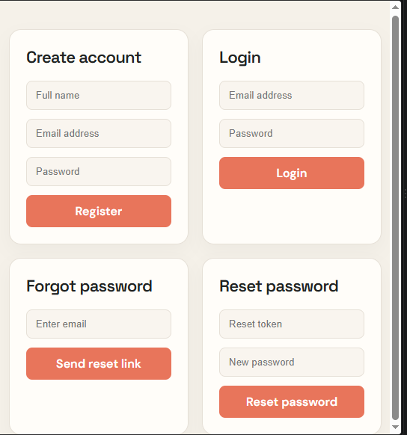

Figure Login/Registration Page

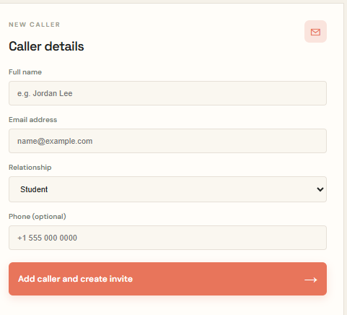
Figure Teacher Dashboard

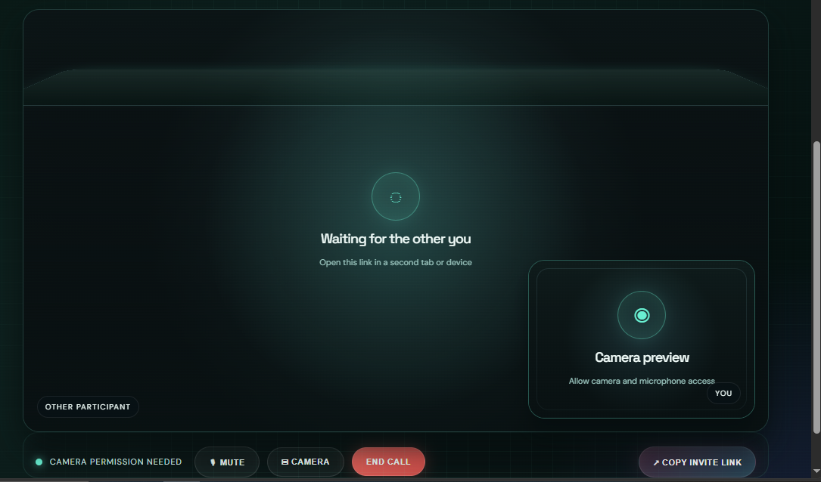

- Figure Backend console

Figure virtual Call Room

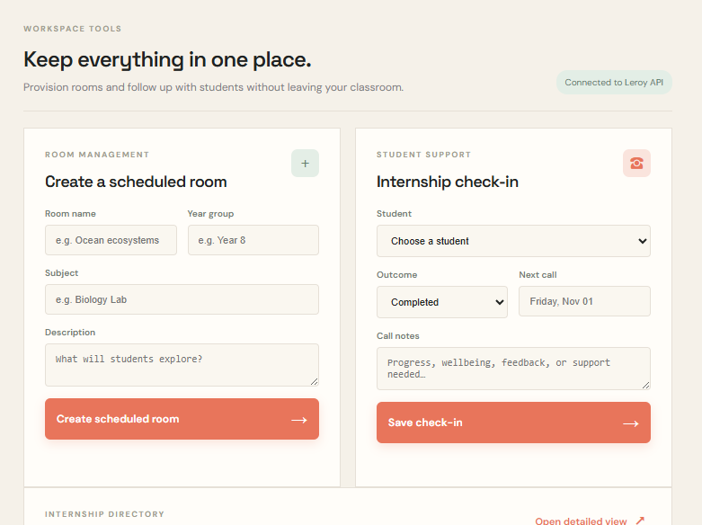
Figure Room Creation Form

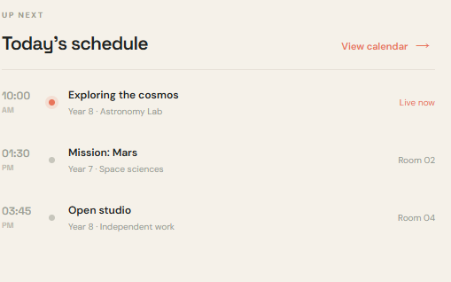
Schedule / Activity Section
DESIGN AND IMPLEMENTATION OF AN AV/VR ENVIRONMENT FOR TEACHER’S AND STUDENT’S TO MEET ONLINE CLASSES

-

ACADEMIC YEAR
2026/2027
ACADEMIC SUPERVISOR
Mr. NGOUNA

PROFESSIONAL SUPERVISOR
Mr. FOSSO ALFRED

REVIEWED BY:
NFOTA LEROY-FRED EWONJUG
WRITTEN AND PRESENTED BY:
SOFTWARE ENGINEERING
SPECIALITY:
AN INTERNSHIP CARRIED OUT FROM JUNE 1TH, TO AUGUST 30ᵗʰ, 2026 AND REPORT SUBMITTED AS A PARTIAL FULFILLMENT FOR THE HIGHER NATIONAL DIPLOMA (HND)
REPUBLIC OF CAMEROON
Peace–Work –Fatherland
**********
MINISTRY OF HIGHER EDUCATION

**********
UNIVERSITY OF DSCHANG
**********
ESTUARY ACADEMIC AND
STRATEGIC INSTITUTE

REPUBLIQUE DU CAMEROUN
Paix – Travail – Patrie
**********
MINISTRE DE L’ENSEIGNEMENT
SUPERIEUR
**********
UNIVERSITE DE DSCHANG
**********
INSTITUT UNIVERSITAIRE ET
STRATEGIQUE DE L’ESTUAIRE




