2:1 Chill Marionberry Doozies by Green Revolution ‑ 100mg THC / 50mg CBN  $35  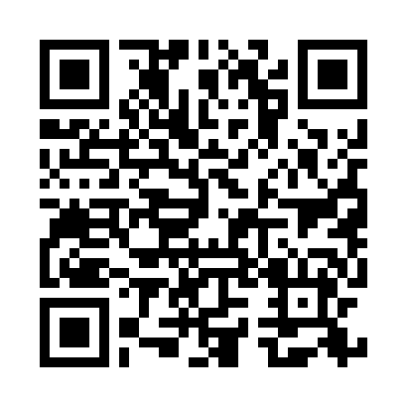  GREEN REVOLUTION | 3:1 Strawberry Lime Elevate Doozies by Green Revolution ‑ 300mg CBC / 100mg THC  $35    GREEN REVOLUTION | 1:1:1 Strawberry Pineapple +Plus Doozies by Green Revolution ‑ 50mg THC / 50mg CBG / 50mg CBC  $35    GREEN REVOLUTION | 1:1 Watermelon Elevate Doozies by Green Revolution ‑ 100mg THC / 100mg CBG  $35    GREEN REVOLUTION
1:1 Mocha Fly Dopio Shot by Green Revolution ‑ 100mg THC / 100mg CBG  $18    GREEN REVOLUTION | 1:1 Vanilla Fly Dopio Shot by Green Revolution ‑ 100mg THC / 100mg CBG  $18  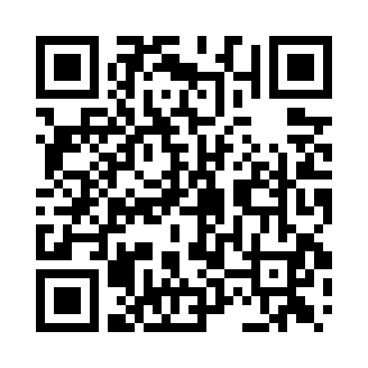  GREEN REVOLUTION | 2:1:1 Agave Lime MAX Wildside Shot by Green Revolution ‑ 100mg THC / 50mg CBG / 50mg CBC  $18  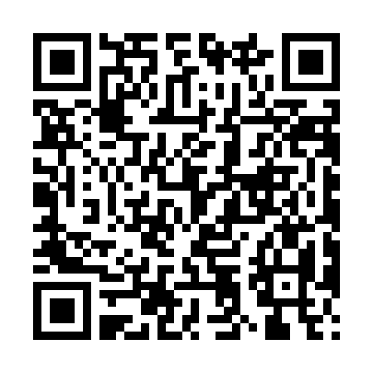  GREEN REVOLUTION | 2:1:1 Blueberry Acai MAX Wildside Shot by Green Revolution ‑ 100mg THC / 50mg CBD / 50mg CBN  $18    GREEN REVOLUTION
1:1 Sour Green Apple MAX Wildside Shot by Green Revolution ‑ 100mg THC / 100mg CBG  $18    GREEN REVOLUTION | Sour Watermelon MAX Fly Wildside Shot by Green Revolution ‑ 100mg THC / 5mg CBG  $12    GREEN REVOLUTION | 1:1:1 Midnight Grape +Plus Doozies by Green Revolution ‑ 100mg THC / 100mg CBD / 100mg CBN  $35    GREEN REVOLUTION | 1:1:1 Blue Raspberry Night Time Doozies by Green Revolution ‑ 50mg CBD / 50mg THC / 50mg CBN  $35  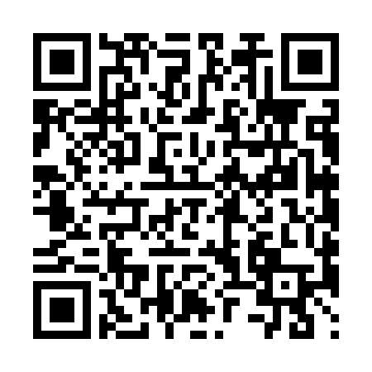  GREEN REVOLUTION

