RATIO - Beverage - 100mg THC - Strawberry Burst
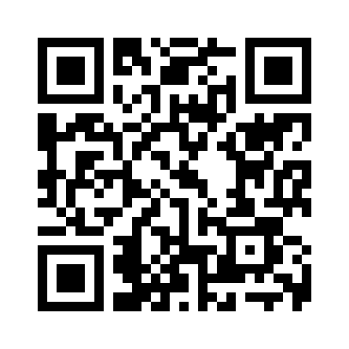
Mixed

