|  |  |  |
| --- | --- | --- |
| **FRIB_rgb** | **Facility for Rare Isotope Beams** U.S. Department of Energy Office of Science | Michigan State University East Lansing, MI 48824-1321 • Ph: (517) 355-9672 • Fax: (517) 353-5967 www.frib.msu.edu | MSU-Wordmark-PMS-567.eps |

Naming System - Installation Manual

Version 2.3.1

|  |  |  |  |
| --- | --- | --- | --- |
|  | Name | Signature | Date |
| Prepared By | Vasu Vuppala |  |  |
| Reviewed By |  |  |  |
| Approved By |  |  |  |

Revision History

|  |  |  |  |
| --- | --- | --- | --- |
| Version | Date | Author | Description |
| 2.3 | 17-May-2013 | Vuppala, V | Initial |
| 2.3.1 | 03-Jun-2013 | Vuppala, V | Fixed JDBC resource name |
| 2.4.0 | 12-Aug-2013 | Vuppala V | Added upgrade and data loads |
|  |  |  |  |
|  |  |  |  |
|  |  |  |  |

Table of Contents

[1 Introduction 5](#_Toc357560319)

[1.1 Purpose 5](#_Toc357560320)

[1.2 Scope 5](#_Toc357560321)

[1.3 Definitions, Acronyms, and Abbreviations 5](#_Toc357560322)

[1.4 References 5](#_Toc357560323)

[1.5 Overview 6](#_Toc357560324)

[2 System Requirements 6](#_Toc357560325)

[3 Installation 6](#_Toc357560326)

[3.1 Introduction 7](#_Toc357560327)

[3.1.1 Deployment Environment 7](#_Toc357560328)

[3.1.2 Accessing the GUI and Service 8](#_Toc357560329)

[3.2 Pre Installation 8](#_Toc357560330)

[3.3 Install 9](#_Toc357560331)

[3.4 Post Installation 9](#_Toc357560332)

[4 Compiling Naming System 11](#_Toc357560333)

[5 Support 12](#_Toc357560334)

[Appendix A – Glassfish Installation 13](#_Toc357560335)

[Appendix B – Apache and Glassfish 14](#_Toc357560336)

[Appendix C – Application Server Configuration 16](#_Toc357560337)

List of Figures and Tables

[Figure 1 Deployment Environment 7](#_Toc357560338)

[Figure 2 Naming System Home Page 11](#_Toc357560339)

[Table 1 Definitions, Acronyms, and Abbreviations 5](#_Toc357560340)

# Introduction

*DISCS Naming System Module* (or simply *Naming System*) is a software tool for managing the naming convention associated with an accelerator facility.

*Naming System* consists of the following:

* A database to store the accelerator facility’s Naming Convention
* A Graphical User Interface (GUI)

## Purpose

The objective of this document is to describe the installation of *Naming System*.

## Scope

It is assumed that the required infrastructure (DBMS, Application Server, Web Server) is already installed. Even though we provide basic installation instructions for them, it is assumed that you are familiar with installation of these services.

## Definitions, Acronyms, and Abbreviations

Table 1 Definitions, Acronyms, and Abbreviations

|  |  |
| --- | --- |
| Item | Description |
| DBMS | Database Management System |
| DISCS | Distributed Information Services for Controls Systems |
| EPICS | Experimental Physics and Industrial Control System |
| ERD | Entity-Relationship Diagram |
| FRIB | Facility for Rare Isotope Beam |
| IOC | Input/Output Controller |
| RDBMS | Relational Database Management System |
| REST | Representational State Transfer |
|  |  |
|  |  |
|  |  |
|  |  |

## References

1. Naming System: Schema Design Manual, Open EPICS Web Site
2. Open EPICS Web Site, <http://openepics.sourceforge.net>

## Overview

The next section lists the system requirements for Naming System. Installation Section describes the installation procedure.

# System Requirements

Naming System has been developed using Java EE.It needs the following for its operation:

* Java 6
* MySQL Database Management System Version 5. *Naming System* has been tested with MySQL version 5.1.
* Java EE 6 Application Server
* A Web Server (preferably Apache 2)

*Naming System* has been tested in the following environment:

* MySQL version 5.1.63 running on Debian Squeeze
* Glassfish version 3.1.2.2 running on Debian Squeeze
* Apache version 2.2 running on Debian Squeeze

However, it should work with MySQL or Glassfish running on other platforms such Windows Server 2008, Windows 7, OS X, or other distributions of Linux.

# Installation

Application Server

Database Server

Authentication Server

Web Server

Browser

Figure 1 Deployment Environment

## Introduction

Naming System contains the following packages:

* Database Schemas: One or more SQL DDL files containing SQL commands to create the database structures. It creates the following database (schema) in MySQL:
  + discs\_names (you may use any other name for the database)
* GUI Application: A WAR file to be installed on a Java EE Application Server
* Sample data: Data for trying out the Naming System
* Source: Source code for the service, GUI, API, documentation, and sample programs

### Deployment Environment

As shown in Figure 1, you need the following logical servers[[1]](#footnote-1) to install Naming System:

* An application server that supports Java EE 6. Naming System has been tested with Glassfish 3 but you may use other servers such as JBoss or WebSphere.
* A database server. Database Schemas are installed on the database server.
* A Web Server: Running Glassfish on the HTTP port (80) is not advised. Hence it is kept behind a web server. Preferred web server is Apache 2 but you may use any other web server that can interact with the application server. Nothing from Naming System is installed on the web server.
* Authentication Server: This is optional based on the chosen authentication scheme. If LDAP based authentication is configured, then this is the LDAP server. If file based authentication is used, then this server is not needed (the application server performs the authentication).

### Accessing the GUI and Service

Naming System GUI is a web application to be accessed through a browser. Based on your installation it can be accessed in one the following ways:

* You may access it directly through the application server: https://app-server.domain:8181/names where ‘app-server.domain’ is the name of your application server which is running on port 8181.
* A better way is to access it through a web server (direct access through the application server is disabled). In such case your URL will be something like https://web-server.domain/names where ‘web-server.domain’ is the name of your web server.

## Pre Installation

The following steps are to be done first, and only once.

1. Download and install MySQL.
2. Create the *Naming System* schema (the schema is available on the Open EPICS website [2]). If you are upgrading from an old version of Naming System, run the appropriate upgrade script from Naming System source code. The upgrade scripts are under ‘design’ subdirectory in the source.
3. Download and install Glassfish. See Appendix A – Glassfish Installation for details.
4. Configure Glassfish:
   1. Login to the Glassfish administrator console (at https://glassfishserver:4848)
   2. Go to Resources → JDBC → JDBC Connection Pools
      1. Create new pool called "org.openepics.names.dbpool" (you may choose any other name).
      2. Resource Type = javax.sql.ConnectionPoolDataSource
      3. Datasource Classname = com.mysql.jdbc.jdbc2.optional.MysqlConnectionPoolDataSource
      4. Additional Properties

ServerName = <Name of Server> ex. localhost, qa01

DatabaseName = discs\_names

User = <Database user> eg. namesapp

Password = <Database user's password>

* 1. Test the database connect
     1. Go to Resources → JDBC → JDBC Connection Pools
     2. Select the pool created in the above step
     3. Click on ‘Ping’ button to test the connection
     4. If ping was not successful, go back to the previous step and check the connection-pool configuration
  2. Resources → JDBC → JDBC Resources
     1. Create a new resource called "org.openepics.names.data". You must use this exact name for the resource.
     2. Pool Name = org.openepics.conf.dbpool (or the pool name used in Step b above).

## Install

1. Obtain Naming System GUI Application package (the WAR file). You can download it from [2], or generate it by compiling the source code. For latter, please see the section *Compiling Naming System.* It is recommended that you compile the source code as each lab will need to make slight changes to Naming System’s home page.
2. Deploy the WAR file. You can do this from Glassfish’s administrator console or command-line. The procedure for deploying it from the administrator console is:
   1. Login to the Glassfish administrator console (at <https://glassfishserver:4848>).
   2. Go to Applications → Deploy
      1. Choose the Naming System WAR file (as a ‘Packaged file to be uploaded to the server’)
      2. Choose *Type* as *Web Application*
      3. Enter *Context Root* as */names*
      4. Enter *Application Name* as *names-v2.3* (or any other name you prefer)
      5. Deploy by clicking on ‘OK’
3. If you prefer deploying the application from the command line, run the following command:

asadmin –H app-server-name deploy –contextroot=/conf names-v2.3.war

## Post Installation

1. Add the Naming Categories and User Privileges through SQL scripts. Example:

% mysql –u root –p

**mysql>** use schema discs\_names;

**mysq>** lINSERT INTO name\_category(id,name,description,version) VALUES ('device-type','Device-Type','Device-Type',0), ('signal-domain','Signal Domain','Signal Domain',0), ('signal-suffix','Signal Suffix','Signal Suffix',0),('signal-type','Signal Type','Signal Type',0), ('subsystem','Subsystem','Subsystem',0), ('system','System','System',0);

**mysq**l> INSERT INTO privilege(userid, operation) VALUES (‘doejohn’,'E');

1. To load existing naming data (from CSV files etc), use something similar to the following :

INSERT INTO name\_event(`name\_id`. `event\_type', `requested\_by`, `requestor\_comment`,

`request\_date`, `status’, `processed\_by`, `processor\_comment` , `process\_date`,

`name\_category\_id`, `name\_code`, `name\_description`) VALUES (UUID(),’i’,’j doe’, ‘initial’, now(),’a’, ‘j doe’, ‘initial’, now(),’device-type’,’QH’,’Quadrupole’), (UUID(), ‘I’, …..)

Use UUID() for name\_id field, ‘i’ for event\_type (insert), and ‘a’ for status field (approved).

1. Modify the front page of the GUI as per your lab’s naming convention. The better way to do this is to modify the index.xhtml file before compiling the Naming System. This requires changing index.xhtml file. This is located in the application server’s directories. On Glassfish, this is generally <glassfish-install-dir>/glassfish3/glassfish/domains/<domain-name>/applications/names-2.3.
2. Setup the security realm. Naming System authenticates users using the Application Server (such as Glassfish). The Application Server can be configured to authenticate users from a variety of sources such as Active Directory, PAM, a password file, a database etc. You have to setup the security realm in the Application Server for Naming System. Based on the authentication methodology chosen, you may have to get the required information from your local system administrator. In the Glassfish administrator console, do the following:
   1. Go to Configurations → Server Config → Security → Realms
   2. Click on ‘New’ to create new realm
   3. Enter the name as *org.openepics.names.realm* (you must use this exact name)
   4. Choose the appropriate Class Name based on the authentication source.
   5. The rest depends on the chosen Class Name. For a LDAPRealm (in case you want to authenticate with Active Directory), you must setup a number of properties. Your local Application Server Administrator or System Administrator will be able to help you the values for these properties.
3. Test the application by visiting the URL <http://application-server:8080/names> or <https://application-server:8181/names> (preferred).
4. Eventually, once it is in production, use the URL <https://web-server/names> (do not use http).

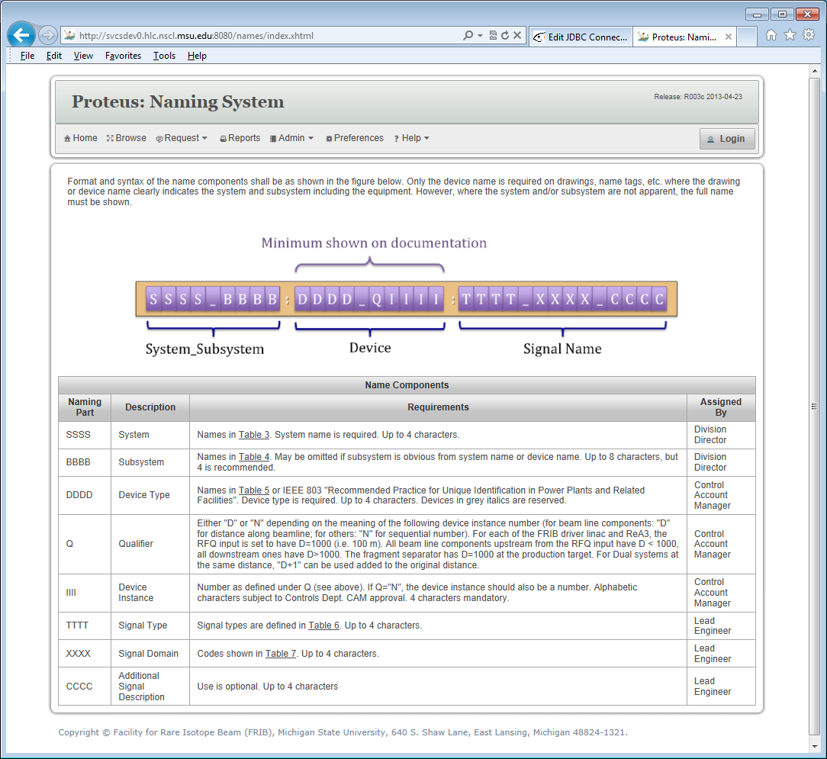

Figure 2 Naming System Home Page

# Compiling Naming System

* Checkout the source files from [2].
* The directory structure of the source is as follows. It contains a top-level directory named ‘conf’, and has the following sub-directories:
  + data: SQL scripts to load Naming Categories and User Privileges. Sample data.
  + docs: Design and installation documentation
  + design: Design artifacts (SQL DDL scripts, Enterprise Architect files etc)
  + src: Source code
* Use an IDE such as Netbeans or Text Editor to edit index.xhtml file. Replace the content with the naming convention appropriate for your lab.
* To generate the Naming System package:
  + Open it in Netbeans and start the build process (Project -> Build)
  + Or run the command ‘mvn package’ in the root directory of the source

You must have access to the Internet to be able to build these projects because the required libraries are downloaded from the repositories automatically. You may have to run the build process a couple of times; sometimes the library files do not get downloaded during the first try. If you access the Internet through a proxy server, you will need to specify that in the maven configuration.

* The WAR file will be generated in the ‘target’ directory.

# Support

Please visit <http://openepics.sourceforge.net> to report problems or seek help.

# Appendix A – Glassfish Installation

1. Download Glassfish (zip) distribution
2. Install it in /soft (/soft/glassfish3/...). You may choose some other directory.
3. Setup the startup scripts (/etc/init.d/glassfish):

update-rc.d glassdish defaults

1. Start Glassfish server. Set admin password:

asadmin change-admin-password

1. Enable secure/remote admin:

asadmin enable-secure-admin

1. Restart Glassfish server:

asadmin restart-domain

1. Add your organization’s CA certificate. This is needed only if the MySQL server is using SSL (which is recommended if the MySQL server is running on another server).

keytool -trustcacerts -import -alias "your\_ca\_Cert" -file your-cacert.pem -keystore /soft/glassfish3/glassfish/domains/domain1/config/cacerts.jks

1. Check the certificate:

keytool -list -v -keystore /soft/glassfish3/glassfish/domains/domain1/config/cacerts.jks

1. Restart Glassfish server

asadmin restart-domain

1. Configure for mod\_jk:

asadmin create-http-listener --listenerport 8009 --listeneraddress 0.0.0.0 --defaultvs server jk-connector

asadmin set configs.config.server-config.network-config.network-listeners.network-listener.jk-connector.jk-enabled=true

1. Patch installation

# Appendix B – Apache and Glassfish

1. Install Apache2 and libapache2-mod-jk (debian). Make sure mod\_jk is enabled (in /etc/apache2/mods-enabled)
2. Install glassfish 3.x
3. Create /etc/apache2/workers.prorperties with following content



1. Add the following to httpd.conf



1. Configure Glassfish

asadmin create-http-listener --listenerport 8009 --listeneraddress 0.0.0.0 --defaultvs server jk-connector

asadmin set configs.config.server-config.network-config.network-listeners.network-listener.jk-connector.jk-enabled=true

1. Create a site as follows (in /etc/apache2/sites/{available,enabled})



1. Restart Apache and Glassfish

# Appendix C – Application Server Configuration

Naming System requires the following resources to be defined in the Application Server:

|  |  |
| --- | --- |
| Name | Description |
| org.openepics.names.data | JDBC Resource |
| org.openepics.names.realm | Security Realm |
|  |  |
|  |  |
|  |  |
|  |  |

1. These logical servers may be running on one or more physical servers. [↑](#footnote-ref-1)