1. Conceptual Model and Technical Design 1

### Hypothesis

* This model will be built using only **Tomato, Potato and Bell Pepper** Images only as in the publicly available dataset.
* This model will process only selected types of diseases in above mentioned plant leaves.

1. Problem Formulation 1

**Research Question**

**“How can Convolutional Neural Networks (CNN) be applied to accurately and efficiently detect crop diseases from leaf images to minimize yield losses and improve agricultural sustainability?”**

2. Data Collection 2

Link to the publicly available data set - <https://www.kaggle.com/datasets/emmarex/plantdisease/data>

**Data Exploration**

Example Images of the dataset

3. Data Preprocessing Exploration 2

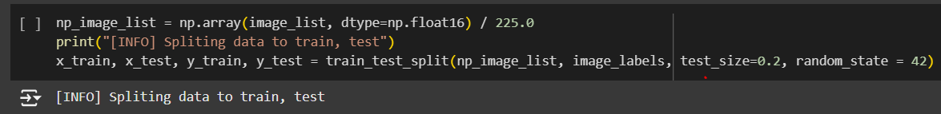

4. Model Building and Validation 2

Model Training

Model Validating

Model Testing

5. Model Deployment and Monitoring 2

Deployment – Using an app

(app interface)

Monitoring Plan

(write like this, give the same tools and ideas using your words)