Retail Sales Analysis Using Microsoft Excel
1. Project Background
This project involved analysing retail sales data using Microsoft Excel. The aim was to understand business performance by examining sales revenue, costs, profits, product performance, regional sales and salesperson performance. The analysis was used to identify patterns and provide recommendations that could help improve business decisions.
2. Project Objectives
The objectives of this project were to:
- Calculate total sales revenue, costs and profit.
- Identify products generating the highest and lowest revenue.
- Compare sales performance across regions.
- Evaluate salesperson performance based on profit.
- Analyse sales across product categories.
- Present findings using charts and an Excel dashboard.
3. Dataset Description
The dataset contained 20 retail sales records. It included information such as:
- Date and order ID
- Product and category
- Quantity
- Unit price and unit cost
- Salesperson
- Region
- Payment method
Additional calculations were used to determine total sales, total cost and profit.
4. Tools and Skills Used
Tool: Microsoft Excel
Skills applied:
- Data organisation and formatting
- Data cleaning
- Excel formulas and functions
- Sorting and filtering
- PivotTables and PivotCharts
- Data visualisation
- Dashboard creation
5. Analysis Process
- Organised the sales records into an Excel table.
- Calculated total sales, total cost and profit.
- Calculated key business performance indicators.
- Used sorting and filtering to examine the data.
- Created PivotTables to analyse product, category, region and salesperson performance.
- Created charts to present the results.
- Developed a dashboard to summarise the business performance.
6. Key Findings
- Sneakers generated the highest total profit.
- Caps generated the lowest total profit.
- Gauteng generated the highest total sales revenue among the regions.
- Amanda generated the highest total profit among the salespeople.
- Clothing generated the highest total sales revenue among the categories.
7. Business Recommendations
- Consider increasing stock for products performing well, while monitoring demand.
- Investigate ways to reduce purchasing costs without unnecessarily changing selling prices.
- Improve the marketing of products with lower profit performance.
- Recognise high-performing salespeople and encourage them to share effective selling strategies.
- Monitor regional sales performance when planning stock distribution.
- Continue analysing sales data to support better business decisions.
8. Dashboard
The Excel dashboard summarises the key performance indicators and sales analysis.
Performance Indicator | Result
Total Revenue | R30,890
Total Cost | R17,180
Total Profit | R13,710
Number of Orders | 20
Average Order Value | R1,544.50
Dashboard screenshots will be inserted in this section.
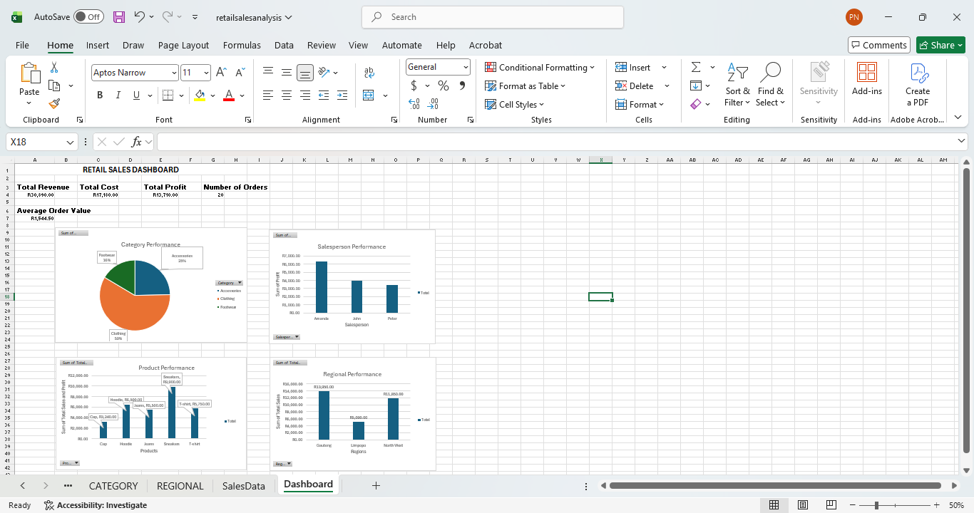
9. Conclusion
This project provided practical experience in using Microsoft Excel to analyse retail sales data. Through formulas, PivotTables, charts and a dashboard, I developed an understanding of how data can be used to evaluate business performance and support decision-making.
The project strengthened my skills in data organisation, analysis and visualisation.

