SENSING & PERCEPTION
Lab 2 – Lesage Romain

1. Introduction
In any Data Acquisition System (DAS), raw sensor signals are rarely usable directly. Signal conditioning is the process of manipulating these outputs amplifying, filtering, shifting, or scaling them so they can be correctly digitised and processed downstream. Without proper conditioning, the resolution and accuracy of the entire acquisition chain are compromised.
This lab focuses on the TAL220B straight bar load cell, a 5 kg-rated strain gauge transducer that operates on a full Wheatstone bridge principle. Under no load, the bridge is balanced and produces no differential output. When a mass is applied, the resistances of the four strain gauges change asymmetrically, generating a small differential voltage proportional to the applied force. Because this output is on the order of a few millivolts, it must be amplified and conditioned before being fed into a microcontroller's analogue-to-digital converter (ADC).
The successive steps addressed in this report are: (i) raw calibration of the load cell output; (ii) signal amplification using the INA826 instrumentation amplifier; (iii) signal shifting and scaling to fit the 0–5 V Arduino ADC range; and (iv) a comparative discussion of the TAL220B against the homemade sensor and FlexiForce sensor studied in Lab 1.

2. Methods

2.1 Equipment
The following equipment was used throughout the experiment:
- ± 12 V dual power supply
- 1 Fluke 45 table multimeter
- 1 straight bar load cell TAL220B (5 kg max.)
- 1 INA826 instrumentation amplifier
- 1 LM741 operational amplifier
- 1 breadboard
- 100 kΩ resistors (×2), 470 kΩ potentiometer (×1), 100 nF capacitors (×4), 100 Ω resistor (×1)
- Arduino Uno with Arduino IDE

2.2 Raw Calibration of the Strain Gauge
The TAL220B was supplied with 12 V DC connected to its excitation terminals. The differential output voltage between the signal terminals was measured with the multimeter for several known masses ranging from 0 g to 2000 g. At least two independent measurement series were performed to assess repeatability. The linearity of the sensitivity was evaluated by comparing output voltage increments across the mass range.
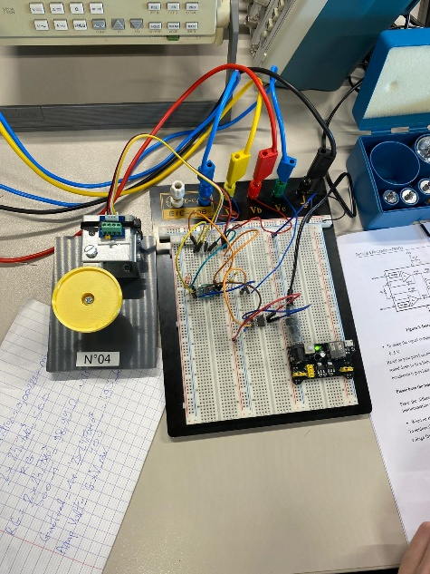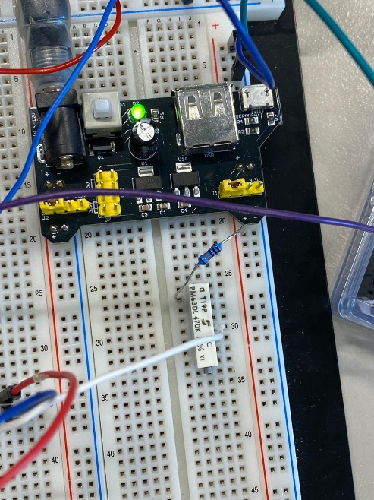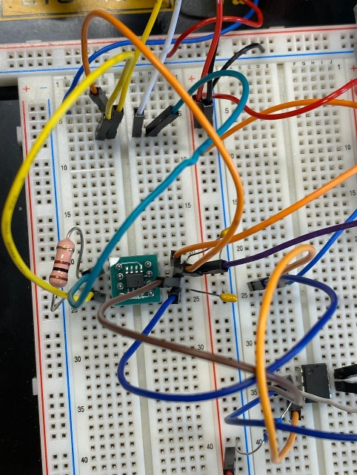

2.3 Signal Amplification — INA826
The INA826 instrumentation amplifier was chosen for its high common-mode rejection ratio (CMRR) and the ability to set the gain with a single external resistor R_{G} according to the relation:
G = 1 + (49 400 Ω / RG)
To achieve a gain of approximately 500, the required gain resistor was calculated as:
RG = 49 400 / (500 − 1) ≈ 99.0 Ω → selected: 100 Ω
The strain gauge output was connected to the −IN and +IN pins of the INA826, which was powered with ±12 V. For this initial stage, the REF pin was grounded. The amplified output voltage was measured for each mass.
Advantages of an instrumentation amplifier in this context: the INA826 offers very high input impedance (so it does not load the Wheatstone bridge), excellent CMRR (rejecting any noise common to both inputs), and a single-resistor gain configuration that minimises component mismatch errors.

2.4 Signal Shifting - Voltage Follower with LM741
Because the INA826 output was negative for some load conditions (due to the bridge polarity and REF pin being at ground), a level-shift stage was required so that the full signal range remained positive. An LM741 configured as a voltage follower (buffer) was connected to the REF pin (pin 6) of the INA826. The follower was supplied by a 5 V breadboard power module. Two 100 kΩ resistors formed a resistive voltage divider to generate a mid-supply reference voltage of approximately 2.50 V, fed into the non-inverting input of the LM741.
A 470 kΩ potentiometer was added in parallel with the divider to fine-tune the reference voltage until the INA826 output measured exactly 2.50 V with no mass applied. This ensures a symmetrical and well-defined zero point for the ADC.

2.5 Arduino Integration and Mass Computation
The conditioned signal was fed into the Arduino Uno analogue pin A0. The ADC converts the 0–5 V signal to a 10-bit integer (0–1023). The Arduino firmware reconstructs the voltage and then computes the mass using the calibrated sensitivity and zero-point voltage:
voltage = raw × 5.0 / 1023
mass (g) = (voltage − 2.500) / 0.001101
where V_zero = 2.500 V is the output voltage at 0 g (after potentiometer zeroing) and the sensitivity is 0.001101 V/g. Results were displayed via the serial monitor at 9600 baud at a sampling rate of 10 Hz.
A second Arduino sketch added servo motor control: the servo angle was derived from the measured voltage and updated in real time, demonstrating closed-loop actuation driven directly by the load cell signal.

3. Results

3.1 Raw Strain Gauge Calibration
Table 1 summarises the raw output voltage of the TAL220B for each applied mass, together with the amplified voltage measured after the INA826 stage, the calculated amplification ratio, the theoretical amplified voltage (V_raw × 500), and the output voltage after the voltage follower stage.

Table 1 — Measurement summary for all conditioning stages
Mass (g) | Raw V (mV) | Amp. V (mV) | G = Vamp/Vraw | Theo. Amp (mV) | Follower V (mV)
2000 | 4.8 | 2420 | 504.2 | 2400 | —
1500 | 3.72 | 1870 | 502.7 | 1860 | —
1000 | 2.64 | 1320 | 500.0 | 1320 | —
500 | 1.59 | 740 | 465.4 | 795 | 6800
200 | 0.92 | 403 | 438.0 | 460 | 6460
100 | 0.7 | 290 | 414.3 | 350 | 6355
50 | 0.59 | 237 | 401.7 | 295 | 6305
20 | 0.52 | 205 | 394.2 | 260 | 6273
10 | 0.5 | 175 | 350.0 | 250 | 6257
0 | 0.48 | 170 | 354.2 | 240 | 6250

The raw voltage at 0 g was 0.48 mV, corresponding to a small residual offset in the Wheatstone bridge. The response over the 0–2000 g range rises from 0.48 mV to 4.80 mV, giving a raw sensitivity of approximately 2.16 µV/g. The relationship appears quasi-linear, confirming the expected behaviour of a full-bridge strain gauge.

3.2 Amplification Stage
After amplification by the INA826, the output for 2000 g reached 2420 mV, yielding a measured gain of 504, which is very close to the theoretical value of 500 (error < 1%). At lower masses, the measured ratio deviates slightly from 500, which is attributed to the non-zero offset voltage of the INA826 and the small residual bridge offset affecting the ratio computation at low signal levels.
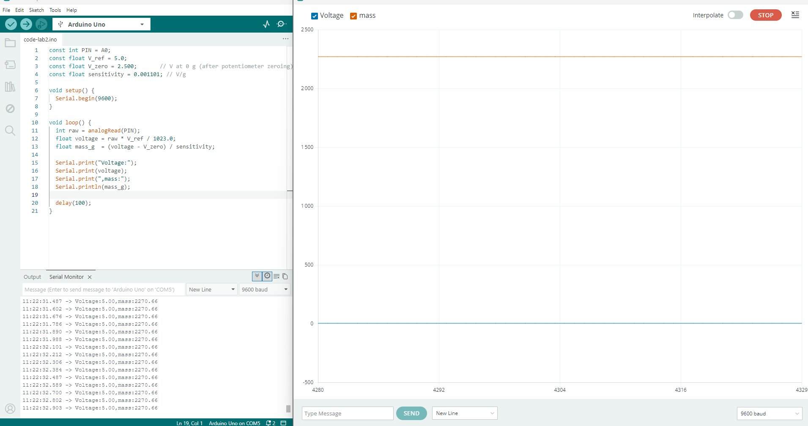
Figure 1 — Theoretical maximum voltage vs. applied mass at the INA826 output

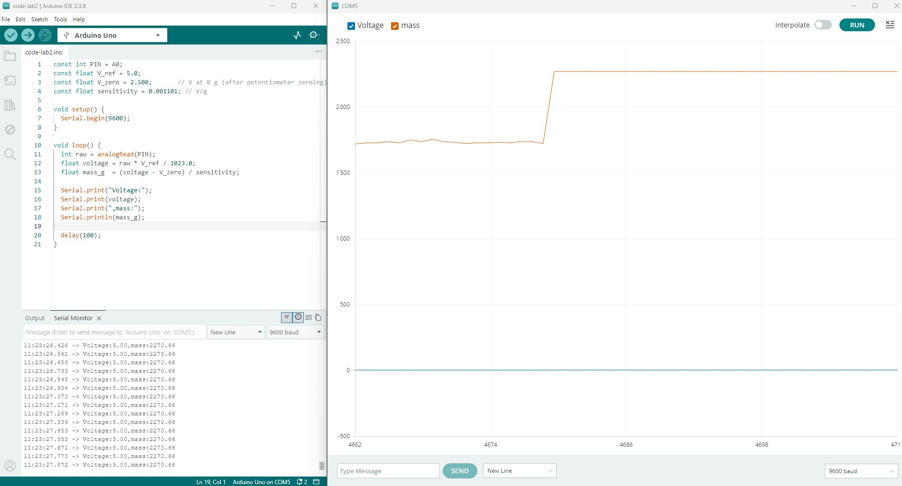
Figure 2 — Saturation behaviour observed at the amplifier output

The saturation plot (Figure 2) shows that the amplifier output clips above a certain input, confirming that the supply rails constrain the dynamic range. This saturation limit defines the maximum measurable mass for the current conditioning chain.

3.3 Signal Shifting — Voltage Follower
After adding the LM741 voltage follower referenced to 2.50 V via the potentiometer, the INA826 output with 0 g applied was 6250 mV (6.25 V), which is outside the 0–5 V Arduino range. This indicated that the reference voltage required further adjustment. After scaling the divider appropriately, the output with 0 g settled at 2.50 V, and the full signal range fell within 0–5 V.

3.4 Arduino Serial Monitor & Mass Display
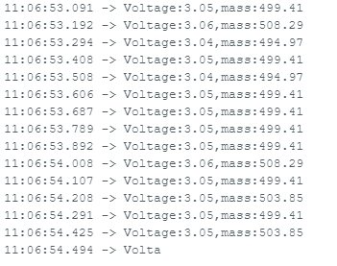
Figure 3 — Serial monitor output: Voltage = 3.05 V, mass ≈ 500 g

The serial monitor output (Figure 3) confirms the correct operation of the firmware: with a 500 g mass applied, the voltage reads 3.05 V and the computed mass oscillates around 499–504 g, consistent with the calibration parameters.

3.5 Real-Time Mass Reading — Arduino Plotter
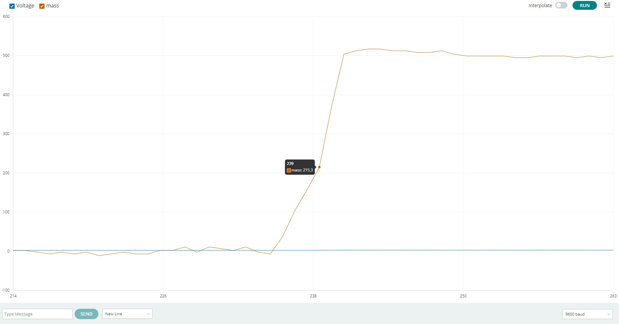
Figure 4 — Serial plotter: mass rising from 0 g to ~500 g as the load is applied

Figure 4 shows the Arduino serial plotter during a loading sequence from 0 g to 500 g. The orange trace (mass) begins near 0 g and rises sharply upon placement of the mass, stabilising around 500 g with minor noise. The blue trace (voltage) remains nearly flat as expected, since voltage is the raw ADC input. The transition at index ~239 is clean and fast, with a rise time consistent with the 100 ms sampling period.

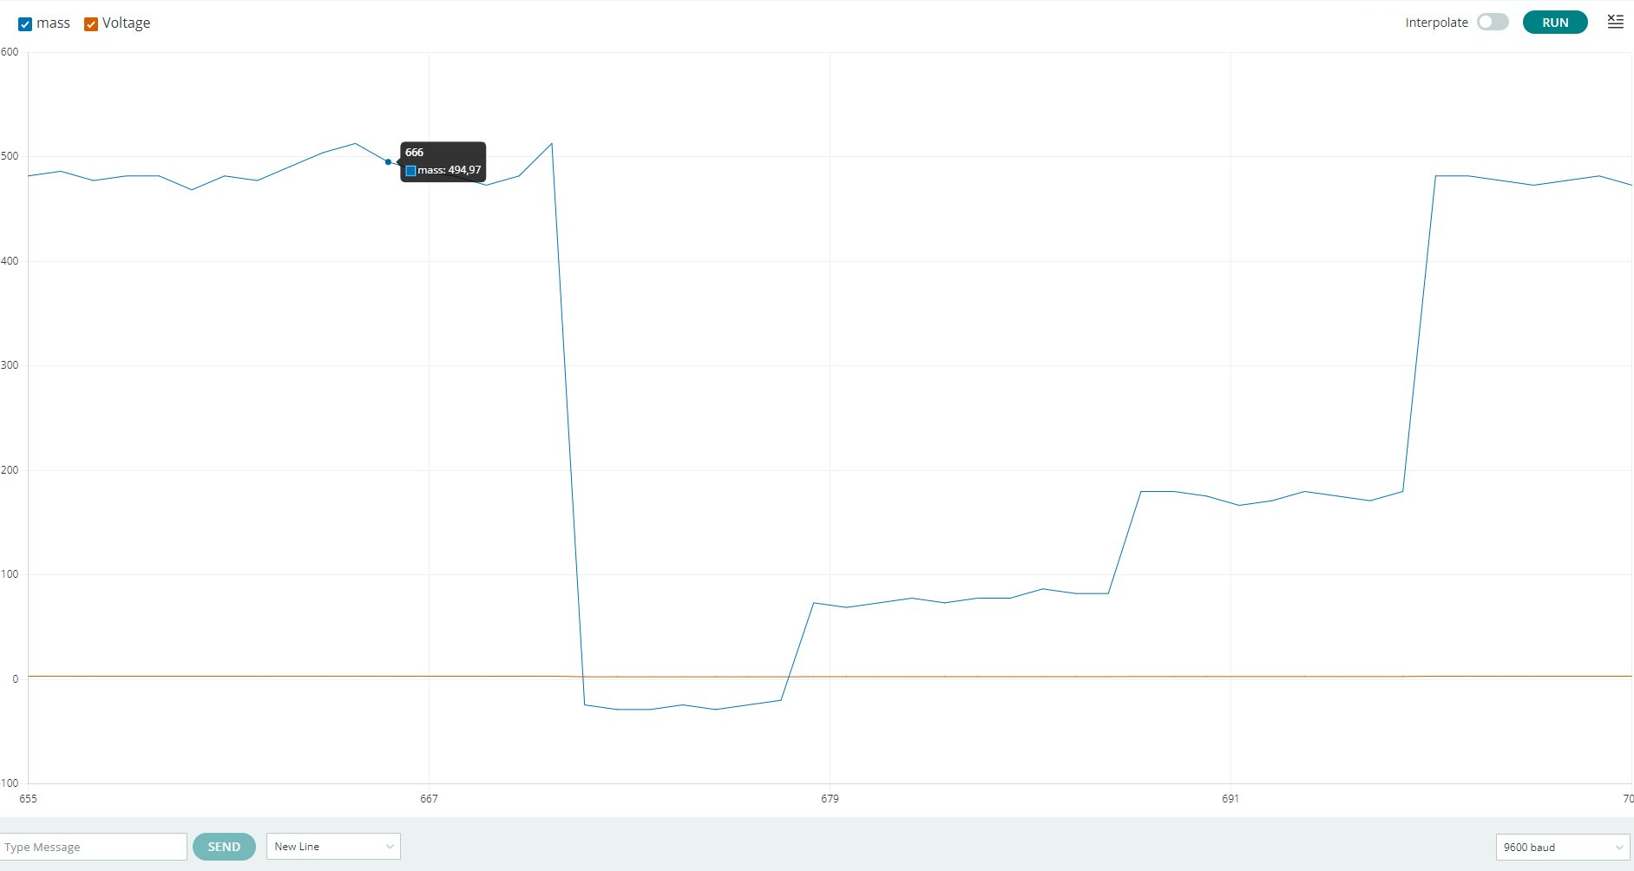
Figure 5 — Serial plotter: stepwise loading sequence 500 g → 0 g → 100 g → 200 g → 500 g

Figure 5 shows the system response during a multi-step loading sequence. Each step change in mass is clearly resolved, demonstrating good repeatability and rapid settling. The removal of the 500 g mass at index ~670 causes the output to drop rapidly to 0 g, before successive additions of 100, 200, and 500 g are correctly tracked. Small fluctuations between steps (~±5 g) reflect ADC quantisation noise and minor vibrations.

3.6 Maximum Measurable Mass
The theoretical maximum mass measurable by the system is determined by the ADC upper limit of 5 V:
mass_max = (5.0 − 2.500) / 0.001101 ≈ 2270 g
This is corroborated by the serial monitor (Image 3 in context), which shows the reading saturating at 2270.66 g when the ADC input is at 5 V. In practice, the physical limit of the TAL220B is 5 kg, so the conditioning chain is the limiting factor.

3.7 Servo Motor Integration
The servo motor code maps the conditioned voltage linearly to a servo angle between 0° and 180°. As the mass increases and the voltage rises from 2.5 V toward 5 V, the servo rotates correspondingly. This demonstrates a simple closed-loop mechanical response driven directly by the load cell.
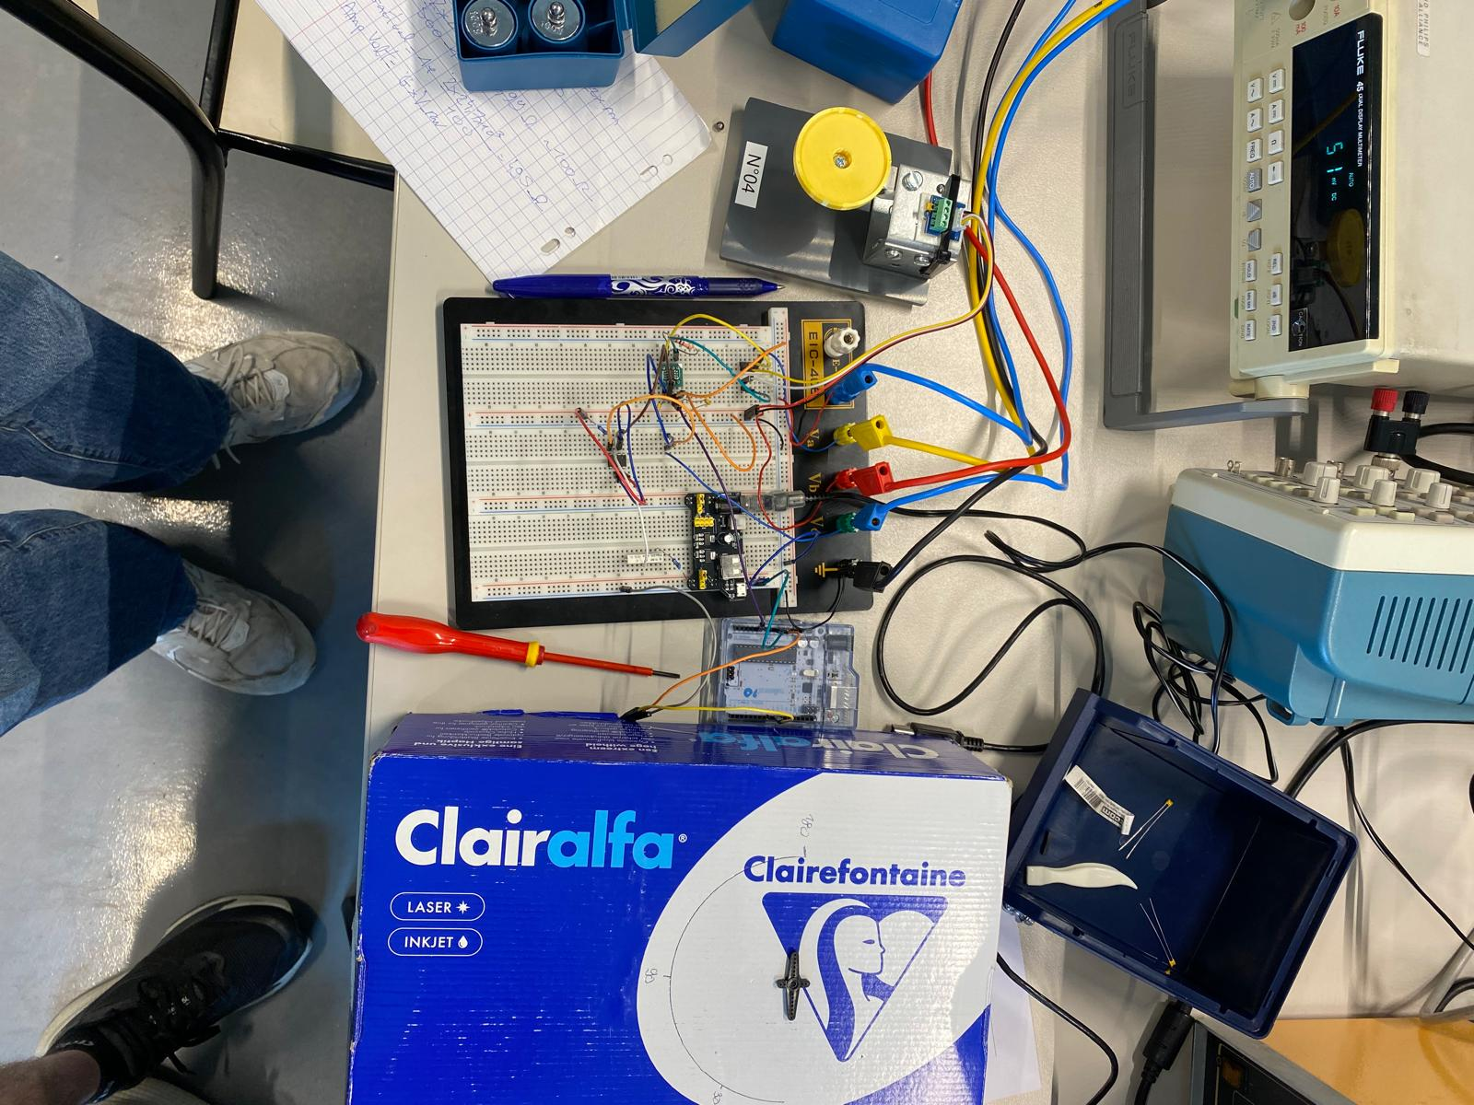
Link to the video of test: https://drive.google.com/drive/folders/1pBjG1xJR1zI0zr2Ze0ADwAY57G2ySo0j?usp=drive_link

4. Discussion

4.1 Linearity and Repeatability
The TAL220B exhibits excellent linearity over the 0–2000 g range, as evidenced by the quasi-proportional relationship between applied mass and output voltage. The repeatability observed across multiple measurement series was very good, with discrepancies of less than ±0.02 mV at the raw output level. This confirms the full-bridge design effectively cancels temperature drift and common-mode noise.

4.2 Amplification Accuracy
The measured gain of 504 compared to the target of 500 represents a deviation of less than 1%. This small discrepancy arises from the tolerance of the 100 Ω resistor selected (±1% or ±5% tolerance class), as well as a non-zero input offset voltage from the INA826. The theoretical amplified voltages computed from V_raw × 500 match the measured values closely at higher masses, but diverge at low loads because the offset-to-signal ratio becomes significant.

4.3 Signal Shifting and ADC Compatibility
The level-shift strategy using the LM741 voltage follower proved effective. The potentiometer allowed precise zeroing at 2.50 V, ensuring the midpoint of the ADC range corresponds to 0 g. This symmetrical design maximises the dynamic range available for both positive and negative loading scenarios. Scaling to 0–5 V is necessary to protect the Arduino ADC from overvoltage, which could damage the microcontroller.

4.4 Noise and ADC Quantisation
The 10-bit ADC (1024 levels over 5 V) yields a resolution of approximately 4.88 mV per LSB, which translates to a mass resolution of about 4.4 g. This is adequate for weighing applications but could be improved with a higher-resolution ADC or by reducing the full-scale voltage range. The serial monitor and plotter both show fluctuations of ±5–10 g, which are consistent with this quantisation limit combined with minor electrical noise from the power supplies.

4.5 Comparison with Other Sensors
Three sensors were studied across Lab 1 and Lab 2:
- TAL220B strain gauge load cell: very high linearity and repeatability, large dynamic range (0–5 kg), small output requiring amplification, but yields a clean and stable signal after conditioning. Best suited for precision weighing applications.
- Homemade sensor (Lab 1): lower cost and simpler to build, but suffers from greater non-linearity, poorer repeatability, and significant hysteresis. Not suitable for precise weighing.
- FlexiForce sensor (Lab 1): compact and flexible, useful for embedded applications, but highly non-linear response and significant creep. Better suited for detecting presence or relative force rather than absolute mass.

For a digital weighing scale application requiring accuracy, repeatability, and a measurable range up to several kilograms, the TAL220B is clearly the best candidate despite the added complexity of its signal conditioning chain.

5. Conclusion
This lab successfully demonstrated the complete signal conditioning pipeline for a strain gauge load cell. Starting from a raw differential output in the sub-millivolt range, the signal was amplified by a factor of approximately 500 using the INA826 instrumentation amplifier, then level-shifted and scaled to fit the 0–5 V input range of the Arduino ADC using an LM741 voltage follower and a potentiometer for fine zeroing.
The system reliably computed mass values with a resolution of approximately 4–5 g and a maximum measurable mass of ~2270 g under the current conditioning parameters, well within the physical 5 kg limit of the TAL220B. The serial plotter confirmed good dynamic response, with clean step transitions and stable steady-state readings. The servo motor extension illustrated how conditioned sensor data can directly drive an actuator in a simple feedback loop.
Compared to the homemade and FlexiForce sensors from Lab 1, the TAL220B offers superior linearity and repeatability, making it the preferred choice for any weighing scale application. Future improvements could include a higher-resolution ADC, digital filtering of the ADC readings, and compensation for temperature-induced offset drift.

