**Step 1: Scanner (Tokenizer) -- Due 9/21/15**

You will develop a scanner (also known as a tokenizer) for the given grammar in this step. A scanner will take a sequence of characters (i.e. the source files of the LITTLE language) as input and produce a sequence of tokens which will be the input to the next step (Parser) as shown in the figure.

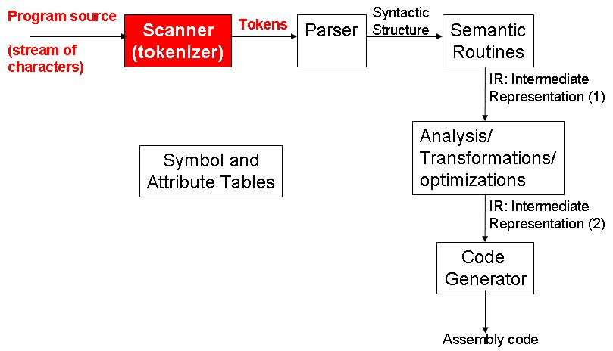

## **Scanner Generation Tools**

The scanner's source code is normally generated by a scanner generation tool. You can use one of the tools available to generate your scanner in this step. These tools normally work by taking the *token definitions* expressed by *regular expressions* and generates the source code for the scanner automatically (for this project, the tokens are specified in the language's grammar).

The programmer has to add the code to handle the scanner's output. For example, at this step you will print all the tokens in the standard output. In the step 2 of this project you will modify your scanner to feed the parser replacing the print routines by calls to the parser and passing the tokens as parameters. In order to learn how to merge the code of the scanner generator with the rest of your source code, please, read the user's manual of the tool you decide to use.

Some popular tools are:

* [Antlr](http://www.antlr.org/): The most popular option if you're developing the compiler in Java.
* Lex (or Flex) : Generates the scanner's source in C language.

## **The compiler's tokenizer (scanner)**

At the end of this step, the program developed (the very first part of our compiler) should be able to open a program's source file written in the LITTLE language and recognize its tokens. At this step, the output of your program should be the prints of each token's type and value (see below). In the next step the same output will be used to feed the parser.

Your scanner program should be able to open and read a LITTLE source file and print the all the valid tokens within the source file and their respective type in the standard output. You might want to redirect the output to a file and compare your results with the output files provided for the testcases.

### **Testcases**

Test inputs can be found [here](https://drive.google.com/open?id=0B2Ja5B1pmMV3fkhMaVhpRmdFWDNSSERjaWJBUE9nb2lMbm5DN2ZHUmNrNGc0OW1CQUkyMHM), and the expected outputs are [here](https://drive.google.com/open?id=0B2Ja5B1pmMV3fmMtVDQxbUQtLWlMbnlvVzhJQ21TT0U4OVJ6UXVmSE9oMVpYTE9JUDNnclU). See [grammar](https://drive.google.com/open?id=0B2Ja5B1pmMV3bWhvaDgzb2xMaEk) file for token definitions (Keywords, Operator, Literals).

### **Output Format**

The program is expected to print each token in a predefined format. Here is an example

Token Type: INTLITERAL  
Value: 20

Please read the output samples for more details.

Note: This step will be graded automatically and the outputs generated by your code will be directly compared with the expected outputs using "diff -b -B" command. Please make sure the your outputs are identical to the sample outputs provided.

## **Readings**

Several books introduce the theory necessary for a good understanding of lexical analysis and how a compiler tokenizer works, as well a good description of how a simple compiler is structured. You may find it helpful to check some of the following references:

1. Aho, A. V., Sethi, R., & Ullman, J. D. (1986). *Compilers, Principles, Techniques*. Addison wesley.
2. Andrew, W. A., & Jens, P. (2002). *Modern compiler implementation in Java*.
3. Fischer, C. N., Cytron, R. K., & LeBlanc, R. J. (2009). *Crafting a compiler*. Addison-Wesley Publishing Company.

## **Q&A**

* Q: What should I do if I encounter an illegal token?
* A: Stop the lexer at that point. You are not required to do error handling.