安装MySQL 5.7
安装命令：
apt-get -y install mysql-server mysql-client
安装过程中要求设置 root 账户密码，如图：
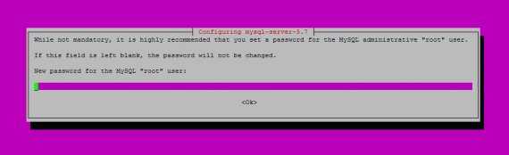
MySQL 安装更改设置命令：
mysql_secure_installation
如下进行设置：
root@server1:~# mysql_secure_installation
Securing the MySQL server deployment.
Enter password for user root: <– Enter the MySQL root password
VALIDATE PASSWORD PLUGIN can be used to test passwords
and improve security. It checks the strength of password
and allows the users to set only those passwords which are
secure enough. Would you like to setup VALIDATE PASSWORD plugin?
Press y|Y for Yes, any other key for No: <– Press y if you want this function or press Enter otherwise.
Using existing password for root.
Change the password for root ? ((Press y|Y for Yes, any other key for No) : <– Press enter
… skipping.
By default, a MySQL installation has an anonymous user,
allowing anyone to log into MySQL without having to have
a user account created for them. This is intended only for
testing, and to make the installation go a bit smoother.
You should remove them before moving into a production
environment.
Remove anonymous users? (Press y|Y for Yes, any other key for No) : <– y
Success.
Normally, root should only be allowed to connect from
‘localhost’. This ensures that someone cannot guess at
the root password from the network.
Disallow root login remotely? (Press y|Y for Yes, any other key for No) : <– y
Success.
By default, MySQL comes with a database named ‘test’ that
anyone can access. This is also intended only for testing,
and should be removed before moving into a production
environment.
Remove test database and access to it? (Press y|Y for Yes, any other key for No) : <– y
– Dropping test database…
Success.
– Removing privileges on test database…
Success.
Reloading the privilege tables will ensure that all changes
made so far will take effect immediately.
Reload privilege tables now? (Press y|Y for Yes, any other key for No) : <– y
Success.
All done!

