Amy Lese

2/18/2021

CS296N Term Project Proposal

**Description**

My term project will consist of an Oregon bird sighting website. There will be a searchable set of Oregon birds, each with its common characteristics described, along with a picture and hopefully a sound recording of its call. I am hoping to make the birds searchable at least by name, primary color, and size. Registered BirdWatchers will be able to add their own sightings of the bird via its page. A sighting will include a description and location (possible API service: map showing location), as well as an optional picture upload. Then other registered users will be able to comment on a sighting. Comments will only have text. There will also be an Administration section for adding and removing BirdWatchers, as well as adding and removing the roles of BirdWatchers.

**UML Diagram**

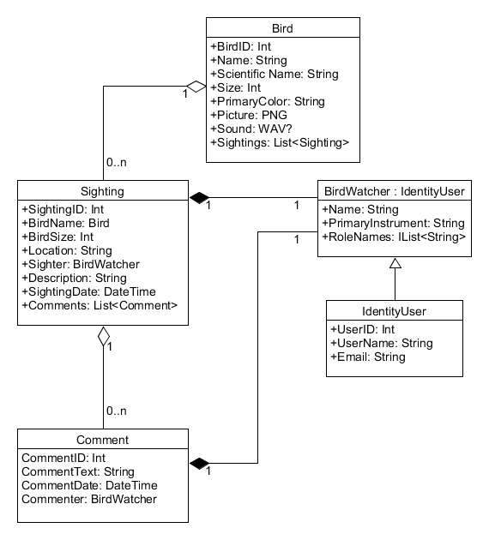

**Site Map**

* Home Page
* Birds
  + Bird Species
  + Post a Sighting
  + Sightings
    - Edit Sighting
    - Delete Sighting
  + Comment
    - Add Comment
    - Edit Comment
    - Delete Comment
* Account
  + Login
  + Register
* Admin
  + User List

**UI Sketches**

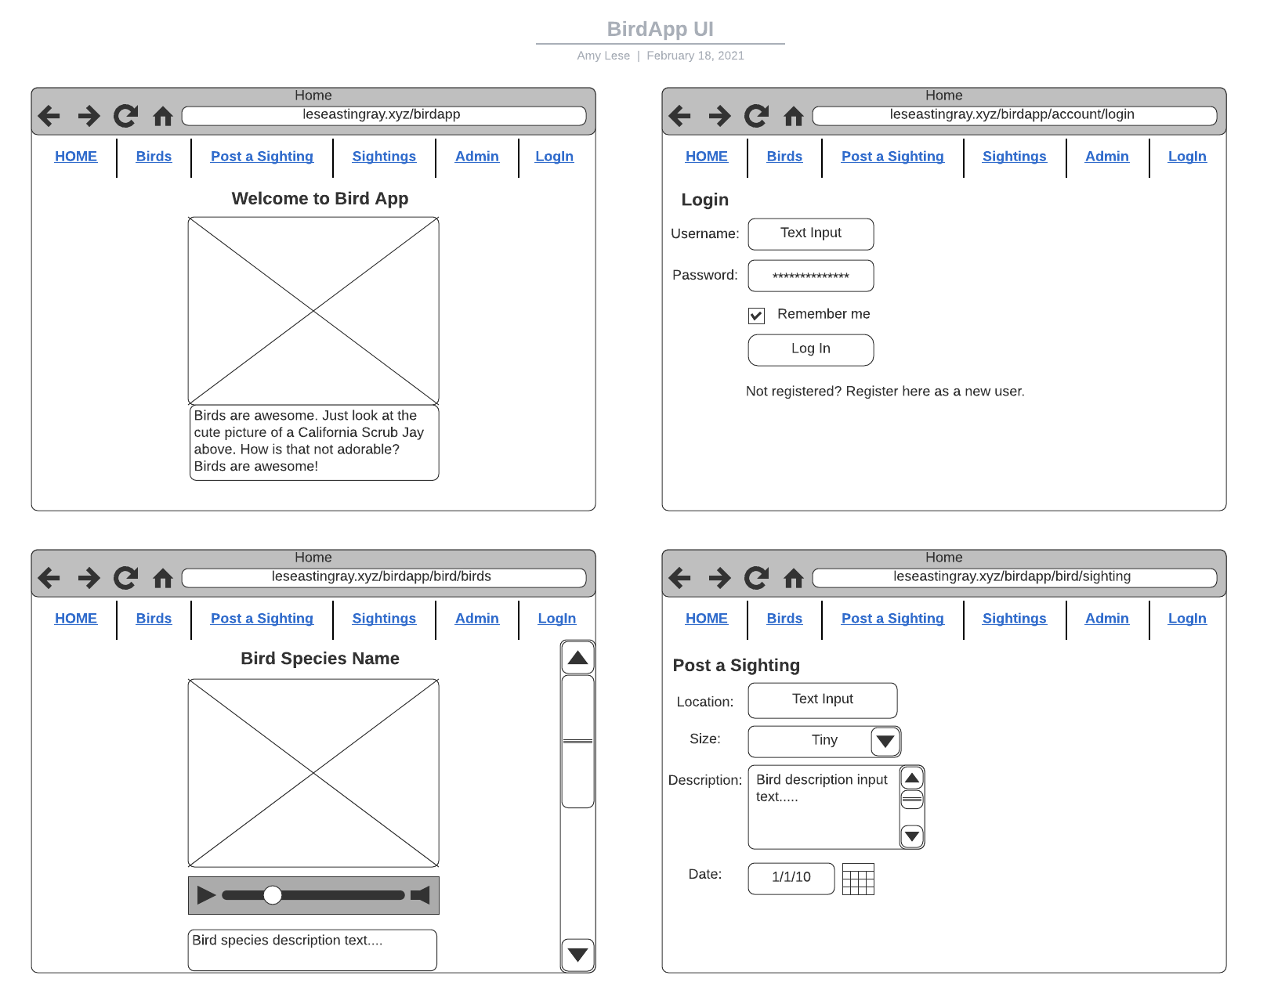

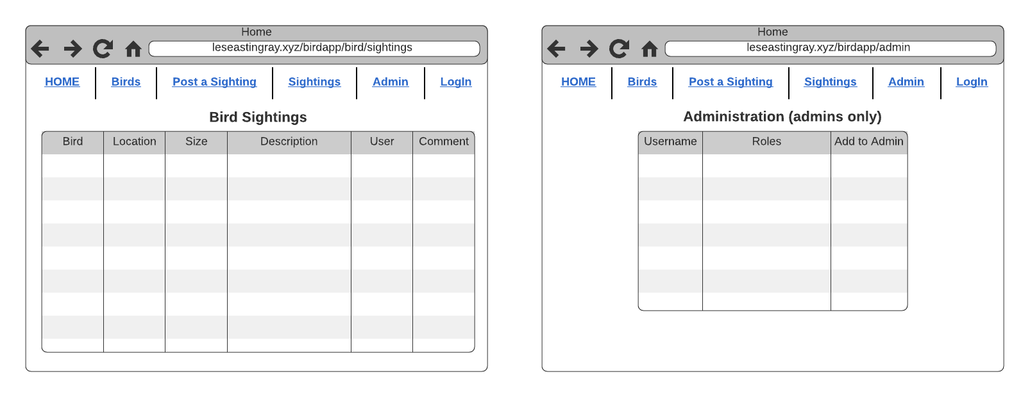

LucidChart link: <https://lucid.app/lucidchart/invitations/accept/2abcd716-36d9-4fd1-a4d3-8ab3d452bdc6>