Appendix A

Sufficient Cause Model of the Causal Relationship between Alternative Tobacco Product Use and Intention to Smoke Cigarettes.

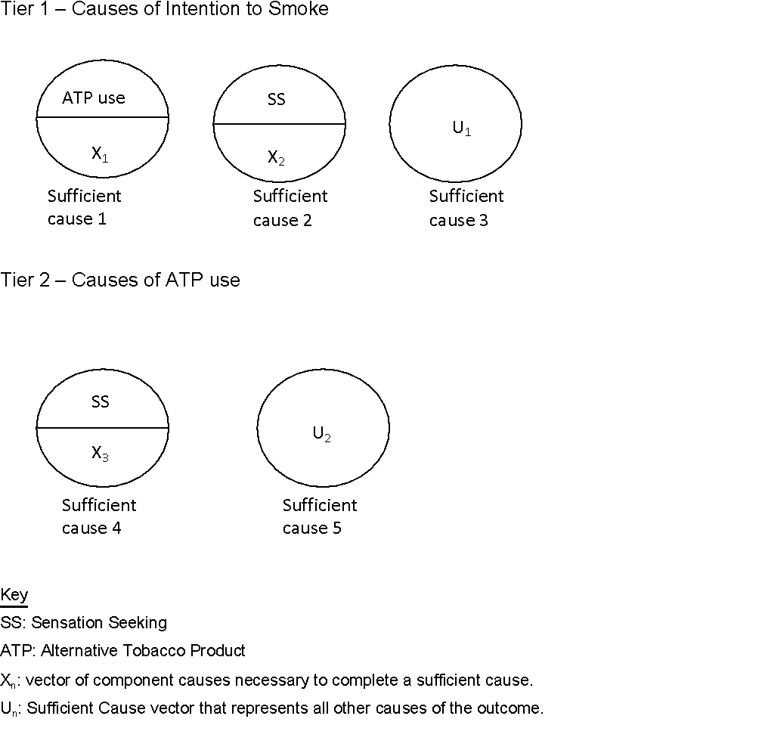

The figure above represents, through the sufficient cause model, the causes of ATP use (Tier 2), and the causes of Intention to Smoke Cigarettes (Tier 1) in cigarette-naïve adolescents. In Tier 1, we see that individuals get the outcome, intention to smoke cigarettes, by completing either the sufficient cause where ATP use is a component, the sufficient cause where sensation seeking is a component, or other sufficient causes U1. For the sake of simplicity, we will talk about sensation seeking instead of biological sex. In our analysis, we used sex as an imperfect proxy of sensation seeking; a higher proportion of male adolescents show sensation seeking and impulsivity behaviors, which leads to drug experimentation. In Tier 2, we see that individuals get the outcome, ATP use, by completing the sufficient cause where sensation seeking is a component, or the other sufficient sufficient case U2.

Several things need to be considered from this figure. First, ATP use is a cause of intention to smoke. Second, sensation seeking is a cause of both intention to smoke and ATP use, which would create noncomparability, and confound partially, the relationship between ATP use and intention to smoke. Third, we are allowing for other causes (U1) to contribute to the risk of intention to smoke cigarettes. Fourth, this model explains the causal relationship between ATP use and intention to smoke at one point in time (Tn). This last point is relevant when interpreting the change in the prevalence over time, because at each Tn+1 we are sampling a U.S. representative population of cigarette-naïve adolescents. In other words, we are not following a cohort of individuals to assess their incidence of ATP use or intention to smoke.

The implications in the Tier 1 of Sufficient Causes are the following. An increase in ATP use at each Tn+1 means that more Sufficient Causes 1 are being completed at each Tn. Even if at each Tn+1 the association between ATP use and intention to smoke is partially confounded by sensation seeking (SS), and the prevalence of sensation seeking and therefore Sufficient Causes 2 is stable at each Tn+1, it is reasonable to expect an increase in the prevalence of intention to smoke over time due to the increase in ATP use.

In Tier 2, an increase in ATP use means that either Sufficient Cause 4 or Sufficient Cause 5 are increasingly being completed at each Tn+1. For example, we can imagine that ATP becomes more commonly used, and socially accepted, at each Tn+1. In other words, early adopters, those who completed Sufficient Cause 4 with high sensation seeking, form the majority of ATP users at Tn. As time goes by, ATP use is disseminated by early adopters to late adopters (those who do not have sensation seeking as a component cause), and ATP becomes more common (increases) due to increasing completion of Sufficient Cause 5 at each Tn+1. Another way of seeing this is that at each Tn+1 the proportion of low sensation seekers increases in the group of adolescents who use ATP due to an increased completion of Sufficient Cause 5. Nonetheless, increasing the prevalence of Sufficient Cause 5 at each Tn+1, and in consequence increasing ATP use at each Tn+1, will lead to an expected increase in the prevalence of intention to smoke cigarettes over time.

If the sufficient causes depicted in the Sufficient Cause Model above are true, then ATP being a cause of intention to smoke cigarettes, and ATP use increasing over time, would result in an increasing trend in future intention to smoke regardless of the presence of confounding, and not otherwise.

Appendix B

Causal diagram showing the relationship between alternative tobacco products, sensation seeking, and intention to smoke over time.

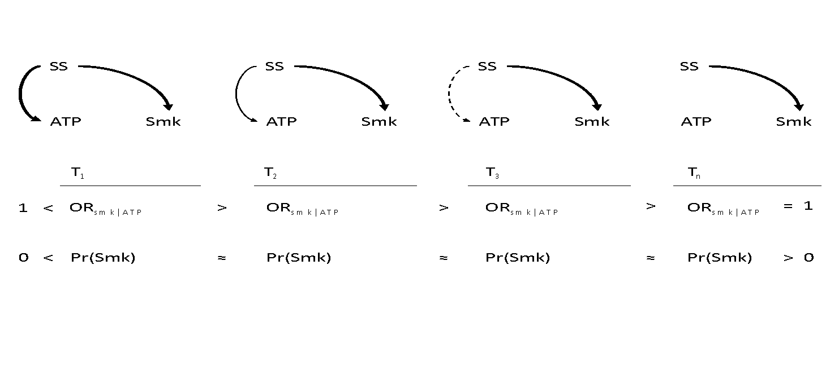

Key

ATP: Alternative tobacco products

Smk: Intention to Smoke Cigarettes

SS: Sensation Seeking

Pr(Smk): Prevalence of Smoking

T1…Tn: Different surveys at year n.

The figure above shows the causal relationship between SS, ATP, and Smk at each time point (Tn) in cigarette-naïve adolescents; the causal contrast (ORsmk|ATP) at each Tn; and the prevalence at each Tn. To read this graph, we use the assumptions behind DAGs (directed acyclic graphs). Each arrow represents a direct causal relationship between two nodes, there are no feedback loops, and the arrow heads represent the direction of the causal relationship.

In the DAGs at each Tn, we assume that there is no causal association (no arrow) between ATP and Smk. Thus, the association seen in the ORsmk|ATP is not causal and represents the total confounded association between ATP and Smk by SS. We also assume that the causal associations SS–>Smk and SS–>ATP are positive, meaning that SS increases Smk and SS increases ATP.

The change in the quality of the arrow, from solid to dashed, represents the diminishing association between SS and ATP. As ATP becomes disseminated from high-risk taking early adopters to less risk taking individuals, the association between ATP and SS disappears (the arrow disappears). In other words, the group of ATP users has an increased proportion of individuals with low risk behaviors at each Tn+1. This in turn reduces the association between ATP and SS until there is none—the arrow disappears. This results in the decrease over time in the ORsmk|ATP until the association is null (ORsmk|ATP=1) due to total confounding by SS and disappearance of the association between ATP and SS.

On the other hand, the prevalence of Smk is determined by the totality of its causes. In the figure above the only cause of Smk is SS. If the prevalence of SS remains stable at each Tn+1, we would expect no change in the prevalence of Smk even if ATP use increases.