Pei ~ Ne*Ni*Zi*Zi*(Te-Ti)/(M*Te*sqrt(Te))

clear all;

Zef = 4;
Zi = 1;
Zimp = 6;
Mimp = 12;
Mi = 1;

for i=1:40
Zef = 1 + i*.1;
ci = (Zimp-Zef)/(Zi*(Zimp-Zi));
cimp = (Zi-Zef)/(Zimp*(Zi-Zimp)); % impurity density normalized to electron density

Zeff(i) = Zef;
Pei(i) = Zi^2*ci/Mi;
Peimp(i) = Zimp^2*cimp/Mimp;
end

plot(Zeff,Pei,Zeff,Peimp);
pause;

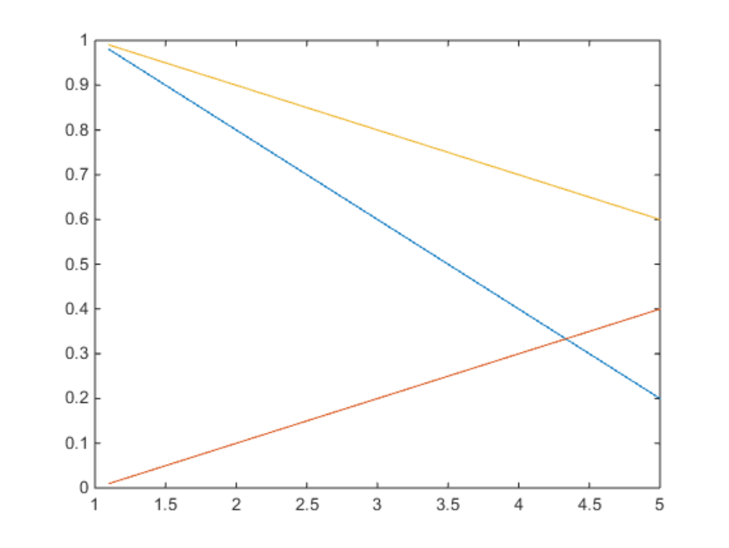
Pei
Peimp
Pei+Peimp

