**BUG Report - Contractzy**

**Bug ID:** 0001 **Summary: Validation messages until closed/ not able to submit the form  
 Module: Contract Creation  
 Environment: Staging**

**Steps to Reproduce:**

1. **Enter data in the highlighted fields**
2. **click outside the field**

**Expected Result:  
 As the field is non-mandatory, the validation must not appear after clicking outside the box**

**Actual Result:  
 Validation messages until closed/ not able to submit the form**

**Severity: Medium  
 Priority: Medium  
 Attachments:**

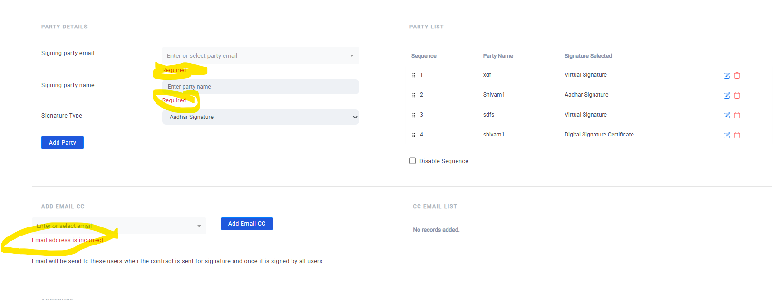

**Bug ID:** 0002

**Summary:** Asterisk must be in Red font  
**Module:** Guide Book (AI)  
**Environment:** Staging

**Steps to Reproduce:**

//

**Expected Result:**Asterisk must be highlighted red

**Actual Result:**Asterisk is not highlighted

**Severity:** Medium  
 **Priority:** Low  
 **Attachments:**

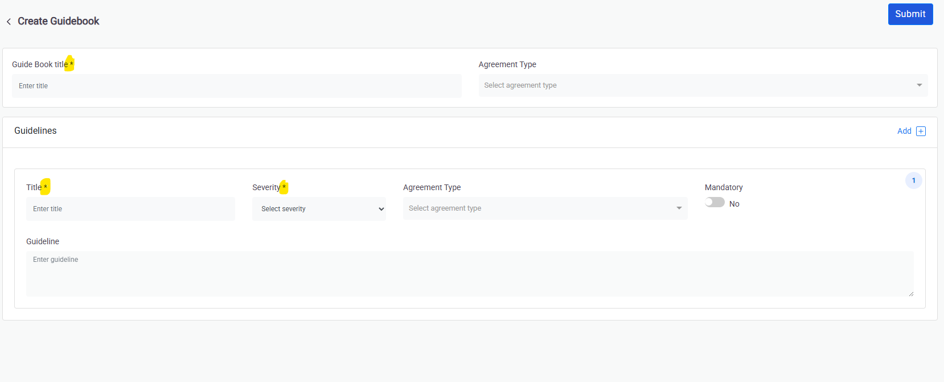

**Bug ID:** 0003

**Summary:** Newly created Contract appears blank  
**Module:** Risk Analysis  
**Environment:** Staging

**Steps to Reproduce:**

1.Create a new contract

**Expected Result:**The contract must be created

**Actual Result:**The contract must have all the added data

**Severity:** Critical  
 **Priority:** Urgent  
 **Attachments:** [**https://drive.google.com/file/d/11tTKJHIOfEpW9FT9CEefJZfbNdxpDjri/view?usp=drive_link**](https://drive.google.com/file/d/11tTKJHIOfEpW9FT9CEefJZfbNdxpDjri/view?usp=drive_link)

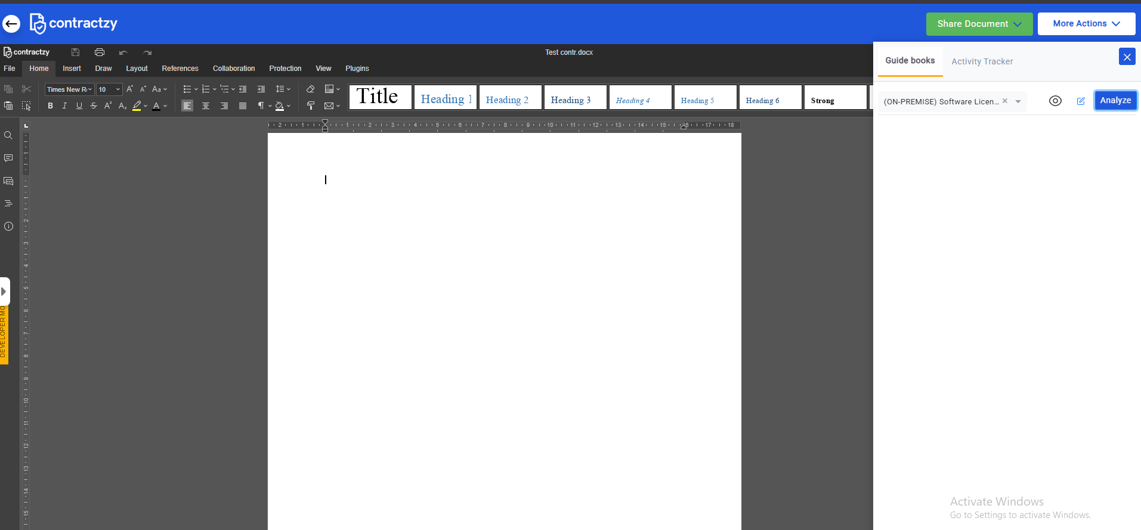

**Bug ID:** 0004

**Summary:** No confirmation pop-up on deleting Guidebook entry  
**Module:** AI  
**Environment:** Staging

**Steps to Reproduce:**

1.Delete an entry from the Guidebook Table list

2.Check for confirmation pop-up

**Expected Result:**A confirmation pop-up must be displayed

**Actual Result:**No confirmation pop-up, the entry gets deleted directly

**Severity:** High  
 **Priority:** High  
 **Attachments:**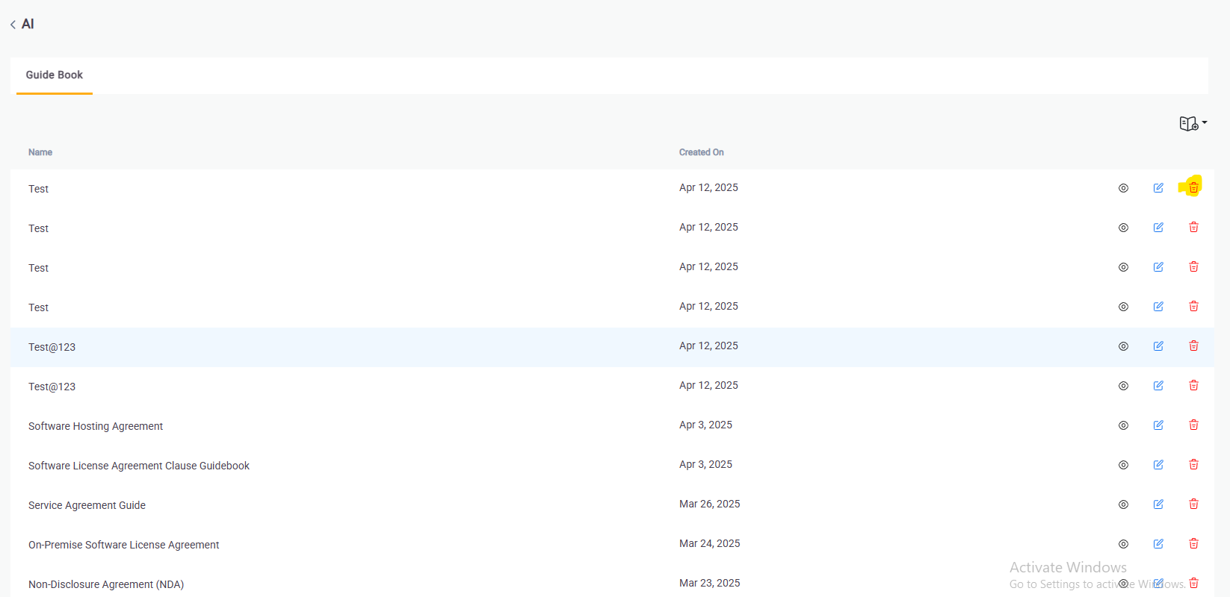

**Bug ID:** 0005

**Summary:** QA Test template issue  
**Module:** Contract Repository  
**Environment:** Staging

**Steps to Reproduce:**

1.Navigate to contract repo

2.From Draft add QA Test Template

3.Proceed

**Expected Result:**QA Test Template must be added and valid

**Actual Result:**Throws a JS validation message

**Severity:** High  
 **Priority:** High  
 **Attachments:**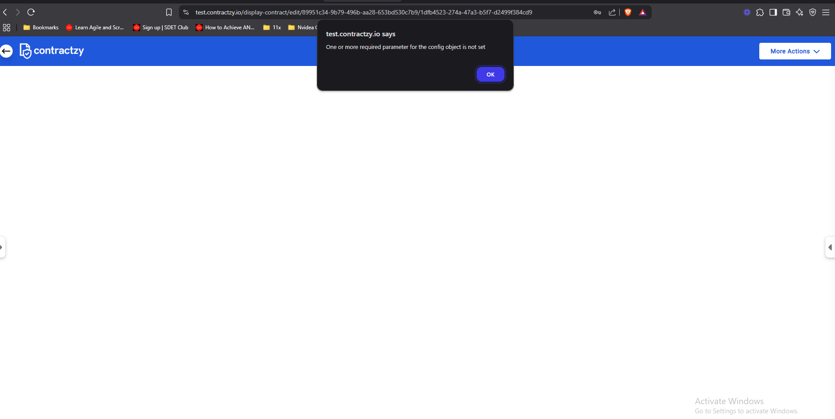

**Bug ID:** 0006

**Summary:** Duplicate entries  
**Module:** Guidebook(AI)  
**Environment:** Staging

**Steps to Reproduce:**

1.Add an entry in the Guidebook

2.Without navigating back click on add button multiple times

**Expected Result:**Guidebook creation page must refresh after submitting a new Guidebook

**Actual Result:**Page is not refreshed after submitting a form and user is able to create multiple duplicate entries

With multiple clicks

**Severity:** Medium  
 **Priority:** Medium  
 **Attachments:**

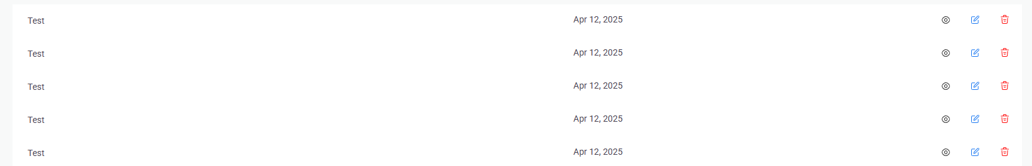

**Bug ID:** 0007

**Summary:** Asterisk must be in Red font  
**Module:** Contract Creation  
**Environment:** Staging

**Steps to Reproduce:**

//

**Expected Result:**Asterisk must be highlighted red

**Actual Result:**Asterisk is not highlighted

**Severity:** Medium  
 **Priority:** Low

**Attachments:**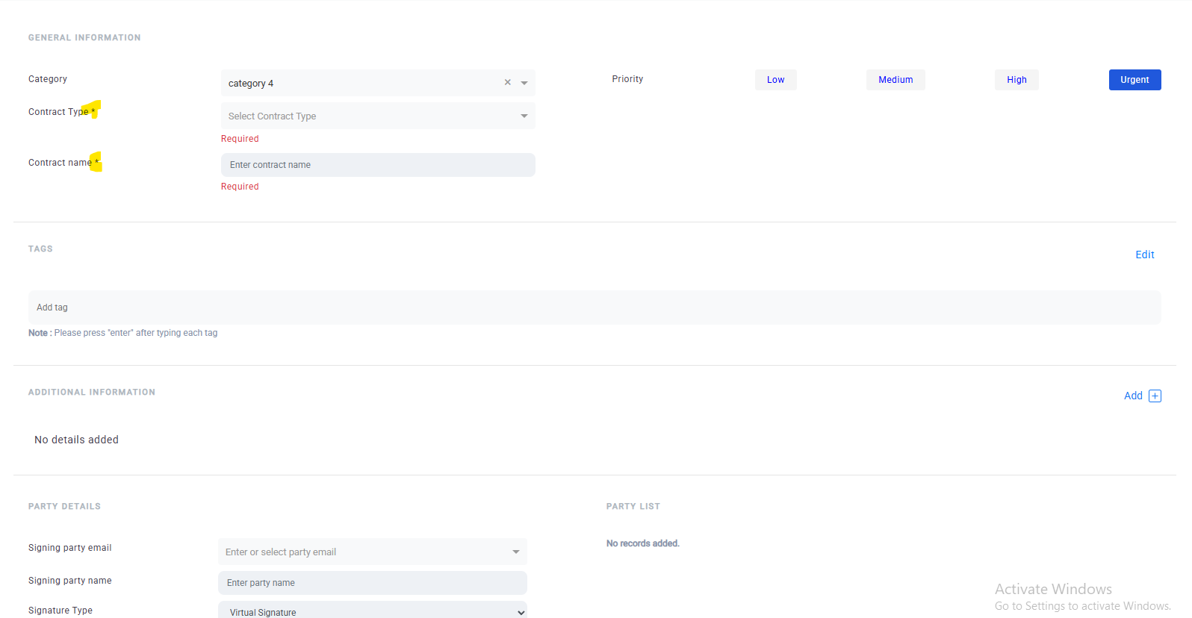

**Bug ID:** 0008

**Summary:** Multiple Success messages  
**Module:** AI  
**Environment:** Staging

**Steps to Reproduce:**

1. Navigate to Contract Creation>Part List

2.Check and uncheck “Disable Sequence” checkbox

**Expected Result:**There should not be multiple success/ validation messages

**Actual Result:**Multiple success messages

**Severity:** low  
 **Priority:** low  
 **Attachments:**

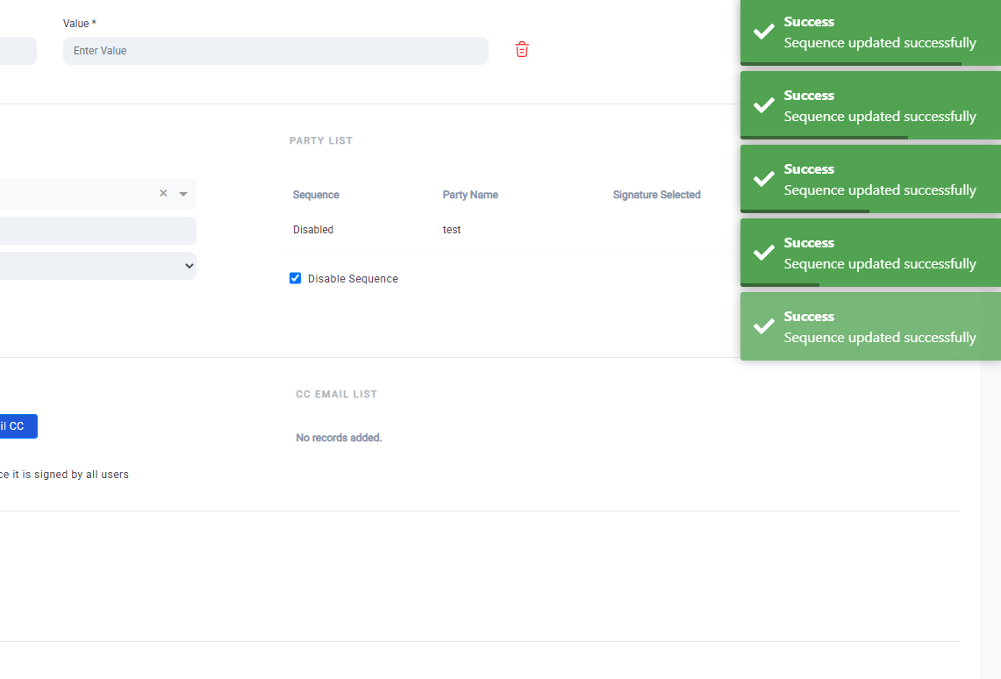

**Bug ID:** 0009

**Summary:** UI and alignment issue  
**Module:** Guide Book(AI)  
**Environment:** Staging

**Steps to Reproduce:**

1.Navigate to Guidebook section

2.Create multiple entries

**Expected Result:**The space must be handled with proper amount of entries in on a single page

**Actual Result:**No page entry list management

**Severity:** high  
 **Priority:** high  
 **Attachments:**

**BugID-0009**

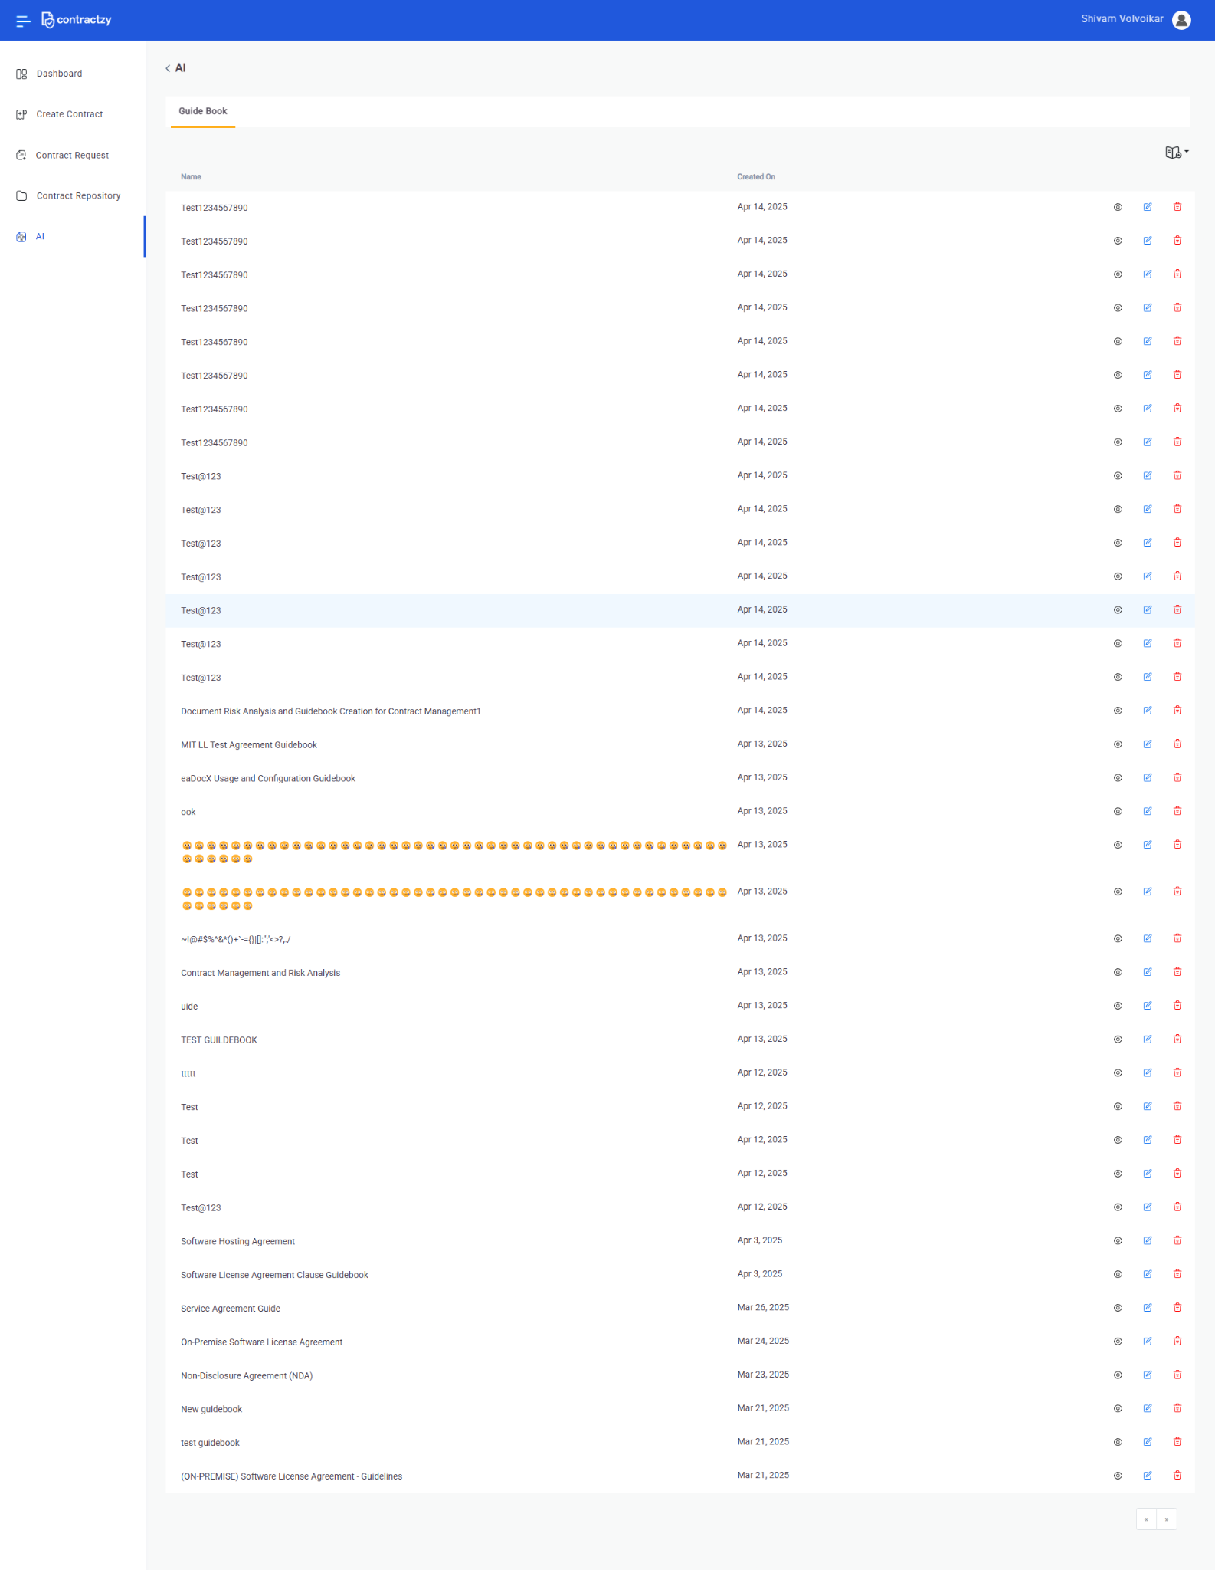

**Bug ID:** 0010

**Summary:** Increase the Label font size with a darker shade of color   
**Module:** Guide Book(AI)  
**Environment:** Staging

**Steps to Reproduce:**

1.Navigate to Guidebook section

2.Check for Label headings

**Expected Result:**The label heading must be properly visible with darker color

**Actual Result:**Label font size too small with lighter font color

**Severity:** Medium  
 **Priority:** high  
 **Attachments:**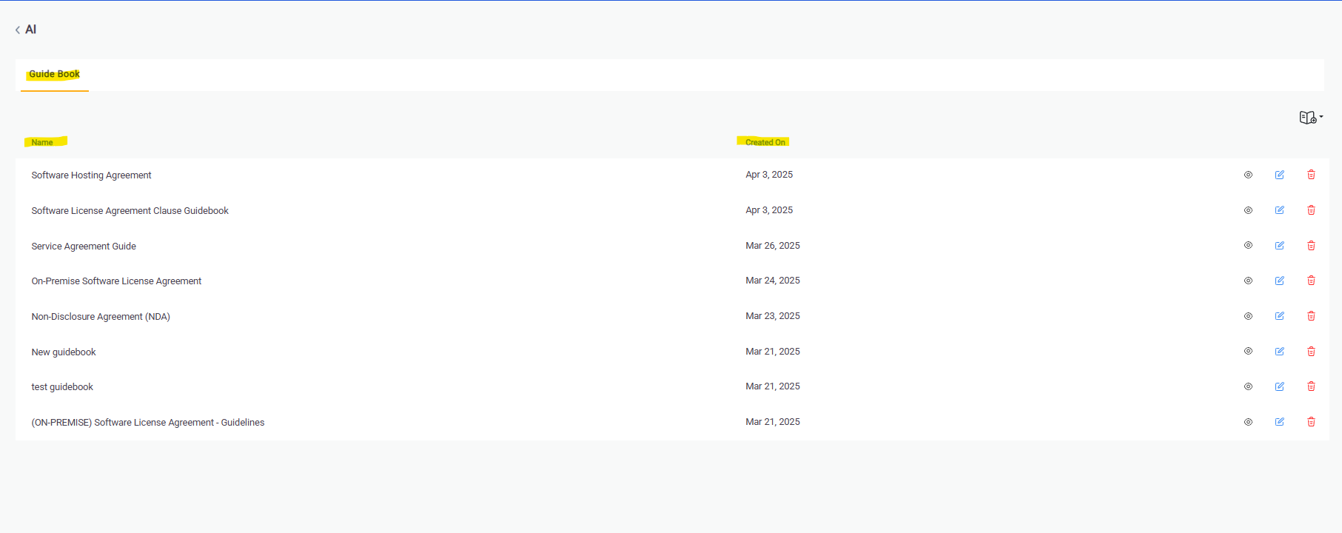

**Bug ID:** 0011

**Summary:** Typo in Contract Creation  
**Module:** Guide Book(AI)  
**Environment:** Staging

**Steps to Reproduce:**

1.Navigate to Contact Creation> Add Email CC

2.Check for Typo in “Email will be send to these users when the contract is sent for signature and once it is signed by all users” Verbiage

**Expected Result:**“Email will be SENTto these users when the contract is sent for signature and once it is signed by all users”

**Actual Result:**“Email will be send to these users when the contract is sent for signature and once it is signed by all users”

**Severity:** low  
 **Priority:** low  
 **Attachments:**

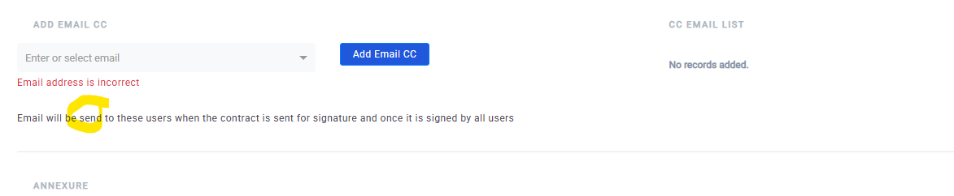

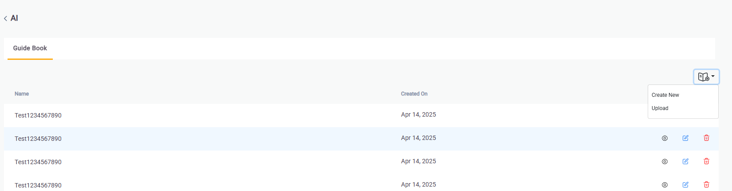

**Bug ID:** 0012

**Summary:** Adjust the UI of “Create New” and “Upload” Dropdown in Guidebook section

**Module:** Guide Book(AI)  
**Environment:** Staging

**Steps to Reproduce:**

1.Navigate to Guidebook(Ai)

2.Click on the dropdown section on right

**Expected Result:**Adjust the dropdown

**Actual Result:**Too much of whitespace

**Severity:** low  
 **Priority:** low  
 **Attachments:**



**Bug ID:** 0013

**Summary:** Pagination issue in Guide Book(AI)

**Module:** Guide Book(AI)  
**Environment:** Staging

**Steps to Reproduce:**

1.Navigate to Guidebook(Ai)

2.Click on right arrow of pagination

3.Click on Left arrow of pagination

**Expected Result:**Pagination must adjust the entities in multiple pages

**Actual Result:**Pagination doesn’t work

**Severity:** Medium  
 **Priority:** Medium  
 **Attachments:**

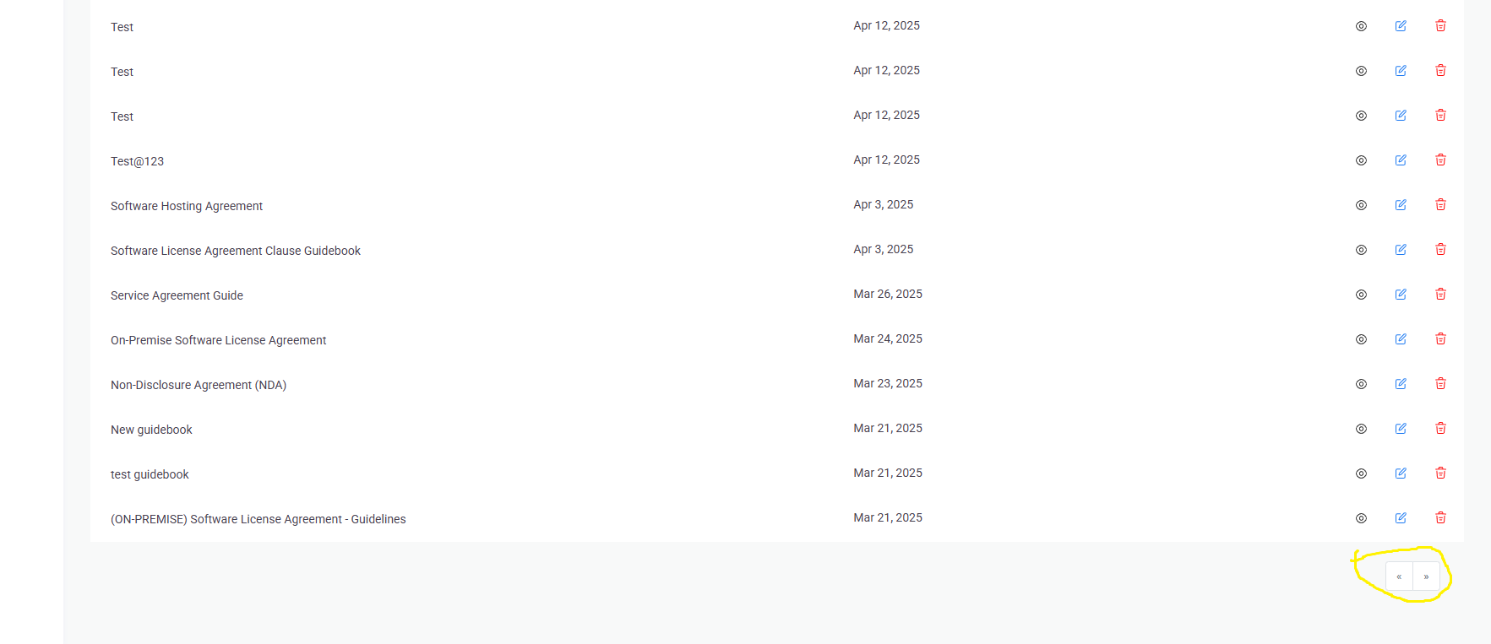

**Bug ID:** 0014

**Summary:** Login issue

**Module:** Login page   
**Environment:** Staging

**Steps to Reproduce:**

1.Click on email address field and trigger the validation

2.Click on Password field and trigger the validation

3.Add valid details and click on Login

**Expected Result:**The user must login with the first click

**Actual Result:**User doesn’t login with a single click

**Severity:** Low  
 **Priority:** Medium  
 **Attachments:** [**https://drive.google.com/file/d/1tPT7jcmAfaV7AXqgecGpabYNQXnAC_ke/view?usp=drive_link**](https://drive.google.com/file/d/1tPT7jcmAfaV7AXqgecGpabYNQXnAC_ke/view?usp=drive_link)

**Bug ID:** 0015

**Summary:** Analyze error

**Module:** Risk Analysis  
**Environment:** Staging

**Steps to Reproduce:**

1.Navigate to Contract Creation page

2.Add valid data and click on Create Contract

3.Click on save and proceed

4.click on analyze

**Expected Result:**The contract must get created and analyze button must process

**Actual Result:**Contract stays blank and analyze button throws an error

**Severity:** Critical  
 **Priority:** Urgent  
 **Attachments:**

[**https://drive.google.com/file/d/11tTKJHIOfEpW9FT9CEefJZfbNdxpDjri/view?usp=drive_link**](https://drive.google.com/file/d/11tTKJHIOfEpW9FT9CEefJZfbNdxpDjri/view?usp=drive_link)

**Bug ID:** 0016

**Summary:** No Validation message/ no response on blank input in Upload functionality for Guidebook

**Module:** Guidebook(AI)

**Environment:** Staging

**Steps to Reproduce:**

1.Navigate to Guidebook(AI)

2.Click on Upload functionality

3.Without adding any file click on Submit

**Expected Result:**A validation message must be displayed

**Actual Result:**No response/ No validation message

**Severity:**low  
 **Priority: Medium**  
 **Attachments:**

