**Test Strategy Summary –**

**Claims Submission Flow**

# 1. Introduction

This report provides a visual and structured summary of the QA strategy for the Claims Submission Flow in the healthcare mobile application. It includes risks, testing constraints, scenarios covered, and insights from the planning phase to support UAT readiness and final QA sign-off.

# 2. Risks Involved

The following key risks were identified and planned for mitigation during the test planning phase:

- Delayed access to design or staging environments

- Unclear file upload limits and validations

- Last-minute UI or feature changes

- Limited physical device access for cross-platform testing

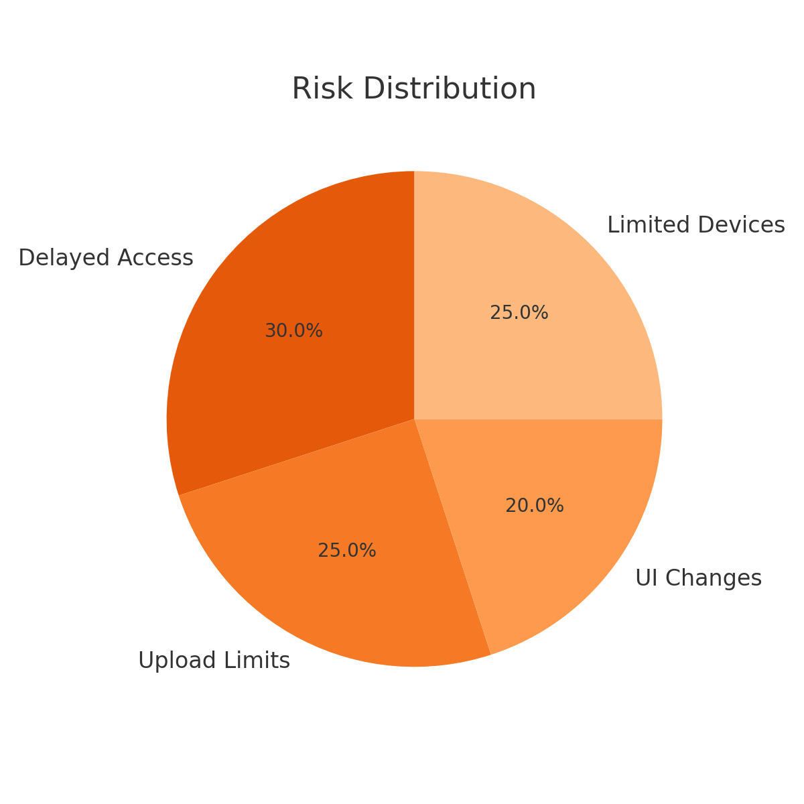

Figure 1: Risk Distribution

# 3. Constraints in Testing

The constraints below were acknowledged during the test preparation phase:

- Backend API testing Unavailable

- Payment gateway or external service integrations not included

- Web platform testing out of scope for this release

-Login Credentials not provided

-Test/ staging link/ apk not provided

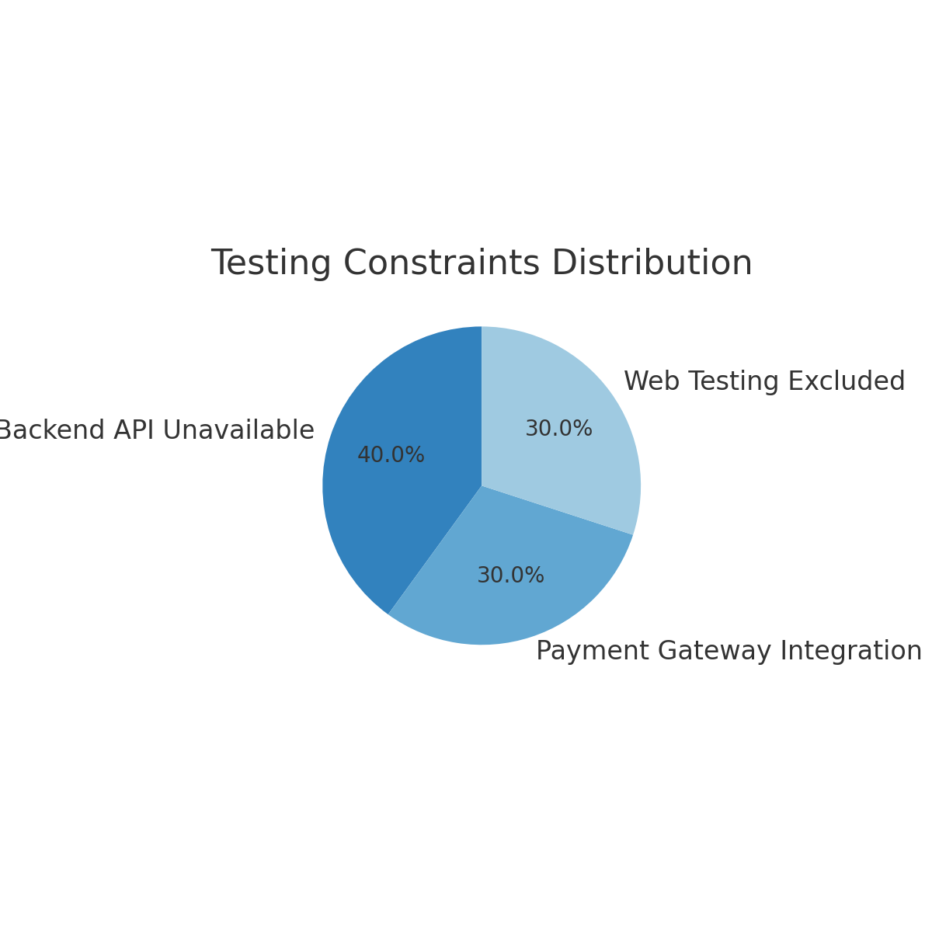

Figure 2: Testing Constraints Distribution

# 4. Scenarios Covered

The QA team ensured wide coverage of all essential test categories:

- Functional Testing

- UI/UX Testing

- Negative and Boundary Testing

- Usability, Security, and Performance Testing

- Cross-Device and Compatibility Testing

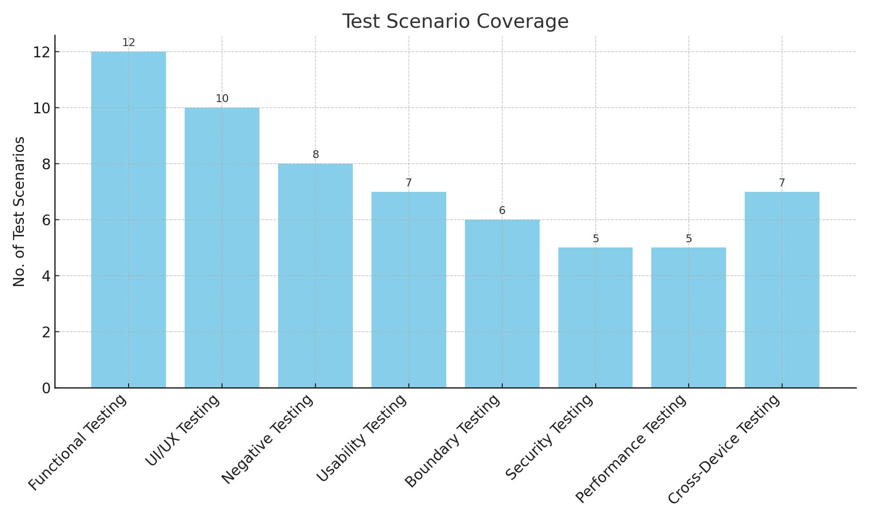

Figure 3: Test Scenario Coverage by Category

# 5. Overall Summary

The QA process for the Claims Submission Flow was comprehensive, addressing both core functionality and user experience flows. Through proactive risk mitigation and scenario planning, the testing team ensured maximum test coverage, reliability, and UAT readiness. The visuals in this report reflect our coverage focus and risk prioritization.