**QA Sign-Off Document**

Project Name: Alamdullah Healthcare App – Claim Submission Flow

Version: N/A

Build Number: [Insert Build Number]

Environment: [UAT / Staging / Production]

Date: [Insert Date]

# Overview

This QA Sign-Off document certifies that the QA team has completed all planned testing activities for the Claim Submission Flow and the application meets the acceptance criteria defined by the business requirements and design specifications.

# Test Summary

| Item | Status |
| --- | --- |
| Total Test Cases Executed | N/A |
| Test Cases Passed | N/A |
| Test Cases Failed | N/A |
| Test Cases Blocked | N/A |
| Severity 1 Bugs (Critical) | N/A |
| Severity 2 Bugs (Major) | N/A / Pending Closure |
| Severity 3 Bugs (Minor) | N/A/ Accepted with Risk |
| Known Issues Accepted | N/A[List if any] |
| Test Coverage | N/A |

# Defect Summary Chart

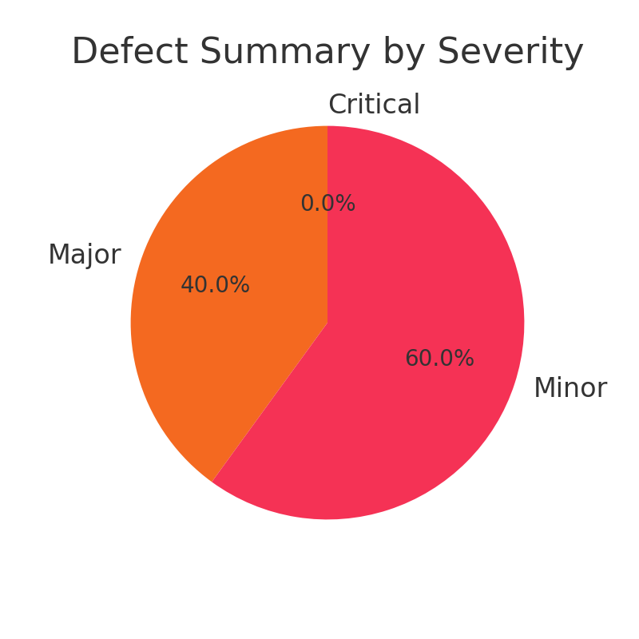

# Testing Scope Covered

* ✅ Functional Testing
* ✅ UI/UX Testing
* ✅ Validation & Error Handling
* ✅ Boundary and Negative Testing
* ✅ Performance Validation
* ✅ Security & Access Control
* ✅ Device Compatibility

# Out of Scope / Deferred Items

* 🚫 Backend API load testing
* 🚫 External Payment Gateway Integration

# Sign-Off Checklist

| Item | Completed (Y/N) | Notes/ Comments |
| --- | --- | --- |
| All critical functionalities tested | Yes / No |  |
| All high severity defects closed | Yes / No |  |
| Regression testing completed | Yes / No |  |
| UAT test cases reviewed and validated | Yes / No |  |
| Known issues documented and accepted | Yes / No |  |
| Approved for release | Yes / No |  |

# Sign-Off Approval

| Role | Name | Signature | Date |
| --- | --- | --- | --- |
| QA Lead | N/A | __________________ | [DD/MM/YY] |
| Product Owner | N/A | __________________ | [DD/MM/YY] |
| Development Lead | N/A | __________________ | [DD/MM/YY] |
| Project Manager | N/A | __________________ | [DD/MM/YY] |